**Biology 1450 Virus Hunting**

**2018**

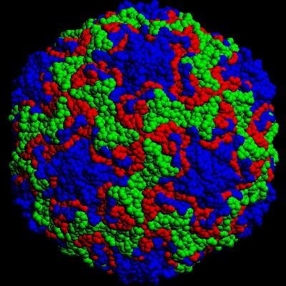

**Figure of Human Rhinovirus courtesy of Jean-Yves Srgo, University of Wisconsin**

**Discovering Bacteriophages in Water Samples**

**Introduction**

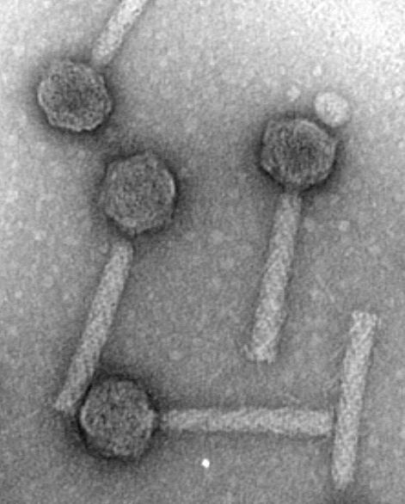It is estimated that there are 1031 viral particles on earth. It is also estimated that there are 109 viral particles per gram of human feces. Obviously, viruses contribute a great deal to biology and to human health. Research has already revealed a large number of different viruses and much is known about virus biology, but the fact is, the vast majority of viruses remain to be discovered.

Next generation sequencing led to metagenomic analysis of viral sequences from many different ecosystems. For example, several studies have examined the viral genome sequences present in the human gut. Over the last few years, these studies have determined that each individual harbors an incredibly diverse population of viruses in their gut and, interestingly, this population is unique to that individual. The vast majority of gut viruses are bacteriophages that infect the gut microbiome and the population of bacteriophages in an individual is a reflection of the bacterial population in the microbiome. The total population of viruses in an individual is termed the virome. In every study conducted so far, the human gut virome has been shown to be composed of a very diverse population of bacteriophages, some of which are temperate (capable of lytic or lysogenic multiplication cycles) and some of which are purely lytic. Interestingly, the Microviridae (X174 and M13) account for a large percentage. As with studies of other ecosystems, the majority of viral genomes in the human gut have not been previously characterized. The viruses remain undiscovered. Since a major component of the gut microbiome is *E. coli*, many of these undiscovered viruses are bacteriophages that infect *E.coli*. Another common bacterial species, *Psuedomonas fluorescens* (*P. fluorescens*) is common in lakes, ponds, streams, and soil, particularly in association with plants. Little is known about the viruses that infect *P. fluorescens.*

Figure 1. Bacteriophage P2.

<https://www.biochem.wisc.edu/faculty/inman/empics/0021a.jpg>

In Biology 1450 lab this semester, we wish to discover new bacteriophages. We will test water from ponds, lakes and streams to learn if there are *P. fluorescens* bacteriophages present in the water. When these phages are present, we will isolate a particular phage, characterize the virion, characterize the viral genome and determine if the phage is known to science.

Throughout this project it is very important for you to carefully and completely document every procedure and finding. Remember, you may be finding and characterizing a virus that was unknown to science prior to your work. For example, detailed descriptions of the location of your water collection site and descriptions of the water itself are critical if you go on to publish your findings. Be sure you are extremely descriptive. It is easy to disregard one of your descriptions. It is much more difficult to recollect a description weeks after the event.

In this first virus-hunting laboratory, we wish to screen water samples for phages. This may be a simple process or may require a several step amplification procedure. You have already collected water samples. Your samples have been stored at 4C. The procedures that follow describe the initial steps necessary to screen for phages.

**Preparing the Sample**

Water samples are filled with debris and all manner of organisms. We wish to isolate bacteriophage specific for *P. fluorescens*. To obtain a sample suitable for screening, we must remove debris and cellular organisms. This can be accomplished by centrifugation and filtering.

1. Mix the water sample well before removing 10 ml into an SS-34 centrifuge tube.
2. Centrifuge the sample in an SS-34 rotor at 6K for 10 min at 4 C.
3. Carefully remove the supernatant into a clean test tube without disturbing the pellet.
4. Pipet the water into a 10 ml syringe that has a 0.45 um (or 0.22 um) syringe filter attached.
5. Filter the water into a clean 15 ml Falcon tube.

**Initial Phage Screen**

There is a chance that bacteriophage is highly concentrated in your water sample. If so, we wish to observe the water directly for the diversity and concentration of bacteriophages that are present. You should recognize the procedure below as a titering experiment similar to the experiment conducted previously.

1. Mix 100 ul of water with 100 ul of log phase *P. fluorescens* host cells.
2. Incubate at room temperatue for 30 minutes to infect host cells with phages.
3. Add incubated phage infection to 3.5 ml of molten (45 C) 0.7% agarose and immediately pour onto the surface of an LB plate. Tilt the plate to distribute the molten agarose evenly.
4. Let the agarose harden before inverting the plate, then place in the 37 C incubator overnight.

**Amplifying Phage in the Water Samples**

For most water samples, the concentration of bacteriophage will not be high enough to detect using a direct screen of the water. In this case, we wish to enhance our chances of detecting bacteriophage by amplifying any viruses that are present. We will mix a water sample with a growing culture of host cells and allow the viruses to multiply in culture. This should amplify the viruses, but also realize it may decrease the viral diversity. If there are viruses that multiply very efficiently, they may overtake the culture and outcompete other viruses. During the amplification, be sure to watch for host cell lysis. This would be indicative of viral multiplication in the lytic phase.

1. Add 100 ul of host *P. fluorescens* bacteria to 10 ml of LB in a 125 ml flask.
2. Add 5 ml of filtered water to the flask.
3. Place into a shaking water bath at 37 C and incubate overnight.
4. Following incubation, transfer the culture to an SS-34 centrifuge tube and centrifuge in an SS-34 rotor at 6K for 10 min at 4 C.
5. Remove the supernatant (cleared supernatant) to a 15 ml Falcon tube, add 100 ul of chloroform and store at 4 C.

**Screening the Amplified Culture**

If the water sample had bacteriophages capable of infecting *P. fluorescens*  , they should now be in high concentration in the cleared supernatant of the amplified culture. The next step is to titer this sample to determine whether bacteriophages are present, what kinds of bacteriophages and present, and the concentration of bacteriophages.

1. Make serial dilutions of 10-2, 10-4, and 10-6 in SM.
2. Set up infections (100 ul of log phase *P. fluorescens* and 100 ul of dilution) using the undiluted cleared supernatant and each dilution.
3. Incubate the infections for 20 minutes at 37 C.
4. Add the infection to 3.5 ml of molten 0.7% agarose and immediately pour onto an LB plate. Tilt the plate to distribute the molten agarose evenly.
5. Let the agarose harden before inverting the plate, then place in the 37 C incubator overnight

**Plaque Purification**

If you observe well-isolated bacteriophage plaques on one of the dilution plates it is time to choose a plaque to characterize the bacteriophage. It is very common to see many different kinds of viruses on these plates. Plaque morphology (large, small, clear, cloudy, clear center with a halo etc) is often used as one characteristic indicative of a particular virus. If you see several morphologies it is likely you have isolated several different viruses. Be sure to describe all of the morphologies you see and their relative frequencies. At this point, you must make a choice. We can only characterize one virus at a time. Choose one well isolated plaque and remove the plaque for further work. This procedure is called plaque purification.

1. Surround a well isolated plaque with a sterile Pasteur pipet equipped with a rubber bulb and drive the pipet through the agar until it contacts the bottom of the plate. Rotate the pipet to loosen the agar core then lift the core out of the plate.
2. Place the pipet with the core into 0.5 ml of SM in an eppendorf tube and squeeze the rubber bulb. This should transfer the core into the SM. Add 10 ul of chloroform and store overnight at 4 C.
3. Titer the sample in SM using a dilution series of 10-1, 10-2, 10-3, 10-4, 10-5, and 10-6
4. Choose a plate that has confluent plaques (plaques contacting one another with a webbing of cells between the plaques) and add 5 ml of SM to the surface of the agar. Incubate on a tilt table at 4 C for 6 hours.
5. Recover the SM using a pipet and place into a 10 ml centrifuge tube, add a fresh 2 ml of SM to the surface of the plate, distribute the SM over the plate, then set the plate in a tilted position for 10 min. Recover the SM and add to the centrifuge tube. Centrifuge for 10 minutes at 10K at 4 C.
6. Pour the supernatant into a fresh 10 ml centrifuge tube, add 100 ul of chloroform and store at 4 C.

**Characterizing Bacteriophages Found in Water Samples**

At this point, you have a high titer stock of plaque purified bacteriophage in SM. There are many potential experiments that are possible using your unknown virus, but one major goal of our project is to learn the genome sequence. This requires isolation of the phage genome. We will attempt a simple extraction of nucleic acids from the phage stock to isolate the genome.

**Nucleic Acid Extraction from Virions**

Working from procedures that have been successful with other bacteriophages, we will treat the virus preparation with nucleases that digest contaminating cellular nucleic acids before separating the viral genome from the viral capsid. After nuclease treatment, we will digest and denature viral capsid proteins then extract the nucleic acids using phenol and phenol chloroform. Viral nucleic acid will be recovered using ethanol precipitation.

1. Remove two aliquots of 0.5 ml of viral stock into separate eppendorf tubes.
2. To each aliquot add DNase I to a final concentration of 10 ug/ml and RNase A to a final concentration of 10 ug/ml. Incubate at room temperature for 30 minutes.
3. Add proteinase K to a final concentration of 50 ug/ml and SDS to a final concentration of 0.5%. Incubate 1 hr at 56 C.
4. Next, you will do a phenol extraction. The entire procedure is written here, but also, please read the more general instructions for phenol extraction at the end of this experiment. Add 500 ul of phenol, vortex 30 sec, separate phases by centrifugation for 2 min in a microfuge at room temperature. Carefully transfer the upper aqueous phase to a fresh microfuge tube using a P200 tip. **Caution: phenol is very dangerous, it will cause severe burns if it contacts your skin or eyes. Wear gloves and eye protection and work in the hood.** Add 500 ul of phenol-chloroform (phenol:chloroform:isoamyl alcohol, 25:24:1), vortex for 30 sec, separate phases by centrifugation for 2 min in a microfuge at room temperature. Carefully transfer the upper aqueous phase to a fresh microfuge tube using a P200 tip. Add 500 ul of chloroform, vortex for 30 sec, separate phases by centrifugation for 2 min in a microfuge at room temperature. Carefully transfer the upper aqueous phase to a fresh microfuge tube using a P200 tip.
5. Add 50 ul of 3 M NaOAc pH 7.0 and 1 ml of 95% ethanol. Mix by inverting and look for the stringy nucleic acid precipitate in the tube.
6. Store the ethanol precipitated nucleic acid overnight at -20 C
7. Recover the nucleic acid by centrifugation in a microfuge for 10 min at 4°. Discard the supernatant, wash the pellet with 600 ul of cold 70% ethanol (do not vortex or mix, just add the ethanol). Centrifuge for 5 min in a microfuge. Discard the supernatant, dry the pellet for 2 min in the speed vac. Resuspend the pellet in 50 ul of TE pH 8.0.
8. Determine the concentration of the nucleic acid by spectrophotometry using the nanodrop.

***Phenol Extraction and Ethanol Precipitation***

One of the most common procedures in recombinant DNA is phenol extraction. Whenever DNA needs to be purified from a enzymatic manipulation (such as restriction digestion) in preparation for another manipulation (such as ligation), the DNA is extracted with phenol, precipitated with ethanol, and resuspended in a convenient volume of TE. The procedure is the same every time. If a procedure calls for "phenol extraction", this is what you do.

**REMEMBER: PHENOL IS DANGEROUS, WEAR SAFETY GLASSES AND GLOVES. IF YOU CONTACT THE PHENOL, RINSE WELL WITH WATER AND NOTIFY THE INSTRUCTOR. DO NOT DISPOSE OF PHENOL IN THE SINK, PLACE VESSELS CONTAINING PHENOL INTO A LABELED RACK MEANT FOR HOLDING THE MATERIAL.**

1. Add an equal volume of buffer-equilibrated phenol to the sample. The stock bottle of phenol has two layers, an upper buffer layer and a lower phenol layer. Be sure to pipet from the lower phenol layer. Vortex for 30 sec. Centrifuge for 2 min to separate the phases.
2. Carefully remove the upper, aqueous phase to a fresh tube. Add an equal volume of buffer-equilibrated phenol-chloroform (phenol:chloroform:isoamyl alcohol, 25:24:1). Vortex 30 sec. Centrifuge for 2 min to separate the phases.
3. Carefully remove the upper, aqueous phase to a fresh tube. Add 1/10 vol of 3 M sodium acetate pH 5.2 or pH 7.0 and 2.5 vol of cold 95% EtOH. Mix well and let stand at room temperature for 30 min.
4. Centrifuge at 14 K for 10 min at to pellet the DNA. Remove supernatant (without losing the pellet). Add 1/2 vol of cold 70% EtOH, don't vortex or mix, centrifuge for 5 min 14 K at. Remove supernatant.
5. Dry pellet for 3 min in speed-vac.
6. Resuspend in a convenient volume of TE (10 mM Tris pH 8.0, 1 mM EDTA).

**Characterizing the Genome**

We have isolated nucleic acids by phenol extraction and now have a sample containing the viral genome. For all of the subsequent experiments to characterize the genome we must know the concentration of nucleic acid in the sample. We will determine the concentration by spectrophotometry. In recent years, technical advances in spectrophotometers have made it possible to accurately read the absorbance of extremely small volumes of sample (1-2 ul), directly generate a digital report of the absorbance, and automatically calculate the concentration. The Nanodrop instrument in our lab has this capability. We will use the Nanodrop to determine the concentration of the nucleic acid samples. It will take only a few minutes to complete the reading using the Nanodrop. The procedure will be demonstrated in lab. What follows is a more general description of spectrophotometry and the parameters that allow nucleic acid concentrations to be determined. These general principles apply to the Nanodrop, but the digital interface and the software conduct all of the calculations in the background.

***Determination of DNA Concentration by Spectrophotometry***

Nucleic acids such as DNA and RNA will absorb ultraviolet light (UV) with a maximal absorbance at a wavelength of 260 nm. The property of light absorbance is very convenient for determining the concentration of a nucleic acid solution because the concentration is directly proportional to the absorbance

Simple model of a spectrophotometer reading the absorbance of a DNA sample

A = cl A = absorbance

 = extinction coefficient

c = concentration

l = path length (equal to 1 in most spectrophotometers)

The extinction coefficient is an experimentally determined proportionality constant that is specific for the type of molecule being measured, the concentration units, and the wavelength of light.

For DNA at 260 nm and mg/ml concentration,  = 20.

For standard spectrophotometers, most nucleic acid samples are too concentrated to read directly. Therefore, a dilution, typically 1:100 in TE pH 8.0 (6 ul of DNA sample, 594 ul of TE) is read.

**Restriction Analysis of Viral DNA**

Restriction endonucleases recognize specific DNA sequences and make scissions in the DNA. These enzymes are used for a number of applications in molecular biology and are routine tools for most experiments. In our experiment, we will use restriction enzymes as an initial screen of the unknown viral genome. We will characterize the viral DNA preparations in a diagnostic restriction digest.

Restriction endonuclease activity is extremely important in molecular biology. In fact, it was the discovery of restriction endonucleases that made recombinant DNA experiments possible. Any molecular biology textbook, web site or laboratory manual will have descriptions of restriction enzyme activity and utilization. Rather than repeat those descriptions here, I will request that you become familiar with restriction endonuclease activity by reading a textbook or website description and come to class prepared for discussion.

The diagnostic restriction digests will be analyzed by agarose gel electrophoresis. Gel electrophoresis is also a standard technique in molecular biology. It is a method to separate a complex mixture of molecules according to their migration rate through a gel matrix. Once again, descriptions of gel electrophoresis are easy to find in textbooks and websites. Please read a description of gel electrophoresis and come to class prepared to discuss the technique. A procedure for setting up and running an agarose gel is at the end of this experiment.

***Diagnostic Restriction Digest***

A restriction digest will be used to characterize the preparation of viral DNA. For the diagnostic digest we will use the restriction enzyme HindIII. The expected pattern of HindIII on lambda DNA is known from sequencing the lambda genome. The figures below show the restriction maps for lambda DNA. The top figure shows a few representative enzymes mapped onto a diagram of lambda. The lower figure shows a table with a more comprehensive listing of enzymes and their recognition sites on lambda DNA. Determine the sizes of DNA fragments that would be expected from a HindIII digest using the restriction map of the lambda genome below. Set up a 10 ul HindIII restriction digest according to the procedure below.

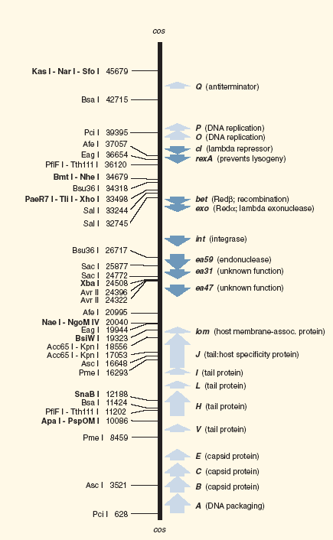

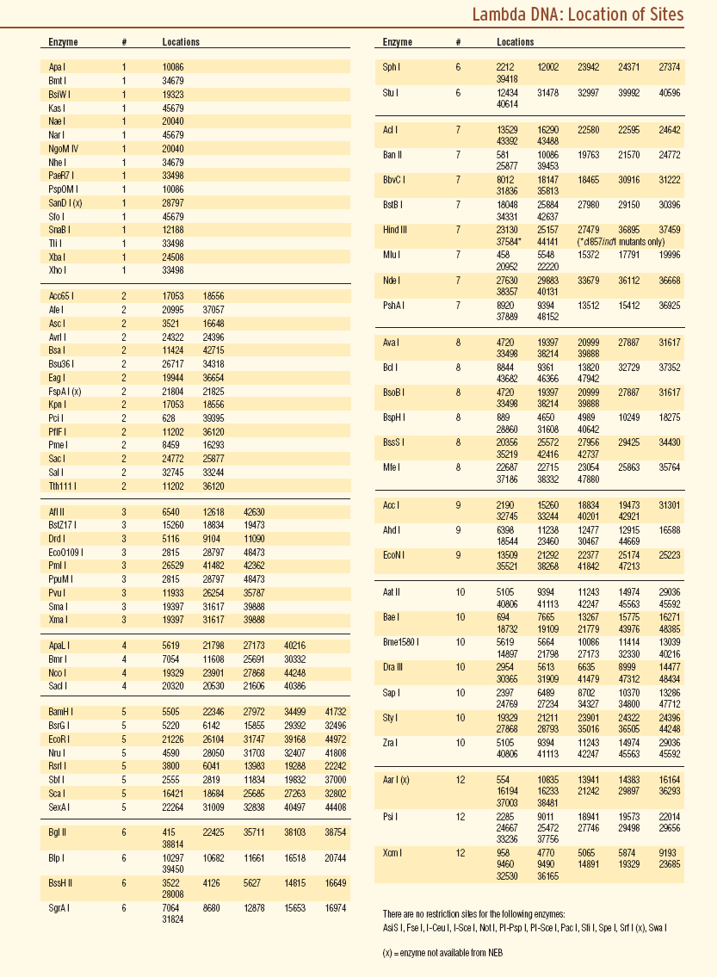

Viral DNA Restriction Digest with HindIII

5 ul (approx., should be 1 ug) of viral DNA

1 ul 10X assay Buffer M

1 ul (12 units) Hind III

3 ul ddH2O

Assemble reaction; H2O, 10X assay buffer, DNA, enzyme.

Incubate for 1 hr at 37°

After the incubation , add 5 ul of agarose gel dye and load onto a 1% agarose gel. Also be sure that a molecular weight marker has been loaded onto the gel.

10X Assay Buffer M

100 mM Tris-HCl pH 7.5

100 mM NaCl

100 mM MgCl2

10 mM DTT

Unit definition for Hind III – one unit completely digests 1 ug of lambda DNA in 1 hr at 37°.

***Gel Electrophoresis***

You should run samples of digested and undigested DNA on an agarose gel. For each sample calculate the volume that will give you 0.5 ug of DNA.

***Preparation of an Agarose Gel***

Most of the agarose gels that we will use in this laboratory will be 1% agarose in TAE buffer. The size of the gel, the concentration of agarose, and the buffer conditions can be changed depending on the molecules being separated, but in general, prepare an agarose gel as outlined below.

For a 50 ml gel:

1. Place 0.5 g of agarose into a 125 ml flask that contains 45 ml of dH2O.
2. Learn the mass of the flask, and then melt the agarose completely in the microwave. The solution will have to boil to dissolve the agarose completely. Be careful not to let the solution boil over.
3. Replace the water that has boiled away by restoring the flask to its original mass.
4. Add 5 ml of 10X TAE buffer containing 5 ug/ml Ethidium Bromide*

**\*CAUTION: Ethidium Bromide is a powerful mutagen. It will cross the skin barrier relatively easily. Always handle ethidium bromide gels and solutions with gloves and use extreme care.**

1. Let the solution cool to less than 60° (the temperature at which you can hold the flask in the palm of your hand without pain) then pour the molten solution into the gel tray.
2. Place a comb into the gel tray to form the wells, then let the gel solidify.

TAE Buffer (1X)

40 mM Tris acetate pH 7.8

1 mM EDTA

The gel running buffer is 1X TAE containing 1 ug/ml of ethidium bromide.

# 50X TAE Stock

2M Tris 24.2 g/100 ml

Acetic acid 5.7 ml/100 ml

50 mM EDTA 10 ml of 0.5M stock, pH 8

To make 10X TAE buffer with 5 ug/ml EthBr, dilute 10 ml of 50X to 50 ml then add   
25 ul of 10 mg/ml EthBr.

To make 1X TAE with 1 ug/ml EthBr, dilute 20 ml of 50X to 1 liter then add 100 ul of 10 mg/ml EthBr stock

To load a sample on the gel, add approximately 1/6 volume of gel loading dye to the sample then pipet directly into the well.

You should run a lane of molecular weight markers on the gel for reference. Ask the instructor for the appropriate markers.

**Next Generation Genome Sequencing**

One goal of our project is to obtain the complete sequence of your viral genome. This will be accomplished using next generation sequencing on the Illumina platform. There is an Illumina instrument at UNMC. The sequencing facility at UNMC will run samples on their instrument provide bioinformatics support for a fee. We have secured funding to purchase this service. For DNA samples in the concentration range we have produced (0.1-1.0 ug/ul) we must provide about 10 ul. Remove 30 ul of your isolated DNA and place it into a fresh 1.5 ml eppendorf tube. Label the tube very clearly with labeling tape using the following format: UNO Phage #x. These samples will be delivered to the sequencing facility at UNMC.

The Illumina platform sequencing approach is too complex to summarize in this manual. Please use resources available on the web such as <http://res.illumina.com/documents/products/illumina_sequencing_introduction.pdf> to become familiar with the approach. We will be using de Novo paired end sequencing.

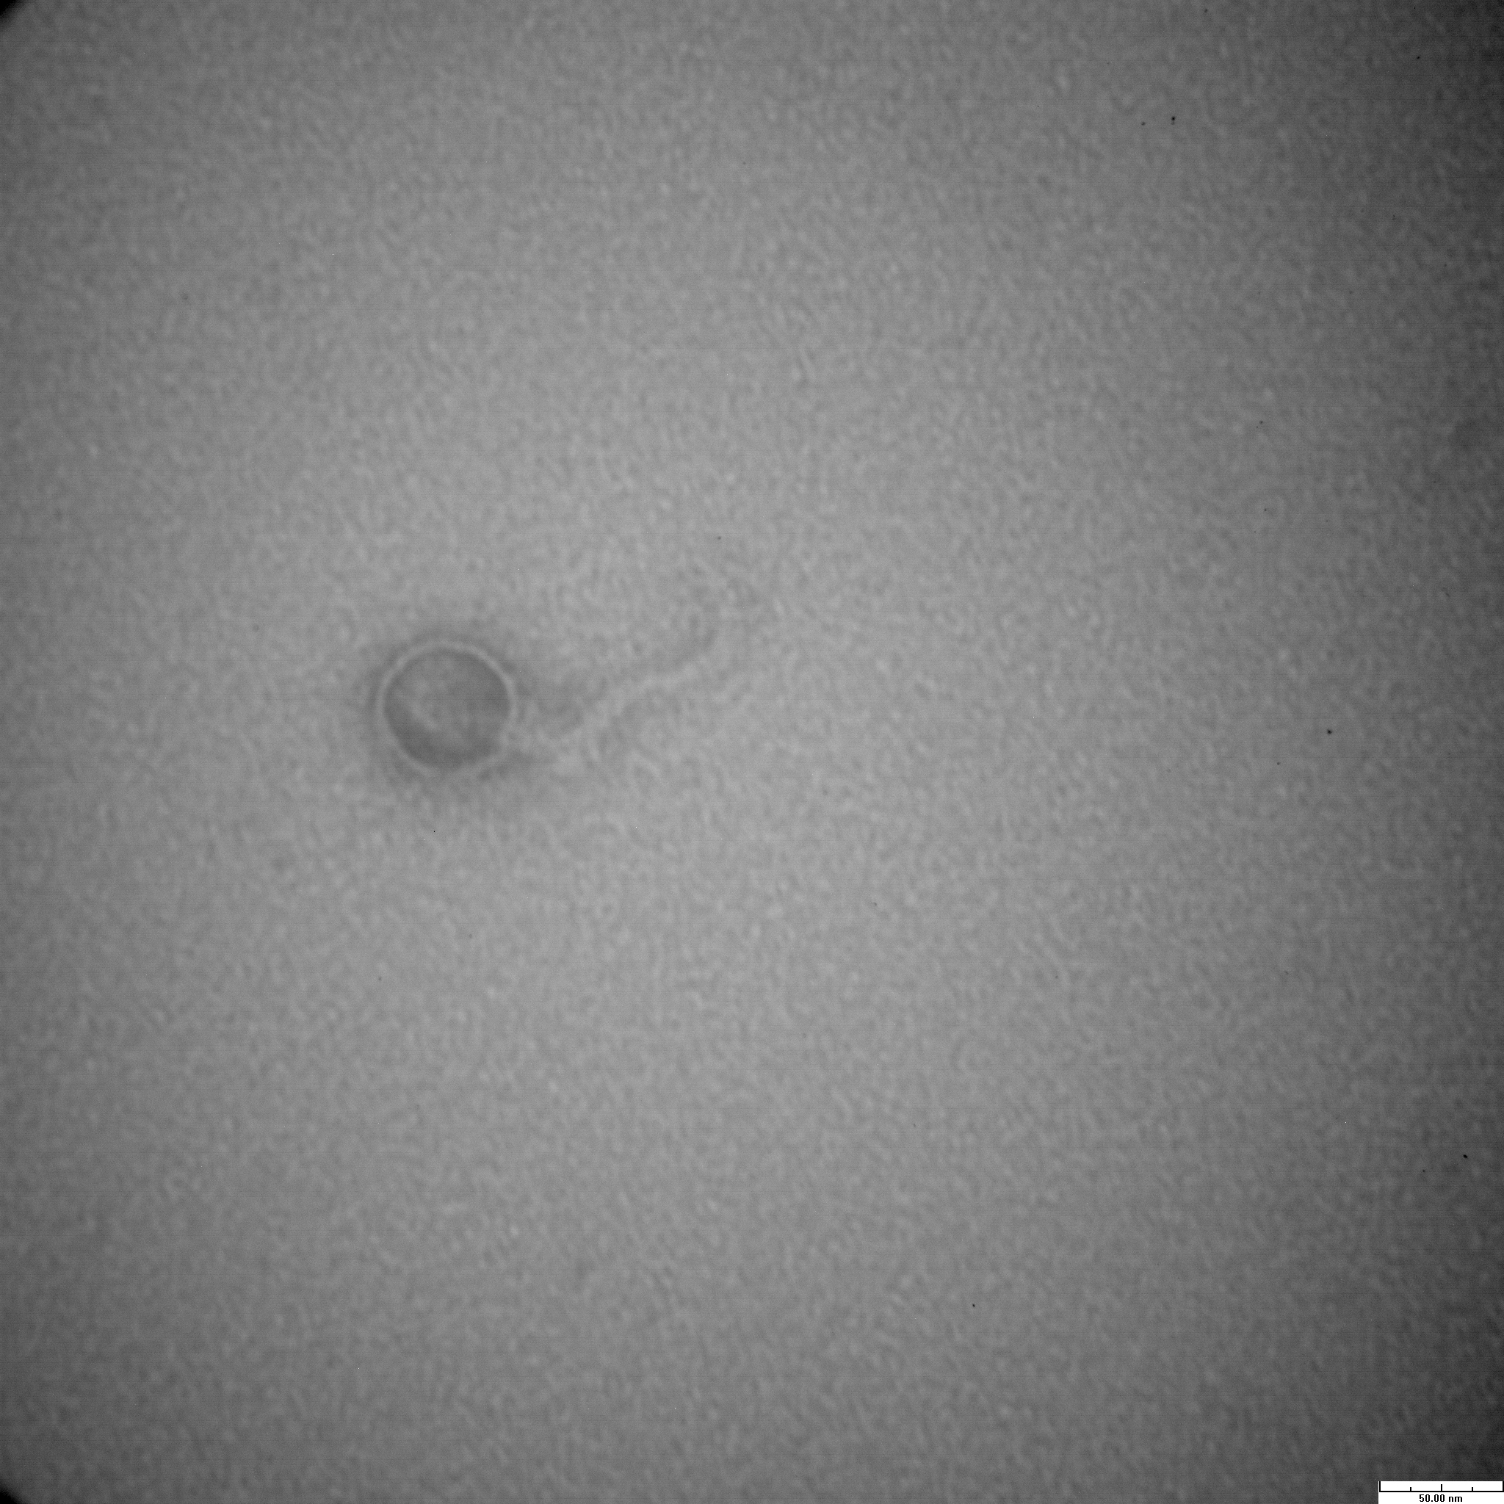

**Electron Microscopy**

Another goal of our project is to visualize the viral particles you have discovered. We will do this by electron microscopy. The imaging facility at UNL has a transmission electron microscope capable of visualizing viral particles after they have been stained by negative staining. The negative staining procedure is below. We will send a small sample of our high titer stock to the imaging facility for staining and visualization. Your high titer stocks are in the range of 1010 particles per ml. At this concentration, it should be possible to visualize viral particles in your sample without further concentrating the solution. Remove 50 ul of your high titer stock into a fresh eppendorf tube. Label the tube very clearly with labeling tape using the following format: UNO Phage #x. These samples will be shipped to the UNL imaging facility. We have arranged for you to visit and image your phages using the transmission electron microscope UNL. You will be informed about the schedule.

Figure 2. Electron micrograph of a bacteriophage isolated by UNO students in 2013.

**Negative Staining**

1. 30 μl sample drop is moved onto a strip of PARAFILM® laboratory film.
2. With Formvar® and carbon coated copper grids (400 mesh, Electron Microscopy Sciences), a grid is floated with the coated surface on the drop of suspension for 1 min and excess material wicked away with an edge of filter paper(Hardened filter paper, Whatman®), air dried for 30 seconds.
3. Put 30 μl negative staining solution(2% w/v aqueous phosphate tungsten acid, pH 7.2) onto the film.
4. The grid with sample adsorbed to the surface is floated on the drop of negative stain for 2 min, excess stain wicked away with a piece of filter paper, air dried

for 60 min.

1. The drying of the grids is carried out at room temperature.
2. The grid is examined by the transmission electron microscope (Hitachi H7500 at Morrison Microscopy Core Research Facility, University of Nebraska Lincoln).

**Characterizing Virion Proteins**

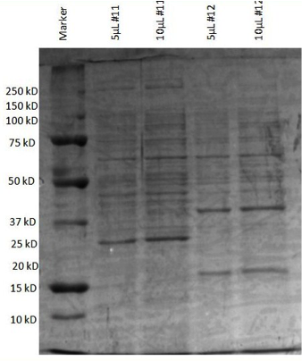Molecular characterization of a new virus begins by determining the number of proteins in the virion. We can use SDS polyacrylamide gel electrophoresis (SDS-PAGE) to separate the proteins present in the high titer stocks of the viruses we have isolated. This enables us to determine the number of proteins, the relative abundance of each protein and an approximate molecular weight for each protein present in each virion. Figure 3 shows an SDS PAGE analysis of viruses isolated by students in the 2013 class

**SDS-PAGE**

**Materials:**

* SDS-PAGE Mini-Protean tank, gel casting cassettes, and gel casting frame
* 29:1 Acrylamide/Bis acrylamide solution (pre-made stock)

Figure 3. SDS-PAGE separation of proteins in the virion of bacteriophages isolated by UNO students in 2013.

* 10% (w/v) SDS
* 1.5M Tris–Cl pH 8.8
* .5M Tris-Cl pH 6.8
* SDS Sample Buffer
* SDS Running Buffer (tank, pH 8.3)
* 10% Ammonium Persulfate (APS)
* Coomassie Blue Staining Solution
* Destaining Solution

**Solutions:**

**10% SDS:** Dissolve 5g of SDS in 50mL of ddH2O and stir until dissolved

**1.5M Tris-HCl pH 8.8:** Dissolve 27.23g of Tris in 80mL of ddH2O. Use HCl to adjust the pH to 8.8. Add ddH2O to final volume of 100mL.

**0.5M Tris-HCl pH 6.8:** Dissolve 6g of Tris in 70mL of ddH2O. Use HCl to adjust the pH to 6.8. Add ddH2O to final volume of 100mL.

**SDS Sample Buffer:**

0.5M Tris-HCl pH 6.8 1.25 mL

50% Glycerol 5.00 mL

10% SDS 2.00 mL

2.5% Bromophenol Blue 0.04 mL

ddH2O 1.21 mL

Total 9.50 mL

**SDS Sample Buffer can be stored at room temperature. 50μL of β-mercaptoethanol (BME) must be added to 950μL of buffer prior to use. After addition of BME, 1mL aliquots may be frozen at 4°C.

**Sample will have high viscosity due to glycerol.

**SDS Running Buffer:**

Tris 30.3g

Glycine 144.0g

SDS (solid) 10.0g

Add ddH2O to 1L and dissolve.

**If solid remains after excess of mixing, you may use gentle heating. Do not over heat as this can alter the pH of the solution.

**10% Ammonium Persulfate (APS):** Dissolve .1g of APS in 1.0mL of water. Make fresh every 2 weeks.

**Coomassie Blue Staining Solution:** Prepare in hood

Methanol 450mL

Glacial Acetic Acid 100mL

ddH2O 450mL

Coomassie Dye 3.0g

Mix water and acetic acid. Dissolve 3g of Coomassie Dye in methanol and mix the solutions together well. Filter the solution to remove any un-dissolved Coomassie particles.

**Destaining Solution #1:** Prepare in hood

Glacial Acetic Acid 100mL

Methanol 300mL

ddH2O 600mL

**Destaining Solution #2:** Prepare in hood

Glacial Acetic Acid 100mL

Methanol 100mL

ddH2O 800mL

**Procedure:**

**Casting gels:** (**Note: acrylamide is a neurotoxin and easily crosses the skin barrier. Wear gloves and use caution when manipulating liquid acrylamide. Once polymerized, acrylamide is no longer toxic**)

* Place thin glass plate with space plate into casting frame and lock clamps to secure, be sure the plates are on a flat surface.
* Place casting frame into casting stand with spring-loaded clamp.
* Squirt a little amount of EtOH between the plates to ensure no leaking. Use filter paper to soak up the EtOH between the plates once no leakage is found.
* Assemble gel mixtures following the list below.
  + The addition of APS and TEMED begin the polymerization process; add last and when ready to load into the gel.
* Using a P1000, pipette the separating gel into the space between the plates.
  + Fill the space until 1cm below the lower glass plate.
  + May add 1ml of ddH2O or EtOH to the top of mixture to ensure an even line. Once the gel has polymerized the excess water or EtOH can be poured off or blotted with a Kimwipe.
* Using P1000, pipette the stacking gel on top of the separating gel.
  + Fill to the top and insert spacer comb. Wipe overflow making sure not to touch the top of the gel and soaking up solution out of the gel.
* Allow to gel to polymerize, look at remaining solutions in the beakers.
* Once the gel has polymerized, you may remove the comb and place gel cassette into electrode assembly with the short plate facing inward.
* Add second gel or dam to other side of the electrode assembly and secure clamps.
* Place assembly into the tank.
* Fill the inner chamber or space between the two gels entirely full with running buffer.
* Fill outer chamber ~1/3 full or full enough to cover the lower electrode wire.

**Separating Gel 10% Polyacrylamide**

40% Acrylamide (29:1) 2.5 mL

1.5M Tris pH 8.8 2.5 mL

10% APS 0.1 mL

10% SDS 0.1 mL

TEMED 0.004mL

ddH2O 4.8 mL

Total 10.00mL

**Stacking Gel 5% Polyacrylamide**

40% Acrylamide (29:1) 1.25 mL

.5M Tris (pH 6.8) 2.5 mL

10% APS 0.1 mL

10% SDS 0.1 mL

TEMED 0.01mL

ddH2O 6.04mL

Total 10.00 mL

**Preparing/Loading Samples:**

* Mix equal volumes of virion samples and SDS sample buffer
* Heat samples at 95°C for 5 minutes
* Allow samples to cool to room temperature, ~3 – 5 minutes
* Load samples into wells using a P20 pipette, the glycerol will sink the samples into the bottom of the wells
* Attach lid and run at 130V for 2 hours

**Staining the gel:**

* Remove gel cassettes from the apparatus
* Use plate separator to remove the thin glass plate
* Remove gel with saran wrap and invert into staining container
* Add 50mL of Coomassie Blue stain solution
* Cover container with foil and stain overnight on a rocking table.

**Destaining the gel:**

* Remove Coomassie Blue staining solution into waste container
* Rinse gel with 100mL of ddH2O and discard into waster container
* Pour 75mL of destain solution #1 over gel for 30 minutes with gentle agitation on rocking table
* Remove stain and dispose in used alcohol container.
* Rinse gel with 100mL of ddH2O and discard into waste container
* Pour 75mL of destain solution #2 over gel and destain gel over night with gentle agitation on the rocking table.
* Remove destain solution into used alcohol container
* Cover gel with 50mL ddH2O