AdaptiveSubtraction for PixInsight
Removes an unwanted signal by subtracting a model of it, after matching the model to the image
User guide and technical description · version 1.4 · Guillaume Richard (erellaz) · October 2026
In short. Many unwanted signals in an astronomical image can be modelled: stars from a catalog, a satellite trail, diffraction spikes, a gradient, camera banding. AdaptiveSubtraction takes the image A and such a model B, produced by a separate process, and subtracts it. Because a model is never exact, B is first matched to A locally: in every window the script fits a small convolution kernel and an offset by robust least squares, which absorbs errors in amplitude, profile width and sub-pixel position that vary slowly across the field. Only the matched model is subtracted; everything B does not model stays in the image. Modelling the unwanted signal is the only limit to what can be removed. All numbers in this guide come from the Node.js test suite shipped with the script (tests/run_tests.js), run on synthetic images; they are not measurements on real frames.

1. Quick start

1.1 Installation
- Copy AdaptiveSubtraction.js and this guide into a scripts folder of your choice.
- In PixInsight, open Script › Feature Scripts…, click Add, select that folder and click Done.
- The script now appears as Script › BlackRig › AdaptiveSubtraction.
- Alternatively, run it once without installing through Script › Execute Script File….
Both images must be open before the script is launched: its image selectors list the open views.

1.2 What data to use it on
- Image A: linear (not stretched), monochrome, registered. A master or a single frame.
- Noise model B: an image of the unwanted signal alone, made by another process, with the same dimensions and geometry as A. Ideally it is zero, or constant, wherever the unwanted signal is absent. Section 3 lists the models tested and how to make them.
- Linear data only. The script scales and subtracts intensities, which is valid only in linear space. The model must also be additive: a multiplicative error such as vignetting is not removed by subtraction (§11).
- Pixel values in the range 0 to 1. The saturation level and the output pedestal are expressed in that range.
- Colour images are processed one channel at a time; each input must have one channel.

1.3 First run
- Produce the model B with the tool of your choice (§3) and open it next to A.
- Crop both images identically to a test region: a full frame takes from seconds to minutes (§10.4).
- Launch the script and select Image (A) and Noise model (B). Keep Mode on Model subtraction (the default).
- Set Matching filter radius and Window radius for your kind of model with the table of §1.4; §3.7 explains the choice.
- Keep Norm L1 (IRLS) with Iterations 4, and Fit offset b(x,y) checked.
- If A contains clipped stars, set Saturation level just below the clipping level; 1 switches the exclusion off.
- Tick Output scale map and Output subtracted component, then click OK.
- Inspect _clean (the result), _model (the matched model that was subtracted) and _scale (the local gain) as described in §8. Then run the full frame.

1.4 Recommended settings
Starting points from the tests of §3; refine them on a crop.
Unwanted signal | Settings to start from
Stars (catalog starfield) | Matching filter radius 1 (3×3); window radius large enough to hold dozens of stars (60 px in the test); Saturation level below the clipping level.
Satellite or aircraft trail | Matching filter radius 1; window radius 25 px, small enough to follow brightness changes along the trail.
Diffraction spikes | Matching filter radius 1; window radius 40 px.
Camera banding (row or column pattern) | Matching filter radius 0 (scalar gain); window radius 40 px (not critical).
Gradient (background model) | Matching filter radius 0; window radius 300 px or more. A matching filter makes smooth models worse (§3.7).
Model with few features (few stars, a single trail) | Regularization (lambda) 0.5–1, so that windows without model signal lean on the global fit.
Strong isolated outliers in A | Either robust norm; L2 with k-sigma rejection and L1 performed alike in the test of §10.2.
Remove the background as well (high-pass) | Mode Model and background subtraction (§7.2).

2. What the script does
The script separates two jobs. Modelling the unwanted signal is done elsewhere, by whatever tool describes it best: a star renderer, a line fit for a trail, a background model, a banding estimator. Matching that model to the image and subtracting it is done here. Matching is needed because modelling is never exact: the brightness of a trail changes along its length, a catalog magnitude is not the flux through your filter, a rendered PSF is slightly too narrow, a background model misses a term. Subtracted directly, every such error remains in the image, sometimes worse than the original signal. The script estimates, window by window, how B must be scaled, blurred or sharpened, and shifted to look like A, and then subtracts the matched model:
(1)
where f is a kernel of (2q+1)×(2q+1) taps, q being the Matching filter radius (0 gives a single scalar gain a), and b is a local offset that absorbs everything in A that B does not model. The operation written ⋆ is a correlation; the kernel printed on the console is therefore the mirror image of the equivalent convolution kernel, which makes no difference to the result. Figure 1 shows the processing chain.
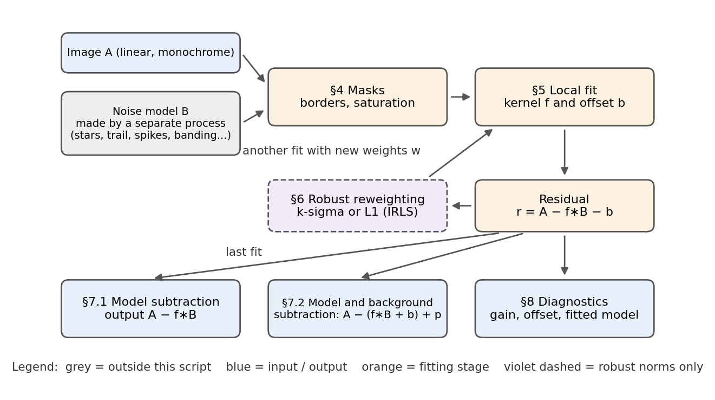
Figure 1. Processing chain. The model B is produced outside the script. Each box carries the number of the section of this guide that describes it. The reweighting loop runs only for the robust norms; with L2 the fit runs once.
The fit is least squares, made robust, in windows. What the matching can and cannot correct follows from that form:
Imperfection of the model | Corrected? | How
Overall amplitude (scale) error | Yes | Gain, or sum of the kernel taps (§5).
Amplitude error that varies across the field | Yes, if slower than the window | The fit is local; window radius sets how fast it can follow (§3.7).
Profile too narrow or too wide (PSF, trail width) | Yes, within the kernel | Matching filter, q ≥ 1 (§5.2).
Small shift | Yes, up to about q px | Asymmetric kernel taps (§5.2).
Structure in A that B does not model (sky, nebula, stars) | Kept in the output | Offset b and robust norm keep it out of the fit (§6, §7.1).
Rotation, magnification, distortion of the model | No | Re-model.
Different errors for objects sharing a window | No | One kernel per window: re-model, or reduce the window.
Multiplicative error (vignetting, flat-field) | No | The model is additive (§11).

3. Use cases
Each use case below was tested on the same synthetic image (sky gradient, nebula, 700 stars, noise of standard deviation 0.001), to which one unwanted signal was added and for which an imperfect model was supplied. The table compares the error left by no subtraction, by subtracting the model directly (A − B), and by the script in model subtraction mode with the L1 norm. The error is the RMS of (output − true image without the unwanted signal) on the pixels the unwanted signal covers, or, for banding and gradient, its standard deviation over the whole image, since a constant level is arbitrary (details in §10.1).
Unwanted signal | Imperfect model | Settings | No subtraction | Direct A − B | AdaptiveSubtraction
Satellite trail | constant brightness, width σ 1.2 px, nominal position | q = 1, r = 25 | 5.36 × 10⁻² | 2.47 × 10⁻² | 8.71 × 10⁻³
Diffraction spikes | σ 0.7 px wide, 40 % too bright, no gain variation | q = 1, r = 40 | 1.33 × 10⁻² | 1.41 × 10⁻² | 3.07 × 10⁻³
Row banding | constant across the field, 20 % low, estimation noise σ 0.0008 per row | q = 0, r = 40 | 4.42 × 10⁻³ | 1.75 × 10⁻³ | 1.37 × 10⁻³
Gradient | the cross term missing, an amplitude 25 % low and a level offset of 0.003 | q = 0, r = 300 | 1.49 × 10⁻² | 5.93 × 10⁻³ | 2.14 × 10⁻³

The matched subtraction reduced the error left by direct subtraction by a factor of 2.8 for the trail, 4.6 for the spikes, 1.3 for banding and 2.8 for the gradient. For the spikes, direct subtraction left a larger error than no subtraction at all. Figure 2 shows the four cases; stars are treated in §3.1.
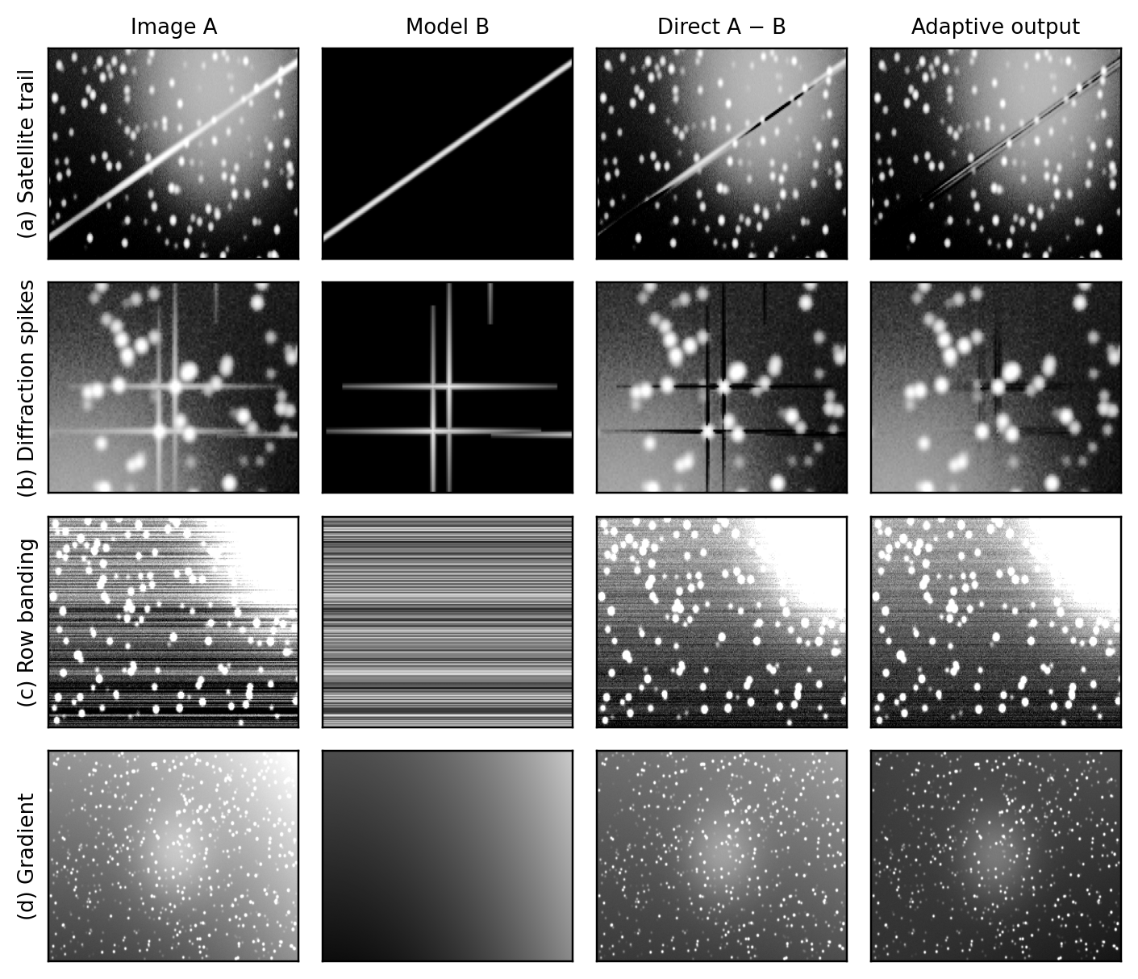
Figure 2. Use cases on the synthetic test image: image with the unwanted signal, imperfect model, direct subtraction, and output of the script. Crops (x, y ranges in pixels): (a) 100–400, 70–230; (b) 286–426, 235–335; (c) 0–300, 0–200; (d) full image. Display stretch: (a), (b) asinh((v − m)/0.004) from m − 0.01 to m + 0.12, m = median of the output; B: asinh(v/0.004) from 0 to 0.12; (c) linear, median ± 0.008; B: ± 0.008; (d) linear 0 to 0.12; B: 0 to 0.06. The trail in (a) leaves a faint residual where its brightness changes fastest.

3.1 Stars
Model: the field rendered from a star catalog (for example Gaia) with the astrometric solution of A, on a zero background, with a PSF measured on A. Typical imperfections: the catalog band differs from your filter, so the flux scale is off and varies with transparency and vignetting; the rendered PSF is slightly too narrow or too wide; the astrometry is off by a fraction of a pixel. What the script corrects: all three, as long as they are common to the stars of a window.
On the test field the model PSF was too narrow (σ = 1.4 px against 1.7 px), shifted by (0.3, -0.2) px and its scale wrong by a factor rising from 0.5 to 0.8 across the field. Leaving the stars in gives an RMS of 5.07 × 10⁻² on star pixels; a scalar gain brings it to 1.23 × 10⁻², leaving rings, and the 3×3 matching filter to 1.93 × 10⁻³ (Figure 3). The console reported a shift of (0.255, -0.163) px.
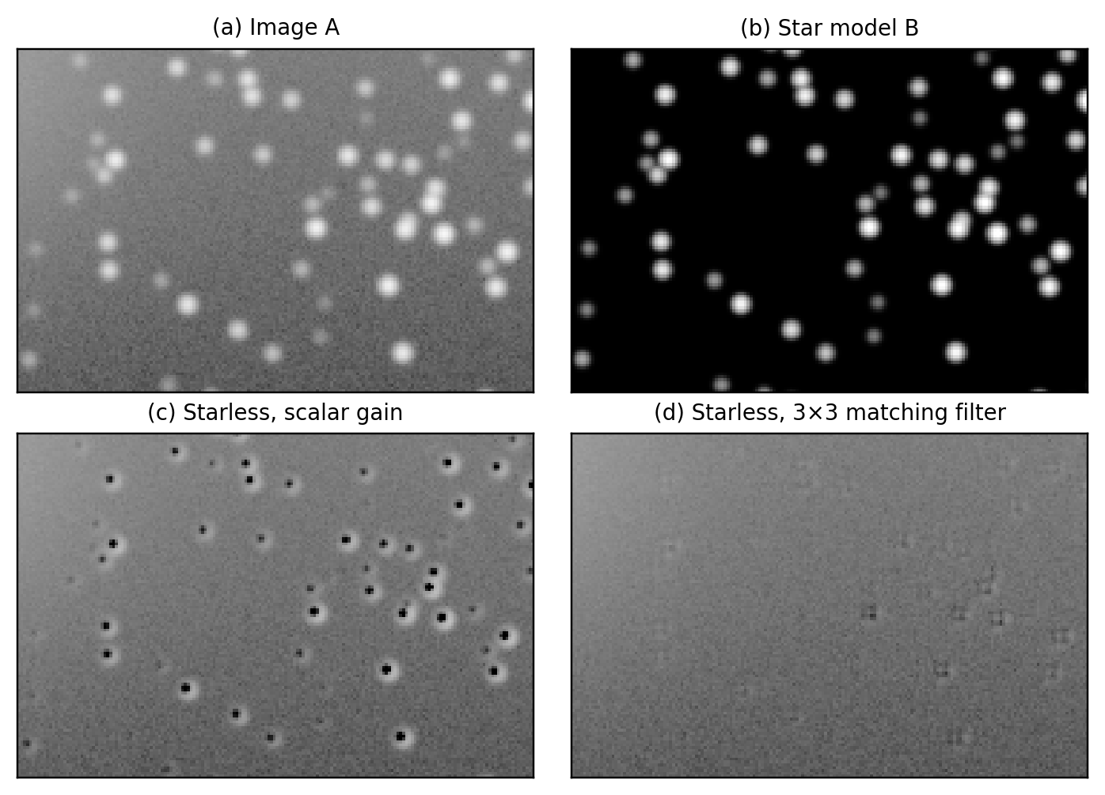
Figure 3. Stars on a 180×120-pixel crop of the test field. (a), (c) and (d) share the display stretch asinh((v − 0.03)/0.004) between 0.02 and 0.30; (b) is shown with asinh(v/0.004). Window radius 60 px, L2 with 3σ rejection, 2 fits. Faint residuals remain at the brightest stars in (d).
What cannot be corrected: differences between individual stars in the same window, such as a variable star, a star whose colour makes its catalog flux unrepresentative, or proper motion since the catalog epoch (Gaia DR3 positions refer to J2016.0 [5]). Render B from PSF photometry of A when these matter.

3.2 Satellite and aircraft trails
Model: a line with a cross-section profile, from a trail detection or line-fitting step. Typical imperfections: the brightness changes along the trail (tumbling, glints), the width differs from the assumed profile, the position is off by a fraction of a pixel. Test: glint brightness varies by ±60 % along the trail; width σ 1.5 px, offset 0.4 px; the model had constant brightness, width σ 1.2 px, nominal position. The window must be small enough for the gain to follow the brightness changes: with a 3×3 kernel the error was 8.78 × 10⁻³ at r = 15 px, 8.71 × 10⁻³ at 25 px and 1.48 × 10⁻² at 40 px. Model crossing trails separately and subtract them one after the other: one kernel cannot match two trails of different brightness in the same window.

3.3 Diffraction spikes
Model: spikes drawn from the positions and brightness of the stars and the geometry of the secondary-mirror supports. Typical imperfections: spike width and brightness, and a brightness scale that follows the throughput of the field. Test: spikes σ 0.9 px wide, brightness following the field gain 0.5–0.8; the model was σ 0.7 px wide, 40 % too bright, no gain variation. The orientation and length of the spikes must be right in the model: the kernel corrects width and small shifts, not rotation. The star cores themselves are not in the spike model; the robust norm keeps them from biasing the fit.

3.4 Camera banding
Model: the row or column pattern estimated by a banding tool, for example the difference between an image and its debanded version from FourierDeband. Typical imperfections: the estimate is noisy, and the real amplitude varies across the sensor while the estimate is uniform. Test: row offsets σ 0.004, amplitude rising from 0.6 to 1.4 across the field; the model was constant across the field, 20 % low, estimation noise σ 0.0008 per row. A scalar gain (q = 0) suffices, and the result hardly depended on the window: 1.36 × 10⁻³ at 20 px, 1.37 × 10⁻³ at 40 px, 1.37 × 10⁻³ at 80 px. The remaining error is set by the image noise and the noise of the estimate, which matching cannot remove.
A banding model is zero-mean, so it has negative values. If the modelling tool stores it with a constant pedestal c added, the subtracted model includes the gain times c, which lowers the output by a smooth offset; remove the pedestal from B first when your image format allows negative values.

3.5 Gradients
Model: a background surface from a background-extraction process. Typical imperfections: a surface of too low an order misses terms, and its amplitude or level is off. Test: 0.04x² + 0.02y + 0.015xy (x, y as fractions of the image width and height); the model had the cross term missing, an amplitude 25 % low and a level offset of 0.003. Use a scalar gain and a large window: the error was 4.08 × 10⁻³ at 80 px, 3.36 × 10⁻³ at 150 px, 2.14 × 10⁻³ at 300 px. With a 3×3 kernel it rose to 9.66 × 10⁻³: on a smooth model the shifted copies of B are almost identical, the kernel taps are poorly determined, and the fit follows the stars and the nebula instead. A level error in B is harmless in model subtraction mode: it lowers the output by a near-constant amount.

3.6 Other uses
The following uses follow the same principle but have not been tested; the settings are starting points.
- Continuum subtraction: A = a narrowband image, B = the broadband image of the same field, to remove the stellar continuum. Model and background subtraction mode with Fit offset off if both images are background-neutralized; L1, which kept extended emission best in §7.2.
- Dark-current scaling: A = a light frame, B = a master dark, to match the dark to the temperature and exposure of the light. Matching filter radius 0, so hot pixels are not blurred; large window.
- Amplifier glow: B = the glow pattern isolated from darks; a large window and a scalar gain.
- Internal reflections and ghost halos: B = the reflection modelled from the bright star that causes it.
- Residual fixed-pattern noise: B = the pattern averaged from many frames, scaled to each frame.

3.7 Choosing the kernel and the window
The window must contain enough model signal to determine the fit, and its signal must dominate the other structures of A in the window; it must also be small enough to follow how the error of the model changes across the field. The kernel helps when the model has fine structure (stars, trails, spikes) whose profile or position is slightly wrong; it hurts on smooth models (gradients), where its taps cannot be told apart. The table gathers the sensitivity runs of the test suite, with the settings recommended in §1.4 in bold.
Use case | Kernel radius q | Window radius r (px) | Error after subtraction
Satellite trail | 0 | 25 | 1.67 × 10⁻²
Satellite trail | 1 | 15 | 8.78 × 10⁻³
Satellite trail | 1 | 25 | 8.71 × 10⁻³
Satellite trail | 1 | 40 | 1.48 × 10⁻²
Satellite trail | 2 | 25 | 8.02 × 10⁻³
Diffraction spikes | 0 | 40 | 3.56 × 10⁻³
Diffraction spikes | 1 | 25 | 3.37 × 10⁻³
Diffraction spikes | 1 | 40 | 3.07 × 10⁻³
Diffraction spikes | 1 | 60 | 3.85 × 10⁻³
Diffraction spikes | 2 | 40 | 3.94 × 10⁻³
Row banding | 0 | 20 | 1.36 × 10⁻³
Row banding | 0 | 40 | 1.37 × 10⁻³
Row banding | 0 | 80 | 1.37 × 10⁻³
Row banding | 1 | 40 | 1.40 × 10⁻³
Gradient | 0 | 80 | 4.08 × 10⁻³
Gradient | 0 | 150 | 3.36 × 10⁻³
Gradient | 0 | 300 | 2.14 × 10⁻³
Gradient | 1 | 150 | 9.66 × 10⁻³

4. Masks
The script builds two masks before fitting. The output mask marks pixels that receive an output value: pixels where A is exactly 0, typically the borders left by registration, are excluded from the fit and set to 0 in every output. With Exclude pixels where B = 0 checked (off by default), pixels where B is exactly 0 are treated the same way; leave it off for models that are zero over most of the image, such as stars, trails and spikes.
The fit mask also excludes pixels of A at or above the Saturation level (default 1, which switches the exclusion off). A clipped star core cannot be matched by an unclipped model; left in the fit, it would bias the gain of the window. Excluded pixels are still processed in the output.
A window in which fewer than 25 % of the pixels are usable falls back to the global solution. This fraction is fixed in the code (minFraction = 0.25).

5. Local fit

5.1 Scalar gain (matching filter radius 0)
With q = 0 the kernel is a single gain a, fitted with the offset b by weighted least squares in the window 𝒲_{r}(x,y) of (2r+1)×(2r+1) pixels centred on each pixel and clipped at the image borders:
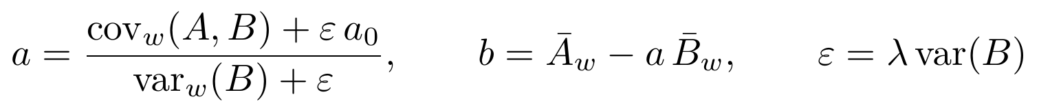 (2)
Here cov_{w}, var_{w} and the barred means are weighted over the window, w being the pixel weight (1 inside the fit mask on the first fit, then set by the robust norm, §6); a₀ is the gain fitted on the whole image, var(B) the variance of B over the whole image, and λ the Regularization (lambda). Without the offset, a = (ΣwAB + εa₀) / (ΣwB² + ε) with ε = λ times the mean of B². All window sums are running box sums, so the cost does not depend on r. In a window where B is constant, var_{w}(B) = 0 and a = a₀: the global gain is used where the model carries no information.
The gain and offset maps are then averaged over the same window, as in the guided filter [1]:
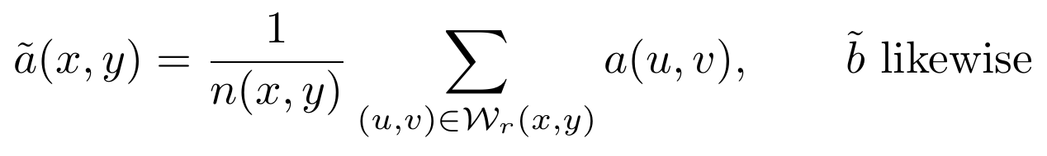 (3)
where n(x,y) is the number of pixels of the window inside the image. Without this step the coefficients would change from one pixel to the next and the matched model would follow the noise of A.

5.2 Matching filter (matching filter radius 1 to 3)
With q ≥ 1 the script fits the kernel taps and the offset in each window by minimizing
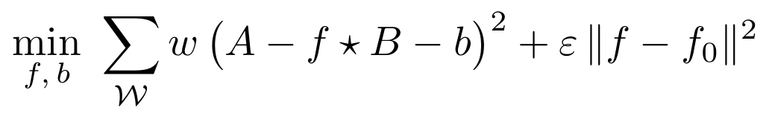 (4)
where f₀ is the kernel fitted on the whole image and the norm runs over the kernel taps (the offset is not regularized). Setting the derivatives to zero gives the normal equations
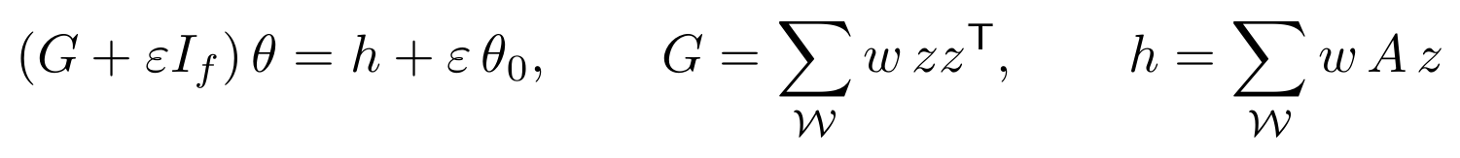 (5)
in which θ = (f, b), z holds the (2q+1)² values of B around the pixel followed by 1 when the offset is fitted, and I_{f} is the identity on the kernel taps only. The script accumulates G and h per block of side about (2r+1)/5 pixels (at least 4), pools them over the 5×5 surrounding blocks, which covers about the same (2r+1)² window, solves each system by Gaussian elimination with partial pivoting, and interpolates the coefficients bilinearly between block centres. G is built from the pixels actually in the fit mask, so excluded pixels do not distort it.
The kernel encodes the mismatches separately: the sum of its taps is the amplitude, its asymmetry is a shift and its spread is a difference in profile width. The console reports, for the global kernel,
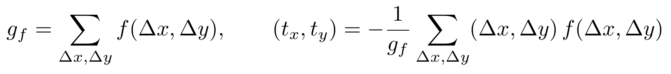 (6)
the DC gain g_{f} and the shift (t_{x}, t_{y}) of A relative to B, in pixels. On the star test, with a true shift of (0.3, -0.2) px, the 3×3 kernel reported (0.255, -0.163) px.

5.3 Regularization
The term ε is a ridge penalty [6] that pulls each local solution toward the global one. Because ε = λ var(B), λ is dimensionless: 0 gives a fully local fit and large values a single global fit; the default is 0.1. It matters most in windows with little model signal, where the local system is poorly determined. A further 10⁻⁹ var(B) is added to the diagonal for numerical stability. When a local system is singular or the window has too few usable pixels, the global solution is used and the console reports how many blocks fell back.

6. Robust norms
A always contains structure that B does not model: sky, nebula, stars when B models something else, other artefacts. Least squares lets such pixels pull the fit. With the L2 norm the fit runs once. With the two robust norms it runs Iterations times (default 4); the first fit is plain least squares and each later fit uses weights computed from the previous residual r = A − f⋆B − b. Both robust norms scale their threshold by a robust estimate of the residual noise, the normalized median absolute deviation [4]:
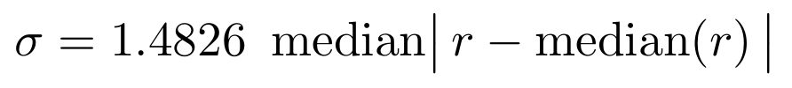 (7)
The factor 1.4826 makes σ equal to the standard deviation for Gaussian noise. It is computed on a regular subsample of at most about 10⁶ pixels of the fit mask.

6.1 L2 with k-sigma rejection
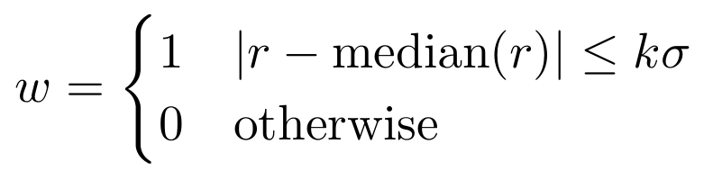 (8)
Pixels farther than k = Rejection k (sigma) (default 3) from the median residual are removed from the next fit. This removes strong, isolated outliers completely; its weakness is that contamination below the threshold, such as faint extended nebulosity, keeps full weight.

6.2 L1 by iteratively reweighted least squares
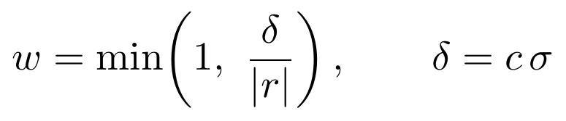 (9)
with c = L1 threshold c (sigma) (default 0.5). Iterating weighted least squares with these weights [2] converges to the minimum of Σρ(r), with ρ the Huber loss [3]:
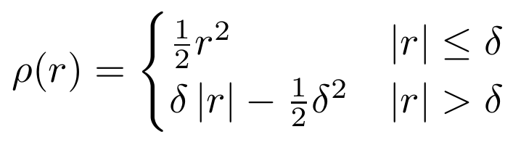 (10)
Residuals below δ count quadratically, as in least squares; larger ones count linearly, as in an L1 (least absolute deviations) fit. A pixel that B cannot explain therefore pulls on the fit in proportion to its residual instead of its square, and no hard threshold has to be chosen. Smaller c brings the fit closer to pure L1 but needs more fits to converge. With Iterations = 1 the L1 option is identical to L2.

7. Output modes
The fit is the same in both modes; they differ in what is subtracted:
(11)
where p is the Output pedestal (default 0.05), added in model and background subtraction mode only so that negative noise is not clipped.

7.1 Model subtraction (default)
Only the matched model is subtracted. The offset b is fitted as a nuisance term: it absorbs the sky and the nebula under the model during the fit and is left in the image. Without it, that background biases the gain. For a model on a zero background, a true gain g and a background s > 0 under it,
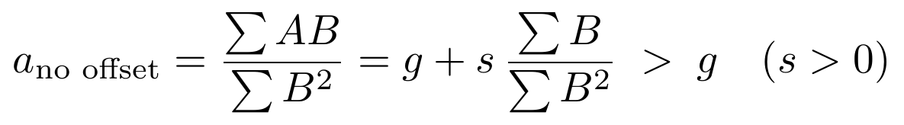 (12)
and the model is over-subtracted. On the star test the RMS error on star pixels was 1.01 × 10⁻¹ with the offset off and 1.23 × 10⁻² with it on (Figure 4). Keep Fit offset b(x,y) checked in this mode.
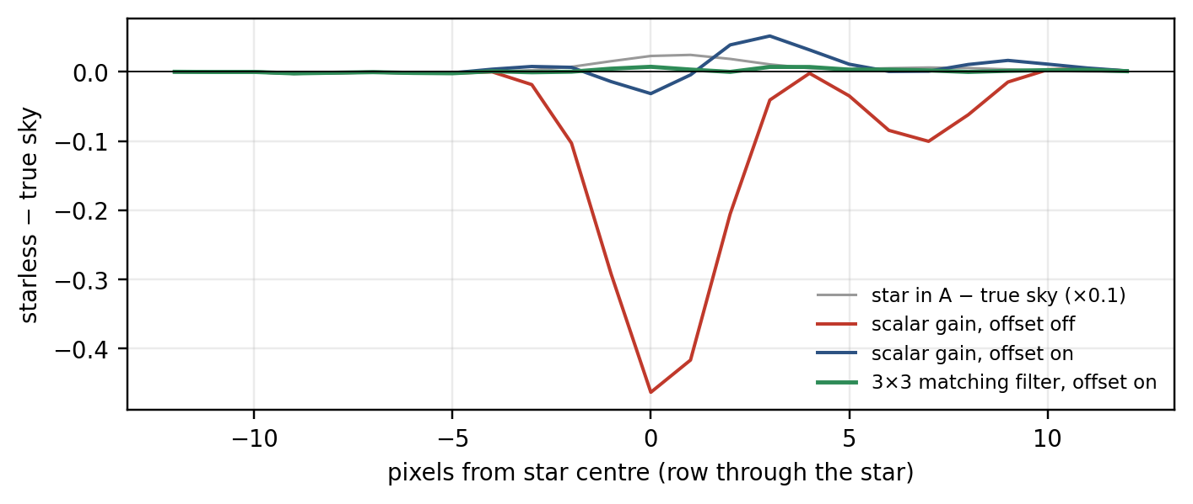
Figure 4. Output minus the true image along a row through a bright star of the star test (§3.1). Without the offset the star is over-subtracted; the scalar gain with offset leaves a ring because the model PSF is too narrow; the 3×3 matching filter stays close to zero. The grey curve is the star itself, scaled by 0.1.

7.2 Model and background subtraction
The offset is subtracted as well. Because the offset of a window is its mean of A − aB, and the offset map is averaged over the window again, the output behaves as a high-pass filter on whatever B does not explain:
(13)
where 𝒦_{2r} is the box filter of the window applied twice, a tent of half-width about 2r. Structure in A that is broader than about 2r and absent from B is absorbed into b and removed, unless the robust norm keeps it out of the fit. Use this mode when the background should go too; avoid it when A holds extended signal that B lacks.
Figure 5 measures this on a test image whose A contains a Gaussian nebula (peak 0.04, σ = 40 px) that B lacks. With L2 the output keeps 15 % of the nebula at r = 20 px and 94 % at r = 250 px. The L1 norm keeps at least 91 % at every radius tested: the nebula pixels have large residuals in the first fit and are down-weighted in the following ones. k-sigma rejection needs r ≥ 80 px to do as well.
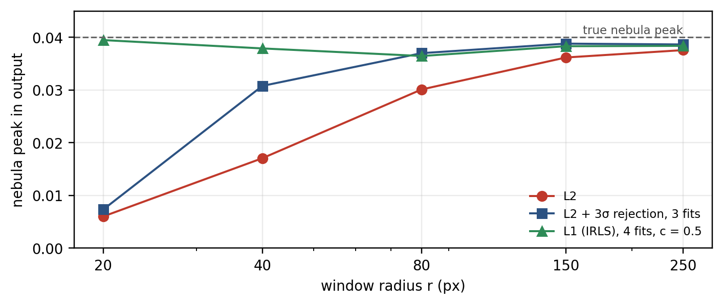
Figure 5. Model and background subtraction mode, scalar gain: peak of a nebula present in A only, measured in the output (mean of the central 5×5 pixels), against the window radius, for the three norms.

8. Outputs and diagnostics
Every output is a new 32-bit floating-point image named after A, carrying the FITS keywords of A.
- <A>_clean (model subtraction): A − f⋆B. The unwanted signal should be gone with no ring, dipole or dark imprint where the model was.
- <A>_adaptsub (model and background subtraction): A − (f⋆B + b) + p. The background should be flat near the pedestal value.
- <A>_model (model subtraction, Output subtracted component): f⋆B, the model as matched and subtracted. It should contain nothing but the unwanted signal; any trace of real structure here was removed from the image.
- <A>_prediction (model and background subtraction, Output subtracted component): f⋆B + b.
- <A>_scale (Output scale map): the gain a, or the sum of the kernel taps g_{f}. It shows how the amplitude of the model had to change across the field; it should vary smoothly. Sharp features shaped like the model mean a profile mismatch is leaking into the gain.
- <A>_offset (Output offset map b(x,y)): the background under the model. In model and background subtraction mode, anything in it is subtracted from the image.
The console reports, for each fit:
- Run header: the input views, mode, kernel size, window radius, lambda, norm and number of fits.
- Global kernel (matching filter): its DC gain g_{f}, the shift of A vs B, the global offset, the range of the local DC gain and the kernel taps as a grid. A shift above about half a pixel points to a geometric problem in the model.
- Global and local gain (scalar gain): the global a and b and the range of the local a.
- Fallback count: blocks that used the global kernel because their local system was singular or had too few pixels.
- Reweighting line: the residual σ and either the percentage of pixels kept (k-sigma) or the mean L1 weight and the share of pixels within δ (L1).
- Truncation count (when Truncate output to [0,1] is on): pixels clipped below 0 and above 1. In model subtraction mode, clipping below 0 signals over-subtraction; in the other mode, a pedestal that is too low.

9. Parameters
Labels are those of the dialog; defaults are read from the parameter object of the script (version 1.4).
Dialog control | Default | Symbol | Effect
Image (A) | active view | A | Image to be cleaned. Monochrome.
Noise model (B) | none | B | Model of the unwanted signal. Same dimensions as A.
Mode | Model subtraction |  | Model subtraction outputs A − f⋆B; model and background subtraction outputs A − (f⋆B + b) + p (§7).
Matching filter radius | 1 | q | Kernel half-size, 0 to 3: 0 = scalar gain, 1 = 3×3, 2 = 5×5, 3 = 7×7 (§5).
Window radius (px) | 100 | r | Half-size of the fitting window, 2 to 4000; the window is about (2r+1)² pixels (§3.7).
Regularization (lambda) | 0.1 | λ | Ridge weight toward the global solution, relative to var(B); 0 to 10 (§5.3).
Norm | L1 (IRLS) |  | L2 (one fit), L2 with k-sigma rejection, or L1 by IRLS (§6).
Iterations | 4 |  | Number of fits for the robust norms, 1 to 20; ignored for L2.
Rejection k (sigma) | 3 | k | k-sigma norm: threshold in units of σ, 1 to 10 (§6.1).
L1 threshold c (sigma) | 0.5 | c | L1 norm: δ = cσ, 0.05 to 5 (§6.2).
Saturation level | 1 |  | Pixels of A at or above it are excluded from the fit; 1 = off (§4).
Output pedestal | 0.05 | p | Added to the output in model and background subtraction mode; 0 to 0.5.
Fit offset b(x,y) (affine model) | on | b | Fits the offset. Keep it on in model subtraction mode (§7.1).
Exclude pixels where B = 0 | off |  | Treats B = 0 as missing (§4).
Truncate output to [0,1] | on |  | Clips the output and reports the number of clipped pixels.
Output scale map (a, or sum of filter taps) | off | a, g_{f} | Writes _scale.
Output offset map b(x,y) | off | b | Writes _offset.
Output subtracted component | off |  | Writes _model or _prediction (§8).

10. Validation

10.1 Test suite and metrics
The test suite tests/run_tests.js loads the numerical core directly from AdaptiveSubtraction.js, with the PixInsight preprocessor lines and the dialog stripped, so the code under test is the code that runs in PixInsight. Run it with node tests/run_tests.js; it prints one line per check and writes tests/results.json, from which every number in this guide is taken. The option --dump also writes the images used for the figures. The random generator is seeded, so the results are reproducible.
The base test image is 600×400 pixels: a sky gradient, a Gaussian nebula, 700 Gaussian stars and white noise of standard deviation 0.001. Star test: A has PSF σ = 1.7 px, a shift of (0.3, -0.2) px and a flux scale rising from 0.5 to 0.8 across the field; B has PSF σ = 1.4 px and no background. One variant adds a satellite trail and 0.2 % hot pixels to A. Use-case tests (§3): one unwanted signal and its imperfect model at a time, run in model subtraction mode with L1 and 4 fits.
Metrics. All errors are computed on interior pixels, excluding a 20-pixel border on every side. For stars, the RMS of (output − true image without stars) on pixels where the true star signal exceeds 0.01, excluding outlier pixels. For trails and spikes, the RMS of (output − true image without the unwanted signal) on pixels where that signal exceeds 0.004 (trail) or 0.003 (spikes). For banding and gradient, the standard deviation of the same difference over all interior pixels. The gain error is the largest |g_{f} − g| over pixels at least 40 pixels from the border.

10.2 Results
The use-case results are in §3 and the kernel and window sensitivity in §3.7. Star test, no outliers, window radius 60 px, L2 with 3σ rejection, 2 fits:
Estimator | RMS on stars | RMS, all pixels | Max gain error
Scalar gain, offset off | 1.01 × 10⁻¹ | 2.98 × 10⁻² | 1.101
Scalar gain, offset on | 1.23 × 10⁻² | 3.83 × 10⁻³ | 0.184
3×3 matching filter | 1.93 × 10⁻³ | 1.13 × 10⁻³ | 0.051
5×5 matching filter | 1.58 × 10⁻³ | 1.08 × 10⁻³ | 0.118

Star test with a satellite trail and hot pixels in A that the model does not contain, 3×3 matching filter, window radius 60 px:
Norm | RMS on stars | RMS, all pixels | Max gain error
L2 | 2.62 × 10⁻³ | 1.24 × 10⁻³ | 0.091
L2 + 3σ rejection, 3 fits | 1.84 × 10⁻³ | 1.12 × 10⁻³ | 0.048
L1 IRLS, 4 fits, c = 0.5 | 1.92 × 10⁻³ | 1.13 × 10⁻³ | 0.045

Both robust norms reduce the error on star pixels relative to L2 (2.62 × 10⁻³), by 30 % for k-sigma rejection and 27 % for L1. These outliers are strong and well separated from the noise, which favours hard rejection; with extended, graded contamination, L1 performed best (§7.2).

10.3 Correctness checks
- The box sum matches a brute-force sum to 2.8 × 10⁻⁶ (single-precision storage).
- The linear solver recovers a random 10×10 system to 2.2 × 10⁻¹⁶.
- All 17 checks of the suite pass in version 1.4.

10.4 Speed and memory
Time per pixel and per fit, measured in Node.js v22.22.2 on an Intel(R) Xeon(R) Processor @ 2.10GHz, window radius 100 px, average of 3 runs after a warm-up:
Kernel | µs per pixel per fit | s per fit, 100-megapixel image
Scalar gain | 0.102 | 10
3×3 matching filter | 0.177 | 18
5×5 matching filter | 0.897 | 90

The robust norms multiply these times by the number of fits. The window radius has no systematic effect: for the 3×3 filter, r = 50 and 200 px took 0.18 and 0.17 µs per pixel in single timings, within the run-to-run scatter. The script engine of PixInsight was not benchmarked, so times there may differ. Counted from the arrays the code allocates, memory is about 42 bytes per pixel for the scalar gain and 30 bytes per pixel for the matching filter, plus 4 bytes per pixel when the subtracted component is written, in addition to the images open in PixInsight.
Scope of the validation. The tests use synthetic images with Gaussian profiles and white noise, and models whose errors were chosen for the test; they are not a substitute for real data, and the uses of §3.6 are not tested at all. The dialog and the image input and output are not exercised by the suite. Version 1.0 has been run inside PixInsight; versions 1.1 to 1.4 have been tested in Node.js only. On real frames, inspect _model for real structure that should not be there, _scale for sharp features, and the residual where the unwanted signal was strongest.

11. Limitations and troubleshooting
The script can only remove what the model describes, and only correct errors of the model that are common to everything in a window. Errors that differ from one object to the next in the same window remain; the robust norms keep such objects from corrupting the fit, but they are subtracted with the kernel of their window.
- Bright core in a dark ring, or the reverse, along the subtracted signal: profile of B narrower or wider than in A; use Matching filter radius 1 or 2, or improve the profile of the model.
- Half-bright, half-dark residual (dipole): B offset by a fraction of a pixel; check the shift on the console and the geometry of the model.
- Dark imprint of the model in model subtraction mode: Fit offset is off, so the background biases the gain (§7.1); turn it on.
- Residual that comes and goes along a trail or across the field: window too large for how fast the error of the model changes; reduce the window radius (§3.7).
- Real structure in _model: the model is too flexible or the window too small, so the fit is matching structure that B does not contain; increase the window or lambda, use a smaller kernel or q = 0 for smooth models.
- Some objects badly subtracted while their neighbours are fine: errors specific to those objects (a variable star, a different colour, a second trail); not correctable with a shared kernel; improve the model or subtract them separately.
- Residuals at clipped stars: a saturated core cannot be matched; set Saturation level and repair the cores afterwards.
- Smooth offset in the output: B carries a constant pedestal (§3.4); remove it from B first.
- Extended signal fainter after model and background subtraction: the offset is subtracted (§7.2); use model subtraction mode, L1, or a larger window; check _offset.
- Multiplicative errors (vignetting, flat-field residuals) not removed: the model is additive; correct them by division, or work on the logarithm of the images where a gain becomes an offset.
- Patch of higher noise where a bright signal was: the photon noise of the removed signal stays in A; it can only be masked or smoothed.
- Error "Both images must be monochrome" or "identical dimensions": colour image, or B not on the pixel grid of A.
- Error "Not enough valid pixels" or "system is singular": B empty or nearly so, or most of A is 0 or saturated.
Every pixel has the same weight apart from the robust weights: the fit is not weighted by the inverse noise variance, so noisy bright regions weigh more than an optimal estimator would give them.

12. Version history
Version | Changes
1.0 | Subtraction of a reference image with a local scalar gain and offset, k-sigma reweighting, output pedestal.
1.1 | Mode that keeps the background; local matching filter (3×3 to 7×7); saturation exclusion.
1.2 | Norm selector: L2, L2 with k-sigma rejection, L1 (IRLS); 3×3 matching filter by default.
1.3 | Menu moved to Script › BlackRig; author and documentation lines in the script header.
1.4 | Generalized to any model of an unwanted signal: selector "Noise model (B)", modes renamed Model subtraction (now the default) and Model and background subtraction, outputs _clean and _model; option "Exclude pixels where B = 0", off by default (previously always on in the mode that removes the background).

13. For contributors
The numerical core is the block of functions before the PixInsight I/O section of the script: makeMasks, axisCounts, boxSum, robustStats, numberOfFits, reweight, adaptiveFit, solveLinear and matchingFilterFit. They use no PixInsight classes and can be run in Node.js. run() reads the images, calls the core and writes the outputs; ASDialog is the dialog.
- Run node tests/run_tests.js before and after a change; all 17 checks must pass.
- To add a use case, add an unwanted signal and an imperfect model to the use-case block of the suite, with a check against direct subtraction.
- Rebuild this guide from results.json so that the quoted numbers follow the code.
Keep the script to ES5 syntax, as the rest of the script is written: var and function, no arrow functions, let, const or classes. Typed arrays (Float32Array, Float64Array) are used throughout for the image buffers.

14. References
[1] K. He, J. Sun and X. Tang, "Guided image filtering", IEEE Transactions on Pattern Analysis and Machine Intelligence 35 (2013), 1397–1409.
[2] P. W. Holland and R. E. Welsch, "Robust regression using iteratively reweighted least-squares", Communications in Statistics – Theory and Methods 6 (1977), 813–827.
[3] P. J. Huber, "Robust estimation of a location parameter", Annals of Mathematical Statistics 35 (1964), 73–101.
[4] P. J. Rousseeuw and C. Croux, "Alternatives to the median absolute deviation", Journal of the American Statistical Association 88 (1993), 1273–1283.
[5] Gaia Collaboration, A. Vallenari et al., "Gaia Data Release 3: Summary of the content and survey properties", Astronomy & Astrophysics 674 (2023), A1.
[6] A. E. Hoerl and R. W. Kennard, "Ridge regression: biased estimation for nonorthogonal problems", Technometrics 12 (1970), 55–67.

