FourierDeband for PixInsight
Removing CMOS banding and periodic pattern noise in the Fourier domain
User guide and technical description · version 1.4 · BlackRig (Erellaz) · October 2026
In short. FourierDeband estimates the row and column banding of a CMOS frame (and, optionally, checkerboard and periodic interference patterns) in the 2-D Fourier spectrum, and subtracts that estimate from the original image. Stars, halos and saturated cores are protected so that they do not leak into the estimate, and an optional adaptive subtraction step matches the strength of the bands locally. The script is a single JavaScript file for PixInsight; all of its numerical code is self-contained.

1. Quick start

1.1 Installation
- Copy FourierDeband.js into a folder of your choice.
- In PixInsight: Script › Feature Scripts… › Add, select that folder, then Done.
- The script appears as Script › Black Rig › FourierDeband. (Alternatively, Script › Execute Script File… runs it once without installing.)

1.2 Data suitable for the script
- Linear, calibrated data. Banding is an additive offset per row or column; it is best removed before any stretch.
- Before registration. Banding is aligned with the sensor rows and columns only until the frames are registered; after rotation and resampling it no longer sits on the spectral axes. The best candidates for band removal are therefore the calibrated subs (batch mode, §13). An integrated master may also works when the frames were registered with minimal rotation, as long as the bands stay aligned with the axes.
- Monochrome frames or debayered colour images. Each channel is processed independently. Do not run it on raw, undebayered colour (CFA) mosaics: the Bayer pattern puts signal at the Nyquist frequency on the spectral axes, exactly where the band notches act, and it could create invalid results.

1.3 First run on a single image
- Open the image, start the script, keep the defaults (horizontal and vertical bands, star protection on) and tick Output protection mask and Output removed-noise image.
- Check the protection mask: white must cover every bright star with its halo and spikes, and any saturated core. Check the removed-noise image: it should contain bands only, with no trace of stars.
- If bands remain in places, see the recommendations below; if a star leaves a trace in the removed noise, lower the halo threshold or raise the mask dilation (§4.5).

1.4 Recommended settings
Situation | What to change
Ordinary frames, uniform banding | Defaults.
Bands visibly stronger on one side of the sensor, or different in two halves | Tick Adaptive amplitude matching (§11).
Bright nebulae or very bright stars covering a large area | Refinement passes 2–3 (§10), and adaptive matching.
Electronic interference: diagonal stripes, grids, moiré | Tick Periodic pattern noise (§8.3).
Pixel-to-pixel checkerboard (drizzle ×2, some debayering) | Tick Checkerboard / Nyquist (§8.2).
Large-scale gradients must stay untouched | Nothing: periods longer than 128 px are never removed (§8.1). Use DBE/ABE for gradients.
Many subs | Batch mode on the calibrated subs (§13); tune the settings on one sub first.

2. What the script does
FourierDeband does not filter the image in the Fourier domain. It builds a model of the pattern noise (row offsets, column offsets, optionally a checkerboard and isolated periodic patterns) and subtracts (or adaptively subtracts) that model from the untouched original. The model is obtained by notching the 2-D spectrum of a carefully prepared estimation image: a copy of the data in which stars, halos, saturated cores and other compact structures have been masked out and replaced by a smooth background, and in which the image-edge discontinuities have been removed. Most of the code exists to make that estimation image a faithful carrier of the bands and nothing else. Figure 1 shows the pipeline; the section numbers in the boxes refer to this document.
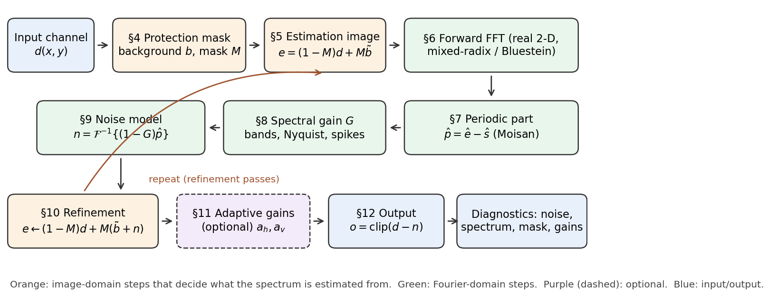
Figure 1. Processing pipeline for one image channel; section numbers refer to this document. Colour channels are processed independently with the same settings.
Why the extra machinery is needed follows from the mathematics of the notch (§3): a band notch is, to a very good approximation, a row or column mean. A mean is not robust. Anything bright that sits in a row is treated as part of that row's band and subtracted along the full width of the image, which shows as a dark streak through bright stars. Hence the protection mask (§4), the refill (§5, §10) and the edge treatment (§7).

3. Why bands live on the spectral axes
Write a calibrated, linear frame as the sum of the sky signal s, a row-offset term r(y) (constant along each row: horizontal bands), a column-offset term c(x) (vertical bands), other periodic patterns p and random noise:
(1)
With the discrete Fourier transform convention used throughout (W columns, H rows, frequency indices k_{x}, k_{y}):
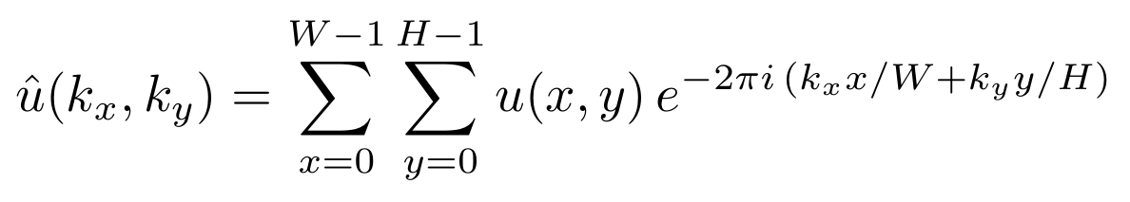 (2)
a pure row-offset image transforms to a single line of energy on the k_{x} = 0 axis, and a pure column-offset image to the k_{y} = 0 axis:
(3)
Horizontal bands therefore appear as a vertical line through the centre of the (centred) spectrum, vertical bands as a horizontal line, and a periodic pattern such as electronic interference as an isolated pair of points (a pair because the transform of a real image is Hermitian). Figure 2b shows all three.
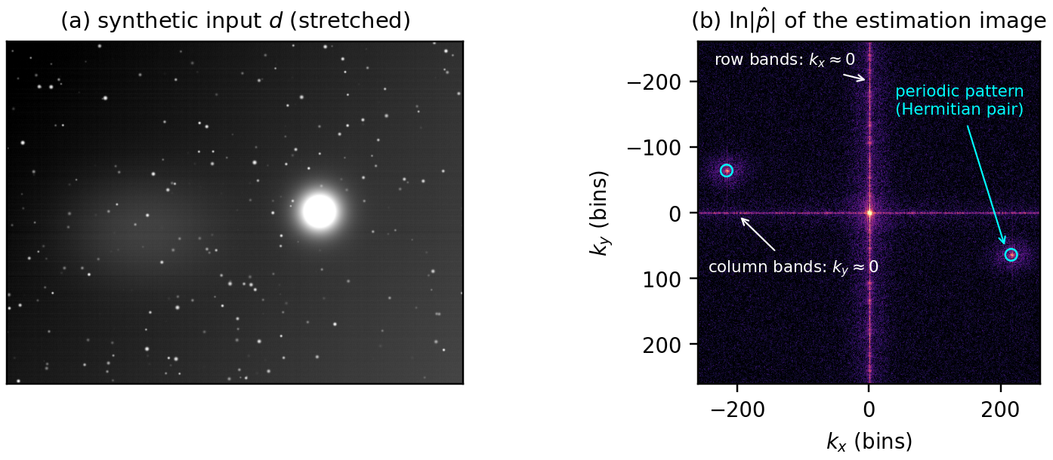
Figure 2. (a) Synthetic test frame: gradient, faint nebula (left), a saturated star with halo (right), 350 field stars, random and periodic row bands, column bands, an oblique periodic pattern and noise. (b) Log-magnitude spectrum of the estimation image that the script actually transforms (stars masked and refilled, edges made periodic): row bands = vertical line, column bands = horizontal line, oblique pattern = circled pair.
The key identity for everything that follows: the inverse transform of the k_{x} = 0 column alone is exactly the row mean,
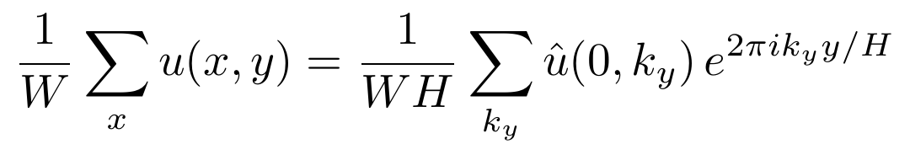 (4)
so a notch on that axis estimates each row's offset as the average of the row. (The script's notch is slightly wider than one bin, §8.1, which turns the plain average into one weighted by a very broad Gaussian along the row.) Consequently whatever is bright in a row leaks into that row's estimated band: a saturated star 100 px across at 10 000 times the noise contributes about 100 × 10 000 / W ≈ 100 σ per pixel to the row offset of a 10 000-px-wide frame, subtracted along the whole row.

4. Protection mask
The protection mask decides which pixels may contribute to the band estimate. Its output is a binary mask M (1 = protected, excluded from the estimate) and a smooth background b̃ used to fill the protected pixels. Steps 4.2–4.5 are iterated three times, each iteration starting from the previous mask. Figure 3 shows the result.

4.1 Saturation
If at least nine pixels lie within 10⁻⁴ (relative) of the data maximum, that level is taken as saturation and every pixel at it is always protected:
(5)
Saturated cores are flat plateaus, and a plateau is invisible to any test that compares a pixel with its local background, because inside the plateau the local background is the plateau itself. Saturated pixels are therefore unconditional seeds of the mask.

4.2 Background from unprotected pixels
The frame is tiled into 64 × 64-pixel blocks; in each block the median of the unprotected pixels is taken (every 4th pixel in each direction, up to 256 samples). Blocks with fewer than 8 usable samples are filled from their valid neighbours, and the block values are interpolated bilinearly:
(6)
In the first iteration a bright star pulls the medians of its blocks up; in the next iteration its pixels are excluded, the background falls back to the sky, more of the halo is detected, and so on. Excluding protected pixels, rather than clipping them, is what stops the background from following a star.

4.3 Residual, with the bands removed first
Without precaution, strong bands would themselves look like structure in the residual r₀ = d − b. The band-like part of the robust row and column medians is therefore removed first:
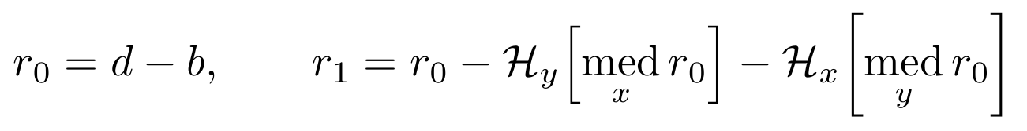 (7)
where med_{x} is the median over the unprotected pixels of a row (sampled every ⌊W/2000⌋ pixels) and 𝓗 a running-median high-pass over 65 rows or columns:
(8)
Only the high-passed part is removed, so a smooth bias (for instance the faint tail of a halo in rows crossing a protected star) is not pushed back into whole rows. A row or column is skipped only when fewer than 16 of its sampled pixels are unprotected.

4.4 Smoothing and noise scale
The residual is averaged over a 5 × 5 box B₅, and its noise scale is measured with the median absolute deviation (1.4826 makes it consistent with the standard deviation for Gaussian noise [5]):
(9)
Averaging 25 pixels divides white noise by 5 while a star keeps much of its flux in the box, so detection on the smoothed residual is about five times more sensitive to stars and far less prone to single-pixel false alarms. With the default detection threshold k_{d} = 5, stars down to a per-pixel peak of about 3 σ are detected, while pure noise yields a mask coverage of about 0.05 %.

4.5 Seeds, growth and dilation
(10)
Seeds are pixels whose smoothed residual exceeds k_{d} σ_{s} in absolute value (bright structures and dark defects such as dust donuts), plus all saturated pixels. The mask grows from the seeds through 4-connected neighbours whose smoothed residual exceeds the lower halo threshold k_{ℓ} σ_{s} (default 2): this two-threshold scheme follows halos, diffraction spikes and bleed columns down to the noise floor without picking up isolated noise. Finally the mask is dilated by a square of half-width g (default 4 px). Lower the halo threshold or raise the dilation if stars leave traces in the removed-noise image.

4.6 Fill surface
The bilinear background has slope discontinuities along every block row and column, a grid of kinks aligned with the image axes that the notches would read as bands wherever a large area is filled. The fill surface is therefore smoothed by two passes of a 65 × 65 box:
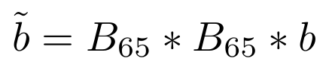 (11)
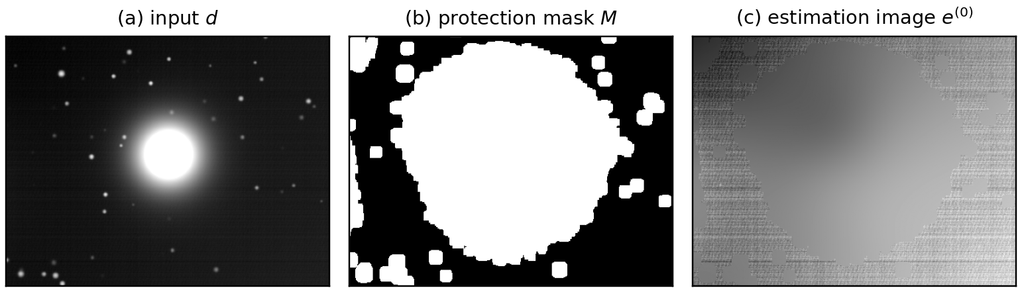
Figure 3. Protection mask on the test frame of Figure 2, around the saturated star. (a) Input. (b) Mask after three iterations: saturated core, halo traced down to the halo threshold, field stars with their wings, dilated by 4 px. (c) The estimation image of §5: protected pixels replaced by the smooth fill; the bands remain visible in the unprotected sky.

5. Estimation image
The image that is actually Fourier-transformed is
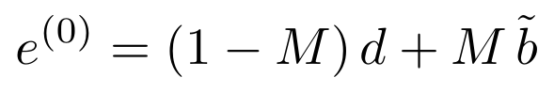 (12)
Unprotected pixels keep their data, bands included; protected pixels carry the smooth fill, which has no bands. In the first pass this biases the band estimate low in rows that are heavily protected; §10 and §11 remove that bias. With star protection switched off, e = d.

6. Fourier transform
PJSR provides FFT methods on its Image class, but those routines may enlarge the image dimensions for speed [7]. The script carries its own transform, in plain ECMAScript 5, so that sizes, the half-spectrum layout and the precision are under its control and the whole numerical core can be tested outside PixInsight:
- 1-D transform: mixed-radix decimation-in-time FFT in the structure of KISS FFT [6] (radix 4, 2 and a generic butterfly for odd primes up to 31). Lengths with a larger prime factor (e.g. 6388 = 4 × 1597) use Bluestein's chirp-z algorithm [3], which rewrites the DFT as a convolution evaluated with power-of-two FFTs:
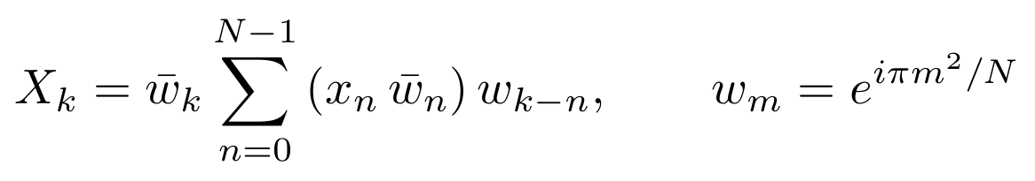 (13)
- No padding: every image size is transformed at its native dimensions; zero-padding would itself create edge artifacts.
- Real 2-D transform: two real rows are packed into one complex row and separated with conjugate symmetry; only the half-spectrum k_{x} = 0 … W/2 is stored, then the columns are transformed:
(14)
- Precision: 64-bit spectrum; against a naive DFT the transform agrees to better than 10⁻¹² relative, and 2-D round trips are exact to float32 output precision.

7. Periodic + smooth decomposition (edge treatment)
The DFT treats the image as periodic: the right edge is glued to the left and the bottom to the top. A sky gradient makes those seams discontinuous, and a vertical seam puts its energy on the k_{y} = 0 axis, a horizontal one on the k_{x} = 0 axis, precisely where the band notches act. The script removes the seams with Moisan's periodic-plus-smooth decomposition [1], computed in the Fourier domain. The boundary image v holds the jumps across the seams,
(15)
its transform is cheap because v lives only on the border,
(16)
and the smooth component s, solution of a discrete Poisson equation driven by v, is diagonal in the Fourier domain; the periodic component p is what remains:
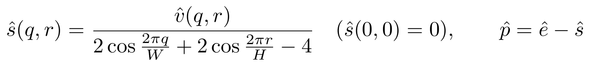 (17)
Everything downstream works on p̂. The smooth component is never part of the noise model, so it stays in the image. One visible consequence: the jump between the band values of the first and last row (and column) is not a band but part of the smooth component, so the corrected image keeps a very gentle linear ramp of that amplitude across the frame, typically below one band rms from edge to edge. DBE or ABE removes it with the other gradients. Without the decomposition, the output shows artifacts of about 6 σ along the image borders in the tests (Figure 4c).
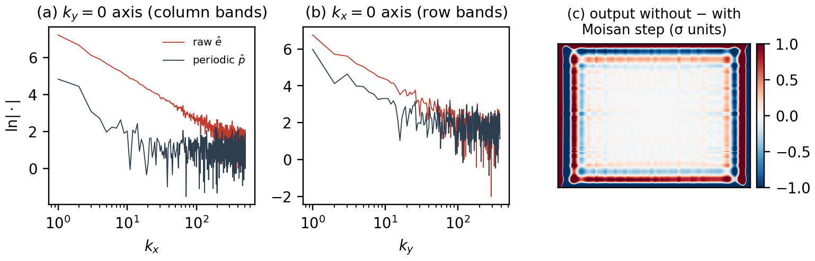
Figure 4. Effect of the periodic + smooth decomposition on the estimation image of the test frame. (a), (b) Log-magnitude along the two axes the notches act on: raw spectrum (red), dominated by the seam discontinuities, and periodic component (dark). (c) Difference between the outputs computed without and with the decomposition, in units of the per-pixel noise.

8. The spectral gain G
All targets are expressed as attenuations A_{j}(k_{x}, k_{y}) between 0 (leave alone) and 1 (remove entirely), combined into a gain G with a global strength s (default 1):
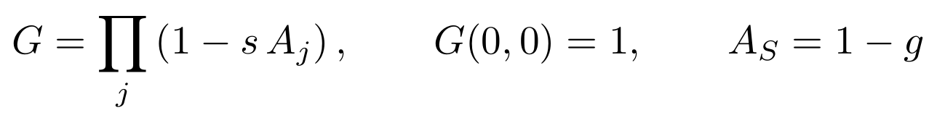 (18)
The product means overlapping targets never remove more than 100 % of a bin, and G(0,0) = 1 guarantees that the mean level of the image is never touched. Figure 5a shows G for the test frame.

8.1 Band notches
Each band notch is the product of a Gaussian across the axis, of width σ_{ℓ} bins (default 1), and a low-frequency protection ramp ρ along the axis (Figure 5b):
(19)
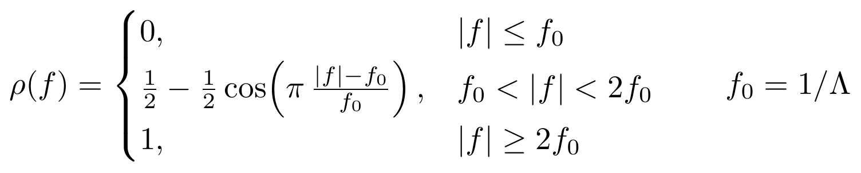 (20)
ρ is zero for periods longer than the protection scale Λ (default 128 px), rises with a raised-cosine taper and is fully on for periods shorter than Λ/2. It leaves large-scale structure (gradients, nebulae, vignetting residuals) to DBE/ABE: a slow sky variation along y also has its energy near the k_{x} = 0 axis, at low k_{y}. What makes banding visible is the row-to-row jump, a short-period component fully inside the notch.
Each notch is separable and has a simple image-domain reading. For the horizontal-band notch,
(21)
each row of p is averaged along x with a Gaussian of standard deviation τ, then the resulting profile is high-passed along y by R_{y}, the inverse transform of ρ. For a 9576-px-wide frame and σ_{ℓ} = 1, τ ≈ 1500 px: the band estimate is essentially a row mean whose amplitude may drift slowly across the frame. Faster changes of band strength along the row are the job of the adaptive matching (§11).
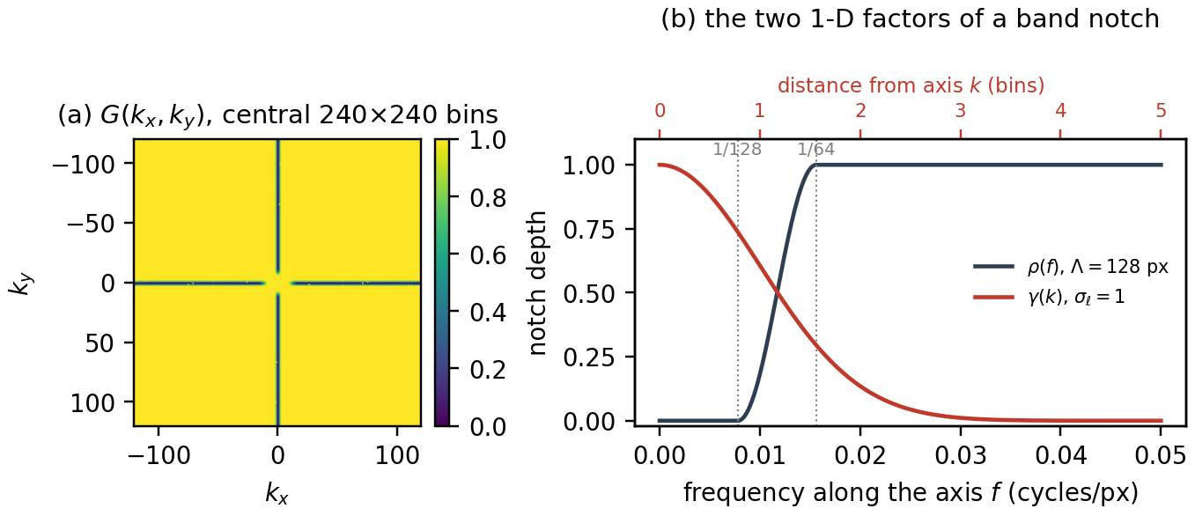
Figure 5. (a) Gain G for the test frame (yellow = kept, dark = removed): the two axis notches with their central gap (the protection ramp), and the dots of a detected periodic pattern. (b) The two 1-D factors of a band notch: ρ along the axis (Λ = 128 px) and the Gaussian across it (σ_{ℓ} = 1 bin).

8.2 Checkerboard / Nyquist (off by default)
An alternation between even and odd pixels (drizzle ×2, some debayering, dual-readout sensors) lives at the Nyquist row and column of the spectrum, notched with Gaussians of width σ_{N} (default 1.5 bins):
(22)

8.3 Periodic pattern noise (off by default)
Isolated peaks away from the axes are found on the log-magnitude spectrum ℓ = ln|p̂|:
- A local background ℓ̄_{loc} is computed from 16 × 16-bin block medians of ℓ, and the robust scatter σ_{L} of ℓ − ℓ̄_{loc} is measured with the MAD. The axes and a disc of radius 2/Λ around the origin are excluded: they belong to the band notches and to the protected low frequencies.
- A bin is a spike if its excess Δ exceeds k_{p} σ_{L} (default 6); pure noise gives no detections in the tests.
- Each spike and its neighbours within ±d_{p} bins (default 1) receive the gain g = e^{−Δ}, with the Hermitian mirror so the model stays real.
(23)
g = e^{−Δ} brings the magnitude of the bin back to its local background while keeping its phase: the peak is flattened, not zeroed. Zeroing would carve a hole in the spectrum, which rings in the image and removes the genuine signal sharing the bin.

9. Noise model and subtraction
(24)
The noise model n is the inverse transform of the removed part of the periodic spectrum; it has no DC term and none of the smooth component. The output is the original data minus that model, clipped to [0, 1]:
- stars, nebulae and every pixel value change only by the band (and pattern) values estimated for their row, column or frequency; nothing is low-passed or otherwise filtered;
- protected regions receive the correction too: their pixels contain the same row and column offsets as the rest of the row;
- the overall level of the image is unchanged, since n has zero mean.

10. Refinement passes
In the first pass the protected pixels carry the band-free fill, so in a row that is a fraction f_{y} protected the band is underestimated by the factor 1 − f_{y}. Each refinement pass (default 1) puts the current band model back into the protected pixels and estimates again. Writing 𝒜 for the chain of §7–§9 applied to an estimation image:
(25)
This is the Gerchberg–Papoulis scheme [2, 4]: alternate between "agrees with the data where the data are trusted" and "is a band field". For a pure row-mean model the error in row y contracts by f_{y} at every pass:
(26)
Lightly protected rows converge at once, heavily protected rows need more passes. Each pass costs one forward and one inverse 2-D FFT. Figure 7d shows the behaviour on the nebula test scene: residual banding in the rows through the bright star falls from 0.76 σ without refinement to 0.58, 0.45 and 0.35 σ after 1, 2 and 3 passes, and further with adaptive matching (§11).

11. Adaptive amplitude matching (optional)
The noise model has the right shape (exact row and column structure) but can have the wrong local amplitude, for two reasons: bands whose strength changes across the sensor faster than the notch's along-row averaging can follow (§8.1), for example bands that fade from one side to the other or differ between two readout halves; and rows that cross large protected areas, whose band is underestimated (§10). The option borrows the remedy of seismic multiple attenuation, where a predicted noise model is matched to the data by locally estimated filters before subtraction [8, 9].

11.1 Components
When the option is on, the final pass also synthesizes the row-band and column-band parts of the model separately; spikes, checkerboard and cross terms remain in a residual component that is subtracted unchanged:
(27)

11.2 Local fit
In every window of the chosen size (default 128 px) the unprotected pixels are fitted, by least squares, as an offset plus a gain times each component:
(28)
The offset c absorbs the local sky and is never subtracted. Eliminating it leaves a 2 × 2 system in the centred covariances C of the components and the data within the window. A plain least-squares gain would chase noise where the bands are weak, because its variance is
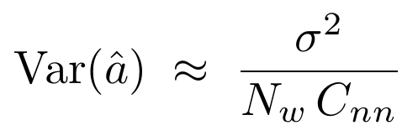 (29)
which grows without bound as the band energy C_{nn} goes to zero. The script therefore uses the posterior mean under a Gaussian prior a ~ N(1, τ²) with τ = 0.1 (N_{w}: unprotected pixels in the window; σ: per-pixel noise):
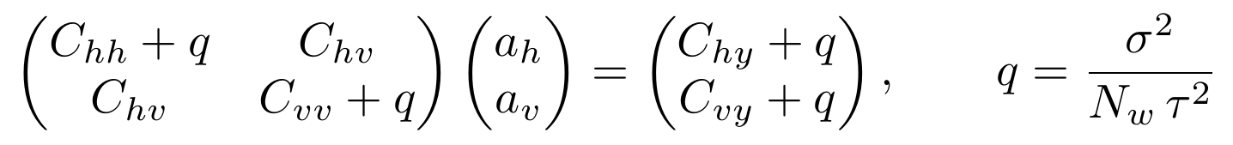 (30)
Where the bands are strong, q is negligible against C_{nn} and the gain follows the data freely, far from 1 if needed; where they are weak or absent, the gain stays at 1 and the result is that of the fixed model. Windows with less than 20 % unprotected pixels keep gain 1. Gains are clamped to [0, 2], smoothed with the same window and interpolated to every pixel; the fit is computed on a grid of 8 × 8-pixel blocks, so its memory cost is small. The output is
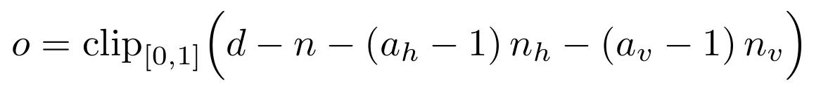 (31)

11.3 Why a gain and not a convolution kernel
General adaptive subtraction uses short matching filters, to correct timing, phase or PSF differences between model and data. Here the model has none of those errors: its row and column structure is exact, and only its amplitude is uncertain. Along a row the row-band model is essentially constant, so filter taps along x would add nothing; taps along y would let the fit blend neighbouring rows, an extra freedom with no physical error to correct and a way to absorb genuine signal. One gain per component and window is the matching filter of minimal length that fits the error actually present.

11.4 Effect and cost
On a test frame whose right half has bands at 0.3 × the left-half amplitude, the fixed model, which averages along the whole row, over-corrects one half and under-corrects the other; the fitted gains recover the two halves (Figure 6) and residual banding falls from 0.187 to 0.105 σ in the left third and from 0.144 to 0.034 σ in the right third. On frames without banding the result is unchanged to within 0.002 σ. The option costs one extra inverse FFT per band direction: about 26 s and 0.2 GB more for a 9576 × 6388 channel in the Node.js benchmark (§15).
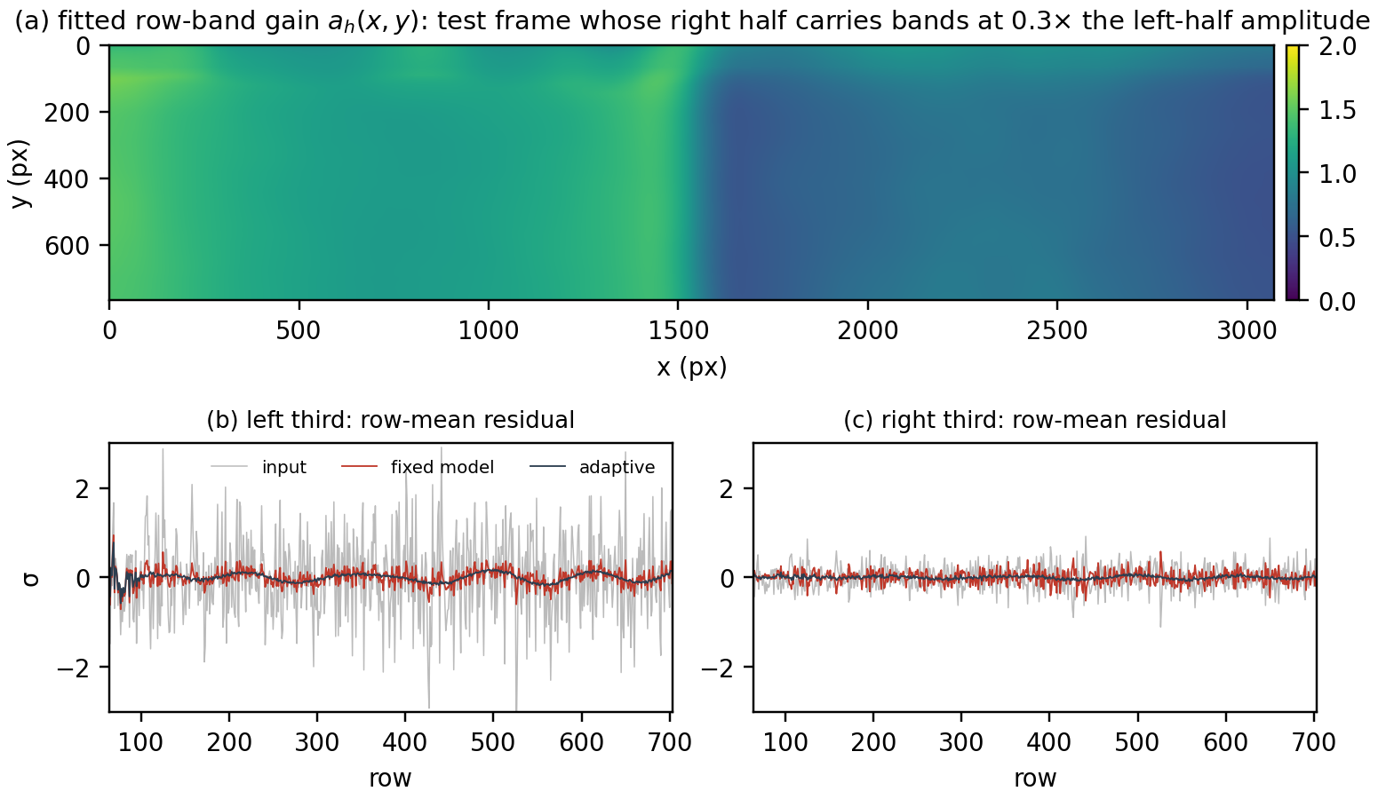
Figure 6. Adaptive amplitude matching on a test frame whose right half carries bands at 0.3 × the amplitude of the left half. (a) Fitted row-band gain. (b), (c) High-passed row-mean residuals in the left and right thirds: input, fixed model, adaptive.

12. Outputs and diagnostics
- Corrected image: a new window (keywords and astrometric solution copied, HISTORY lines added) or applied to the target (can be undone).
- Removed noise (option): n + 0.5, so mid-grey means "nothing removed". It should show only bands and patterns; any trace of a star means the protection missed something.
- Spectrum diagnostic (option, channel 0): the centred log-magnitude of the last pass, scaled from (median − 1) to its maximum; red shows the spectrum, green and blue show it times G, so everything attenuated appears red.
- Protection mask (option, channel 0): white = excluded from the estimate. The first thing to check on a new kind of data.
- Gain maps (option, with adaptive matching, channel 0): pixel value = gain / 2, so 0.5 means the model was used unchanged.
- Console: noise σ, mask coverage, number of spike bins, gain statistics and the RMS of the removed model:
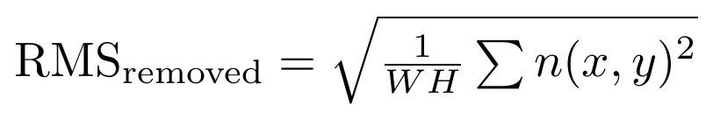 (32)

13. Batch mode
Batch mode applies the same processing to a list of files and is meant for calibrated subs before registration. For each file:
- The file is opened (only the first image of a multi-image file is used) and every channel is processed.
- The result is written into the opened window itself, so FITS keywords, XISF properties and the astrometric solution are carried over; HISTORY lines record the version and settings.
- It is saved as name + postfix (default _fd) in the output folder, or next to the input. XISF and FITS keep their format; other formats are written as XISF. Existing files get _1, _2… unless overwriting is enabled. The optional removed-noise image is saved alongside as …_removed.
- Errors are logged and the batch continues; the console Abort button stops cleanly after the current file.
The final summary lists the RMS of the removed model for each file, relative to the batch median; files above 2× are flagged as carrying unusual pattern noise (interference, a bad readout) and deserve a look.

14. Parameters
Dialog control | Default | Symbol | Effect
Horizontal bands | on | A_{h} | Notch the k_{x} ≈ 0 axis (row-to-row offsets).
Vertical bands | on | A_{v} | Notch the k_{y} ≈ 0 axis (column-to-column offsets).
Notch width sigma (bins) | 1.0 | σ_{ℓ} | Width across the axis; larger lets the band amplitude vary faster along the row.
Keep structures larger than (px) | 128 | Λ | Periods longer than Λ are not touched; fully notched below Λ/2.
Adaptive amplitude matching | off | a_{h}, a_{v} | Local gain per band component (§11).
Adaptive window (px) | 128 |  | Window of the gain fit; 64–256 is a sensible range.
Periodic pattern noise | off | A_{S} | Automatic off-axis spike detection and flattening (§8.3).
Spike threshold (sigma) | 6 | k_{p} | Detection level in robust σ of the log spectrum.
Spike dilation (bins) | 1 | d_{p} | Neighbouring bins also flattened if above background.
Checkerboard / Nyquist | off | A_{N} | Notch the Nyquist row and column (§8.2).
Nyquist notch width (bins) | 1.5 | σ_{N} | Gaussian width of the Nyquist notches.
Protect stars and bright structures | on | M | Build the mask and refill (§4–5). Leave on.
Detection (sigma, smoothed) | 5 | k_{d} | Seed threshold on the 5 × 5-smoothed residual.
Halo threshold (sigma, smoothed) | 2 | k_{ℓ} | Growth threshold; lower = larger masks around bright stars.
Mask dilation (px) | 4 | g | Final square dilation.
Refinement passes | 1 | n | Passes of §10; 2–3 when large areas are protected.
Strength | 1.0 | s | Fraction of the modelled noise removed.
Output: removed noise, spectrum, mask, gain maps | off |  | Diagnostics of §12 (spectrum, mask and gain maps: single image only).

15. Validation
The project includes a regression suite (node tests/run_all.js, 27 checks, about three minutes) that runs the script's numerical core on synthetic frames under Node.js, and the dialog, single-image and batch code against mocks of the PixInsight classes. The checks that guard against past defects (dark streaks, full-row masking, the dialog fault, the adaptive improvements) were each confirmed to fail on the version that had the defect. The synthetic frames combine sky gradients, nebulae, field stars, saturated and unsaturated bright stars, random and regular row bands, column bands, periodic patterns and Gaussian noise, at both sub-exposure and deep-stack noise levels.
Metric. Residual banding is measured on the row (or column) means of output − truth, high-passed by subtracting a 129-sample running mean and evaluated at least 64 samples from the frame edges, in units of the per-pixel noise σ. The high-pass matches what the script is meant to remove (periods below 128 px); the interior restriction avoids a one-sided running mean near the edges, which would misreport the gentle ramp of §7 as banding.

Bright stars (the "black streak")
Deep-stack noise level (σ = 3 × 10⁻⁵), broad halo; worst row and column residual near the star in % of σ, versus version 1.2, which protected stars by clipping at background ± 3 σ.
Case | Input (rows / cols) | v1.2 | 1.4
Saturated core, radius ≈ 60 px | 29 / 20 (band rms) | −3561 / −2367 | −38 / 18
Saturated core, radius ≈ 170 px | 29 / 20 | 3473 / 2766 | −47 / 70
Unsaturated bright star, 90 px core | 29 / 20 | −1779 / −1681 | −36 / 19
Same field without the bright star: residual rms | 29 / 20 | 4.9 / 6.0 | 6.6 / 8.2
The last row shows the price of protection on a star-free frame: excluding the field stars leaves fewer samples per row, so the estimate is slightly noisier than unprotected clipping.
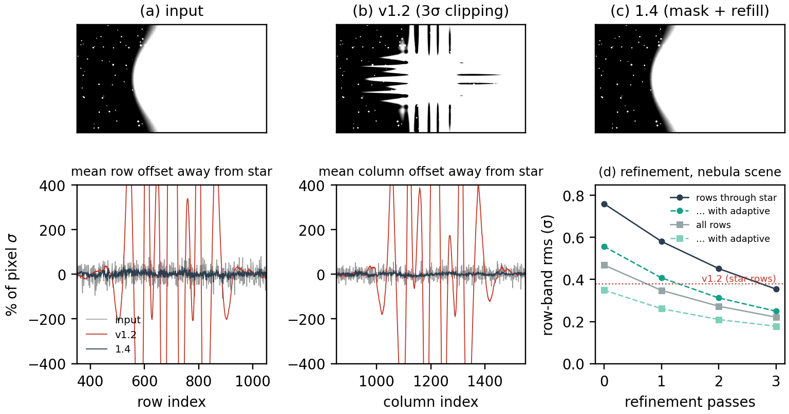
Figure 7. Deep-stack test with a saturated star (saturated radius ≈ 60 px), display stretched to a few σ around the sky. (a) Input. (b) v1.2: the star's flux, not removed by 3σ clipping because the background followed the star, is subtracted along its rows and columns. (c) 1.4. Lower left and centre: mean row and column offsets away from the star. (d) Refinement passes on the nebula test scene, with and without adaptive matching.

Band removal and adaptive matching
Residual banding in σ (rows / columns / left third / right third, and rows through the bright star where present). "Fixed" is the default processing, "adaptive" adds §11.
Scene | Input | Fixed | Adaptive
No banding (noise and stars only) | 0.031 / 0.036 / 0.054 / 0.057 | 0.016 / 0.018 / 0.037 / 0.034 | 0.017 / 0.020 / 0.037 / 0.033
Weak bands (0.15 / 0.10 σ) | 0.151 / 0.107 / 0.160 / 0.155 | 0.021 / 0.022 / 0.040 / 0.037 | 0.021 / 0.023 / 0.039 / 0.036
Field stars, uniform bands (0.9 / 0.5 σ) | 0.904 / 0.502 / 0.908 / 0.902 | 0.111 / 0.078 / 0.113 / 0.113 | 0.104 / 0.069 / 0.104 / 0.107
Bands fading 1 → 0.2 across the sensor | 0.545 / 0.505 / 0.788 / 0.304 | 0.058 / 0.066 / 0.173 / 0.139 | 0.056 / 0.064 / 0.096 / 0.037
Right half at 0.3 × band amplitude | 0.590 / 0.505 / 0.908 / 0.274 | 0.065 / 0.066 / 0.187 / 0.144 | 0.063 / 0.064 / 0.105 / 0.034
Nebula, regular bands, saturated star | 0.980 / 0.505 / 0.983 / 0.977; star 1.100 | 0.348 / 0.092 / 0.375 / 0.225; star 0.581 | 0.261 / 0.071 / 0.320 / 0.133; star 0.408
Deep stack, large saturated star | 0.993 / 0.706 / 0.994 / 0.992; star 1.031 | 0.311 / 0.270 / 0.258 / 0.359; star 0.436 | 0.231 / 0.225 / 0.205 / 0.261; star 0.266
On the nebula scene, version 1.2 (which did not mask the nebula) reaches 0.22 σ over all rows and 0.38 σ in the star rows with one pass; 1.4 with the defaults reaches 0.35 / 0.58 σ, and with three refinement passes and adaptive matching 0.18 / 0.25 σ. Removing pure row banding (no stars, no noise) leaves about 10 % of its rms, the part with periods between 64 and 128 px that the protection ramp deliberately keeps.

Speed and memory
In the Node.js benchmark a 9576 × 6388 channel takes about 68 s with the defaults (protection mask about 24 s, each FFT pass about 20 s) and about 94 s with adaptive matching, with a peak of about 1.4 / 1.6 GB. PixInsight's JavaScript engine may be slower; colour images take three times as long.
Scope of the validation. The synthetic tests and mocks establish the numerical behaviour and the logic of the script; they are not a substitute for real data. Before relying on it for a new camera or workflow, run it on a few representative frames with the protection mask and removed-noise outputs and inspect them.

16. Limitations and troubleshooting
- A dark or bright line through a star: the protection missed part of it. Check the protection mask; lower the halo threshold (e.g. 1.5) or raise the mask dilation.
- Bands remain across bright nebulae or very bright stars: those areas are protected and the rows crossing them rest on fewer samples. Use 2–3 refinement passes and adaptive matching. Bright compact nebulae are protected by design of the mask (the 64-px background cannot follow strong curvature); this costs accuracy, not correctness.
- Bands stronger on one side of the frame: adaptive matching.
- A very gentle gradient appears: the smooth component of §7; remove it with DBE/ABE with the other gradients.
- Long-period bands remain: periods longer than the protection scale (128 px) are left alone on purpose; lower it with care, as gradients then start to be affected.
- Registered or rotated data, raw CFA mosaics: not supported (§1.2).
- Slow: the script is pure JavaScript; full-frame CMOS channels take about a minute each. Batch overnight.

17. Version history
Version | Changes
1.0 | Fourier band notches with protection ramp, periodic-pattern detection, checkerboard notch, edge treatment, 3σ star clipping.
1.1 | Batch mode for lists of files, with keyword and astrometry preservation.
1.2 | Dialog fix: radio-button groups interfered with each other.
1.3 | Star protection rebuilt as a mask with saturation detection, iterated background, hysteresis growth and refill (fixes dark streaks through bright stars).
1.3.1 | Fix: heavily protected rows kept their bands in the mask residual, so the mask grew along whole rows.
1.4 | Optional adaptive amplitude matching with gain maps; compatibility fix for older JavaScript engines; corrected test metric.

18. For contributors
The numerical core sits between the markers // ==== CORE BEGIN and // ==== CORE END of the script and is plain ECMAScript 5 without PixInsight objects; the tests load it with tests/load.js. Run node tests/run_all.js (Node.js 18 or later, about 2 GB of memory); it must print ALL PASSED. When fixing a defect, first add a test that fails on the current version. Keep the script ECMAScript 5 (no let, const, arrow functions, template literals or ES2015 typed-array methods), since some PixInsight installations run older JavaScript engines.

References
[1] L. Moisan, "Periodic plus smooth image decomposition", Journal of Mathematical Imaging and Vision 39 (2011), 161–179.
[2] R. W. Gerchberg, "Super-resolution through error energy reduction", Optica Acta 21 (1974), 709–720.
[3] L. I. Bluestein, "A linear filtering approach to the computation of discrete Fourier transform", IEEE Transactions on Audio and Electroacoustics 18 (1970), 451–455.
[4] A. Papoulis, "A new algorithm in spectral analysis and band-limited extrapolation", IEEE Transactions on Circuits and Systems 22 (1975), 735–742.
[5] P. J. Rousseeuw and C. Croux, "Alternatives to the median absolute deviation", Journal of the American Statistical Association 88 (1993), 1273–1283.
[6] M. Borgerding, KISS FFT, https://github.com/mborgerding/kissfft
[7] PixInsight Forum, "A few pointers on use of Image and ImageWindow classes in JavaScript" (staff reply on PJSR FFT routines), https://pixinsight.com/forum/index.php?threads/a-few-pointers-on-use-of-image-and-imagewindow-classes-in-javascript.4413/
[8] D. J. Verschuur, A. J. Berkhout and C. P. A. Wapenaar, "Adaptive surface-related multiple elimination", Geophysics 57 (1992), 1166–1177.
[9] A. Guitton and D. J. Verschuur, "Adaptive subtraction of multiples using the L1-norm", Geophysical Prospecting 52 (2004), 27–38.
[10] erellaz, "The ultimate weapon to deband CMOS sensor", AstroBin forum, PixInsight board, https://app.astrobin.com/forum/topic/137515/pleiades-astrophoto-pixinsight/the-ultimate-weapon-to-deband-cmos-sensor (origin of the idea).

