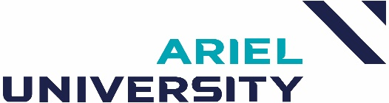

A multidisciplinary approach to Oral Functions
School of Health Sciences
Communication Disorders Department
Course no.: 5034510-1, 5034510-2
Degree: B.A.

Schedule
3rd year, 2nd semester, Thursday, 09:00 - 10:30

Lecturer
Dr. Gat Savaldi Harussi, 53.1.27, 50-6841344, gatsh@ariel.ac.il, office hours: upon appointment, Guest lecturers.

Teaching assistant/tutor

N/A

Course goal

To impart theoretical and practical knowledge about the functions of the mouth (speech, eating, swallowing) with a multidisciplinary perspective that combines the perspectives of dentists, postural, speech therapists, lactation consultants (breastfeeding) physiotherapists, and nutrition clinicians.

Prerequisites
Passing grades in Articulation courses.

Method of instruction

Frontal lectures, guest lecturers

Course plan

Lesson unit | Subject | Lesson #
1 | Introductory to Myofunctional Therapy | 1-2
2 | Introduction to Stomatology: The Structure of the Teeth and Occlusion | 3-4
3 | Myofunctional Disorders: Posture and Malocclusion Orofacial | 5-6
4 | Clinical nutritionist perspective: Eating functions: chewing, swallowing, eating habits, nutrition, and food textures | 7
5 | Breastfeeding and oral functions in Infants | 8-9
6 | Salivation: etiology, evaluation, and treatment | 10
7 | Speech disorders among populations with developmental motor disorders. Down syndrome, cerebral palsy | 11-12
8 | Summary and case studies | 13

Course requirements:

1. Attendance at classes. Active participation in a class discussion relating to each oral function approach.

2. Course grading:

90% - Final exam

10% - participation at the classroom

Learning Outcomes:
By the end of the course:
1. Students will explain the reciprocal relationship between the function and structure of the oral cavity (eating, speaking, breathing).
2. Students will be able to describe various aspects that might impact the abnormal orofacial structure and function: breathing, tongue posture, and swallowing.
3. Students will present basic clinical thinking regarding evaluating and treating oral functions.

Required material for the examination

N/A

