Jubilee Algorithm Analysis
Our goal is that every citizen has a land plot.
There are N citizens, and the country is divided into N plots.
Initially, the lands are divided arbitrarily, so that M citizens have no land, and N-M citizens have one or more land plots.
Now, citizens buy and sell lands.
After 50 years, we check, for each citizen, whether he HAD land before, and does NOT have land now. If so, we let him take back one of the lands that he had before. We continue this process, until there are no more eligible citizens.
Mark the number of landless citizens after the Jubilee as RM. A certain thing we can say about RM is:
(1) (or equivalently)
since every citizen that had land before, will have land now - either one of his original plots, or a new one.
In order to get some tighter approximations, let us assume that during the 50 years, each land plot is sold with probability q, and if it is sold, the buyer is a random citizen.
NOTE: From now on, for ease of notation, we will freely interchange between quantities and their expected values. So, for example, we will use RM do denote both the number of landless after the Jubilee, and the expected value of this number. This is not justified mathematically, but it will enable us to get a first approximation.
Denote by T the total number of lands sold permanently (- sold and not returned). The probability of a citizen to NOT get any of these lands is . Therefore, the expected number of citizens, out of the M that were landless initially, that will remain landless after the Jubilee, is:
(2)
What can we say about T? On one hand, it is certainly less than or equal to qN (the expected number of lands sold),; On the other hand, it is certainly at least qM, since the (N-M) citizens that had lands, had in total M “extra lands” - M lands that can be sold permanently because their owners has other lands, and on average, qM of these lands will be sold. Therefore:
(3)
For a first approximation, Assume q=1, so that all lands are sold.
Also, let's assume that the lands are sold in a certain order: first, M “extra lands” are sold. That is, every citizen, out of the (N-M) landowners, that has more than one land, sells all his lands except one. Some of these lands are sold to the M landless citizens, but some of them are sold to the (N-M) landowners. Those latter landowners can now sell the single land plot that they haven't sold before. This process continues until the total number of lands sold converges to T.
Hence, out of the T lands sold permanently, M come from “extra lands”, and the rest (T-M) come from (T-M) landowners that bought other lands.
Hence, out of the (N-M) landowners, (N-M)-(T-M) = (N-T) citizens bought no land during the 50 years.
On average, the citizens that bought no land are distributed proportionally between the landless and the landowners. Therefore, on average:
(4)
or:
Substituting (4) into (2), we get an equation where only R is unknown:
(5)
We can solve this equation using the Lambert W-function. This is the function for which:
iff
This function can be used to solve equations of the form:
:

Substituting from 5, we get:
(6)
Since N is small, we can further use the approximationsand:
(7)
For easier calculation of the Lambert W function, we can use an approximation due to Serge Winitzki:

Substituting into (7) gives:
(8)
Simulations for N=1000 citizens show that this is a fairly good approximation:
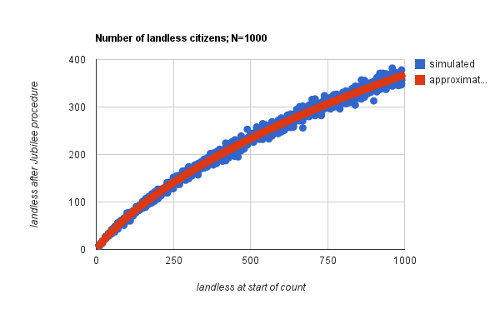

Future work: solve the case where q<1, i.e., not all lands are sold during the 50 years.

I am indebted to J.M. and nbubis from Math Stack Exchange for their help with this solution: http://math.stackexchange.com/questions/138496/approximate-solution-for-an-exponential-equation

