A Corpus Based Morphological Analyzer for
Unvocalized Modern Hebrew
Alon Itai and Erel Segal
Department of Computer Science
Technion—Israel Institute of Technology, Haifa, Israel

Abstract
Most words in Modern Hebrew texts are morphologically ambiguous. We describe a method for finding the correct morphological analysis of each word in a Modern Hebrew text. The program first uses a small tagged corpus to estimate the probability of each possible analysis of each word regardless of its context and chooses the most probable analysis. It then applies automatically learned rules to correct the analysis of each word according to its neighbors. Finally, it uses a simple syntactical analyzer to further correct the analysis, thus combining statistical methods with rule-based syntactic analysis. It is shown that this combination greatly improves the accuracy of the morphological analysis—achieving up to 96.2% accuracy.

1. Introduction
Most words in Modern Hebrew (henceforth Hebrew) script are morphologically ambiguous. This is due to the rich morphology of the Hebrew language and the inadequacy of the common way in which Hebrew is written. Morphological disambiguation is a must for many applications, such as spellers, search engines and machine translation. It is used as a front-end of a syntactic parser (Sima’an 2002).
Morphological analysis partitions a word token into morphemes and features. The morphemes consists of the lexical lemma, short words such as determiners, prepositions and conjunctions that are prepended to the word, suffixes for possessives and object clitics. The linguistic features mark part-of-speech (POS), tense, person etc. Following Kempe, we partition this data to a lexical lemma and a tag. For example, the first analysis of the ambiguous word token $QMTI(שקמתי) is “my sycamore” whose tag is [noun:definite: feminine:sg]; the second analysis of the same word token, “that I got up” and its tag is [connective+verb:1sg:past]. The morphological analysis consists of determining the tag and the lemma. Thus, determining the correct tags in context is similar to POS tagging in English.
POS tagging in English has been successfully attacked by corpus based methods. Thus we hoped to adapt successful POS tagging methodologies to the morphological analysis of Hebrew. There are two basic approaches: Markov Models (Church 1988, DeRose 1988) and acquired rule-based systems (Brill, 1995). Markov Model based POS tagging methods were not applicable, since such methods require large tagged corpora for training. Weischedel et al (1994) use a tagged corpus of 64,000 words, which is the smallest corpus we found in the literature for HMM tagging, but is still very big. Such corpora do not yet exit for Hebrew. We preferred, therefore, to adapt Brill’s rule based method, which seems to require a smaller training corpus. Brill's method starts with assigning to each word its most probable morphological tag, and then applies a series of “transformation rules”. These rules are automatically acquired in advance from a modestly sized training corpus.
In this work, we find the correct morphological analysis in context by combining probabilistic methods with syntactic analysis. The solution consists of three consecutive stages:

(a) The word stage: In this stage we find all possible morphological analyses of each word in the analyzed text. Then we approximate, for each possible analysis, the probability that it is the correct analysis, independent of the context of the word. For this purpose, we use a small analyzed training corpus. After approximating the probabilities, we assign each word the analysis with the highest approximated probability (this stage is inspired by Levinger et al, 1995).

(b) The pair stage: In this stage we use transformation rules, which correct the analysis of a word according to its immediate neighbors. The transformation rules are learned automatically from a training corpus (this stage is based on Brill, 1995).

(c) The sentence stage: In this stage we use a rudimentary syntactical parser to evaluate different alternatives for the analysis of whole sentences. We use dynamic programming to find the analysis which best matches both the syntactical information obtained from the syntactical analysis and the probabilistic information obtained from the previous two stages.

The data for the first two stages are acquired automatically, while the sentence stage uses a manually created parser.
These three stages yield a morphological analysis which is correct for about 96% of the word tokens, thus approaching results reported for English probabilistic POS tagging. Our method uses a very small training corpus – only 4900 words, similar in size to the corpus used by Brill and much smaller than the million-word corpora used for HMM based POS tagging of English. The results show that combining probabilistic methods with syntactic information improves the accuracy of morphological analysis.
In addition to solving a practical problem of Modern Hebrew and other scripts that lack vocalization (such as Arabic, Farsi), we show how several learning methods can be combined to solve a problem, which cannot be solved by any one of the methods alone.
Because of space limitations, this description is very terse, we had no space to give algorithms and show in detail the statistical analyses.

1.1. Previous Work
Both academic and commercial systems have attempted to attack the problem posed by Hebrew morphology. The Rav Millim (Choueka, 2002) commercial system provided a morphological analyzer and disambiguator. Within a Machine Translation project, IBM Haifa Scientific Center provided a morphological analyzer (Ben-Tur et al. 1992) that was later used in several commercial products. Since these sources are proprietary, we used Segal’s publicly available morphological analyzer (Segal 2001).
Other works attempt to find the correct analysis in context. Choueka and Luisignan (Chueka and Lusingnan, 1985) proposed to consider the immediate context of a word and to take advantage of the observation that quite often if a word appears more than once in the same document the same analysis will be the correct analysis throughout the document. Orly Albeck (1992) attempted to mimic the way humans analyze texts by manually constructing rules that would allow finding the right analysis without backtracking. Levinger (1992) gathered statistics to find the probability of each word, and then used hand crafted rules to rule out ungrammatical analyses. Carmel and Maarek (1999) used statistics on our tags to partially disambiguate words and then indexed the disambiguated text for use in a search engine. The first stage of our work, the sentence stage, was based on Levinger (1995), but like Carmel (1999) used the morphological tags independently of the lemmas. Ornan and Katz built a disambiguation system for Modern Hebrew based on the phonemic script and semantic clues (Ornan 1994).

1.2 The basic morphological analyzer
A basic morphological analyzer is a function that inputs a word token and returns the set of all its possible morphological analyses. The analyzer we used supplies all the morphological information, except for the object clitics. We found only two object clitics in a 4900 word corpus of a Hebrew newspaper, so we concluded that adding the object clitics to the analysis won't add much to its coverage, while substantially increasing the ambiguity. Other analyzers, such as Rav-Milim, identify the object clitic in some but not all of the words.
In this work, we didn't intend to tackle the problem of the two standards for unvocalized orthography, so we used a conservative analyzer that identified only “full-script” unvocalized words (ktiv male). However, the same methods can easily be applied to other standards.

2. The word stage
We followed Levinger et al. (Levinger 1995) and used a variant of their algorithm, the similar words algorithm, to find the probability of each analysis, regardless of context. As in Levinger et al. the probability of a lemma m of a word w, was estimated by looking at other words that contained m but differed from w in its tags.
The only difference from Levinger was that to overcome the sparseness problem of the data, we followed Carmel (1992) and assumed that the occurrences of the tags are statistically independent and estimated the probability of each tag independently. The probability of an analysis was derived by multiplying the probability of the tag by that of the lemma. Even though the assumption is not always valid (Altman 2002), in most cases this procedure correctly ranked the analyses.

3. The pair stage

3.1 Using transformation rules to improve the analysis
The concept of rules was introduced by Brill (1995), who first used acquired transformation rules to build a rule-based POS tagger. He argued that transformation rules have several advantages over other context-dependent POS tagging methods (such as Markov models):
(a) The transformation-rule method keeps only the most relevant data. This both saves a lot of memory space and enables the development of more efficient learning algorithms.
(b) Transformation rules can be acquired using a relatively small training corpus.
We too use transformation rules, but in contrast to Brill, our transformation rules do not automatically change the analyses of the matching words. In order to use the probabilistic information gathered in the word stage, we assign each possible analysis of each word a morphological score. The score of each analysis is initialized to the probability as determined at the word stage. The transformation rules modify the scores of the analyses. The modified scores can be used to select a single analysis for each word (that with the highest score), or used as an input to a higher level analyzer (such as the syntactic analyzer to be described below).
A transformation rule operates on a pair of adjacent words. The general syntax of a transformation rule is:

pattern₁ pattern₂ [agreement] ➔
newpattern₁(+inc₁) newpattern₂(+inc₂)

Both the left-hand side and a right-hand side of a rule contain two analysis patterns and an optional agreement pattern. An analysis-pattern is any pattern that matches the tag of a single word. An agreement pattern is a pattern that indicates how two adjacent tags agree, for example "agreeing-by-gender", "agreeing-by-gender-and-number", etc.
A rule comes into effect only for pairs of adjacent tags, where the first tag matches "pattern₁", the second tag matches "pattern₂", and the two tags agree according to "agreement".
Here is an example of a transformation rule:
proper-name noun ➔ proper-name(+0) verb
(+0.5) agreeing-in-gender

Its meaning is as follows: Let w₁, w₂ be two adjacent words

If the POS of the current tag of w₁ is a proper-noun and the POS of the current tag of w₂ is a noun
and w₂ has an analysis as a verb that
matches w₁ by gender and number,
then add 0.5 to the morphological score of
w₂ as a verb, and normalize the scores .

Consider the combination “YWSP &DR” (יוסף עדר). The word “&DR” has two possible analyses: one as a masculine noun (= herd) and the other as a verb (masculine past-tense 3sg; = hoed). Suppose our analyzer has found, in the word stage, that the most probable analysis of the word “YWSP” is a masculine proper name (=Joseph), and the most probable analysis of the word “&DR” is a noun (= herd). The current analysis of this combination is “Joseph herd”, which is most unlikely. However, this combination of analyses matches the first part of the transformation rule: the current analysis of w₁ is a proper noun and the current analysis of w₂ is a noun. Moreover, w₂ has an analysis that matches the second part of the rule: a verb that matches w₁ by gender. Therefore, the rule will add 0.5 to the morphological score of the other analysis of w₂. If the difference between the scores of the two analyses was less than 0.5 – the highest-scored analysis of w₂ will now be the verb, so that the analysis of the entire combination will be “Joseph hoed”. Had the difference between the scores been greater than 0.5 – the analysis would not have changed.

Rules can also depend on the lexical value of the words:
'HWA' noun ➔ 'HWA'(+0) verb-agreeing-in-
person-gender-and-number(+0.5)

3.2. Acquiring the transformation rules
Transformation rules are acquired automatically using an analyzed training corpus. The learning algorithm uses the following input:

(a) For each word in the training corpus: the set of its analyses, and the morphological score of each
analysis.
(b)
The correct analysis of each word in the training corpus.

The output of the algorithm is an ordered list of transformation rules.

The learning algorithm proceeds as follows:

a. (Initialization): Assign to each word its most probable analysis.
b. (Transformation rule generation): loop over all incorrectly tagged words in the corpus. Generate all transformation rules that correct the error.
c. (Transformation rule evaluation): loop over the candidate transformation rules and retain the rule that corrects the maximum number of errors, while causing the least damage.
d. Repeat the entire process until the net gain of all rules is negative.

The process terminates, since in each iteration the number of errors in the training corpus decreases. The worst-case complexity of the algorithm is 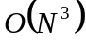, where N is the size of the training corpus.

4. The sentence stage
The aim of this stage is to improve the accuracy of the analysis using syntactic information. A correct analysis must correspond to a syntactically correct sentence. We therefore try to syntactically parse the sentence (actually the tags of the sentence). If the parse fails, we would like to conclude that the proposed analysis is incorrect and try another morphological analysis. However, since no syntactic parser is perfect, we do not reject sentences for which the parsing fails. We use the syntactic grammaticality, estimated by the syntactic parser, as one of two measures for the correctness of the analysis, and combine this with the score that results from the pair phase.
4.1 The grammar.
Our syntactic parser uses a handcrafted grammar of about 150 rules. The rules attempt to simplify the sentence, for example, the rule
noun → noun adjective
[agree in number and gender],
reduces two tokens into one.
For an input sentence w₁,…,w_{n}, let T_{i} ={t_{i1},…,t_{ik}} be the set of tags of w_{i}, and s_{im} be the score of t_{im} as determined by the previous stages.
4.2 The algorithm.
4.2.1 Dynamic Programming
Our algorithm uses dynamic programming to determine the score of partial parses. For a nonterminal A, let a Table[i,j,A] be the maximum score of all parses 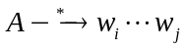.(If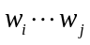 cannot be derived from A, then Table[i,j,A] = 0.) If we consider the scores as probabilities then Table[i,j,A] is the probability of the best parse that derives from A.
Table is computed by increasing value of 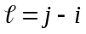: .
Assuming that the probability of choosing tags of words are statistically independent; i.e.,
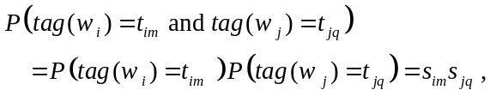
we can use dynamic programming and compute Table by increasing value of :
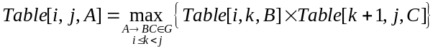4.2.2 Parsing the sentence
Ideally, the score should be 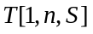. However, no parser is perfect and our rudimentary parser is no exception. Since a properly analyzed sentence should consist of simple sentences connected by connectives, we try to cover the sentence with a minimum number of components. In other words, we look for r and 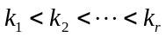such that
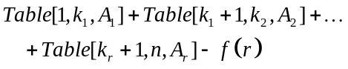
is maximum. The function f is monotonically increasing, reflecting the cost of having r components. The rationale is that we should get a bonus for choosing the best tags and pay a fine for failing to parse.
The function f should have been determined by Machine learning techniques, but we assumed that 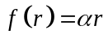. Under this assumption, finding the “best parse” is equivalent to finding a shortest path in a graph from 1 to n in a graph whose vertex set is 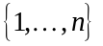and 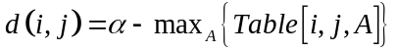. If all the distances are nonnegative, we can apply Dijsktra’s algorithm whose complexity is 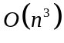.
4.2.3 Tine complexity
The complexity of the entire algorithm is calculated as follows: To compute 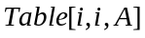 we check for all rules 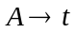if 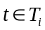. The time is linear with the number of rules whose left hand side is A. Thus, computing 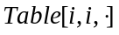is linear with g, the size of the grammar G. Therefore, computing the first row requires 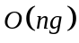 time.
The dynamic programming step requires 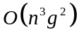 time. The final step, requires time. Thus, the entire algorithm requires time.
4.3 Heuristics
In our experiments we did used a heuristic search, which in practice was faster. We started stage with the output of the pair stage – a sentence in which each word is assigned a tag.

5. Evaluation
To test the algorithm we used an analyzed corpus of 5361 word tokens, which contained 16 articles of various subjects from a Hebrew daily newspaper. The results are summarized in Table 1.

Error (%) | Sentence Stage | Pair Stage | Word Stage
36.0 | No | No | No
14.0 | No | No | Yes
21.0 | No | Yes | No
7.0 | No | Yes | Yes
20.0 | Yes | No | No
5.3 | Yes | No | Yes
14.0 | Yes | Yes | No
3.8 | Yes | Yes | Yes

Table 1: The percentage of error when using each method separately and in combination with other methods.
5.3
14
7
3.8
36
21
20
14

Word Phase
Pair Phase
Sentence Phase

Figure 1: A graphical representation of Table 1

The first line (No, No, No) assumed that all analyses are equiprobable. The second line (Yes, No, No) consider only the word stage. Subsequent lines show using different combinations of stages. The word stage seems most essential – leaving out most degrades the performance. The pair stage and the sentence stage both use syntactic structure. However using both yielded the best the results.
The accuracy of the analysis increased from 93.8% after the pair stage to 96.2% after the sentence stage. A statistical analysis revealed that the error rate is less than 5.3% with a confidence level of 95%.
We performed two experiments, each with a different test article:
- Article A with 469 word tokens (which leaves 4892 word tokens in the training corpus),
- Article B with 764 word tokens (which leaves 4597 word tokens in the training corpus),
In order to examine how the size of the training corpus affects the number of transformation rules learned and the final accuracy, we conducted experiments using only part of the training corpus (when using 1/k of the corpus, we did k experiments and took the average). The results are shown in Appendix B. A statistical analysis revealed that with 95% confidence the error rate at most 8%.
The error-rate graphs are quite flat even for this small training corpus. Perhaps it is possible to conclude that using a larger training corpus won't make the results much better. Right now, however, we cannot verify this conclusion because we don't have a much larger tagged corpus. Such a corpus is in the process of being prepared (Sima’am 2001).

The algorithm for finding the best morphological analysis was run on two articles whose analyses have been corrected using transformation rules learned from a corpus of about 4900 words.

7. Conclusions and further research
The research shows that corpus based methods are effective for choosing the correct morphological analysis in context. However, from the error analysis, we see that there is still a lot to be done. At least two more “expert systems” need be incorporated: (a) a recognizer for proper nouns, and (b) a recognizer of idioms.
Furthermore, the sentence stage is not automatic, and is not sufficiently robust. We plan on attempting to attack this problem in several ways. Currently, Sima’an et al (2001) is creating a tree-bank that will enable to automatically learn a grammar for Hebrew. However, even when complete, parsing will be slow. Another vein of research is to follow Abney (1996) and construct a finite state cascade parser. Even though such parsers do not provide full coverage, they may be sufficient for the purpose of morphological disambiguation.

Bibliography
Steven Abney. 1996. Partial Parsing via Finite-State Cascades. In J. of Natural Language Engineering, 2(4), pp. 337-344.
Orly Albeck. 1992. Formal analysis by a restriction grammar on one of the stages of Modern Hebrew. Computerized analysis of Hebrew words. In Israel Science and Technology Ministry. (In Hebrew.)
Alon Altman. 2002. Private communication.
Esther Ben-Tur, Aviela Angel, Danit Ben-Ari, and Alon Lavie. 1992. Computerized analysis of Hebrew words. In Israel Science and Technology Ministry. (In Hebrew.)
Eric Brill. 1995. Transformation-based error-driven learning and natural language processing: a case study in part-of-speech tagging. In Computational Linguistics, 21, pp. 543-565.
David Carmel and Yoëlle Maarek. 1999. Morphological disambiguation for Hebrew search systems. In Next Generation Information Technologies and Systems, NGITS ’99, Springer LNCS 1649, pp. 312-325.
Yaacov Choueka and S. Lusignan. 1985. Disambiguation by short context. In Computers and the Humanities, 19(3).
Yaacov Choueka. 2002. Rav Millim. Technical report, The Center for Educational Technology in Israel.
(http://www.cet.ac.il/rav-milim/)

Appendix A: The Hebrew-Latin transliteration
Kenneth W. Church. 1988. A stochastic parts program and noun phrase parser for unrestricted text. In ANLP, 2, pp. 136-143.
Steven J. DeRose. 1988. Grammatical category disambiguation by statistical optimization, In Computational Linguistics, 14, pp. 31-39.
ISO. 1999. “Information and documentation – Conversion of Hebrew characters into Latin characters – Part 3: Phonemic Conversion, ISO/FDIS 259-3: (E).
André Kempe Probabilistic parsing with feature structures.
Moshe Levinger, Uzzi Ornan and Alon Itai. 1995. Morphological disambiguation in Hebrew using a priori probabilities, Computational Linguistics 21, pp. 383-404.
Uzzi Ornan and Michael Katz. 1994. A new program for Hebrew index based on the phonemic script, Technical Report #LCL 94-7, Laboratory for Computational Linguistics, CS Dept., Technion, Haifa, Israel.
Erel Segal. 2001. A Hebrew morphological analyzer (includes free source code) http://come.to/balshanut or http://www.cs.technion.ac.il/~erelsgl/bxi/hmntx/teud.html
Khalil Sima'an, Alon Itai, Yoad Winter, Alon Altman and Noa Nativ. 2001. Building a Tree-Bank of Modern Hebrew Text. In Traitment Automatique des Langues, 42, pp. 347-380.
Ralph M. Weischedel, Marie Meteer, Richard L. Schwartz, Lance Ramshaw and Jeff Palmucci. 1994. Coping with Ambiguity and Unknown Words through Probabilistic Models. In Computational Linguistics. 19(2), pp. 359-382.

Heb. letter | Heb. name | Latin | Heb. letter | Hebr. name | Latin
א | Alef | A | ל | Lamed |  | L
ב | Bet | B | מ,ם | Mem |  | M
ג | Gimmel | G | נ,ן | Nun |  | N
ד | Dalet | D | ס | Samek |  | S
ה | Hei | H | ע | Ayn |  | &
ו | Waw | W | פ,ף | Pei |  | P
ז | Zayn | Z | צ,ץ | Tsadiq |  | C
ח | Xet | X | ק | Quf |  | Q
ט | Tet | @ | ר | Reish |  | R
י | Yud | I | ש | Shin |  | $
כ,ך | Kaf | K | ת | Taw |  | T
The choice of letters follows the ISO standard of phonemic script (ISO 1999). Note that this is not a phonologic transcription. The vowels ‘a’ and ‘e’, which are usually not represented in the Hebrew unvocalized script, are also not represented in our Latin transliteration. For example, the word: שלג which is pronounced “sheleg”, is transliterated: $LG.

Appendix B: The results of the pair-stage experiment
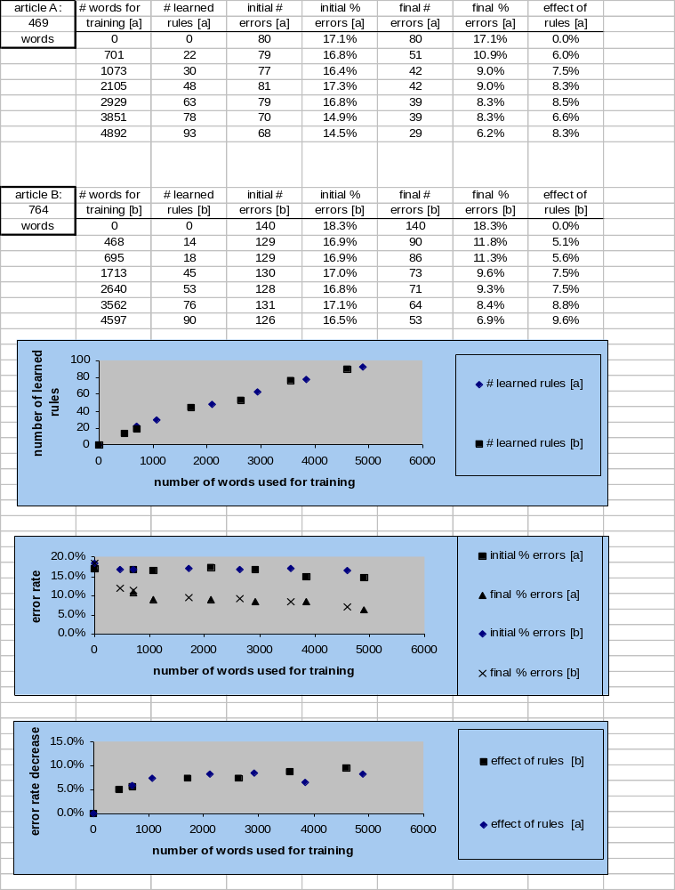

The third graph shows the effect of the rules, defined as the percent of errors after the word phase minus the percent of errors after the pair stage.

