A Corpus Based Morphological Analyzer for Unvocalized Modern Hebrew
Alon Itai and Erel Segal
Department of Computer Science
Technion—Israel Institute of Technology, Haifa, Israel

Abstract
Most words in Modern Hebrew texts are morphologically ambiguous. We describe a method for finding the correct morphological analysis of each word in a Modern Hebrew text. The program first uses a small tagged corpus to estimate the probability of each possible analysis of each word regardless of its context and chooses the most probable analysis. It then applies automatically learned rules to correct the analysis of each word according to its neighbors. Finally, it uses a simple syntactical analyzer to further correct the analysis, thus combining statistical methods with rule-based syntactic analysis. It is shown that this combination greatly improves the accuracy of the morphological analysis—achieving up to 96.2% accuracy.

1. Introduction
Most words in Modern Hebrew (henceforth Hebrew) script are morphologically ambiguous. This is due to the rich morphology of the Hebrew language and the inadequacy of the common way in which Hebrew is written.

In Hebrew, the morphological analysis partitions a word token into morphemes and features; consisting of the lexical value, linguistic features that mark tense and person, suffixes for possessives and object clitics, and short words such as determiners, prepositions and conjunctions that are prepended to the word. The part-of-speech (POS) of the lexical value and the other morphemes and features of a word define a tag. These tags correspond to POS tags in English (Kempe).

POS tagging in English has been successfully attacked by corpus based methods. Thus we hoped to adapt successful POS tagging methodologies to the morphological analysis of Modern Hebrew. There are two basic approaches: Markov Models (Church 1988, deRose 1988) and acquired rule-based systems (Brill, 1995). Markov Model based POS tagging methods were not applicable, since such methods require large tagged corpora for training. Weischedel et al (1994) use a tagged corpus of 64,000 words, which is the smallest corpus we found in the literature for HMM tagging, but is still very big. Such corpora do not yet exit for Hebrew. We preferred, therefore, to adapt Brill’s rule based method, which seems to require a smaller training corpus. Brill's method starts with assigning to each word its most probable tag, and then applies a series of “transformation rules”. These rules are automatically acquired in advance from a modestly sized training corpus.

In this work, we find the correct morphological analysis by combining probabilistic methods with syntactic analysis. The solution consists of three consecutive stages:

(a) The word stage: In this stage we find all possible morphological analyses of each word in the analyzed text. Then we approximate, for each possible analysis, the probability that it is the correct analysis, independent of the context of the word. For this purpose, we use a small analyzed training corpus. After approximating the probabilities, we assign each word the analysis with the highest approximated probability (this stage is inspired by Levinger et al, 1995).

(b) The pair stage: In this stage we use transformation rules, which correct the analysis of a word according to its immediate neighbors. The transformation rules are learned automatically from a training corpus (this stage is based on Brill, 1995).

(c) The sentence stage: In this stage we use a rudimentary syntactical analyzer to evaluate different alternatives for the analysis of whole sentences. We use dynamic programming to find the analysis which best matches both the syntactical information obtained from the syntactical analysis and the probabilistic information obtained from the previous two stages.

The data for the first two stages is acquired automatically, while the sentence stage uses a manually created parser.

These three stages yield in a morphological analysis which is correct for about 96% of the word tokens, thus approaching results reported for English probabilistic POS tagging. It does so by using a very small training corpus – only 4900 words, similar in size to the corpus used by Brill and is much smaller than the million-word corpora used for HMM based POS tagging of English. The results show that combining probabilistic methods with syntactic information improves the accuracy of morphological analysis.

In addition to solving a practical problem of Modern Hebrew and other scripts that lack vocalization (such as Arabic, Farsi), we show how several learning methods can be combined to solve a problem, which cannot be solved by any one of the methods alone.

Because of space limitations, this description is very terse, we had no space to give algorithms and show in detail the statistical analyses.

1.1. Previous Work
Both academic and commercial systems have attempted to attack the problem posed by Hebrew morphology. The Rav Millim (Choueka, 2002) commercial system provided a morphological analyzer and disambiguator. Within a Machine Translation project, IBM Haifa Scientific Center provided a morphological analyzer (Ben-Tur et al. 1992) that was later used in several commercial products. Since these sources are proprietary so we used Segal’s publicly available morphological analyzer (Segal 2001).

Other works attempt to find the correct analysis in context. Choueka and Luisignan (Chueka and Lusingnan, 1985) proposed to consider the immediate context of a word and to take advantage of the observation that quite often if a pair of adjacent words appears more than once the same analysis will be the correct analysis in all these contexts. Orly Albeck (Albeck) attempted to mimic the way humans analyze texts by manually constructing rules that would allow finding the right analysis without backtracking. Levinger (1992) gathered statistics to find the probability of each word, and then used hand crafted rules to rule out ungrammatical analyses. Ornan XXX

1.2 The basic morphological analyzer
A basic morphological analyzer is a function that inputs a word token and returns the set of all its possible morphological analyses. The analyzer we used supplies all the morphological information, except for the object clitics. We found only 2 object clitics in a 4900 word corpus of a Hebrew newspaper, so we concluded that adding the object clitics to the analysis won't add much to its coverage, while it will increase the ambiguity substantially. Other analyzers, such as Rav-Milim, identify the object clitic in some but not all of the words.

In this work, we didn't intend to tackle the problem of the two standards for unvocalized orthography, so we used a conservative analyzer that identified only “full-script” unvocalized words (ktiv male). However, the same methods can easily be applied to other standards

2. The word stage
We followed Levinger et al. (Levinger 1995) and used a variant of the similar words algorithm. To overcome the sparseness problem we assumed that the occurrences of the morphemes of a word are statistically independent thus allowing us to estimate the probability of each morpheme independently. The probability of an analysis was derived by multiplying the probabilities of each of its morphemes. Even though the assumption is not valid, in most cases this procedure correctly ranked the analyses (Altman 2002).

3. The pair stage

3.1 Using transformation rules to improve the analysis
The concept of rules was introduced by Brill (1995), who first used acquired transformation rules to build a rule-based POS tagger. He argued that transformation rules have several advantages over other context-dependent POS tagging methods (such as Markov models):

(a) The transformation-rule method keeps only the most relevant data. This both
saves a lot of memory space and enables the development of more efficient learning
algorithms.
(b) Transformation rules can be acquired using a relatively small training corpus.

We too use transformation rules, but in contrast to Brill, our transformation rules do not automatically change the analyses of the matching words. In order to use the probabilistic information gathered in the word stage, we assign each possible analysis of each word a morphological score. The score of each analysis is initialized to the probability as determined at the word stage. The transformation rules modify the scores of the analyses. The modified scores can be used to select a single analysis for each word (that with the highest score), or used as an input to a higher level analyzer (such as the syntactic analyzer to be described below).

A transformation rule operates on a pair of adjacent words (let's mark them: w₁ w₂). Here is an example of a transformation rule:

if the current analysis of w₁ is a proper-noun and the current analysis of w₂ is a noun
and w₂ has an analysis as a verb that matches w₁ by gender and number,
then add 0.5 to its morphological score, and normalize the scores .

Consider the combination “YWSP &DR” (יוסף עדר). The word “&DR” has two possible analyses: one as a masculine noun (= herd) and the other as a masculine past-tense verb (= hoed). Suppose our analyzer has found, in the word stage, that the most probable analysis of the word “YWSP” is a masculine proper name (=Joseph), and the most probable analysis of the word “&DR” is a noun (= herd). The current analysis of this combination is “Joseph herd”, which is ungrammatical. However, this combination of analyses matches the first part of the transformation rule: the current analysis of w₁ is a proper noun and the current analysis of w₂ is a noun. Moreover, w₂ has an analysis that matches the second part of the rule: a verb that matches w₁ by gender. Therefore, the rule will add 0.5 to the morphological score of the other analysis of w₂. If the difference between the scores of the two analyses was less than 0.5 – the highest-scored analysis of w₂ will now be the verb, so that the analysis of the entire combination will be “Joseph hoed”. If the difference between the scores was greater than 0.5 – the analysis will not be changed.

The general syntax used in this work for a transformation rule is:
pattern₁ pattern₂ [agreement] ➔ newpattern₁(+inc₁) newpattern₂(+inc₂)

A rule has a left-hand side and a right-hand side. Both sides contain two analysis-patterns and an optional agreement-pattern. An analysis-pattern is any pattern that matches morphological analyses of single words, for example “proper-name”, “noun without prepended particles”, “anything but absolute noun”, etc. An agreement-pattern is a pattern that indicates how two adjacent analyses agree, for example "agreeing-by-gender", "agreeing-by-gender-and-number", etc.

A rule comes into effect only for pairs of adjacent analyses, where the first analysis matches "pattern₁", the second analysis matches "pattern₂", and the two analyses agree according to "agreement" (if it exists). In this case we say that the two analyses "match the left-hand-side of the rule".

Using this syntax, the above example will be written:
proper-name noun ➔ proper-name(+0) verb (+0.5) agreeing-in-gender

Rules can depend on the lexical value of the words:
'HWA' noun ➔ 'HWA'(+0) verb-agreeing-in-person-gender-and-number(+0.5)

3.2. Acquiring the transformation rules
Transformation rules are acquired automatically using an analyzed training corpus. The learning algorithm uses the following input:

(a) For each word in the training corpus: the set of its analyses, and the morphological score of each
analysis.
(b)
The correct analysis of each word in the training corpus.

The output of the algorithm is an ordered list of transformation rules.

The learning algorithm proceeds as follows:

a. (Initialization): Assign each word its most probable analysis.
b. (Transformation rule generation): loop over all incorrectly tagged words in the corpus. Generate all transformation rules that correct the error.
c. (Transformation rule evaluation): loop over the candidate transformation rules and retain the rule that
corrects the maximum number of errors, while causing the least damage.
d. Repeat the entire process until the net gain of all rules is negative.

The process terminates, since in each iteration the number of errors in the training corpus decreases. The worst-case complexity of the algorithm is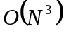.

The rules are generated from fixed patterns such as, Tag₁ Tag₂ ➔ Tag₃ Tag₂ Condition

3.3. Evaluation
To test the algorithm we used an analyzed corpus of 5361 word tokens, which contained 16 articles of various subjects from a Hebrew daily newspaper. We made two experiments, each with a different test article:

- Article A with 469 word tokens (which leaves 4892 word tokens in the training corpus),
- Article B with 764 word tokens (which leaves 4597 word tokens in the training corpus),

We performed 6-fold cross validation and examined how the size of the training corpus affects the number of transformation rules learned and the final accuracy. The results are shown in Appendix A. A statistical analysis revealed that with 95% confidence the error rate at most 8%.

The error-rate graphs are quite flat even for this small training corpus. Perhaps it is possible to conclude that using a larger training corpus won't make the results much better. Right now, however, we cannot verify this conclusion because we don't have a much larger tagged corpus. Such a corpus is in the process of being prepared (Sima’am 2001).

4. The sentence stage
The aim of this stage is to improve the accuracy of the analysis using syntactic information. We start this stage with the output of the pair stage – a sentence in which each word is assigned a morphological analysis, such that 93.8% of the words on average are assigned their correct analysis. A correct analysis must correspond to a syntactically correct sentence. We therefore try to syntactically parse the sentence (actually the POS’s of the sentence). If the parse fails, we would like to conclude that the proposed analysis is incorrect and try another morphological analysis. However, since no syntactic parser is perfect, we do not reject sentences for which the parsing fails. We use the syntactic grammaticality, estimated by the syntactic parser, as one of two measures for the correctness of the analysis, and combine this with the score that results from the pair phase.

Our syntactic parser uses a handcrafted grammar with about 150 rules. There are about 10 nonterminals (one for each basic part-of-speech), and about 30 terminals (these 10, plus about 20 words with special syntactic meaning, such as "AW" (or), "HWA" (he, a pronoun), etc.

5. Combining the scores
In order to define the "best" constituent, we attach, to each constituent, a final score, that is a combination of two scores:
- a morphological score - defined as the logarithm of the product of all morphological scores (generated by the pair stage) of the analyses covered by the constituent. The motivation for this definition is as follows: suppose the constituent covers analyses a_{i}…a_{j} of words w_{i}…w_{j}. if we interpret score(a_{k}) as the probability that a_{k} is the correct analysis of w_{k}, and in addition we assume that the probabilities of the analyses of different words in the series w_{i}…w_{j} are statistically independent, then 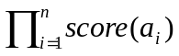 is the probability that the constituent covers the correct analysis of the entire series w_{i}…w_{j}. The morphological score of the constituent is the logarithm of this probability.
- a syntactic score - defined as 0 for constituents of type "a verb with a subject" and of type "connective", and a negative number for other types. The motivation for this definition is that a properly analyzed sentence should be made of simple sentences connected by connectives, and a properly analyzed simple sentence can be reduced to a single constituent of type “a verb with a subject". Therefore, a properly analyzed sentence will have the highest possible syntactic score - 0, and each "improper" element will make the syntactic score more negative.
We now have a problem of combining the two scores into one score, the final score. This is a non-trivial task, which requires an extra phase of machine learning in order to be done automatically. Currently, we use a weighted average.

6. Evaluation of the entire algorithm
The algorithm for finding the best morphological analysis was run on two articles whose analysis has been corrected using transformation rules learned from a corpus of about 4900 words (as described in the end of the previous section). The accuracy of the analysis increased from 93.8% after the pair stage to 96.2% after the sentence stage. A statistical analysis revealed that the error rate is less than 5.3% with a confidence level of 95%.
Error (%) | Sentence Stage | Pair Stage | Word Stage
36.0 | No | No | No
14.0 | No | No | Yes
21.0 | No | Yes | No
7.0 | No | Yes | Yes
20.0 | Yes | No | No
5.3 | Yes | No | Yes
14.0 | Yes | Yes | No
3.8 | Yes | Yes | Yes
Table 1: The percentage of error when using each method separately and
in combination with other methods.

Word Phase
Pair Phase
Sentence Phase
5.3
14
7
3.8
36
21
20
14

Figure 1: A graphical representation of Table 1

7. Conclusions and further research
The research shows that corpus based methods are effective for choosing the correct morphological analysis in context. However, from the error analysis, we see that there is still a lot to be done. At least two more “expert systems” need be incorporated: (a) a recognizer for proper nouns, and (b) a recognizer of idioms.

Furthermore, the sentence stage is not automatic, and is not sufficiently robust. We plan on attempting to attack this problem in several ways. Currently, Sima’an et al (2001) is creating a tree-bank that will enable to automatically learn a grammar for Hebrew. However, even when complete, parsing will be slow. Another vein of research is to follow Abney (1996) and construct a finite state cascade parser. Even though such parsers do not provide full coverage, they may be sufficient for the purpose of morphological disambiguation.
Bibliography
Abney (1996)
Steven Abney. Partial Parsing via Finite-State Cascades. J. of Natural Language Engineering, 2(4): 337-344. 1996.
Albeck
Orly Albeck. Formal analysis by a restriction grammar on one of the stages of Modern Hebrew. Computerized analysis of Hebrew words. Israel Science and Technology Ministry. (In Hebrew.)

Altman (2002)
Alon Altman – private communication.

Ben-Tur et al., (1992)
Esther Ben-Tur, Aviela Angel, Danit Ben-Ari, and Alon Lavie. Computerized analysis of Hebrew words. Israel Science and Technology Ministry. (In Hebrew.)

Brill (1995)
Eric Brill: transformation-based error-driven learning and natural language processing: a case study in part-of-speech tagging. Computational Linguistics 21, 543-565, (1995).

Choueka and Lusignan (1985).
Yaacov Choueka and S. Lusignan Disambiguation by short context. Computers and the Humanities, 19(3), (1985).

Choueka (2002)
Choueka, Y., Rav Millim. Technical report, The Center for Educational Technology in Israel. (http://www.cet.ac.il/rav-milim/)

Church (1988)
Kenneth W. Church: A stochastic parts program and noun phrase parser for unrestricted text.
In ANLP 2. 136-143 (1988).

DeRose (1988)
Steven J. DeRose, Grammatical category disambiguation by statistical optimization, Computational Linguistics 14, 31-39, (1988).

ISO (1999)
“Information and documentation – Conversion of Hebrew characters into Latin characters – Part 3: Phonemic Conversion, ISO/FDIS 259-3: (E)

Kempe
André Kempe, Probabilistic parsing with feature structures.

Levinger et al (1995)
Moshe Levinger, Uzzi Ornan and Alon Itai, Morphological disambiguation in Hebrew using a priori probabilities, Computational Linguistics 21, 383-404, (1995).

Ornan and Katz (1994)
Uzzi Ornan and Michael Katz: A new program for Hebrew index based on the phonemic script, Technical Report #LCL 94-7, Laboratory for Computational Linguistics, Technion, Israel (1994).
http://www.multitext.co.il

Segal (2001)
A Hebrew morphological analyzer (includes free source code)
http://come.to/balshanut or http://www.cs.technion.ac.il/~erelsgl/bxi/hmntx/teud.html

Sima’an et al (2001)
Khalil Sima'an, Alon Itai, Yoad Winter, Alon Altman and Noa Nativ. Building a Tree-Bank of Modern Hebrew Text. Traitment Automatique des Langues, 42, 347-380, (2001).
Weischedel et al (1994)

Ralph M. Weischedel, Marie Meteer, Richard L. Schwartz, Lance Ramshaw, Jeff Palmucci: Coping with Ambiguity and Unknown Words through Probabilistic Models. Computational Linguistics 19(2): 359-382 (1994).
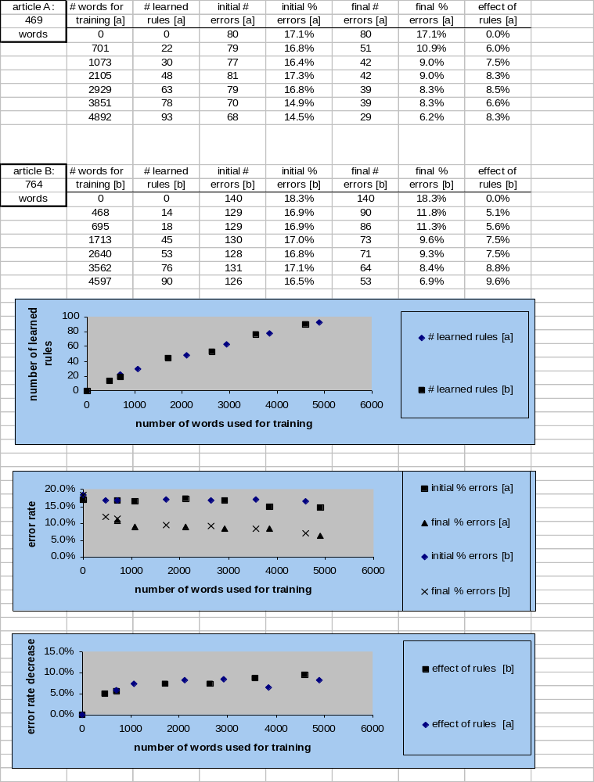
Appendix A: The results of the pair-stage experiment
The x axis in all graphs is the number of words used for training, starting with a minimum of 0 (for no training), to a maximum of 4597 (for article B) or 4892 (for article A).
The first graph shows the number of rules learned for each training-corpus size. The second graph shows the initial and final error rate for each training-corpus size. The third graph shows the effect of the rules, defined as the percent of errors after the word phase minus the percent of errors after the pair stage.

Appendix B: The Hebrew-Latin transliteration
Working with Hebrew letters is still a non-trivial task on some computer systems. In order to overcome this technical problem, and help readers not familiar with the Hebrew alphabet, we used a 1-1 transliteration, in which a single capital Latin letter or a single special symbol represents each Hebrew letter.

The 1-1 correspondence is shown in the following table:

Hebrew letter | Hebrew name | Latin | Hebrew letter | Hebrew name | Latin | Hebrew letter | Hebrew name | Latin
א | Alef | A | ט | Tet | @ | ע | Ayn | &
ב | Bet | B | י | Yud | I | פ | Pei | P
ג | Gimmel | G | כ | Kaf | K | צ | Tsadiq | C
ד | Dalet | D | ל | Lamed | L | ק | Quf | Q
ה | Hei | H | מ | Mem | M | ר | Reish | R
ו | Waw | W | נ | Nun | N | ש | Shin | $
ז | Zayn | Z | ס | Samek | S | ת | Taw | T
ח | Xet | X

The end-of-word Hebrew letters are not differentiated from their middle-of-word counterparts (K, M, N, P, C).

Also, as in the undotted Hebrew script, there is no distinction between the letter "Shin" and the letter "Sin".

Note that this is not a phonologic transcription. The vowels ‘a’ and ‘e’, which are usually not represented in the Hebrew unvocalized script, are also not represented in our Latin transliteration. For example, the word: שלג which is pronounced “sheleg”, is transliterated: $LG.

However, the 1-1 correspondence was chosen so that most Latin letters are similar in sound to the Hebrew letters they replace. This makes it quite easy to read transliterated Hebrew scripts after a short practice.

