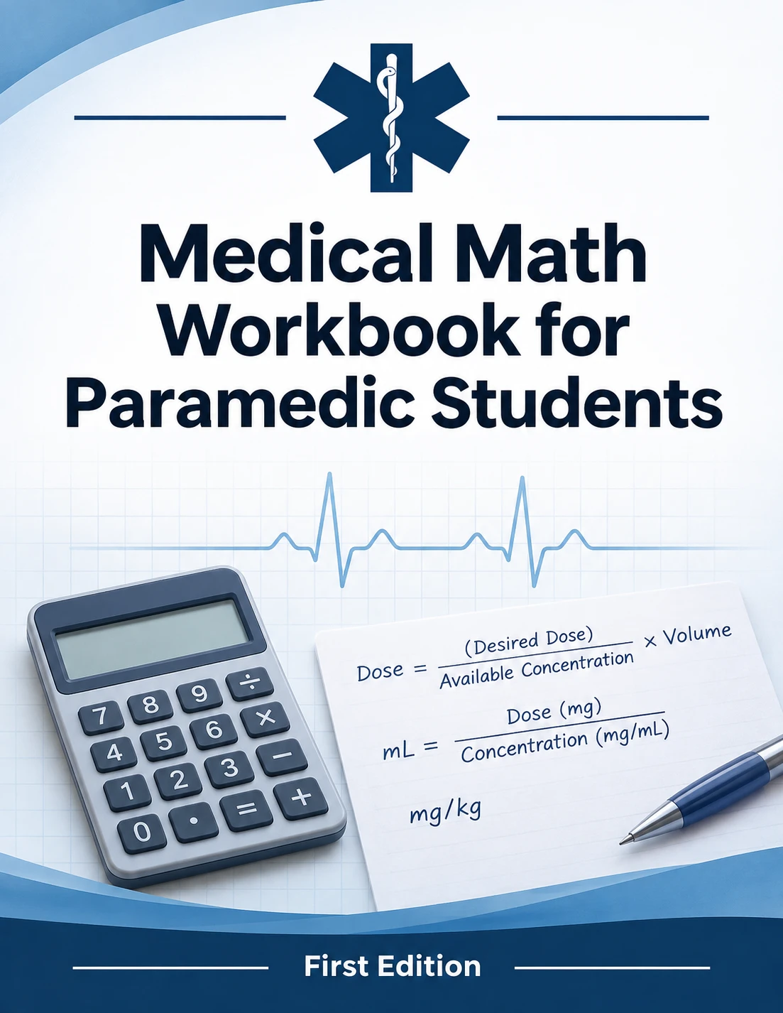

FIRST EDITION
Medical Math Workbook
for Paramedic Students
Drug math, IV fluids and infusion pumps, explained step by step with formulas, worked examples and practice problems.

This workbook belongs to
NAME
PROGRAM
COHORT
INSTRUCTOR

Medical Math Workbook for Paramedic Students, First Edition, 2026.
For educational use. This workbook is a study resource for paramedic students. Drug concentrations, doses and fluid volumes are teaching examples that reflect common EMS practice and resuscitation guidance current at the time of writing. They are not orders.
Always follow your local protocols, your medical director, the product labeling, and the manufacturer's instructions for your equipment. Check every vial and bag label against the order before you draw up or hang a medication.
Equipment shown, including the infusion pump, is generic and does not represent any manufacturer's product.

How to use this workbook
Each chapter starts with the concept, then gives the formula in a labeled box, then walks through worked examples one step at a time. Practice problems follow, with space to show your work. Worked solutions are in the answer key at the back.
Show every step. On a call, a calculation you can check is worth more than a fast guess, and your partner can only double-check work they can see.
LOCAL PROTOCOL RULES
Drugs, concentrations and doses here are teaching examples drawn from common EMS practice. Your formulary, packaging and medical director's protocols always win. Check every vial label against the order before you draw up.

Contents

CHAPTER ONE
01

Medication safety foundations
Drug math only matters if it lands in the right patient, by the right route, at the right time. Most medication errors in EMS are not arithmetic failures. They come from grabbing the wrong vial, misreading a concentration, or a decimal point in the wrong place. Build the habits in this chapter before you build speed.

The rights of medication administration
- Right patient: confirm identity and allergies.
- Right medication: read the label three times (when you pick it up, draw it up, and give it).
- Right dose: calculate, then have a partner verify.
- Right route: IV, IO, IM, IN, SL, PO, neb, ET.
- Right time: rate of push, interval between doses.
- Right documentation: drug, dose, route, time, response.
- Right reason, response, and right to refuse.

Writing numbers safely
WRITE | NEVER | WHY
0.5 mg | .5 mg | Missed decimal reads as 5 mg (10× overdose)
5 mg | 5.0 mg | Trailing zero reads as 50 mg
mcg | µg | µ looks like "m": 1,000× error
units | U, IU | U reads as 0 or 4
mL | cc | cc reads as "u" or "00"

Rounding rules used in this workbook
QUANTITY | ROUND TO | EXAMPLE
Volume to draw up, over 1 mL | Tenths (0.1 mL) | 2.36 mL → 2.4 mL
Volume to draw up, under 1 mL (1 mL syringe) | Hundredths (0.01 mL) | 0.456 mL → 0.46 mL
Patient weight in kg | Tenths, or whole kg for adults | 16.36 kg → 16.4 kg
Drip rate (gtt/min) | Whole drops | 31.25 gtt/min → 31 gtt/min
Pump rate (mL/hr) | Tenths or whole, per pump | 26.25 mL/hr → 26.3 mL/hr

Round only at the end. Carry full numbers through each step so small rounding errors do not stack up.
HIGH-ALERT MEDICATIONS
Vasopressors (norepinephrine, epinephrine infusions, dopamine), opioids, sedatives, insulin, potassium and concentrated electrolytes cause serious harm in small errors. Use an independent double-check: your partner calculates the dose separately before you compare answers. Reading your answer aloud for them to agree with does not count as a check.

FIELD TIP: DOES THE ANSWER MAKE SENSE?
Before you push, ask whether the number is plausible. Most single IV push doses fit in 0.1 to 10 mL. If your answer is 25 mL of fentanyl or 0.02 mL of naloxone, stop and recalculate.

Practice 1: Safety foundations
1.1 Rewrite safely: .25 mg
1.2 Rewrite safely: 2.0 mg
1.3 Rewrite safely: 50 µg
1.4 Rewrite safely: 10 U regular insulin
1.5 Round 1.46 mL for a 3 mL syringe. __________ mL
1.6 Round 0.333 mL for a 1 mL syringe. __________ mL
1.7 Round a calculated drip rate of 62.5 gtt/min. __________ gtt/min
1.8 Your partner calculates 25 mL of fentanyl 50 mcg/mL for an adult. What is wrong, and what should you do?

1.9 Name three of the rights of medication administration that you confirm before every push.

CHAPTER TWO
02

The metric system and conversions
Almost every drug calculation starts with getting the order and the vial into the same unit. If the order is in micrograms and the vial is labeled in milligrams, convert first. The metric system makes this easy: each common step is a factor of 1,000.
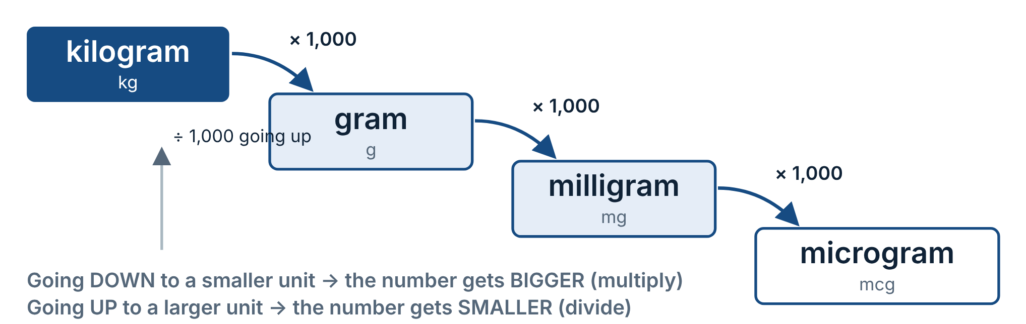
Figure 2.1 The metric staircase. Volume works the same way: 1 L = 1,000 mL.
CONVERSION FACTORS TO MEMORIZE FORMULA 2.1
Mass | 1 kg = 1,000 g | 1 g = 1,000 mg | 1 mg = 1,000 mcg
Volume | 1 L = 1,000 mL | 1 mL = 1 cc | 1 tsp ≈ 5 mL
Weight | 1 kg = 2.2 lb | lb ÷ 2.2 = kg | kg × 2.2 = lb
Time | 1 hr = 60 min | mL/hr ÷ 60 = mL/min | mL/min × 60 = mL/hr
Temperature | °C = (°F − 32) ÷ 1.8 | °F = (°C × 1.8) + 32

The decimal-shift method
Multiplying or dividing by 1,000 means moving the decimal point three places. Move it right when going to a smaller unit, left when going to a larger unit.
WORKED EXAMPLE 2.1 0.25 mg to mcg
DIRECTION | mg → mcg is a step down, so multiply by 1,000.
SHIFT | 0.250 → 250.
ANSWER | 250 mcg

WORKED EXAMPLE 2.2 176 lb to kg
RULE | Pounds to kilograms: divide by 2.2.
MATH | 176 ÷ 2.2 = 80
ANSWER | 80 kg

WORKED EXAMPLE 2.3 1.5 g to mg
DIRECTION | g → mg is a step down: multiply by 1,000.
SHIFT | 1.500 → 1500.
ANSWER | 1,500 mg

WORKED EXAMPLE 2.4 102.2 °F to °C
SUBTRACT | 102.2 − 32 = 70.2
DIVIDE | 70.2 ÷ 1.8 = 39
ANSWER | 39 °C

FIELD TIP: QUICK KG ESTIMATE
Halve the pounds, then subtract 10% of that. 180 lb → 90 → 90 − 9 = 81 kg (exact: 81.8 kg). Use this to sanity-check, then calculate exactly for the dose.

Practice 2: Conversions
2.1 0.4 mg = __________ mcg
2.2 2,500 mcg = __________ mg
2.3 198 lb = __________ kg
2.4 1.2 L = __________ mL
2.5 A newborn weighs 3.5 kg. How many pounds is that? __________ lb
2.6 0.025 g = __________ mg
2.7 A patient's temperature is 39.5 °C. Convert to °F. __________ °F
2.8 An infusion runs at 90 mL/hr. How many mL per minute is that? __________ mL/min
2.9 0.15 mg = __________ mcg
2.10 750 mg = __________ g
2.11 An 18 kg child weighs how many pounds? __________ lb
2.12 101.3 °F = __________ °C
2.13 2.5 L = __________ mL
2.14 0.08 mg = __________ mcg
2.15 143 lb = __________ kg

CHAPTER THREE
03

IV fluids in the paramedic scope
IV fluids are drugs. Each one has indications, contraindications and a dose. To choose well you need two ideas: where water lives in the body, and tonicity, which decides which way water moves once a fluid is in the bloodstream.

Body fluid compartments
About 60% of an adult's body weight is water. Two-thirds of it sits inside cells (intracellular fluid, ICF). The remaining third is extracellular (ECF), split between the interstitial space around the cells and the plasma inside the vessels.
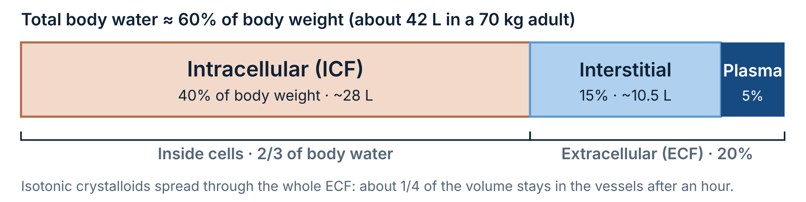
Figure 3.1 This is why a 1 L saline bolus raises blood volume by only about 250 mL once it equilibrates, and why reassessment after each bolus matters.

Tonicity: which way does water move?
Tonicity compares a fluid's effective solute concentration to plasma (about 275–295 mOsm/kg). Water always moves toward the side with more solute.
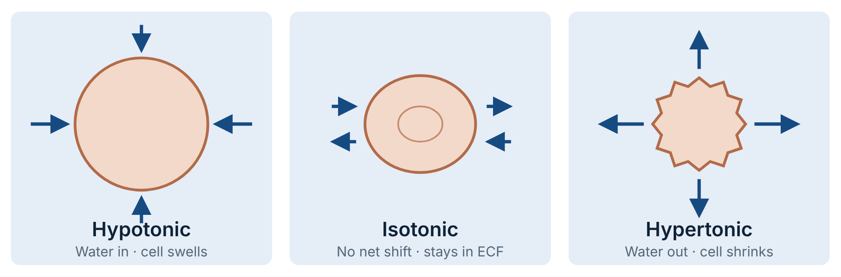
Figure 3.2 Isotonic fluids expand the extracellular space and are the workhorse for volume replacement. Hypotonic fluids shift water into cells, including brain cells, which is why they are avoided in head injury.

The fluids you will hang
Most paramedic formularies carry normal saline and lactated Ringer's for volume, D5W as a drug diluent, and D10 for hypoglycemia. Some services also carry a balanced solution or monitor hypotonic maintenance fluids on interfacility transfers. Bags come in 100, 250, 500 and 1,000 mL sizes.
0.9% Sodium Chloride
"Normal saline" · NS
ISOTONIC · CRYSTALLOID
PER LITER | Na⁺ 154 · Cl⁻ 154 mEq
OSMOLARITY | 308 mOsm/L · pH ≈ 5.5
USES | Hypovolemia, dehydration, sepsis, DKA, heat illness, burns, crush injury. Default carrier for most IV drugs. The only crystalloid compatible with blood products.
CAUTIONS | Fluid overload (CHF, renal failure, pulmonary edema). Large volumes cause hyperchloremic metabolic acidosis.

Lactated Ringer's
LR · Ringer's lactate · Hartmann's
ISOTONIC · BALANCED
PER LITER | Na⁺ 130 · K⁺ 4 · Ca²⁺ 2.7 · Cl⁻ 109 · lactate 28 mEq
OSMOLARITY | 273 mOsm/L · pH ≈ 6.5
USES | Trauma and hemorrhage until blood is available, burns (Parkland formula), large-volume resuscitation. Electrolytes closer to plasma than NS.
CAUTIONS | Calcium binds the citrate in stored blood: do not run in the same line as blood. Liver failure (lactate is cleared by the liver). Mildly hypotonic: many protocols prefer NS in traumatic brain injury.

5% Dextrose in Water
D5W
ISOTONIC IN THE BAG · HYPOTONIC IN THE BODY
PER LITER | Dextrose 50 g · 170 kcal
OSMOLARITY | 252 mOsm/L · pH ≈ 4.3
USES | Diluent for drugs that require it (amiodarone infusions in many protocols). KVO line. Not a volume replacement fluid.
CAUTIONS | The cells use the dextrose, leaving free water that moves into cells. Avoid in head injury, stroke and hyperglycemia. Will not raise blood pressure.

10% Dextrose in Water
D10 · D10W
HYPERTONIC · TREATS HYPOGLYCEMIA
PER LITER | Dextrose 100 g = 0.1 g/mL
OSMOLARITY | 505 mOsm/L
USES | Symptomatic hypoglycemia in adults and children, titrated in 5–25 g aliquots (50–250 mL). Less vein damage than D50 if it infiltrates.
CAUTIONS | Recheck glucose after each aliquot. Watch the IV site: extravasation still damages tissue.

0.45% Sodium Chloride
"Half-normal saline" · ½NS
HYPOTONIC · SCOPE VARIES
PER LITER | Na⁺ 77 · Cl⁻ 77 mEq
OSMOLARITY | 154 mOsm/L
USES | Maintenance fluid seen on interfacility transfers, sometimes with dextrose (D5 ½NS) or KCl added. Usually monitored, not started, by paramedics.
CAUTIONS | Never for volume resuscitation. Avoid in head injury, burns, trauma and hyponatremia.

Plasma-Lyte A / Normosol-R
Balanced multiple-electrolyte solution
ISOTONIC · CARRIED BY SOME SERVICES
PER LITER | Na⁺ 140 · K⁺ 5 · Mg²⁺ 3 · Cl⁻ 98 · acetate 27 · gluconate 23 mEq
OSMOLARITY | 294 mOsm/L · pH ≈ 7.4
USES | Volume replacement with less acid-base disturbance than NS. No calcium, so it is compatible with blood products.
CAUTIONS | Fluid overload; contains potassium (caution in hyperkalemia).

COLLOIDS AND BLOOD
Colloids (albumin, hetastarch) contain large molecules that stay in the vessels. Blood products (packed red cells, plasma, whole blood) are the preferred replacement for hemorrhage. Most paramedics only monitor these during transfers; some critical care and prehospital blood programs start them under specific protocols.

Fluid dosing in the field
SITUATION | TYPICAL APPROACH | REASSESS FOR
Adult hypovolemia, dehydration, sepsis | Isotonic crystalloid in 250–500 mL boluses. Sepsis protocols may target up to 30 mL/kg. | BP, HR, mental status, lung sounds, SpO₂
Hemorrhagic shock (no TBI) | Permissive hypotension: small boluses to a radial pulse or SBP about 80–90 mmHg. Blood first where available. | Radial pulse, mentation
Traumatic brain injury | Avoid any hypotension. Many protocols target SBP ≥ 110 mmHg. Isotonic fluid only. | GCS, pupils, BP
Pediatric hypovolemia | 20 mL/kg isotonic bolus, repeat after reassessment. 10 mL/kg for neonates or suspected cardiac dysfunction. | Cap refill, HR, mental status, liver edge, crackles
Burns | LR by formula: 2–4 mL × kg × %TBSA over 24 h, half in the first 8 h from the time of the burn. | Urine output on long transports
KVO / saline lock | Run just enough to keep the catheter open, often 10–30 mL/hr. | Site patency

WORKED EXAMPLE 3.1 Parkland formula: 80 kg adult, 30% TBSA partial and full thickness burns
24-HOUR | 4 mL × 80 kg × 30 = 9,600 mL LR
FIRST 8 H | 9,600 ÷ 2 = 4,800 mL
RATE | 4,800 mL ÷ 8 hr = 600 mL/hr
ANSWER | 600 mL/hr (if the clock starts at the time of injury; subtract fluid already given). Many burn centers now start at 2 mL/kg/%TBSA: 300 mL/hr.

Catheters and administration sets
Flow through a catheter depends mostly on its diameter and length (Poiseuille's law). Doubling the radius raises flow sixteen-fold, so a short, large-bore catheter is what you want for volume. Gauge numbers run backwards: the smaller the number, the bigger the catheter.
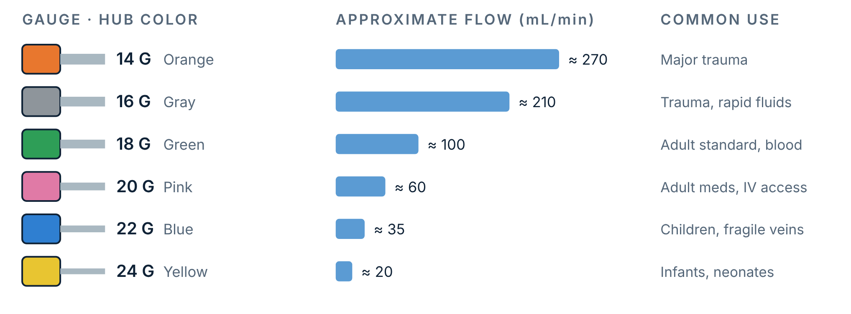
Figure 3.3 ISO 10555 hub colors. Flow rates are approximate for a 1–1.25 inch catheter under gravity with crystalloid; they vary by length and manufacturer.
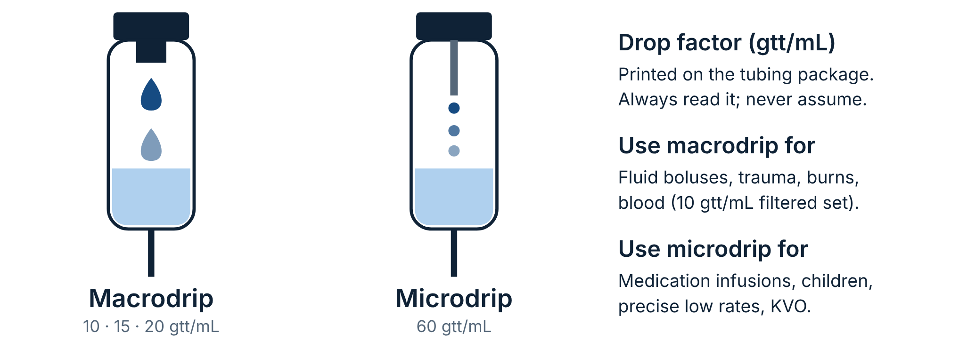
Figure 3.4 Inside a microdrip chamber you can see a thin metal cannula. With a 60 gtt/mL set, gtt/min equals mL/hr, which makes gravity medication drips simple to set.

Practice 3: IV fluids
3.1 Which crystalloid is the only one compatible with blood products, and why can't LR run in the same line?

3.2 D5W is isotonic in the bag. Explain why it behaves as a hypotonic fluid once infused.

3.3 Name the tonicity of each: 0.9% NaCl __________ · 0.45% NaCl __________ · D10W __________
3.4 A 25 kg child is in compensated hypovolemic shock. Calculate a 20 mL/kg bolus. __________ mL
3.5 Your patient has a severe head injury and is hypotensive. Which fluids should you avoid, and why?

3.6 A 60 kg adult has 40% TBSA burns. Using 4 mL/kg/%TBSA, what rate (mL/hr) runs for the first 8 hours, starting at the time of injury? __________ mL/hr
3.7 About how much of a 1,000 mL NS bolus remains in the vascular space after an hour? __________ mL
3.8 30 kg child, 20 mL/kg isotonic bolus. __________ mL
3.9 3.2 kg neonate, 10 mL/kg bolus. __________ mL
3.10 90 kg adult, 25% TBSA. Using 2 mL/kg/%TBSA, what rate runs for the first 8 hours from the time of injury? __________ mL/hr
3.11 How many grams of dextrose are in 100 mL of D10? __________ g
3.12 An adult receives 2 L of NS. About how much stays in the vascular space after an hour? __________ mL
3.13 Which fluid would you choose to run alongside packed red cells, and why not LR?

CHAPTER FOUR
04

Dose and volume: how much to draw up
The order tells you the dose (mg, mcg, g, units). The vial tells you the concentration: how much drug is in each mL. Your job is to find the volume that holds the ordered dose.
DESIRED OVER HAVE FORMULA 4.1
Volume to give (mL) = D ÷ H × Q
D desired dose (the order) · H dose on hand (drug amount on the label) · Q quantity (the volume that holds H)
D and H must be in the same unit. Convert first if they are not.

WORKED EXAMPLE 4.1 Fentanyl 75 mcg IV. Vial: 100 mcg / 2 mL
IDENTIFY | D = 75 mcg · H = 100 mcg · Q = 2 mL
UNITS | Both in mcg. No conversion needed.
SOLVE | 75 ÷ 100 × 2 = 0.75 × 2 = 1.5 mL
CHECK | 75 is a bit less than 100, so the answer should be a bit less than 2 mL. It is.
ANSWER | Draw up 1.5 mL

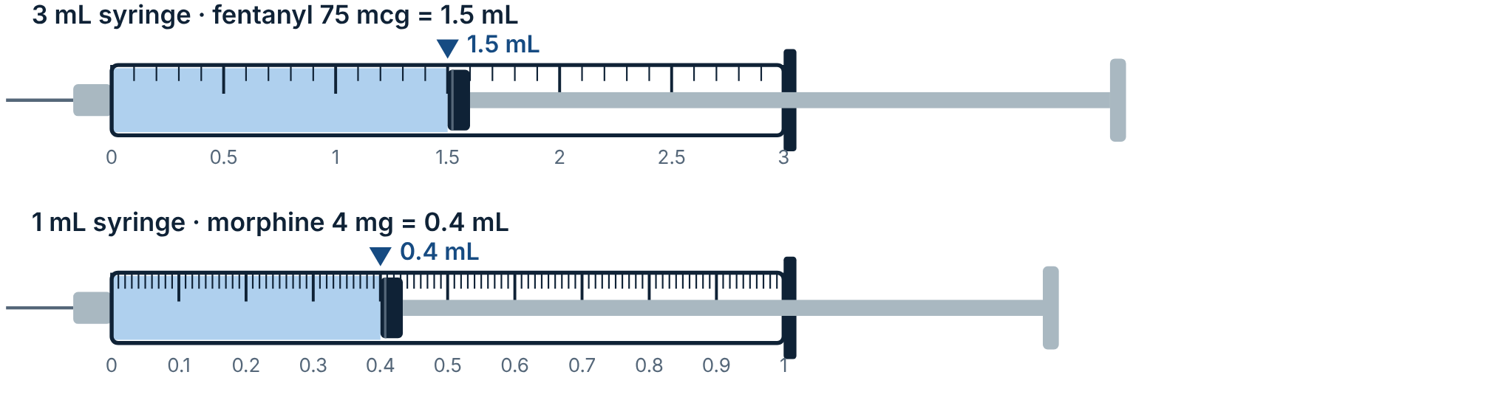
Figure 4.1 Read the volume at the leading edge of the rubber stopper, the ring closest to the needle. Pick the smallest syringe that holds the volume: it has the finest markings.

Three ways to solve the same problem
Use whichever method you trust. They always agree. Here is the same order solved three ways: morphine 4 mg IV, vial 10 mg/mL.
METHOD A Formula
D/H × Q
4 ÷ 10 × 1 mL
0.4 mL

METHOD B Ratio and proportion
10 mg : 1 mL = 4 mg : x mL
10x = 4 → x = 0.4
0.4 mL

METHOD C Dimensional analysis
4 mg × (1 mL / 10 mg)
mg cancels → 0.4 mL
0.4 mL

When the units don't match
WORKED EXAMPLE 4.2 Order: naloxone 400 mcg IV. Vial: 2 mg / 2 mL
CONVERT | 400 mcg = 0.4 mg
IDENTIFY | D = 0.4 mg · H = 2 mg · Q = 2 mL
SOLVE | 0.4 ÷ 2 × 2 = 0.4 mL
ANSWER | Draw up 0.4 mL

Find the concentration per mL first
Many paramedics simplify every vial to "per 1 mL" first, then divide the order by that number. It is fast and harder to get wrong.
CONCENTRATION FORMULA 4.2
Concentration (per mL) = (total drug) ÷ (total volume)
Volume (mL) = (ordered dose) ÷ (concentration per mL)

DRUG AS SUPPLIED | PER ML | ORDER | VOLUME
Epinephrine 1 mg / 10 mL | 0.1 mg/mL | 1 mg IV (arrest) | 10 mL
Epinephrine 1 mg / 1 mL | 1 mg/mL | 0.3 mg IM | 0.3 mL
Amiodarone 150 mg / 3 mL | 50 mg/mL | 300 mg IV | 6 mL
Adenosine 6 mg / 2 mL | 3 mg/mL | 12 mg rapid IV | 4 mL
Atropine 1 mg / 10 mL | 0.1 mg/mL | 1 mg IV | 10 mL
Ondansetron 4 mg / 2 mL | 2 mg/mL | 4 mg IV | 2 mL
Diphenhydramine 50 mg / 1 mL | 50 mg/mL | 25 mg IV | 0.5 mL
Midazolam 10 mg / 2 mL | 5 mg/mL | 2.5 mg IV | 0.5 mL

WATCH THE TOTAL VOLUME ON THE LABEL
"Fentanyl 100 mcg/2 mL" is 50 mcg per mL, not 100. Misreading the total amount as the per-mL concentration is one of the most common drug-math errors. Midazolam comes as both 1 mg/mL and 5 mg/mL; check which one you are holding.

Practice 4: Dose and volume
4.1 Order: diphenhydramine 25 mg IV. Vial: 50 mg/mL. __________ mL
4.2 Order: adenosine 12 mg rapid IV push. Vial: 6 mg/2 mL. __________ mL
4.3 Order: amiodarone 150 mg IV. Vial: 150 mg/3 mL. __________ mL
4.4 Order: fentanyl 50 mcg IN. Vial: 100 mcg/2 mL. __________ mL
4.5 Order: midazolam 2 mg IV. Vial: 5 mg/mL. __________ mL
4.6 Order: naloxone 0.5 mg IV. Vial: 0.4 mg/mL. __________ mL
4.7 Order: ketorolac 15 mg IV. Vial: 30 mg/mL. __________ mL
4.8 Order: epinephrine 0.5 mg IM. Vial: 1 mg/mL. __________ mL
4.9 Order: ondansetron 4 mg IV. Vial: 2 mg/mL. __________ mL
4.10 Order: hydromorphone 500 mcg IV. Vial: 2 mg/mL. __________ mL
4.11 Order: fentanyl 100 mcg IV. Vial: 50 mcg/mL. __________ mL
4.12 Order: morphine 6 mg IV. Vial: 10 mg/mL. __________ mL
4.13 Order: ketamine 25 mg IV. Vial: 50 mg/mL. __________ mL
4.14 Order: atropine 0.5 mg IV. Vial: 1 mg/10 mL. __________ mL
4.15 Order: methylprednisolone 125 mg IV. Vial: 125 mg/2 mL. __________ mL
4.16 Order: ketorolac 10 mg IV. Vial: 15 mg/mL. __________ mL
4.17 Order: diazepam 5 mg IV. Vial: 5 mg/mL. __________ mL
4.18 Order: hydromorphone 1 mg IV. Vial: 2 mg/mL. __________ mL
4.19 Order: naloxone 0.4 mg IV. Vial: 2 mg/2 mL. __________ mL
4.20 Order: fentanyl 0.075 mg IV. Vial: 50 mcg/mL. __________ mL

CHAPTER FIVE
05

Weight-based calculations
Children, and many adult drugs, are dosed per kilogram. The order reads like mg/kg or mcg/kg. This adds one step in front of the dose-volume formula: find the patient's dose from their weight.
WEIGHT-BASED DOSE FORMULA 5.1
Step 1 · kg = lb ÷ 2.2
Step 2 · Dose = (dose per kg) × kg
Step 3 · Volume = Dose ÷ (concentration per mL)
Step 4 · Compare with the maximum single dose

WORKED EXAMPLE 5.1 Pediatric cardiac arrest: epinephrine 0.01 mg/kg IV/IO. Child weighs 44 lb. Vial: 1 mg/10 mL.
WEIGHT | 44 lb ÷ 2.2 = 20 kg
DOSE | 0.01 mg/kg × 20 kg = 0.2 mg
CONC. | 1 mg ÷ 10 mL = 0.1 mg/mL
VOLUME | 0.2 mg ÷ 0.1 mg/mL = 2 mL
MAX | Single dose max 1 mg. 0.2 mg is under it.
ANSWER | 0.2 mg = 2 mL Shortcut: with 0.1 mg/mL epinephrine, the arrest dose is 0.1 mL/kg.

WORKED EXAMPLE 5.2 Fentanyl 1 mcg/kg IV. 66 lb child. Vial 50 mcg/mL.
WEIGHT | 66 ÷ 2.2 = 30 kg
DOSE | 1 × 30 = 30 mcg
VOLUME | 30 ÷ 50 = 0.6 mL
ANSWER | 0.6 mL

WORKED EXAMPLE 5.3 Hypoglycemia: D10 0.5 g/kg IV. 10 kg toddler.
DOSE | 0.5 g × 10 = 5 g
CONC. | D10 = 10 g/100 mL = 0.1 g/mL
VOLUME | 5 ÷ 0.1 = 50 mL
ANSWER | 50 mL of D10 (= 5 mL/kg)

WORKED EXAMPLE 5.4 When the calculation passes the maximum: naloxone 0.1 mg/kg IV, max 2 mg. Child weighs 25 kg. Vial 1 mg/mL.
DOSE | 0.1 × 25 = 2.5 mg
MAX | 2.5 mg is more than the 2 mg maximum. Give the maximum.
VOLUME | 2 mg ÷ 1 mg/mL = 2 mL
ANSWER | 2 mg = 2 mL

FIELD TIP: LENGTH-BASED TAPES
For children, a length-based resuscitation tape estimates weight from height and gives pre-calculated doses by color zone. Use it, but understand the math behind it so you can catch an error or work without one.

COMMON PEDIATRIC WEIGHT-BASED DOSES | PER KG | USUAL MAX SINGLE DOSE
Epinephrine (arrest), 0.1 mg/mL | 0.01 mg/kg (0.1 mL/kg) | 1 mg
Epinephrine (anaphylaxis IM), 1 mg/mL | 0.01 mg/kg | 0.3 mg (child) · 0.5 mg (adult)
Amiodarone (VF/pVT) | 5 mg/kg | 300 mg
Adenosine (first dose) | 0.1 mg/kg | 6 mg
Atropine (bradycardia) | 0.02 mg/kg | 0.5 mg
Dextrose | 0.5–1 g/kg | 25 g
Fluid bolus, isotonic | 20 mL/kg | Reassess each
Defibrillation | 2 J/kg, then 4 J/kg | 10 J/kg or adult dose

Reference values from current pediatric resuscitation guidelines; confirm against your protocol.

Practice 5: Weight-based
5.1 154 lb adult. Fentanyl 1 mcg/kg IV. Vial 100 mcg/2 mL. Dose __________ mcg · Volume __________ mL
5.2 33 lb child in cardiac arrest. Epinephrine 0.01 mg/kg, vial 1 mg/10 mL. Dose __________ mg · Volume __________ mL
5.3 20 kg child in VF. Amiodarone 5 mg/kg, vial 150 mg/3 mL. Dose __________ mg · Volume __________ mL
5.4 12 kg child, glucose 38 mg/dL. D10 0.5 g/kg. Dose __________ g · Volume __________ mL
5.5 8 kg infant, symptomatic bradycardia after epinephrine. Atropine 0.02 mg/kg, vial 0.1 mg/mL. Dose __________ mg · Volume __________ mL
5.6 18 kg child, 20 mL/kg NS bolus. __________ mL
5.7 220 lb adult. Ketamine 0.3 mg/kg IV for pain, vial 50 mg/mL. Dose __________ mg · Volume __________ mL
5.8 14 kg child with SVT. Adenosine 0.1 mg/kg, vial 6 mg/2 mL. Dose __________ mg · Volume __________ mL
5.9 88 lb child. Fentanyl 1 mcg/kg, vial 50 mcg/mL. Dose __________ mcg · Volume __________ mL
5.10 25 kg child. Ondansetron 0.15 mg/kg (max 4 mg), vial 2 mg/mL. Dose __________ mg · Volume __________ mL
5.11 6 kg infant, glucose 30 mg/dL. D10 5 mL/kg. Volume __________ mL · Grams __________ g
5.12 40 kg child in VF. Amiodarone 5 mg/kg, vial 50 mg/mL. Dose __________ mg · Volume __________ mL
5.13 22 lb child in arrest. Epinephrine 0.01 mg/kg, vial 0.1 mg/mL. Dose __________ mg · Volume __________ mL
5.14 50 kg teen with SVT. Adenosine 0.1 mg/kg (max 6 mg), vial 3 mg/mL. Dose __________ mg · Volume __________ mL
5.15 132 lb adult. Ketamine 0.5 mg/kg IV, vial 100 mg/mL. Dose __________ mg · Volume __________ mL
5.16 18 kg child seizing. Midazolam 0.2 mg/kg IN (max 10 mg), vial 5 mg/mL. Dose __________ mg · Volume __________ mL

CHAPTER SIX
06

Drip rates I: volume over time
Volume-based drip problems give you a volume of fluid and a time to run it over. Without a pump, you control the rate by counting drops per minute in the drip chamber. With a pump, you enter mL/hr.
GRAVITY DRIP RATE FORMULA 6.1
gtt/min = (volume (mL) × drop factor (gtt/mL)) ÷ (time (min))
mL/hr = (volume (mL)) ÷ (time (hr))
drop factor from the tubing package: 10, 15, 20 or 60 · time in minutes for gtt/min

WORKED EXAMPLE 6.1 Infuse 250 mL NS over 30 minutes with a 10 gtt/mL set
SET UP | (250 mL × 10 gtt/mL) ÷ 30 min
SOLVE | 2,500 ÷ 30 = 83.3
ANSWER | 83 gtt/min ≈ 21 drops every 15 seconds

WORKED EXAMPLE 6.2 Infuse 1,000 mL LR over 8 hours with a 15 gtt/mL set
MINUTES | 8 hr × 60 = 480 min
SOLVE | (1,000 × 15) ÷ 480 = 31.25
PUMP RATE | 1,000 ÷ 8 = 125 mL/hr
ANSWER | 31 gtt/min or 125 mL/hr on a pump

Shortcuts that come from the formula
DROP FACTOR | DIVIDE ML/HR BY | SO 120 ML/HR IS
60 gtt/mL | 1 (gtt/min = mL/hr) | 120 gtt/min
20 gtt/mL | 3 | 40 gtt/min
15 gtt/mL | 4 | 30 gtt/min
10 gtt/mL | 6 | 20 gtt/min

The divisor is 60 ÷ drop factor. It works because gtt/min = (mL/hr × drop factor) ÷ 60.
INFUSION TIME FORMULA 6.2
Time (hr) = (volume (mL)) ÷ (rate (mL/hr))
Example: 500 mL at 125 mL/hr lasts 4 hours. Useful for planning long transfers and knowing when a bag will run dry.

FIELD TIP: COUNTING DROPS
Count drops for 15 seconds and multiply by 4. To set 83 gtt/min, aim for about 21 drops in 15 seconds. Recheck after moving the patient: bag height, arm position and kinks all change a gravity rate.

IS THE RATE COUNTABLE?
Above about 100–150 gtt/min the drops blur into a stream and can't be counted. If your answer is 300 gtt/min, switch to a set with a smaller drop factor, use a pump, or run it wide open with a pressure bag as protocol allows.

Practice 6: Volume drip rates
6.1 1,000 mL over 4 hours, 15 gtt/mL set. __________ gtt/min · __________ mL/hr
6.2 500 mL over 1 hour, 10 gtt/mL set. __________ gtt/min
6.3 100 mL over 20 minutes, 10 gtt/mL set. __________ gtt/min
6.4 KVO at 30 mL/hr with a 60 gtt/mL set. __________ gtt/min
6.5 250 mL bolus over 15 minutes with a 10 gtt/mL set. __________ gtt/min
6.6 A 20 gtt/mL set is running at 25 gtt/min. What is the rate in mL/hr? __________ mL/hr
6.7 500 mL over 2 hours, 15 gtt/mL set. __________ gtt/min
6.8 1,000 mL over 6 hours, 20 gtt/mL set. __________ gtt/min · __________ mL/hr
6.9 150 mL/hr ordered, 10 gtt/mL set. __________ gtt/min
6.10 75 mL/hr ordered, 15 gtt/mL set. __________ gtt/min
6.11 100 mL over 30 minutes, 20 gtt/mL set. __________ gtt/min
6.12 A 15 gtt/mL set is running at 40 gtt/min. __________ mL/hr
6.13 250 mL over 1 hour with a 60 gtt/mL set. __________ gtt/min. Is that practical?

CHAPTER SEVEN
07

Drip rates II: concentration infusions
A medication infusion is ordered as a dose over time, such as mcg/min, mg/min or mcg/kg/min. To run it you need to know how much drug is in each mL of the bag (the concentration), then turn the dose per minute into mL per minute.
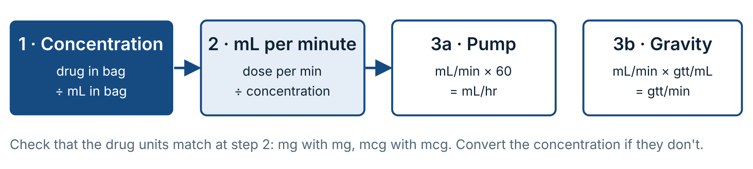
Figure 7.1 Every concentration infusion follows the same path.
CONCENTRATION INFUSION FORMULA 7.1
mL/hr = (dose per min × 60) ÷ (concentration (per mL))
gtt/min = (dose per min × drop factor) ÷ (concentration (per mL))
Weight-based: dose per min = (dose per kg per min) × kg

WORKED EXAMPLE 7.1 Norepinephrine 8 mcg/min. Bag: 4 mg in 250 mL. 60 gtt/mL set or pump.
CONVERT | 4 mg = 4,000 mcg (order is in mcg)
CONC. | 4,000 mcg ÷ 250 mL = 16 mcg/mL
ML/MIN | 8 mcg/min ÷ 16 mcg/mL = 0.5 mL/min
PUMP | 0.5 × 60 = 30 mL/hr
GRAVITY | 0.5 × 60 gtt/mL = 30 gtt/min
ANSWER | 30 mL/hr = 30 gtt/min on a microdrip

WORKED EXAMPLE 7.2 Dopamine 5 mcg/kg/min for an 80 kg patient. Premix: 400 mg in 250 mL.
DOSE/MIN | 5 mcg/kg/min × 80 kg = 400 mcg/min
CONC. | 400,000 mcg ÷ 250 mL = 1,600 mcg/mL
ML/MIN | 400 ÷ 1,600 = 0.25 mL/min
PUMP | 0.25 × 60 = 15 mL/hr
ANSWER | 15 mL/hr = 15 gtt/min on a microdrip

WORKED EXAMPLE 7.3 Timed infusion: amiodarone 150 mg in 100 mL D5W over 10 minutes, 10 gtt/mL set
IDEA | The whole bag runs in 10 minutes, so this is really a volume-over-time problem.
GRAVITY | (100 mL × 10) ÷ 10 min = 100 gtt/min
PUMP | 100 mL ÷ (10/60 hr) = 600 mL/hr, VTBI 100 mL
ANSWER | 100 gtt/min or 600 mL/hr

Working backward: what dose is running?
On a transfer you often inherit a running drip. Reverse the formula to confirm the dose matches the order.
DOSE FROM RATE FORMULA 7.2
dose per min = (mL/hr × concentration) ÷ 60
Example: norepinephrine 16 mcg/mL running at 15 mL/hr → 15 × 16 ÷ 60 = 4 mcg/min.

Standard concentrations at a glance
DRUG (MIX) | CONCENTRATION | RATE PER DOSE STEP
Norepinephrine 4 mg / 250 mL | 16 mcg/mL | 1 mcg/min = 3.75 mL/hr
Epinephrine 1 mg / 250 mL | 4 mcg/mL | 1 mcg/min = 15 mL/hr
Dopamine 400 mg / 250 mL | 1,600 mcg/mL | mL/hr = mcg/kg/min × kg ÷ 26.7
Lidocaine 2 g / 500 mL | 4 mg/mL | 1 mg/min = 15 mL/hr
Amiodarone 450 mg / 250 mL | 1.8 mg/mL | 1 mg/min = 33.3 mL/hr
Magnesium 2 g / 50 mL | 40 mg/mL | Over 15 min = 200 mL/hr

Many services use pharmacy premixed bags; concentrations differ between systems. Always read the bag label.
FIELD TIP: THE CLOCK METHOD
For any drug mixed at 4 units per mL (lidocaine 4 mg/mL, epinephrine 4 mcg/mL) on a 60 gtt/mL set, 1 unit/min = 15 gtt/min, 2 = 30, 3 = 45, 4 = 60. Picture the quarter-hours on a clock face.

VASOPRESSORS ARE HIGH-ALERT
Run vasopressors on a pump through a dedicated line whenever possible, label the line, and never flush it: a flush pushes a bolus of drug. Watch the site closely for extravasation.

Practice 7: Concentration infusions
7.1 Norepinephrine 12 mcg/min. Bag 4 mg/250 mL. 60 gtt/mL set. Concentration __________ · __________ gtt/min
7.2 Dopamine 10 mcg/kg/min, 70 kg patient. Bag 400 mg/250 mL. __________ mL/hr
7.3 Epinephrine 5 mcg/min. Bag 1 mg/250 mL. __________ mL/hr
7.4 Magnesium sulfate 2 g in 50 mL over 15 minutes, 10 gtt/mL set. __________ gtt/min · pump __________ mL/hr
7.5 Lidocaine 3 mg/min. Bag 2 g/500 mL. 60 gtt/mL set. __________ gtt/min
7.6 You receive a patient with norepinephrine 4 mg/250 mL running at 15 mL/hr. What dose is the patient getting? __________ mcg/min
7.7 Amiodarone maintenance 1 mg/min. Bag 450 mg/250 mL. __________ mL/hr
7.8 Dopamine 400 mg/250 mL is running at 30 mL/hr on a 75 kg patient. What is the dose in mcg/kg/min? __________
7.9 Norepinephrine 2 mcg/min. Bag 4 mg/250 mL. __________ mL/hr
7.10 Epinephrine 10 mcg/min. Bag 1 mg/250 mL. __________ mL/hr
7.11 Dopamine 5 mcg/kg/min, 90 kg. Bag 400 mg/250 mL. __________ mL/hr
7.12 Dopamine 15 mcg/kg/min, 60 kg. Bag 800 mg/500 mL. Concentration __________ · __________ mL/hr
7.13 Lidocaine 2 mg/min. Bag 1 g/250 mL, 60 gtt/mL set. __________ gtt/min
7.14 Epinephrine 4 mcg/min. Bag 2 mg/250 mL. __________ mL/hr
7.15 Norepinephrine 8 mg/250 mL is running at 30 mL/hr. What dose is infusing? __________ mcg/min
7.16 Magnesium 2 g in 100 mL over 20 minutes, 15 gtt/mL set. __________ gtt/min · pump __________ mL/hr
7.17 Dopamine 400 mg/250 mL at 45 mL/hr, 80 kg patient. __________ mcg/kg/min

CHAPTER EIGHT
08

Percent and ratio concentrations
Some drugs are labeled by percentage (lidocaine 2%, D50, magnesium 50%) or by an older ratio (epinephrine 1:1,000). Before you can calculate a volume, convert the label to mg per mL or g per mL.
PERCENT (WEIGHT/VOLUME) FORMULA 8.1
X% = X g per 100 mL
mg/mL = % × 10
1% = 1 g/100 mL = 1,000 mg/100 mL = 10 mg/mL

RATIO FORMULA 8.2
1:X = 1 g in X mL
1:1,000 = 1 mg/mL
1:10,000 = 0.1 mg/mL

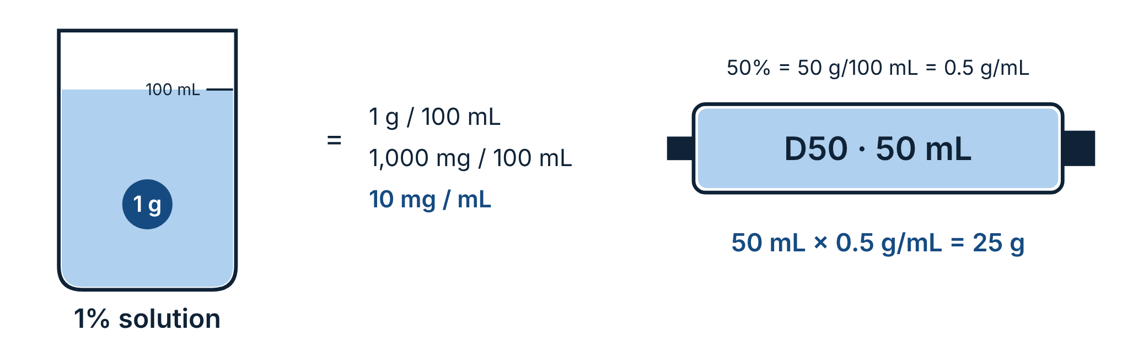
Figure 8.1 Percent means grams per 100 mL. Multiply by 10 to get mg/mL.
LABEL | MEANS | PER ML | EXAMPLE DOSE → VOLUME
Lidocaine 2% | 2 g/100 mL | 20 mg/mL | 100 mg → 5 mL
Dextrose 50% (D50) | 50 g/100 mL | 0.5 g/mL | 25 g → 50 mL
Dextrose 25% (D25) | 25 g/100 mL | 0.25 g/mL | 5 g → 20 mL
Dextrose 10% (D10) | 10 g/100 mL | 0.1 g/mL | 25 g → 250 mL
Magnesium sulfate 50% | 50 g/100 mL | 500 mg/mL | 2 g → 4 mL
Calcium chloride 10% | 10 g/100 mL | 100 mg/mL | 1 g → 10 mL
Calcium gluconate 10% | 10 g/100 mL | 100 mg/mL | 3 g → 30 mL
Sodium bicarbonate 8.4% | 8.4 g/100 mL | 84 mg = 1 mEq/mL | 50 mEq → 50 mL
Sodium chloride 0.9% | 0.9 g/100 mL | 9 mg/mL | 1 L contains 9 g NaCl
Epinephrine 1 mg/mL (old 1:1,000) | 1 g/1,000 mL | 1 mg/mL | 0.3 mg IM → 0.3 mL
Epinephrine 0.1 mg/mL (old 1:10,000) | 1 g/10,000 mL | 0.1 mg/mL | 1 mg IV → 10 mL

CALCIUM CHLORIDE VS. CALCIUM GLUCONATE
Both are 10%, but calcium chloride delivers about three times more elemental calcium per mL. They are not interchangeable mL for mL. Confirm which one the protocol names.

WHY RATIO LABELS CHANGED
Since 2016 US labels state epinephrine as mg/mL (1 mg/mL, 0.1 mg/mL) instead of 1:1,000 and 1:10,000, because ratio labels caused 10-fold errors. You will still hear the old names on calls and see them in older references.

Dilutions: C₁V₁ = C₂V₂
When you need a weaker solution than you have, use the dilution formula. The amount of drug stays the same; only the volume grows.
DILUTION FORMULA 8.3
C₁ × V₁ = C₂ × V₂
C₁ V₁ starting concentration and volume · C₂ V₂ final concentration and total volume

WORKED EXAMPLE 8.1 Make D10 from a 50 mL D50 syringe
SET UP | 50% × 50 mL = 10% × V₂
SOLVE | V₂ = 2,500 ÷ 10 = 250 mL
MIX | Add 50 mL D50 to 200 mL NS or sterile water.
ANSWER | 250 mL of D10 (25 g)
Rule of thumb: D50 to D10 is 1 part D50 + 4 parts diluent. D50 to D25 is 1 + 1.

WORKED EXAMPLE 8.2 Push-dose epinephrine 10 mcg/mL
START | 0.1 mg/mL epi = 100 mcg/mL
SET UP | 100 mcg/mL × V₁ = 10 mcg/mL × 10 mL
SOLVE | V₁ = 1 mL
MIX | Waste 1 mL from a 10 mL NS flush, add 1 mL of 0.1 mg/mL epinephrine. Label it.
ANSWER | 10 mL at 10 mcg/mL

Practice 8: Percent and ratio
8.1 Lidocaine 2%: how many mg/mL? __________ How many mL for 1.5 mg/kg in a 60 kg patient? __________ mL
8.2 Magnesium sulfate 50%, order 2 g IV. __________ mL
8.3 How many grams of dextrose are in 250 mL of D10? __________ g
8.4 Calcium chloride 10%, order 500 mg IV. __________ mL
8.5 Sodium bicarbonate 8.4%, order 1 mEq/kg for a 70 kg patient. __________ mL
8.6 You have 25 mL of D50. How much diluent makes D10, and what is the total volume? __________ mL diluent · __________ mL total
8.7 Epinephrine 1:1,000, order 0.5 mg IM. __________ mL
8.8 How many grams of NaCl are in 500 mL of 0.9% NS? __________ g
8.9 Push-dose epinephrine 10 mcg/mL, order 20 mcg. __________ mL
8.10 Lidocaine 1%: __________ mg/mL. Volume for 50 mg? __________ mL
8.11 D25 for a 10 kg child, 0.5 g/kg. Grams __________ · Volume __________ mL
8.12 Calcium gluconate 10%, order 1 g IV. __________ mL
8.13 How many mL of D50 contain 12.5 g? __________ mL
8.14 Magnesium sulfate 50%, order 4 g IV. __________ mL
8.15 Epinephrine 0.1 mg/mL (1:10,000), order 0.3 mg IV. __________ mL
8.16 How many grams of dextrose are in 1 L of D5W? __________ g
8.17 Make 50 mL of D25 from D50. __________ mL D50 + __________ mL diluent

CHAPTER NINE
09

IV infusion pumps
A volumetric infusion pump pushes fluid at a set rate in mL/hr, regardless of bag height, back-pressure or patient position. That makes it the standard for medication infusions, children, and any transfer where the rate must be exact. Pumps differ by brand, but the controls and concepts below are common to all of them. Learn your service's model from its manufacturer training.
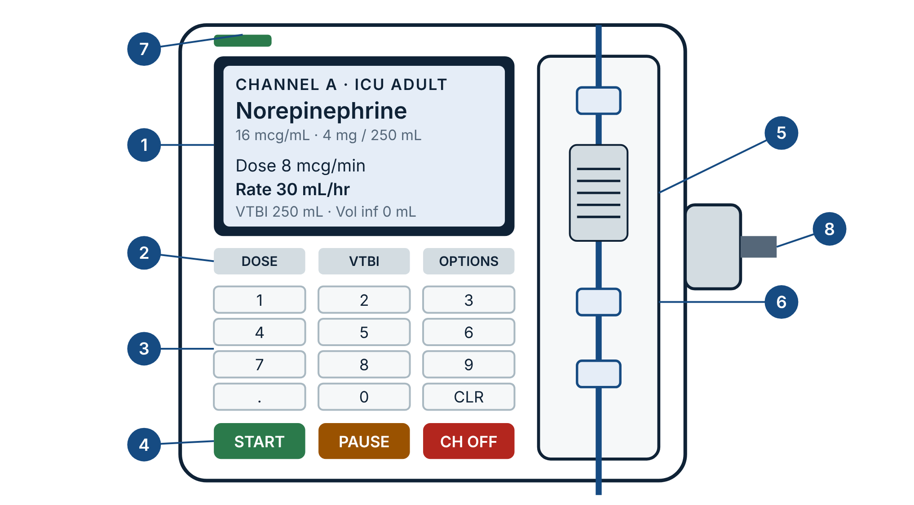
Figure 9.1 A generic large-volume infusion pump. Layout varies by manufacturer, but every pump has these parts.
# | PART | WHAT IT DOES
1 | Display | Shows drug, concentration, dose, rate (mL/hr), VTBI, volume infused, alarms and battery.
2 | Soft keys | Context buttons whose labels change on screen: dose, VTBI, options, secondary.
3 | Numeric keypad | Enters rate, dose, weight and volume. Watch the decimal key.
4 | Start · Pause · Channel off | Start runs the program. Pause holds it. Channel off stops it and clears that channel.
5 | Door and set | The pump segment of the tubing loads here. The pumping mechanism (peristaltic fingers or a cassette) moves fluid. Anti-free-flow clamps close when the door opens.
6 | Sensors | Upstream and downstream pressure sensors detect occlusions; the air-in-line detector catches bubbles.
7 | Power / battery | Shows AC or battery operation and charge left. Plan for transport time.
8 | Pole clamp | Mounts the pump to an IV pole or stretcher mount.

Key terms
Rate | Volume per hour, in mL/hr. The pump always runs on this, even in dose mode.
VTBI | Volume to be infused. The pump stops (or drops to KVO) when it reaches this. Set it to the volume in the bag or the volume ordered, whichever is less.
Volume infused | Running total. Record it at handoff and clear it at the start of your transport.
Rate mode vs. dose mode | Rate mode: you enter mL/hr. Dose mode: you enter drug, concentration, weight and dose, and the pump calculates mL/hr. Verify the calculation yourself.
Drug library (DERS) | Dose error reduction software: preloaded drugs, standard concentrations and dose limits by care area. Always choose the drug from the library instead of using basic rate mode.
Soft limit | An unusual dose. The pump warns you; you can override after re-checking.
Hard limit | An unsafe dose. The pump will not accept it. Re-check the order and the math.
KVO | Keep vein open: a low rate (often 1–5 mL/hr) the pump falls back to when VTBI is complete.
Primary vs. secondary | Primary is the main infusion. Secondary (piggyback) runs a short infusion through the same channel, then returns to primary.
Bolus / loading dose | A set amount delivered over a set time from the same bag, on pumps that support it.

Programming a medication infusion, step by step
- Verify the order and the rights. Drug, concentration, dose, patient weight, route, and any titration parameters.
- Calculate the expected rate by hand. You need your own number to check the pump against (Chapter 7).
- Spike and prime the set. Clear all air, label the tubing with the drug name, and close the roller clamp.
- Power on and choose the care area or profile. This sets which drug library and limits apply.
- Load the set into the channel and close the door. Orient the set in the direction of flow (bag above, patient below).
- Select the drug from the library. Confirm the concentration on screen matches the bag label exactly.
- Enter weight (if weight-based), dose and VTBI. Read the rate the pump calculated.
- Compare the pump's rate to your hand calculation. If they differ, stop and find out why before you start.
- Independent double-check with your partner. They check drug, concentration, dose, rate, line and patient on their own.
- Open the roller clamp, connect to the patient, press Start. Trace the line from bag to patient to confirm the right channel and port.
- Monitor. Watch the drip chamber, vital signs and IV site. Document start time, dose and rate.

Running a secondary (piggyback) infusion
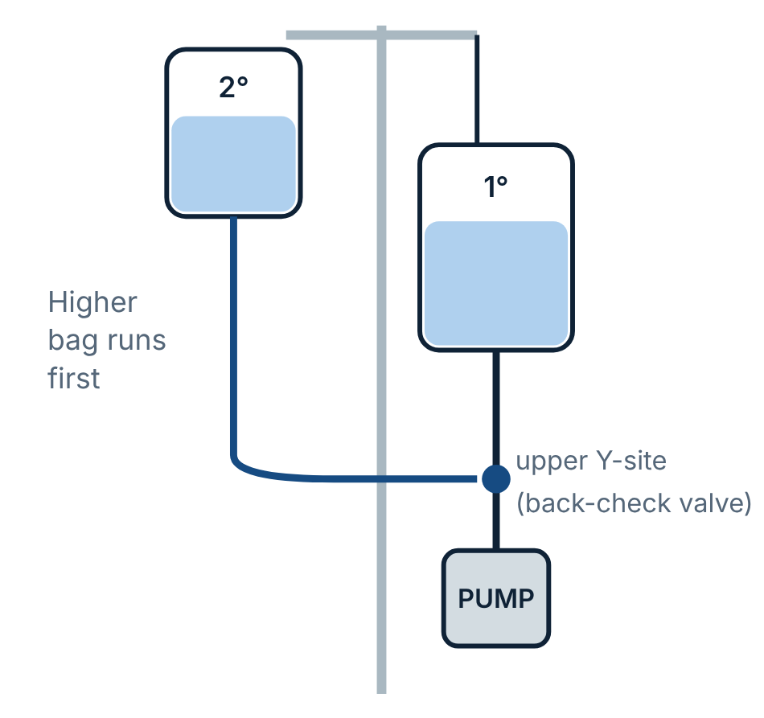
Figure 9.2 The secondary bag must hang higher than the primary.
- Hang the secondary bag higher than the primary; use the extension hook to lower the primary.
- Connect the secondary line to the upper Y-site, above the pump.
- Select Secondary on the pump. Enter the drug, rate and VTBI for the secondary.
- Open the secondary clamp. Watch the secondary drip chamber to confirm it is the one dripping.
- When VTBI is complete the pump returns to the primary rate. Confirm the primary resumed.
COMMON MISS
If the secondary clamp is closed, or the bags are at the same height, the pump runs primary fluid at the secondary rate. Always look at which chamber is dripping.

Alarm troubleshooting
ALARM | LIKELY CAUSE | WHAT TO DO
Downstream occlusion (patient side) | Closed clamp below the pump, kinked line, patient's arm bent, infiltrated or clotted IV | Trace the line to the patient. Open clamps, straighten the arm, check and flush the site (not a vasopressor line).
Upstream occlusion (bag side) | Roller clamp closed above the pump, empty bag, vent closed on a glass bottle, kink | Open the clamp, check the bag and the spike, straighten the tubing.
Air in line | Bubbles from poor priming, empty bag, loose connection | Pause, clamp, remove air per the manufacturer's method, re-prime. Never just silence and restart.
Infusion complete / VTBI reached | Programmed volume delivered; pump is at KVO | Hang a new bag or reprogram if the order continues.
Door open / set not loaded | Set not seated, door not latched | Reload the set in the direction of flow and close the door.
Low battery | Running on battery too long | Plug into AC or the ambulance inverter. Check charge before departure.
Channel paused too long (callback) | Program left on pause | Resume or cancel. Don't leave a drip paused unnoticed.
Dose limit (soft or hard) | Entered dose outside library limits | Re-check the order, units, weight and concentration. Soft limits allow an override only after verification.

Pumps on interfacility transports
- Verify on arrival. Match each channel against the transfer orders: drug, concentration, dose, rate, line and port. Record volume infused, then clear it.
- Count the bags. Will each bag and the battery last the trip plus delays? Use Formula 6.2.
- Move one thing at a time. When switching from the hospital's pump to yours, clamp the line before opening any door so nothing free-flows, reprogram, re-verify, then unclamp.
- Stay in scope. Only run and titrate medications your protocols and the transfer orders allow.
- Hand off by reading back. At the receiving facility, read each pump's settings aloud with the receiving clinician.

Practice 9: Infusion pumps
9.1 Define VTBI. If a 250 mL bag is ordered to run 100 mL, what do you set as VTBI? __________ mL

9.2 Explain the difference between a soft limit and a hard limit in a drug library.

9.3 The pump alarms "downstream occlusion" right after the patient bends their elbow. What do you check first?

9.4 You program magnesium as a secondary, but the primary NS chamber is the one dripping. Name two likely causes.

9.5 Norepinephrine 4 mg/250 mL at 6 mcg/min is ordered. The pump in dose mode shows 22.5 mL/hr. Is that correct? Show your check.

9.6 Dopamine 1,600 mcg/mL, 70 kg, 8 mcg/kg/min. The pump shows 21 mL/hr. Correct? __________
9.7 A 1,000 mL bag is hung for a 500 mL bolus. VTBI? __________ mL
9.8 Amiodarone 1.8 mg/mL, order 1 mg/min. The pump shows 3.3 mL/hr. Correct? __________
9.9 Right after you hang a new bag, the pump alarms "upstream occlusion." What do you check?

9.10 You receive epinephrine 4 mcg/mL running at 45 mL/hr. The order is 10 mcg/min. Does it match? __________

CHAPTER TEN
10

Putting it all together
One hundred problems from every chapter, shuffled the way calls come in. Nothing tells you which formula to use; deciding that is part of the skill. Most of the set is drug volumes, drip rates and concentrations, because those are the calculations you will do most often in the field.

Before each problem, ask
- What is being asked for: mL, gtt/min, mL/hr, or a dose?
- Are the units the same? Convert first if not.
- Is it weight-based? Find the kg and check the maximum.
- Does the answer make sense?
TOPIC IN THIS SET | PROBLEMS
Dose & volume | 22
Drip rate (concentration) | 20
Drip rate (volume) | 18
Percent & concentration | 16
Weight-based | 10
Conversions | 6
IV fluids | 4
Infusion pumps | 4

ROUNDING
Use the Chapter 1 rules: volumes over 1 mL to tenths, under 1 mL to hundredths, gtt/min to whole drops, pump rates to tenths. Set a timer: a strong target is 100 problems in 2 hours.

Practice 10: Mixed review (100 problems)
10.1 70 kg adult, 20% TBSA. Parkland 4 mL/kg/%TBSA. Rate for the first 8 hours from injury? __________ mL/hr
10.2 Infuse 500 mL over 3 hours on a pump. __________ mL/hr
10.3 A 60 gtt/mL set is running at 20 gtt/min. What is the rate? __________ mL/hr
10.4 Lidocaine 1 mg/min. Bag 2 g/500 mL, 60 gtt/mL set. __________ gtt/min
10.5 Order: fentanyl 0.075 mg IV. On hand: 50 mcg/mL. How many mL? __________ mL
10.6 Dopamine 400 mg/250 mL at 18 mL/hr, 80 kg patient. Dose? __________ mcg/kg/min
10.7 15 kg child, bradycardic. Atropine 0.02 mg/kg, 0.1 mg/mL. __________ mL
10.8 A 2.75 kg newborn weighs __________ lb
10.9 Push-dose epinephrine 10 mcg/mL, order 50 mcg. __________ mL
10.10 Norepinephrine 4 mg/250 mL is running at 22.5 mL/hr. Dose? __________ mcg/min
10.11 Ordered rate 100 mL/hr on a 15 gtt/mL set. __________ gtt/min
10.12 24 kg child. Fentanyl 1.5 mcg/kg IN, 50 mcg/mL. __________ mL
10.13 165 lb = __________ kg
10.14 Infuse 1,000 mL over 10 hours with a 15 gtt/mL set. __________ gtt/min
10.15 Epinephrine 1 mg/250 mL is running at 30 mL/hr. Dose? __________ mcg/min
10.16 Order: midazolam 5 mg IM. On hand: 5 mg/mL. How many mL? __________ mL
10.17 Order: fentanyl 150 mcg IN. On hand: 100 mcg/2 mL. How many mL? __________ mL
10.18 D25, order 2.5 g. __________ mL
10.19 Infuse 500 mL over 1 hour with a 15 gtt/mL set. __________ gtt/min
10.20 A 500 mL bag is ordered to infuse 250 mL. VTBI? __________ mL
10.21 A 10 gtt/mL set is running at 30 gtt/min. What is the rate? __________ mL/hr
10.22 9 kg infant, hypoglycemic. D10 5 mL/kg. __________ mL (how many grams?)
10.23 Pump in dose mode: dopamine 1,600 mcg/mL, 90 kg, 5 mcg/kg/min. Pump shows 16.9 mL/hr. Correct? __________
10.24 Norepinephrine 10 mcg/min. Bag 4 mg/250 mL. __________ mL/hr
10.25 Order: hydromorphone 750 mcg IV. On hand: 1 mg/mL. How many mL? __________ mL
10.26 Epinephrine 1:10,000, order 0.5 mg IV. __________ mL
10.27 Magnesium 4 g in 100 mL over 30 minutes on a pump. __________ mL/hr
10.28 Order: naloxone 1 mg IV. On hand: 2 mg/2 mL. How many mL? __________ mL
10.29 32 kg child in VF. Amiodarone 5 mg/kg, 50 mg/mL. __________ mL
10.30 Order: ketamine 20 mg IV. On hand: 50 mg/mL. How many mL? __________ mL
10.31 16 kg child, D10 at 0.25 g/kg. __________ mL
10.32 Epinephrine 1:1,000, order 0.3 mg IM. __________ mL
10.33 Norepinephrine 20 mcg/min. Bag 4 mg/250 mL. __________ mL/hr
10.34 35 kg child. Ondansetron 0.15 mg/kg (max 4 mg), 2 mg/mL. __________ mL
10.35 Order: ketorolac 15 mg IV. On hand: 15 mg/mL. How many mL? __________ mL
10.36 16 kg child, second adenosine dose 0.2 mg/kg (max 12 mg), 3 mg/mL. __________ mL
10.37 Lidocaine 2%, 1 mg/kg for a 75 kg patient. __________ mL
10.38 Lidocaine 1%, order 30 mg. __________ mL
10.39 A 15 gtt/mL set is running at 45 gtt/min. What is the rate? __________ mL/hr
10.40 Epinephrine 4 mcg/mL, order 2 mcg/min. Pump shows 60 mL/hr. Correct? __________
10.41 Infuse 250 mL over 1 hour with a 15 gtt/mL set. __________ gtt/min
10.42 0.75 g = __________ mg
10.43 Infuse 100 mL over 30 minutes with a 10 gtt/mL set. __________ gtt/min
10.44 22 kg child, 20 mL/kg bolus. __________ mL
10.45 Order: amiodarone 150 mg IV. On hand: 50 mg/mL. How many mL? __________ mL
10.46 Infuse 1,000 mL over 2 hours with a 15 gtt/mL set. __________ gtt/min
10.47 0.3 mg = __________ mcg
10.48 Order: atropine 0.6 mg IV. On hand: 1 mg/10 mL. How many mL? __________ mL
10.49 Order: midazolam 3 mg IV. On hand: 10 mg/2 mL. How many mL? __________ mL
10.50 Order: haloperidol 2.5 mg IM. On hand: 5 mg/mL. How many mL? __________ mL
10.51 Amiodarone 0.5 mg/min. Bag 450 mg/250 mL. __________ mL/hr
10.52 4,000 mcg = __________ mg
10.53 11 kg child, opioid overdose. Naloxone 0.1 mg/kg (max 2 mg), 1 mg/mL. __________ mL
10.54 Norepinephrine 16 mcg/mL, order 5 mcg/min. Pump shows 18.75 mL/hr. Correct? __________
10.55 D10, order 15 g. __________ mL
10.56 What is the concentration of norepinephrine 8 mg in 250 mL? __________ mcg/mL
10.57 Order: naloxone 0.4 mg IM. On hand: 0.4 mg/mL. How many mL? __________ mL
10.58 How many grams of NaCl are in 250 mL of 0.9% NS? __________ g
10.59 Infuse 250 mL over 2 hours with a 60 gtt/mL set. __________ gtt/min
10.60 Infuse a 250 mL bolus over 20 minutes with a 10 gtt/mL set. __________ gtt/min
10.61 66 lb child, 20 mL/kg NS bolus. __________ mL
10.62 Order: dexamethasone 10 mg IV. On hand: 4 mg/mL. How many mL? __________ mL
10.63 Calcium gluconate 10%, order 2 g. __________ mL
10.64 Order: morphine 5 mg IV. On hand: 10 mg/mL. How many mL? __________ mL
10.65 Dopamine 15 mcg/kg/min, 80 kg. Bag 400 mg/250 mL. __________ mL/hr
10.66 Order: lorazepam 2 mg IV. On hand: 4 mg/mL. How many mL? __________ mL
10.67 Order: epinephrine 1 mg IV. On hand: 1 mg/10 mL. How many mL? __________ mL
10.68 Infuse 500 mL over 4 hours with a 20 gtt/mL set. __________ gtt/min
10.69 Ordered rate 80 mL/hr on a 10 gtt/mL set. __________ gtt/min
10.70 Order: ketamine 200 mg IM. On hand: 100 mg/mL. How many mL? __________ mL
10.71 Which is hypertonic: NS, LR, D10W or 0.45% NaCl? __________
10.72 Magnesium 2 g in 100 mL over 20 minutes, 10 gtt/mL set. __________ gtt/min
10.73 27.5 lb child in cardiac arrest. Epinephrine 0.01 mg/kg, 0.1 mg/mL. __________ mL
10.74 Ordered rate 200 mL/hr on a 20 gtt/mL set. __________ gtt/min
10.75 Dopamine 10 mcg/kg/min, 100 kg. Bag 400 mg/250 mL. __________ mL/hr
10.76 Order: adenosine 6 mg rapid IV. On hand: 6 mg/2 mL. How many mL? __________ mL
10.77 Epinephrine 8 mcg/min. Bag 1 mg/250 mL. __________ mL/hr
10.78 An infusion runs at 125 mL/hr for 90 minutes. How much is infused? __________ mL
10.79 D50, order 12.5 g. __________ mL
10.80 Calcium chloride 10%, order 750 mg. __________ mL
10.81 Order: morphine 2 mg IV. On hand: 4 mg/mL. How many mL? __________ mL
10.82 You dilute 10 mL of D50 to make D10. Total volume? __________ mL
10.83 Order: epinephrine 0.15 mg IM. On hand: 1 mg/mL. How many mL? __________ mL
10.84 Epinephrine 6 mcg/min. Bag 2 mg/500 mL. __________ mL/hr
10.85 104 °F = __________ °C
10.86 Epinephrine 1 mcg/min. Bag 1 mg/250 mL. __________ mL/hr
10.87 Infuse 1,000 mL over 8 hours with a 10 gtt/mL set. __________ gtt/min
10.88 Dopamine 5 mcg/kg/min, 60 kg. Bag 400 mg/250 mL. __________ mL/hr
10.89 What is the concentration of dopamine 800 mg in 500 mL? __________ mcg/mL
10.90 Which IV fluid is hypotonic in the body even though it is isotonic in the bag? __________
10.91 Epinephrine 3 mcg/min. Bag 1 mg/250 mL. __________ mL/hr
10.92 Magnesium sulfate 50%, order 1.5 g. __________ mL
10.93 Infuse 50 mL over 15 minutes with a 10 gtt/mL set. __________ gtt/min
10.94 Norepinephrine 4 mcg/min. Bag 4 mg/250 mL. __________ mL/hr
10.95 Order: fentanyl 25 mcg IV. On hand: 100 mcg/2 mL. How many mL? __________ mL
10.96 Order: ondansetron 8 mg IV. On hand: 4 mg/2 mL. How many mL? __________ mL
10.97 Sodium bicarbonate 8.4%, order 50 mEq. __________ mL
10.98 Sodium bicarbonate 4.2% (0.5 mEq/mL), 1 mEq/kg for an 8 kg infant. __________ mL
10.99 85 kg adult. Ketamine 0.3 mg/kg IV, 50 mg/mL. __________ mL
10.100 Lidocaine 4 mg/min. Bag 2 g/500 mL, 60 gtt/mL set. __________ gtt/min

REFERENCE
11

Formula reference card
Every formula in this workbook on one page. Copy it into your field guide.
METRIC  kg ↔ g ↔ mg ↔ mcg: × or ÷ 1,000  1 L = 1,000 mL | WEIGHT  kg = lb ÷ 2.2  lb = kg × 2.2
DOSE TO VOLUME  mL = (D ÷ H) × Q  mL = dose ÷ (amount per mL) | WEIGHT-BASED DOSE  dose = dose/kg × kg  then check the max dose
GRAVITY DRIP  gtt/min = mL × gtt/mL ÷ min  gtt/min = mL/hr ÷ (60 ÷ gtt/mL) | PUMP RATE (VOLUME)  mL/hr = mL ÷ hr  time (hr) = mL ÷ mL/hr
CONCENTRATION  conc = drug in bag ÷ mL in bag | MEDICATION INFUSION  mL/hr = dose/min × 60 ÷ conc  gtt/min = dose/min × gtt/mL ÷ conc
DOSE FROM RATE  dose/min = mL/hr × conc ÷ 60 | WEIGHT-BASED INFUSION  mL/hr = mcg/kg/min × kg × 60 ÷ conc
PERCENT  X% = X g / 100 mL  mg/mL = % × 10 | RATIO AND DILUTION  1:1,000 = 1 mg/mL · 1:10,000 = 0.1 mg/mL  C₁V₁ = C₂V₂
FLUIDS  Peds bolus 20 mL/kg  Burns 2–4 mL × kg × %TBSA / 24 h | TEMPERATURE  °C = (°F − 32) ÷ 1.8  °F = °C × 1.8 + 32

ANSWER KEY
12

Worked solutions
Try every problem before you check. If your answer differs, find the step where it went wrong. That step is what to practice.

Practice 1 · Safety foundations
1.1 Add a leading zero: 0.25 mg
1.2 Drop the trailing zero: 2 mg
1.3 Write out micrograms: 50 mcg
1.4 Write out units: 10 units
1.5 Over 1 mL → tenths: 1.5 mL
1.6 Under 1 mL → hundredths: 0.33 mL
1.7 Whole drops: 63 gtt/min
1.8 25 mL × 50 mcg/mL = 1,250 mcg, far above any single dose. Implausible: stop and recalculate
1.9 Any three: patient, medication, dose, route, time, documentation, reason, response, right to refuse.

Practice 2 · Conversions
2.1 0.4 × 1,000 = 400 mcg
2.2 2,500 ÷ 1,000 = 2.5 mg
2.3 198 ÷ 2.2 = 90 kg
2.4 1.2 × 1,000 = 1,200 mL
2.5 3.5 × 2.2 = 7.7 lb
2.6 0.025 × 1,000 = 25 mg
2.7 39.5 × 1.8 = 71.1; + 32 = 103.1 °F
2.8 90 ÷ 60 = 1.5 mL/min
2.9 0.15 × 1,000 = 150 mcg
2.10 750 ÷ 1,000 = 0.75 g
2.11 18 × 2.2 = 39.6 lb
2.12 (101.3 − 32) ÷ 1.8 = 69.3 ÷ 1.8 = 38.5 °C
2.13 2.5 × 1,000 = 2,500 mL
2.14 0.08 × 1,000 = 80 mcg
2.15 143 ÷ 2.2 = 65 kg

Practice 3 · IV fluids
3.1 0.9% NS. LR contains calcium, which binds the citrate anticoagulant in stored blood and can cause clotting in the line.
3.2 The dextrose is taken up and metabolized, leaving free water that moves into cells.
3.3 Isotonic · hypotonic · hypertonic
3.4 20 × 25 = 500 mL
3.5 Hypotonic fluids (D5W, 0.45% NaCl): free water shifts into brain cells and worsens cerebral edema. Many protocols also prefer NS over LR.
3.6 4 × 60 × 40 = 9,600 mL; half = 4,800 mL over 8 h = 600 mL/hr
3.7 About 1/4: ≈ 250 mL
3.8 20 × 30 = 600 mL
3.9 10 × 3.2 = 32 mL
3.10 2 × 90 × 25 = 4,500 mL; half = 2,250 ÷ 8 = 281.25 → 281 mL/hr
3.11 D10 = 10 g/100 mL → 10 g
3.12 About 1/4 of 2,000 → ≈ 500 mL
3.13 0.9% NS. LR's calcium binds the citrate in stored blood and can clot the line.

Practice 4 · Dose and volume
4.1 25 ÷ 50 × 1 = 0.5 mL
4.2 12 ÷ 6 × 2 = 4 mL
4.3 150 ÷ 150 × 3 = 3 mL
4.4 50 ÷ 100 × 2 = 1 mL
4.5 2 ÷ 5 × 1 = 0.4 mL
4.6 0.5 ÷ 0.4 × 1 = 1.25 mL (1.3 mL on a 3 mL syringe)
4.7 15 ÷ 30 × 1 = 0.5 mL
4.8 0.5 ÷ 1 × 1 = 0.5 mL
4.9 4 ÷ 2 = 2 mL
4.10 500 mcg = 0.5 mg; 0.5 ÷ 2 = 0.25 mL
4.11 100 ÷ 50 × 1 = 2 mL
4.12 6 ÷ 10 × 1 = 0.6 mL
4.13 25 ÷ 50 × 1 = 0.5 mL
4.14 0.5 ÷ 1 × 10 = 5 mL
4.15 125 ÷ 125 × 2 = 2 mL
4.16 10 ÷ 15 × 1 = 0.667 → 0.67 mL
4.17 5 ÷ 5 × 1 = 1 mL
4.18 1 ÷ 2 × 1 = 0.5 mL
4.19 0.4 ÷ 2 × 2 = 0.4 mL
4.20 0.075 mg = 75 mcg; 75 ÷ 50 × 1 = 1.5 mL

Practice 5 · Weight-based
5.1 70 kg → 70 mcg; 50 mcg/mL → 1.4 mL
5.2 15 kg × 0.01 = 0.15 mg; ÷ 0.1 = 1.5 mL
5.3 5 × 20 = 100 mg; 50 mg/mL → 2 mL
5.4 0.5 × 12 = 6 g; ÷ 0.1 g/mL = 60 mL
5.5 0.02 × 8 = 0.16 mg; ÷ 0.1 = 1.6 mL
5.6 20 × 18 = 360 mL
5.7 220 ÷ 2.2 = 100 kg × 0.3 = 30 mg; ÷ 50 = 0.6 mL
5.8 0.1 × 14 = 1.4 mg (under 6 mg max); 3 mg/mL → 0.47 mL
5.9 88 ÷ 2.2 = 40 kg → 40 mcg; 40 ÷ 50 = 0.8 mL
5.10 0.15 × 25 = 3.75 mg (under max) → 3.75 mg; 3.75 ÷ 2 = 1.875 → 1.9 mL
5.11 5 × 6 = 30 mL; 30 × 0.1 = 3 g
5.12 5 × 40 = 200 mg; 200 ÷ 50 = 4 mL
5.13 22 ÷ 2.2 = 10 kg → 0.1 mg; ÷ 0.1 = 1 mL
5.14 0.1 × 50 = 5 mg; 5 ÷ 3 = 1.67 → 1.7 mL
5.15 132 ÷ 2.2 = 60 kg → 30 mg; 30 ÷ 100 = 0.3 mL
5.16 0.2 × 18 = 3.6 mg; 3.6 ÷ 5 = 0.72 mL

Practice 6 · Volume drip rates
6.1 (1,000 × 15) ÷ 240 = 62.5 → 63 gtt/min; 1,000 ÷ 4 = 250 mL/hr
6.2 (500 × 10) ÷ 60 = 83.3 → 83 gtt/min
6.3 (100 × 10) ÷ 20 = 50 gtt/min
6.4 Microdrip: gtt/min = mL/hr → 30 gtt/min
6.5 (250 × 10) ÷ 15 = 166.7 → 167 gtt/min. Too fast to count: use a pump or run wide open and watch the bag.
6.6 25 gtt/min ÷ 20 gtt/mL = 1.25 mL/min × 60 = 75 mL/hr
6.7 (500 × 15) ÷ 120 = 62.5 → 63 gtt/min
6.8 (1,000 × 20) ÷ 360 = 55.6 → 56 gtt/min; 1,000 ÷ 6 = 166.7 → 167 mL/hr
6.9 150 ÷ 6 = 25 gtt/min
6.10 75 ÷ 4 = 18.75 → 19 gtt/min
6.11 (100 × 20) ÷ 30 = 66.7 → 67 gtt/min
6.12 40 ÷ 15 = 2.67 mL/min × 60 = 160 mL/hr
6.13 (250 × 60) ÷ 60 = 250 gtt/min: too fast to count. Use a macrodrip set (10 gtt/mL → 42 gtt/min) or a pump.

Practice 7 · Concentration infusions
7.1 16 mcg/mL; 12 ÷ 16 = 0.75 mL/min × 60 = 45 gtt/min
7.2 10 × 70 = 700 mcg/min ÷ 1,600 = 0.4375 mL/min × 60 = 26.3 mL/hr
7.3 4 mcg/mL; 5 ÷ 4 = 1.25 mL/min × 60 = 75 mL/hr
7.4 (50 × 10) ÷ 15 = 33.3 → 33 gtt/min; 50 ÷ 0.25 hr = 200 mL/hr
7.5 4 mg/mL; 3 ÷ 4 = 0.75 mL/min × 60 = 45 gtt/min
7.6 15 × 16 ÷ 60 = 4 mcg/min
7.7 1.8 mg/mL; 1 ÷ 1.8 = 0.556 mL/min × 60 = 33.3 mL/hr
7.8 30 × 1,600 ÷ 60 = 800 mcg/min ÷ 75 kg = 10.7 mcg/kg/min
7.9 16 mcg/mL; 2 ÷ 16 × 60 = 7.5 mL/hr
7.10 4 mcg/mL; 10 ÷ 4 × 60 = 150 mL/hr
7.11 450 mcg/min ÷ 1,600 × 60 = 16.875 → 16.9 mL/hr
7.12 800,000 ÷ 500 = 1,600 mcg/mL; 900 ÷ 1,600 × 60 = 33.75 → 33.8 mL/hr
7.13 1,000 mg ÷ 250 = 4 mg/mL; 2 ÷ 4 × 60 = 30 gtt/min
7.14 2,000 ÷ 250 = 8 mcg/mL; 4 ÷ 8 × 60 = 30 mL/hr
7.15 32 mcg/mL; 30 × 32 ÷ 60 = 16 mcg/min
7.16 (100 × 15) ÷ 20 = 75 gtt/min; 100 ÷ (20/60) = 300 mL/hr
7.17 45 × 1,600 ÷ 60 = 1,200 mcg/min ÷ 80 = 15 mcg/kg/min

Practice 8 · Percent and ratio
8.1 20 mg/mL; 1.5 × 60 = 90 mg ÷ 20 = 4.5 mL
8.2 500 mg/mL; 2,000 ÷ 500 = 4 mL
8.3 250 × 0.1 = 25 g
8.4 100 mg/mL; 500 ÷ 100 = 5 mL
8.5 70 mEq at 1 mEq/mL = 70 mL
8.6 50% × 25 = 10% × V₂ → V₂ = 125 mL: 100 mL diluent · 125 mL total (12.5 g)
8.7 1 mg/mL → 0.5 mL
8.8 0.9 g/100 mL × 5 = 4.5 g
8.9 20 ÷ 10 = 2 mL
8.10 10 mg/mL; 50 ÷ 10 = 5 mL
8.11 0.5 × 10 = 5 g; D25 = 0.25 g/mL → 20 mL
8.12 100 mg/mL; 1,000 ÷ 100 = 10 mL
8.13 12.5 ÷ 0.5 = 25 mL
8.14 4,000 ÷ 500 = 8 mL
8.15 0.3 ÷ 0.1 = 3 mL
8.16 5 g/100 mL × 10 = 50 g
8.17 50% × V₁ = 25% × 50 → V₁ = 25: 25 mL D50 + 25 mL diluent

Practice 9 · Infusion pumps
9.1 The volume the pump will deliver before stopping or going to KVO. 100 mL
9.2 Soft limit: a warning you may override after verifying. Hard limit: the pump refuses the entry.
9.3 The patient side: straighten the arm, look for a closed clamp or kink, then check the IV site for infiltration.
9.4 Secondary clamp closed; secondary bag not hung higher than the primary (also: connected below the pump).
9.5 6 ÷ 16 = 0.375 mL/min × 60 = 22.5 mL/hr: correct
9.6 8 × 70 × 60 ÷ 1,600 = 21 → Correct
9.7 Volume ordered, not the bag: 500 mL
9.8 1 ÷ 1.8 × 60 = 33.3 mL/hr. Incorrect: decimal error, 10× too slow. Reprogram.
9.9 The bag side: roller clamp above the pump, spike fully seated, tubing kinked above the pump.
9.10 45 × 4 ÷ 60 = 3 mcg/min. No: 3 mcg/min running; 10 mcg/min needs 150 mL/hr. Clarify before transport.

Practice 10 · Putting it all together
10.1 4 × 70 × 20 = 5,600; half = 2,800 ÷ 8 = 350 mL/hr [IV fluids]
10.2 500 ÷ 3 = 166.67 → 166.7 mL/hr [Drip rate (volume)]
10.3 20 ÷ 60 = 0.33 mL/min × 60 = 20 mL/hr [Drip rate (volume)]
10.4 4 mg/mL; 1 ÷ 4 × 60 = 15 gtt/min [Drip rate (concentration)]
10.5 0.075 mg = 75 mcg; 75 ÷ 50 × 1 = 1.5 mL [Dose & volume]
10.6 18 × 1,600 ÷ 60 = 480 mcg/min ÷ 80 = 6 mcg/kg/min [Drip rate (concentration)]
10.7 0.02 × 15 = 0.3 mg ÷ 0.1 = 3 mL [Weight-based]
10.8 2.75 × 2.2 = 6.05 → 6.1 lb [Conversions]
10.9 50 ÷ 10 = 5 mL [Percent & concentration]
10.10 22.5 × 16 ÷ 60 = 6 mcg/min [Drip rate (concentration)]
10.11 100 ÷ 4 = 25 gtt/min [Drip rate (volume)]
10.12 1.5 × 24 = 36 mcg ÷ 50 = 0.72 mL [Weight-based]
10.13 165 ÷ 2.2 = 75 kg [Conversions]
10.14 (1,000 × 15) ÷ 600 = 25 gtt/min [Drip rate (volume)]
10.15 30 × 4 ÷ 60 = 2 mcg/min [Drip rate (concentration)]
10.16 5 ÷ 5 × 1 = 1 mL [Dose & volume]
10.17 150 ÷ 100 × 2 = 3 mL [Dose & volume]
10.18 0.25 g/mL; 2.5 ÷ 0.25 = 10 mL [Percent & concentration]
10.19 (500 × 15) ÷ 60 = 125 gtt/min [Drip rate (volume)]
10.20 250 mL [Infusion pumps]
10.21 30 ÷ 10 = 3 mL/min × 60 = 180 mL/hr [Drip rate (volume)]
10.22 5 × 9 = 45 mL = 4.5 g [Weight-based]
10.23 5 × 90 × 60 ÷ 1,600 = 16.875 → Correct [Infusion pumps]
10.24 16 mcg/mL; 10 ÷ 16 × 60 = 37.5 mL/hr [Drip rate (concentration)]
10.25 750 mcg = 0.75 mg; 0.75 ÷ 1 × 1 = 0.75 mL [Dose & volume]
10.26 0.1 mg/mL; 0.5 ÷ 0.1 = 5 mL [Percent & concentration]
10.27 100 ÷ 0.5 hr = 200 mL/hr [Drip rate (concentration)]
10.28 1 ÷ 2 × 2 = 1 mL [Dose & volume]
10.29 5 × 32 = 160 mg ÷ 50 = 3.2 mL [Weight-based]
10.30 20 ÷ 50 × 1 = 0.4 mL [Dose & volume]
10.31 0.25 × 16 = 4 g ÷ 0.1 = 40 mL [Percent & concentration]
10.32 1 mg/mL → 0.3 mL [Percent & concentration]
10.33 16 mcg/mL; 20 ÷ 16 × 60 = 75 mL/hr [Drip rate (concentration)]
10.34 0.15 × 35 = 5.25 mg → over max, give 4 mg ÷ 2 = 2 mL [Weight-based]
10.35 15 ÷ 15 × 1 = 1 mL [Dose & volume]
10.36 0.2 × 16 = 3.2 mg ÷ 3 = 1.07 → 1.1 mL [Weight-based]
10.37 20 mg/mL; 75 mg ÷ 20 = 3.75 → 3.8 mL [Percent & concentration]
10.38 10 mg/mL; 30 ÷ 10 = 3 mL [Percent & concentration]
10.39 45 ÷ 15 = 3 mL/min × 60 = 180 mL/hr [Drip rate (volume)]
10.40 2 ÷ 4 × 60 = 30 mL/hr. Incorrect: double the dose. Stop and reprogram. [Infusion pumps]
10.41 (250 × 15) ÷ 60 = 62.5 → 63 gtt/min [Drip rate (volume)]
10.42 0.75 × 1,000 = 750 mg [Conversions]
10.43 (100 × 10) ÷ 30 = 33.3 → 33 gtt/min [Drip rate (volume)]
10.44 20 × 22 = 440 mL [IV fluids]
10.45 150 ÷ 50 × 1 = 3 mL [Dose & volume]
10.46 (1,000 × 15) ÷ 120 = 125 gtt/min [Drip rate (volume)]
10.47 0.3 × 1,000 = 300 mcg [Conversions]
10.48 0.6 ÷ 1 × 10 = 6 mL [Dose & volume]
10.49 3 ÷ 10 × 2 = 0.6 mL [Dose & volume]
10.50 2.5 ÷ 5 × 1 = 0.5 mL [Dose & volume]
10.51 1.8 mg/mL; 0.5 ÷ 1.8 × 60 = 16.67 → 16.7 mL/hr [Drip rate (concentration)]
10.52 4,000 ÷ 1,000 = 4 mg [Conversions]
10.53 0.1 × 11 = 1.1 mg ÷ 1 = 1.1 mL [Weight-based]
10.54 5 ÷ 16 × 60 = 18.75 → Correct [Infusion pumps]
10.55 0.1 g/mL; 15 ÷ 0.1 = 150 mL [Percent & concentration]
10.56 8,000 mcg ÷ 250 = 32 mcg/mL [Drip rate (concentration)]
10.57 0.4 ÷ 0.4 × 1 = 1 mL [Dose & volume]
10.58 0.9 × 2.5 = 2.25 g [Percent & concentration]
10.59 (250 × 60) ÷ 120 = 125 gtt/min [Drip rate (volume)]
10.60 (250 × 10) ÷ 20 = 125 gtt/min [Drip rate (volume)]
10.61 66 ÷ 2.2 = 30 kg × 20 = 600 mL [Weight-based]
10.62 10 ÷ 4 × 1 = 2.5 mL [Dose & volume]
10.63 100 mg/mL; 2,000 ÷ 100 = 20 mL [Percent & concentration]
10.64 5 ÷ 10 × 1 = 0.5 mL [Dose & volume]
10.65 15 × 80 = 1,200 mcg/min ÷ 1,600 × 60 = 45 mL/hr [Drip rate (concentration)]
10.66 2 ÷ 4 × 1 = 0.5 mL [Dose & volume]
10.67 1 ÷ 1 × 10 = 10 mL [Dose & volume]
10.68 (500 × 20) ÷ 240 = 41.7 → 42 gtt/min [Drip rate (volume)]
10.69 80 ÷ 6 = 13.3 → 13 gtt/min [Drip rate (volume)]
10.70 200 ÷ 100 × 1 = 2 mL [Dose & volume]
10.71 D10W (505 mOsm/L) [IV fluids]
10.72 (100 × 10) ÷ 20 = 50 gtt/min [Drip rate (concentration)]
10.73 27.5 ÷ 2.2 = 12.5 kg × 0.01 = 0.125 mg ÷ 0.1 = 1.25 → 1.3 mL [Weight-based]
10.74 200 ÷ 3 = 66.7 → 67 gtt/min [Drip rate (volume)]
10.75 10 × 100 = 1,000 mcg/min ÷ 1,600 × 60 = 37.5 mL/hr [Drip rate (concentration)]
10.76 6 ÷ 6 × 2 = 2 mL [Dose & volume]
10.77 4 mcg/mL; 8 ÷ 4 × 60 = 120 mL/hr [Drip rate (concentration)]
10.78 125 × 1.5 = 187.5 mL [Drip rate (volume)]
10.79 0.5 g/mL; 12.5 ÷ 0.5 = 25 mL [Percent & concentration]
10.80 100 mg/mL; 750 ÷ 100 = 7.5 mL [Percent & concentration]
10.81 2 ÷ 4 × 1 = 0.5 mL [Dose & volume]
10.82 50% × 10 = 10% × V₂ → 50 mL total (add 40 mL) [Percent & concentration]
10.83 0.15 ÷ 1 × 1 = 0.15 mL [Dose & volume]
10.84 4 mcg/mL; 6 ÷ 4 × 60 = 90 mL/hr [Drip rate (concentration)]
10.85 (104 − 32) ÷ 1.8 = 40 °C [Conversions]
10.86 4 mcg/mL; 1 ÷ 4 × 60 = 15 mL/hr [Drip rate (concentration)]
10.87 (1,000 × 10) ÷ 480 = 20.8 → 21 gtt/min [Drip rate (volume)]
10.88 5 × 60 = 300 mcg/min ÷ 1,600 × 60 = 11.25 → 11.3 mL/hr [Drip rate (concentration)]
10.89 800,000 mcg ÷ 500 = 1,600 mcg/mL [Drip rate (concentration)]
10.90 D5W: the dextrose is metabolized, leaving free water. [IV fluids]
10.91 4 mcg/mL; 3 ÷ 4 × 60 = 45 mL/hr [Drip rate (concentration)]
10.92 500 mg/mL; 1,500 ÷ 500 = 3 mL [Percent & concentration]
10.93 (50 × 10) ÷ 15 = 33.3 → 33 gtt/min [Drip rate (volume)]
10.94 16 mcg/mL; 4 ÷ 16 × 60 = 15 mL/hr [Drip rate (concentration)]
10.95 25 ÷ 100 × 2 = 0.5 mL [Dose & volume]
10.96 8 ÷ 4 × 2 = 4 mL [Dose & volume]
10.97 1 mEq/mL → 50 mL [Percent & concentration]
10.98 8 mEq ÷ 0.5 = 16 mL [Percent & concentration]
10.99 0.3 × 85 = 25.5 mg ÷ 50 = 0.51 mL [Weight-based]
10.100 4 mg/mL; 4 ÷ 4 × 60 = 60 gtt/min [Drip rate (concentration)]
This workbook is an educational resource for paramedic students. Drug concentrations, doses and fluid volumes are examples that reflect common EMS practice and current resuscitation guidance at the time of writing; they are not orders. Always follow your local protocols, your medical director, the product labeling, and manufacturer instructions for your equipment.

MEDICAL MATH WORKBOOK FOR PARAMEDIC STUDENTS
Drug math you can trust on every call.
This workbook takes students from metric conversions to vasopressor infusions, one step at a time. Every concept comes with its formula, a worked example and practice problems with room to show your work.
- IV fluids in the paramedic scope: tonicity, compartments and when to use each bag
- Dose and volume: how much to draw up, three ways to solve it
- Weight-based and pediatric dosing with maximum-dose checks
- Gravity and pump drip rates, by volume and by concentration
- Percent, ratio and dilution problems: D50, lidocaine, magnesium, push-dose epinephrine
- Infusion pump programming, secondary infusions and alarm troubleshooting
- A 100-problem mixed review and a complete worked answer key
Always follow local protocols and medical direction.

