ИТМО

Отчет
Дисциплина «Методы оптимизации»
Вариант №14

Выполнил:
Рахматов Нематджон
P3233

Поток: 4.4
Преподаватель: Кудашев Вячеслав Николаевич

Санкт-Петербург
2024

Вариант 14
f(x)=x² + x + sinx [a,b]=[-1,0]
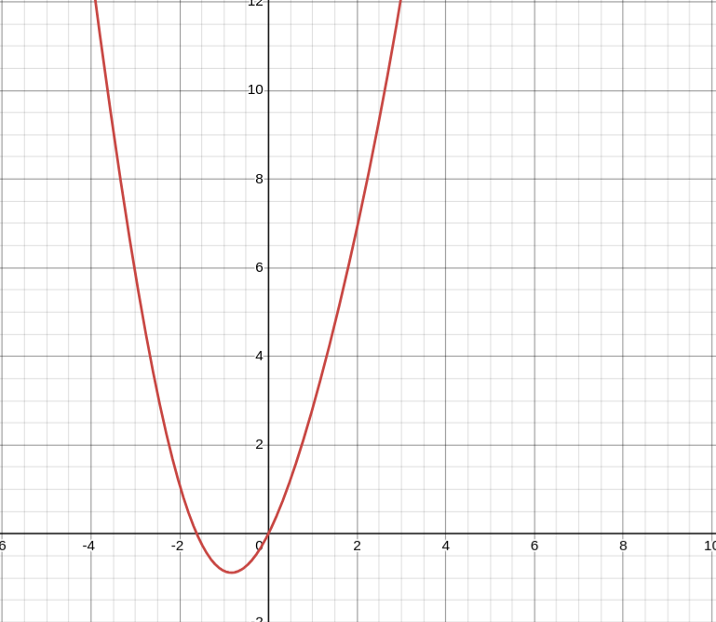

Метод Половинного деления

import math
def func(x):
return math.pow(x, 2) + x + math.sin(x)
def bisection_method(a, b):
count = 0
f_a = func(a)
f_b = func(b)
while (abs(b - a) > epsilon) and (count < iterations):
x0 = (a + b) / 2
f_xm = func(x0)
if f_a * f_xm <= 0:
b = x0
else:
a = x0
count += 1
x = (a + b) / 2
print('шаг', count, ':', 'x =', x, ' ', 'f(x) =', func(x))
a = -1
b = 0
epsilon = 10 ** -10
iterations = 25
bisection_method(a, b)

Ответ:
шаг 1 : x = -0.25 f(x) = -0.43490395925452296 a = -0.5 b = 0
шаг 2 : x = -0.125 f(x) = -0.2340497333852277 a = -0.25 b = 0
шаг 3 : x = -0.0625 f(x) = -0.12105306784238021 a = -0.125 b = 0
шаг 4 : x = -0.03125 f(x) = -0.061518351485326084 a = -0.0625 b = 0
шаг 5 : x = -0.015625 f(x) = -0.03100522359988337 a = -0.03125 b = 0
шаг 6 : x = -0.0078125 f(x) = -0.015563885371132832 a = -0.015625 b = 0
шаг 7 : x = -0.00390625 f(x) = -0.007797231276837617 a = -0.0078125 b = 0
шаг 8 : x = -0.001953125 f(x) = -0.0039024340609711793 a = -0.00390625 b = 0
шаг 9 : x = -0.0009765625 f(x) = -0.0019521711704631722 a = -0.001953125 b = 0
шаг 10 : x = -0.00048828125 f(x) = -0.0009763240620183451 a = -0.0009765625 b = 0
шаг 11 : x = -0.000244140625 f(x) = -0.00048822164292990544 a = -0.00048828125 b = 0
шаг 12 : x = -0.0001220703125 f(x) = -0.00024412572353564127 a = -0.000244140625 b = 0
шаг 13 : x = -6.103515625e-05 f(x) = -0.00012206658717180593 a = -0.0001220703125 b = 0
шаг 14 : x = -3.0517578125e-05 f(x) = -6.103422492268844e-05 a = -6.103515625e-05 b = 0
шаг 15 : x = -1.52587890625e-05 f(x) = -3.051734529376423e-05 a = -3.0517578125e-05 b = 0
шаг 16 : x = -7.62939453125e-06 f(x) = -1.5258730854765073e-05 a = -1.52587890625e-05 b = 0
шаг 17 : x = -3.814697265625e-06 f(x) = -7.62937997932552e-06 a = -7.62939453125e-06 b = 0
шаг 18 : x = -1.9073486328125e-06 f(x) = -3.8146936276450367e-06 a = -3.814697265625e-06 b = 0
шаг 19 : x = -9.5367431640625e-07 f(x) = -1.9073477233176538e-06 a = -1.9073486328125e-06 b = 0
шаг 20 : x = -4.76837158203125e-07 f(x) = -9.536740890325566e-07 a = -9.5367431640625e-07 b = 0
шаг 21 : x = -2.384185791015625e-07 f(x) = -4.768371013597039e-07 a = -4.76837158203125e-07 b = 0
шаг 22 : x = -1.1920928955078125e-07 f(x) = -2.3841856489070752e-07 a = -2.384185791015625e-07 b = 0
шаг 23 : x = -5.960464477539063e-08 f(x) = -1.1920928599806754e-07 a = -1.1920928955078125e-07 b = 0
шаг 24 : x = -2.9802322387695312e-08 f(x) = -5.9604643887212205e-08 a = -5.960464477539063e-08 b = 0
шаг 25 : x = -1.4901161193847656e-08 f(x) = -2.9802322165650708e-08 a = -2.9802322387695312e-08 b = 0

Метод Золотого Сечения
import math
def func(x):
return math.pow(x, 2) + x + math.sin(x)
def golden_section_method(a, b, eps):
cgs = (3 - 5 ** 0.5) / 2
x1 = a + cgs * (b - a)
x2 = b - cgs * (b - a)
f1 = func(x1)
f2 = func(x2)
count = 0
while (abs(b - a) > eps) and (count < iterations):
count += 1
if f1 < f2:
b = x2
x2 = x1
f2 = f1
x1 = a + cgs * (b - a)
f1 = func(x1)
else:
a = x1
x1 = x2
f1 = f2
x2 = b - cgs * (b - a)
f2 = func(x2)
x = (a + b) / 2
print('шаг', count, ':', 'x = ', x, ' ', 'f(x) =', func(x))
a = -1
b = 0
epsilon = math.pow(10, -10)
iterations = 25
golden_section_method(a, b, epsilon)

Ответ:
шаг 1 : x = -0.6909830056250525 f(x) = -0.8508205052903988 a = -1 b = -0.3819660112501051
шаг 2 : x = -0.8090169943749475 f(x) = -0.8781175408893749 a = -1 b = -0.6180339887498949
шаг 3 : x = -0.8819660112501051 f(x) = -0.8760920011296426 a = -1 b = -0.7639320225002103
шаг 4 : x = -0.8368810393753681 f(x) = -0.8790688764735786 a = -0.9098300562505258 b = -0.7639320225002103
шаг 5 : x = -0.8090169943749475 f(x) = -0.8781175408893749 a = -0.8541019662496846 b = -0.7639320225002103
шаг 6 : x = -0.826237921249264 f(x) = -0.8789560380291341 a = -0.8541019662496846 b = -0.7983738762488434
шаг 7 : x = -0.8368810393753681 f(x) = -0.8790688764735786 a = -0.8541019662496846 b = -0.8196601125010515
шаг 8 : x = -0.8303032306271556 f(x) = -0.8790357560181126 a = -0.8409463487532598 b = -0.8196601125010515
шаг 9 : x = -0.8343685400050473 f(x) = -0.8790702215615371 a = -0.8409463487532598 b = -0.8277907312568349
шаг 10 : x = -0.8368810393753681 f(x) = -0.8790688764735786 a = -0.8409463487532598 b = -0.8328157299974764
шаг 11 : x = -0.8353282293677973 f(x) = -0.8790717506074536 a = -0.837840728738118 b = -0.8328157299974764
шаг 12 : x = -0.836287918730547 f(x) = -0.8790707547064058 a = -0.837840728738118 b = -0.8347351087229761
шаг 13 : x = -0.8356947980857259 f(x) = -0.8790716682689055 a = -0.8366544874484757 b = -0.8347351087229761
шаг 14 : x = -0.8353282293677972 f(x) = -0.8790717506074536 a = -0.8359213500126182 b = -0.8347351087229761
шаг 15 : x = -0.8355547812946895 f(x) = -0.8790717432034639 a = -0.8359213500126182 b = -0.8351882125767609
шаг 16 : x = -0.8354147645036534 f(x) = -0.8790717643884239 a = -0.8356413164305457 b = -0.8351882125767609
шаг 17 : x = -0.8355012996395095 f(x) = -0.8790717576395779 a = -0.8356413164305457 b = -0.8353612828484731
шаг 18 : x = -0.8354478179843292 f(x) = -0.8790717642338339 a = -0.8355343531201854 b = -0.8353612828484731
шаг 19 : x = -0.8354147645036534 f(x) = -0.8790717643884239 a = -0.8354682461588335 b = -0.8353612828484731
шаг 20 : x = -0.8354351926781576 f(x) = -0.879071764646426 a = -0.8354682461588335 b = -0.8354021391974816
шаг 21 : x = -0.8354225673719858 f(x) = -0.8790717646220134 a = -0.83544299554649 b = -0.8354021391974816
шаг 22 : x = -0.8354303702403183 f(x) = -0.8790717646886825 a = -0.83544299554649 b = -0.8354177449341467
шаг 23 : x = -0.8354255478024791 f(x) = -0.8790717646671811 a = -0.8354333506708116 b = -0.8354177449341467
шаг 24 : x = -0.8354285282329723 f(x) = -0.8790717646879954 a = -0.8354333506708116 b = -0.8354237057951331
шаг 25 : x = -0.8354303702403183 f(x) = -0.8790717646886825 a = -0.8354333506708116 b = -0.835427389809825

Метод Ньютона
import math
def func(x):
return math.pow(x, 2) + x + math.sin(x)
def derivative(x):
return 2 * x - math.pow(math.e, -x)
delta = 1
epsilon = math.pow(10, -10)
x0 = 1
iterations = 0
while delta > epsilon:
iterations += 1
x = x0 - func(x0) / derivative(x0)
delta = abs(x - x0)
print('шаг', iterations, ':', 'x =', x, ' ','f(x) =', func(x))
x0 = x
if iterations > 24:
break
Ответ:
шаг 1 : x = -0.7409688086077055 f(x) = -0.8669370630506679
шаг 2 : x = -0.9831364475565635 f(x) = -0.848819527751836
шаг 3 : x = -1.1661072128207577 f(x) = -0.725526028702811
шаг 4 : x = -1.2970286773806716 f(x) = -0.5775043951914853
шаг 5 : x = -1.3893929146218202 f(x) = -0.44257171513616445
шаг 6 : x = -1.454561333019755 f(x) = -0.3320649768403561
шаг 7 : x = -1.5007345224409208 f(x) = -0.2460770911705178
шаг 8 : x = -1.5336041804072746 f(x) = -0.18097085008932434
шаг 9 : x = -1.557100602286785 f(x) = -0.13244453167598869
шаг 10 : x = -1.5739526709571043 f(x) = -0.09662067929400198
шаг 11 : x = -1.5860702587032036 f(x) = -0.07033474893010339
шаг 12 : x = -1.5948002754726354 f(x) = -0.05112427588181434
шаг 13 : x = -1.6010987379211983 f(x) = -0.03712248641880089
шаг 14 : x = -1.6056476859591755 f(x) = -0.026935947383459058
шаг 15 : x = -1.6089356129139658 f(x) = -0.019534591995521766
шаг 16 : x = -1.6113134260764035 f(x) = -0.014161763639361724
шаг 17 : x = -1.6130337541737148 f(x) = -0.010263994536997445
шаг 18 : x = -1.6142787682542599 f(x) = -0.007437614202098208
шаг 19 : x = -1.6151799891406988 f(x) = -0.005388798757228197
шаг 20 : x = -1.615832452993939 f(x) = -0.00390398191113539
шаг 21 : x = -1.6163048761203174 f(x) = -0.0028280882216983327
шаг 22 : x = -1.616646967176648 f(x) = -0.0020485942200126894
шаг 23 : x = -1.6168946970017761 f(x) = -0.0014838940897377029
шаг 24 : x = -1.617074101660871 f(x) = -0.0010748262695403632
шаг 25 : x = -1.6172040296728143 f(x) = -0.000778511888895772

