Personalized Fashion Recommendation from User Ratings Fashion Combinations with CNN Learning Approach

Eren Acarer Saitcan Yıldırım Aybüke Aydemir

Izmir Democracy University Izmir Democracy University Izmir Democracy University erenacarerr@icloud.com tunaycan@hotmail.com [melifay9808@gmail.com](mailto:melifay9808@gmail.com)

2006102013 2106102018 2006102042

# ABSTRACT

# The need for precise and customized fashion recommendations has increased in response to the growing trend of online fashion retail. By closely examining images of pants and t-shirts, this project aims to develop an intelligent system capable of suggesting tailored fashion ensembles. The foundation of the methodology is based on recommendations for personalized clothing, with user-rated preferences serving as the key input. This system integrates preferred combinations to carefully analyze and then suggest new and harmonious fashion blends using Convolutional Neural Network( CNN) models. By incorporating user ratings of preferred combinations into the architecture of the CNN model, the project takes a user-centric approach. This made it easier to develop a recommendation system that could synthesize and suggest cutting-edge clothing combinations tailored to specific preferences.

# KEYWORDS

Fashion recommendation, Recommendation system, CNN, User ratings, preferred combinations.

# INTRODUCTION

This project aims to develop an intelligent system that provides tailored and precise fashion guidance in the online fashion retail industry. The system will analyze images of pants and t-shirts to combines and suggest personalized fashion ensembles.

The main objective of the project is to create personalized clothing recommendations based on user-rated preferences. By examining user ratings and preferences, the system will delve deep into the complex nuances of individual fashion inclinations. The goal is to build a recommendation system that is perceptive and sympathetic to each user's specific preferences.

To achieve this, the project will incorporate preferred combinations into an advanced Convolutional Neural Network (CNN) model. The CNN model will be trained to understand and generate personalized fashion recommendations based on the information gathered from user ratings.

By leveraging user preferences and utilizing advanced machine learning techniques, this initiative aims to give a new impulse to the online fashion retail industry by providing tailored fashion guidance to users.

**Interface photography from our code:**

**giyim, ekran görüntüsü, kişi, şahıs, kol, paça içeren bir resim

Açıklama otomatik olarak oluşturuldu**

This smart system is built on the combination of user-rated preferences and state-of-the-art CNN models. By harnessing the power of preferable ratings, this method seeks to extract the essence of favored pairings and incorporates these insights into the architecture of the CNN model. Because of this, the model can integrate, decipher, and provide fresh looks that go well with users' diverse and complex tastes.

Through a comprehensive examination of pants and t-shirt photos, this research aims to transform the field of fashion recommendation systems by creating a method that embodies personal tastes. recommendations based on each user's customized preferences relates with sophisticated CNN model.

We attached our contributions as follows to the fashion recommendation:

* We show a fashion recommendation system built on Trendyol -which is most popular shopping site- database. Our system recommends personalized outfits, taking the input from interface which is provides users ratings to the combines.
* We evaluate our approach on our collected dataset. Extensive experiments on the real world dataset demonstrates the effectiveness of our approach.

## Fashion Recommendation Related Works

There are several attempts about at personalized fashion recommendation systems we took it into some of them consideration and examined it.

1. [1] Edgar Simo-Serra, Sanja Fidler, Francesc Moreno-Noguer, and Raquel Urtasun. 2015.

Propose a random field model that jointly reasons about fashionability factors of users for fashion outfit recommendation.

[2] [2] Vignesh Jagadeesh, Robinson Piramuthu, Anurag Bhardwaj, Wei Di, and Neel Sundaresan. 2014. Design a data driven model that performs complementary fashion recommendation from visual input.

[3] [3] Yang Hu, Xi Yi, and Larry S Davis. 2015.

Propose a tensor factorization approach for collaborative fashion recommendation.

# DATA CONSTRUCTION

To create the data set, we collected images of various T-shirts and pants from websites such as "Trendyol". This data set served as the primary data source for the analysis, and to ensure accuracy including user ratings and preferences for different clothing combinations, we resized the images went to 150 and 150 pixels and modeled the pixel values ​​as they should be inserted.

## Data Overview

Figures of various T-shirts and pants from website "Trendyol".

giyim, kişi, şahıs, adam, insan, moda içeren bir resim

Açıklama otomatik olarak oluşturuldu

From pants path way:

giyim, pantolon, ayakkabı, kişi, şahıs içeren bir resim

Açıklama otomatik olarak oluşturuldu

# METHOD

## Model architecture

In this study, was used to design the CNN model. The architecture includes key components such as convolutional layers, activation functions, pooling layers, and fully connected layers. Furthermore, we use transfer learning to extract the feature maps of the pre-trained network and tune these features to improve the generalization ability of the model.

## Convolution operation

Convolutional layers are the basic building blocks for extracting feature maps from input images. These layers highlight specific features and learn them through different convolution kernels. This study uses feature kernels and various convolution strategies in the convolution operation to ensure that the model learns visual information effectively.

## Training and Optimization

To minimize the loss of learning data, model training was performed. Hyperparameters such as loss function, learning rate, and number of epochs are carefully tuned. Additionally, regularization techniques such as dropout and batch normalization are used to improve the overall performance of the network. During the optimization process, the optimization algorithms SGD (Stochastic Gradient Descent) and Adam were compared.

## Transfer learning

In this study, the learned features of a pre-trained model were used using a transfer learning approach. General features learned on large datasets that are not directly related to the task of interest help the model learn faster and more efficiently on the target task.

## Model evaluation

After the training process, the performance of the model is evaluated on a validation set and another test set. Various performance metrics are reported to quantitatively evaluate the success of the model based on criteria such as classification accuracy, sensitivity, and sensitivity. These steps include the basic methods for properly training, optimizing, and evaluating CNN models.

metin, diyagram, ekran görüntüsü, yazı tipi içeren bir resim

Açıklama otomatik olarak oluşturuldu

metin, ekran görüntüsü, yazı tipi, grafik tasarım içeren bir resim

Açıklama otomatik olarak oluşturuldu

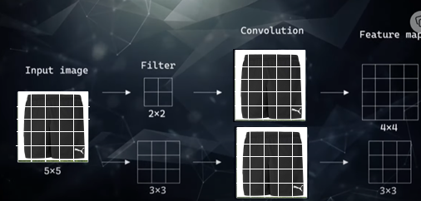

Filter moving around the image and create the our feature map

*padding the original input to avoid information loss.

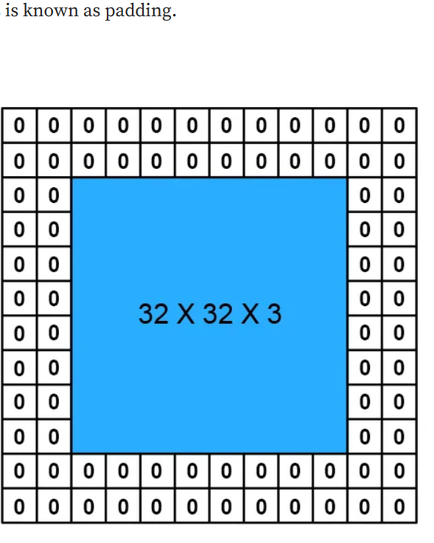

‘padding = valid’, this means that no padding

padding = same” this means that padding will be applied to

metin, diyagram, çizgi içeren bir resim

Açıklama otomatik olarak oluşturuldu

Filter examples

Sobel Filter: It finds the direction of greatest increase from light to dark and the rate of change in that direction.  It works by calculating the gradient of image intensity at each pixel in the image.

[4]

metin, ekran görüntüsü, diyagram, çizgi içeren bir resim

Açıklama otomatik olarak oluşturuldu

ekran görüntüsü, metin içeren bir resim

Açıklama otomatik olarak oluşturuldu

metin, ekran görüntüsü, saat, yazı tipi içeren bir resim

Açıklama otomatik olarak oluşturuldu

Pooling:

metin, ekran görüntüsü, sayı tahtası, skorbord içeren bir resim

Açıklama otomatik olarak oluşturuldu

metin, ekran görüntüsü, grafik tasarım, yazı tipi içeren bir resim

Açıklama otomatik olarak oluşturuldu

metin, ekran görüntüsü, yazı tipi, çizgi içeren bir resim

Açıklama otomatik olarak oluşturuldu

# EXPERIMENTS

## Model Development and Training

A deep learning architecture leveraging Convolutional Neural Networks (CNNs) was implemented to process paired images of pants and t-shirts. The model's architecture consisted of dual inputs for both clothing categories. The aim was to learn the relationship between different clothing combinations and corresponding user ratings.

## Training Process

The dataset was split into training and validation sets to facilitate model training and assessment. The model was trained using a mean squared error loss function, optimized with the Adam optimizer, over a span of 10 epochs. The batch size was set to 32 for efficient processing.

## Evaluation Metrics

The performance of the trained model was evaluated primarily using Mean Absolute Error (MAE) as the metric to gauge the disparity between predicted and actual user ratings. Additionally, other metrics such as Root Mean Squared Error (RMSE) were considered to provide comprehensive insights into the model's performance.

## User Testing and Predictions

To simulate user interactions, a section of the dataset was withheld during training and used as a pseudo-test set. The model predicted ratings for these combinations, enabling an assessment of its ability to infer user preferences accurately.

## Results Analysis

The experiment outcomes were analyzed in-depth, emphasizing the model's proficiency in predicting ratings for unseen combinations. Insights into the model's strengths, limitations, and areas for potential enhancement were derived from this evaluation.

# CONCLUSION

In this project, a personalized mode recommendation system was developed that is rated according to the user's preferences and uses CNN models. The system analyzes the user's scores on combinations of clothes, learns individual fashion tendencies, and then uses this information to create outfit suggestions.

Thanks to the CNN model, it uses user evaluations to understand the user's preferences and learn from them. This allows the system to generate personalized recommendations for each user.

Although the scores obtained in the first stage did not meet the expectations, the resulting photographs could be printed close to the preferences. The scores being between 1 and 3 were far beyond our expectations. After some optimization, the maximum score we could get was approximately 5.5. However, the clothes conformed to the wearer's preferences.

giyim, kişi, şahıs, pantolon, adam, insan içeren bir resim

Açıklama otomatik olarak oluşturuldu

# REFERENCES

[1] Edgar Simo-Serra, Sanja Fidler, Francesc Moreno-Noguer, and Raquel Urtasun.

2015. Neuroaesthetics in fashion: Modeling the perception of fashionability. In *Proceedings of the IEEE Conference on Computer Vision and Pattern Recognition*. 869–877.

[2] Vignesh Jagadeesh, Robinson Piramuthu, Anurag Bhardwaj, Wei Di, and Neel Sundaresan. 2014. Large scale visual recommendations from street fashion images. In *Proceedings of the 20th ACM SIGKDD international conference on Knowledge discovery and data mining*. 1925–1934.

[3] Yang Hu, Xi Yi, and Larry S Davis. 2015. Collaborative fashion recommendation: A functional tensor factorization approach. In *Proceedings of the 23rd ACM international conference on Multimedia*. 129–138.

[4] https://crosspointe.net/what-is-sobel-in-imaging/