Lab A3. Absorption Spectrum of Algae

## Background

Today you will make a graph that illustrates the absorption rates of your algae samples at different wavelengths. When you are done, your graph will look very similar to the output of the spectrophotometer you used during the lab. However, you will be able to visualize the similarities and differences of all three algae species at once to make easy comparisons.

## Goals for Lab 2

Be able to... *

## 1. Getting Started

**Make a new project in a new directory and open a new script.**

* Copy the comment lines into your script
* Enter the necessary code based on the previous lab and your R script from Labs A1 and A2.

# Load the packages ggplot2, gsheet, and dplyr

## 2. Get your data into R

We will use the same procedure as the last lab to load data into R. Go to the Lab Sakai Site and scroll down like you did last week. Select the link for your lab section.

# Store the Google sheets link as the variable url

# load the data stored in the variable url using the gsheet2tbl function  
# and store it as the variable algae_data

Remember, once we have our data in, it is always good to check to make sure the data was imported correctly.

# Check your data looks right (first lines only)

## 3. Graphing the Algae Data

Just like last time, we are going to use ggplot to graph the data. We want to compare which wavelengths are most strongly and poorely absorbed by which species of algae. We are first going to graph the data as points.

### 3a. Create the base layer of your plot

* First identify the variables (by looking at column names; *write them down*)
* What is the independent variable (x axis)?
* What is the dependent variable (y axis)?
* How will you plot different algae types separately?

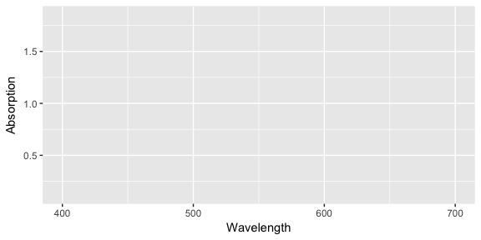

### 3b. Add the data to the plot (using geom_point)

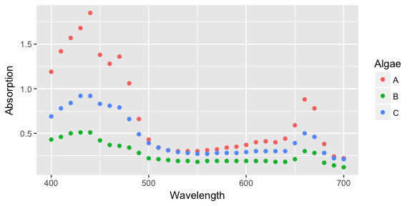

* What wavelengths are most strongly (and most poorly) absorbed by which algae extracts?
* Does your data match the known absorption spectra of different pigments found in chloroplasts?
* Which pigments have absorption spectra most similar to your results?