

Custom Web Server

Version 1.0

June 18, 2017

### Presented by Eren Çetin

# Custom Web Server

## To Run Our Custom Web Server

* Minimum Framework 4.5 or higher version must be installed.
* For default usage, we set default web path of Custom Web Server as ‘C:\\web\’. You might copy your html files into this folder. Or you can specify a new path. You specify your port number and web server root path into application config file (DanskeWebServer.exe.config).
* 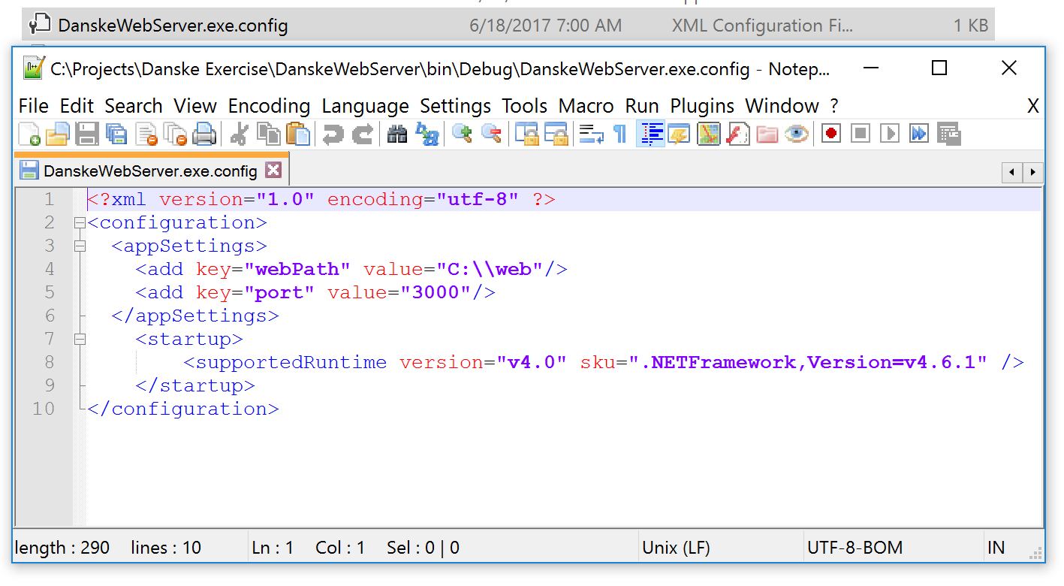*You must run our console application (DanskeWebServer.exe) as administrator.*
* 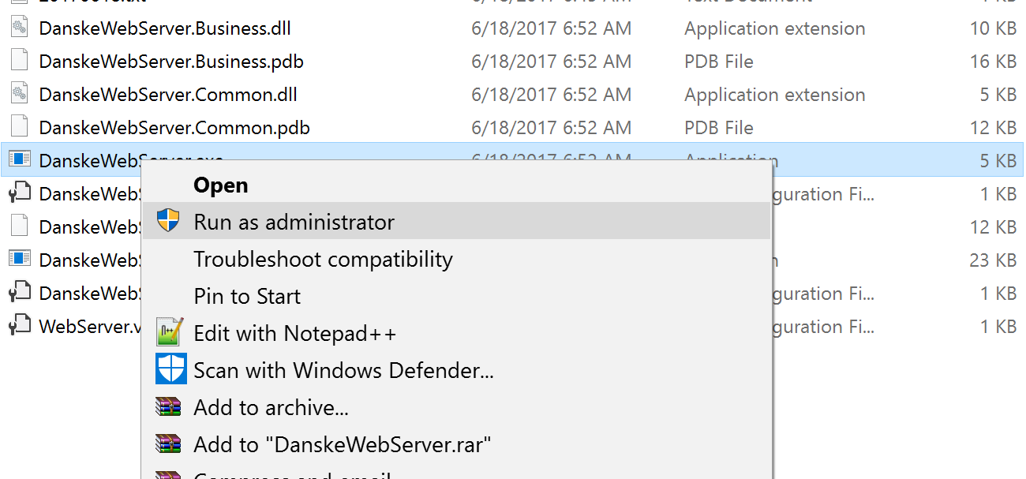

## Logging

* Our application has a simple logging mechanism. Log are written into application path. The name of the log files formatted with date information such : YYYMMDD.txt (20170618).

