SNR-Adaptive Gating for Automatic Modulation Classification
via Adaptive Wavelet Network
Egemen Durmaz, Eren Dervişoğlu, İlker Doğan
MYZ307E - Machine Learning for Electrical and Electronics Engineering
Baseline code: https://github.com/zjwfufu/AWN | Project GitHub: https://github.com/egemendrmaz159-oss/MYZ307E-SAG-AWN

Abstract
Automatic Modulation Classification (AMC) becomes difficult at low Signal-to-Noise Ratio (SNR), where modulation-specific I/Q patterns are distorted by noise. In this project, we first reproduced the Adaptive Wavelet Network (AWN) baseline on RadioML2016.10a and then extended it with an SNR-Adaptive Gating (SAG) module. The original AWN learns wavelet-based signal representations, but it does not explicitly use receiver-side SNR information. Our contribution is a lightweight two-layer gating module that conditions wavelet features on normalized SNR before classification. SAG-AWN improves overall test accuracy from 64.24% to 69.00% with only 4,288 additional parameters. The improvement is most visible between -12 dB and -6 dB, which is the main transition region where the baseline begins to recover but still struggles.
1. Introduction
AMC aims to identify the modulation type of a received wireless signal without prior transmitter information. This is important for cognitive radio, spectrum monitoring and adaptive communication receivers. Deep learning-based AMC models commonly operate directly on I/Q samples, which makes performance highly dependent on channel noise.
The baseline implementation in this project is AWN, a learnable wavelet-based network for modulation classification. AWN is a strong reference because wavelet decomposition can capture multi-scale time-frequency structure in communication signals. However, the same feature pathway is applied to all samples, regardless of whether the input is at -20 dB or +18 dB SNR. In a practical receiver, SNR estimates are usually available, so this information can be used to guide feature weighting.
Our objective is to reproduce the AWN baseline and then add value through an SNR-aware extension. The proposed SAG module does not replace AWN; it modifies the feature representation by dynamically weighting wavelet features according to channel quality.
2. Methodology
2.1 Baseline Reference: AWN
AWN takes I/Q samples and extracts features using convolutional layers followed by a learnable wavelet transform. The wavelet representation is processed by attention layers and then passed to a classifier. Using the reproduced baseline setup, AWN reaches 64.24% overall accuracy on RadioML2016.10a.
2.2 Our Modifications
The main code-level change is the insertion of an SNR-Adaptive Gating block after the wavelet feature extraction stage. The block receives normalized SNR as an auxiliary scalar and produces feature-wise gates through a two-layer MLP. A residual formulation is used so that the original AWN features are preserved while the SAG branch learns an SNR-dependent correction.
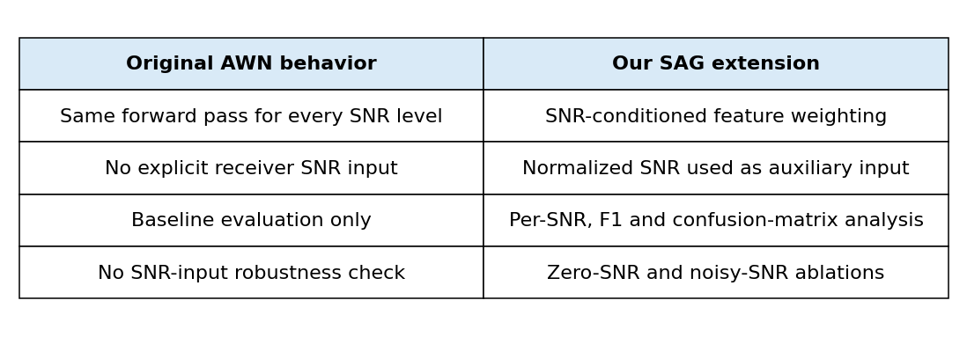
Table I. Baseline behavior and modifications introduced in this project.
2.3 Dataset and Training
Experiments use RadioML2016.10a, which contains 220,000 I/Q samples from 11 modulation classes over SNR values from -20 dB to +18 dB. During training, the AWN backbone uses a small learning rate (1e-5), while the new SAG module uses a larger learning rate (1e-3). This prevents the reproduced backbone from changing too aggressively while allowing the new module to learn quickly.
3. Results
The main comparison is reported in Table II. The proposed SAG-AWN model improves the reproduced AWN baseline by about 4.8 percentage points in overall accuracy.
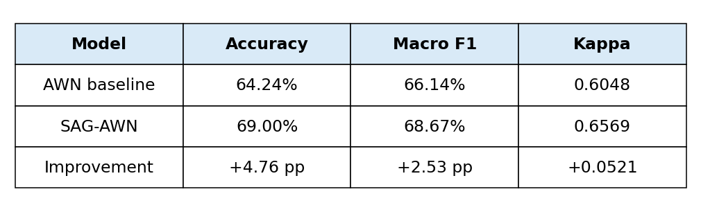
Table II. Overall test-set comparison against the reproduced AWN baseline.
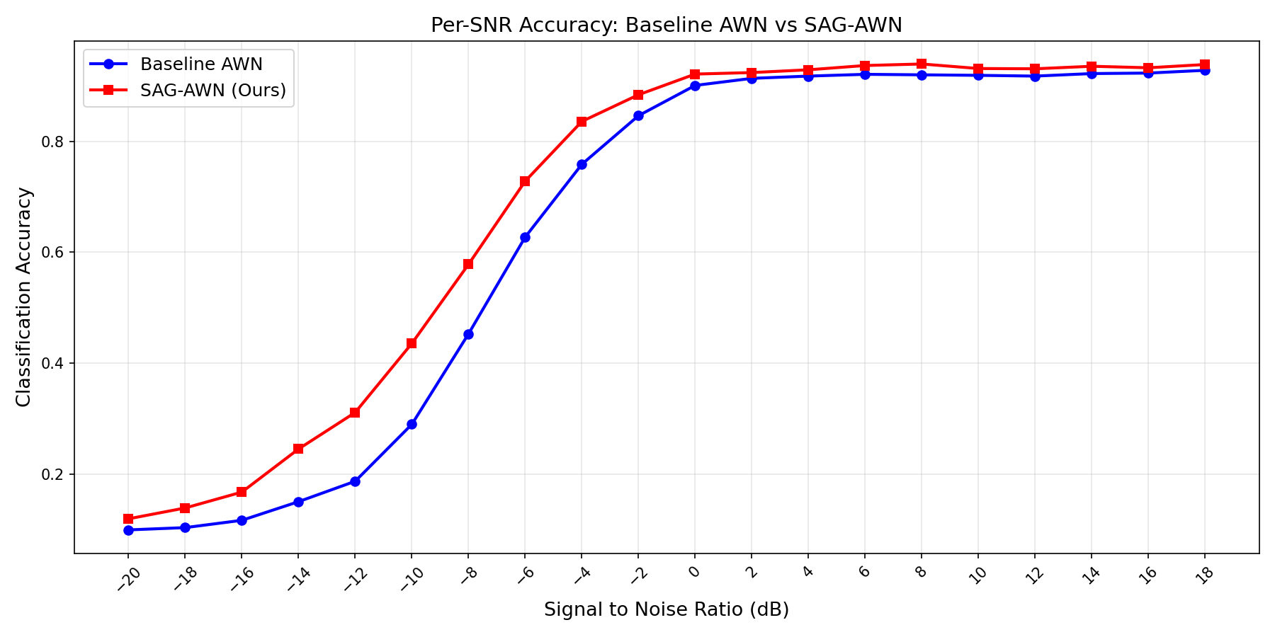
Fig. 1. Per-SNR accuracy comparison between baseline AWN and SAG-AWN.
The per-SNR curve shows that the improvement is not uniform across all noise levels. The largest gap occurs in the low-to-mid SNR transition region, especially from -12 dB to -6 dB. At high SNR, both models approach saturation, so the incremental gain naturally becomes smaller.
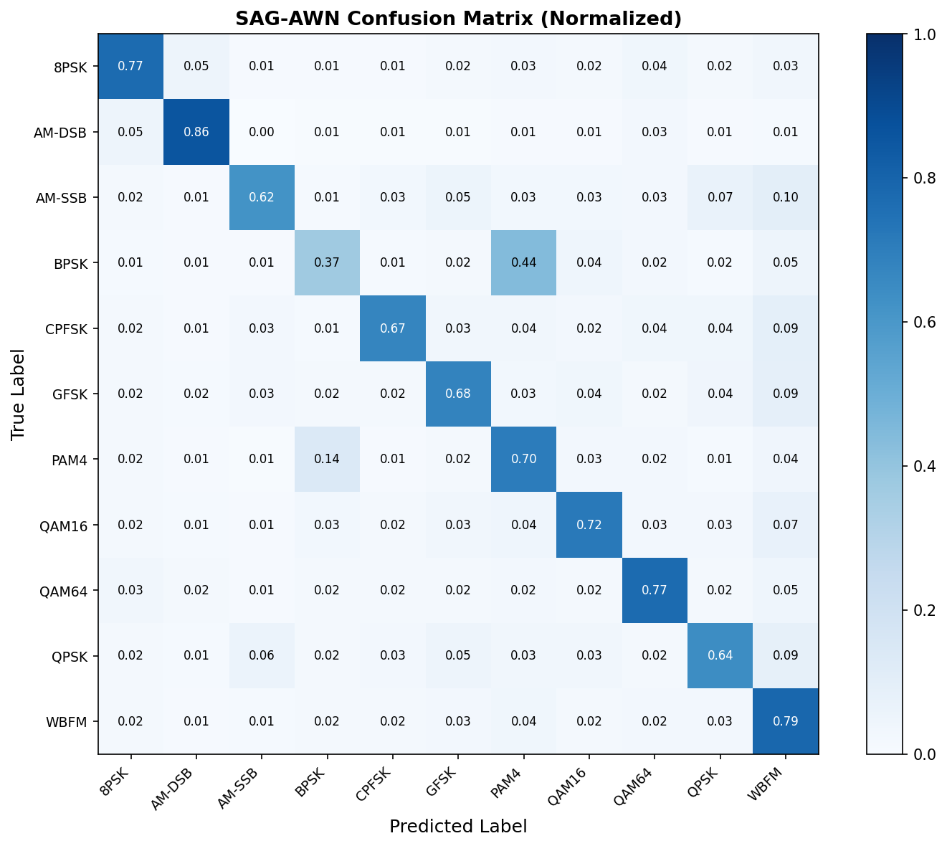
Fig. 2. Normalized confusion matrix of SAG-AWN.
The confusion matrix shows strong diagonal behavior for AM-DSB, WBFM, QAM64 and 8PSK. The most visible remaining error is between BPSK and PAM4, which is reasonable because their low-SNR I/Q patterns can become difficult to separate.
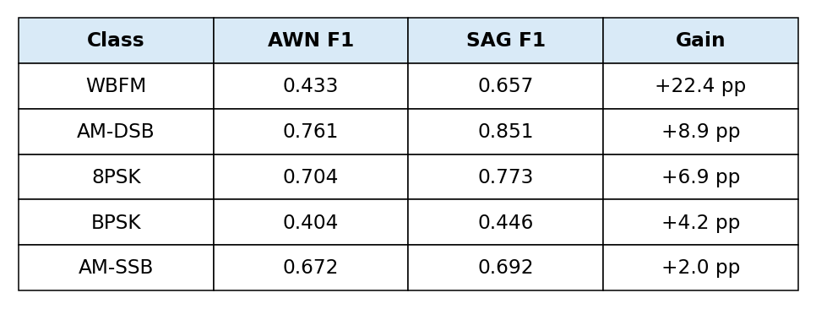
Table III. Largest class-wise F1 improvements after adding SAG.
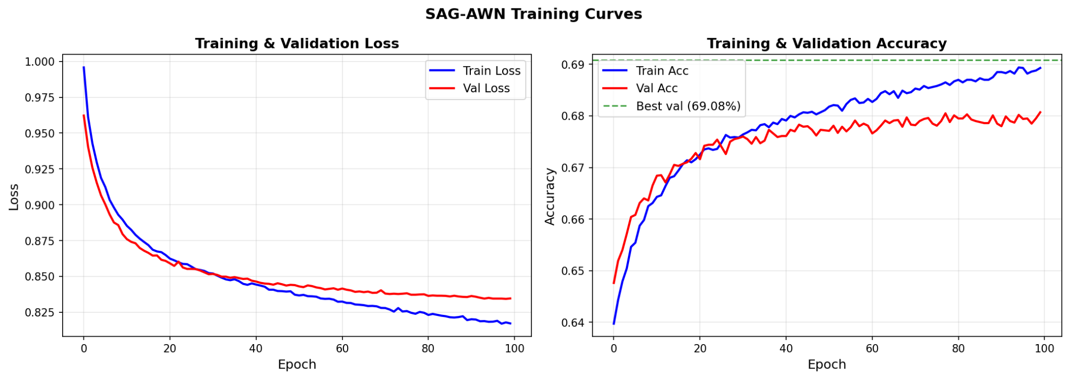
Fig. 3. SAG-AWN training and validation curves.
The training curves indicate stable convergence. Validation accuracy improves quickly at the beginning and then stabilizes near 69%, while training accuracy continues to increase slightly. This suggests that SAG learns useful conditioning without destabilizing the AWN backbone.
4. Ablation Study
We also tested whether the improvement comes from meaningful SNR conditioning rather than simply adding parameters. The zero-SNR and noisy-SNR experiments directly evaluate the dependence of SAG on the SNR input.
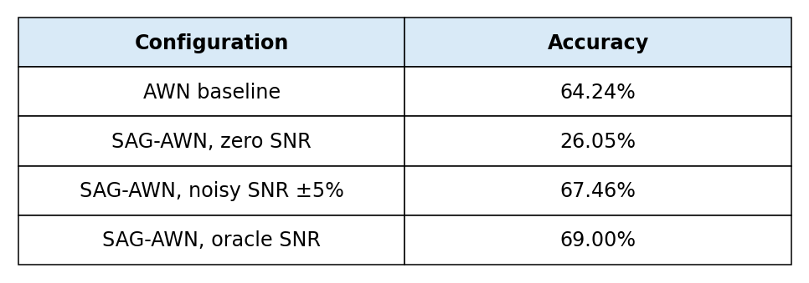
Table IV. Ablation results for SNR input reliability.
When SNR is forced to zero, performance drops sharply to 26.05%, confirming that the model has learned to use SNR information. With noisy SNR input, SAG-AWN still achieves 67.46%, which remains above the baseline and shows robustness to imperfect SNR estimation.
5. Conclusion
This project reproduced AWN and extended it with a lightweight SNR-Adaptive Gating mechanism. The contribution is explicit: the original AWN code processes every sample in the same way, while our version uses receiver-estimated SNR to dynamically reweight wavelet features. SAG-AWN improves test accuracy from 64.24% to 69.00% and performs particularly well in the difficult low-to-mid SNR region. A limitation is that the current implementation uses dataset-provided SNR labels; future work should integrate a real SNR estimator and investigate class-specific gating strategies.
References
[1] J. Zhang, T. Wang, Z. Feng, and S. Yang, "Towards the Automatic Modulation Classification with Adaptive Wavelet Network," IEEE Transactions on Cognitive Communications and Networking, 2023.
[2] T. J. O'Shea and J. Hoydis, "An Introduction to Deep Learning for the Physical Layer," IEEE Transactions on Cognitive Communications and Networking, vol. 3, no. 4, pp. 563-575, 2017.
[3] DeepSig, "RadioML Datasets," RadioML2016.10a dataset.
[4] Original AWN code repository: https://github.com/zjwfufu/AWN
[5] Project repository: https://github.com/egemendrmaz159-oss/MYZ307E-SAG-AWN

