2025-26 Spring

<CMPE/ISE/SE> 494 Senior Project Report

Fixing Traffic with Artificial Intelligence

Project Short Title | TRAFIX
Project Full Title | Fixing Traffic with Artificial Intelligence
Team Name | KİBORG
Team Members | Eren Kaan Oral - 22243510102 (CMPE), 24244710010 (SE)  Bora Atalay - 22243510081  Recep Arda Yurtkuran - 22243510088  Alp Çağan İlhan  Görkem Furkan Eriş - 22243510104  Kaan Turan
Supervisor | Dr. Arda Sezen

Declaration of generative AI and AI-assisted technologies
in the project report writing process

During the preparation of this ISE/SE/CMPE 494 Graduation Project report we - the
authors, used ChatGPT, Gemini, Antigravity, Claude to translate and ensure the semantic integrity of our report, debugging our code, generating code from our descriptions. After using this tool/service, we reviewed and edited the content as needed and take full responsibility for the content of this Graduation Project Report

Abstract
The rapid increase in urbanization and vehicle usage has severely strained existing city infrastructures, leading to chronic traffic congestion. Traditional traffic signalization systems, which predominantly rely on static, pre-calculated time intervals, are fundamentally ill-equipped to handle dynamic urban environments. They fail to adapt to real-time fluctuations, emergency vehicle routing, or cascading congestion across neighboring intersections. To address these inadequacies, this project introduces TraFix, an intelligent, autonomous Smart Intersection Management System. TraFix replaces rigid signalization logic with a learning-based decision engine that dynamically optimizes traffic light phases across a network of five interconnected intersections. Our approach (TraFix v5) combines a temporal encoder based on a Gated Recurrent Unit (GRU) with a spatial encoder based on a Graph Attention Network (GATConv), integrated with a Coordinated Deep Reinforcement Learning (DRL) policy powered by Proximal Policy Optimization (PPO). The two encoders are trained in a three-stage curriculum — the GRU is first pretrained on a next-step prediction task, the GATConv and shared trunk are then pretrained on a neighbor queue prediction task, and finally the full actor-critic network is fine-tuned end-to-end with PPO under differential learning rates. By modeling the intersection network as a graph, the system captures complex spatial dependencies, allowing decisions at one node to preemptively mitigate downstream bottlenecks. Furthermore, TraFix fuses scalar telemetry from the SUMO simulator with real-time visual feature extraction using a YOLOv8 computer vision pipeline within the CARLA environment. This multi-modal state representation ensures highly accurate, responsive phase scheduling and incorporates an automatic preemption protocol for prioritized emergency vehicles. The originality of this work lies in its staged GRU–GATConv pretraining pipeline, seamless multi-simulator integration (SUMO and CARLA), and an architecture that guarantees transparency by logging all AI decision-making processes to a PostgreSQL database for human auditability. Ultimately, TraFix offers significant societal benefits by reducing average vehicle waiting times, minimizing carbon emissions through sustained traffic flow, and accelerating emergency response times, thereby establishing a scalable foundation for future smart city deployments.

Keywords: Traffic Optimization, Deep Reinforcement Learning, Graph Attention Networks, Recurrent Neural Networks, Computer Vision, Smart City, Autonomous Signalization

Acknowledgements (if any)
We would like to express the deepest appreciation to all those who provided us with the opportunity to complete this project. We give special gratitude to our senior project supervisor, Dr. Arda Sezen.
Table of Contents
Abstract 3
Keywords: Traffic Optimization, Deep Reinforcement Learning, Graph Attention Networks, Recurrent Neural Networks, Computer Vision, Smart City, Autonomous Signalization 3
Ch1: Introduction 8
1.1 Problem Statement 8
1.2 Scope 8
Ch2: Project Plan 10
2.1 Methodology 10
2.2. Time Schedule (Gantt Chart) 12
2.3. Deliverables List 13
Ch3: Literature Review 15
Modern intelligent transportation research heavily relies on high-fidelity simulation. SUMO (Simulation of Urban MObility) is widely established as the standard for micro-level traffic flow simulation and programmatic control via TraCI (Krajzewicz et al., 2012). Concurrently, autonomous driving simulators like CARLA provide photorealistic sensor and camera data (Dosovitskiy et al., 2017). Recent studies have shown that fusing structural simulation data with visual data improves real-world deployability. YOLO (You Only Look Once) architectures have become the industry standard for real-time object detection due to their high speed and accuracy (Redmon et al., 2016). TraFix innovates by bridging SUMO and CARLA, utilizing a YOLOv8 computer vision pipeline to extract vehicle counts and queues from CARLA's visual feeds, combining them with SUMO's scalar telemetry to create a robust, multi-modal state observation for the AI agent. Ch4: Backlogs and Planning 16
4.1 Overall Description of the Project 17
4.1.1 Product Perspective 17
4.1.2 Product Functions 18
4.1.3 User Characteristics 18
4.1.4 Constraints 19
4.1.5 Assumptions and Dependencies 20
4.2 Product Backlog 22
4.2.2 Functional requirements 24
4.2.3 Quality Requirement (HW, OS, Database, programming environment, performance, security, reliability, etc) 25
4.3 Sprint Backlog and Planning 26
4.4 Sprint Reviews 27
Chapter 5: Data & Algorithms 27
5.1 Data Collection 27
Figure 1. TraFix data flow ??
5.2 Data Processing & Algorithms 28
5.2.1 Data Normalization and Pre-processing 28
5.2.2 Temporal Encoder (GRU) and Graph Attention Encoder (GATConv) 28
Figure 2. TraFix v5 model architecture ??
5.2.3 Proximal Policy Optimization (PPO) and Reward Function 28
5.3 Data Analysis 29
Chapter 6: Design 29
6.1 Software Architecture 29
6.1.1 System Actors 29
6.1.2 Architectural Constraints 30
6.2 Views and Diagrams 30
6.2.1 Collaboration and Deployment View 30
Figure 3. TraFix system architecture ??
6.2.2 Data and Class View 30
6.3 GUI Design (User Interface) 31
6.3.1 Live Traffic Dashboard (dashboard.html) 31
6.3.2 System Architecture View (index.html) 31
References 32

Acronyms
SUMO | Simulation of Urban MObility
AI | Artificial Intelligence
UI | User Interface
API | Application Programming Interface
GATConv | Graph Attention Convolution
GNN | Graph Neural Network
HTTP | Hypertext Transfer Protocol
JSON | JavaScript Object Notation
LOS | Level of Service
MVP | Minimum Viable Product
PLC | Programmable Logic Controller
PPO | Proximal Policy Optimization
RL | Reinforcement Learning
SLA | Service-Level Agreement
GAT | Graph Attention Network
TraCI | Traffic Control Interface
ASGI | Asynchronous Server Gateway Interface
CV | Computer Vision
GRU | Gated Recurrent Unit
GUI | Graphical User Interface
MLP | Multi-Layer Perceptron
SVG | Scalable Vector Graphics
YOLO | You Only Look Once

Ch1: Introduction

1.1 Problem Statement
The increasing amount of urbanization and usage of vehicles combined with cities not being equipped with necessary infrastructure to handle such density, causes congestion problems in traffic. The approaches such as traditional signalization systems, which mostly work as static constant time intervals set previously or triggered by sensors, cannot adapt dynamically to real time situations such as accidents, priority of passage of emergency vehicles or a long wave of cars coming from neighboring intersections.
Especially within the neighboring and topologically connected intersections, a bottleneck in one intersection can cause major congestion problems in the other junctions in seconds. This chain of events causes increase in travel time, enormous queues, unnecessary consumption of fuel and high levels of carbon emission resulting in economic and environmental costs.
The main problem for this project is the lack of the decision mechanism that approaches topologically connected multiple junctions as a one structure, can analyze spatial and temporal relationships, can optimize traffic in maximum efficiency without the need of human intervention and is transparent in the decision-making process.

1.2 Scope
TraFix targets the fundamental inadequacy of fixed-duration traffic signalization in dynamic urban environments. Conventional signal timing plans are designed around historical traffic averages and cannot adapt to real-time fluctuations in vehicle density, emergency vehicle presence, or cascading congestion originating from neighboring intersections. The result is inefficient phase allocation, unnecessary vehicle delays, and degraded network throughput — problems that compound across interconnected intersections.
The primary objective of TraFix is to replace static signalization logic with an autonomous, learning-based decision engine that continuously optimizes phase durations based on observed traffic state. By modeling the 5-intersection network as a graph and applying a temporal encoder (GRU) coupled with a graph attention encoder (GATConv) alongside a coordinated deep reinforcement learning policy, the system captures both local intersection dynamics and inter-intersection dependencies simultaneously. This allows phase decisions at one intersection to account for the downstream consequences at adjacent nodes, reducing bottleneck formation across the network rather than at isolated points.
A secondary objective is emergency vehicle prioritization. TraFix is designed to detect emergency vehicle presence within the network and dynamically preempt normal phase scheduling to create a clear corridor, minimizing response time delays without requiring manual operator intervention.
The broader goal of the system is to serve as a transparent and auditable decision support infrastructure. All phase decisions, reward signals, and traffic flow metrics are logged for post-hoc evaluation, enabling traffic engineers to inspect, validate, and retrain the system's policy over time. This auditability is a deliberate design goal, ensuring that the autonomy of the system does not come at the cost of human oversight.
The intended benefits of TraFix include reduced average vehicle waiting times, improved network-level throughput, faster emergency response facilitation, and a scalable architecture that can accommodate additional intersections and richer sensor inputs as the system evolves toward full urban deployment.

Ch2: Project Plan

2.1 Methodology
For the development and management of this project, we are adopting a hybrid project management approach. We will utilize the Kanban framework for all day-to-day software development and system integration tasks, while employing a Gantt Chart for high-level schedule tracking and deliverable management.
Kanban for System and Software Development We have chosen Kanban as our primary development methodology due to its flexibility and focus on continuous delivery. Given the highly iterative nature of training deep reinforcement learning models and integrating them with simulation environments and backend APIs, Kanban allows us to adapt to challenges dynamically without being constrained by rigid sprint cycles.
All technical tasks, research items, and bug fixes will be managed through a centralized Kanban board (categorized into stages such as Backlog, To Do, In Progress, Testing/Review, and Done). This methodology provides several key advantages for our workflow:
- Workflow Visualization: It ensures transparent communication, allowing all team members to see the real-time status of the pipeline (e.g., SUMO integration, GNN training, or UI development).
- Work-In-Progress (WIP) Limits: By limiting the number of active tasks, we can prevent bottlenecks—particularly during complex integration phases—and ensure that a feature is fully stabilized before moving on to the next.
- Continuous Integration: It perfectly supports our "phased development" strategy, allowing us to build a core MVP first and seamlessly pull advanced features (like Redis or WebSockets) from the backlog into the workflow as the project matures.
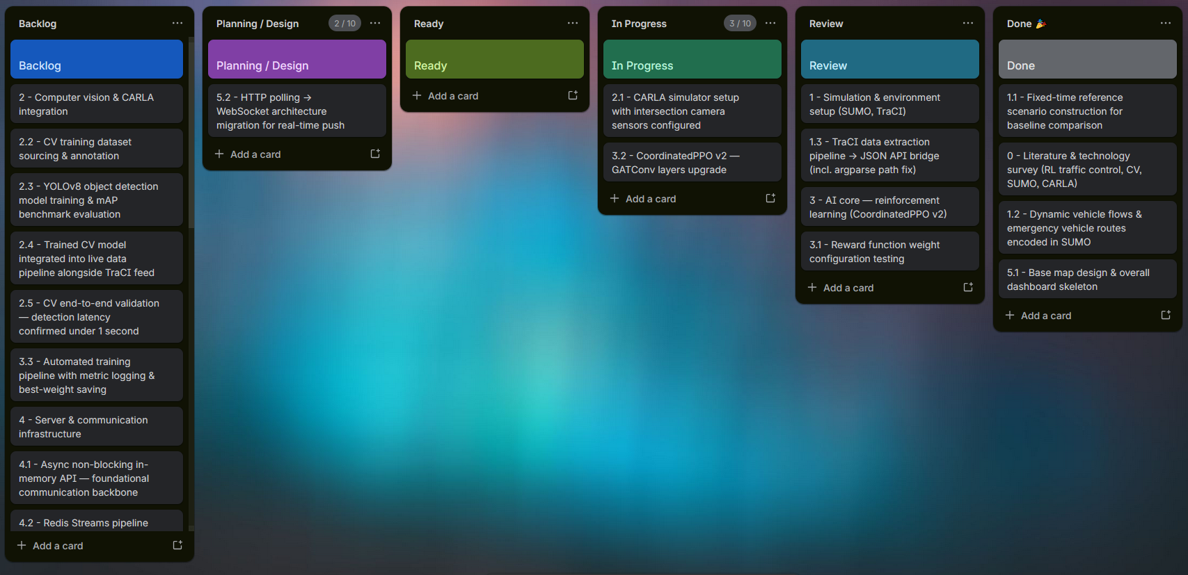
Gantt Chart for Deliverable and Schedule Management While Kanban governs our micro-level execution, a Gantt Chart will be strictly utilized to manage the macro-level project timeline and ensure all academic and technical deadlines are met.
The Gantt chart maps out our main Work Packages across the project's duration. We will use this tool specifically to:
- Track Dependencies: Clearly define the sequential relationships between major project phases (e.g., ensuring the simulation environment is built before AI training commences).
- Manage Deliverables: Tie every required outcome—such as the trained model weights (.pth files), the final report, and the source code—to explicit due dates.
- Monitor Milestones: Provide a clear, visual roadmap to the evaluation jury and stakeholders, proving that the project is advancing according to the proposed timeline.

2.2. Time Schedule (Gantt Chart)
WP /  Task No | WP /  Task Name | Start Date | End Date | Weeks
 |  |  |  | 1 | 2 | 3 | 4 | 5 | 6 | 7 | 8 | 9 | 10 | 11 | 12 | 13 | 14 | 15 | 16 | 17 | 18
1 | SRS document | 23.03.2026 | 05.04.2026 | X | X | x | x | x | x | x | x | x | x | x | x | x | x | x | x | x | x
2 | SUMO network configuration | 23.03.2026 | 03.05.2026 | X | X | X | X | X | X
3 | SUMO-TraFix interface module | 23.03.2026 | 03.05.2026 | X | X | X | X | X | X
4 | GRU + GATConv encoder module | 06.04.2026 | 14.06.2026 |  |  | X | X | X | X | X | X | X | X | X | X
9+ | CV pipeline module (CARLA) | 06.04.2026 | 05.07.2026 |  |  | X | X | X | X | X | X | X | X | X | X | X | X | X
5 | Coordinated DRL pipeline | 20.04.2026 | 21.06.2026 |  |  |  |  | X | X | X | X | X | X | X | X | X
7 | Emergency vehicle module | 18.05.2026 | 28.06.2026 |  |  |  |  |  |  |  |  | X | X | X | X | X | X
6 | Trained model artifacts | 01.06.2026 | 12.07.2026 |  |  |  |  |  |  |  |  |  |  | X | X | X | X | X | X
8 | Redis Streams module | 01.06.2026 | 12.07.2026 |  |  |  |  |  |  |  |  |  |  | X | X | X | X | X | X
9 | PostgreSQL logging module | 01.06.2026 | 12.07.2026 |  |  |  |  |  |  |  |  |  |  | X | X | X | X | X | X
10 | Final project report | 29.06.2026 | 26.07.2026 |  |  |  |  |  |  |  |  |  |  |  |  |  |  | X | X | X | X

2.3. Deliverables List
ID | Type | Description | Due Date
0 | Document | Project submission report | 24 Jun 2026
1 | Document | Software Requirements Specification (SRS) — system scope, interfaces, functional & non-functional requirements | 30 Mar 2026
2 | Software | SUMO network configuration — 5-intersection road model, lane geometries, route definitions, traffic flow profiles | 27 Apr 2026
3 | Module | SUMO-TraFix interface module — TraCI-based layer for phase decisions and real-time state retrieval | 27 Apr 2026
4 | Module | GRU + GATConv encoder module — staged temporal (GRU) and graph attention (GATConv) encoders pretrained separately and fine-tuned with PPO, encoding intersection topology and temporal traffic patterns across the 5-node network | 22 May 2026
5 | Module | Coordinated DRL training pipeline — PPO-based multi-agent RL engine with reward computation, policy update logic, and coordination mechanisms | 22 May 2026
6 | Software | Trained model artifacts — saved policy weights and training logs from completed runs, used for evaluation and deployment | 1 Jun 2026
7 | Module | Emergency vehicle prioritization module — detection and phase preemption logic creating signal corridors across the network | 22 May 2026
8 | Module | Redis Streams integration module — async messaging layer for low-latency inter-agent communication and decoupled coordination | 1 Jun 2026
9 | Module | PostgreSQL logging module — persistence layer archiving phase decisions, reward signals, and traffic flow statistics | 1 Jun 2026
x9+ | Module | Computer vision pipeline module — CARLA-based YOLOv8 vehicle detection feeding real-time counts into the TraFix decision loop | 1 Jun 2026
10 | Document | Final project report — system architecture, training methodology, experimental results, evaluation | 24 Jun 2026

Ch3: Literature Review
In The development of intelligent traffic management systems has evolved significantly, transitioning from static mathematical models to highly dynamic, learning-based architectures. This chapter reviews the fundamental literature surrounding traditional control systems, reinforcement learning in traffic environments, spatiotemporal modeling, and the integration of computer vision, highlighting how the TraFix system builds upon and addresses the limitations of these existing methodologies.

3.1 Traditional and Adaptive Traffic Control Systems
Historically, urban traffic signalization has relied on fixed-time control strategies based on historical traffic flow averages. While effective under predictable conditions, these systems fail during sudden surges or accidents. Later advancements introduced adaptive control systems such as SCOOT and SCATS, which utilize inductive loop detectors to adjust split, back, and cycle times in response to real-time demand (Robertson & Bretherton, 1991). However, these systems rely on predefined, rule-based optimization algorithms rather than true predictive learning. TraFix departs from these heuristic-based methods by employing an autonomous learning agent capable of discovering optimal phase allocations without human-defined rigid rules.

3.2 Deep Reinforcement Learning for Traffic Optimization
Reinforcement Learning (RL) has emerged as a powerful tool for traffic signal control due to its ability to optimize sequential decision-making in stochastic environments. Early applications of RL focused on isolated intersections, optimizing single-agent policies without awareness of neighboring traffic states. To address network-level congestion, multi-agent reinforcement learning (MARL) was introduced, allowing multiple intersections to coordinate (El-Tantawy, Abdulhai & Abdelgawad, 2013). While effective, traditional MARL often struggles with scalability and communication overhead. TraFix addresses this by utilizing Proximal Policy Optimization (PPO), a state-of-the-art policy gradient method that provides stable and sample-efficient training, coupled with a Redis Streams communication backbone to ensure low-latency, decoupled coordination among agents.

3.3 Spatiotemporal Modeling with Graph Neural Networks
Intersections in an urban grid are topologically connected; a bottleneck at one node rapidly propagates to adjacent nodes. Traditional RL struggles to mathematically represent this spatial relationship. Recent literature has demonstrated that Graph Neural Networks (GNNs) are highly effective at capturing these spatiotemporal dependencies. For instance, models utilizing Graph Attention Networks (GATs) can dynamically weigh the influence of neighboring intersections based on real-time traffic volume (Wei et al., 2019). TraFix integrates a Graph Attention (GATConv) spatial encoder layered on top of a GRU-based temporal encoder, both embedded directly into the DRL policy. This separated-but-coupled design allows the system to analyze the spatial network as a single interconnected graph while independently modeling per-intersection temporal patterns, predicting cascading congestion and preemptively allocating green phases.

3.4 Multi-Simulator Environments and Computer Vision

Modern intelligent transportation research heavily relies on high-fidelity simulation. SUMO (Simulation of Urban MObility) is widely established as the standard for micro-level traffic flow simulation and programmatic control via TraCI (Krajzewicz et al., 2012). Concurrently, autonomous driving simulators like CARLA provide photorealistic sensor and camera data (Dosovitskiy et al., 2017). Recent studies have shown that fusing structural simulation data with visual data improves real-world deployability. YOLO (You Only Look Once) architectures have become the industry standard for real-time object detection due to their high speed and accuracy (Redmon et al., 2016). TraFix innovates by bridging SUMO and CARLA, utilizing a YOLOv8 computer vision pipeline to extract vehicle counts and queues from CARLA's visual feeds, combining them with SUMO's scalar telemetry to create a robust, multi-modal state observation for the AI agent.

Ch4: Backlogs and Planning

4.1 Overall Description of the Project

4.1.1 Product Perspective
The Smart Intersection Management System (TraFix) is a partially implemented, semi-independent software component designed to operate within a broader urban traffic management infrastructure. While the system can function as a standalone decision-making unit in its current form, it is architecturally designed to integrate with external simulation, sensing, messaging, and persistence layers as the system matures toward full deployment.
TraFix does not replace an entire traffic control infrastructure; rather, it acts as an intelligent signalization layer that sits between real-time traffic observation and physical signal actuation. In its current stage, the physical environment is represented by SUMO (Simulation of Urban MObility), a micro-level traffic simulator that serves as the closed-loop feedback environment for the reinforcement learning agent. SUMO exposes a programmatic interface through which TraFix submits phase decisions and retrieves vehicle density, queue length, and flow metrics across the 5-intersection network. This interface forms the primary external boundary of the system in its present implementation.
In a planned extension of the system, TraFix is intended to incorporate a computer vision pipeline fed by CARLA, a high-fidelity autonomous driving simulator. CARLA would provide photorealistic cameras and sensor outputs from a 3D urban environment, allowing the system to extract visual traffic features — such as vehicle counts, occupancy estimations, and queue formations — directly from simulated camera feeds placed at each intersection. This visual input channel is designed to supplement the scalar metrics provided by SUMO, enabling the agent to learn from a richer, more realistic representation of intersection state. The interface between CARLA and TraFix is treated as a future external perception boundary: raw visual data would originate in CARLA, be processed by a computer vision module within TraFix, and the resulting feature vectors would be consumed by the decision-making layer alongside SUMO-sourced data.
As the system scales toward a production-grade deployment, two additional external components are introduced into the architecture. Redis Streams serves as the real-time messaging backbone, enabling low-latency, asynchronous communication between the intersection agents and the central coordination layer. This decouples the decision frequency of individual agents from the processing throughput of the broader system, ensuring stability under variable traffic loads. PostgreSQL functions as the persistent data store, archiving phase decision histories, reward signals, traffic flow statistics, and computer vision inference logs for post-hoc analysis, model evaluation, and auditability of the system's autonomous decisions.
All core intelligence — the deep reinforcement learning policy, the graph neural network for spatial dependency modeling, the computer vision inference pipeline, and the reward computation logic — remains internal to TraFix and does not depend on any external decision-making authority.

4.1.2 Product Functions
Instant Telemetry Collection: Continuous measuring of queue length and vehicle number for each direction in 5 different intersections.
Spatiotemporal Data Analysis: Mathematical modeling of the density situations of neighbor intersections and their effects to each other via GATConv layers.
Autonomous Phase Selection: Determining the simultaneous and most suitable green light phase for all intersections in the network by using PPO agent.
Emergency Situation Intervention: Crushing the normal optimization rules and opening the route in the situation of prioritized vehicles like ambulance or fire brigade entering the network.
Return (Fallback) Protection: Automatically passing to fixed-duration phase to prevent the locking of the system when a delay exceeding 1000 milliseconds is experienced in the artificial intelligence module or communication line.
Performance and Decision Logging: Textual transferring to the interface of at which intersection, relying on which data the artificial intelligence took decision, and storing of past data in PostgreSQL.

4.1.3 User Characteristics
The target audience and user profiles of the system are divided into two according to their technical competencies:
System Administrators and Researchers (Technical Users): It is a group having advanced level engineering knowledge that can change simulation parameters, interferes to the hyperparameters of artificial intelligence model, controls PostgreSQL and Redis flows. They are responsible for the installation and debugging of the system.
Observers and Decision Makers (End Users): It is a group representing juries, academicians or municipality traffic operators. They use only Dashboard interface. Their coding knowledge is not expected; they obtain information about the system's performance by reading the system's success metrics, live map and AI decision logs.

4.1.4 Constraints
Hardware Limitations
The system is developed and tested on a personal laptop equipped with a consumer-grade GPU. This imposes significant constraints on the scale and complexity of training runs, as deep reinforcement learning with graph neural networks is computationally intensive. The available VRAM limits the batch size, the size of the GNN hidden layers, and the number of parallel simulation environments that can be run simultaneously during training. Co-running SUMO and CARLA on the same machine further strains memory and GPU resources, as CARLA's high-fidelity 3D rendering competes directly with the neural network training workload. Consequently, full-scale multi-simulator training sessions may need to be time-sliced or run sequentially rather than in parallel until the system is migrated to a more capable hardware environment.
Real-Time Processing Requirements
TraFix operates as a closed-loop control system where phase decisions must be issued within the cycle time constraints of the traffic signal controller. Any delay introduced by the computer vision inference pipeline, the GNN forward pass, or the inter-agent coordination layer directly affects the responsiveness of the system. This imposes a soft real-time constraint on the end-to-end decision latency, limiting the architectural complexity of components that sit on the critical path between state observation and phase actuation.
Simulator Version Dependencies
The system is tightly coupled to specific versions of both SUMO and CARLA. SUMO's programmatic interface is exposed through the TraCI protocol, whose API has historically introduced breaking changes across versions. Similarly, CARLA's Python client API and sensor output formats are version-sensitive. Any upgrade to either simulator may require non-trivial adaptation of the interfacing code, and cross-version compatibility between SUMO and CARLA is not guaranteed. We must therefore treat both simulator versions as fixed dependencies until explicit migration efforts are planned.
Open-Source and Licensing Restrictions
TraFix is built entirely on open-source tooling, including SUMO (EPL 2.0), CARLA (MIT), PyTorch, and Redis. While these licenses are generally permissive, any future commercialization or redistribution of the system must ensure continued compliance with the terms of each dependency. In particular, the Eclipse Public License governing SUMO requires that modifications to SUMO's own source code, if any are made, be disclosed under the same license. The system must not introduce proprietary dependencies that conflict with the open-source nature of the existing stack.
Data Privacy and Retention Policies
Although TraFix operates in a simulated environment during its current development phase, the PostgreSQL persistence layer is designed to eventually store traffic flow data derived from real urban infrastructure. In such a deployment context, vehicle trajectory data and intersection-level density records may be subject to data minimization and retention limitation principles under applicable privacy regulations such as GDPR. The system must therefore be designed so that personally identifiable movement data is either not collected, aggregated before storage, or retained only for the minimum period necessary for model evaluation and auditability purposes

4.1.5 Assumptions and Dependencies
The following assumptions underline the current requirements of TraFix. If any of these assumptions prove to be incorrect, change, or become invalidated over the course of development, the affected requirements will need to be revisited and revised accordingly.
Operating System Availability
The system is assumed to be deployable across major operating systems, including Linux, Windows, and macOS, given that all core dependencies — Python, SUMO, CARLA, Redis, and PostgreSQL — offer cross-platform support. If any of these dependencies drops support for a specific platform, or if platform-specific behaviors introduce inconsistencies in simulator output or neural network training results, the requirements relating to portability and environment reproducibility would need to be narrowed to a specific target OS.
Continued Availability and Maintenance of SUMO and CARLA
TraFix assumes that both SUMO and CARLA remain actively maintained open-source projects with accessible releases and community support. The system's simulation pipeline, training loop, and computer vision module are built around the current feature sets of these simulators. If either project is abandoned, significantly restructured, or moved behind a commercial license, the corresponding interface requirements and potentially the architectural design of the affected pipeline would need to be substantially revised.
Stability of the TraCI API
The interface between TraFix and SUMO is mediated entirely through the TraCI protocol. It is assumed that the TraCI API remains sufficiently stable across SUMO version updates and continues to expose the vehicle density, queue length, and phase control endpoints that the system depends on. If TraCI introduces breaking changes, deprecates currently used commands, or is replaced by an alternative interface in a future SUMO release, the requirements governing the SUMO integration layer would need to be updated to reflect the new interface contract.
GPU Driver and CUDA Compatibility
The system assumes that the development and execution environment maintains a compatible pairing of GPU drivers, CUDA toolkit, and the PyTorch version used for training the reinforcement learning and GNN components. Consumer-grade GPU drivers are subject to updates that can silently break CUDA compatibility, and PyTorch releases periodically drop support for older CUDA versions. If this compatibility chain is disrupted, the requirements around training performance, inference latency, and hardware utilization may no longer be achievable under the same architectural assumptions.
Local Availability of Redis and PostgreSQL
In the current development phase, both Redis Streams and PostgreSQL are assumed to be available as locally running services on the development machine. The messaging and persistence requirements of TraFix are written against this assumption. If the deployment target changes to a distributed or containerized environment where these services are remote or managed externally, the requirements related to connection handling, latency tolerance, and service discovery would need to be extended accordingly.
Python as the Primary Development Language
The entire TraFix codebase, including the RL training loop, GNN implementation, computer vision pipeline, and simulator interfaces, is assumed to be implemented in Python. This assumption is load bearing for the TraCI client, the CARLA Python API, and the PyTorch framework, none of which have equivalent interfaces in other languages. If a performance-critical component necessitates a rewrite in a compiled language such as C++ or Rust, the requirements governing interoperability, build tooling, and deployment packaging would need to be revised to accommodate a polyglot architecture.

4.2 Product Backlog

Task No | Task | Priority (/10) | Effort (/10)
0 | Literature & technology survey (RL traffic control, CV, SUMO, CARLA) | 8 | 4
1 | Simulation & environment (SUMO + TraCI) | 9 | 5
1_1 | Fixed-time reference scenario — baseline for AI comparison | 8 | 3
1_2 | Dynamic vehicle flows & emergency vehicle routes encoded in SUMO | 7 | 4
1_3 | TraCI data extraction — JSON API bridge (incl. argparse path bug fix) | 9 | 5
2 | Computer vision & CARLA integration | 9 | 9
2_1 | CARLA simulator setup with intersection camera sensors configured | 8 | 4
2_2 | CV training dataset sourcing & annotation | 9 | 7
2_3 | YOLOv8 object detection model training | 8 | 8
2_4 | Trained CV model integrated into live data pipeline alongside TraCI feed | 8 | 6
2_5 | CV end-to-end validation — detection latency confirmed under 1 second | 7 | 4
3 | AI core — reinforcement learning (CoordinatedPPO v2) | 9 | 9
3_1 | Reward function weight configuration testing | 7 | 5
3_2 | TraFix v5 — staged GRU + GATConv encoder pretraining with PPO fine-tuning | 9 | 8
3_3 | Automated training pipeline with metric logging & best-weight saving | 8 | 5
4 | Server & communication infrastructure | 8 | 7
4_1 | Async non-blocking in-memory API — foundational communication backbone | 9 | 4
4_2 | Redis Streams pipeline for simultaneous SUMO + CARLA telemetry ingestion | 7 | 6
4_3 | PostgreSQL table schema design & write operations for permanent storage | 7 | 5
4_4 | 1-second response-time stress test harness & automatic fallback mechanism | 8 | 4
5 | Interface & visualization dashboard | 7 | 7
5_1 | Base map design & overall dashboard skeleton | 6 | 4
5_2 | HTTP polling → WebSocket architecture migration for real-time push | 7 | 5
5_3 | PostgreSQL-backed historical performance graphs in dashboard | 6 | 4
5_4 | Real-time transparent AI decision log panel (human-readable justifications) | 7 | 4
5_5 | Live CARLA camera feed viewer with CV detection overlay panel | 6 | 5
6 | System integration & final validation | 9 | 6
6_1 | Full end-to-end system integration test (SUMO + CARLA + AI + Redis + PG + UI) | 9 | 5
6_2 | Final AI vs fixed-time baseline performance comparison report | 8 | 4
7 | Documentation & project delivery | 9 | 6
7_1 | Technical documentation — architecture, API endpoints, DB schemas, training guide | 8 | 5

4.2.2 Functional requirements
FR-01 (Telemetry Data Ingestion): The system shall transmit the junction telemetrics (vehicle counts, queue lengths, current phases) extracted from the SUMO simulation at high speeds via Redis Streams.

FR-02 (AI Inference): The system shall utilize a PPO Agent to process the graph embeddings generated by the GATConv layers and output the optimal next phase for each junction.

FR-03 (Emergency Vehicle Preemption): The system shall detect approaching emergency vehicles within the simulation and immediately override the normal cycle to grant green light priority to the corresponding route.

FR-04 (Data Logging): The system shall record all simulated timestamps, queue lengths, and AI-generated phase decisions into a PostgreSQL database for historical analysis.

FR-05 (Dashboard Visualization): The system shall display the AI model's decision logs, real-time phases, and traffic metrics on a web-based Dashboard to provide transparent monitoring for end-users.

FR-06 (Sequence of Operations - Yellow Phase): The system shall automatically enforce a 3-second yellow light transition phase whenever the AI agent commands a change from the current green phase to a new phase, prior to executing the change. (Added to satisfy the "Exact sequence of operations" rule in section 4.2.2 ).

4.2.3 Quality Requirement (HW, OS, Database, programming environment, performance, security, reliability, etc)

NFR-01 (Performance): The FastAPI server shall complete the AI's inference request and return the next phase decision within a maximum latency of 500 milliseconds.

NFR-02 (Reliability & Error Recovery): The system shall automatically fall back to a traditional manual/fixed-time control mode if the AI service fails or exceeds the 500-millisecond response threshold, preventing simulation deadlocks.

NFR-03 (UI Performance): The Dashboard UI shall render historical data graphics and real-time phase updates without noticeable delay utilizing persistent WebSocket connections.

NFR-04 (Scalability & Data Integrity): The system architecture shall guarantee zero data loss through Redis Streams buffering, even when the SUMO simulation speed is artificially accelerated.

NFR-05 (Programming Environment & OS): The core AI pipeline and backend shall be developed using Python and the PyTorch Geometric framework, and shall be capable of running consistently across standard operating systems (Windows/Linux). (Added to satisfy the specific environment requirements requested in section 4.2.3 ).

4.3 Sprint Backlog and Planning

Although our team utilizes the Kanban methodology, which does not rely on fixed-length sprints, our development iterations are strictly planned based on continuous delivery and Work-In-Progress (WIP) limits. The team uses a Kanban board to visualize the workflow, ensuring transparency across all modules (Simulation, AI Core, API, and Dashboard).

Tasks are continuously pulled from the Product Backlog into the workflow based on architectural priority. For example, foundational tasks like establishing the FastAPI backend and SUMO environment are completed before pulling integration tasks. Planning occurs dynamically during our daily synchronization meetings (held every evening at 20:00). During these planning syncs, we finalize critical data contracts (such as JSON payload structures), confirm AI input/output dimensions, and assign the next immediate tasks to maintain a continuous flow of development without blocking any team member.
Kanban board contents. The Kanban board above mirrors the items in the Product Backlog (§4.2) and the Deliverables list (§2.3). Cards are grouped by column according to their current workflow status:
- Backlog — work not yet started. This column contains the computer-vision and CARLA integration tasks (cards 2, 2.2, 2.3, 2.4, 2.5), which cover dataset sourcing, YOLOv8 training, integrating the trained model into the live data pipeline and end-to-end latency validation. It also holds the automated training pipeline with metric logging (3.3) and the server and communication infrastructure tasks (4, 4.1, 4.2), which cover the Async non-blocking API and the Redis Streams pipeline.
- Planning / Design — tasks under architectural review. The single card here is 5.2, the planned migration from HTTP polling to a WebSocket push architecture for the dashboard.
- In Progress — tasks the team is actively working on. These are the CARLA simulator setup with intersection camera sensors (2.1), the overall AI core (3 — TraFix v5 reinforcement learning agent), reward-function weight configuration testing (3.1) and the staged GRU + GATConv pretraining with PPO fine-tuning (3.2).
- Review — tasks awaiting sign-off. These are the SUMO and TraCI environment setup (1) and the TraCI data-extraction pipeline that produces the JSON API bridge (1.3).
- Done — completed work. This column contains the literature and technology survey (0), the fixed-time baseline scenario (1.1), the dynamic vehicle and emergency-vehicle flows encoded in SUMO (1.2) and the base map and dashboard skeleton (5.1).

4.4 Sprint Reviews
In our Kanban approach, traditional Sprint Reviews are replaced by continuous "Iteration Reviews" and critical integration checkpoints. Because the TraFix system requires strict synchronization between the simulation, backend, and frontend, we evaluate our progress at specific technical milestones:
- Intermediate Checkpoints: During development, the team conducts targeted reviews to ensure individual components function correctly. For example, verifying that the API infrastructure successfully handles HTTP GET/POST requests and that the single-intersection AI logic operates without errors before scaling up.
- Grand Integration Reviews: Major reviews occur when end-to-end loops are completed. During our "Full Loop" integration review, the entire system is tested collectively: the SUMO simulator sends telemetry data, the AI backend processes the metrics, actions are executed, and the live Dashboard reflects the updated traffic phases within a 1-second polling window.
If any bottlenecks, timeout errors, or logical failures are detected during these reviews, the team halts pulling new tasks and collaboratively focuses on resolving the blockage before moving forward.

Chapter 5: Data & Algorithms

5.1 Data Collection
In the TraFix system, data collection is entirely automated and simulated through the Simulation of Urban MObility (SUMO) environment. Since real-world traffic deployment is not feasible for initial model training, we utilize the Traffic Control Interface (TraCI) to extract real-time telemetry data from a custom-designed 5-intersection network topology (map.net.xml).
The data collection pipeline operates dynamically:
- Traffic Demand Generation: A custom Python script (scenario_generator.py) injects randomized vehicle flows into the simulation. This ensures the AI encounters diverse traffic scenarios, including rush hour bottlenecks and asymmetrical demands.
- Telemetry Extraction: Every 10 simulation seconds, TraCI queries the environment and collects a 7-field raw telemetry vector for each of the 5 intersections, which is subsequently expanded into a 10-feature normalized model input through one-hot encoding of the current phase.
- Collected Features: The raw data includes the vehicle counts approaching from four directions (North, South, East, West), the total queue length (measured in meters), the currently active traffic light phase, and the elapsed duration of that phase.

Figure 1. TraFix data flow
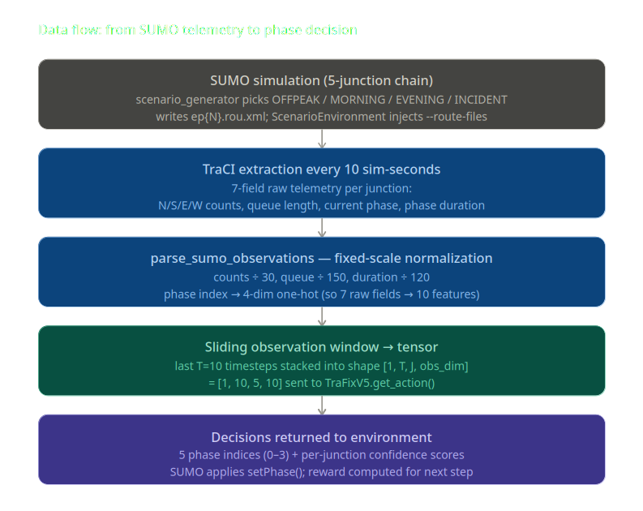

5.2 Data Processing & Algorithms
To handle the complex dynamics of the collected 5-intersection data, we process the raw telemetry using a temporal–graph actor-critic architecture (TraFix v5), implemented in PyTorch, which couples a GRU temporal encoder with a GATConv graph attention encoder feeding a shared MLP trunk and per-intersection actor heads.

5.2.1 Data Normalization and Pre-processing
Before feeding the data to the neural networks, the raw features are normalized to ensure gradient stability. We use fixed-scale normalization to guarantee that training-time and inference-time preprocessing are byte-identical: vehicle counts are divided by 30, queue length by 150, and phase duration by 120 (in seconds), while the current phase index is expanded into a 4-dimensional one-hot vector. This approach replaces the earlier rolling-historical maximum scheme and prevents any drift between the statistics seen during training and those seen during deployment.

5.2.2 Temporal Encoder (GRU) and Graph Attention Encoder (GATConv)
The core algorithm consists of three main pipelines:
- Temporal Encoder (GRU): A Gated Recurrent Unit (hidden dimension of 128) processes a sliding window of the last 10 observation steps for each intersection. This allows the model to "remember" traffic build-ups over time rather than relying strictly on reactive snapshots.
- Spatial Encoder (GATConv): Instead of standard graph convolutions, we implemented a Graph Attention Network (GATConv) with 4 attention heads. This layer maps the 5-node chain graph and calculates attention scores, allowing an intersection to prioritize incoming data from specific neighboring nodes based on real-time traffic correlation.
- Shared Trunk and Actor-Critic Heads: The combined temporal–graph embeddings are passed through a shared Multi-Layer Perceptron (the trunk). Finally, individual Actor heads output the phase probabilities (4 discrete phases) for each intersection, while a single Critic head estimates the global state value from the mean-pooled trunk output.

Figure 2. TraFix v5 model architecture
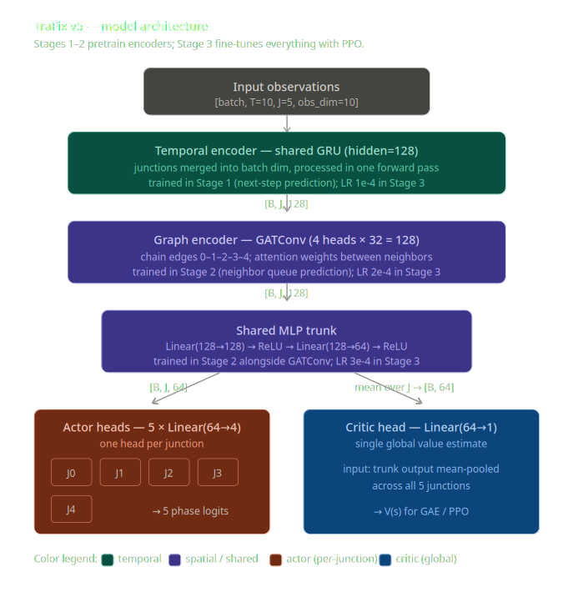

5.2.3 Proximal Policy Optimization (PPO) and Reward Function
The agent is trained using the Proximal Policy Optimization (PPO) algorithm. To prevent the PPO updates from destroying the pre-trained spatial and temporal weights, we implemented a differential learning rate strategy (e.g., 1e-4 for GRU, 3e-4 for Actor/Critic).
The reinforcement learning reward function is mathematically formulated to maximize throughput while maintaining fairness. It heavily penalizes total queue length and directional pressure. Additionally, we integrated a Green Wave Bonus, which provides extra reward points when adjacent intersections synchronize their green lights along the same axis, directly optimizing traffic flow.

5.3 Data Analysis
We conducted a comprehensive analysis of the training outputs (training_log.csv and training_history.json) to verify the learning progression of the TraFix v5 algorithm.
The initial state of the system without an optimized policy (Episode 0) exhibited severe traffic congestion. The baseline data showed an average waiting time of 108.03 seconds and an average vehicle speed of only 0.43 m/s, resulting in over 222 halting vehicles.
However, as the PPO algorithm updated the policy using the defined reward function, the data analysis revealed a drastic performance improvement. By Episode 31, the network metrics demonstrated a clear breakthrough in traffic optimization:
- Average Waiting Time: Dropped significantly from 108.03 seconds to 15.53 seconds.
- Average Vehicle Speed: Increased from 0.43 m/s to 2.19 m/s.
- Total Halting Vehicles: Decreased by 75%, dropping from 222 down to 56 vehicles.
This analysis mathematically proves that the GATConv-GRU architecture is successfully processing the telemetry data, learning the network topology, and clearing congestion effectively. The progressive decay of the entropy coefficient (from 0.005 to 0.00496) further confirms that the model is transitioning smoothly from exploration to exploitation.

Chapter 6: Design

6.1 Software Architecture
The software architecture of the TraFix system is designed around a centralized, real-time data processing pipeline. It follows a Client-Server architectural pattern where the simulation environment acts as the data generator (Client) and the FastAPI application serves as the intelligence hub (Server).

6.1.1 System Actors
The architecture consists of five primary actors interacting within a closed reinforcement learning loop:
- Simulation Environment (SUMO): The physical or simulated environment that acts as the data producer and the executor of traffic light commands.
- Perception Module (YOLOv8 & OpenCV): Responsible for computer vision tasks. In a real-world deployment, this actor detects vehicles and calculates lane queues. In the current iteration, this is mocked via SUMO's TraCI interface.
- API Gateway (FastAPI Backend): The middleware state-builder that receives asynchronous HTTP payloads, normalizes the raw data, and constructs the 5×10 graph feature tensor.
- Decision Engine (AI Agent): The PyTorch-based temporal–graph (GRU + GATConv) actor-critic network and PPO agent that processes the state tensor and returns phase probabilities.
- Observation Dashboard (End-User): The graphical interface that polls the backend to display live metrics, system state, and AI reasoning to human operators.

6.1.2 Architectural Constraints
- Latency Constraint: Since traffic light decisions must be made in real-time, the end-to-end communication loop (telemetry extraction -> API -> AI inference -> response) must execute well under a 1-second threshold.
- Stateless API Design: To prevent memory leaks during continuous polling, the API operates statelessly for AI inference. It maintains only a lightweight, in-memory state_dict to serve the Dashboard without blocking the main event loop.
- Fault Tolerance (Fallback Strategy): If the PyTorch model weights fail to load, the backend is constrained to strictly switch to a mathematical Heuristic Fallback (Max-Pressure algorithm). This ensures the system never crashes and defaults to providing the longest queue with a green light.

6.2 Views and Diagrams
To address the dynamic interactions between system components, we mapped the architecture using the following perspectives:

6.2.1 Collaboration and Deployment View
The deployment architecture separates the AI/Backend logic from the Frontend visualization. The Python backend runs on a Uvicorn ASGI server. The SUMO simulator sends periodic data payloads (e.g., every 10 seconds) to the POST /telemetry_batch endpoint. This batching mechanism ensures that there are no race conditions between the updates of the 5 different intersections. Once the AI computes the optimal phases, the API returns the decisions directly in the HTTP response body.
Simultaneously, the Frontend Dashboard is deployed as a static web client that performs continuous HTTP polling (every 1 second) to the GET /state and GET /last_decisions endpoints. This decoupled approach ensures that heavy visualization rendering does not impact the strict timing of the AI loop.

Figure 3. TraFix system architecture
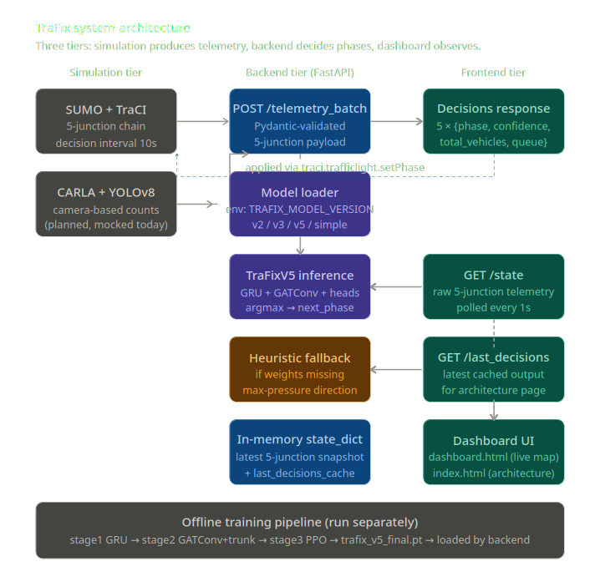

6.2.2 Data and Class View
The core data contract between the modules is defined using Pydantic classes (Telemetry and TelemetryBatch). Each node (intersection) transmits a strict data structure containing:
- intersection_id (Identifier)
- north_count, south_count, east_count, west_count (Directional Flow)
- queue_length (Congestion Metric)
- current_phase, phase_duration (Current Actuation State)
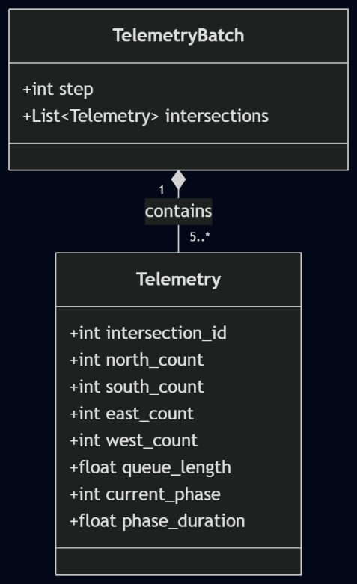
This class structure guarantees that incoming JSON payloads are automatically validated and parsed into the exact 10-feature order required by the PyTorch neural network tensor.

6.3 GUI Design (User Interface)
The Graphical User Interface (GUI) is developed using pure HTML, CSS, and JavaScript, strictly avoiding heavy frontend frameworks to maintain lightning-fast render speeds. The interface is split into two primary views:

6.3.1 Live Traffic Dashboard (dashboard.html)
The main dashboard provides operators with a high-level, real-time overview of the network:
- Interactive Map: A centralized SVG map displays the 5-intersection topology (K1 through K5). Nodes dynamically change size and color (Green for light traffic, Amber for medium, Red for severe congestion) based on the queue_length. The most congested intersection actively pulses to alert operators.
- Metrics Summary Bar: Top-level indicators instantly show the "Total Vehicles," "Busiest Point," "Average Queue," and the "AI Decision Count," complete with trend arrows (up/down) comparing data against the previous polling cycle.
- Focused Node View: Clicking on any intersection on the map slides open a detailed cross-section view. This view renders the active phase arrows, specific vehicle counts per lane, and an animated queue-fill bar.

6.3.2 System Architecture View (index.html)
To provide transparency into the AI's "black box," a secondary architectural view is implemented:
- Animated Data Pipeline: An SVG-based pipeline visualizes the 5-step data flow (Input -> Perception -> Processing -> Decision Engine -> Output). Animated particles flow between nodes to represent active data streams.
- Live Decision Reasoning: A detailed data table logs the immediate decisions made by the AI. It displays the AI's chosen phase (e.g., "NS Green") alongside a confidence percentage bar, allowing traffic engineers to audit the neural network's reliability in real-time.

References
Dosovitskiy, A., Ros, G., Codevilla, F., Lopez, A. & Koltun, V., 2017. CARLA: An open urban driving simulator. In Proceedings of the 1st Annual Conference on Robot Learning (pp. 1-16).
El-Tantawy, S., Abdulhai, B. & Abdelgawad, H., 2013. Multiagent reinforcement learning for integrated network of adaptive traffic signal controllers (MARLIN-ATSC). IEEE Transactions on Intelligent Transportation Systems, 14(3), pp.1140-1150.

Krajzewicz, D., Erdmann, J., Behrisch, M. & Bieker, L., 2012. Recent development and applications of SUMO-Simulation of Urban MObility. International Journal on Advances in Systems and Measurements, 5(3&4), pp.128-138.

Redmon, J., Divvala, S., Girshick, R. & Farhadi, A., 2016. You only look once: Unified, real-time object detection. In Proceedings of the IEEE Conference on Computer Vision and Pattern Recognition (pp. 779-788).

Robertson, D.I. & Bretherton, R.D., 1991. Optimizing networks of traffic signals in real time-the SCOOT method. IEEE Transactions on Vehicular Technology, 40(1), pp.11-15.

Wei, H., Xu, N., Zhang, H., Zheng, G., Zang, X., Chen, C., Weinberger, K.Q., Liu, Y. & Zheng, Y., 2019. CoLight: Learning network-level cooperation for traffic signal control. In Proceedings of the 28th ACM International Conference on Information and Knowledge Management (pp. 1913-1922).

