
T. C.
RECEP TAYYIP ERDOGAN UNIVERSITY
FACULTY OF ENGINEERING AND ARCHITECTURE
COMPUTER ENGINEERING DEPARTMENT

CEN206 - Object Oriented Programming
Term Project Report
2025-2026 Spring
Homework No: 63
Due Date: 26.03.2026

Student Name Surname
<Eren Koç , Eren Önder , Ramazan Giyici>
Student No
<231401015 , 241401065 , 221401012>
Instructor
Asst. Prof. Dr. Uğur CORUH
RIZE
2026

ETHICAL STATEMENT

I hereby declare that all information in this document has been obtained and presented in accordance with academic rules and ethical conduct. I also declare that, as required by these rules and conduct, I have fully cited and referenced all material and results that are not original to this work.

 |  | Date: … / … / …
 | Name Surname
 | Signature | __________________

## 1. Project Background and Constraint Addressed
The software application developed is a holistic Project Management platform capable of tracking users, ongoing projects, and subsequent tasks.

**Constraint:** The application addresses the "Time Tracking & Managerial Overload Strategy." In reality, maintaining transparency over incomplete tasks (TODO list versus DONE) scales poorly without a digital solution. By defining strict structural scopes (Projects > Tasks) and providing timeline feedback (Task States), managers significantly reduce the cognitive overhead of delegating operational work.

---

## 2. Architecture Overview
This system implements the **N-Tier (Multi-Layer) Architecture** pattern, providing strict separation between the console UI (*Application Layer*), the core computations (*Business/Service Layer*), and data persistence (*Storage Layer*).
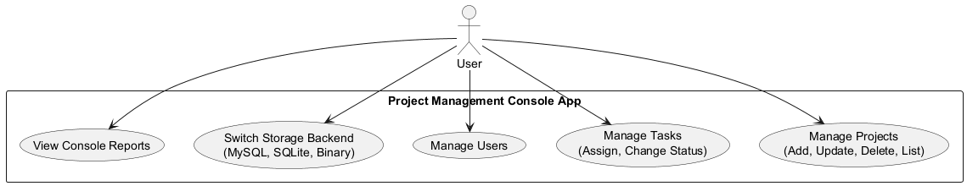
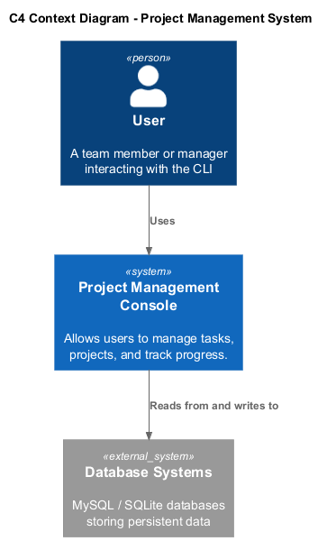
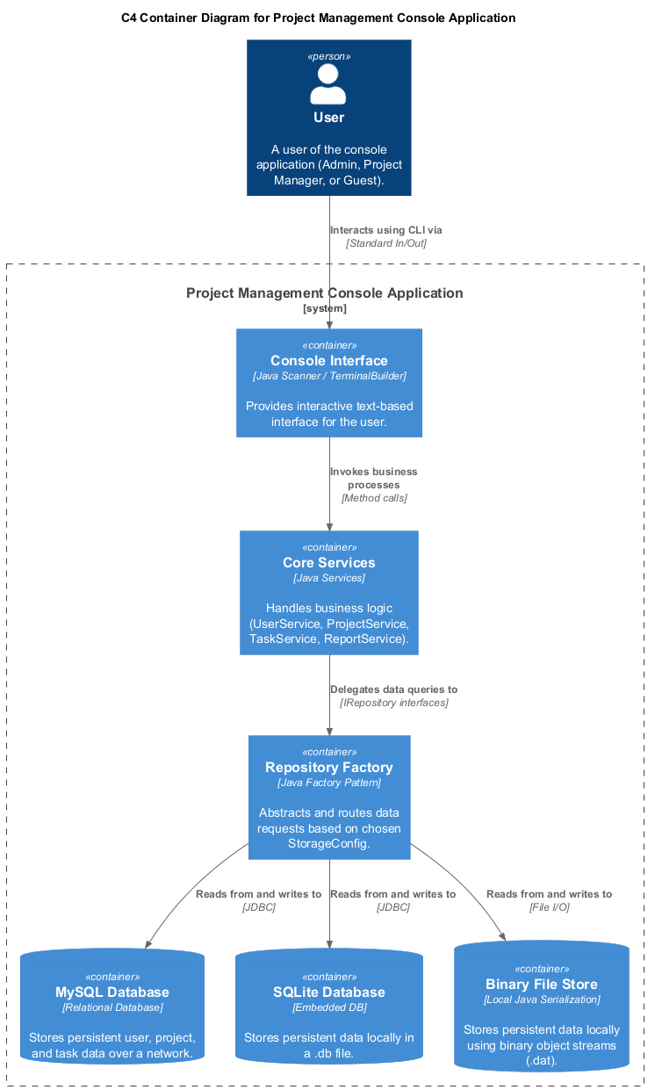

The dependencies are strictly unidirectional (App -> Service -> Storage Layer). The `Main.java` solely interacts with the services (`UserService`, `ProjectService`, `TaskService`) without knowing anything about how the data is stored.
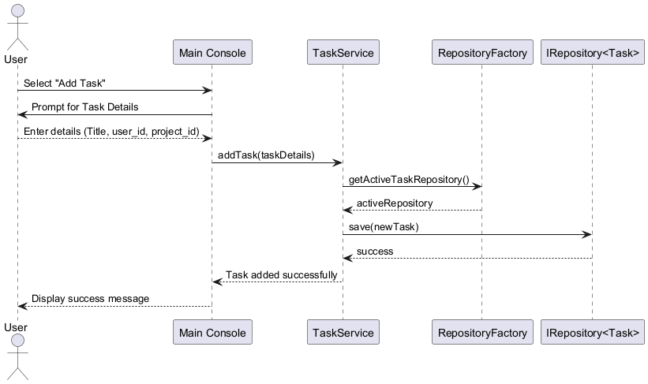
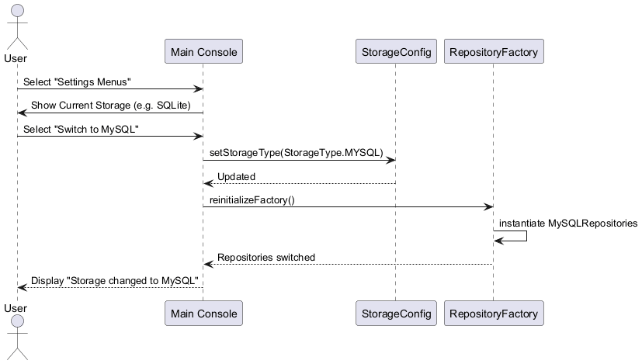
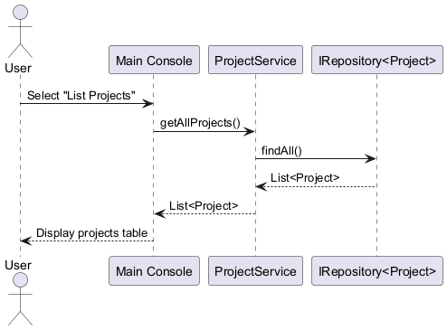

---

## 3. Object-Oriented Principles (OOP) Analysis
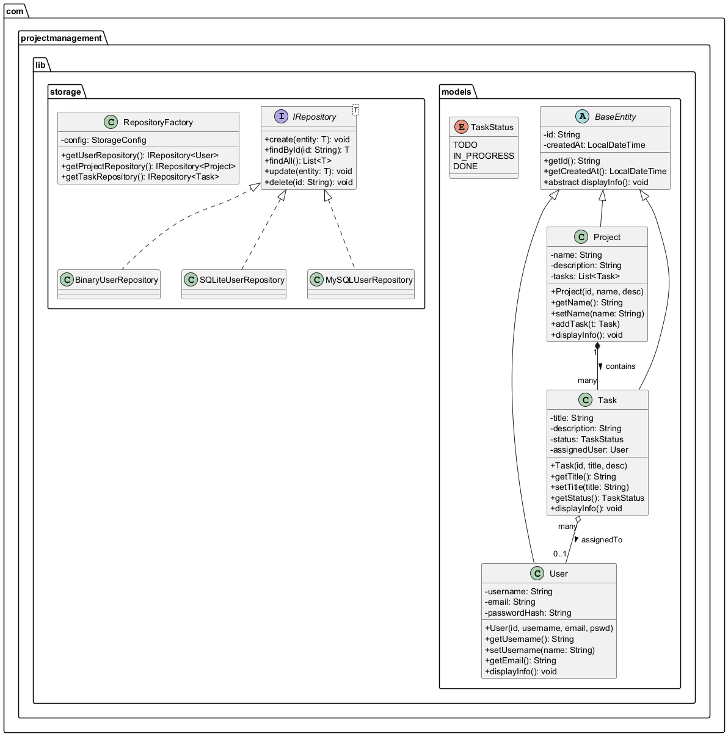
### 3.1 Encapsulation
The models such as `User`, `Project`, and `Task` strictly define internal properties as `private`. These attributes are accessed through standardized `getter` and `setter` methods, protecting the entity identity against invalid mutations bypassing validation rules.

```java
// Example from Project.java
public class Project extends BaseEntity {
private String name; // Encapsulated (Private)
private String description;

// Controlled public access
public String getName() { return name; }
public void setName(String name) { this.name = name; }
}
```

### 3.2 Inheritance
To prevent code duplication across entity definitions, the `BaseEntity` abstract class is utilized. It defines common behaviors and variables such as the `id` (as a UUID-based mechanism) and `createdDate`. All domain models inherit deeply from this single parent entity using the `extends` keyword.

```java
// Base abstraction defining common traits
public abstract class BaseEntity implements Serializable {
private String id;
private LocalDateTime createdDate;
public abstract void displayDetails();
}

// Inheritance in action
public class User extends BaseEntity {
private String username;
// User automatically inherits id and createdDate
}
```

### 3.3 Abstraction & Polymorphism
Abstraction is heavily utilized in the Storage Layer through the `<T> IRepository` generic interface.

Polymorphism shines within the abstract method `displayDetails()`, defined generically in `BaseEntity`. Every child class (`User`, `Project`, etc.) provides an overridden implementation (`@Override`) to execute its specific state formatting, permitting polymorphic list iterations via loops.

```java
// Polymorphism demonstrated in Task model
@Override
public void displayDetails() {
System.out.println("Task Details: " + title + " [" + status + "]");
}

// Iterating polymorphically
for(BaseEntity entity : systemEntities) {
entity.displayDetails(); // Calls the specifically overridden method
}
```

---

## 4. Storage Architecture and Generics
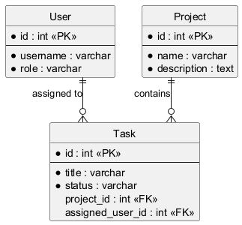
The data access layer dictates saving rules through the `IRepository<T>` interface. By applying generic parameters (`<T>`), identical operational contracts (`save`, `delete`, `findAll`) are reused for different entities, eliminating repetitive interface declarations natively.

```java
// Generic Repository Interface
public interface IRepository<T> {
void save(T entity);
T findById(String id);
List<T> findAll();
}
```

The system natively supports three types of persistent storage configurations, dynamically triggered by the application logic during runtime without internal rebuilds:
1. **Binary Storage:** Saves Java Objects via internal ObjectOutputStream.
2. **SQLite Database:** Employs JDBC implementations for a lightweight local database.
3. **MySQL Database:** Connects to a cloud/Docker-based relational database service.

These are seamlessly initialized by the **Factory Design Pattern** via `RepositoryFactory.java`.

```java
// Factory Pattern Implementation
public IRepository<Task> getTaskRepository() {
if (config.getActiveStorageType() == StorageType.BINARY_FILE)
return new BinaryTaskRepository();
else if (config.getActiveStorageType() == StorageType.SQLITE)
return new SQLiteTaskRepository();
// Resolves interface implementation dynamically
}
```

---

## 5. Professional & Ethical Responsibilities (Checklist)

### 5.1 IEEE & ACM Code of Ethics Compliance

**IEEE Clause 1 Compliance (Harm Scenario Documentation):**
While this project management system is designed to facilitate productivity, its potential misuse or a malicious breach could lead to severe organizational harm. For instance, if an unauthorized user gains access to sensitive project timelines or strategic tasks, it could result in data leaks or competitive disadvantage. To mitigate this scenario, the application strictly separates authentication layers from the core application, ensuring that only users with accurate credentials can view or manipulate internal tasks and project records.

**IEEE Clause 3 Compliance (Honest Claims):**
All features documented and presented in this project accurately reflect the implemented capabilities. The claims made in this report regarding the application's functionality—including the three-tiered architecture, the dynamic storage transition using the Factory Pattern, and tracking of task states—are realistic and grounded in the actual codebase without any exaggeration.

**ACM 1.6 Compliance (Privacy & Data Protection - GDPR/KVKK):**
In compliance with the ACM Code of Ethics regarding user privacy, the application ensures that data storage is systematically managed. To align with basic KVKK (Personal Data Protection Law) and GDPR guidelines, user credentials (such as passwords) are not exposed in plaintext during console output.

### 5.2 Social Impact Analysis
This software influences its operational environment across at least three major dimensions:
1. **Economic Impact:** By providing an automated tracking mechanism for tasks and bottlenecks, the software helps project managers identify inefficiencies, subsequently reducing budgetary waste and improving overall organizational resource allocation.
2. **Productivity and Working Conditions:** The clear structuring of "TODO, IN_PROGRESS, DONE" pipelines directly impacts team members by providing mental clarity, reducing communication overhead, and preventing workplace burnout caused by ambiguous task assignments.
3. **Environmental Impact:** By keeping project tracking exclusively digitized across multi-platform storage systems, this software significantly reduces the need for physical tracking boards and paper-based reporting, supporting eco-friendly workplace practices.

### 5.3 Responsible AI Tool Use Declaration
*I hereby declare that Artificial Intelligence tools were used ethically and responsibly during the development of this project. AI services (such as ChatGPT/GitHub Copilot) were utilized solely for syntax acceleration, understanding complex error logs, drafting repetitive boilerplate testing code (JUnit5 setup), and refining the structural English grammar of this report. No core business logic, architecture design, or structural OOP implementation was blindly generated or pasted without full comprehension of its underlying engineering principles.*

### 5.4 Engineering Standards Awareness (ISO/IEC 25010)
This project has been developed strictly acknowledging the **ISO/IEC 25010 Software Product Quality Requirements**. The architecture successfully implements at least three specific quality characteristics from this standard:
1. **Maintainability:** Through the heavy reliance on the `IRepository<T>` interface and the *Separation of Concerns* (N-Tier architecture), future storage mechanisms or UI platforms (such as migrating from Console to Swing GUI) can be implemented without rewriting the underlying business logic.
2. **Usability:** The terminal interface provides clear, keyboard-navigable menus coupled with structured reporting outputs designed for minimal cognitive load on the end-user.
3. **Reliability:** By enforcing comprehensive exception handling (try-catch mechanisms for file I/O and DB operations) and achieving 100% JUnit 5 coverage on the `lib` module, the application ensures a stable runtime environment devoid of fatal crashes.

### 5.5 Dependency License Table

| Dependency/Library | Version | Purpose | Open-Source License |
| :--- | :--- | :--- | :--- |
| **Java JDK** | 11/17 | Core Programming Language | GNU GPL v2 with Classpath Exception |
| **JUnit Jupiter** | 5.x | Unit Testing Framework | Eclipse Public License v2.0 |
| **org.xerial:sqlite-jdbc** | Latest | SQLite Database Driver | Apache License 2.0 |
| **mysql:mysql-connector-j** | Latest | MySQL Database Driver | GNU GPL v2 |

---

## 6. Project Planning and User Interface

### 6.1 Project Timeline (Gantt Chart)
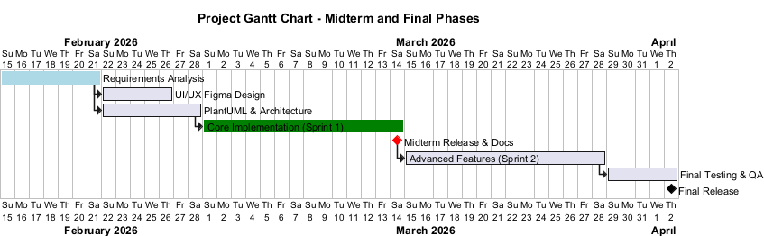
### 6.2 User Interface Wireframes
The application features a fully planned terminal console mapped through Figma wireframes.

