Business Requirements Document
Automatic Processing of Transport Requests
From customer email to order in the TMS, with a person always in control
Item | Details
For | Freight forwarder in Munich (name anonymised)
Prepared by | Eren Tarak
Version / Date | 3.0 / 27 September 2026
Status | Working prototype, tested end to end with test data
Contents
Abbreviations 2
1. Summary 2
1.1 The problem today 2
1.2 The solution 3
1.3 Status of this document 3
1.4 Before and after 3
2. Goals 3
3. How it works 4
3.1 Process flow 4
3.2 System building blocks 5
3.3 Who works with the system (use case diagram) 6
4. What the prototype includes 7
4.1 Included and tested 7
4.2 Not included on purpose 7
4.3 Prototype tools and their real-life replacement 8
5. What the system must do 9
6. Safety rules 9
6.1 Why order acceptance stays manual for now 10
7. How the price is calculated 10
7.1 Example from the live demo 10
8. Data protection (GDPR) 10
9. Benefit and cost 11
9.1 Time saved (example calculation) 11
9.2 Running costs (estimate) 11
10. Next steps 12
11. Open questions for the company 13

Abbreviations
Short forms used in this document, with a simple explanation:
Short form | Full name | What it means
ADSp | Allgemeine Deutsche Spediteurbedingungen | German standard terms for freight forwarders; the offers refer to ADSp 2017.
AI | Artificial Intelligence | Software that can read and understand text, here used to read customer emails.
API | Application Programming Interface | A connection that lets two software systems exchange data automatically.
AVV | Auftragsverarbeitungsvertrag | Data processing agreement. Required by GDPR when an outside service handles personal data.
BRD | Business Requirements Document | This document: it describes what the system should do and why.
CRM | Customer Relationship Management | The system where customer data and contacts are stored.
EU | European Union | Here: servers located inside the EU, for data protection.
GDPR | General Data Protection Regulation (DSGVO) | The EU law for protecting personal data.
LLM | Large Language Model | The type of AI model used to read emails; the prototype uses Claude.
n8n | (product name) | The automation tool that connects all steps of the process.
PDF | Portable Document Format | Common file type for documents such as transport orders.
PoC | Proof of Concept | A working prototype that shows an idea works, before real use.
RFQ | Request for Quotation | A customer request asking for a price offer.
Thread | (email term) | A conversation of emails and replies; used to link a customer reply to its offer.
TMS | Transport Management System | The system used to plan and manage transport orders.
m³ | Cubic metre | Unit for the volume (size) of goods.

1. Summary

1.1 The problem today
Every day, customers send transport requests (also called RFQ, request for quotation) by email. Each email looks different: some give the weight, some only the number of pallets, some send a PDF. An employee must read every email, type the data into the CRM (customer system) and the TMS (transport system), look up carrier prices and write an offer. This takes about 12 to 15 minutes per request. It is slow and repetitive, and typing errors can happen. A customer who waits too long may choose a faster competitor.

1.2 The solution
An automation system does the repetitive work. It reads the email, picks out the transport data, recognises the customer, calculates the price from the price list and prepares an offer email. When the customer later confirms the offer, the system recognises this and suggests the next step. After approval, the order goes to the TMS automatically.
Important principle: the system prepares and suggests, a person decides. No email is sent and no order is accepted without an employee.

1.3 Status of this document
The process described in the job posting is built as a working prototype (Proof of Concept, PoC) and was tested end to end with test emails and example prices. This document describes what it does, how it is built and how it could be taken into daily use at a freight forwarder.

1.4 Before and after
The picture compares one transport request today and with the system. The repetitive work moves to the system. The employee keeps the two decisions that matter: sending the offer and accepting the order.
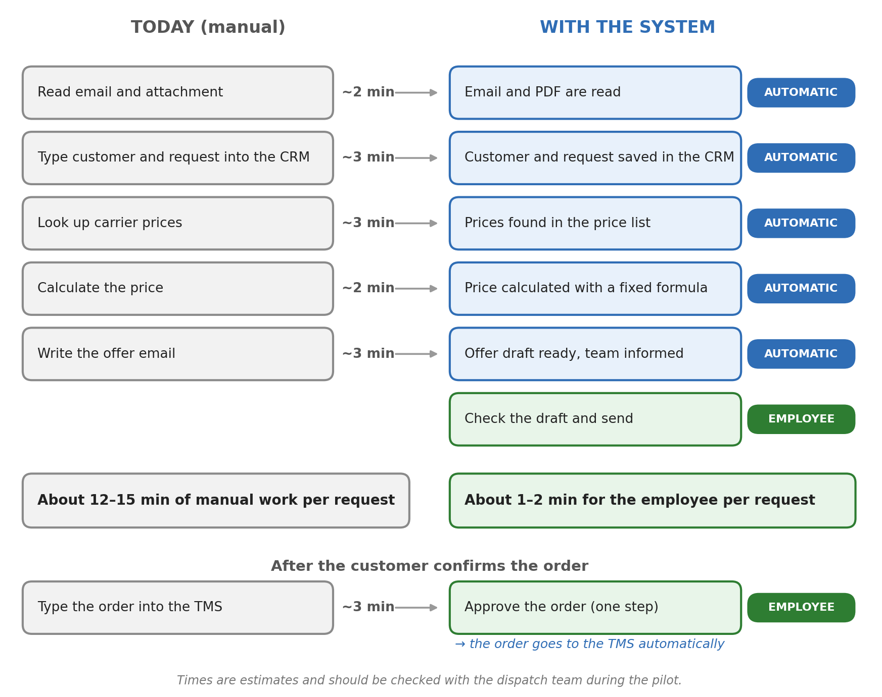
Figure: One transport request today and with the system

2. Goals
- Faster answers: an offer draft is ready about one minute after the email arrives, instead of hours.
- Less typing: request data goes into the CRM and the TMS automatically, so fewer copy-paste errors.
- More time for important work: employees spend less time on routine requests and more on customers and carriers.
- Full control and transparency: a person makes every decision with external effect, and the team is informed about every step.

3. How it works
This chapter shows the system from three sides: the steps of the process (3.1), the parts of the system (3.2), and the people and systems that work with it (3.3).

3.1 Process flow
The process follows the example in the job posting: request by email, data recognised, new or existing customer identified, data saved in the CRM, prices checked, answer draft created, employee checks and sends, confirmed order transferred to the TMS.
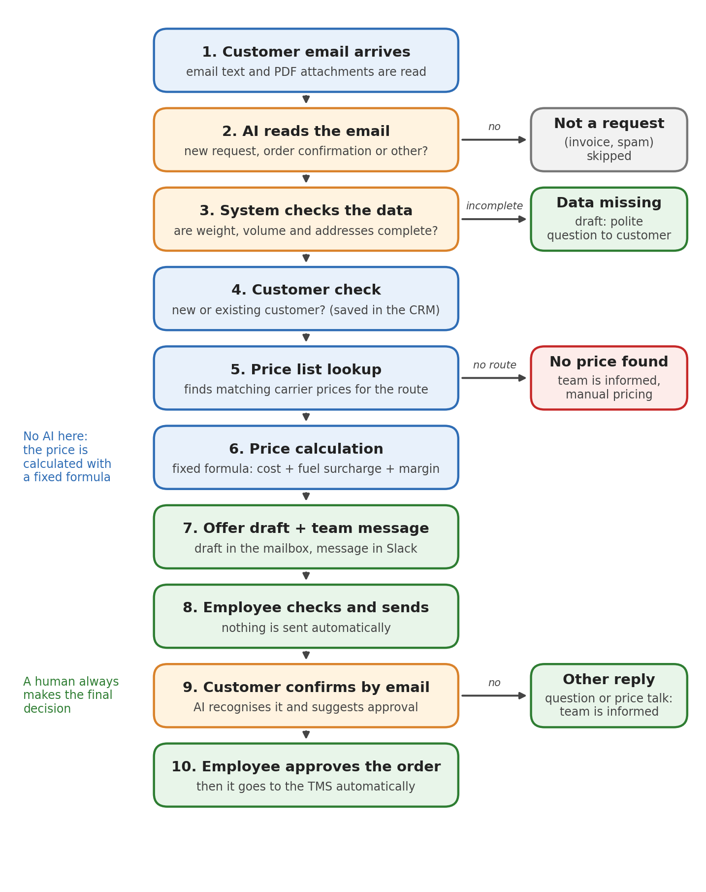
Figure: Process flow, from customer email to order in the TMS
Special cases are handled automatically:
- Not a transport request (for example an invoice or spam): the email is ignored.
- Important data is missing (for example no weight): a polite draft asks the customer for the missing information.
- No price for this route: the system does not guess a price. The team is informed and prices it manually.
- Customer replies to an offer with a question or price request: the reply is never ignored. The team gets a message with the customer's text.

3.2 System building blocks
This picture shows what the system is made of and what it is connected to. Read it from left to right: data comes in on the left, the automation system works in the middle, and on the right are the services it uses.
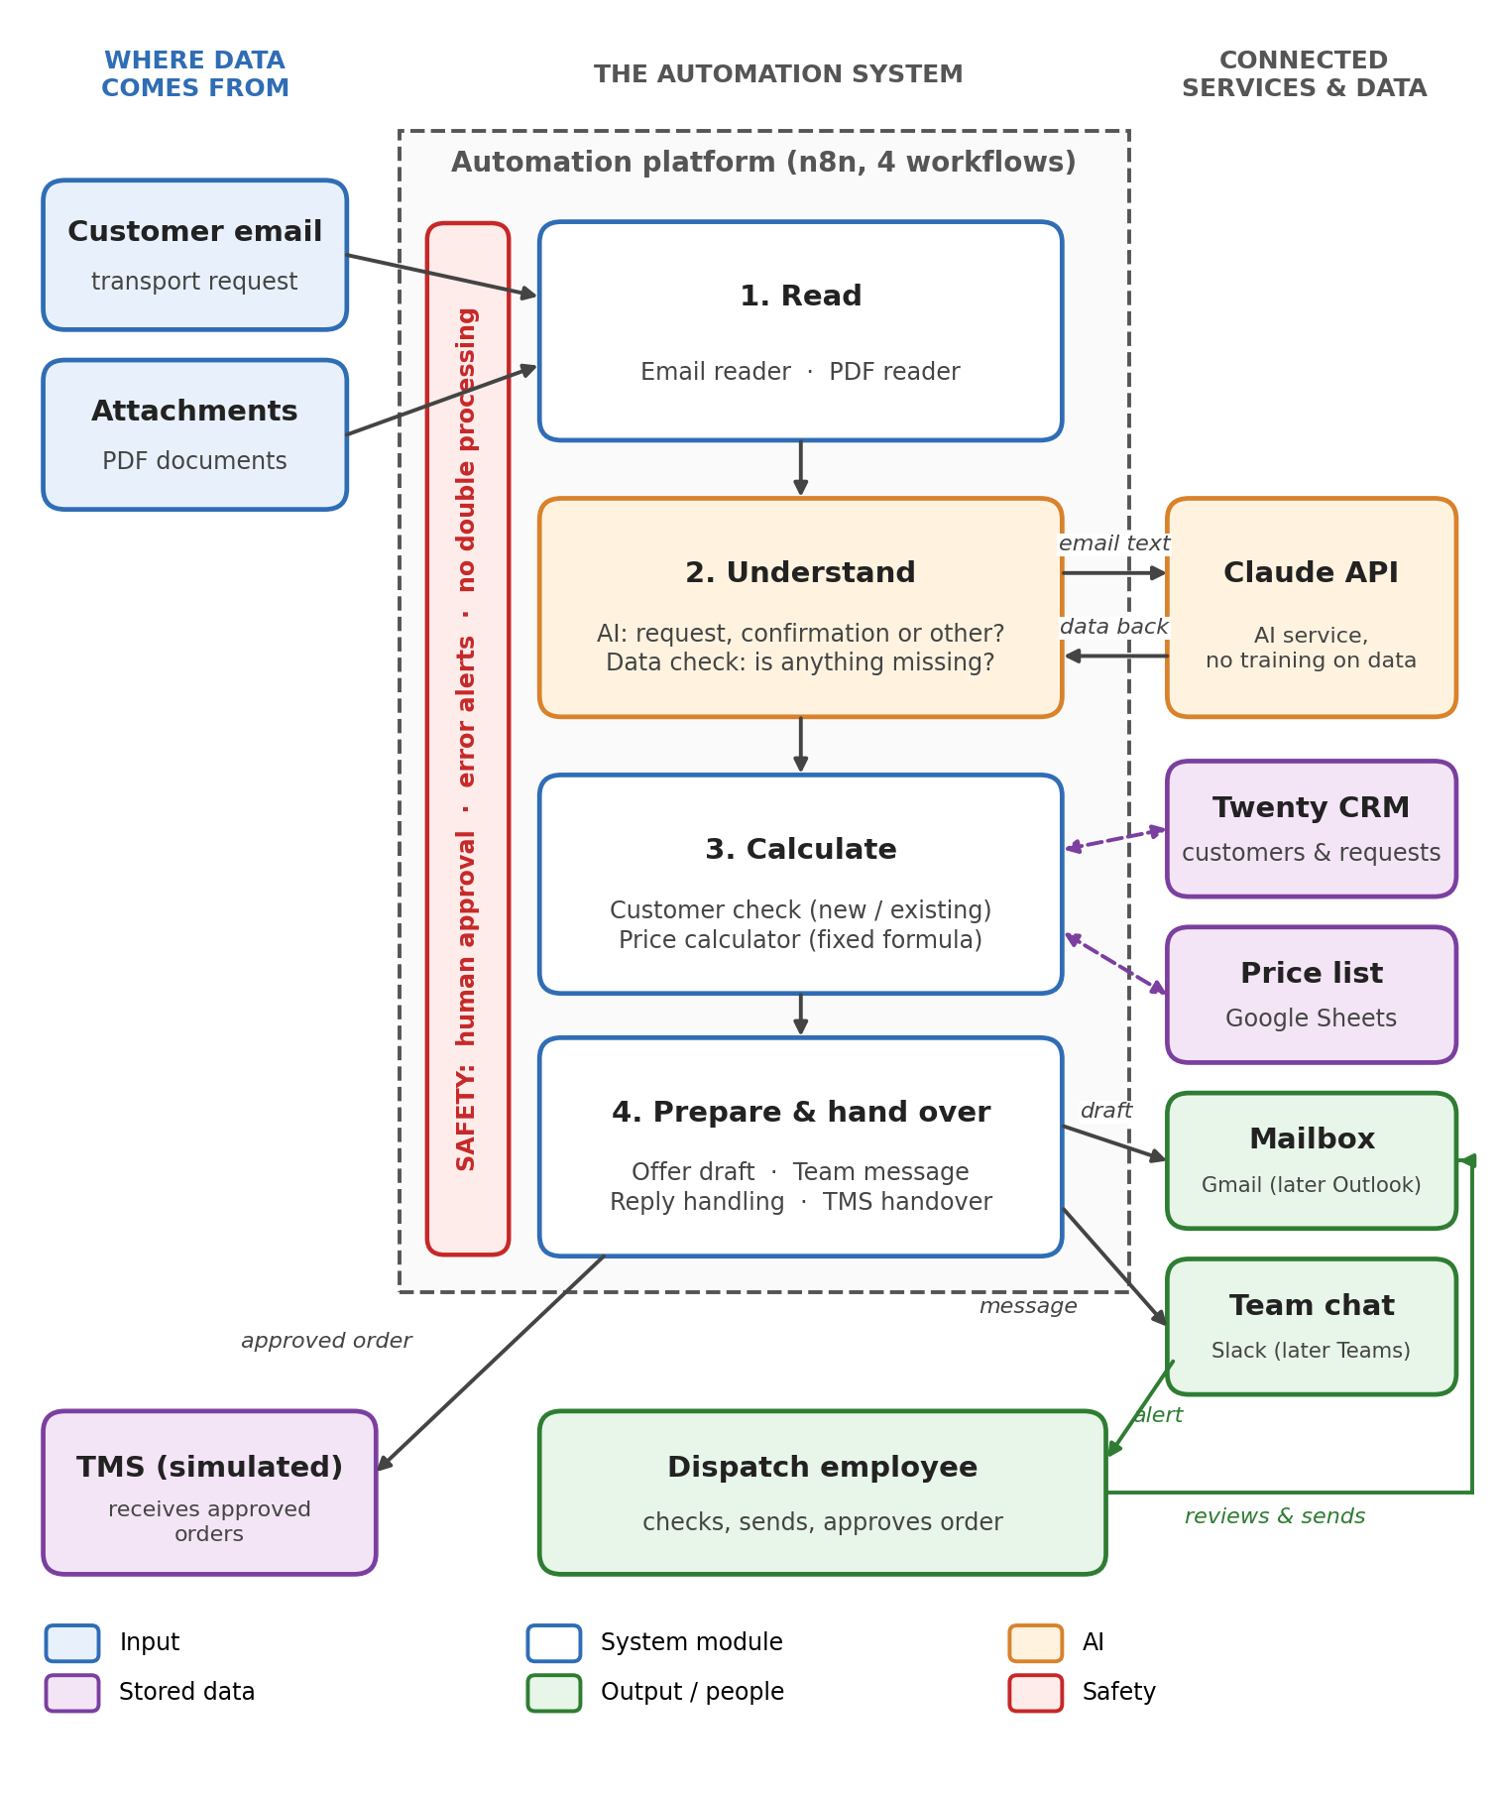
Figure: System building blocks
- Four modules do the work: Read, Understand, Calculate, and Prepare & hand over. Only the Understand module uses AI.
- Four n8n workflows: (1) request intake and offer draft, (2) simulated TMS, (3) approved order to the TMS, (0) error alerts.
- Each part can be exchanged on its own. Gmail can be replaced by Outlook, Slack by Teams, the price list by a database, without changing the logic.

3.3 Who works with the system (use case diagram)
A use case diagram is a standard picture (from UML, the Unified Modeling Language) that shows who works with the system and what they can do with it. It does not show the order of steps; that is shown in 3.1.
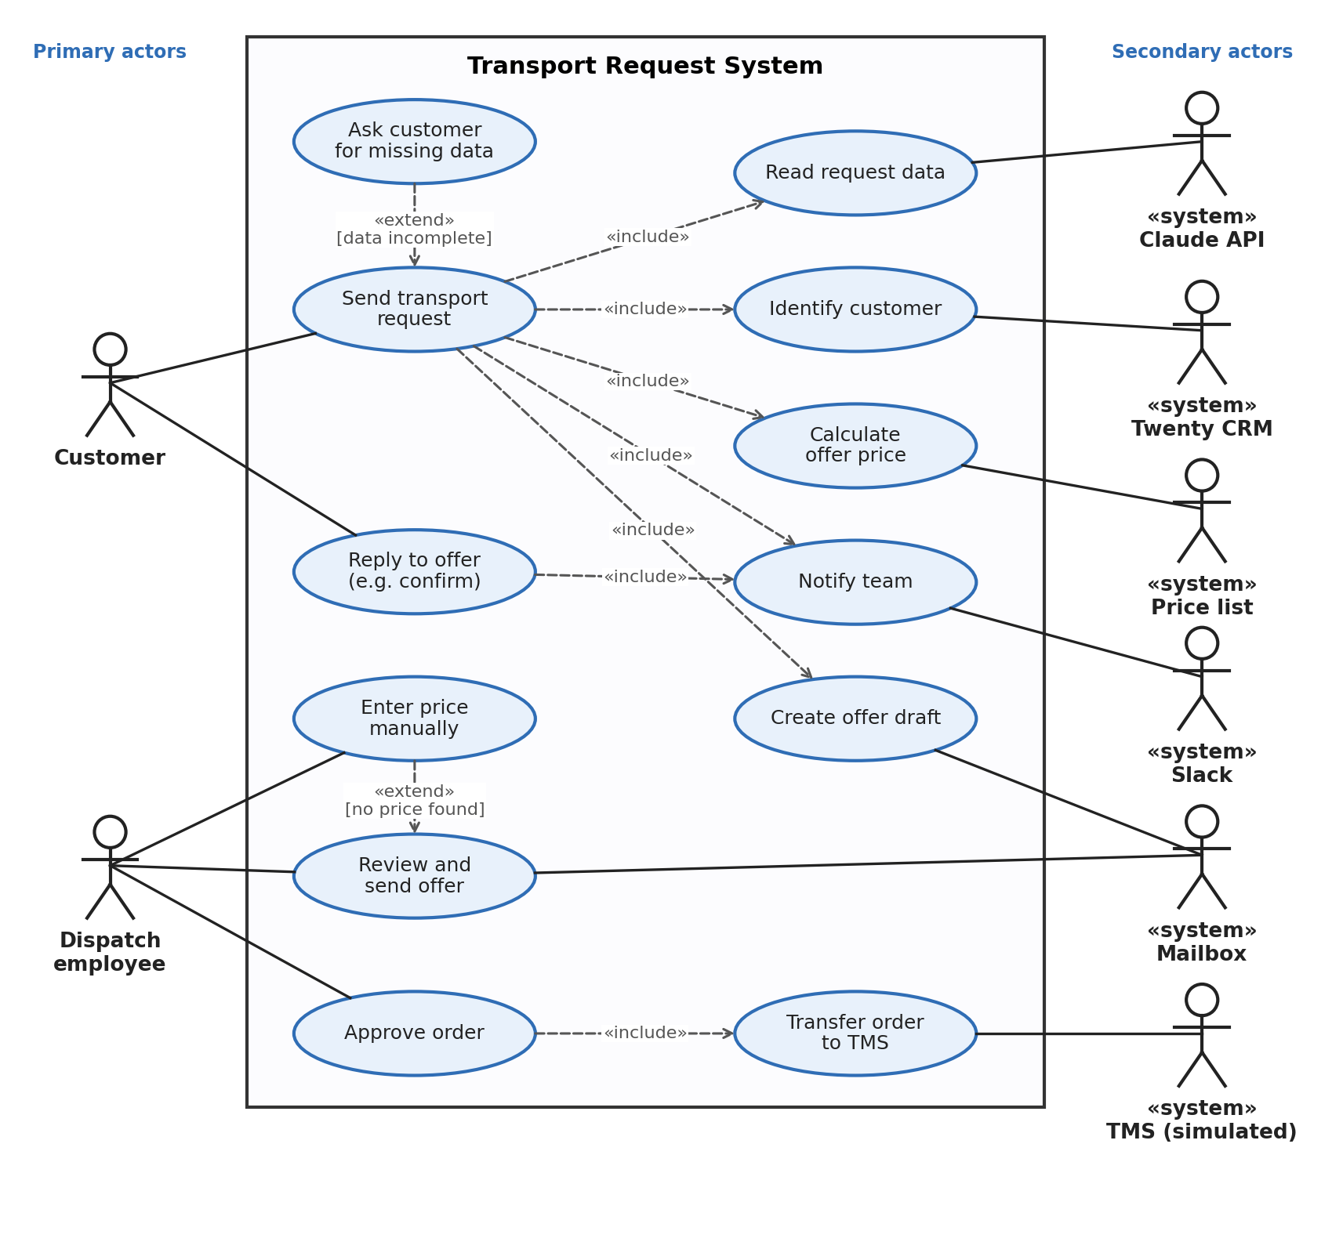
Figure: Use case diagram of the Transport Request System
How to read the diagram:
Symbol | Meaning
Stick figure | An actor: someone or something outside the system that works with it. «system» means the actor is another software system, not a person.
Actors on the left | Primary actors: they start something. The customer sends a request or replies to an offer; the dispatch employee reviews offers and approves orders.
Actors on the right | Secondary actors: services the system needs (Claude API, Twenty CRM, price list, Slack, mailbox, TMS).
Oval | A use case: one thing the system does for its users, for example "Calculate offer price".
Large rectangle | The system boundary: everything inside belongs to the system.
Solid line | The actor takes part in this use case.
Dashed arrow «include» | This step always happens as part of the other one.
Dashed arrow «extend» | This step happens only in a special case; the condition is shown in [square brackets].

4. What the prototype includes

4.1 Included and tested
- Reading incoming emails and PDF attachments automatically.
- AI extraction of transport data in a fixed data format (route, weight, dimensions, pallets, dates, dangerous goods).
- Recognising new and existing customers and saving them in the CRM.
- Price calculation from the carrier price list and offer drafts in German or English.
- Drafts asking for missing data, and messages to the team in Slack.
- Recognising customer replies to an offer and suggesting approval when the customer confirms.
- Handing approved orders to a simulated TMS, which returns an order number that is saved in the CRM.
- Error alerts, and protection against processing the same email or order twice.

4.2 Not included on purpose
- Sending emails without a person. Every offer is checked by an employee.
- Accepting orders without a person. The AI only suggests; the employee sets the order to "won" (see 6.1).
- Connection to the real company systems. The prototype uses the replacements listed in 4.3.

4.3 Prototype tools and their real-life replacement
The prototype uses free or open-source tools that are quick to set up. When they are replaced by the tools the company uses, the logic stays the same; only the connections change.
Task | In the prototype | In production (later)
Mailbox | Gmail | Microsoft Outlook / Microsoft 365
Customer data (CRM) | Twenty CRM, open source, on own server | the existing CRM
Price list | Google Sheets | Excel or a database
Transport system (TMS) | simulated TMS (small n8n service) | the existing TMS
Team message | Slack | Microsoft Teams
AI model | Claude API (Anthropic) | same, with a data processing agreement
Automation engine | n8n in Docker on a laptop | n8n on a secure server in the EU

5. What the system must do
ID | Requirement (in simple words) | Tool
R-01 | Notice new emails in the mailbox automatically. | n8n email trigger
R-02 | Read the text of PDF attachments. | n8n file extractor
R-03 | Separate the new text of a reply from the quoted older emails below it. | n8n code step
R-04 | Decide if the email is a transport request, an order confirmation or something else. | AI model (LLM)
R-05 | Pick out the transport data in a fixed format: customer, addresses, weight, dimensions, pallets, goods, dates. | AI with structured output
R-06 | Check that the most important data is present. Done by normal code, not by the AI. | n8n code step
R-07 | Recognise new or existing customers and save new customers. | Twenty CRM
R-08 | Find carrier prices for the route and calculate the price. | Price list + n8n code step
R-09 | Create an offer draft (or a "missing data" draft) in the customer's language. | Mailbox connection
R-10 | Save each request in the CRM, together with the email thread it belongs to. | Twenty CRM
R-11 | Recognise replies to an offer; suggest approval when the customer confirms. | Email thread + AI + keywords
R-12 | Send only approved orders with complete data to the TMS, never twice. | n8n + TMS interface
R-13 | Inform the team about every relevant step in the team chat. | Slack (later Teams)
R-14 | Report problems with connected systems to the team immediately. | n8n error workflow

6. Safety rules
These rules make sure the system helps the team and never creates risk with customers:
- A person decides everything with external effect. The system creates drafts and suggestions. Only an employee sends an offer or accepts an order.
- The AI never calculates prices. The AI only reads the email. The price comes from a fixed, checkable formula.
- No price is invented. If a route is not in the price list, the team prices it manually.
- Missing data is asked for, not guessed.
- Customer replies are never lost. A reply in an email thread where an offer was sent always reaches the team. This rule is based on the CRM record, not on the AI.
- Nothing is processed twice. Every email is processed once, and the TMS rejects an order it already has.
- Only complete orders go to the TMS. Orders without route, weight or price are held back.
- No problem stays silent. If a connected system is not reachable, the team is informed at once.

6.1 Why order acceptance stays manual for now
Accepting an order is legally binding and causes costs, for example the booking of a carrier. A wrong acceptance is expensive; a wrong suggestion is not. That is why automation should grow step by step, based on measured results:
Stage | What happens | When
1. Suggestion (prototype) | The AI recognises the confirmation and suggests approval; the employee moves the order to "won". | Pilot phase: accuracy is measured.
2. One-click approval | The suggestion arrives in Teams with an "approve" button. | When suggestions are reliably correct.
3. Rule-based automation | Standard cases are accepted automatically, for example: existing customer, unconditional confirmation, valid offer, no dangerous goods. Everything else stays with the employee. | When enough data and trust exist.

7. How the price is calculated
In transport, the price is not based only on the real weight. Light but bulky goods take a lot of space in the truck. That is why the chargeable weight is used: the higher value of real weight and "volume weight".
Formula used in the prototype:
- Volume weight = volume in m³ × 333 kg
- Chargeable weight = the higher value of real weight and volume weight
- Carrier cost = chargeable weight × price per 100 kg (at least the minimum price), plus fuel surcharge
- Offer price = carrier cost + margin (the margin can be set per customer in the CRM)
- If several carriers serve the route, the cheapest valid one is chosen; expired prices are not used.

7.1 Example from the live demo
3 euro pallets of 120 × 80 × 120 cm, about 1.2 t, from Munich to Vienna.
Step | Result
Volume: 3 × 1.2 m × 0.8 m × 1.2 m | 3.46 m³
Volume weight: 3.46 m³ × 333 kg | 1,151 kg
Chargeable weight: higher of 1,200 kg and 1,151 kg | 1,200 kg
Carrier B: 1,200 kg × €13.90 per 100 kg | €166.80
Plus 9% fuel surcharge (carrier cost) | €181.81
Plus 15% margin (offer price) | €209.08
The factor 333 kg per m³, the margins and all prices are example values. The company's real values would replace them.

8. Data protection (GDPR)
Customer emails contain personal and business data, so data protection is part of the design:
- The AI (Claude API) is used through a business interface. Data sent this way is, by default, not used to train the AI models.
- For real use, a data processing agreement (AVV) is signed with the AI provider. Stricter options such as zero data retention can be agreed if needed.
- The AI only receives the email text needed for the task; prices and customer history stay in the company's own systems.
- The CRM (Twenty) and the automation engine run on own servers, for real use in the EU, so customer data stays under the company's control.
- The prototype uses only test data, no real customer data.

9. Benefit and cost

9.1 Time saved (example calculation)
The number of requests per month is an assumption and should be replaced with the real number.
Item | Value
Requests per month (assumption) | 1,500
Time today per request | about 12 to 15 minutes
Time with the system (checking the draft) | about 1 to 2 minutes
Time saved per month | about 250 to 350 hours

9.2 Running costs (estimate)
Item | Cost per month
AI usage (well under 1 cent per email, measured in tests) | about €5 to €15
Server in the EU for n8n and the CRM | about €10 to €20
Twenty CRM, n8n (open source, self-hosted) | €0 licence costs
Total | about €35 or less
Emails with long PDF attachments cost a little more. Costs of tools the company already uses (Microsoft 365, CRM, TMS) are not included.

10. Next steps
The prototype is finished. The following plan assumes about 10 to 15 working hours per week. The timing depends on access to the real systems.
Step | What happens | Rough duration
1. Prototype | Working system with test data, tested end to end. Done. | done
2. Pilot | Run in parallel with real (anonymised) company emails and price lists. Measure how often data and confirmations are recognised correctly. The team works as usual. | 2 to 3 weeks
3. Connect | Switch to Outlook and Teams, connect the real price lists, CRM and TMS. | 2 to 3 weeks
4. Go live | Use in daily work, short guide for the team, monitoring. | 1 to 2 weeks
5. Later | One-click approval in Teams (see 6.1), carrier database, saving and analysing historical spot and purchase prices. | step by step

11. Open questions for the company
To adapt the system to real work, these answers would help:
- How many transport requests arrive per day or month?
- Which CRM and which TMS are used today, and do they offer an API?
- In which format do carrier price lists arrive (Excel, PDF, email)?
- Which volume factor (kg per m³) and which margins are used?
- What types of transport are most common (part loads, full trucks, pallets, international)?
- How do customers usually confirm orders (email reply, phone, portal)?
- Who checks and approves offers and orders today?

