A Statistical Analysis of the Airbnb Prices in Istanbul
2365718 BERAT MERT KAYACAN
2364764 EMRE YILDIRIM
2482635 EREN ÜNAL
2365606 MAHMUT ESATDİLİK

Abstract: This project aims to do a statistical analysis of the AirBnB Prices in Istanbul.

Presentation Link:

INTRODUCTION

Research Question, Its Importance and Background Information

In recent years, platforms for short-term rental houses such as Airbnb have become increasingly popular in the tourism industry. Airbnb is one of the largest platforms that allows the property owners to rent their homes and rooms to tourists or travelers for short periods. Because of Istanbul being a major tourist destination in the world, it has a large and active Airbnb market. Airbnb prices may vary depending on different factors such as its neighbourhood, room type and review numbers. Research question in this sense is: What factors have a significant impact on Airbnb listing prices in Istanbul?
Understanding the factors that influence Airbnb prices in Istanbul is important for both hosts and customers. The findings of this research may help hosts to make better pricing decisions and also help customers to use this information to understand the relationship between the Airbnb listing features and the Airbnb prices.

Objectives of the Study

The aim of this study is to:
- Examine the relationship between listing characteristics and pricing using statistical analysis.
- Identify the factors that significantly affect the Airbnb listing prices in Istanbul.
- Compare Airbnb prices across different features of the data.

The Data

The dataset used in this study is a single comma seperated values (CSV) file that consists of Airbnb listings in Istanbul obtained from InsideAirbnb, a database that provides publicly available Airbnb data. There are 15 columns and 22865 rows in the cleaned version of the dataset. The variables include id, host_id, neighbourhood, latitude, longitude, room_type, price, minimum_nights, number_of_reviews, last_review, reviews_per_month, calculated_host_listings_count, availability_365, number_of_reviews_ltm and side. Our target variable “price” is measured in Turkish Liras (₺).

DATA COLLECTION & DESCRIPTION

Data Collection

The dataset used in this study is collected from InsideAirbnb, a secondary data source that provides detailed information about the listings of Airbnb across different cities in the world. It contains 22867 Airbnb listings, which is a large subset of all Airbnb listings in Istanbul. Therefore, this dataset can be considered as a sample dataset rather than the population because listings are continuously updated, and this dataset is lastly updated on September 29, 2025.

Summary Statistics

The summary statistics of the variable “price” is shown in Table 2.1.

STATISTIC | VALUE
Mean | 2752.049
Median | 2412
Mode | 2000
Variance | 2531678
Standard Deviation | 1591.125
Minimum | 80
1st Quartile | 1581
3rd Quartile | 3602
Maximum | 7787
Range | 7707
Interquartile Range | 2021
Coefficient of Variation | 0.5782
Table ‎2.1 Summary Statistics

Data Visualizations

The histogram and boxplot are shown along with the necessary R code in Figure 2.3.1, Figure 2.3.2, Figure 2.3.3 and Figure 2.3.4.

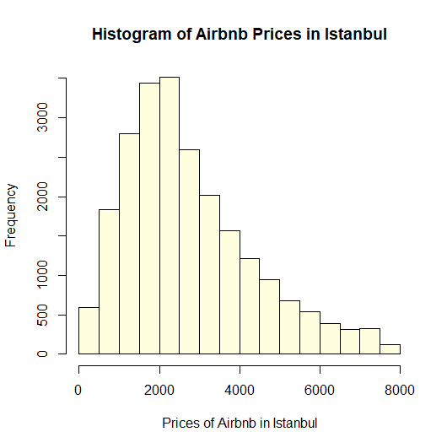
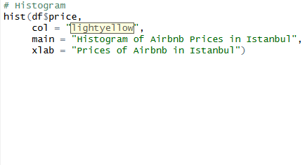
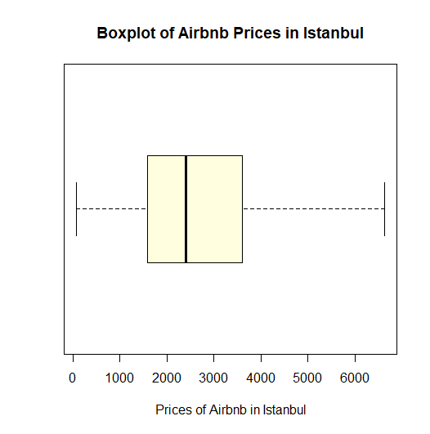
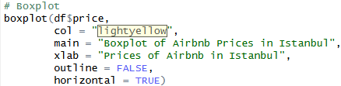
Figure ‎2.3.2 Boxplot
Figure ‎2.3.4 R code for boxplot
Figure ‎2.3.1 Histogram
Figure ‎2.3.3 R code for histogram

FREQUENCY DISTRIBUTION

Range, Width, Class Limits and Boundaries

The range of the prices are 7707₺. The class limits and class boundaries are given in the table below with the necessary R code.
FREQUENCY | CLASS BOUNDARIES
288 | [0,400)
1343 | [400,800)
1738 | [800,1200)
2522 | [1200,1600)
2780 | [1600,2000)
2701 | [2000,2400)
2352 | [2400,2800)
1886 | [2800,3200)
1533 | [3200,3600)
1208 | [3600,4000)
976 | [4000,4400)
808 | [4400,4800)
664 | [4800,5200)
485 | [5200,5600)
431 | [5600,6000)
342 | [6000,6400)
251 | [6400,6800)
262 | [6800,7200)
208 | [7200,7600)
87 | [7600,8000)
Table ‎3.1.1 Class Boundaries

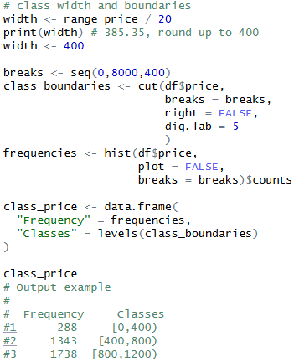
Figure ‎3.1.1 R Code for Class Boundaries

Frequency Distribution Graphs

The frequency polygon and ogive and plots are given in the figures below with corresponding R code.

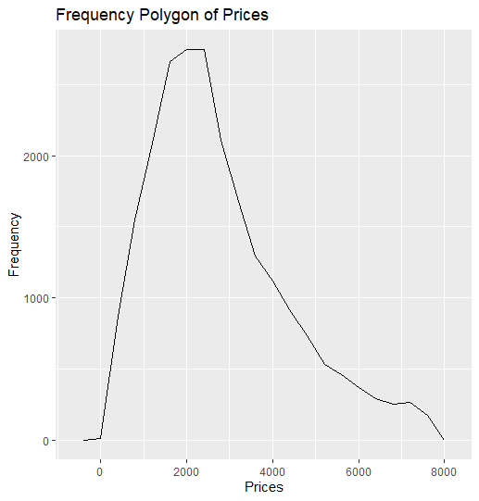
Figure ‎3.2.2 Ogive
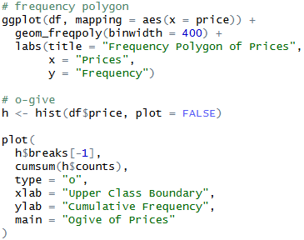
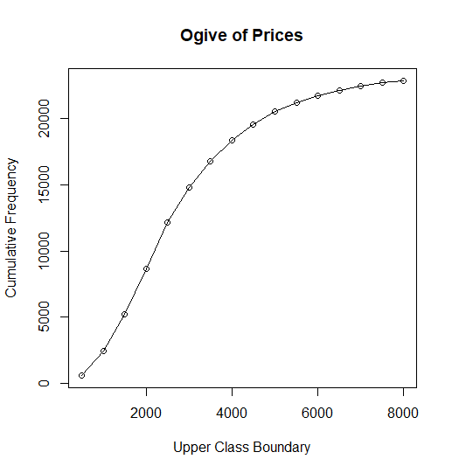
Figure ‎3.2.1 Frequency Polygon

Figure ‎3.2.3 R Code

Shape of the Distribution

The visualizations of the data show that the distribuiton deviates from normality due to the presence of long right tail and we are able to conculde that the prices of the Airbnb houses in Istanbul are heavily right (positive) skewed. The quantitative skewness value is 0.9082 (R code is shown in Figure 3.3.1).
According to the histogram and the frequency polygon, the density of the prices are in the 1000₺-3000₺ range, the mode being 2000₺. The skewness shows us the presence of the high-priced luxury properties or outliers that extend the right tail of the distribuiton and the short left tail suggests that the Airbnb prices in Istanbul are mostly concentrated at lower to moderate prices rather than extremely low prices.
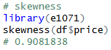
Figure ‎3.3.1

MEASURES OF DATA

Measures of Central Tendency

