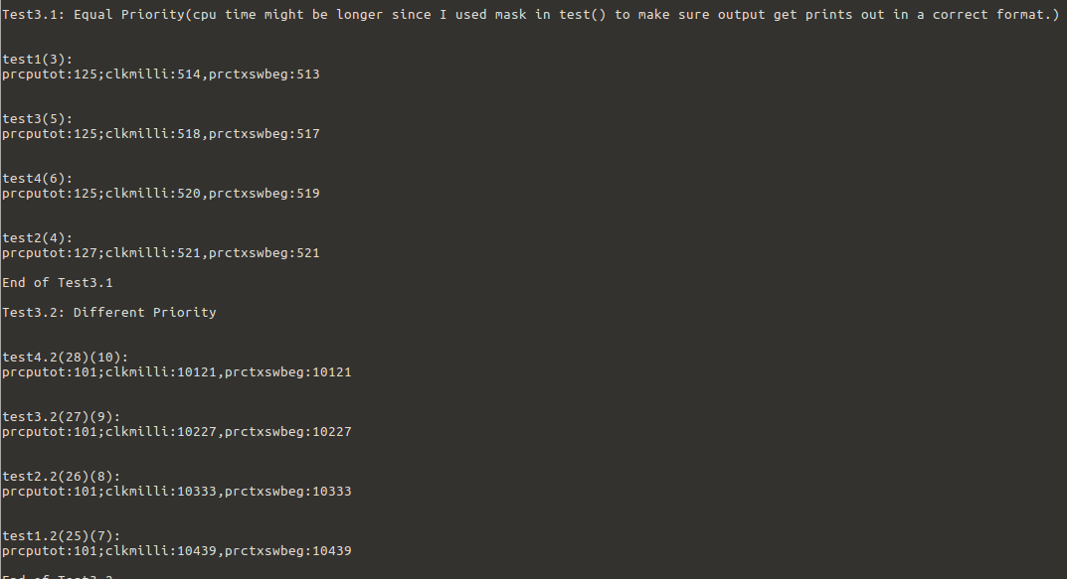
Question 3
Test 3.1, all four processes are spawn with the same priority of 20, and we can see that all 4 processes finished almost at the same moment(based on clkmilli value). They spent around 125 ms each to finish the test.
Test 3.2, on the other hand, all four processes are spawn with different priorities(25,26,27,28), and preforming the exact same task as the one before, but this time, “test4.1” which has the highest priority finished first and so on.
Conclusion, when processes spawned with the same priority, they will share the cpu(round-robin) at the same time to finished the task(by constantly switching in between),while if processes have different priorities, lower priority processes will have to wait until the higher priority task/process is terminated or paused.
This could evidentially cause high priority process with longer time task will end-up using the CPU by itself, causing lower priority process to starve, which is a very bad situation that needs to be addressed.

