Han Wang wang2786(0028451697)

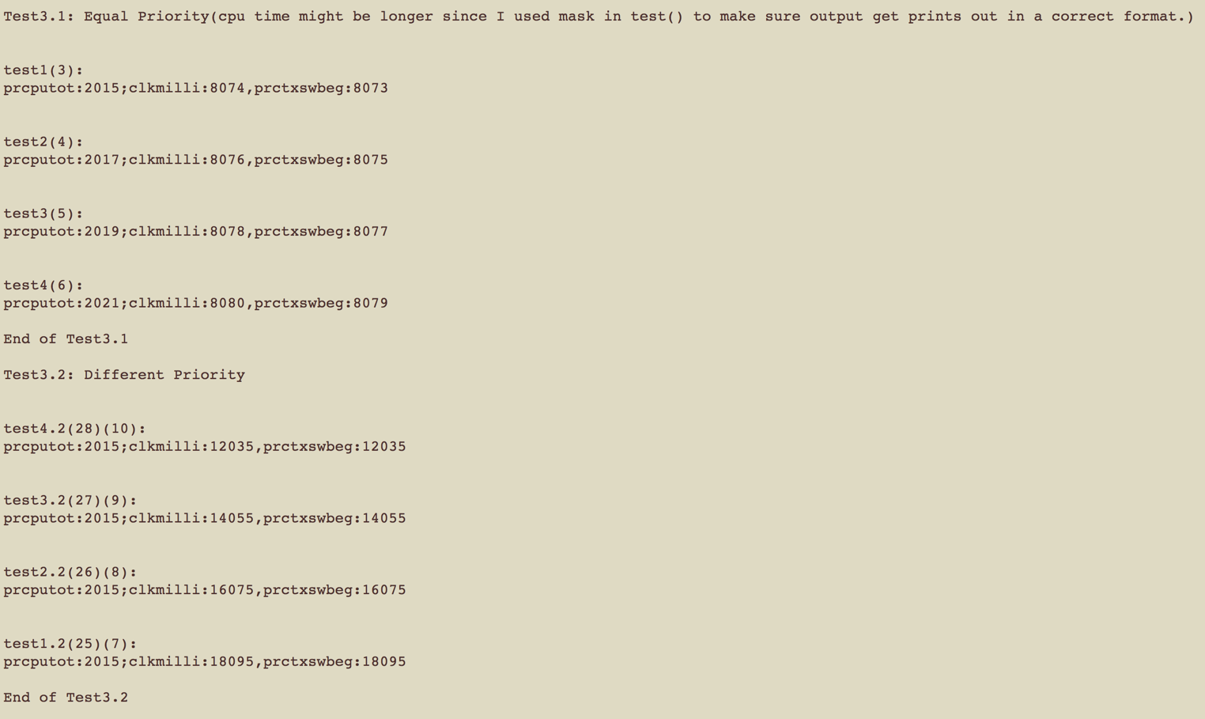

Question 3

Test 3.1, all four processes are spawn with the same priority of 20, and we can see that all 4 processes finished almost at the same moment(based on clkmilli value). They spent around 2021 ms each to finish the test.

Test 3.2, on the other hand, all four processes are spawn with different priorities(25,26,27,28), and preforming the exact same task as the one before, but this time, “test4.1” which has the highest priority finished first and so on.

Conclusion, when processes spawned with the same priority, they will share the cpu(round-robin) at the same time to finished the task(by constantly switching in between),while if processes have different priorities, lower priority processes will have to wait until the higher priority task/process is terminated or paused.

This could evidentially cause high priority process with longer time task will end-up using the CPU by itself, causing lower priority process to starve, which is a very bad situation that needs to be addressed.

Question 4

The output is included in file Q4_OUTPUT.txt. Here is the sample result:

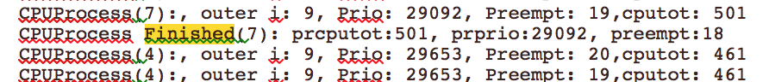



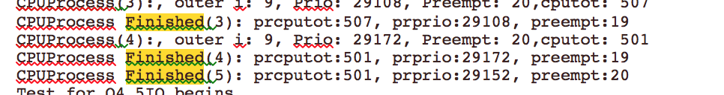

For Q4_5CPU, all processes exchange and sharing the cpu in an alternated fasion, once any process has use cpu for a while and generated longer cpu total time(20ms interval), the priority keep changing and preempt keep counting down from QUANTUM(20) to (1), and cpu replace the current process with the next process in the queue that has MAXPRIO – CPUTOTALTIME. Process finshed the task in 500 ms

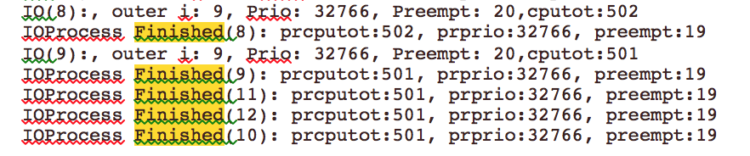

For Q4_5IO, all processes’ priority stayed the same and preempt stay the same(20), so all IO processes switched among themselves and they all finished at the same time. That’s because we have a sleepms() call in the IO test, which pust current process to sleep stage. It mimic when I/O devices like mouse or keyboard interrupt the current process, since they have a high priority. IP process finished around 500 ms.

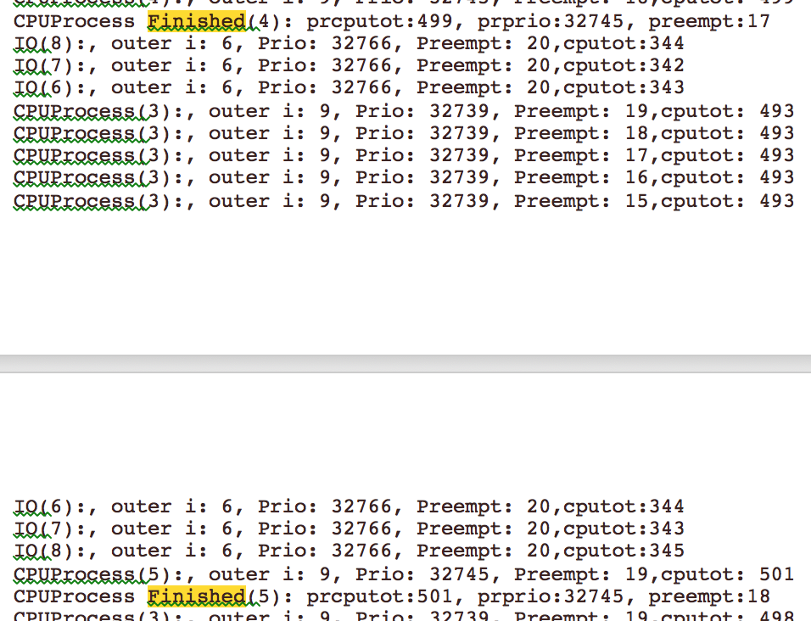

../Desktop/Screen%20Shot%202018-02-27%20at%208.35.15%20PM.png

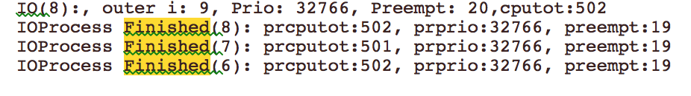

For Q4_3CPU3IO, because IO Processes usually posses the higher priority, if they are not sleeping, they get to use the CPU without interrups, other times, they go the sleep and give way to CPU process to occupie by CPUProcess, within that process, CPU process keep trying to share the CPU among them using QUANTUM time but since the sleep is too short, they end up switch into the next highest process before 20ms. CPU process all finished around the same time, then IO get to finsh after them.(Since IO process sleep and CPU process doesn’t)

This demonstrated that the scheduling method we implemented is very fair, no process is hugging the CPU and let other process to starve. This shows us I/O devices like mouse get to use the CPU without following the scheduling setup for processes, since the input and output for I/O devices are more important.

Bonus Problem

Ans: After research on this topic, I think Rate Monotonic Scheduling is most fitful for our XINU environment, since our system is based on a Round-Robin scheduler. The Rate Monotonic Scheduling it schedule processes in a way that none of the threads will ever exceed their deadline, meaning no matter what the load of the system is, there always a utilization based test that guarantees that the system will always be scheduleable.

* If a system with one process is 100%
* Then a system of 3 processes is approximatedly 69%

The utilization based test make sure that if a process passes the test, it will be scheduleable and vise vesa. In a sense, a RMS scheduling works a lot like the implementation of Q4, which gives the shorstest interval process a highest priority.