***City of youth APP***

Team leader:

Ahmed Mansour Mohamed

Developers:-

* + - * Mohammad Khaled
      * Mohamed montaser
      * Ester andraws
      * Dina ashraf malak

Planning of the project

Our project simulate our life .So , we think about idea that surround us , So that we decided to make an app for help people that work inside any organization , specially people who work on big data .

we decide to make project about city of youth and we supposed imagine information for helping us to construct the base of this project and we follow it through many sprits for dividing the tasks that the team will work on to facilitate the duration of the project ,finally we calculated it and every sprint will take:-

**In first sprint we divide tasks as :-**

Table of Content For The Project Plan

Project Resources:-

*Customer(product owner)*

*1-Manger of the organization*

*2-employee How use the*

*The application*

*Process description*

*Collection of data required to build the application*

*Tools used in the project*

*1-toad database for crating the database*

*2- visual paradigm software to create ERD diagram*

*3 –IDE jdeveloper for*

*Doing the project*

*Risk Management Plan*

*1-there is risk if any one become ill we afford it through give it a short task thant don’t have any efforts and tasks that may be delayed*

*Product/Study Diary*

1. *We use notes and agenda for noting the ideas (two of the team is responsible for this)*
2. *Two of the team responsible for making interview with employee*

*3-one of the team responsible for drawing the schema we*

*Take it to help represent data*

Project planning:-

Scenario of the project:-

we decided to make an interview with the main peoples that form an important role in this project such (students – supervisors of the story – cooker – manger ).

First scenario with a student his name is tarek in the 3rd band he inhabits in this city:-

Developer: - Hi, what's your name?

Student: - I'amTarek.

Developer :- can you tell me the routine of your day in this city and what the thing that make you under the press?

Tarek :- really, I face some obstacles such the daily attendance , the system that the kitchen follow to feed the students , the confirmation of my papers to this organization every year to be a member of this city .

Developer:-can you give me some information in details about your movements to accomplish these tasks?

Tarek :-ok, every day, this require from me to go to the supervisor of the story to enroll myself in the sheet of the attendance by using my ticket and this take a time and if I lost this ticket I will not have the meal of the next day this for attendance, for the kitchen ,there are a chaos in the system because there over-crowded of student and there is a leak of meals because some students have more than one meal by using the ticket of others ,for the enrollment this require from me to travel to the city to apply my paper for the next year and this make me more exhausted.

Developer: - ok, thank you for these information.

Tarek :- thanks

Second scenario with the – supervisors of the store:-

developer:-can I collect from you some of information about the system ?

Mr. Mohamed:-why not?

Developer: - what the procedures that you follow to enroll the student?

Mr. Mohamed :-I use the data sheet for enrollment and this is very boring and this is very better if these data computerized .

Developer:-ok, anything would you need to add?

Mr. Mohamed: - no, thanks

3rd scenario with the – cooker that works in the kitchen:-

Developer:-can I collect from you some of information about the system when the student comes to have a meal till he leave the kitchen?

Cooker:-why not, you are welcome. !

Developer: - what the steps that you follow to make sure that the student have a meal?

Cooker:- the student come with here ticket and his id the examine his id and take the ticket then he have a meal at the end we collect the ticket and count it and compare it with the number of the student the make enroll in the day before.

Developer:- ok , from your view ,what the thing if that added it will make these steps very easy and go smoothly?

Cooker :- if it steps computerized.

Developer :- thank you for these information.

User story:-

For Student about attendance:-

If I lost my ticket I will not have the meal of the next day

I need to check with out ticket

For student about confirm his paper:-

The confirmation of my papers to this organization every year to be a member of this city is very difficult.

I need to upload my paper through the website

For employee responsible for daily check in

The check of the student require sheets and I'm afraid of losing them

I need the data to be computerized

For employee work in kitchen

I need to know the student

**Schedule and corresponding events**

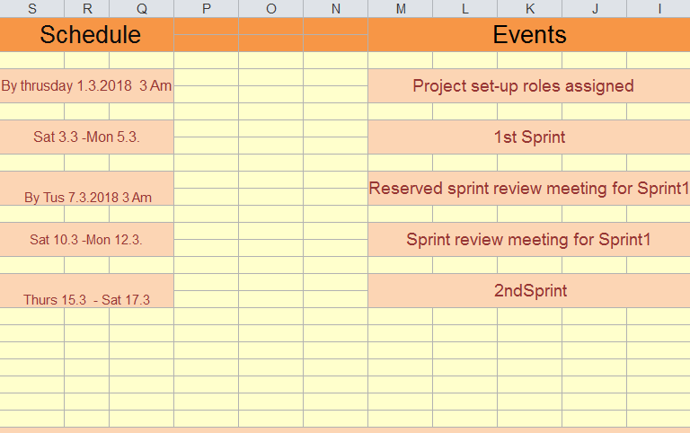

**Function Requirements:**

1 - student can upload his file to join into the city through this web site.

2- student has the ability to know the component of the meal .

3- student affairs have the privileges to add student or delete student .

4- student has the privileges to know his rights and duties.

5- the supervisor can make daily enrollment for the student through this app.

**Non-function requirements: constrains**

1. Student can upload his file through the button he click on and browse the file.
2. The enrollment is available in the start of each year.

**Constrains:**

1. Desktop application.
2. Web application
3. Run in windows and mobile

**Limitations :**

1. Any student can enroll in city of youth but he must be succeeded in last year .
2. He must be egyption .

Sprint backlog:-

Login page of the project and

This is the ER-diagram

Scrum master:

Ester Andrawes

Dina Ashraf Malak

Product owner:

Ahmad Mansour

Stakeholders:

Ahmed Mansour

Mohammad Khaled

Mohamed montaser

Ester andraws

Dina ashraf malak

Time of sprint:

|  |  |  |  |  |  |
| --- | --- | --- | --- | --- | --- |
| Ahmed Mansour | Create database | three table | 5/3/2018-8/32018 | Complete | Sprint 1 |
| Mohamed montaser | Create database | two table | 6/3/2018-8/32018 | Complete | Sprint 1 |
| Mohamed Khaled | ER diagram | Create it through software visual paradigm  And create one table | 10/3/2018-10/3/2018 | Complete | Sprint 1 |
| Dina Ashraf | Design of login page | Fragmentation of the page and put the navigation pane of the buttons | 10/3/2018-  11/3/2018 | Complete | Sprint1 |
| ester andraws | Design of login page | Fragmentation of the page and put the navigation pane of the buttons | 10/3/2018-  11/3/2018 | Complete | Sprint1 |

1-our customer is students and who work in city of youth

Risks:

*1-there is risk if any one become ill we afford it through give it a short task than don’t have any efforts and tasks that may be delayed*

High level goals :

1. Saving time
2. -Planning our app and put the main point that we will follow.
3. -Crate database tables.
4. -Creating ER-DIAGRAM of our app
5. -team leader give the tasks to each one of the team.

*Who participate in sprintreview:-*

All the team:

Ahmed Mansour

Mohammad Khaled

Mohamed montaser

Ester andraws

Dina ashraf malak