**City of outh Team**

Team leader:

Mohammad montaser

Developers:

Ahmed mansor

Mohammad Khaled

Aster andraws

Dina ashraf

**User Story**

Any student need a place to stay between his colleage ,the system help students to confirm his paper to join in the city,the system divided into 3 parts ,one of them belong to students page through it student can make his daily check to have a meal for the next day ,and second part belong to student affairs and the operation that employees must to do and the procedures that this organization must to do

**Function Requirements:**

1 - student can upload his file to join into the city through this web site.

2- student has the ability to know the component of the meal .

3- student affairs have the privileges to add student or delete student .

4- student has the privileges to know his rights and duties.

5- the supervisor can make daily enrollment for the student through this app.

**Non-function requirements: constrains**

1. Student can upload his file through the button he click on and browse the file.
2. The enrollment is available in the start of each year.

**Constrains:**

1. Desktop application.
2. Web application
3. Run in windows and mobile

**Limitations :**

1. Any student can enroll in city of youth but he must be succeeded in last year .
2. He must be egyption .

**Sprint 1 :**

|  |  |  |  |  |  |
| --- | --- | --- | --- | --- | --- |
| Ahmed Mansour | Create database | three table | 5/3/2018-8/32018 | Complete | Sprint 1 |
| Mohamed montaser | Create database | two table | 6/3/2018-8/32018 | Complete | Sprint 1 |
| Mohamed Khaled | ER diagram | Create it through software visual paradigm  And create one table | 10/3/2018-10/3/2018 | Complete | Sprint 1 |
| Dina Ashraf | Design of login page | Fragmentation of the page and put the navigation pane of the buttons | 10/3/2018-  11/3/2018 | complete | Sprint1 |
| Aster andraws | Design of login page | Fragmentation of the page and put the navigation pane of the buttons | 10/3/2018-  11/3/2018 | complete | Sprint1 |

Goals of sprint one:-

-Planning our app and put the main point that we will follow.

-Crate database tables.

-Creating ER-DIAGRAM of our app

-team leader give the tasks to each one of the team.

Sprint backlog:-

Login page of the project and 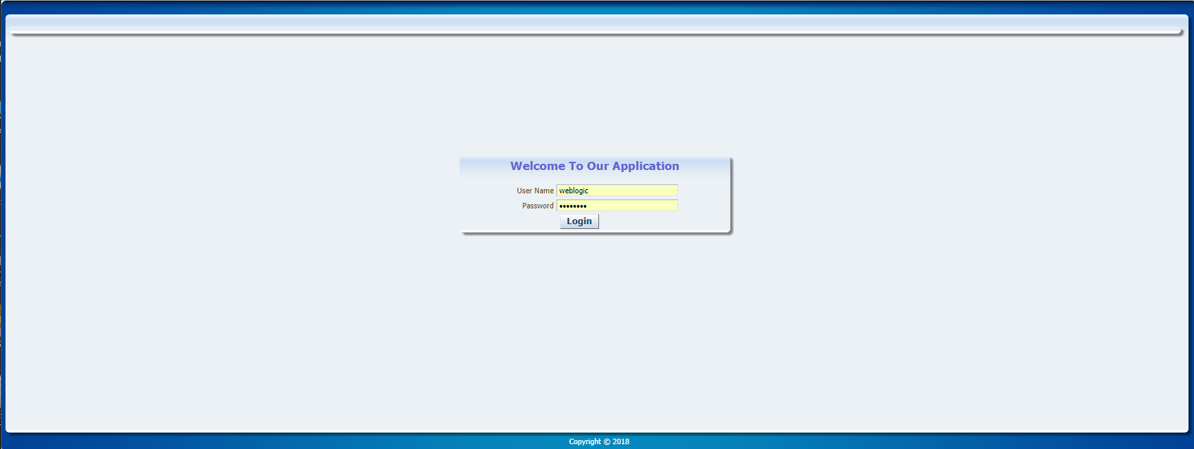

This is login page of our app student enter his name and password

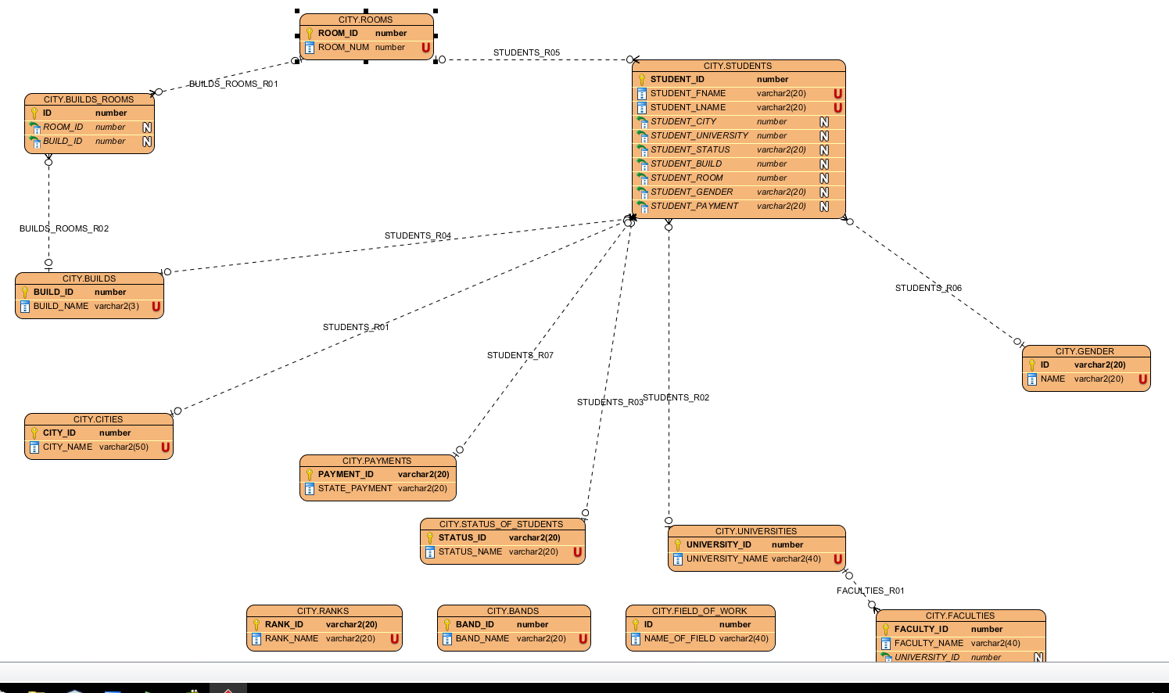

This is the ER-diagram