Agreement

-- **Timing of sprints**

|  |  |
| --- | --- |
| **1st sprint:** | one weak . |
| **2nd sprint:** | two weak . |
| **3rd sprint:** | one weak . |
| **4rd sprint:** | two weak . |

--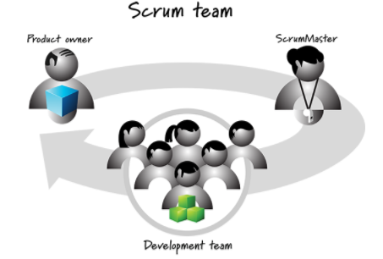

**-- Scrum master**

Eman reda

**-- product owner**

Moamen abdelgawad

--**participate in sprint review**

Alla rafat

Zeniab ahmed

Ereny karam

Yousef samir