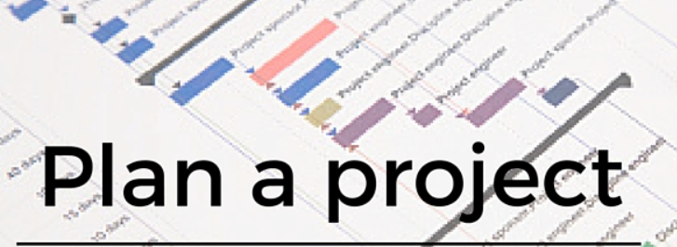



1. **Planning of the project: we will identify all structure of the project plan.**

* **To plan a project, we need to be sure that we have captured all of the**
* **Deliverables and tasks that make up the finished product. Get our team together and ask them to spend 10-20 mins listing out all of the tasks to identify**
* **The requirement correctly.**

Project Resources: -

**1- stakeholders**

**2-customers**

**3-project manager**

**4-Developer**

**5-Designer**

**6- Tester**

**. The risks can be existing at any stage of project**

**Life cycle this risks in our project can be as:**

**short absences, sickness, Delay, confusion**

**lack of communication.**

**Ideal weeks**

* **The developer decide to take 4 weeks to finish that product only .**

**Fudge Factor**

* **Number of weeks token considering any activities is 2 weeks.**

**Project velocity**

* **About 50% of the ideal work can be accomplished in affixed time.**

Structure of tasks

(on line flight booking)

Implementation

Testing

Design

Budget

&Risks

Requirements

Staff

Monitoring

Test

Of

system

Test

plan

Software

Design

Quality

Risk

management

Cost

management

Non-function

requirement

Function

requirement

User

requirement

System

requirement

requirement

re

tere