**Scenario 1**

**API 1- /api/getMoviesByUser**

**Request Parameter: userId (can’t be empty)**

**Sample: http://localhost:8080/api/getMoviesByUser?userId=1000**

**Method: GET**

**JUNIT:** testForUnregisteredUser, testForRegisteredUser, testForRegisteredUserNegative

**Description:** This API will return movies list for both registered and un-registered user.

1-Order of the list will be genre, country and sorted in likes Count in descending order.

2- For registered user if movies list size of order genre is less than 20, then user’s other movies will be populated based on user’s country preference as mentioned in users.json file.

3-For un-registered user movies list will be populated based on most liked videos.

3-Genre will be preference over country, ex- if ‘X’ Movie falls in genre and country then preference will be given to genre.

4-Movies list will be unique, means no movie will be repetitive.

5-Unwatched movies will be on the top of the list followed by watched movies if preference exhausted.

**Please find the flow diagram for above API.**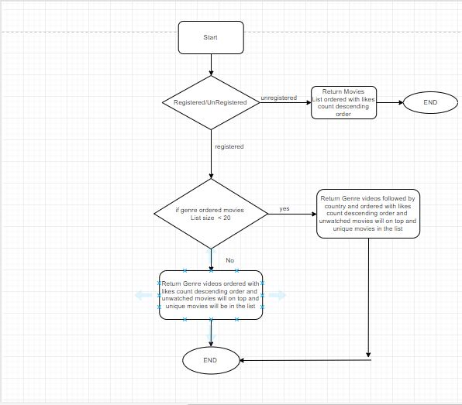

**API 2- /api/getMoviesByUserPref**

**Request Parameter: userId, prefType,** **pref (Can’t be null or empty)**

**SAMPLE:** **http://localhost:8080/api/getMoviesByUserPref?userId=1000&prefType=genre&pref=Romance**

**METHOD: GET**

**JUNIT :** testForRegisteredUserByPreferences ,testForRegisteredUserByPreferencesNegative

**Description:** This API will return movies list based on user preferences passed as the request parameter.

1. If users’ Preferred movie list count is 20 then API return the preference movie list ordered with likes count descending order and unwatched movies will on top and unique movies in the list
2. If Users’ Preferred Movie is Action but only 10 Action movies in data record. Then rest 10 movies will be with likes count descending order and unwatched movies will on top and unique movies in the list ordered. 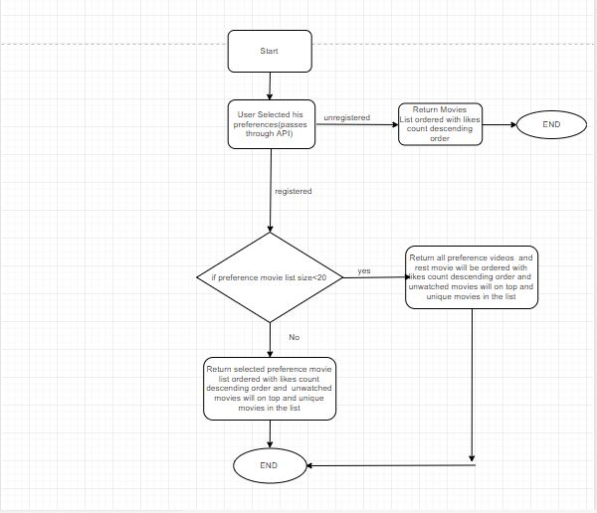

**Scenario 2**

**API : /api/getMoviesGroupedByGenre**

**METHOD: GET**

**SAMPLE:** **http://localhost:8080/api/getMoviesGroupedByGenre**

**Description:** This API will return movies grouped by genre.

It cover’s below scenario.

|  |  |  |
| --- | --- | --- |
| Movie | Genre | Result |
| Avengers Infinity War | Sci-fi, Adventure, War | This movie should be in sci-fi list not in adventure/war, as sci-fi is first in list. |

**JUNIT:** testMoviesGroupedByGenre