Ethan Reuse

GEOG 777

Explore Rocky Mountain National Park

**Introduction:**

For this project the National Park Service tasked me with creating a mobile application to assist and improve their visitor experience of a park. The park I chose to develop an application for was Rocky Mountain National Park. This park is one of the most popular parks in America, ranking fourth on the Top 10, most visited National Park. This park is full of beautiful hiking trails, campsites, glaciers, summits, and scenic points, that I aimed to make visitors more aware of their locations by developing this application.

**Program Design and Implementation Plan:**

The first step I took in developing this application was determining what technology to use and where to access this data. For my database to store my geoJSON data I chose to use Carto because of its simplicity to upload data to and because it integrates nicely with JavaScript and CSS by being able to use cartoCSS inside of your JavaScript file to format your layers and such. I found my data on Rocky Mountain National Parks website actually and they had a large number of shapefiles and data, which I did not even use half of and I included 7 data layers in my map from their site. Once I had all my data, I combined the point shapefiles into one shapefile, so that they could be queried successfully and to cut down on the number of datasets that I had on Carto. Aside from the point datasets, I had one polygon dataset for the park boundary and one-line dataset for the trails. After that, I uploaded the .prj, .dbf, and .shp files to Mapshaper and exported them to geoJSON format in order for them to be uploaded successfully to Carto. Once everything was on Carto successfully, I began to develop my map in my text editor. I decided to use Leaflet since I already had experience with it and there are several great plugins available that are easy to use can make your project better. I first developed a simple design for my application. I was inspired by the Rocky Mountain National Park website with the thin header and then the body beneath, I thought that looked very smooth. Since this application is designed to be a mobile application I used the following script that will redirect this application to a mobile friendly version. If accessed on a PC, the web friendly version will still be used.

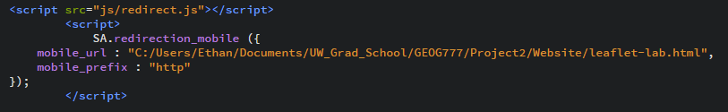

I thought it would be beneficial for the users to give the option to choose between satellite and street imagery. If the user is lost or would like to get a bearing on their location, the satellite imagery will help them. To do this I used leaflet functions and an easy buttons to create a nice button in the top right corner that when hovered over the user can select the imagery that they desire. Once I had my basemaps toggled, I began creating functions for each of my layers using $.getJSON, my Carto username, API, and my SQL variable. In these functions I included what I wanted to be included in my popups as well as the styling for each of the layers. I browsed the web for images I thought would be appropriate and colors for the trails and the boundary layers that I thought were appeasing to the eye. As far as my functions go I have my basemap toggle button, my layers checkbox buttons, I have a location button that when clicked the map will pan to their location, a home button that when clicked will pan the map back to the central location, and four radio buttons that will query through my datasets. The location button will come in handy when trying to determine where the user is in relation to campsites, trailheads, and other recreational features! I also created a bunch of layer toggle check boxes that are located at the bottom of the map by the query radio buttons. This allows the user to turn on and off whichever layers they please since the map can get busy. Below is the main application page that can be referenced above to see the what the buttons and other features look like.

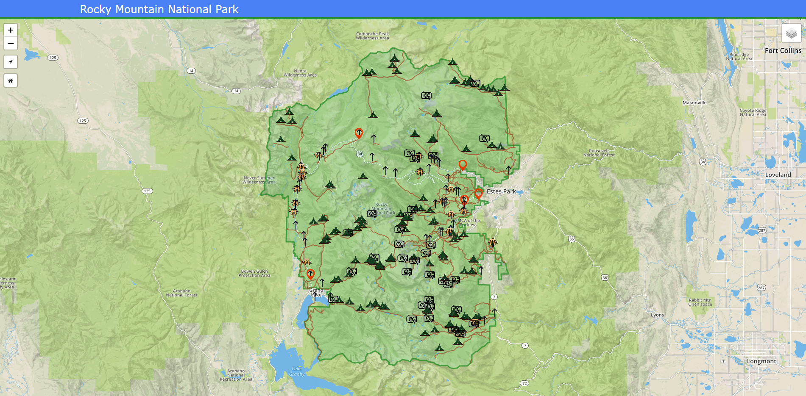  


**Complications:**

I did not hit any big roadblocks on this lab until I tried to create the user input. Another complication I ran into was the user input function. I followed the demo found at <http://duspviz.mit.edu/web-map-workshop/cartodb-data-collection/>, but could not get the user input to post to my carto database. I received a message that read “Feature has been submitted to the Proxy, but nothing appeared in my Carto database that I created for the user input. My plan was to create a user input feature that allowed the user to place a point and describe the wildlife that they saw. To also assist the park rangers as to what the current distribution of wildlife is around the park. I had all the code in my program running with no errors, I just could not get the point placed to post to my database after hours and hours of trying to troubleshoot.

**Diagrams and Schemas:**

In all my datasets I included the park_name field to relate all the datasets and the entry into that field was ‘Rocky Mountain National Park’. This can be seen in the logical schema directly below, with the red line traversing through each dataset and the relationship. Directly below my schema is my ER diagram. There you can see the fields and attributes for each dataset and the relationships between all of them. The boundary dataset has two relationships. One between the Trails layer and the other between the user input dataset called data_collector.

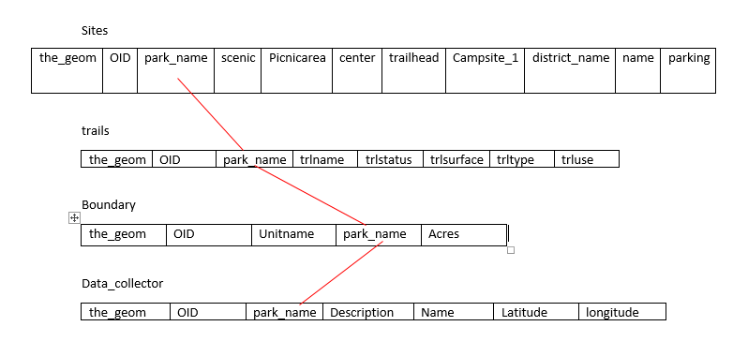 Logical Schema

