**Are grassland restoration actions of woody removal benefiting local native wildlife?**

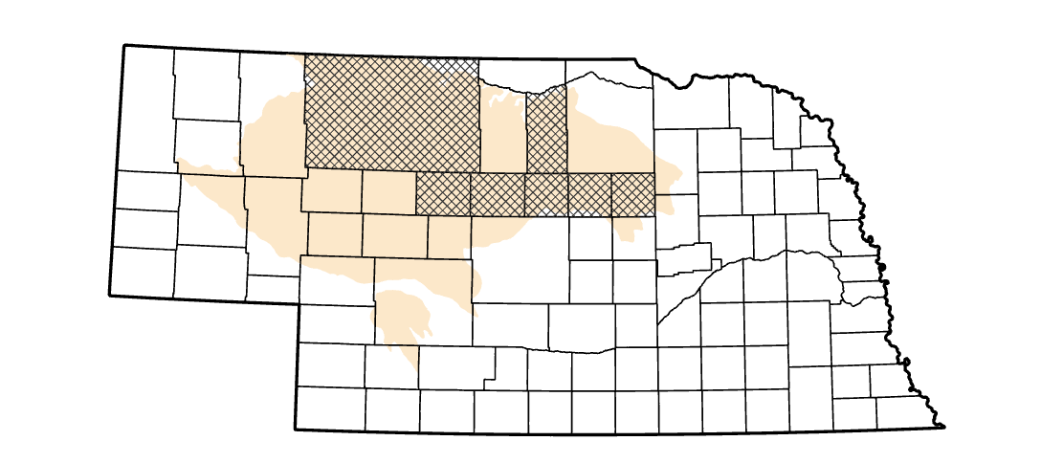

*Study area in Sandhills ecoregion in Nebraska. 2024 field effort enveloped seven counties across 786 survey points.*

**Goal**: Evaluate the effects of Eastern Redcedar removal treatments and management on avian communities in eastern Sandhills Ecoregion in Nebraska, USA

Definitions:

ERC= Eastern Redcedar (*Juniperus virginiana)*

Verdict= Determination of ERC risk of encroachment following the table below

Point= Location avian point is conducted.

Cell= A square cell 400m x 400m centered on a point

Grid= Consists of a morning’s dollop of points for one observer (12 points)

Group= A region of adjacent grids under similar management or same landowner/operator

**Research Design:**

**Layout**: Points will be centered in a 400m square grid cells (r ≥ 200m). The grid will consist of 12 points overlapping treated areas. Each morning, one independent observer navigates one grid to record data at all 12 points. Data collected include avian point counts and a rapid assessment of ERC encroachment. Grids may vary in shape, and almost always have the same survey area.



= ERC removal / treated area

*Figure 1. Example survey grids to capture ERC treatment and neighboring landscape characteristics and management activity.*

**Point counts:**

Conduct 5-minute point counts - observer records all individuals identified, regardless of distance. Radial distance (m) is recorded from observer. Direction is also noted to avoid double counting between points. Restrictions include precipitation, wind gusts (>12mph sustained), and time (<11AM and conducted between May 27 – July 7)

Common grassland birds of interest: GRSP, WEME, DICK, UPSA

**ERC Verdict:**

Following table below, observers record local ERC conditions based on presence, height, and density of trees.

