**Gertrud Quarter Summary**

Gertrud is an automatic tester that measures the accuracy of Neura real-time events. In order to do so Gertrud compares the time of occurrence of real-time and timeline events (both of those events are continuously collected at Neura database).

Ratatouille is the event trigger that is integrated in Neura application and detects events real-time in the mobile. The first version of Ratatouille ran on production on Jan. 2015. Adoption of Ratatoiullie to Neura user is essential for detecting real-time events. The adoption percentage of Ratatouille over Neurra users is presented on “Ratatouille Adiption Rate” where the x-axis represents the adoption on January, February, March, and April and the y-axis shows the percentage of Neura users that installed an app version with Ratatouille.

From Ratatouille adoption rate adoption we can a fast adoption rate between Jan and Feb. In addition, the adoption rate becomes flat on April with 80% adoption. The additional 20% of the users do not have Ratatouille, since most of them use Neura iphone application (which does not has Ratatouille yet). Consequently, we can learn from the adoption rate that currently only 80% of Neura users are generating real-time events.

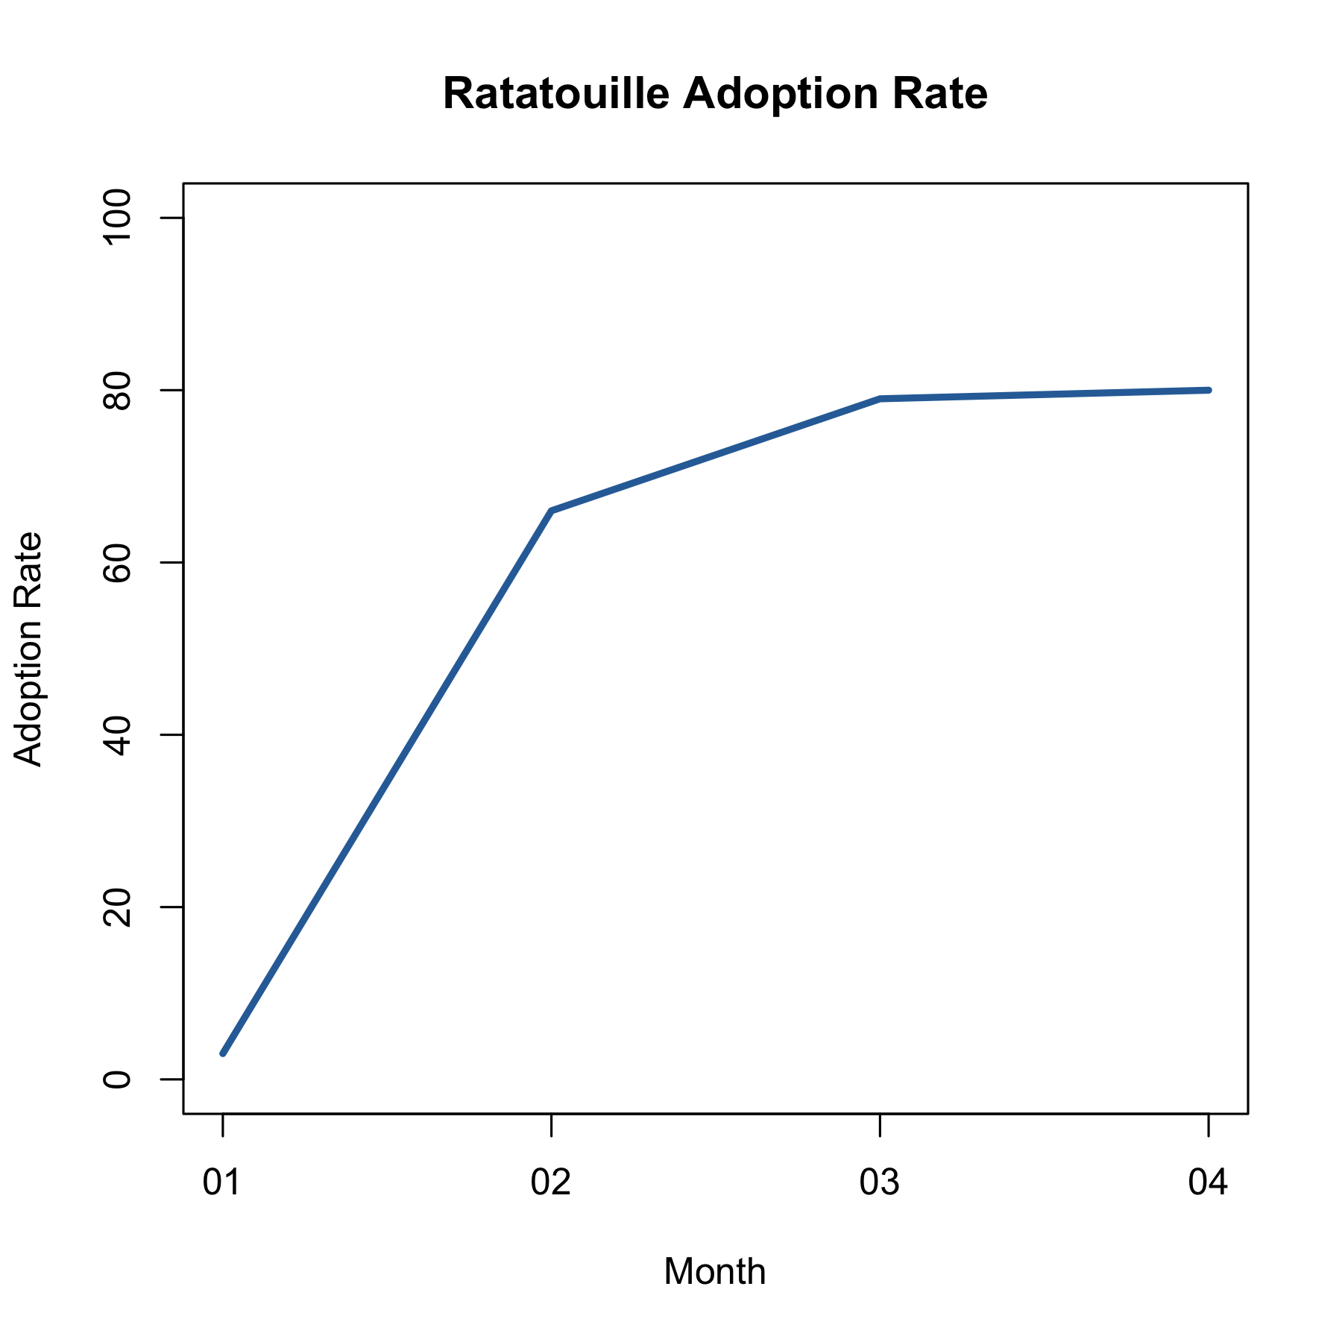

The basic metric for measuring real-time event performance is the accuracy level. The accuracy level is measured in percentage (0-100%), where the accuracy gets 0 when Neura missed all the occurrences and 100% when Neura detects all the occurrence of an event.

The next graph “Real-time events accuracy” shows the progress of Ratatouille during Q1. The x-axis shows the accuracy during each months January, February, March and April and the y-axis represents the distribution of the accuracy across all Neura events (e.g., “user start walking”, “user arrived at work”, “user wake up”, etc.). We later show how the accuracy is distributing over each event.

From the chart, we can see that on January the accuracy was very low at general. On February the accuracy level of the events jumps to almost 30% on average. On March the accuracy level gets to 50% and the variance of the accuracy is between 30% and 60%. On April the variance of the accuracy level decreases to 40% and 60%, since our stabilization process that included detection of events also with the server.

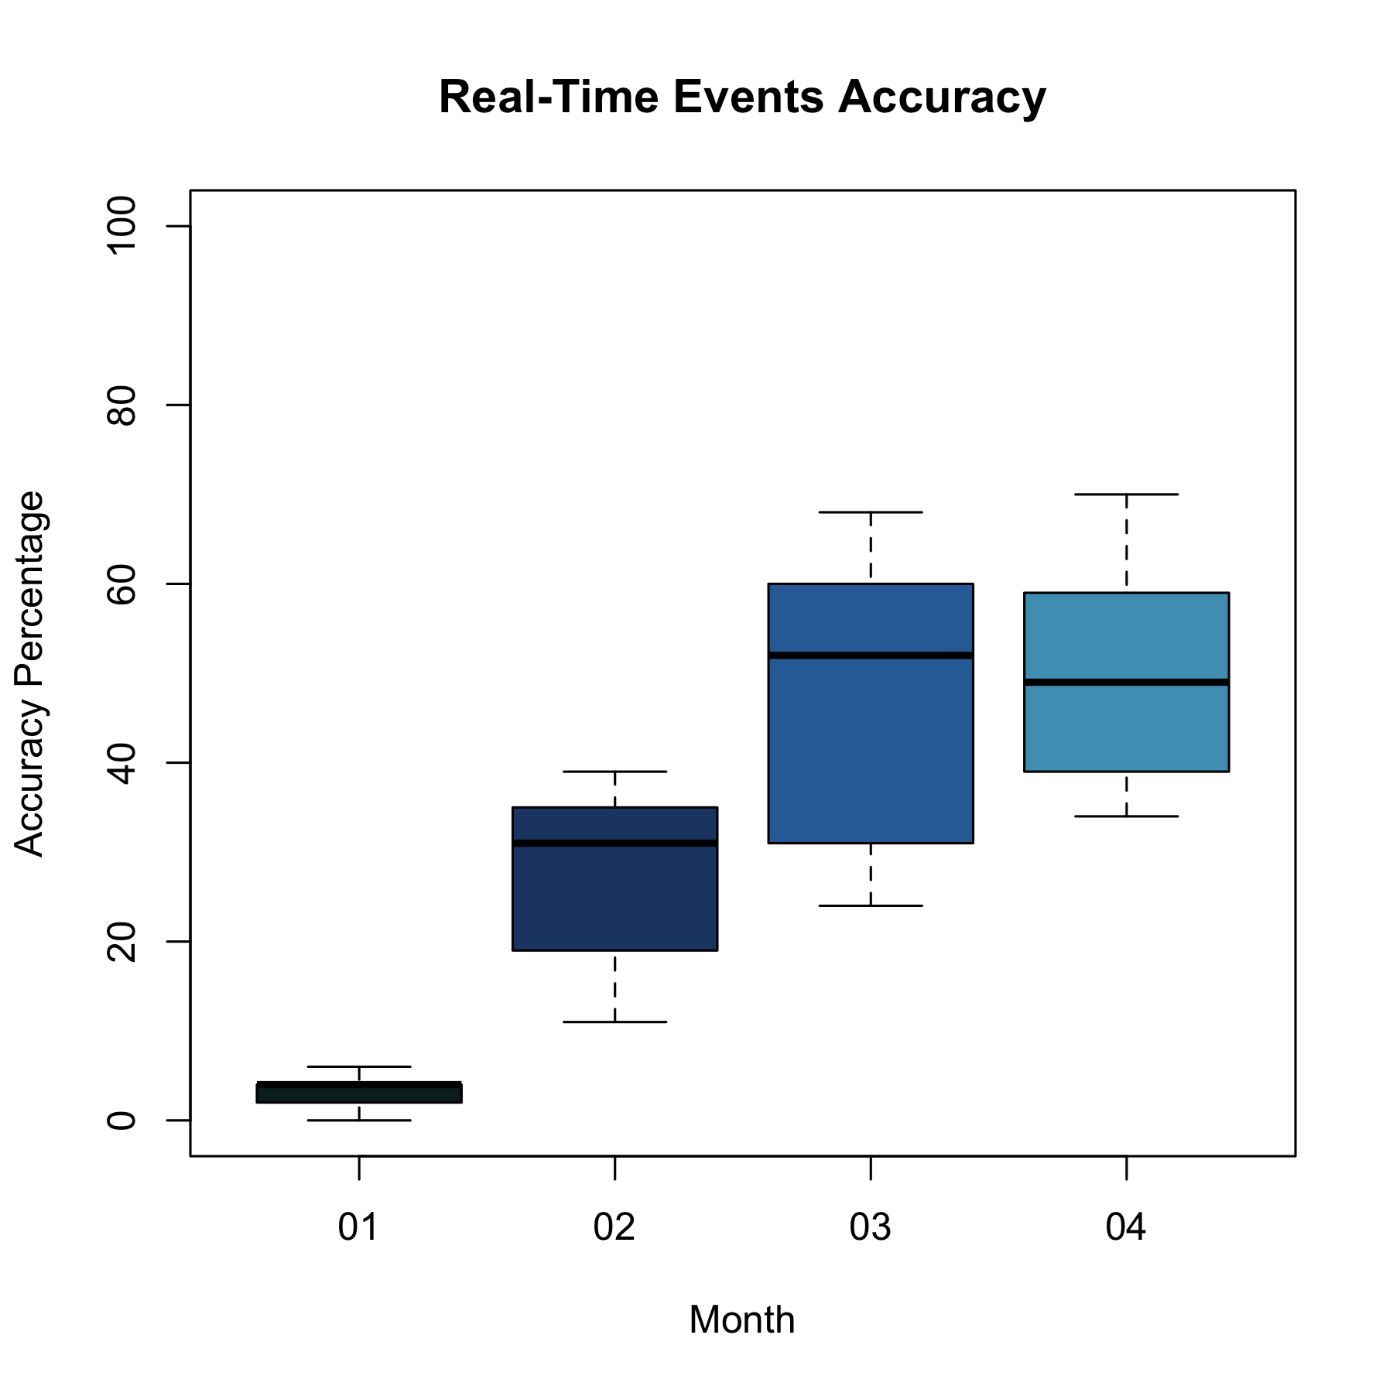

More low-level metrics are the True Positive and False Positive percentage. True Positive measures the percentage of the timeline events that were detected by Ratatouille on real-time. The False Negative percentage measures the number of mistakes of Ratatouille, i.e., events that were detected wrongly on Ratatouille and do not actually occur. The False Positive percentage is the inverse of the False Negative percentage in which 0% is the case where every event of Ratatouille is mistake and 100% where there are no such mistakes.

The graphs “True-Positive Events” and “False-Positive Events” show the progress of these metrics on the January, February, March and April. It shows the distribution of the True-Positive percentage over all Neura events (“user start driving”, “user arrived at work”, etc.), where the horizontal line in each box represents the average value of the True-Positive percentage over all Neura events.

By the “True-Positive Events” graph, we can see the progress in Neura real-time engine, the True-Positive starts with 2% on January 20% on February 30% on March and gets to 40% on April. On the other hand, in False Positive we still don’t improve much. However, we decrease the False Positive variance as well.

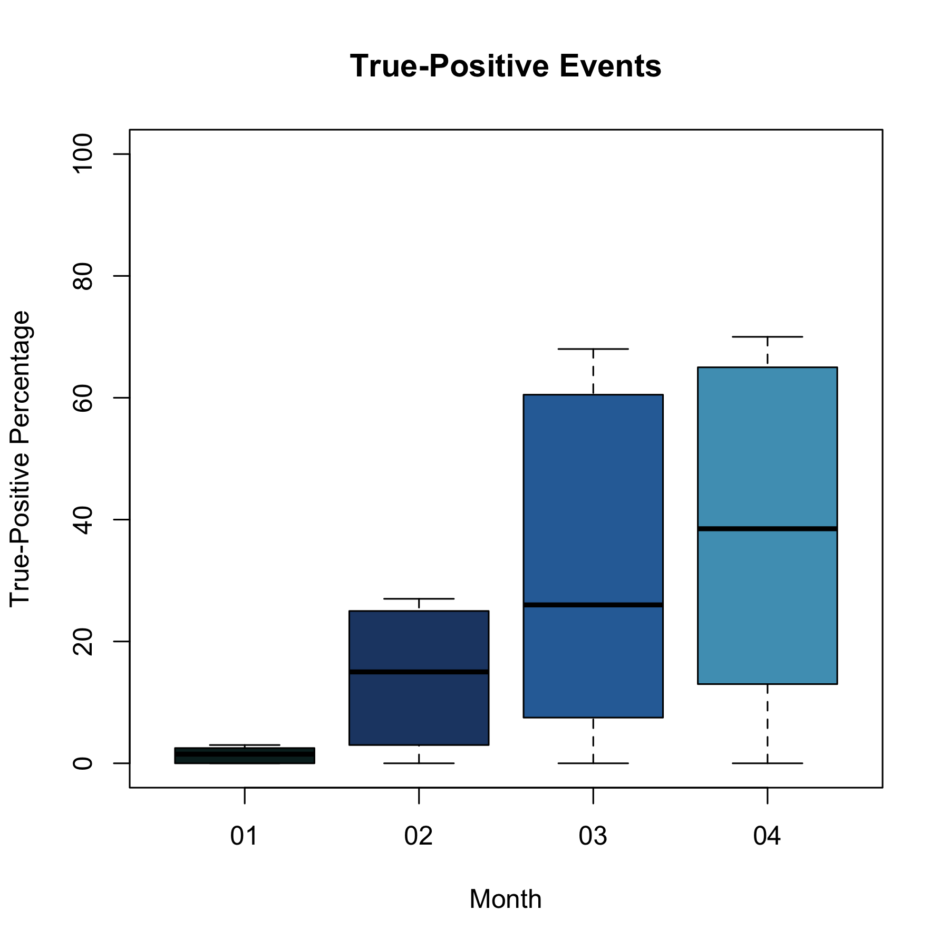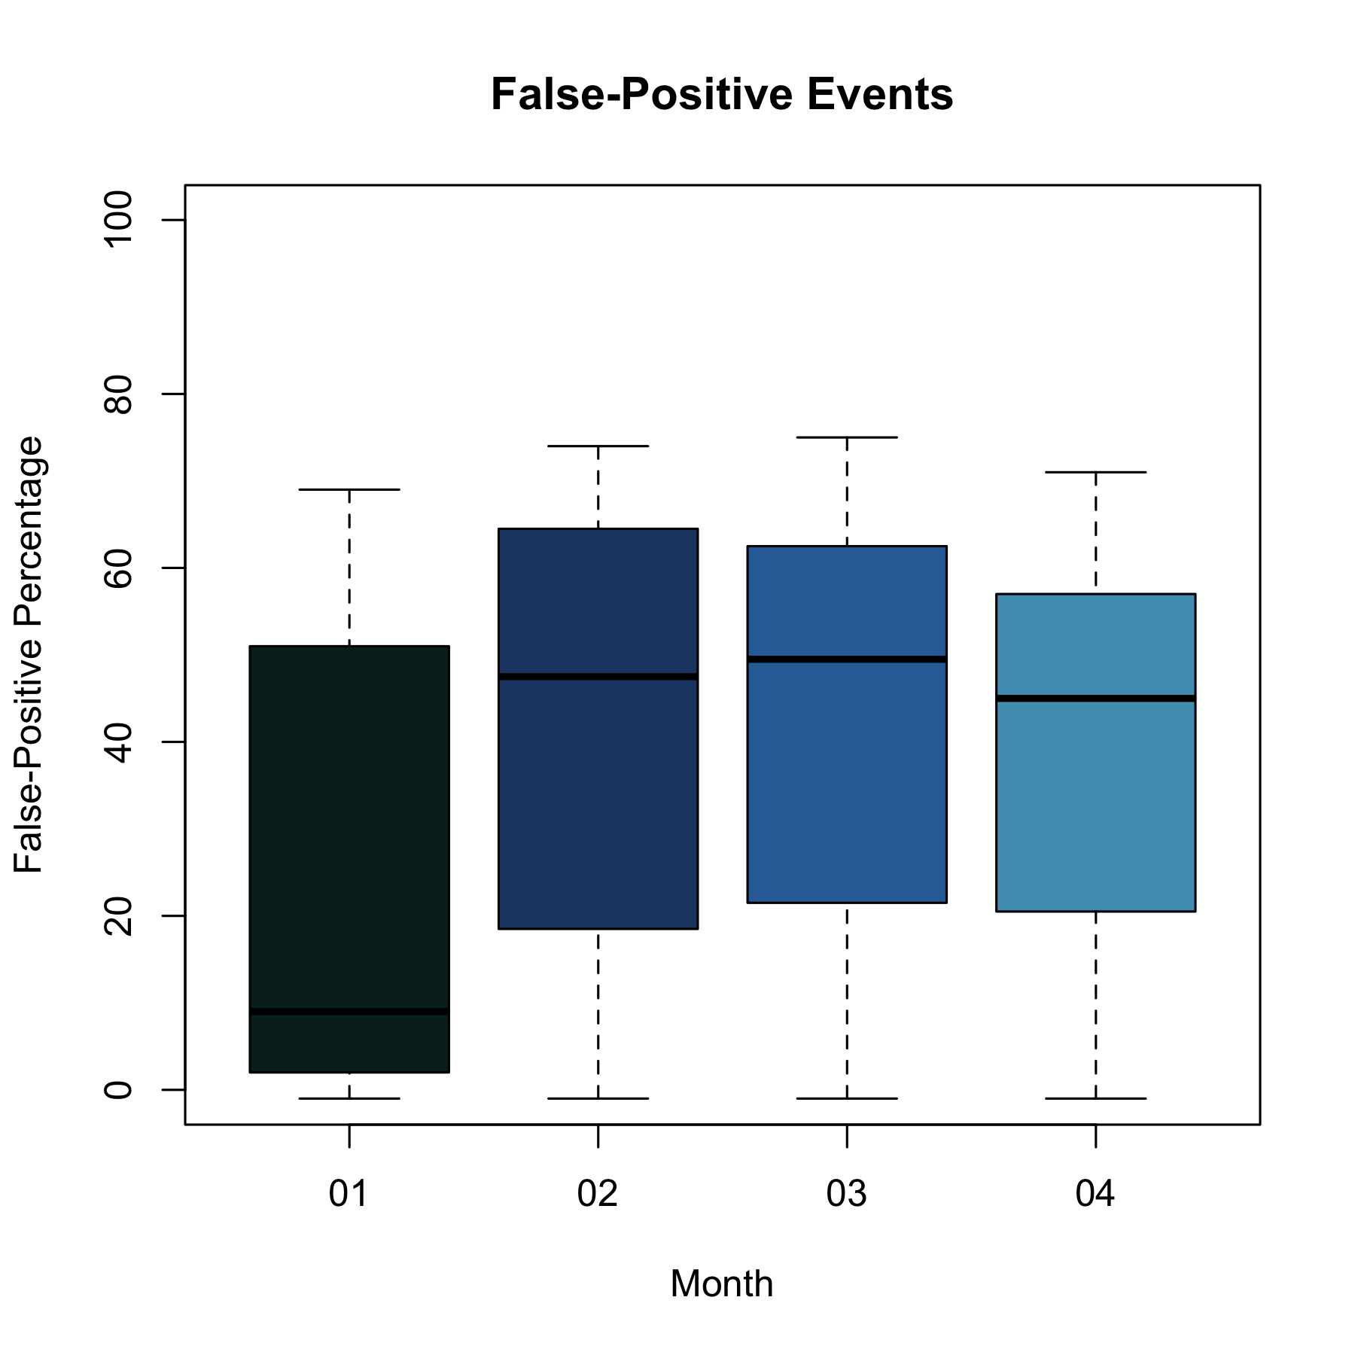

The graphs “Activies Events” and “Places Events” show the accuracy of the *activities’ events* such as “user started driving”, “user finished driving”, “user started walking”, etc. and *places’ events* such as “user arrived at work”, “user left work”, “user arrived home”, etc.

By the graphs the activities’ events are detected at a higher accuracy than the places’ activities. In particular, the detection accuracy of activities is around 60% while the places events are still on low accuracy of around 30%. The event that has the highest accuracy is “user started driving” and “user finished driving”. The events “user fell asleep”, “user arrived at active-zone”, and “user left active-zone” did not detected at all.

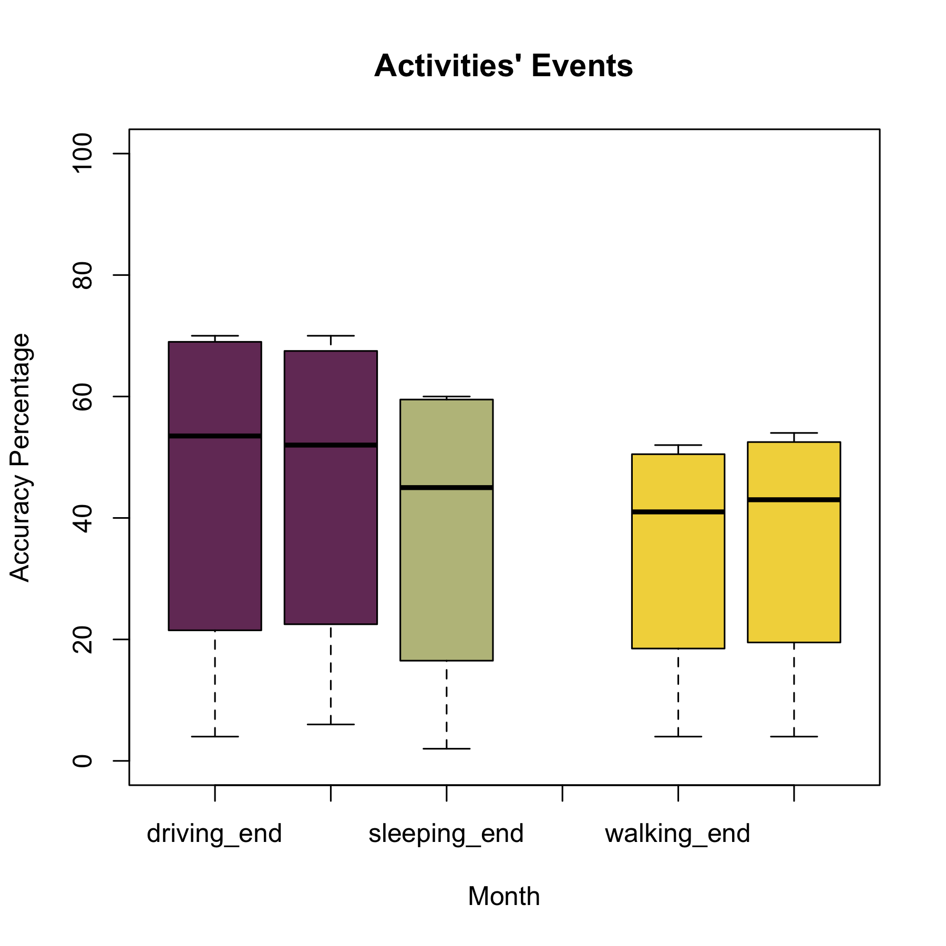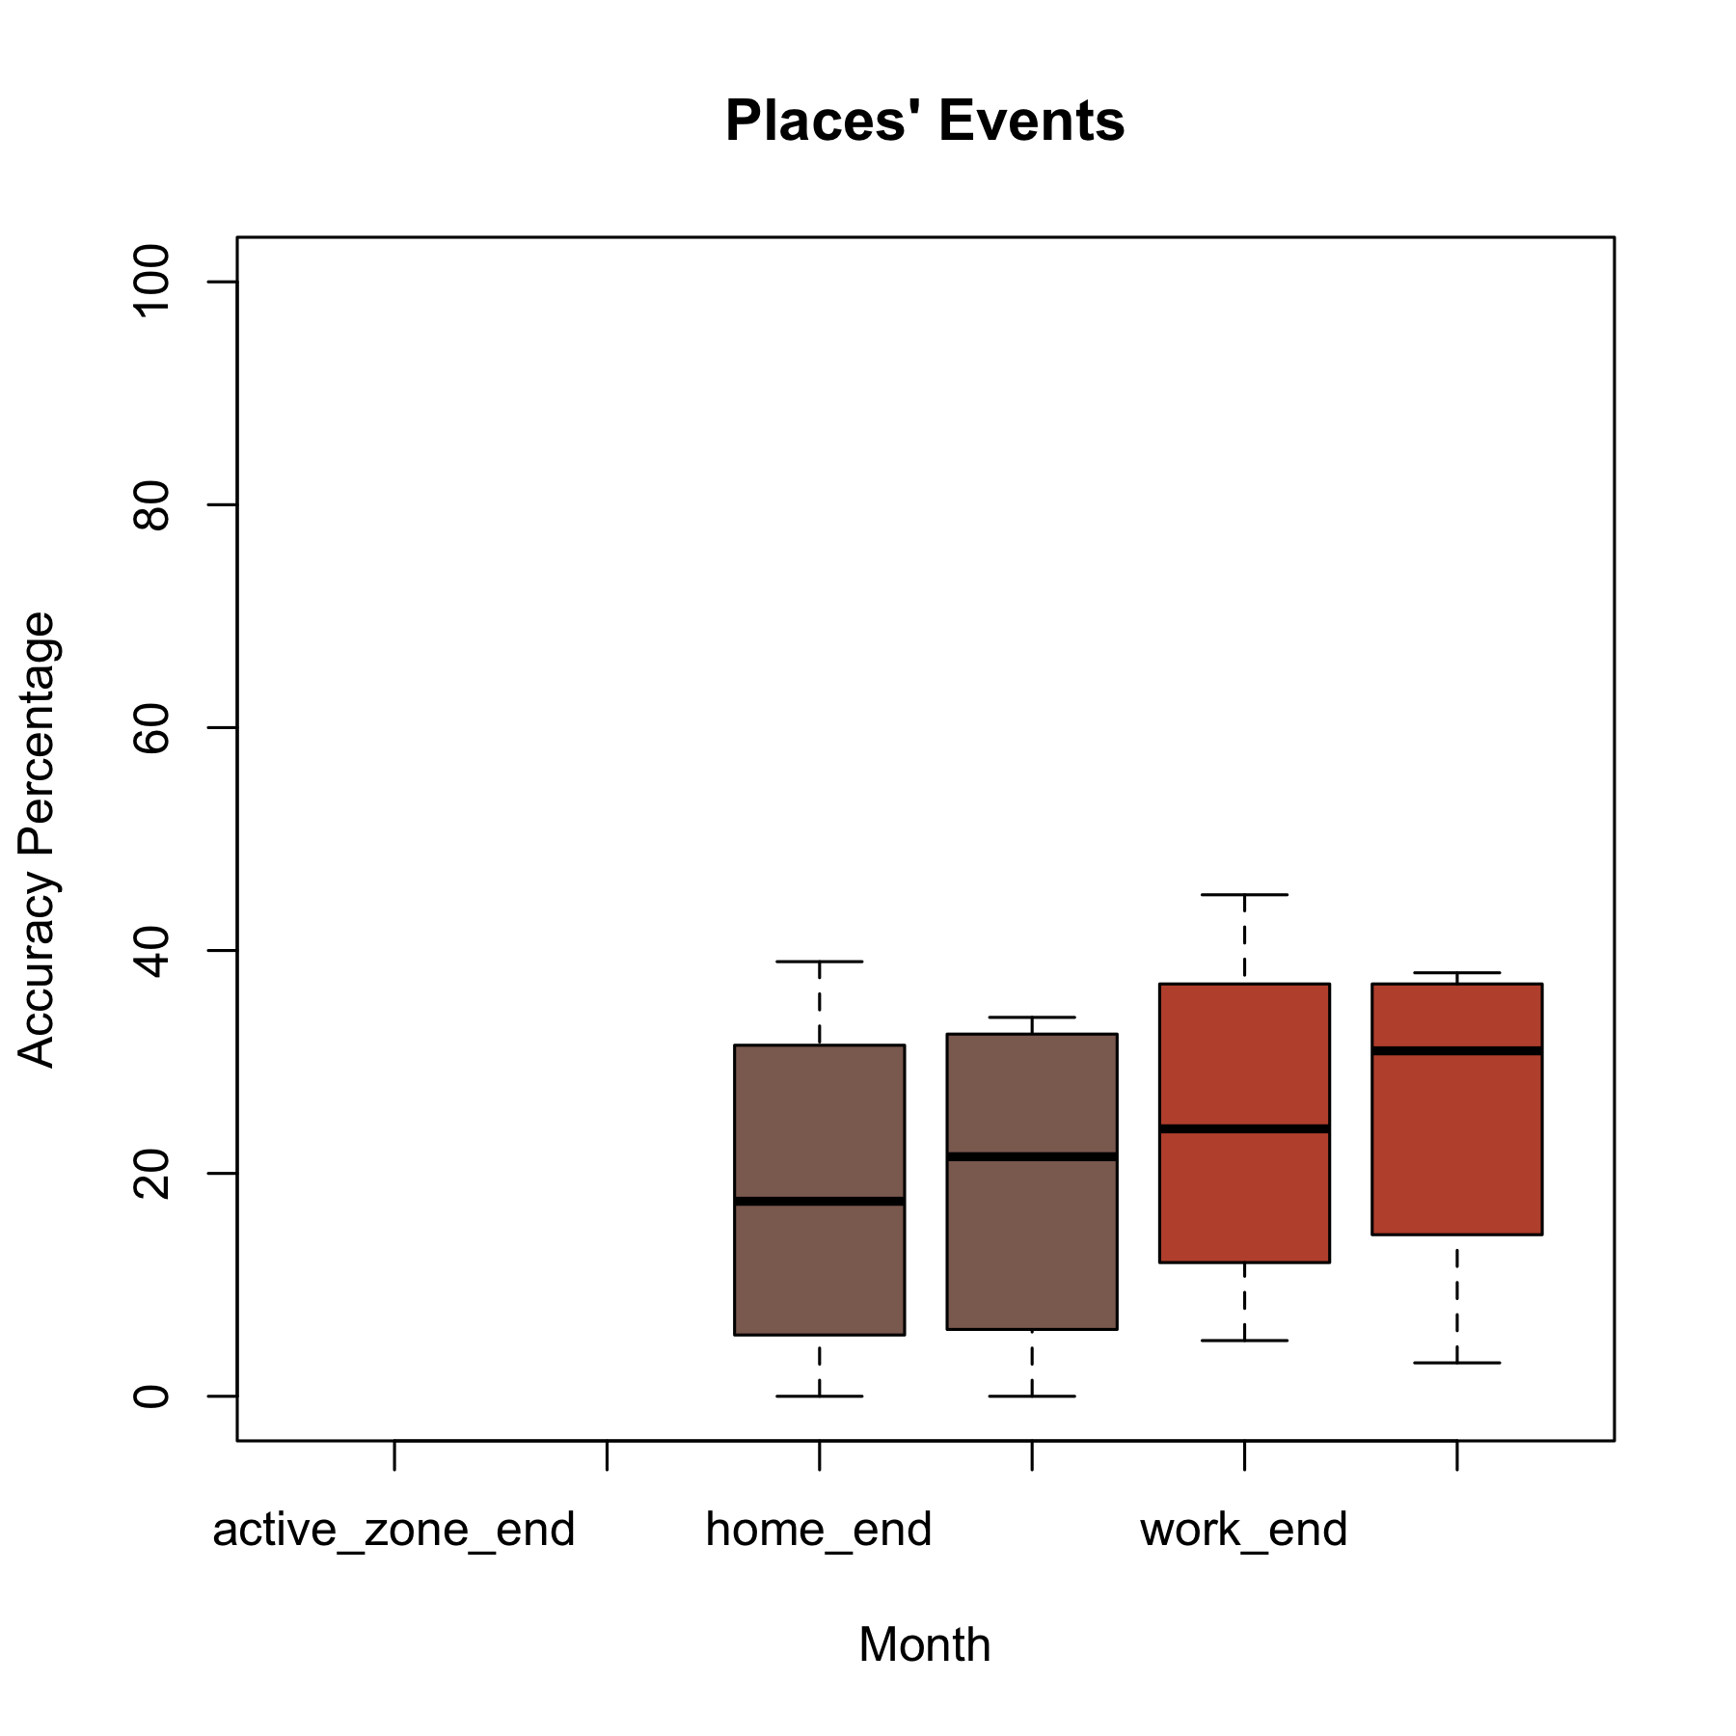

**Appendix - Gertrud raw results**

**January results**

Dates: 20150101 - 20150201

Number of users with neura events is 10

Number of users with timeline events is 288

|  |  |  |  |  |  |  |  |
| --- | --- | --- | --- | --- | --- | --- | --- |
| id | TR | T | R | RT | true_positive | false_positive | accuracy |
| driving_start | 519 | 16331 | 277 | 545 | 3 | 66 | 6 |
| home_start | 3 | 1978 | 63 | 3 | 0 | 5 | 0 |
| home_end | 3 | 1978 | 39 | 4 | 0 | 9 | 0 |
| walking_start | 239 | 10789 | 322 | 263 | 2 | 45 | 4 |
| driving_end | 354 | 16496 | 175 | 383 | 2 | 69 | 4 |
| active_zone_start | 0 | 98 | 0 | 0 | 0 | -1 |  |
| sleeping_start | 0 | 5630 | 0 | 0 | 0 | -1 |  |
| sleeping_end | 66 | 5564 | 52 | 66 | 1 | 56 | 2 |
| work_end | 5 | 150 | 48 | 5 | 3 | 9 | 5 |
| work_start | 4 | 151 | 71 | 4 | 3 | 5 | 3 |
| walking_end | 232 | 10796 | 308 | 261 | 2 | 46 | 4 |
| active_zone_end | 0 | 98 | 0 | 0 | 0 | -1 |  |

**February results**

Dates: 20150201 - 20150301

Number of users with neura events is 142

Number of users with timeline events is 216

|  |  |  |  |  |  |  |  |
| --- | --- | --- | --- | --- | --- | --- | --- |
| id | TR | T | R | RT | true_positive | false_positive | accuracy |
| driving_start | 2913 | 8556 | 1419 | 3435 | 25 | 71 | 39 |
| home_start | 108 | 1500 | 114 | 107 | 7 | 48 | 12 |
| home_end | 96 | 1512 | 80 | 95 | 6 | 54 | 11 |
| walking_start | 2168 | 5822 | 2724 | 2424 | 27 | 47 | 35 |
| work_start | 47 | 200 | 90 | 54 | 19 | 38 | 26 |
| active_zone_start | 0 | 183 | 0 | 0 | 0 | -1 |  |
| sleeping_start | 0 | 3991 | 0 | 0 | 0 | -1 |  |
| sleeping_end | 808 | 3183 | 421 | 808 | 20 | 66 | 31 |
| work_end | 28 | 219 | 16 | 27 | 11 | 63 | 19 |
| driving_end | 2916 | 8553 | 1168 | 3310 | 25 | 74 | 39 |
| walking_end | 2027 | 5963 | 2695 | 2318 | 25 | 46 | 33 |
| active_zone_end | 0 | 183 | 0 | 0 | 0 | -1 |  |

**March Results**

Dates: 20150301 - 20150401

Number of users with neura events is 139

Number of users with timeline events is 175

|  |  |  |  |  |  |  |  |
| --- | --- | --- | --- | --- | --- | --- | --- |
| id | TR | T | R | RT | true_positive | false_positive | accuracy |
| driving_start | 7418 | 4992 | 3609 | 8614 | 60 | 70 | 65 |
| home_start | 472 | 1709 | 430 | 477 | 22 | 53 | 31 |
| home_end | 325 | 1856 | 220 | 321 | 15 | 59 | 24 |
| walking_start | 5956 | 2802 | 7803 | 6738 | 68 | 46 | 54 |
| work_start | 128 | 299 | 179 | 140 | 30 | 44 | 36 |
| active_zone_start | 0 | 299 | 0 | 0 | 0 | -1 |  |
| sleeping_start | 0 | 3478 | 0 | 0 | 0 | -1 |  |
| sleeping_end | 1986 | 1492 | 1128 | 1985 | 57 | 64 | 60 |
| work_end | 81 | 346 | 50 | 79 | 19 | 61 | 29 |
| driving_end | 7572 | 4838 | 2857 | 8582 | 61 | 75 | 68 |
| walking_end | 5528 | 3230 | 7731 | 6415 | 63 | 45 | 52 |
| active_zone_end | 0 | 299 | 0 | 0 | 0 | -1 |  |

**April Results**

Dates: 20150401 - 20150501

Number of users with neura events is 123

Number of users with timeline events is 154

|  |  |  |  |  |  |  |  |
| --- | --- | --- | --- | --- | --- | --- | --- |
| id | TR | T | R | RT | true_positive | false_positive | accuracy |
| driving_start | 8009 | 3394 | 3752 | 8609 | 70 | 70 | 70 |
| home_start | 576 | 1659 | 627 | 588 | 26 | 48 | 34 |
| home_end | 704 | 1531 | 718 | 722 | 31 | 50 | 39 |
| walking_start | 5584 | 2787 | 8622 | 6361 | 67 | 42 | 51 |
| work_start | 230 | 448 | 336 | 246 | 34 | 42 | 38 |
| active_zone_start | 0 | 328 | 0 | 0 | 0 | -1 |  |
| sleeping_start | 0 | 3032 | 0 | 0 | 0 | -1 |  |
| sleeping_end | 1638 | 1394 | 914 | 1639 | 54 | 64 | 59 |
| work_end | 292 | 386 | 348 | 317 | 43 | 48 | 45 |
| driving_end | 7859 | 3544 | 3436 | 8581 | 69 | 71 | 70 |
| walking_end | 5283 | 3088 | 8611 | 6126 | 63 | 42 | 49 |
| active_zone_end | 0 | 328 | 0 | 0 | 0 | -1 |  |

**May Partial Results**

Date: *-20150501

Number of users with neura events is 112

Number of users with timeline events is 133

|  |  |  |  |  |  |  |  |
| --- | --- | --- | --- | --- | --- | --- | --- |
| id | TR | T | R | RT | true_positive | false_positive | accuracy |
| driving_start | 5293 | 1584 | 2472 | 8084 | 77 | 77 | 77 |
| home_start | 510 | 917 | 320 | 788 | 36 | 71 | 51 |
| home_end | 229 | 1198 | 166 | 243 | 16 | 59 | 26 |
| walking_start | 3700 | 1035 | 5395 | 5819 | 78 | 52 | 60 |
| work_start | 304 | 196 | 322 | 510 | 61 | 61 | 61 |
| active_zone_start | 0 | 181 | 0 | 0 | 0 | -1 |  |
| sleeping_start | 0 | 1755 | 0 | 0 | 0 | -1 |  |
| sleeping_end | 1051 | 704 | 573 | 1057 | 60 | 65 | 62 |
| work_end | 144 | 356 | 150 | 152 | 29 | 50 | 37 |
| driving_end | 4968 | 1909 | 2202 | 5392 | 72 | 71 | 72 |
| walking_end | 3300 | 1435 | 5297 | 3819 | 70 | 42 | 51 |
| active_zone_end | 0 | 181 | 0 | 0 | 0 | -1 |  |