**Lifespan Machine Software v2.0: Software Tutorial**

Nicholas Stroustrup. June 17th, 2017   
nicholas_stroustrup@crg.eu  
Centre for Genomic Regulation  
Barcelona, Spain

This guide provides an overview of the daily operation of the lifespan machine software. A step by step guide is provided for the collection and analysis of lifespan data. Installation and configuration of the software is explained in a separate document “Lifespan Machine Software v2.0 : Installation Guide”

Contents

Overview 2

The Basic Steps of Image Processing 3

Starting automated image acquisition 3

Defining an experiment 3

Identifying the locations on each scanner’s surface to be captured. 4

Submitting an experiment to run 6

Cancelling an experiment 7

Specifying the Location of Plates on Scanners 7

Breaking down captured images into individual plates 11

Excluding contaminated, desiccated, or fogged plates 12

Labeling the strain and environmental conditions of each plate 12

Detecting Worms and Analyzing Their Movement 13

Configuring image analysis for your experiment 13

Detecting worms in each image of each plate 14

Analyzing Worm Movement and Estimating Lifespan 14

Validating Automated Worm Detection 15

Generating survival data 18

Thanks 18

# Overview

This document will be most useful to someone with previous hands-on training using the lifespan machine software. As is the case with most protocols in experimental biology, no amount of documentation can replace training from someone already proficient in the technique.

The image processing software is a research tool and as such there are many configurations options and many different approaches to image analysis. Described here is the minimal set of processes required to turn a stack of scanner images into nematode survival data. The document does not address the role that careful experimental design has in ensuring that automated results are biologically meaningful.

A good rule of thumb is—if you don’t have a good idea of what population sizes you should run to account for scanner-to-scanner variation in temperature, you should find someone to help you with the details of your project design. It is assumed that the reader has proficiency in the statistics techniques required to analyze survival data.

The lifespan machine routinely collects terabytes of image data per experiment. Image analysis at this scale creates significant operational challenges. In early prototypes of the lifespan machine, image processing was the major rate-limiting step for automated lifespan assays—we had to run fewer and smaller experiments as we waited days or weeks for analysis to complete. In response, our software is designed to analyze large data sets *in tandem with data collection.* Lifespan experiments take several weeks to complete, and the software can utilize this time to get a large fraction of the basic image analysis performed. This parallelism introduces some complexity to the installation, configuration, and operation of the lifespan machine software, but helps the lifespan machine to keep pace with the ambitions of the researcher.

# The Basic Steps of Image Processing

Most users will be familiar with a traditional routine for image-based experimentation: 1) Collect some images 2) Load those images into Matlab/Image J/etc 3) Run an script to process the images and 4) Evaluate the result. This approach didn’t translate naturally into a context where data acquisition and analysis progress in parallel. So, the lifespan machine software is designed differently.

Outline of a Lifespan Machine Experiment

1. Physically load worms onto plates and plates onto scanners.
2. Create a schedule for the experiment outlining when images should be collected and on which scanners. The schedule is based on an XML template file provided in this document.
3. Using a program called the worm browser, upload the schedule to begin image acquisition.
4. A day or so into the experiment, start automated image analysis:
   1. Using a desktop program called “the worm browser”, create a mask file to specify the locations of each plate in captured images.
   2. Use the lifespan machine web interface, accessed through your web browser, schedule a series of image processing tasks to identify worms in your image data.
5. Wait until all the animals in your experiment are dead, and then cancel all remaining scans on the schedule.
6. Wait for all images are collected and analyzed.
7. Run two final image analysis tasks to collate all image data and build a description of the movement and death times of all animals on all plates.
8. Using the worm browser, validate your experimental data.
9. (Recommended) Using the worm browser, manually annotate the death times of a subset of worms. Using the worm browser, generate a new image processing parameter set for your experiment. Repeat steps 7-8.
10. Output death times as a CSV file; inspect using statistical software. Use the worm browser to investigate any unexpected effects.

These tasks are all performed using two tools—a client program (running on your computer) called the Worm Browser and a website (accessed through a web browser). The Worm Browser allows the user to schedule experiments, validate image analysis, and output statistical data as CSV files. The website allows the user to see what the lifespan machine is doing, both in terms of the activity of scanners and in terms of the image analysis jobs being run. An instance of the image analysis server software must be running on a computer somewhere in order for analysis to proceed—all the image analysis is performed by this software, not by the worm browser or website—but the user never needs to interact directly with this software.

All software components are designed to be operated in parallel—multiple image processing servers can be run simultaneously to speed image analysis. If no image analysis servers are running, no progress is made on the requested jobs. Image analysis servers can be started and stopped at any time. Submitted image analysis tasks are stored in the central database. These jobs are “checked out” by each instance of the image analysis server running. Multiple image servers will each choose distinct jobs which will then be processed parallel. Errors are flagged and visible on the website.

# Starting automated image acquisition

## Scheduling an experiment

After plates are loaded onto scanners, the lifespan machine needs to be told to where to scan, and when to scan. This is done by specifying an experiment using an XML file that contains all relevant information. An example file is included below

<?xml version="1.0">

<experiment>

<name>2013_06_07_my_cool_new_experiment</name>

<default_capture_configuration_parameters>--mode=Gray --format=tiff --source="TPU8X10" --depth=16</default_capture_configuration_parameters>

<default_sample_naming>by_device</default_sample_naming>

<capture_resolution>3200</capture_resolution>

<default_desired_minimum_capture_duration>10m</default_desired_minimum_capture_duration>

</experiment>

<sample><device>cedar</device><scan_area>0.3in,0.103333in,2.07333in,8.74333in</scan_area></sample>

<sample><device>cedar</device><scan_area>2.19in,1.07in,2.11667in,8.78in</scan_area></sample>

<sample><device>cedar</device><scan_area>4.05667in,0.103333in,2.1in,8.79667in</scan_area></sample>

<sample><device>cedar</device><scan_area>5.92333in,1.09333in,2.01in,8.85in</scan_area></sample>

<sample><device>gold</device><scan_area>0.22in,0.116667in,2.16667in,8.69in</scan_area></sample>

<sample><device>gold</device><scan_area>2.15333in,1.08in,2.12667in,8.81in</scan_area></sample>

<sample><device>gold</device><scan_area>4.01667in,0.09in,2.13in,8.84667in</scan_area></sample>

<sample><device>gold</device><scan_area>5.85667in,1.12in,2.07667in,8.82333in</scan_area></sample>

<schedule>

<sample_set_type>all</sample_set_type>

<duration>35d</duration>

<device_capture_period>15m</device_capture_period>

<number_of_consecutive_captures_per_sample>1</number_of_consecutive_captures_per_sample>

<samples_that_belong_to_schedule>all</samples_that_belong_to_schedule>

</schedule>

</xml>

The experiment schedule has three parts. The first part specifies basic information about the experiment—its name, the capture specification to be supplied to scanners, the scheme by which each area of each scanner are named, and so on.

The second part of the experiment schedule specifies the physical locations of each image to be captured on the surface of each scanner—in the example above, four regions of the scanner are captured on each of two scanners, one named cedar and the other gold.

The third part provides information about the timing of image captures. The example above specifies that automated imaging should continue on all scanners for 35 days. Images should be captured every fifteen minutes. Each device will scan each area specified one at a time (rather than, say, taking two pictures of each area before going on to the next).

Generally, this type of experimental specification need not be created from scratch each time an experiment is run. Instead, a previous experiment specification is copied and the small number of relevant changes made.

## Identifying the locations on each scanner’s surface to be captured.

As shown in the previous section, a necessary part of an experiment’s specification is the physical coordinates on each scanner for which images should be captured. To save space and time, only capture images from areas on the scanner surface that corresponding to plates with worms. The lifespan machine provides an efficient way to identify these areas.

* On the lifespan machine web interface, click on the link “Capture Devices and Image Servers”
* In the right column, select the check box next to the scanners on which you have loaded plates
* Scroll to the bottom and click “Request Preview Capture”. This instructs the image acquisition server to collect an image of the entire scanner surface for each scanner you have requested. This will take a few minutes to complete.
* For each scanner requested, an image will be created in a subdirectory of the long term storage directory you have specified in the ns_image_server.ini file: your_long_term_storage/partition_000/misc   
  The preview capture image should look something like this:  
  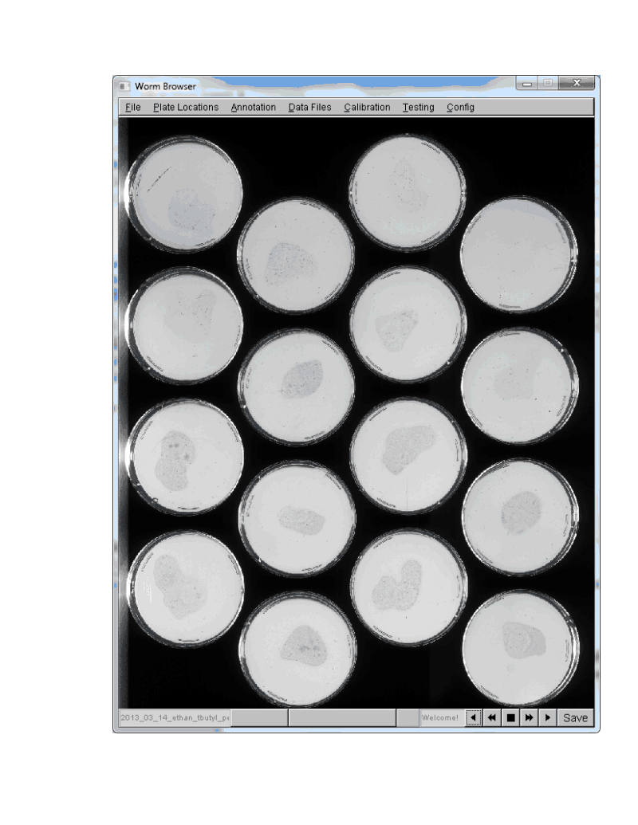
* Open a copy of the Worm Browser and drag the image into the Worm Browser window. The worm browser should open the image.
* Clicking on the image in the worm browser window will mark the upper left hand corner of a rectangle. Clicking again will define the lower-right hand corner of the rectangle. In this way, regions of the image to be scanned can be defined. You can move these areas around by clicking and dragging on the corners. After defining all the regions, you should have something that like this:  
  
* Note that the scanner runs noticeably slower when areas wider than about two inches are scanned. When instructed to scan two columns of plates, we find a significantly increased motion blur, as worms move perceptibly while being measured by the scanner bar. This is why we capture one row of plates at a time.
* After drawing these regions, the worm browser can output them as x,y coordinates in exactly the XML format used to specify experiments. From the worm browser top menu, select the option Plate Locations/Define Scan Areas/Save Selected Scan Areas to Disk  
  This will create a file in the location you specify. You can open in notepad and copy/paste the specification into your experiment schedule.

# Submitting an experiment to run

Once you have completed the experiment specification, save it into a text file with the file extension .xml . Drag this file into the Worm Browser, which will recognize the schedule and ask you if you want to output a summary of the schedule to disk. Alternately, select the menu item “Plate Locations/Submit Experiment Schedule”. When the schedule is loaded, it will be checked for formatting errors. You will have an option to review the schedule before submitting it to be run---the worm browser can generate a file, with the same name as your experiment but with a .txt extension, containing lots of information about your new experiment. Read through this to confirm everything is correct, and then load the schedule into the Worm Browser a second time to submit it to run on the cluster. It may take a few minutes for the image acquisition server to download the schedule to its local buffer, so be patient. It is prudent to observe that scans have started properly before leaving the lab. You shouldn’t have to wait more than 15 minutes. After automated acquisition has started, image analysis does not need to be started immediately; the experimenter can wait until a convenient moment days or weeks later.

# Cancelling an experiment

Experiments will run for the full duration specified unless they are actively canceled by the user. This can be done using the web interface, clicking [Edit] next to the desired experiment on the “Lifespan Machine Home” page, and then clicking the “Cancel Experiment” link revealed. This takes the user to a page with the button “Cancel Scheduled Captures”. Captures can be canceled for specific scanners by following the [Image Analysis] link next to the desired experiment on the “Lifespan Machine Home” page, selecting the desired subject under “Jobs for Device”, clicking the link “[Enable Dangerous Commands]”, and clicking “Cancel Scheduled Captures”.

Currently, entire experiments can be cancelled at any time, but scans can be cancelled for specific scanners can be cancelled only after the location of plates on scanners (image masks) have been specified (details below).

## Specifying the Location of Plates on Scanners

To allow each plate under observation to be analyzed independently, the location of each plate within each image must be identified. The experimenter does this by creating an image mask, which is a drawing made on top of a visualization generated by the worm browser. In this image, the user draws each plate in a different shade of gray, filling the background in as black. The software then interprets each color as a separate plate, and uses the mask to isolate each plate in a separate image.

Wait until at least four images are captured of each area being imaged on each scanner before making a mask—these images are needed by the software to generate the mask composite.

* Open the Worm Browser.
* Select the experiment you’d like to analyze from the list in the menu item File/Select Current Experiment/your_experiment_name.
* Select the menu item Plate Locations/Define Sample Masks/Generate Experiment Mask Composite . You will be prompted to save the mask to disk.
* By default, the most recent image captured is used while generating the mask file. However, it is possible to specifiy a specific time to use, by specifying a value in the web interface [Lifespan Machine Home] / your_experiment [Image Analysis ] / [Configure Machine Analysis] / Date and time of images to use when generating plate region mask
* When the file is created, open it with an image manipulation program, for example Photoshop or GIMP. The image should look something like this:  
  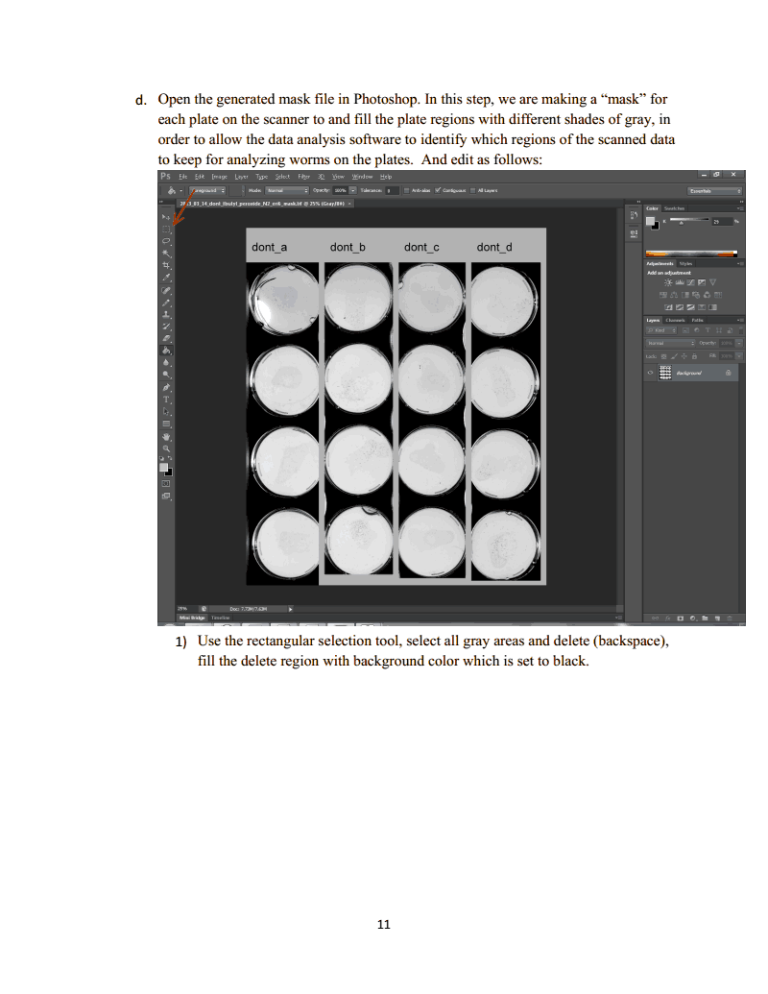
* Notice in this image the upper left plate has started to desiccate. This plate can be excluded from analysis in a later step.
* Using the image manipulation software, your task is to draw an overlay that marks the location of each plate in this image. There are many ways to do this. One relatively fast method using Photoshop is described here. Photoshop elements is often included with the scanner hardware.
  + Select the “Fill” tool, set tolerance to zero, select the contiguous option, and disable anti-aliasing. Click on the gray background to set it completely black. You should now have something like this:  
    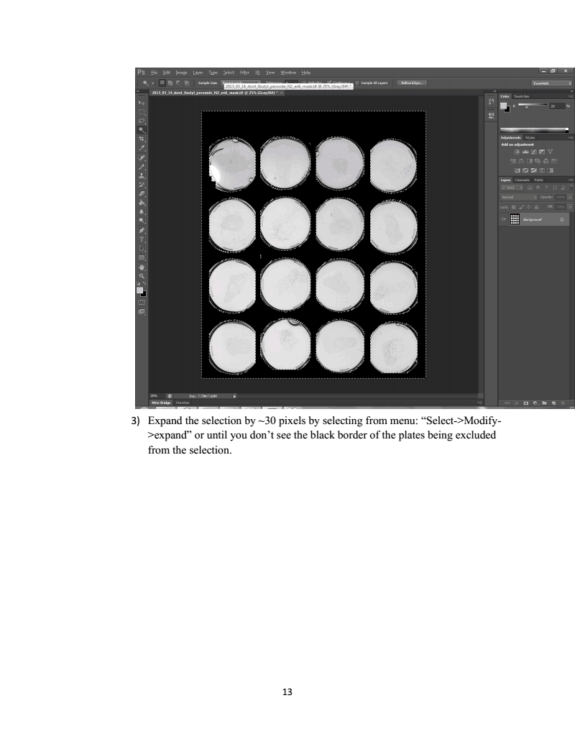
  + Using the magic wand tool, select the black background. Make sure that aliasing is set to “off”, tolerance to 0, and that contiguous is selected.
  + This selection will contain lots of jagged edges. To produce a smooth-edged mask expand the selected background by about 30 pixels (using the menu item Select/Modify/Expand), and then shrink it by 20 pixels (using the menu item Select/Modify/Shrink)
  + Fill the smoothed background entirely with black pixels, either by setting the background color to black and hitting the delete/backspace key or setting the fill tool tolerance to 255 and filling the region.
  + Invert your selection to select the foreground. Use menu item Select/Invert
  + Fill the new region entirely with white pixels, either by setting the background color to white and hitting delete/backspace key or setting the fill tool tolerance to 255 and filling the region with white.
  + You should now have an image with white plates on a black background, looking like this:  
    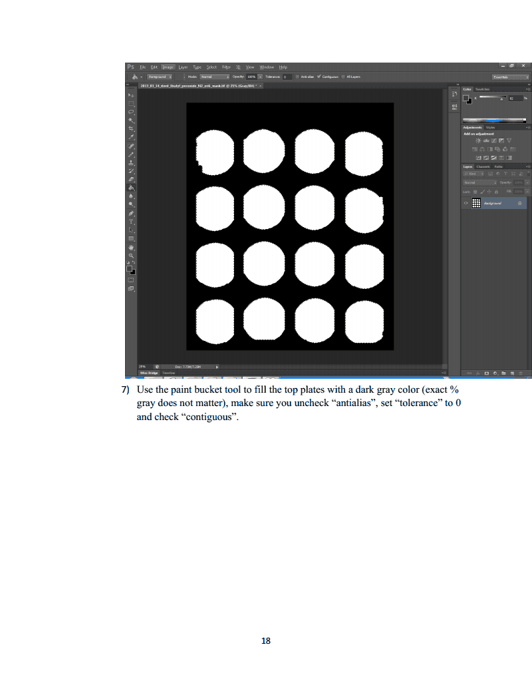
* The lifespan machine needs to know that each white region corresponds to a separate plate. Thus, you need to fill each white region with a different color of gray. Do this with the fill tool. Each image captured by the scanner is treated separately, so you can use similar colors in each region. In this example, each column was scanned separately, so each row can be filled with the same color. **IMPORTANT:** Currently the ordering of plates is set by the color of the regions specified. To have plates named 1,2,3,4 going from top to bottom, specify the colors in decreasing darkness, as shown here:  
  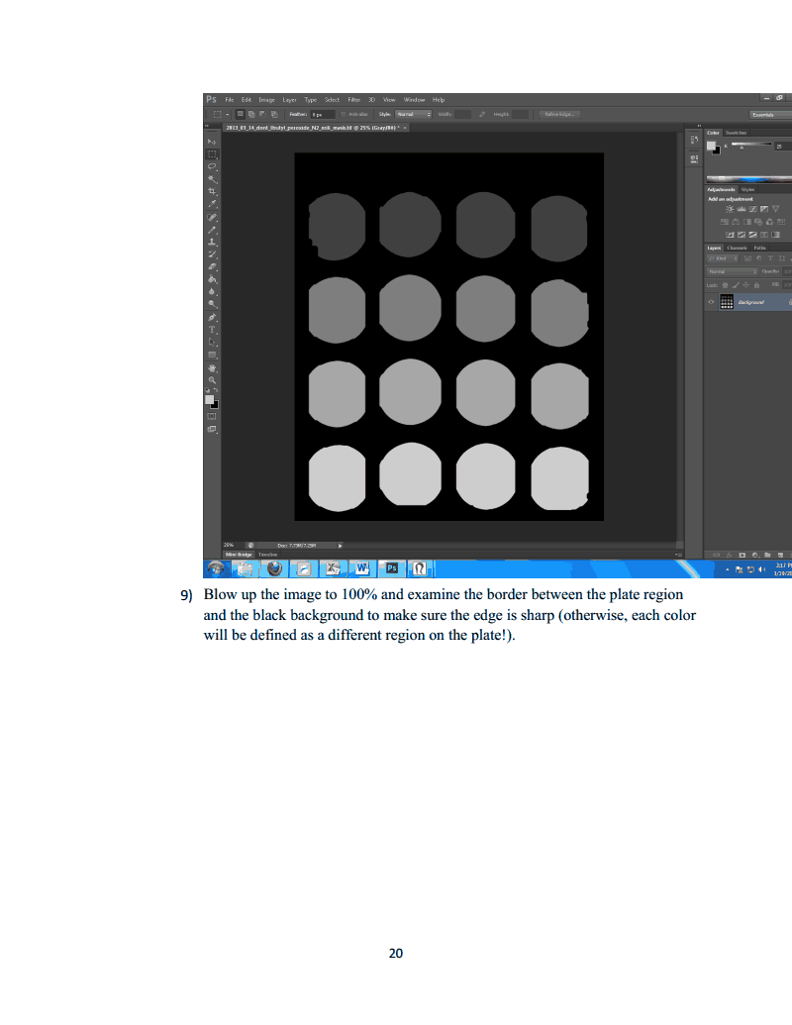  
  If you put the top row light and the bottom row dark, than your plates will be named 4,3,2,1 going from top to bottom. Assigning random colors to random plates would shuffle the order of plates in the database, an act of unforgiveable perverseness.
* Save the image using LZW compression, with no “Layers” specified.
* Ensure that the worm browser configuration file ns_worm_browser.ini, is set correctly. In particular, the line mask_upload_hostname should be set to the host_name of an image processing server currently running somewhere on your system. A list of host-names can be found through the web-interface. Follow the link “Capture Devices and Image Servers” and look at the servers listed in the left-hand column. The host_name are the human-readable names listed here.
* Open the worm browser and select the menu option Plate Locations/Define Sample Masks/Analyze Plate Locations Drawn on Experiment Mask Composite . Select the file you generated moments ago using your image manipulation program.
* The Worm Browser should now spend a few moments analyzing your image. When it is finished, it will display a visualization which will allow you to check for errors in your mask file. Each separate plate should be filled with different color and outlined by a colored rectangle. The edge of each region will be outline in white. Inspect this file to identify problems in your image mask. If two circles are shown in the same color, or included inside a single colored rectangle, then they are have been mistakenly specified as a single same plate, most likely because you accidentally used the same shade of gray for both. If there are lots of white spots inside the plate regions, this suggests the regions aren’t a single uniform color, but have speckles of another color inside. Correct your mask file and load it again into the worm browser. A correct mask visualization will look something like this:  
  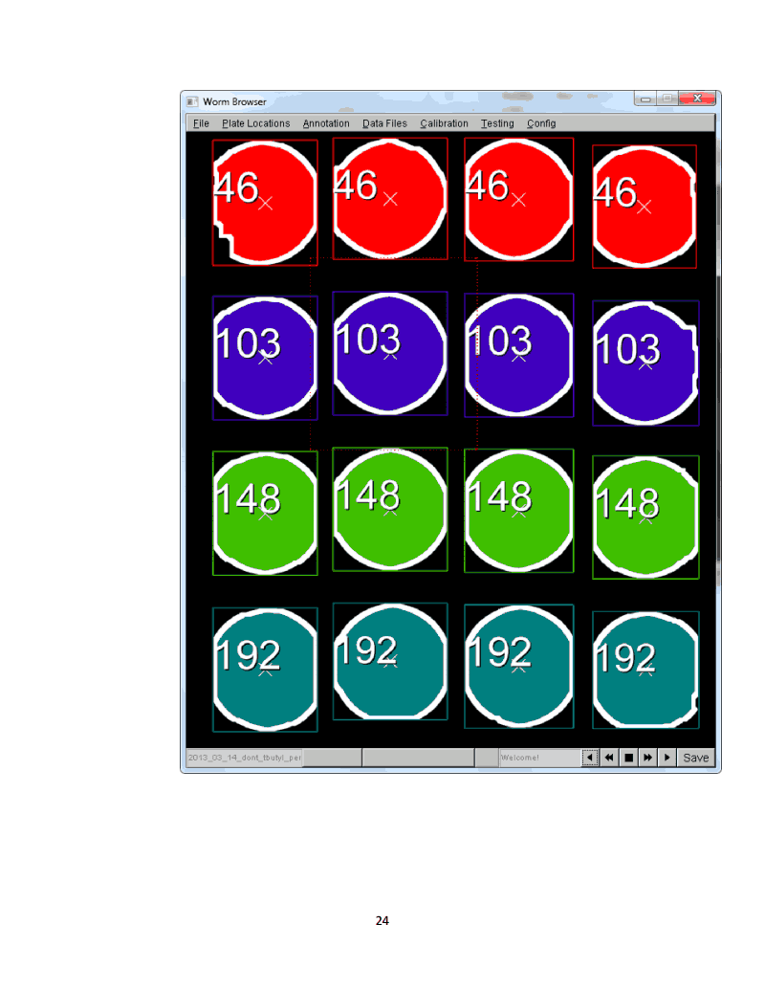
* When you have a good-looking mask prepared, select the Worm Browser menu option Plate Locations/Define Sample Masks/Submit Analyzed Experiment Mask Composite to Cluster. This will upload your mask to an image analysis server. When this completes, you are done and the lifespan machine now knows the location of all your plates.

# Breaking down captured images into individual plates

Before image analysis can begin for individual plates, you must instruct the lifespan machine to use the image mask you submitted to extract single-plate images.

* Using the web interface, go to the main page and locate the table containing experiment names. Next to the name of the experiment you want to analyze, click the link [Image Analysis]
* Click the link [New Job For All Samples].
* Under “Schedule an Image Processing Job”, select the check box next to “Apply Mask” and click “Save Job”. The lifespan machine image acquisition servers will now automatically split captured images into individual plates. This will be performed on any images already captured, as well as any images captured in the future for this experiment.

# Excluding contaminated, desiccated, or fogged plates

Contaminated, desiccated, or fogged plates will not produce valid survival data. Furthermore, they take a very long time to process, as they tend to contain many complex shapes that the machine interprets as potential worms. Once the images for individual plates have been generated, these images can be inspected to remove invalid plates from analysis. In the “Lifespan machine home”, find the desired experiment and click on the link Modify Plate Metadata [By Image]. This will take you to a list of plates, shown sixteen at a time in alphabetical order. Click on the link [Display Images] to inspect images of each plate. For this to work correctly, the linux server must be configured to serve images from its long term storage directory. Instructions on how to do this are included in the software installation guide.

Plates to be excluded from analysis should be marked by selecting an option from the “Reason Censored” drop down box. The button “Save” should be clicked only after all plates on the page have been annotated. Clicking on “Save” will move the user on to the next group of plates to annotate. Plates that have been marked as “Censored” will not have any image analysis jobs scheduled for them unless specifically requested. Any processing jobs previously scheduled to run on censored regions will continue to be performed unless deleted.

# Labeling the strain and environmental conditions of each plate

During image analysis, the Lifespan machine does not consider any metadata pertaining to the genotype or environmental conditions of animals. You do not need to enter in any such metadata to process images. However, various labels can be entered into the Lifespan Machine database that will be included as labels in the CSV data files produced by the lifespan machine, and shown at various places on the web interface. This makes it easier to schedule specific image analysis tasks and reduces the book-keeping required to interpret the resulting statistical output. Data about plates can be entered in several different way, one way is presented here.

Using the web interface, go to the main page and locate the table containing experiment names. Next to the name of the experiment you want to edit, click the link [By Position].

* This page allows you to enter data about each plate on each scanner. You can enter in lots of information for each plate, or only enter a restricted set by clicking the links [Only Show Strain Data] or [Only Show Experiment Conditions]. A common routine involves entering some short code or numbering scheme corresponding to different conditions into the “Experiment Conditions” field, and going back and filling in the additional data in bulk later.
* After entering metadata, you can apply the labels to one or more scanners. Under “Save to Devices”, select one or more devices in your experiment and click “Save to Selected Devices”. If you have the same plate layout on all plates, you can click “Save to All Devices”.
* If you want to go back and see the plate layout for a specific scanner, you can select that scanner by going to the field “Load From Device”, selecting the scanner you’re interested in, and clicking “Load from Device”.

The lifespan machine defines an animal’s lifespan as the duration of time between its death and some user-specified start time. Because all individuals on a plate are assumed to be age-synchronous, this start time (the chronological time at which animals all had an age of zero) is shared among all individuals on each plate. This start time might be the time of hatching, the time at which animals reached late L4 larval stage, or the time at which animals were exposed to some environmental condition (a new temperature, a compound, etc). This start time must be specified to generate sensible lifespan data; the default is to assume animals had age zero at the earliest possible Unix timestamp: January 1, 1970.

* Using the web interface, go to the main page and locate the table containing experiment names. Next to the name of the experiment you want to analyze, click the link [Image Analysis]
* If all animals in an experiment have the same zero-age-time, you can set this time for all animals in one step. Click on the link [New Job for All Regions]. If different plates have different zero-age-times, then you should click on the appropriate link under “Jobs for Specific Animal Types” and repeat the following steps for each animal type.
* After clicking the link, you will arrive at the page “Create New Processing Job”. Consider the section “Update Region Information”. You’ll see a variety of fields you can specify for your plates. Enter in the chronological date that you want to set as the zero-time for your animals in the field “Time at which animals had 0 Age”. Enter in any other metadata you desire at this time. You do not have to specify the Final Time Point (Date) or (Age). Make sure to select the check-box next to any field you want to update. Click on the button “Update Selected Fields”.

# Detecting Worms and Analyzing Their Movement

## Configuring image analysis for your experiment

Image analysis has two main steps 1) Detect each worm in each image 2) infer worm movement from worm position and posture. Each of these steps depends on a user-specified model file, which are placed in the directories your_long_term_storage/models/worm_detection_models and your_long_term_storage/models/posture_analysis_models respectively. These models can be optimized for specific genotypes or specific environmental conditions that influence worm morphology or behavior. New parameter sets must be specified for v2.0 of the software, you cannot use v1.0 parameter sets. V2.0 parameter sets can be downloaded from the lifespan github repository (currently located at https://github.com/nstroustrup/lifespan/tree/master/files )

* Place the model files you want to use in the correct directories. This only needs to be done once—you can use the same model files for all experiments.
* Using the web interface, go to the main page and locate the table containing experiment names. Next to the name of the experiment you want to analyze, click the link [Image Analysis]
* On the top-left corner, click on the link [Configure Machine Analysis]
* In the area named “Posture Analysis Parameter Sets”, specify the name of the parameter file you want to use. Currently only the thresholding method (described in the 2013 methods paper) is supported. Thresholding model files have filenames like mycoolmodel_threshold.txt. Do not enter the _threshold.txt suffix. Just enter mycoolmodel . Click “Set Posture Analysis Models” to submit this information.
* In the area marked “Worm Detection Parameter Sets”, enter the name of the parameter file you want to use. These models involve three separate files, named mycoolmodel_range.txt mycoolmodel_model.txt and mycoolmodel_included_stats.txt Do not enter any of the _range.txt _model.txt or _included_stats.txt suffixes. Just enter mycoolmodel . Click “Set Worm Detection Models” to submit this information.
* Take a look at the section marked “Image Analysis Options”. The defaults for this section usually will not usually need to be changed. The most common alteration is required when an experimenter places more than 100 animals on a single plate. In that case, you should increase the value in “Maximum Number of Worms per Plate” to a value around 25% greater than the maximum number of worms you expect. The image software can handle large numbers of worms per plate. This limitation is set only to prevent image analysis grinding to a halt on very complex plates, generally fogged or contaminated plates mistakenly included in analysis.

## Detecting worms in each image of each plate

The lifespan machine detects the position of each worm in each image, as shown in figure 1 of the 2013 methods paper. To start automated detection of worm positions, you can use the web interface to schedule an image processing job.

* Using the web interface, go to the main page and locate the table containing experiment names. Next to the name of the experiment you want to analyze, click the link [Image Analysis]
* If you want to schedule a job for all plates, click the link “New Job for All Regions”. If you want to schedule a job only for a specific strain or condition, click on the appropriate link under “Jobs for Specific Animal Types”.
* Look at the section entitled “Schedule a Job for Individual Images”**.** The steps required to generate lifespan curves are “Median Filter”, “Threshold”, and “Worm Detection”. If you want to generate some additional visualizations, select “Intensity Stretch” and “Worm Detection (Vis)”. The other two options involving movement paths can only be run later and are not necessary to generate survival data.
* Click on the check box next to the image processing steps you want to execute, and click “Save Job”. These image processing steps will now be performed on any images already captured, as well as any images captured in the future for this experiment.

# Analyzing Worm Movement and Estimating Lifespan

After all animals in an experiment have died, and worm detection has been completed on each captured image, you can then instruct the lifespan machine to analyze worm movement and generate estimates of each worm’s lifespan.

* Using the web interface, go to the main page and locate the table containing experiment names. Next to the name of the experiment you want to analyze, click the link [Image Analysis]
* If you want to schedule a job for all plates, click the link “New Job for All Regions”. If you want to schedule a job only for a specific strain or condition, click on the appropriate link under “Jobs for Specific Animal Types”.
* Under the section entitled “Schedule a Job For an Entire Region”, select the field “Analyze Worm Movement”. Click “Save Job”. The lifespan machine will now run a one-time analysis of all collected image data. If you want to analyze movement again at a later date (for example, if you let an experiment run longer and want to see if anything has changed), you should run this job a second time.
* Wait for all of these jobs to complete. Completed jobs will disappear from the experiment page, and each plate will be marked with a label “Movement Last Calculated (some date)” Up to time (some date)”. Movement analysis can take twenty minutes or more for month-long experiments.

## Validating Automated Worm Detection

The lifespan machine was designed to have validation of automated results as a routine, necessary step in image analysis. It is crucial that the experimenter take a careful look at the automated results to confirm that the many assumptions made by the lifespan machine software concerning nematode morphology and movement remain valid for the data set collected. Fortunately, a careful look need not be a laborious and time-consuming look. The lifespan machine generates visualizations called “Storyboards” for each experiment, viewable using the worm browser, in which the image data collected is synthesized into a compact, accessible format. By looking through the storyboard for each experiment, the experimenter provides a minimum guarantee that the lifespan machine is operating as intended. Of course, correct annotation of the storyboard does not ensure a biologically meaningful result—the details of experimental design, careful analysis of survival data, and the recognition of novel phenomena occurring in each data are necessarily the responsibility of the researcher. However, inspection of storyboards will catch most of obvious problems that crop up in automated analysis.

* Using the web interface, go to the main page and locate the table containing experiment names. Next to the name of the experiment you want to analyze, click the link [Image Analysis]
* Click on the link [New Experiment Job].
* Under the section entitled “Schedule a Database/File Storage Job”, select the field “Generate Animal Storyboard”. The lifespan machine will now spend some time collecting the data required to generate a storyboard. It will then divide the storyboard up into pieces, and generate a set of additional jobs that allow the storyboard generation to be performed in parallel by multiple image analysis servers.
* Wait for all of these jobs to complete. This should take less than 10 minutes even for large experiments.
* Open the Worm browser
* Select the experiment you’d like to analyze from the list in the menu item File/Select Current Experiment/your_experiment_name.
* Select the menu item Annotation/Browse Entire Experiment/Immediately After Each Worm’s Death

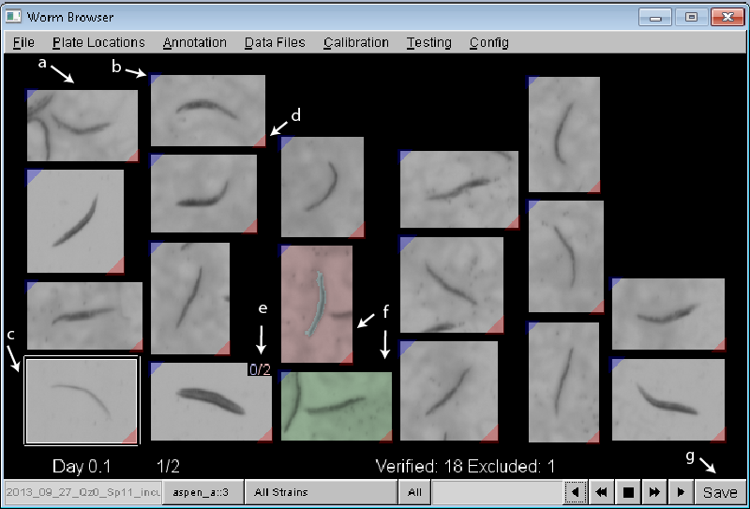

**a)** Each worm identified as stationary during image analysis is shown in chronological order of death time. **b)** The blue tag in the upper right indicates that a by-hand annotation has been made for the animal. Clicking on each worm image will bring up a movie of the animal’s final movements, which can be inspected and annotated**. c)** non-worm objects can be excluded from analysis by right-clicking. Excluded objects are outlined in white. **d)** the red tag in the bottom right indicates that the worm was detected as having died. Objects that become stationary, but never remain still long enough to be declared dead, have a green tag here. **e)** multiple worms juxtaposed can be flagged by holding down shift and left-clicking on the animals. **f)** Worms that die very close to each other can sometimes represent a single worm which the lifespan machine has mistakenly included twice, as can happen when a dead worm is moved slightly by another worm. Objects very close to each other on the plate are included as neighbors on the storyboard, with the green image representing the earlier death and the red representing the later death. **g)** Save early and often. The worm browser needs to integrate several sources of image data and juggle different sets of annotations. Any unsaved changes will be lost if the worm browser closes. The software is increasingly stable but crashes do happen.

* The figure above shows a typical page of a storyboard. Each image is a separate object whose death time was recorded by the lifespan machine. Obviously, many objects will not be worms, but instead shadows, bits of fiber from pipette tips, or clumps of bacteria. The worm detection parameter sets used in the 2013 methods paper and provided on github were designed to minimize the number of worms that go undetected, with the tradeoff that a higher number of“false-positive” non-worm objects are included. Typically, the first few pages and last few pages of a storyboard will consist entirely of non-worm objects. These objects can be rapidly excluded by right-clicking on their image. Clicking once will highlight the object in white, indicating that it should be completely ignored in later analysis. Right clicking a second time will highlight the object in yellow, also indicating that it should be completely ignored in later analysis. Currently, the difference between white and yellow is purely cosmetic. All objects on a page can be simultaneously excluded by holding down the control key and right clicking on any object on that page. An example of a single page of the worm browser is shown here.
* Multiple worms often die in close physical contact. This results in certain objects in the storyboard containing multiple individuals. These can be annotated by holding the shift key and left clicking on the object. The handling of multiple worm objects is discussed in depth in the supplement of the 2013 methods paper.
* You will see some objects colored red and green. This indicates that two worms were identified by the lifespan machine as dying very close to each other, but not touching. Often, this is perfectly fine and the colors can be ignored. In some situations, however, the two worms are actually the same individual who has been mistakenly recorded as two separate individuals as a result of some movement after death (often, the cause is that a live worm physically pushes a dead worm across the plate). This mistake in image analysis is frequent enough to be highlighted in the storyboard to allow the user to resolve the ambiguity, usually by excluding one of the two copies of the same worm. The lifespan machine colors the earliest death among such pairs in green, the later death in red. It is usually the right choice to exclude the later (red) death, as that death is usually the spurious object.
* The experimenter should browse through all pages of the storyboard, either using the arrows located at the bottom right corner of the worm browser, the left-right arrows on the keyboard, or the a and d keys. Click “Save” regularly to save your annotations.
* When you are finished annotating, click “Save”. You can either close the worm browser or select the menu item Annotation/Stop Annotation.

Animals excluded during storyboard annotation should be excluded from the lifespan machine’s automatic estimation of censoring event times. Similarly, animals marked as multiple animals during storyboard annotation should be included twice in censoring calculations. At this time, the censoring algorithm needs to be manually re-run after storyboard annotation to include annotations. This can be done as follows:

* Using the web interface, go to the main page and locate the table containing experiment names. Next to the name of the experiment you want to analyze, click the link [Image Analysis]
* If you want to schedule a job for all plates, click the link “New Job for All Regions”. If you want to schedule a job only for a specific strain or condition, click on the appropriate link under “Jobs for Specific Animal Types”.
* Under the section entitled “Schedule a Database/File Storage Job”, select the field “Analyze Worm Movement using cached image quantification ”. Click “Save Job”. The lifespan machine will now run a one-time re-analysis of worm movement and recalculate censoring data. This should only take a few seconds for each plate.

# Generating survival data

Experimenters can use the worm browser to generate comma separated value (CSV) files containing all sorts of data concerning worm movement and death. The most common task for the lifespan machine is to generate survival curves. The Worm Browser will generate a data file containing the death time of each individual observed. This data file can be then assembled into a survival using your favorite statistical software, including R, SAS, STATA, JMP or OASIS.

* Confirm the directory specified in the ns_image_server.ini file, results_directory. This is the location where all of your data will be written. The same directory should be specified and accessible by all instances of the worm browser and image analysis servers.
* Open the worm browser
* Select the experiment you’d like to analyze from the list in the menu item File/Select Current Experiment/your_experiment_name.
* Select the menu item Data Files/Death Times/Generate Death Times for Current Experiment.
* The lifespan machine will generate a set of files in the directory your_results_directory/your_experiment_name/survival_data . The most commonly used output file is located in the subdirectory your_results_directory/your_experiment_name/survival_data/survival_simple/your_experiment_name=survival=machine_jmp_days.csv

# Thanks

This document benefited immensely from collaboration with Dr. Yan Qi, who adopted the lifespan machine technology in her teaching laboratory before any documentation existed, and produced an early image analysis tutorial from which several of the screen-shots in this document were taken.