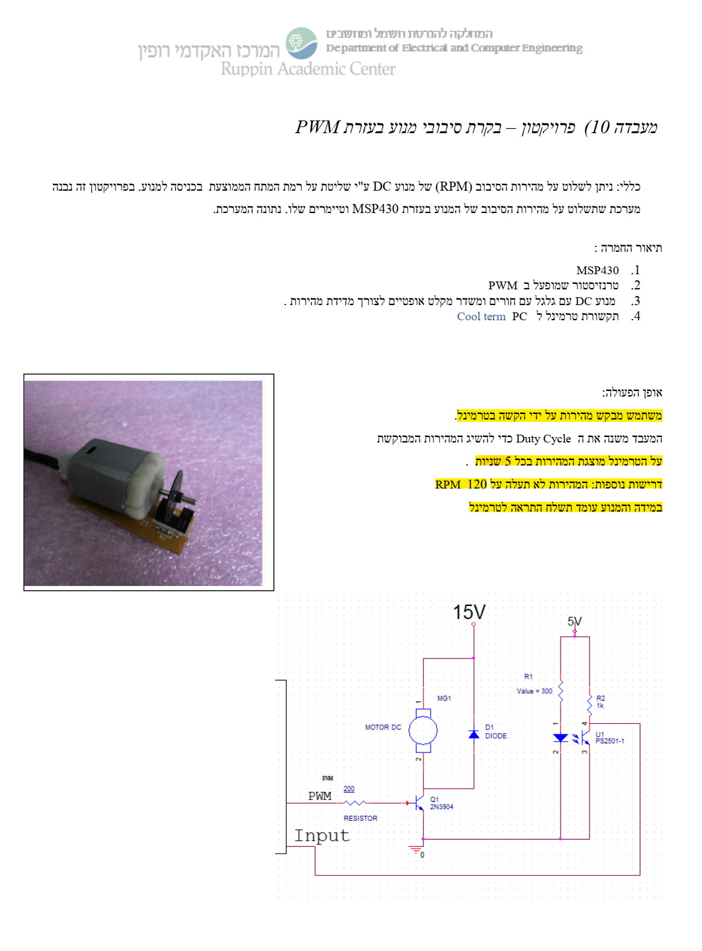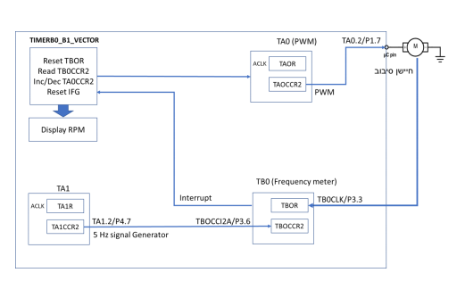

OUTPUT \ INPUT

OUTPUT

INPUT

INPUT

OUTPUT

**P1.7 TA0.2 100hz 50 duty cycle**

$$\frac{1}{32k}*TAxCCRx=1/100 sec$$

$$TAXCCRX=32k*(1/100)=327$$

**P4.7 TA1.2 5hz**

$$\frac{1}{32k}*TAxCCRx=1/3 sec$$

$$TAXCCRX=32k*(1/3)=6553$$

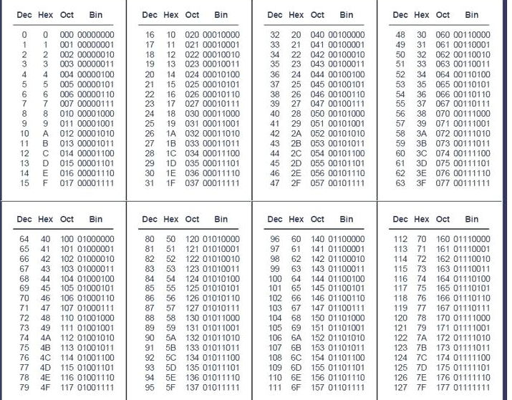

By erez asAmra