Orchid Sample
To use these sample files, please open one of the Revit documents in the "Data" folder. By doing this the "root" directory will be set correctly in all the graphs!

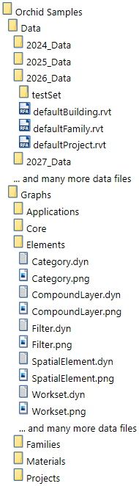
Orchid
Orchid is a solution designed for use in the Dynamo environment. The solution is designed to support practical, technical, geometrical, logical, and mathematical issues. The solution contains functions to solve data handling in Revit projects, Revit families, and materials in Revit. Besides this, also functions to solve common data handling like geometry, printing, exporting, and system actions. Orchid is among the largest and most coherent solutions besides what Autodesk releases for Dynamo.

Software environment:
Built for Dynamo 3.6 (Revit 2026), Dynamo 3.3 (Revit 2025), Dynamo 2.19 (Revit 2024), Dynamo 2.16 (Revit 2023).

More information:
Further information is disseminated at https://github.com/erfajo/OrchidForDynamo

LICENSE
Copyright(c) 2014
Erik Falck Jørgensen

All content in this executable installer is part of Orchid Samples.
The Orchid package is available at https://github.com/erfajo/OrchidForDynamo and http://dynamopackages.com

This work is licensed as a freeware product with an alike license as CC BY-ND 4.0, however, with geographical and behavioral limitations. To view the Creative Commons Attribution-NoDerivatives 4.0 International License (CC BY-ND 4.0), visit http://creativecommons.org/licenses/by-nd/4.0/ or send a letter to Creative Commons, PO Box 1866, Mountain View, CA 94042, USA.
In short terms does the CC BY-ND license state: This license allows for redistribution, commercial and non-commercial, as long as it is passed along unchanged and in whole, with credit to the author.

The geographical and behavioral limitation applied in this work implies if you are either Danish or located in Denmark, you need to be registered to be able to obtain a license. However, not everyone will be able to obtain a license if a scenario exists where a professional work-related conflict of interest may arise with the author. Such a case may be in the geographical vicinity (Denmark), where the author acts professionally and must live off the intellectual property rights in the form of job security/consultancy. It will also be seen as a conflict of interest if the author experiences personal bothering or other harassment from any user or company. In case of conflict of interest, no license will be granted to the Orchid solution for the user/company.

Third Party Licenses
Autodesk
https://www.autodesk.com/company/terms-of-use/en/general-terms

Dynamo
https://github.com/DynamoDS/Dynamo/tree/master/doc/distrib/License.rtf
https://github.com/DynamoDS/Dynamo/tree/master/doc/distrib/Autodesk.rtf
http://www.apache.org/licenses/LICENSE-2.0

Inno Setup
https://github.com/jrsoftware/issrc/blob/master/license.txt

PDFsharp
http://www.pdfsharp.net/Licensing.ashx

Microsoft
https://www.microsoft.com/en-us/servicesagreement/

Microsoft 2012 C Runtime DLLs, msvcp110.dll and msvcr110.dll
https://msdn.microsoft.com/en-us/vstudio/hh857605

Microsoft 2013 C Runtime DLLs, msvcp120.dll, msvcr120.dll
http://msdn.microsoft.com/en-us/vstudio/dn501987

MSBuild tasks
https://github.com/loresoft/msbuildtasks/blob/master/LICENSE

Newtonsoft JSON
https://github.com/JamesNK/Newtonsoft.Json
https://github.com/JamesNK/Newtonsoft.Json/blob/master/LICENSE.md

NUnit
http://www.nunit.org/
http://www.nunit.org/index.php?p=license&r=2.6.2

Prism
http://msdn.microsoft.com/en-us/library/gg406140.aspx
http://msdn.microsoft.com/en-us/library/gg405489(PandP.40).aspx

