Backward Elimination

When Backward Elimination is used as a feature selection method, in the beginning, all the features are selected. Then, at each iteration, we remove the least contributing attribute. We repeat this step until we get no improvement in the model accuracy. The following is the pseudo-code of backward elimination that we use in this study.

1- use all the features
2- calculate the accuracy
3- remove a feature
4- calculate the accuracy
5- store the accuracy with the features used to get it
6- repeat step 3 to 5 until no improvement is received
7- Identify the best accuracy with the most contributing feature

In our study after running backward elimination algorithm, we remove [FEATURES TO BE WRITTEN]. As a result, the accuracy slightly improves in some cases. The results are shown in TABLE 2.

Recursive Feature Elimination

Recursive feature elimination (RFE) is the other feature selection technique that we use. RFE aims to eliminate to detect those attributes that are dependent on each other, and they have a linear correlation between them.

RFE is not a deterministic process to specify precisely which features should be acquired for the learning process. In other words, each time we run this method, different outcomes may be observed. Hence, combining RFE with a cross-validation method can be helpful. The combination of RFE and CV is abbreviated as RFECV.

In RFECV, at each iteration, a part of the dataset is chosen, RFE is performed, and outcomes are observed. This will continue until the maximum number of folds is reached.

Difference of AdaBoost and Bagging

Methodology:

At the beginning performing data visualization helps figuring out if there are any correlated features or not. Figure 1 shows a heat-map which highlights the correlation between different features in the dataset.

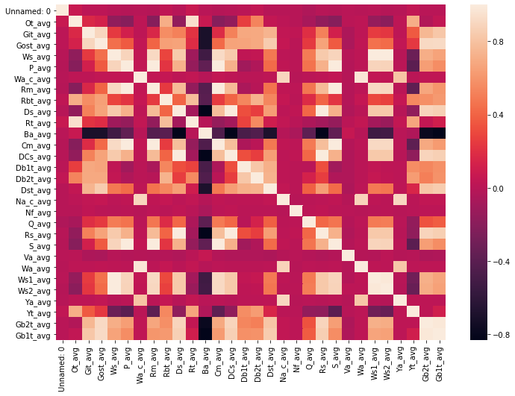

As it can be seen some of the features are highly correlated. However, the results suggest that removing the features are not beneficial in this case. This will be discussed further and in details in the Results and Discussion section.

Figure 2 shows the similar distribution patterns of X and y. As it can be seen, there is a slight difference in the distribution. Therefore, according to the Pearson Correlation Coefficient (PCC), these two features are highly correlated on each other.

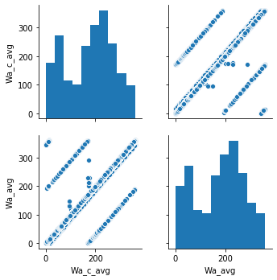

The following joint plot also highlights the linear correlation between X, y.

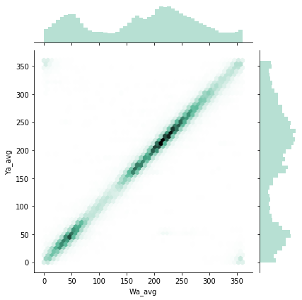

After using all the features, the following is the figure of the predictions of approximately 4000 data samples. The method which is used to obtain these estimations is K-Nearest-Neighbor.

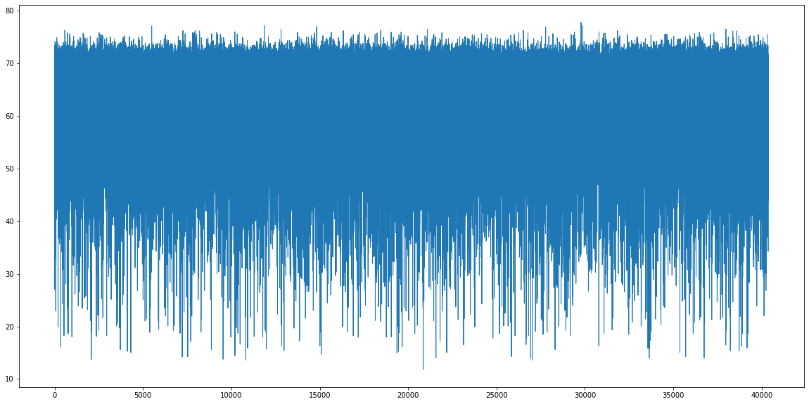
Now, the aim is to see the difference between the predicted and the actual result. The following figure illustrates this.

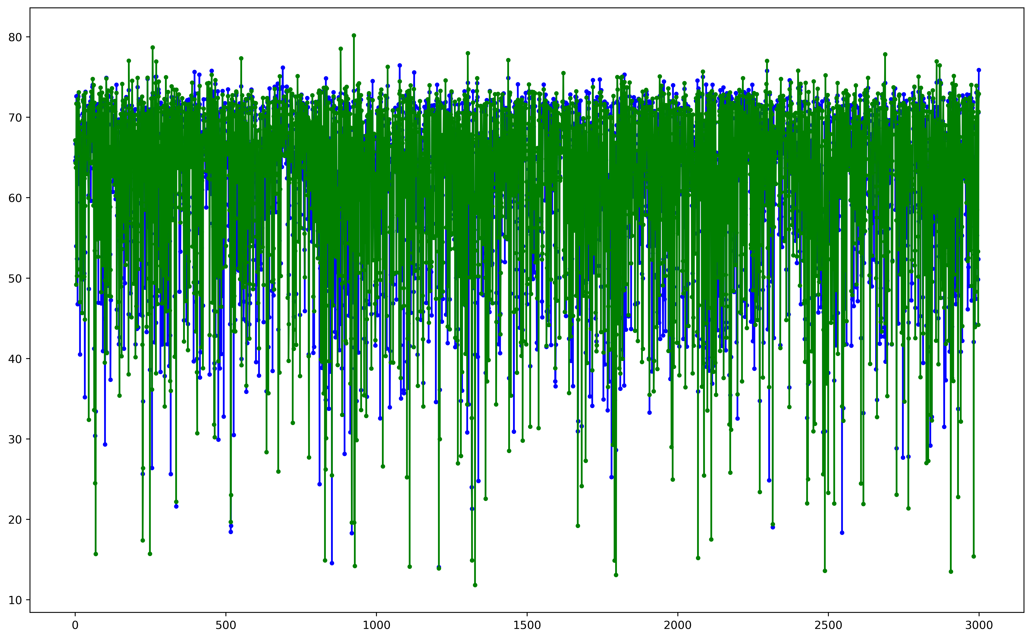
To visually highlight how well this model performs the difference of these two figures is presented in the next plot:

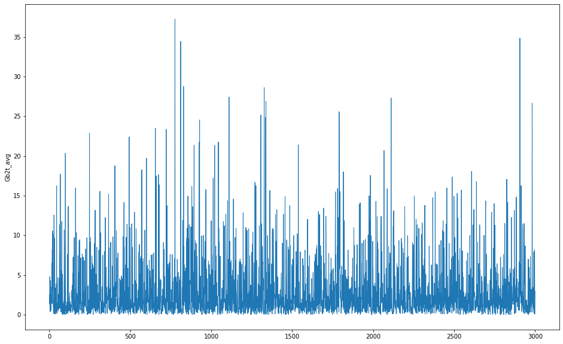
Now we specify upper and lower bound for detecting the problems in the wind turbine. The following figure shows this.

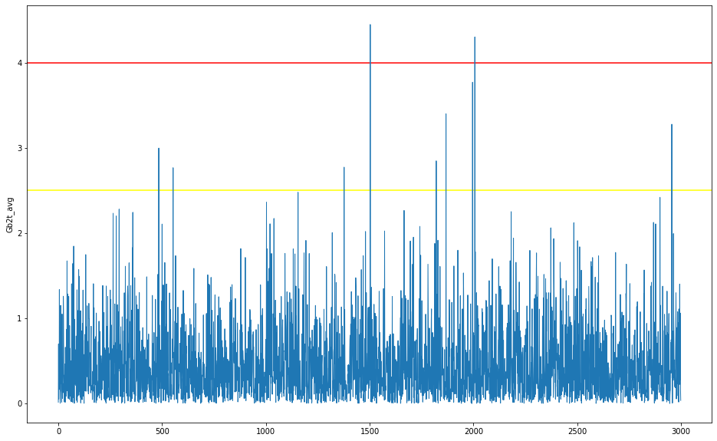

We do exactly the same thing with the best learning model according to how well it works. It will be discussed in details, but it worth mentioning at this stage that we use mean squared error (MSE) as a distance measurement method to realize how well a model works. The best model according to our studying is the bagging classifier.

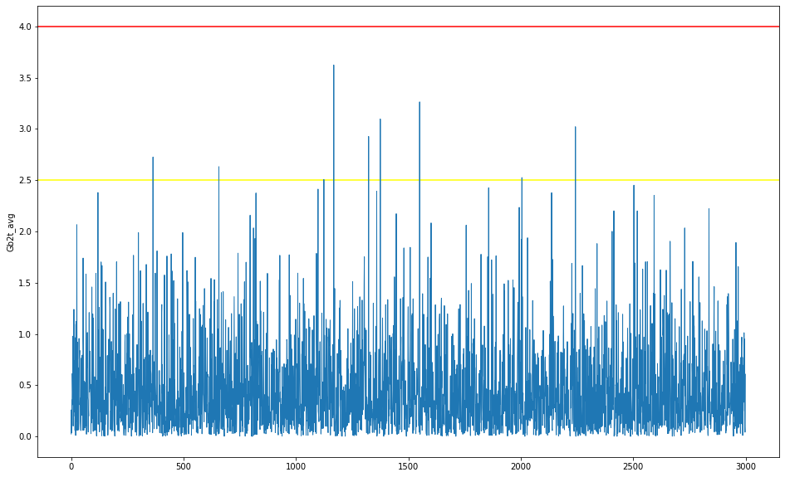

As it can be seen from this figure, it never reaches the red-line. As a conclusion, Bagging regression outperforms other methods and also satisfy the expectations according to the demonstrated figures.

Results and Discussion

The following tables are represented to compare the obtained results regarding the different machine learning models used in this study.

ID | Method | MSE | MAE | TIME | R2
1 | Extra Trees | 0.38
2 | Random Forest
3 | Gradient Boosting
4 | Adaptive Boosting
5 | K-Nearest-Neighbor
6 | Decision Tree
7 | Bagging
8 | Linear Regression
9 | MLP Regressor

