Test Project
Mobile Robotics

Competitor Information Document
Playground Monitor Robot

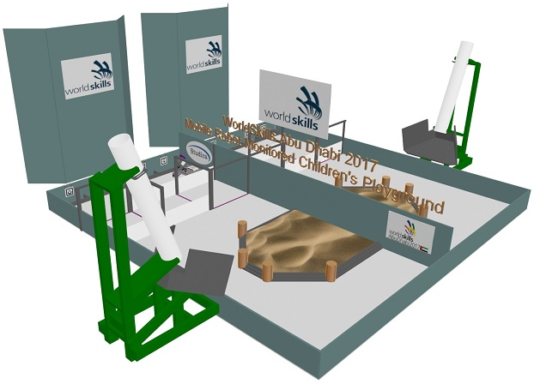

Submitted by:
Name: Bob Tone
External Test Project Designer

Table of contents

1. Introduction 3
2. Competitor Robots 4
3. Mobile Robotics Technician’s Journal 4
4. Component Collection: Allowable Additional Components 5
5. Computing Capability 7
6. Communication Performance Capability 7
7. Vision Performance Capability 7
8. Mobility Performance Capability 7
9. Target Object Management Capability 8
10. A Two Camera Direct Line of Sight / Tele-operated Object Management System Solution 10
The Search Camera 10
The Tele-operation Camera 10
The Playground reception area 11
Playground Entry Slide 12
Playground 13
11. Description of the project and tasks 13
12. Evaluation Criteria and Process 14
13. Competitor’s Mobile Robotics Technician’s Journal Use and Evaluation 14
14. Competition Schedule 15
15. Maintaining Equity while requiring True Search Evaluation Experiences 16
16. Sample Single Day Family Group 17
17. Sample Task Evaluation Run Parent Grid Sets 18
18. Single Task Evaluation Run / Marking Procedure: Maximum Value 5 Marks 18
19. Single Task Evaluation Run and Marking Pattern 19
20. Bill of Materials 19
21. Overall performance Environment details 20
38 mm (3 / 4 in.) Rough Stock Cutting Pattern Page 1 21
38 mm (3 / 4 in.) Rough Stock Cutting Pattern Page 2 22
89 mm (2 by 4 in.) Rough Stock Cutting Pattern Page 23
Entry Slide Parts Details Page 1 24
Entry Slide Parts Details Page 2 25
6 mm (1 / 4 in.) Rough Stock Cutting Pattern 26
Passageway Parts List 27
Passageway Details 28
Sand Area Parts 29
Parent Booths Details 30
Hanging Grid Pattern Plate Details 31

Introduction

Mobile Robots are used in a variety of applications to:

- Move between known in advance locations in prescribed in advance movement patterns
- Interact with known objects positioned in known in advance locations and move these known objects to known in advance new locations
- Interact with known objects positioned in unknown in advance locations and move these known objects to unknown in advance locations
- Distinguish in a group of similar objects between those that are objects of interest and those that are not of interest
- Interpret and respond to specific features found in the robot’s performance environment to manage overall mobility and the robot’s object management system autonomously
- Support the involvement of a remotely positioned tele-operator to manage the robot’s object management system in situations where the tele-operator has or does not have direct line of sight access to the robot

The role of the WorldSkills Mobile Robotics Task is to provide a structure which enables the Mobile Robotics Technician Competitors to showcase their knowledge, skills and talents during the Competition Days and within the bounds of the Competition Space.

The ‘Playground Monitor Robot’ task concept reflects a FUTURE Vendor Driven Mobile Robot application. The premise is that in the future a playground monitor robot would have performance capabilities similar to the Dubai Robot Police Officer shown below scheduled to be introduced in 2017.

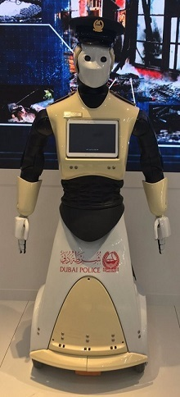 | Computing Capability  - Artificial Intelligence supported by IBM’s supercomputer Watson  Communication Performance Capability  - Ability to maintain a communications link with a Home Base Computer  - Virtual Assistant System supporting the ability to interact directly with parents and children through an on the robot touch screen computer as well as through audio  Mobility Performance Capability  Able to move in autonomous or tele-operation control mode:  - On carpeted or hard flat surfaces  - Can ‘See’ it’s surrounding environment and can interpret / recognize / respond appropriately to environmental features when moving  - Able to move in response to voice commands
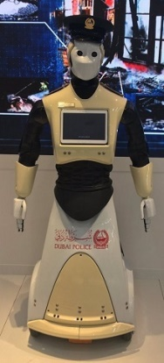 | Interactive Performance Capability  - Can utilize Facial Recognition to identify children at a distance up to 20 meters  - Can reach out verbally to children  - Can motion / wave arms and hands plus bend down towards children to communicate  - Can hold hands with and gently lead children to a pre-determined location  - Can recognize the correct parent to ensure the child is safely returned to their own family

Competitor Robots
The ‘Competitor’s Playground Monitor Robots’ are based on Current Generation Mobile Robot Technology with lower performance thresholds than the Dubai Community Police Robots.

Competitors Design / Fabricate / Manage (Program) a Competitor Designed / Built Robot capable of moving in Autonomous Control Mode within the 2 by 4 metre Competition Performance Environment Court while conducting a ‘Search for Designated Children’. Once a Robot has taken Full Control of a Designated Child the Robot returns to the Reception Area, locates the Parent of the Child and returns the Child to the Correct Family.

Competitors Design / Fabricate / Manage a Competitor Designed / Built Object Management System that is capable of functioning in ALL Three of the following Control Modes:

Object Management System Option One: The Competitor’s Object Management System can function in Autonomous Control Mode and is capable of taking control of ONE Child at a time.

Object Management System Option Two: The Competitor’s Object Management System is capable of taking control of ONE Child at a time under the control of a Tele-operator who HAS Direct Line of Sight Access to their Robot and Object Management System.

Object Management System Option Three: The Competitor’s Object Management System is capable of taking control of ONE Child at a time under the control of a Tele-operator who DOES NOT HAVE Direct Line of Sight Access to their Robot and Object Management System. In this control mode Competitors must rely on the ‘Robot’s Eye View’: A live video sent from the robot to the Competitor’s Lap Top.

Mobile Robotics Technician’s Journal

Competitors MUST create a ‘Mobile Robotics Technician’s Journal’ describing their Robot’s Development to:
- Serve as a resource for the Competitors when they are assembling their robot, and,
- Serve as a resource for the Competitors when / if they are asked questions by an Evaluating Expert Panel during some of their evaluation experiences

Competitors MUST create two copies of their ‘Mobile Robotics Technician’s Journal’ One with English Text and the other in a language of the Competitor’s choosing.

A printed copy and a PDF file version of the English Text Mobile Robotics Technician’s Journal MUST both be handed in to the Expert’s Jury Panel on C-1 the Competition Familiarization Day.

The Mobile Robotics Technician’s Journal is expected to include content in the following areas:

- The Frame / Structural Elements Organization / Strategy
- The Wiring System Organization / Strategy
- The Mobility Management System Organization / Strategy
- The Object Management System Organization / Strategy
- The Computer Programming Organization / Strategy

Component Collection: Allowable Additional Components

Following the start of February Competition Preparation Week Meetings the Skill Management Team will publish the guideline that will apply in the following areas:

- The maximum allowable $ amount with respect to Team spending on additional components.
- The response that will be applied if a Team is deemed to have exceeded the allowable $ amount.

Competitors MUST use the WSI 2017 Abu Dhabi Component Collection as the Primary Source for components when building / assembling / operating their mobile robot.
Competitors MUST use their Mobile Robotics Technician’s Journal to provide the rationale on which the decision to purchase EACH additional component was made.
Competitors CANNOT purchase components as direct replacement / upgrades to the provided components. Example: Four Encoder Motors are provided and teams must use these motors.
The following constraints that will affect the design and production of the robot must be adhered to.
1. The system MUST be designed to include the MyRIO as the main or only processing unit.
2. Programming MUST be accomplished in LabVIEW.
3. Competitors MUST use the components provided in the 2017 WSI Mobile Robotics Component Collection as the Core Elements of their Competition Robot’s Frame and Base Structure.

4. Teams CANNOT use any hydraulic pressure or barometric pressure.
5. Teams CAN use any sensors of their choice – provided they do not exceed the core capability of those provided in the component collection. Additional sensors must be accounted for in the allowed additional spending $XXX
6. Teams can use any additional electrical motors and servos of their choice – no restrictions on brand or number of motors and servos used however teams must use the supplied motor control boards and motors cannot be more powerful than those supplied. Additional purchased control items will be accounted for in the allowed additional spending $XXX.
7. Competitors are NOT to use Commercial, Off the Shelf, Straight Out of the Box Ready to Use Robot Components such as pre-assembled grippers and drive systems.
8. Teams MUST use the supplied batteries
8. All the parts for the robot MUST be disassembled and in their initial state (not pre-built) when the “assemble” time starts. For example, a tire cannot be put on a wheel until assembly time begins.
10. Teams should prepare and bring all the equipment, software and portable computers, they need during the competition

All components / elements / parts that are structural in nature, their contribution is to hold / secure in place functional elements of the robot do NOT need to be accounted for in the listing of additional $ spent to enhance the robot’s performance capabilities.

Example: Neither a purchased nor a competitor fabricated bracket with the functional purpose of holding a Linear Actuator in position needs to be accounted for in the listing of additional $ spent to enhance the robot’s performance capabilities.
The following components are considered to be structural items and will not be counted in the $XXX spending limit:
Channel and Tubing | Extrusions / Beams | Gussets | Linkages | Tank Tread
Plates and Brackets | Clamping Mounts | Attachment Pieces | Stand offs and Spacers | Wheels / Axles / Wheel Hubs
Mounting Hardware | Belting and Pulleys | Linear slide systems | Fasteners | Gears, Sprockets, and Chain
All components / elements / parts that make a direct contribution to expanding the functional capabilities of the robot beyond that supported by the provided components MUST be accounted for in the listing of additional $ spent to enhance the robot’s performance capabilities.

Example: A Linear Actuator provides a functional capability to reach forward and back again and as such must be accounted for in the allowed additional items account listing.
The following are NOT considered structural Items and must be included in the $XXX
Motor and Servo Controllers | Additional Batteries | Linear Actuators | Signal Modifiers | Speed Controls
Micro Controllers | Single Board Computers | Additional Sensors | Additional Motors | Gripper
The following items will NOT be counted in the $XXX spending limit:
Cables, Wires, and Connectors | Safety Switch | Voltage Regulators | Electrical Connectors | Relays
Switches | Electronics Mounts | Breadboards | Competitor manufactured items | Lead Screws
Wheels | Competitor manufactured Sensor Interface Board |  | Competitor Supplied Remote for Tele-operation

Computing Capability
- Labview / NI MyRIO

Communication Performance Capability
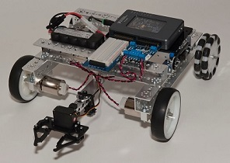
- Ability to maintain a video communication link with an FPV Camera Receiver.
- No ability to support interactive communication with people other than its’ assigned Home Station Operator

Vision Performance Capability
Able to recognize Designated Parent Objects (Black and White Grid Patterns) as well as being able to identify Designated Children Objects (Solid and Striped American 2.25 inch Billiard Balls plus an All White Cue Ball) | 

Mobility Performance Capability
Able to move in autonomous control mode:
- Compulsory Mobility Capability involves movement on hard flat surface
- Mobility in relationship to the structures within the 2 by 4 metre Exclusive Use Competition Court Performance Environment Space
- Mobility within a Maximum Robot Occupancy Space that is 600 by 600 by 500 mm.
- Optional Mobility Capability involves movement UP / DOWN a set of steps, INTO / Out Of and AROUND IN a floor area covered with a minimum 57 mm deep layer of sand.

Target Object Management Capability

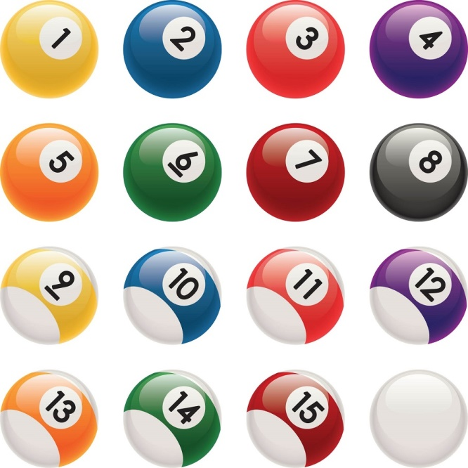 | A set of American Billiard Balls, diameter 2.25 inches, will fill the role of ‘Children’ in the Playground Monitor Robot Task.  Competitors will Design / Fabricate and Operate an Object Management System with the following capabilities:  - Can be managed / operated autonomously and through a Teleoperation Based Control System  - Can function when the Teleoperator either HAS or DOES NOT HAVE Direct Line of Sight Access to their Robot / Robot’s Object Management System  The Object Management System and the Robot in combination can be in possession of a Maximum of ONE Child at a time.

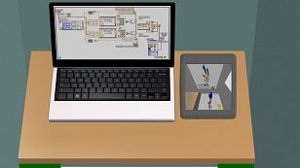 | 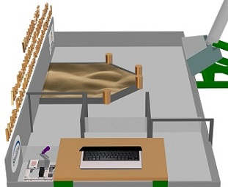
In the NO Direct Line of Sight situation the Object Management System Tele-operator’s Courtside Workstation includes both their Lap Top and their FPV Camera Recieiver. The Robot’s video signal is sent ONLY to the FPV Camera Receiver. | In the Autonomous and Direct Line of Sight situations the Object Management System Tele-operator is positioned in a fixed location behind their computer table and can see the Full Performance Evaluation Space but cannot see their Lowered Lap Top computer screen.

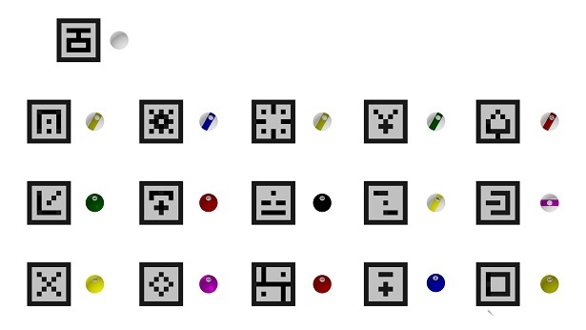
IMAGE: The image above displays the Full Complement of the “Task Families”

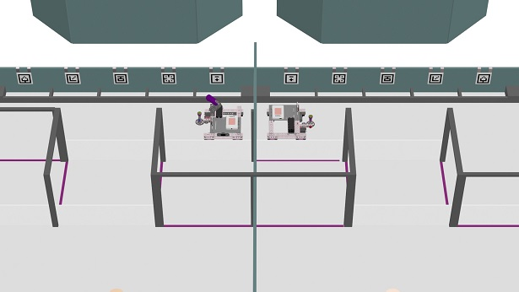
ALL Teams MUST prepare their Robot to be able to execute Evaluated Task Runs when at the Start of the run the Parent Booths are EITHER on the Right OR the Left side of the Robot.

A Two Camera Direct Line of Sight / Tele-operated Object Management System Solution

The Two Camera Solution is intended to:

- Internalizes Camera Management to the on the Robot MyRIO which will support Autonomous Mode Mobility and Object Management Functionality Free from any potential competition space signal interference issues.
- Enable the Tele-operation mode to take place with the Tele-operator NOT Having Direct Line of Sight contact with their Robot which is the most realistic Tele-operating arrangement.

The Search Camera
- This camera is managed exclusively by Labview and all images are analysed on the robot through MyRIO. This camera does NOT send any images to an ‘Off the Robot Device’. This is the camera directly involved in the process of identifying Children (Billiard Balls), Parents (Black and White Grid patterns) plus any additional movement management responsibilities Competitors choose to assign to the camera.
- This puts Labview and MyRIO in full control of managing the processing resources committed to the major vision task elements involved in the search process without the burden of sending a constant live video signal to an off the robot lap top.

The Tele-operation Camera
- Competitors will be provided with a separate FPV Camera, a 5.8Ghz transmitter and a small 4.3”monitor/receiver for use during their competition preparation experiences to support the teleoperation of their Object Management System having NO Direct Line of Sight Access to their Robot or Object Management System.
- At the competition Competitors will be provided with larger HD 7” LCD receivers. These will also have HDMI out so that they can be wired to large screens for viewing by the audience.
- Competitors will have to decide how to power these cameras.
- These cameras will have NO interaction with the Competitor’s Lap Tops, or MyRIO.
- These cameras provide the video image the Tele-operator will use when they are operating their Object Management System.
- ALL Teams will be required to position a light on their Robot where this light is always in the Field of View of the Tele-operation Camera. Robots will need to be programmed to Turn this Light ON at the end all Autonomous Performance Sequences. This will alert the Tele-operator that it is time for them to take control and operate the Object Management System to retrieve or deliver a Child (Billiard Ball).
- When the Tele-operator has completed their task, they will use their Tele-operation Device to signal the Robot to move forward with its’ next Autonomous Performance Sequence.

In Abu Dhabi, the Performance of the Tele-operation Cameras will be monitored to confirm their in the Competition Space functional reliability during Competition Days 1, 2 and 3 when they have no role in the marking experiences. The goal is to have Competition Day 4 involve Tele-operation with No Direct Line of Sight Access to the Robots given this is the most realistic tele-operation application format. However, IF our Competition Days 1, 2 and 3 experiences demonstrate the presence of IN the Competition Space signal problems with the Tele-operation Camera / HD 7” LCD receiver pairings then C4 will be made a Tele-operation Day WITH Direct Line of Sight Access to the Robot.
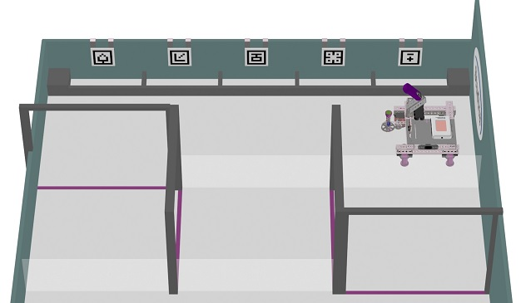

The Playground reception area

The Playground Reception Area is comprised of:
- An Entry Passageway with Clear Plastic Side Walls 200 mm Tall and providing a 600 mm wide travel space with a maximum overhead clearance allowance of 500 mm.
- A Row of Parent Booths, with 100 mm tall front walls, along the longest wall of the Reception Area
- The Parent Grid Patterns will be mounted on Thin, Flat Plates that have either Velcro Tape on the Back of the Plates or Hooks. The Back Wall of the Parent Booths will also have Velcro Tape or support for the hooks which will allow for easily changing the Position of Parent Patterns between Task Runs necessary to support the True Search Element of the overall task.
- The Designated Robot Starting Position is Inside a 600 by 600 mm Tape Line Square at the end of the reception area farthest from the Reception Area Entry.
- ALL of the Performance Environments physical features will be put in place on Familiarization Day and will remain unchanged throughout the Four Competition Days.

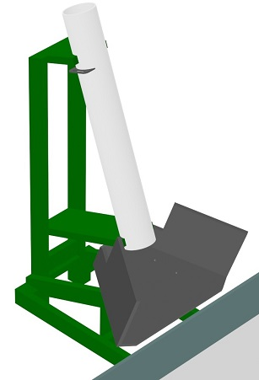 | Playground Entry Slide  - The 16 Children (Billiard Balls) will be placed in the Top of the Entry Slide prior to the Start of each Evaluated Task Run  - The order the balls are placed in the slides will be Identical for ALL courts. This is intended to bring a suitable degree of equity to the otherwise Random Placement of the Children (Target Objects) in the multiple courts running Evaluated Task Runs at the same time.  Note:  Random Placement of the Target Objects in NOT Known to the Competitors in advance positions is essential to enable a ‘True Search for the Designated Five Children’ element to be part of the task experience.  Note:  If a Ball lands either Outside the Playground Entirely or On Top of a Sand Area Pillar then the following procedure will be followed:  - The Ball will be picked up by a Court Area Supervising Expert  - The Ball will be placed in the Entry Slide  - The Entry Slide Procedure will be repeated for this Single Ball
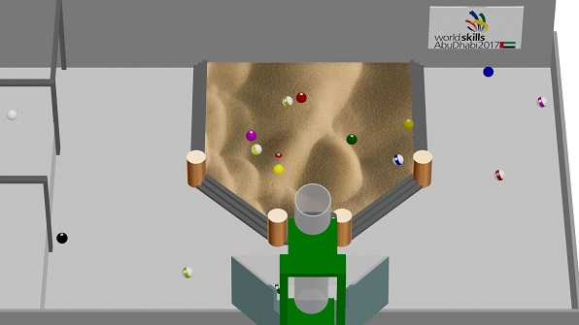

Playground
The 16 Children (Billiard Balls) will tumble out of the Entry Slide Chute into a Playground consisting of:
- A U-shaped open / hard / smooth surface floor area
- A Central 57 mm deep 1100 by 1257 mm Sand Filled Area with a perimeter frame consisting of step sections each with 3 steps having a 19 mm Rise and 25 mm Run per step
- Four Dia. 100 mm 180 mm tall Cylindrical Pillars
- A 600 mm wide 500 mm tall archway entry / exit opening

Description of the project and tasks
The Competitor Built Robots Task is to travel from the Playground Reception Area into the Playground and retrieve, one at a time, the Designated ‘Children of Interest’ then return to the Playground Reception Area and deliver each of the Children to the Correct Parent.

The number of ‘Children of Interest’ Teams will need to manage in each of their 10 minute Evaluated Task Runs will be 5 Children per task run.
The number of Children of Interest per Task Run will be finalized by the Experts Jury Panel during their in Abu Dhabi pre-competition meetings. However, ALL Teams need to prepare to have their Robot ready to manage 3, 4 or 5 Children per 10 Minute Evaluated Task Runs in ALL Object Management System Control Modes.
Prior to coming to Abu Dhabi Competitors will:

- Design and Build a Prototype Mobile Robot capable of managing its’ mobility within the Performance Evaluation Environment in 100% Autonomous Control Mode.

- Design and Build a Prototype Object Management System capable of functioning in a variety of control formats:

a) In Autonomous Control Mode
b) In Tele-operation Control Mode based on the Tele-operator NOT having Direct Line of Sight access to their robot and Object Management System.
c) In Tele-operation Control Mode based on the Tele-operator having Direct Line of Sight access to their robot and Object Management System.

- Competitors need to be prepared to demonstrate in Abu Dhabi their understanding of the structural, mechanical, electrical, and control systems they have included in the design of their robot and object management systems including the rationale behind their design decisions.

- Competitors are required to dis-assemble their proto-type robot and prototype object management system prior to shipping them to Abu Dhabi.
NOTE:
Dis-assembled is defined as follows:
- All motors, sensors and electrical components must be in their ‘Straight out of their delivery box statuses.
- All structural and mechanical components secured to one another by competitor installed mechanical means (nuts and bolts / screws) must have these connecting elements removed resulting in the structural and mechanical components being totally separated from one another.
- ALL competitor installed wiring connections to components must be removed.

- Competitors will be required to build their competition robot on-site in the competition space on Competition Day 1 which has been assigned as the Robot Build / Setup Day.

- Competitors will be allowed to use Program Files created during their Pre-competition Preparation Experiences when conducting their On-site Evaluation Experiences.

- Familiarization Day (C-1) can NOT be used to assemble the Mobile Robot. This day is only intended for Competitors to check whether all components, assembly parts, wires and tools are available and to check whether individual parts (like motors, sensors, and control unit) are still functioning after shipping.

- Competition Day Two will involve Competitor Evaluation Experiences in (a) the Design, (b) the Fabrication and Assembly and (c) Core Programming, Testing and Adjustment evaluation categories.

- Competition Days Three and Four will involve Evaluation Task Runs that will take place in the provided Performance Evaluation Environments.

- Each Court provides Two Side by Side Independent Playgrounds.

- 4 to 6 Teams of Competitors will share the pair of Playgrounds in each court during “Work Periods”.

Evaluation Criteria and Process
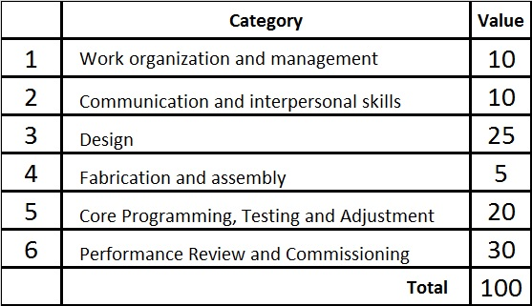 | - In category 1, the Evaluation Process will be conducted each of the Four Competition Days  - In categories 2, 3, 4 and 5 the Evaluation Process will be conducted on Competition Day 2 based on the requirements defined in the Computer Information System Assessment document file.  - In category 6 the Evaluation Process will be conducted on Competition Days 3 and 4

Competitor’s Mobile Robotics Technician’s Journal Use and Evaluation
Competitors are required to maintain a Mobile Robotics Technician’s Journal during their competition preparation activities.
The Mobile Robotics Technician’s Journal will serve the following purposes:
- Provide an insight into the competitor’s thinking throughout their Mobile Robot / Task Specific Solutions Development across the full spectrum of content areas associated with the development of Mobile Robot / Task Specific Solutions.
- Highlight the Competitors thinking relative to their robot design, program file structure, overall task strategy and Team Organization during item 3, 4 and 5 evaluation experiences.
- Serve as an ‘In the Competition Space Competitor Resource’ available to the Competitors to consult while at their workbench and during Expert Jury Panel Interview Experiences.
- Evaluation of the Mobile Robotics Technician’s Journal will comprise the marking content for the Communication and Interpersonal Skills CIS section and will this evaluation will be done by an Expert Jury Panel. The Journals will be examined relative to the quality, appropriateness and organization of the Journal content.
Competitors will be required to include the following Five Content Areas in their Mobile Robotics Technician’s Journal and each of these areas will carry a value of 2 marks in the CIS file.
- Frame / Structural
- Wiring
- Mobility Management
- Object Management
- Computer Programming
In all of these areas the Expert Jury Panel evaluating the Engineering Journal will be looking for:
- Appropriate use of content area specific drawings / diagrams / schematics
- Clarity in which the Competitors understanding of the area specific theories are evident in the design decisions the Competitors have made during the development of their Mobile Robot / Task Specific Solutions.

Competition Schedule

C-2 | Familiarization Day:  - Competitors unpack their tools and robot components  - Competitors examine their tools and robot components to confirm they have not been damaged during shipping to the competition site  - NO Robot or component assembly takes place on C-1  - Competitors hand in to the Expert Jury Panel a printed copy and a PDF file of the English Text version of their Mobile Robotics Technician’s Journal
C1 | Competition Day One:  - Competitors have the Full Competition Day to Build / Assemble their Competition Robot  - Competitors have Shared Access to their Assigned Performance Evaluation Spaces (Playground Courts) on an Unscheduled Basis All Day
C2 | Competition Day Two:  - Competitors continue Building / Assembling / Preparing their Competition Robot  - Competitors have Shared Access to their Assigned Performance Evaluation Spaces (Playground Courts) on an Unscheduled Basis dependent on court availability. Note: Court Access Priority will be given to conducting marked evaluation experiences.  - Competitors will complete the following Evaluation Experiences on a by Competitor Request Schedule Basis with the restriction that ALL Teams MUST complete these Evaluation Experiences by the End of C2  - Robot Development Journal Review, b) Design Evaluation Experiences, c) Fabrication and Assembly Inspection and d) Core Programming, Testing and Adjustment Experiences
C3 | Competition Day Three:  - During the AM Orientation Meeting the Specific Parent Grid Patterns and Child Objects will be identified and this set of Parent and Child objects will be used in ALL Evaluated Task Runs on Competition Day 3  - Competitors have Shared Access to their Assigned Performance Evaluation Spaces during the 30 minutes following the AM Orientation Meeting  - Competitors will have TWO Exclusive Use 20 Minute Access to their Assigned performance Evaluation Spaces  - Competitors will have THREE Autonomous Control Mode Mobility and Autonomous Control Mode Object Management Control System Evaluated Task Run Experiences involving:  - A 5 Minute Final on the court Robot Adjustment Time Block  - A Ten Minute actual Evaluated Task Run Time Block  A 5 Minute POST Evaluated Task Run Time Block used by the Competitors to confirm the results of their Evaluated Task Run have been recorded correctly and to remove their Robot from the Performance Evaluation Environment
C4 | Competition Day Four:  - During the AM Orientation Meeting the Specific Parent Grid Patterns and Child Objects will be identified and this set of Parent and Child objects will be used in ALL Evaluated Task Runs on Competition Day 4  - Competitors have Shared Access to their Assigned Performance Evaluation Spaces during the 30 minutes following the AM Orientation Meeting  - Competitors will have TWO Exclusive Use 20 Minute Access to their Assigned performance Evaluation Spaces  - Competitors will have THREE Autonomous Control Mode Mobility WITH NO Direct Line of Sight Access Tele-operation Control Mode Object Management Control System Evaluated Task Run Experiences  Note: IF On-site Robot to Lap Top communication testing conducted over Competition Days 1, 2 and 3 indicates the presence of any Robot to Lap Top communication irregularities then the Day 4 Task format will be changed to: THREE Autonomous Control Mode Mobility WITH Direct Line of Sight Access Tele-operation Control Mode Object Management Control System Evaluated Task Run Experiences  - A final 5 Minute Final on the court Robot Adjustment Time Block  - A Ten Minute actual Evaluated Task Run Time Block  A 5 Minute POST Evaluated Task Run Time Block used by the Competitors to confirm the results of their Evaluated Task Run have been recorded correctly and to remove their Robot from the Performance Evaluation Environment

Maintaining Equity while requiring True Search Evaluation Experiences
It takes Three Task Runs involving Two Teams at a time per court to complete an Overall Single Evaluated Task Run experience. It is essential that neither a real advantage nor a perceived advantage is associated with a Team being in the First, Second or Third Pair of Teams.
The following Evaluation Task Organization is intended to ensure NO Advantage exists based on a Team’s placement in the First, Second or Third Pair of Teams scheduled to execute the Task sequence.

The Entry Slide is intended to introduce a Mechanical Based Process to managing the entry of the children into the Playground. Balls will be placed in ALL Entry Slide in the same order.

If a Ball lands outside the court or On Top of a Sand Area Pillar an Expert will retrieve the Ball, put it in the Entry Slide and before the Evaluated Task Run starts repeat the Slide Experience for this Ball only.

- There will be Three Evaluated Task Runs per Day C3 and C4
- The AM Exclusive Use Court Access Time Blocks will be scheduled in the same sequence as the Task Evaluation Runs ensuring the time between each Team’s final preparation Time Block and their Evaluated Time Block is equal.
- The Designated Task Parents and Children will be set in the AM and NOT change ALL Day.
The Final Positions of the Children based on tumbling Out of the Entry Slide is by default a Random Task Element.

Sample Single Day Family Group

  Designated Family 1 |   Designated Family 2 |   Designated Family 3 | 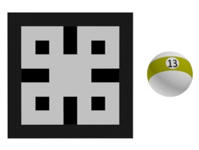  Designated Family 4 | 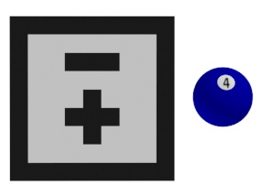  Designated Family 5

- The Positions of the Five Designated Parents in the Reception Area will be a NOT Known in advance by the Competitors Detail.
- The Parent Grid Patterns for each Task Evaluation Run will be IDENTIFIED AFTER the Competitors have placed their Robots in the Performance Environment Court and ALL Task Preparation Activity has been completed.
- The images in the table below are intended to provide an explanation how the Parent Grid True Search Performance Element will be organized to ensure an equitable experience for all teams.
- The sample below has 3 Parent Grid Sets but using 6 Parent Grid Sets is a possibility.
- Each Parent Grid Set will be assigned number values:
Set A = 1 or 2, Set B = 3 or 4 and Set C = 5 or 6.
- AFTER ALL Teams involved in the Task Evaluation Run indicate they are ready, a Die will be rolled to identify which Parent Grid Set would be used for that Task Evaluation Run and then the Parent Grids would be placed in the Designated Reception Area Booths.

Note: If an error is made in placing the Grid Patterns on a single court the Task Runs will NOT be stopped given All Robots must deliver a Child to ALL 5 Parent Booths and the position of the Children of Interest is unknown the error would not generate any measureable advantage to the Team.

Sample Task Evaluation Run Parent Grid Sets
  Parent 5 Reception Area Parent Booth 1 |   Parent 1 Reception Area Parent Booth 2 |   Parent 4 Reception Area Parent Booth 3 |   Parent 2 Reception Area Parent Booth 4 |   Parent 3 Reception Area Parent Booth 5
Sample Parent Grid Pattern Position Set A = Die Values 1 or 2
  Parent 2 Reception Area Parent Booth 1 |   Parent 4 Reception Area Parent Booth 2 |   Parent 5 Reception Area Parent Booth 3 |   Parent 3 Reception Area Parent Booth 4 |   Parent 1 Reception Area Parent Booth 5
Sample Parent Grid Pattern Position Set B = Die Values 3 or 4
  Parent 3 Reception Area Parent Booth 1 |   Parent 5 Reception Area Parent Booth 2 |   Parent 2 Reception Area Parent Booth 3 |   Parent 1 Reception Area Parent Booth 4 |   Parent 4 Reception Area Parent Booth 5
Sample Parent Grid Pattern Position Set C = Die Values 5 or 6

Single Task Evaluation Run / Marking Procedure: Maximum Value 5 Marks
- Each court hosting two side by side Teams in Exclusive Use Performance Evaluation Environments will be monitored by a group of Three Experts.
- Marking will take place at the conclusion of the 10 minute Task Run in compliance with Worldskills Rules indicating Groups of Three Experts must be involved in each Mark Assignment Experience.

Single Task Evaluation Run and Marking Pattern
- Teams will be awarded 0.8 Marks for each Child successfully delivered to the Correct Parent Booth. Maximum Value: 4.0 Marks
- Teams will be awarded 0.6 Marks for Children delivered into the Playground Reception Area but NOT delivered to the Correct Parent Booth.
- Teams delivering ALL Five of the Designated Children to the Correct Five Parent Booths before the End of a Task Run Buzzer Sounds will qualify for a Time Mark with a Maximum Value of 1.0 Mark.
- Time Mark Calculation will be based on the following formulae:

(Fastest Qualifying Team’s Time / Individual Qualifying Team’s Time) X 1.0 = Time Mark Awarded

Bill of Materials
- 2 sheets of ¾ in. by 4 ft. by 8 ft. rough stock of your choice. I recommend Good 2 Sides Birch Plywood

- 4 pieces of 2 by 4 in. by 8 ft. boards

- 2 pieces of clear plastic measuring:

- Piece One: 1362 by 200 by 6 mm

- Piece Two: 1381 by 200 by 6 mm

- 1 PVC Drainage Pipe or SONO Tube Concrete Forming Tube Dia. 6 in. and 48 in. Long

- 1 PVC Drainage Pipe or SONO Tube Concrete Forming Tube Dia. 3.5 in. and 32 in. Long

- 1 sheet of white Hardboard ¼ in. by 2 ft. by 4ft.

- Two Metal Hooks made from thin / flat metal strapping for each Parent Grid Plate
The rest of this document has drawings presenting the cutting patterns and individual parts dimensions required by teams to build a Court for use during their Competition Preparation Activities.
Note: The Entry Slide is primarily required to bring equity to the Ball Distribution when multiple courts are running Evaluation Task Runs at the same time. Teams could decide not to build an Entry Slide and choose to use alternate methods of distributing the balls in the Play Ground.

Overall performance Environment details
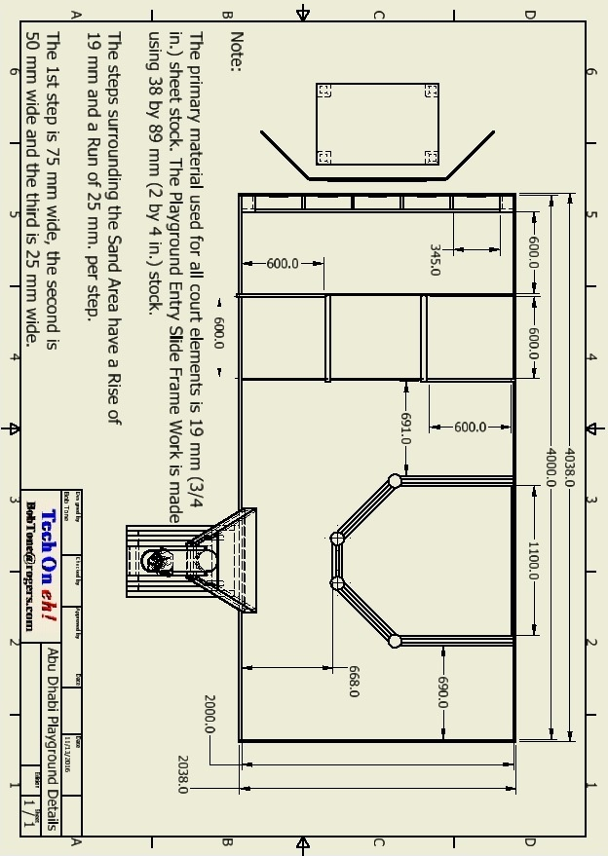

38 mm (3 / 4 in.) Rough Stock Cutting Pattern Page 1

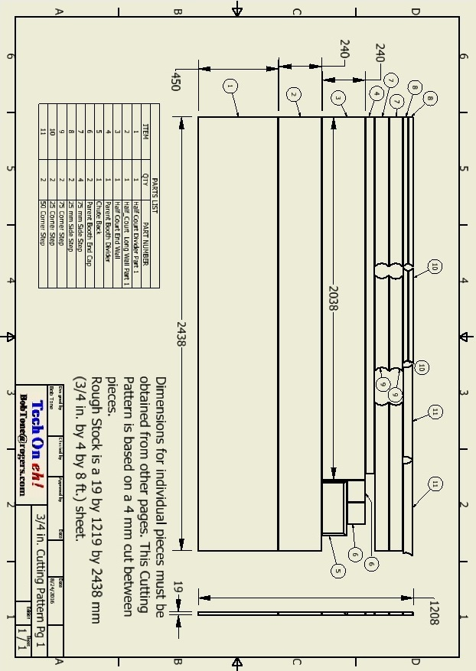

38 mm (3 / 4 in.) Rough Stock Cutting Pattern Page 2

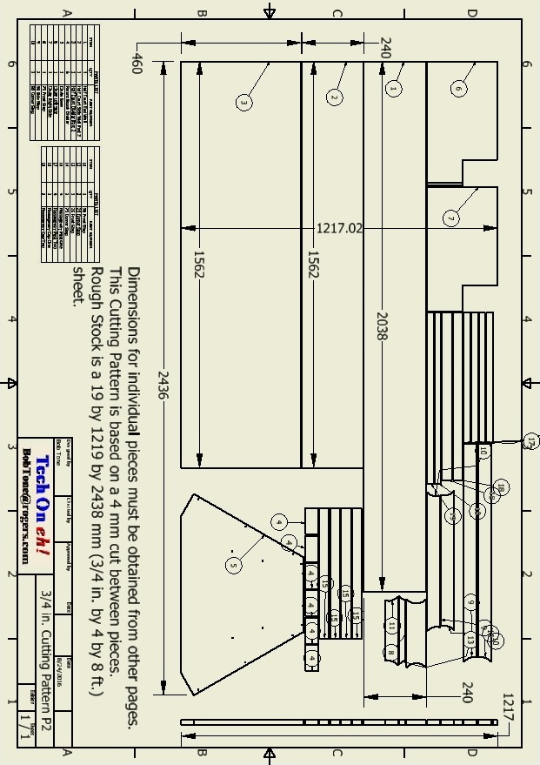

89 mm (2 by 4 in.) Rough Stock Cutting Pattern Page

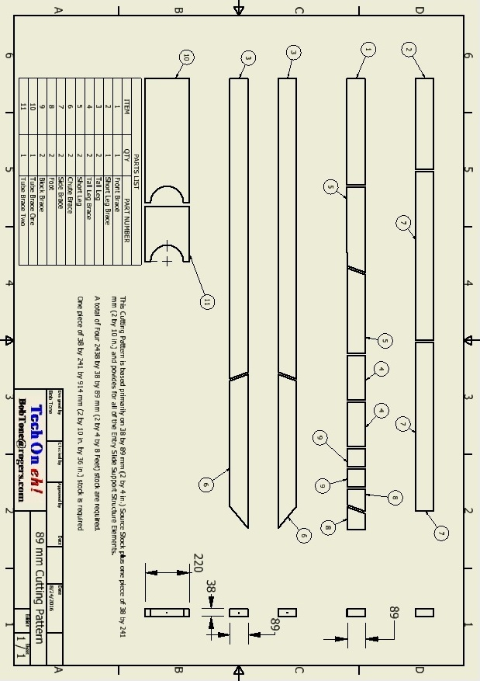

Entry Slide Parts Details Page 1

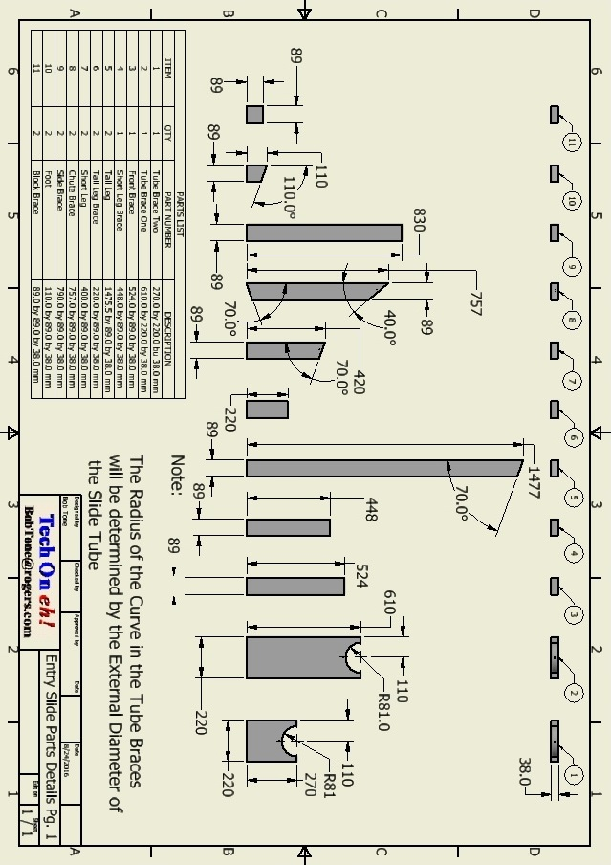

Entry Slide Parts Details Page 2

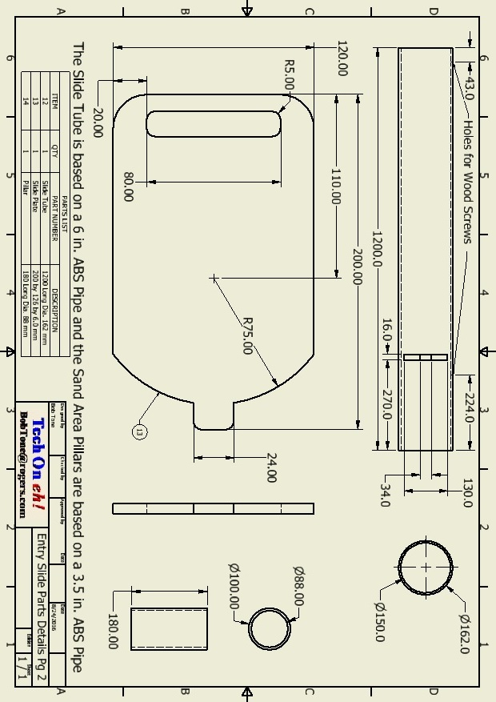

6 mm (1 / 4 in.) Rough Stock Cutting Pattern

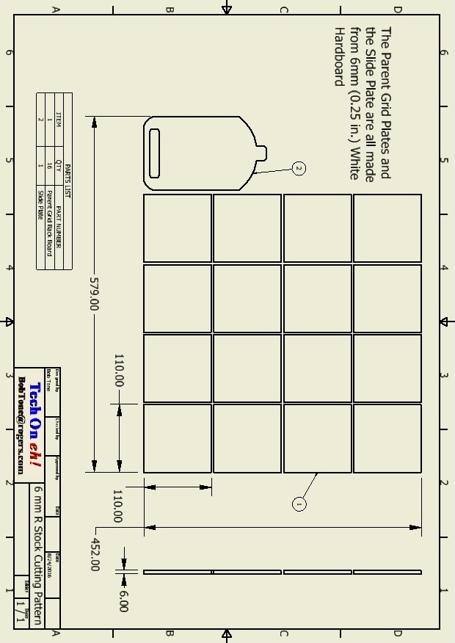

Passageway Parts List

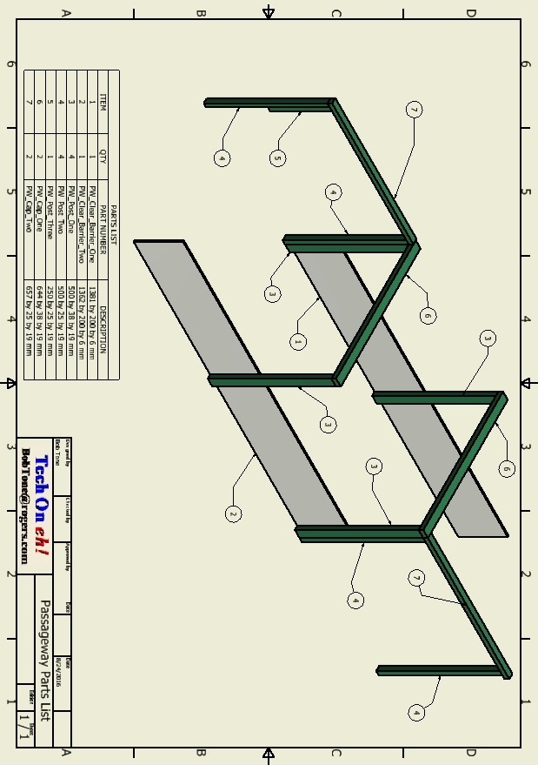

Passageway Details

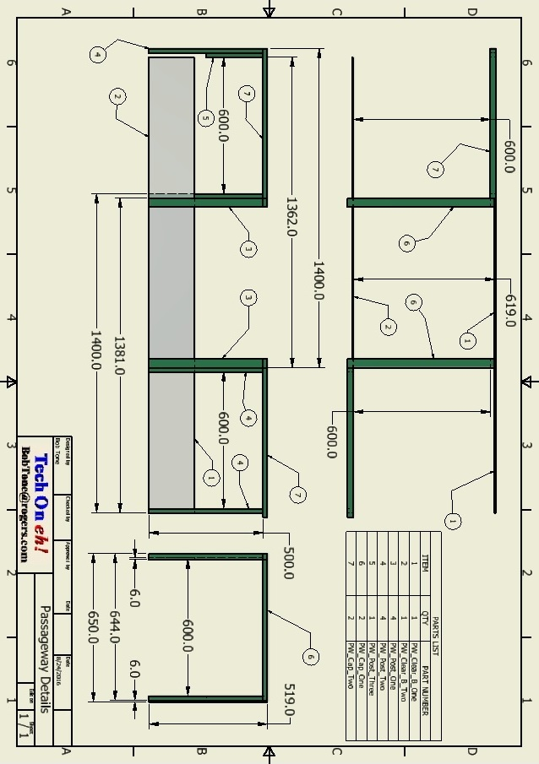

Sand Area Parts

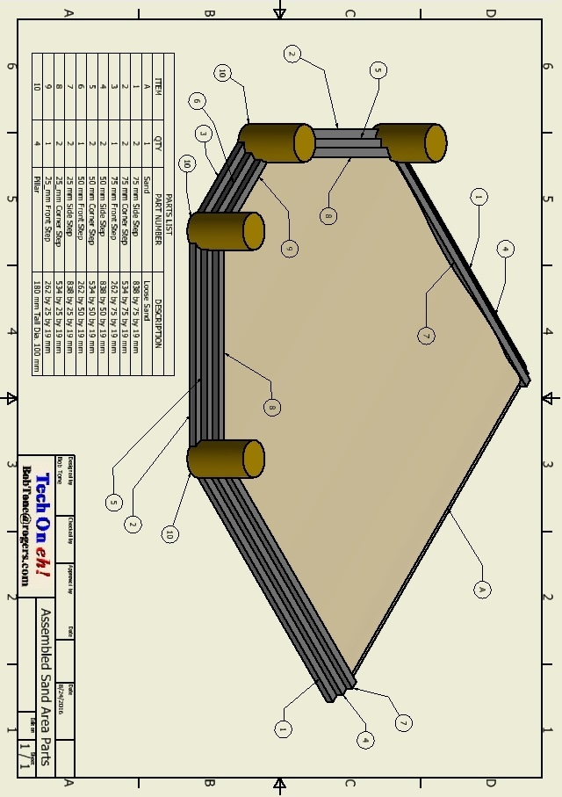

Parent Booths Details

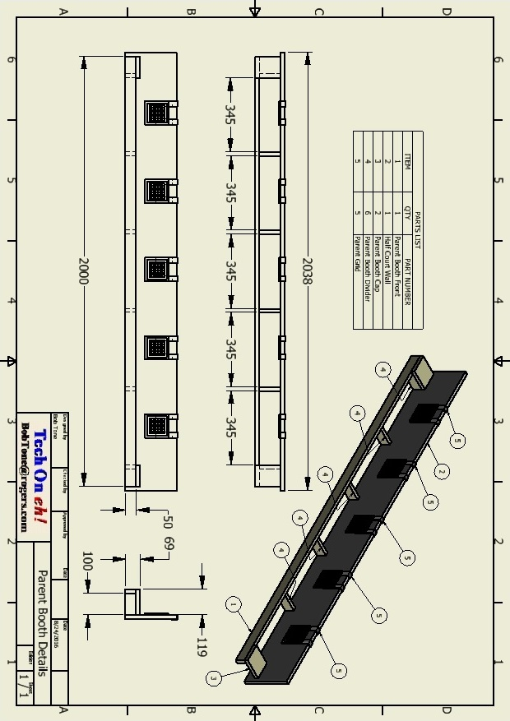

Hanging Grid Pattern Plate Details
