Databases

# Some definitions:

DBMS:

“system software for creating and managing databases. A DBMS makes it possible for end users to create, protect, read, update and delete data in a database.”

ACID:

ACID is an acronym that stands for atomicity, consistency, isolation, and durability.

Together, these ACID properties ensure that a set of database operations (grouped together in a transaction) leave the database in a valid state even in the event of unexpected errors.

# Relational/ SQL:

## Oracle / Microsoft SQL server

+ a lot of features/ working well with other paid-products

- the cost (not suitable due to sanctions as same as Microsoft SQL server)

## MySQL



+ it’s freeware

+ fast and simple

+ ideal for frequent read operations

- there’s not some features in freeware version

## PostgreSQL



+ open-source

+ fully ACID compatibility

+ ideal for lots of write operations

+ ideal for enterprise

- challenging

- requiring memory-intensive resources (due to allocation lots of memory for a single connection)

Another difference is that PostgreSQL is completely object relational(entries are objects with properties), while MySQL is pure relational(passing primary keys to refer other models as a simple field).

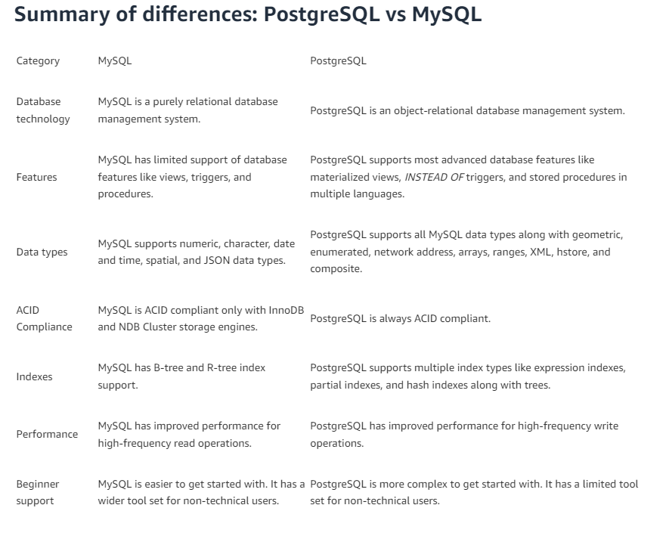

## MariaDB



+ community-driven

+ fast

# Non-relational/ No-SQL:

## MongoDB



+ fast

- SQL is not used as a query lang

## - Redis



+ fast due to being in-memory database

+ advance cache functionalities

- key-value pair based(it’s not general purpose)

- require a lot of memory