answer to labrotary work 7

Discipline: Computer Architecture

Ерфан Хосейнабади

Content

The text file you provided contains a lab report detailing work with NASM assembly language, including conditional and unconditional jumps. I have translated the Russian sections into English, preserving all original spacing and punctuation.

**Goal of the Work**

Study of conditional and unconditional jump instructions. Acquisition of skills in writing programs using jumps. Familiarization with the purpose and structure of the listing file.

**Assignment**

1. Implementation of jumps in NASM
2. Study of the structure of listing files
3. Independent writing of programs based on the materials of the laboratory work

**Theoretical Introduction**

So-called control transfer instructions or jump instructions are used to implement branching in assembler. Two types of jumps can be distinguished: • conditional jump – execution or non-execution of a jump to a specific point in the program depending on the condition check. • unconditional jump – execution of control transfer to a specific point in the program without any conditions.

**Laboratory Work Execution**

**Implementation of Jumps in NASM**

I create a file the programs of laboratory work No. 7 (Fig. -fig. 1).

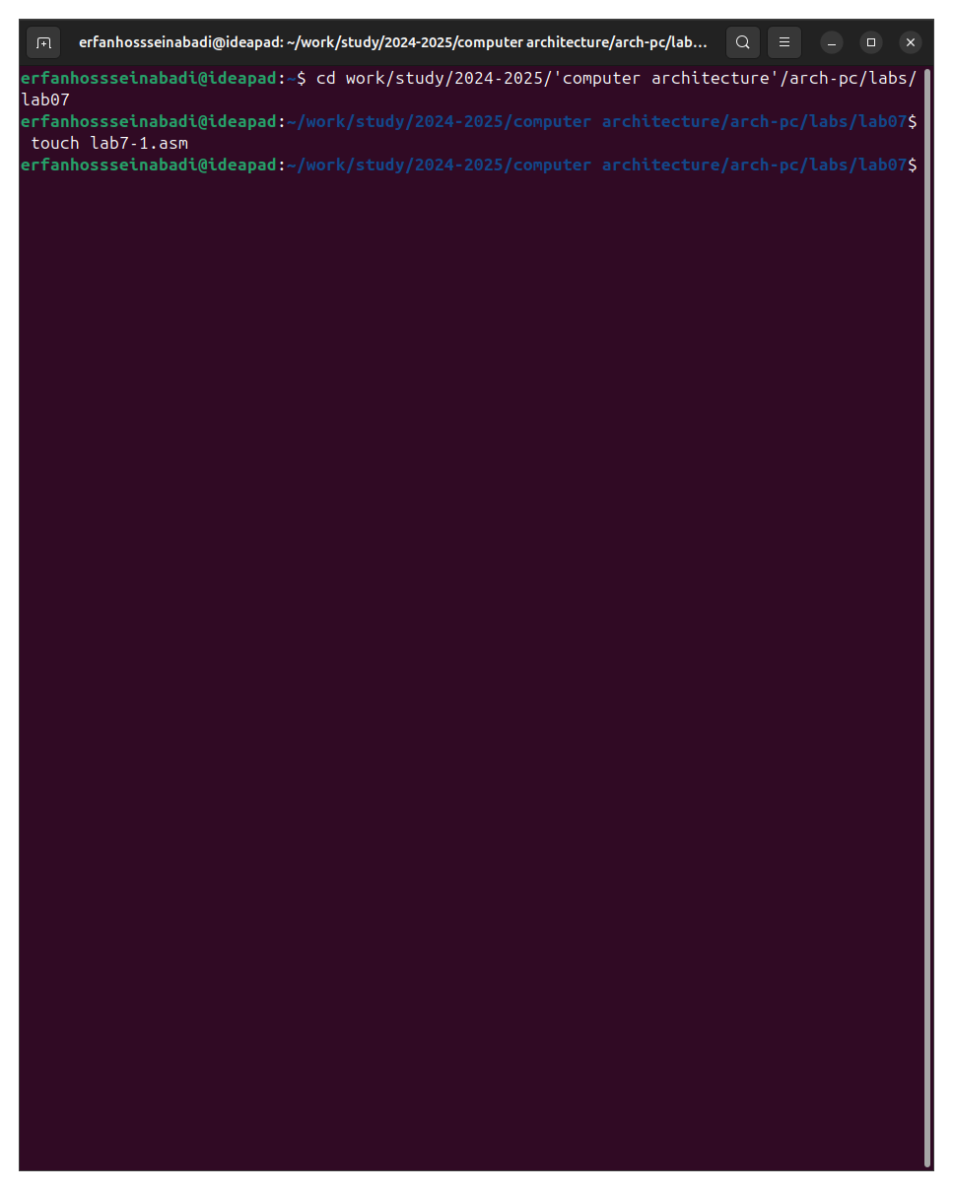

Fig. 1: Сcreate file

I copy the code from the listing into the file of the future program. (Fig. -fig. 2).

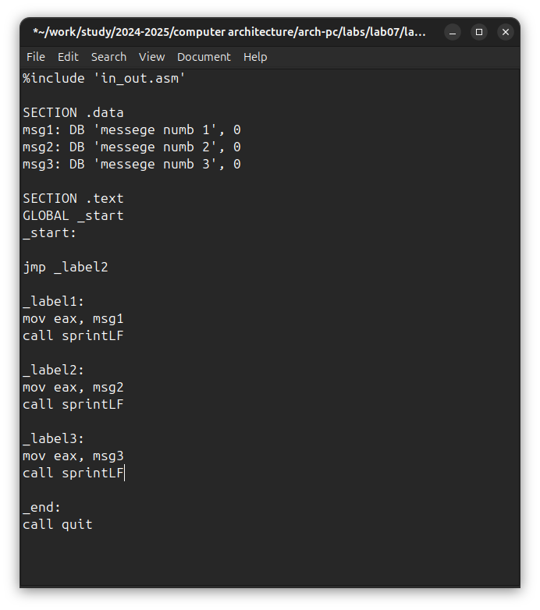

Fig. 2: saving program

When launching the program, I made sure that the unconditional jump really changes the order of execution of instructions (Fig. -fig. 3).

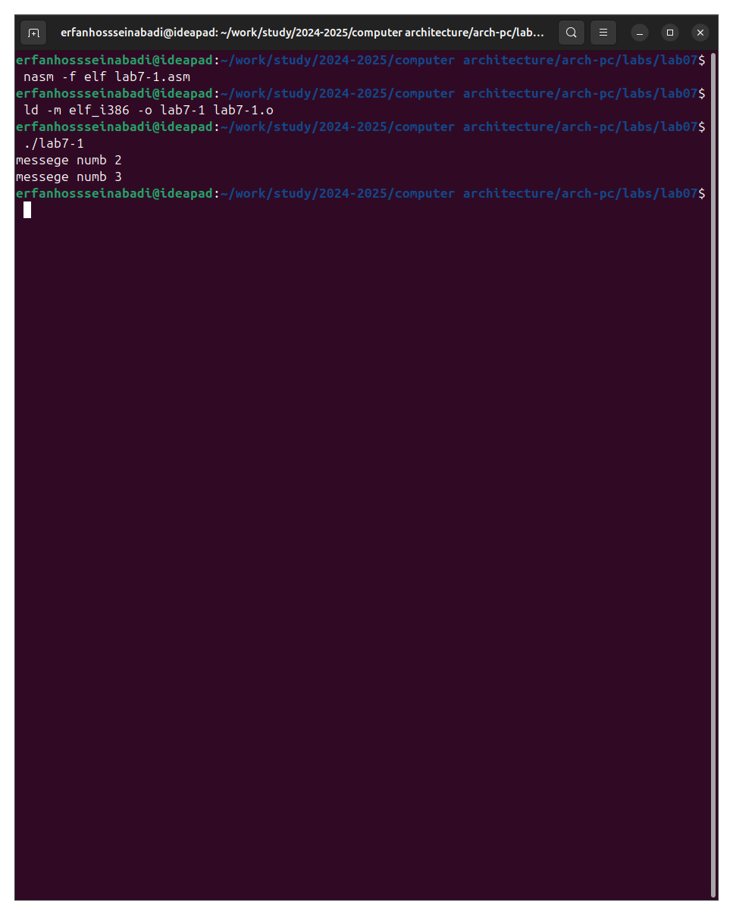

Fig. 3: lunch program

I change the program so that the order of execution of functions changes (Fig. -fig. 4).

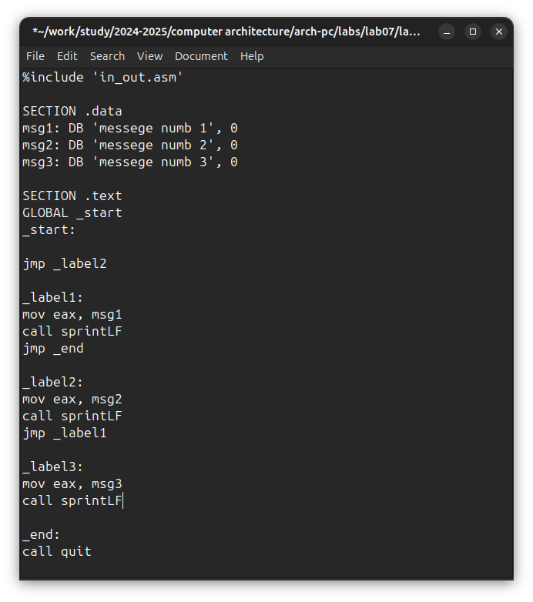

Fig. 4: change program

I launch the program and check that the applied changes are correct (Fig. -fig. 5).

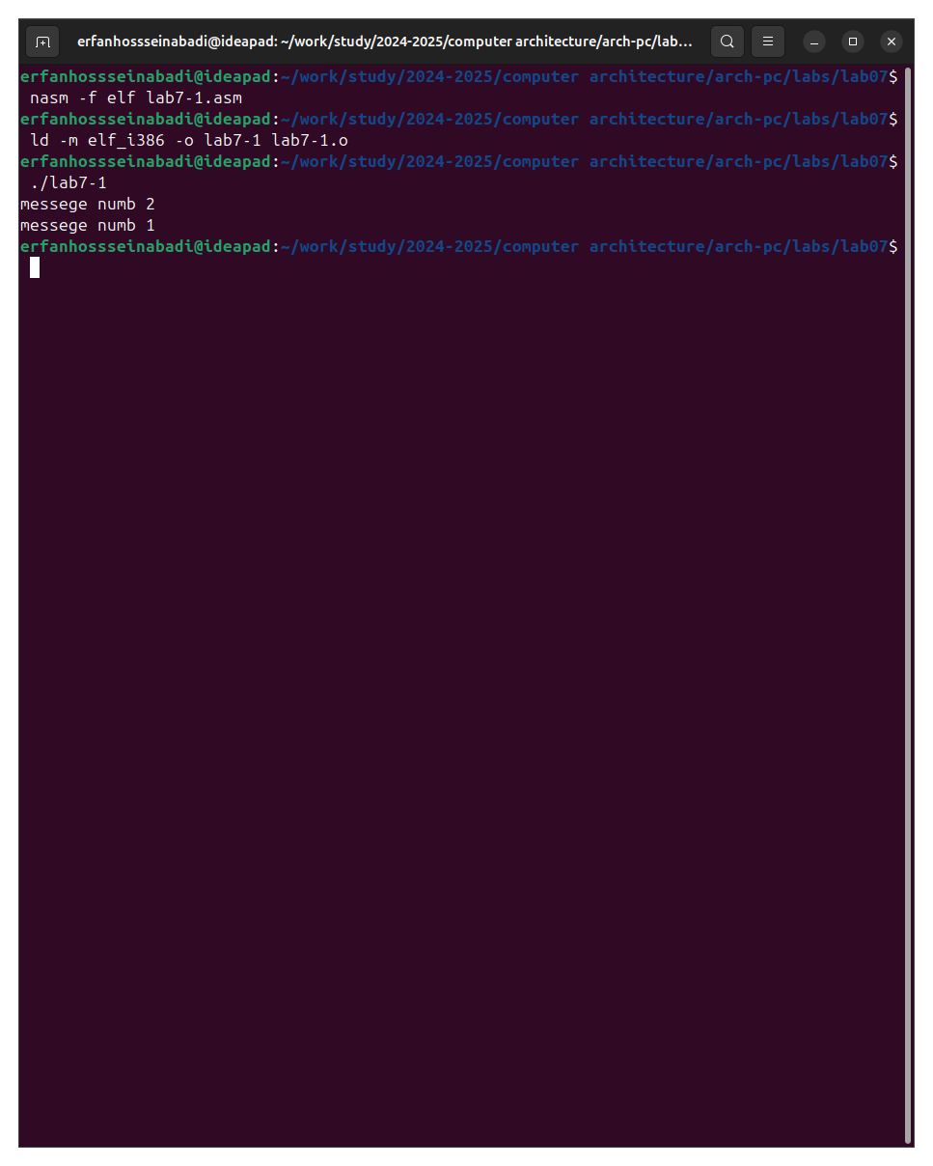

Fig. 5: run the new program

Now I change the text of the program so that all three messages are displayed in reverse order (Fig. -fig. 6).

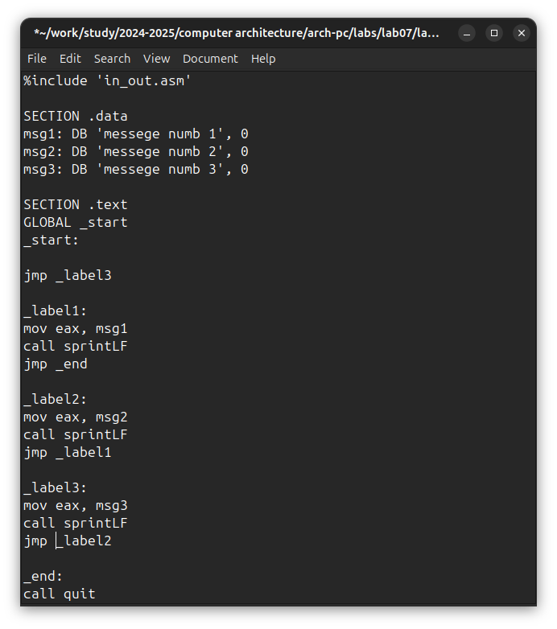

Fig. 6: change program

The work is done correctly, the program displays messages in the order I need (Fig. -fig. 7).

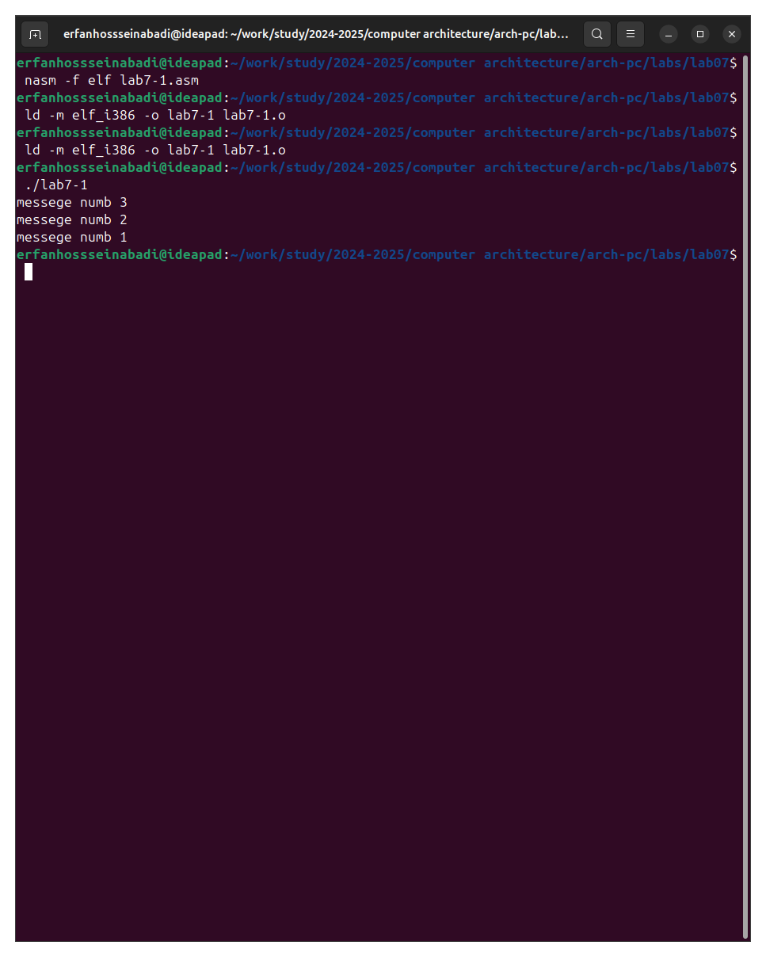

Fig. 7: checking for changes

I create a new working file and paste into it the code from the following listing (Fig. -fig. 8).

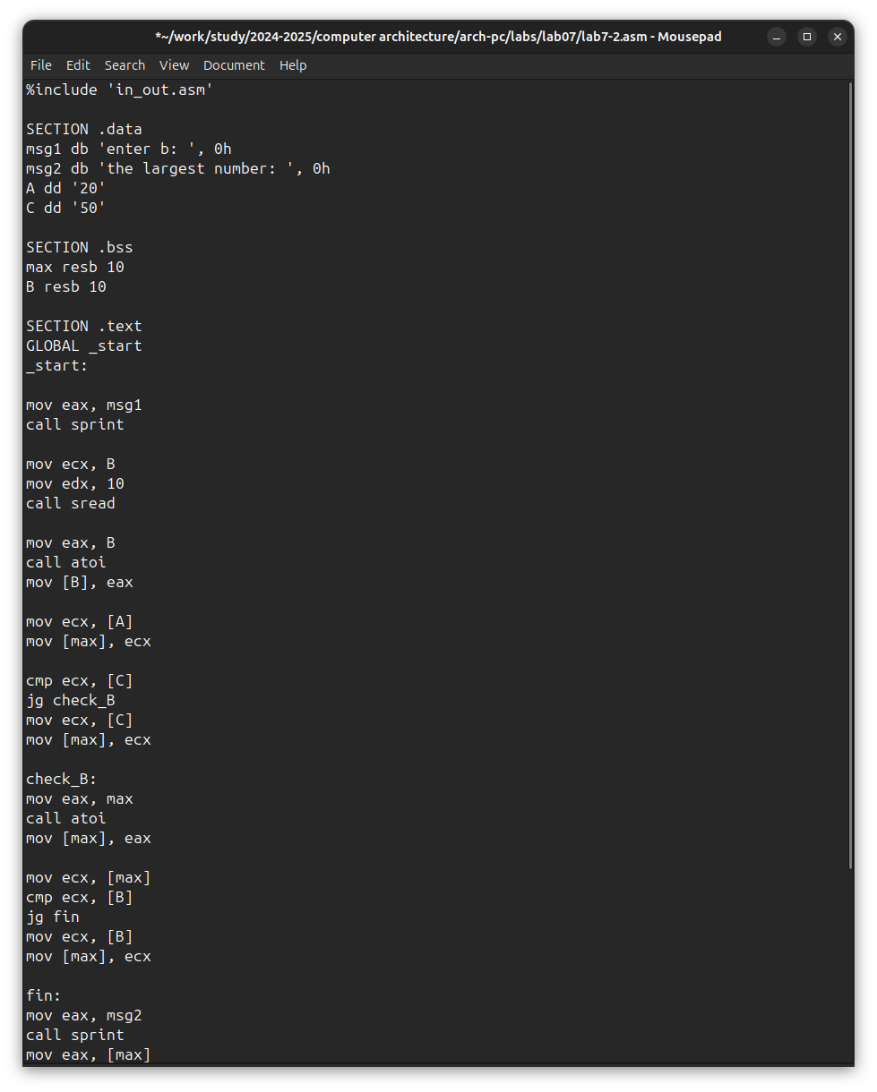

Fig. 8: sacing new program

The program outputs the value of the variable with the maximum value, I check the operation of the program with different input data (Fig. -fig. 9).

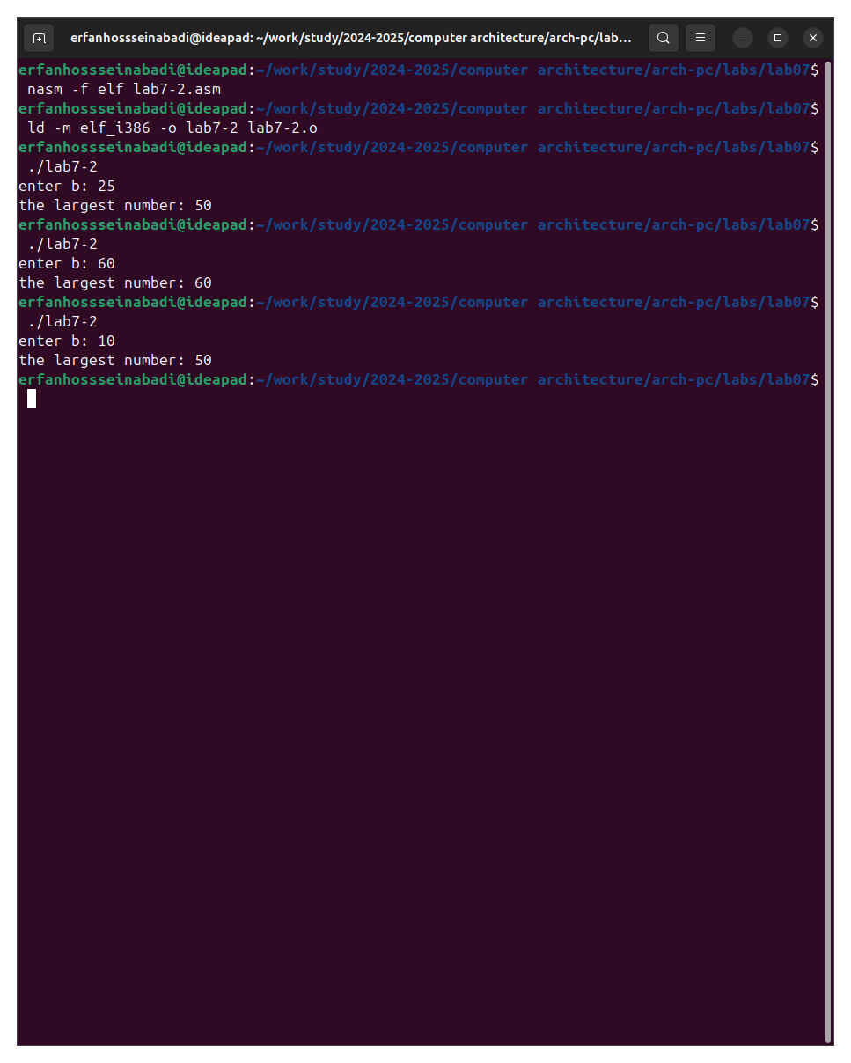

Fig. 9: Checking the program from the listing

#Study of the Listing File Structure

I create a listing file using the -l flag of the nasm command and open it using the mousepad text editor (Fig. -fig. 10).

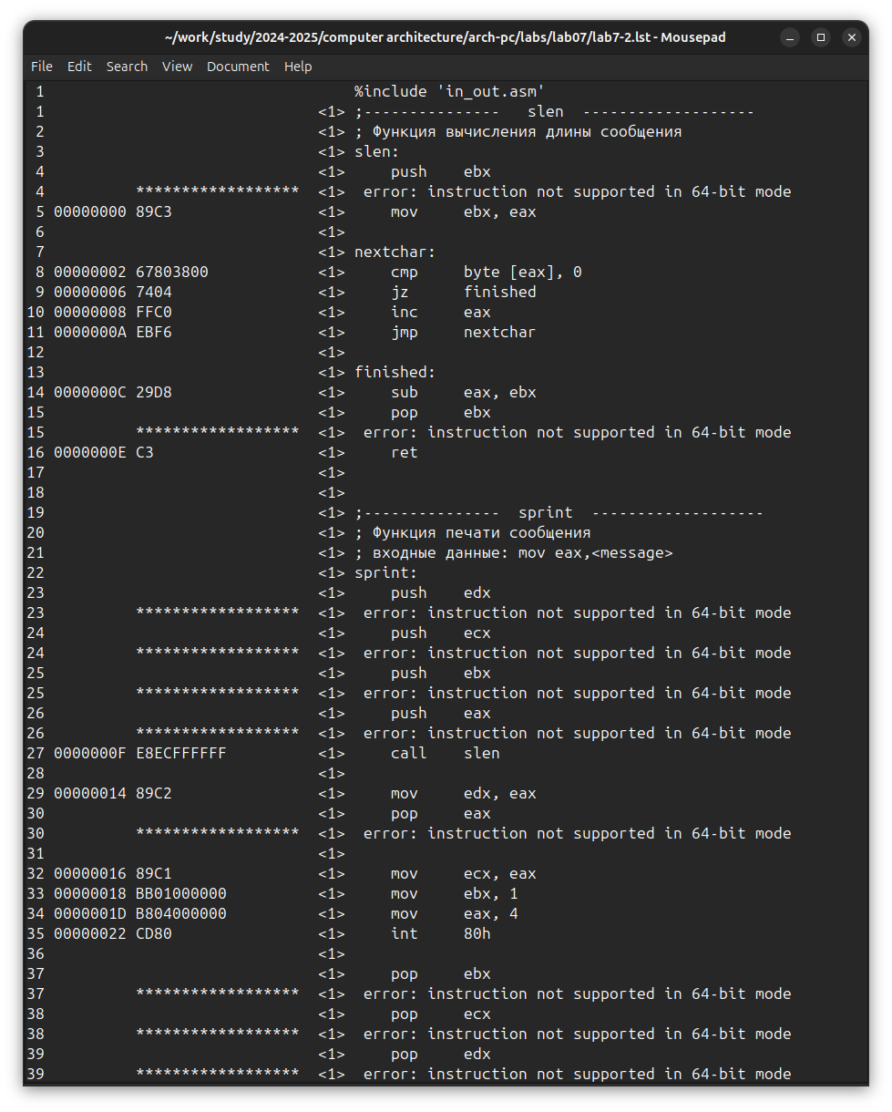

Fig. 10: checking list file

The first value in the listing file is the line number, and it may not coincide with the line number of the original file. The second occurrence is the address, the offset of the machine code relative to the beginning of the current segment, then the machine code itself goes directly, and the line is concluded by the source text of the program with comments.

I delete one operand from a random instruction to check the behavior of the listing file in the future (Fig. -fig. 11).

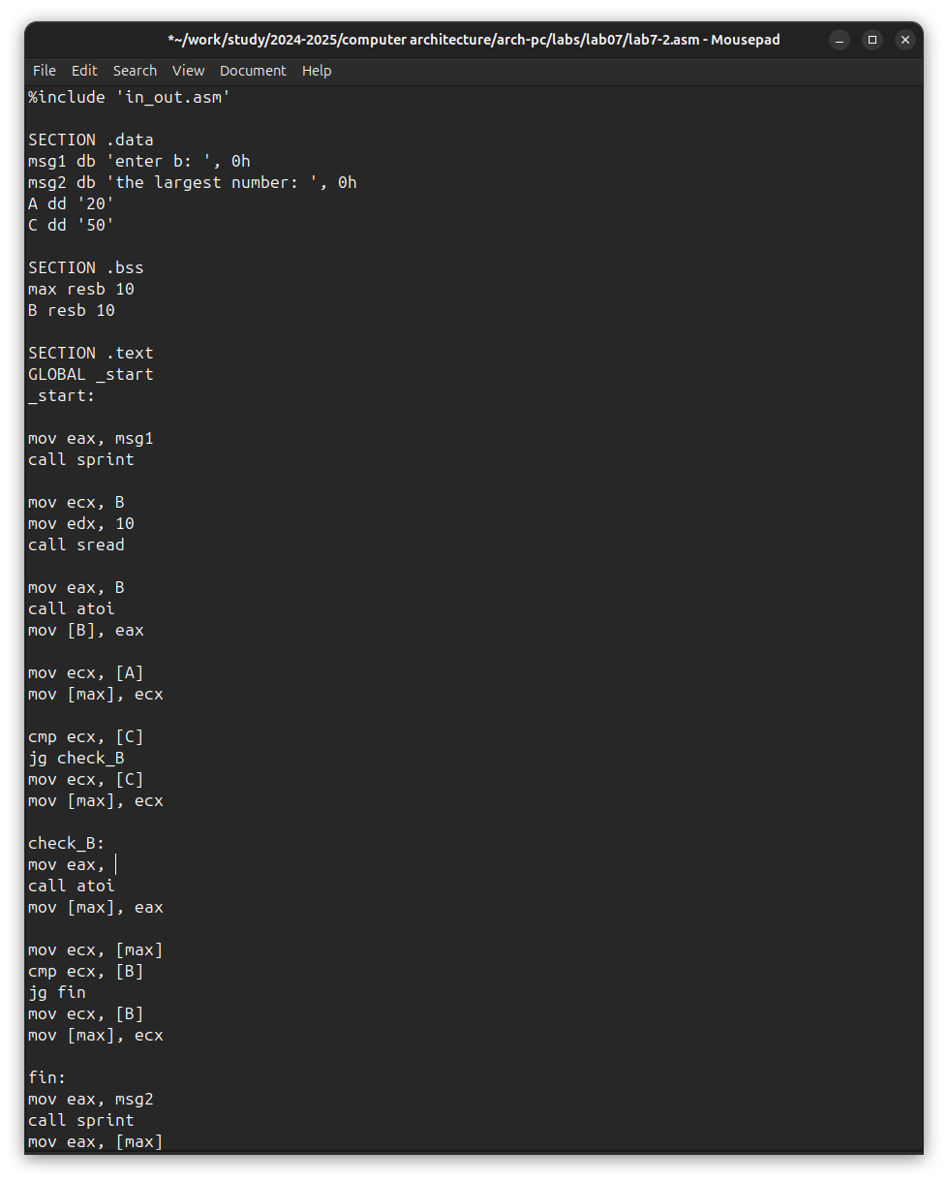

Fig. 11: Removing an operand from a program

The new listing file shows the error that occurred when attempting to compile the file. No output files other than the listing file are created. (Fig. -fig. 12).

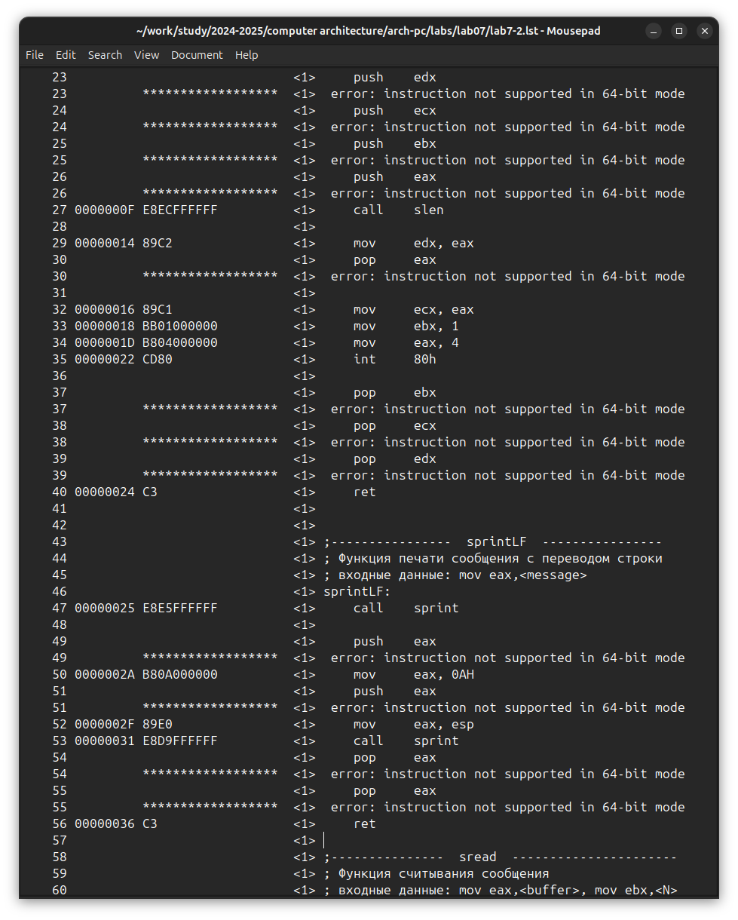

Fig. 12: View error in listing file

**Tasks for Independent Work**

I sincerely do not understand what option I should have received during the 7th laboratory work, so I will use my option - the ninth - from the previous laboratory work. I return the operand to the function in the program and change it so that it outputs the variable with the smallest value (Fig. -fig. 13).

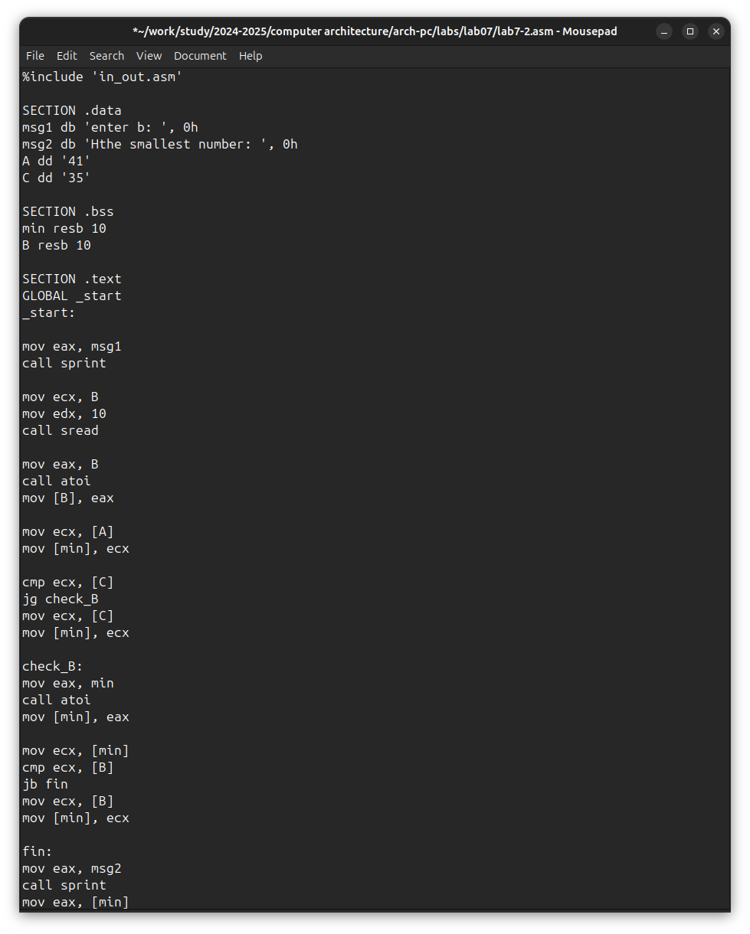

Fig. 13: First independent work program

Code of the first program:

%%include 'in_out.asm'  
  
SECTION .data  
msg1 db 'enter b: ', 0h  
msg2 db 'Нthe smallest number: ', 0h  
A dd '41'  
C dd '35'  
  
SECTION .bss  
min resb 10  
B resb 10  
  
SECTION .text  
GLOBAL _start  
_start:  
  
mov eax, msg1  
call sprint  
  
mov ecx, B  
mov edx, 10  
call sread  
  
mov eax, B  
call atoi  
mov [B], eax  
  
mov ecx, [A]  
mov [min], ecx  
  
cmp ecx, [C]  
jg check_B  
mov ecx, [C]  
mov [min], ecx  
  
check_B:  
mov eax, min  
call atoi  
mov [min], eax  
  
mov ecx, [min]  
cmp ecx, [B]  
jb fin  
mov ecx, [B]  
mov [min], ecx  
  
fin:  
mov eax, msg2  
call sprint  
mov eax, [min]  
call iprintLF  
call quit

I check the correctness of writing the first program (Fig. -fig. 14).

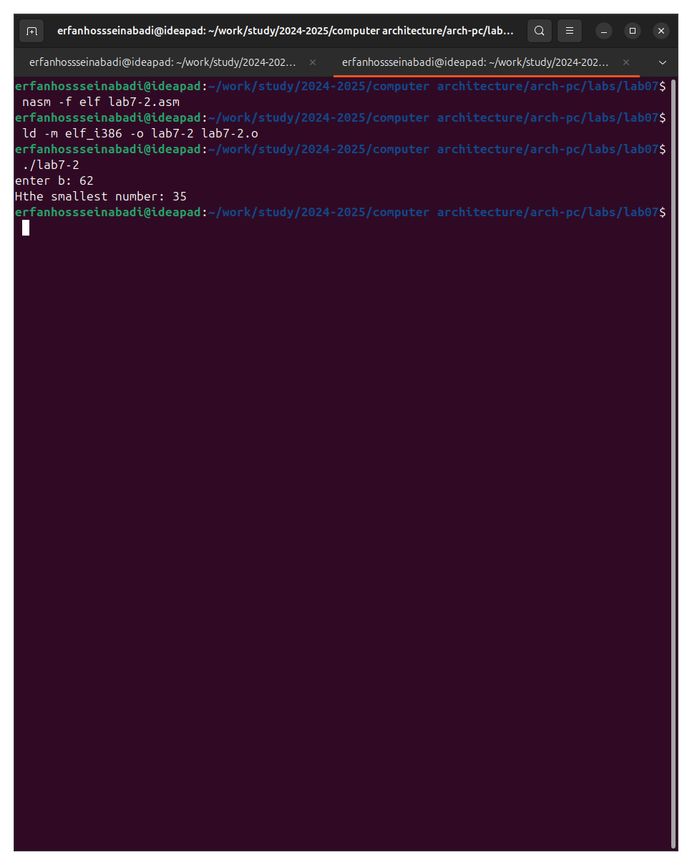

Fig. 14: check the first task

I write a program that will calculate the value of a given function according to my option for variables a and x entered from the keyboard (Fig. -fig. 15).

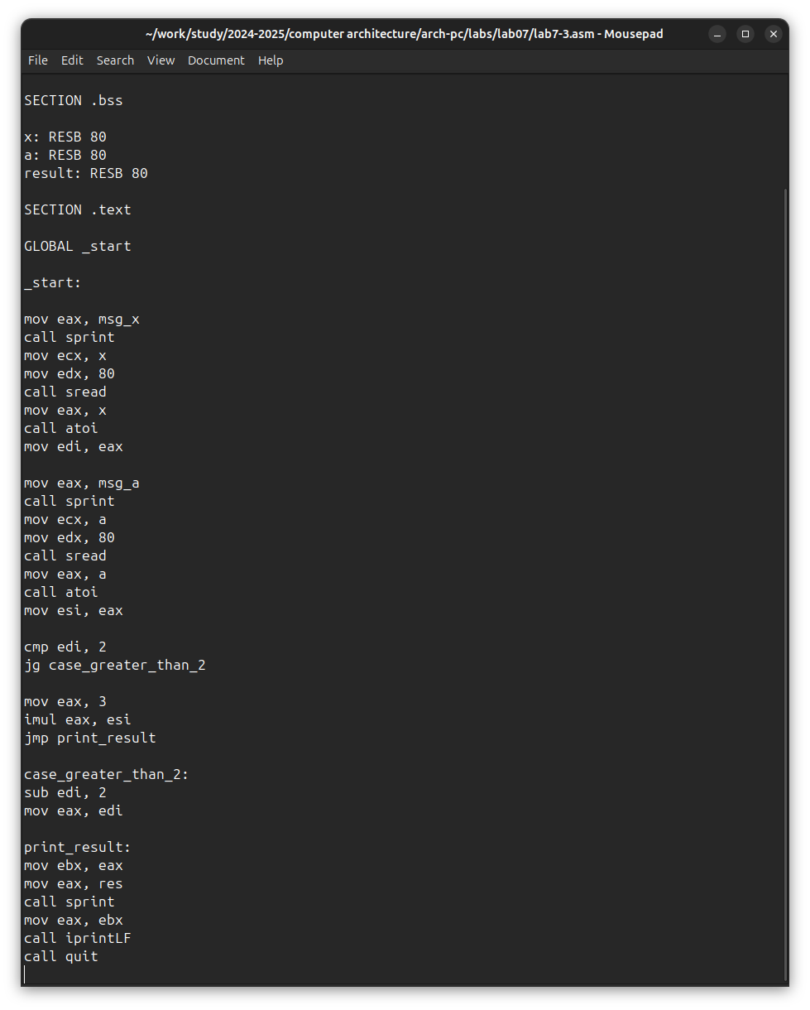

Fig. 15: The second independent work program

Code of the second program:

%include 'in_out.asm'  
  
SECTION .data  
  
msg_x: DB 'Enter x: ', 0  
msg_a: DB 'Enter a: ', 0  
res: DB 'Result: ', 0  
  
SECTION .bss  
  
x: RESB 80  
a: RESB 80  
result: RESB 80  
  
SECTION .text  
  
GLOBAL _start  
  
_start:  
  
mov eax, msg_x  
call sprint  
mov ecx, x  
mov edx, 80  
call sread  
mov eax, x  
call atoi  
mov edi, eax  
  
mov eax, msg_a  
call sprint  
mov ecx, a  
mov edx, 80  
call sread  
mov eax, a  
call atoi  
mov esi, eax  
  
cmp edi, 2  
jg case_greater_than_2  
  
mov eax, 3  
imul eax, esi  
jmp print_result  
  
case_greater_than_2:  
sub edi, 2  
mov eax, edi  
  
print_result:  
mov ebx, eax  
mov eax, res  
call sprint  
mov eax, ebx  
call iprintLF  
call quit

I translate and link the file, run and check the operation of the program for various values of a and x (Fig. -fig. 16).

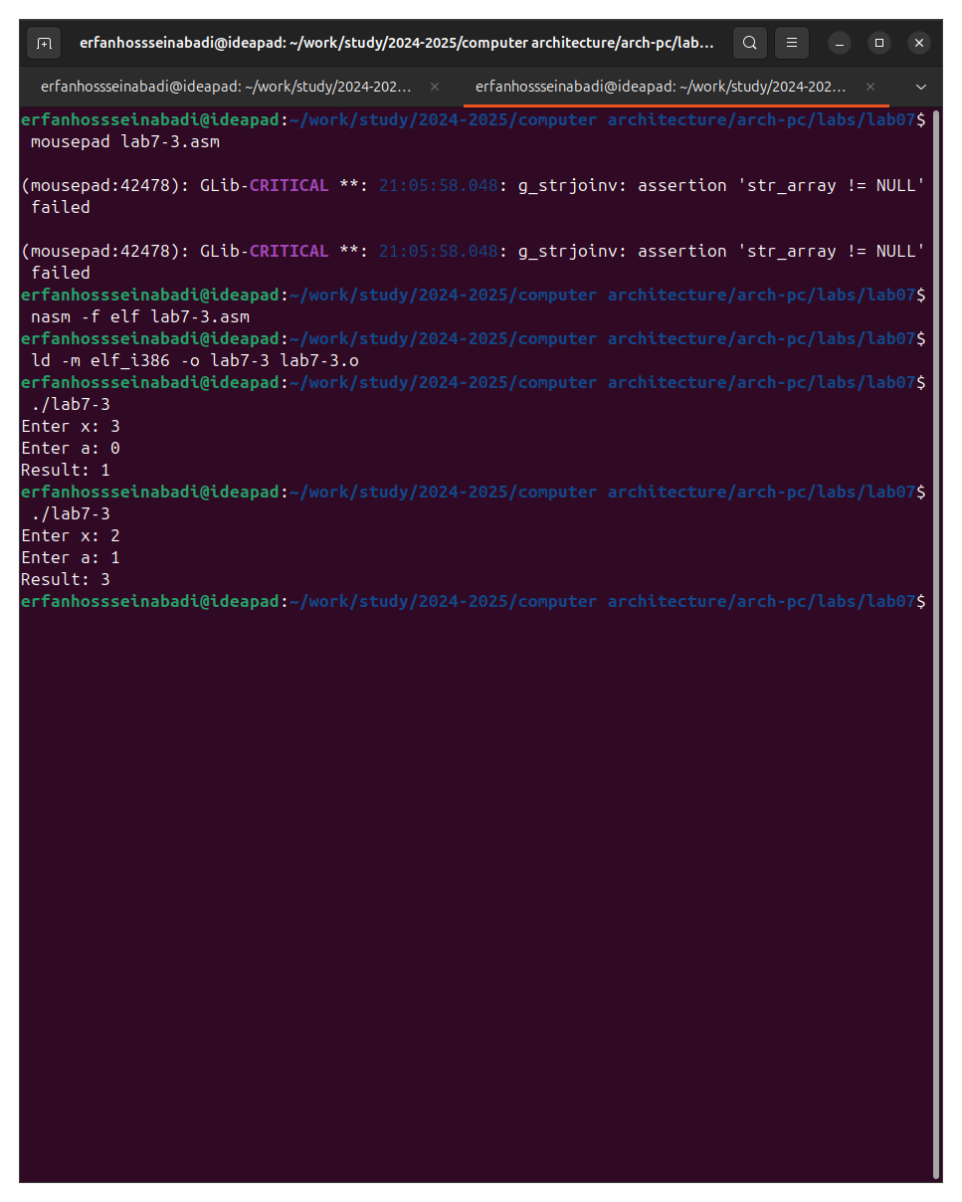

Fig. 16: check the second program

**Conclusions**

During the laboratory work, I studied the commands of conditional and unconditional jumps, and also acquired skills in writing programs using jumps, got acquainted with the purpose and structure of listing files.

**References**

1. [Course at RUDN University](https://esystem.rudn.ru/course/view.php?id=112)
2. [Laboratory work No. 7](https://esystem.rudn.ru/pluginfile.php/2089087/mod_resource/content/0/%D0%9B%D0%B0%D0%B1%D0%BE%D1%80%D0%B0%D1%82%D0%BE%D1%80%D0%BD%D0%B0%D1%8F%20%D1%80%D0%B0%D0%B1%D0%BE%D1%82%D0%B0%20%E2%84%967.%20%D0%9A%D0%BE%D0%BC%D0%B0%D0%BD%D0%B4%D1%8B%20%D0%B1%D0%B5%D0%B7%D1%83%D1%81%D0%BB%D0%BE%D0%B2%D0%BD%D0%BE%D0%B3%D0%BE%20%D0%B8%20%D1%83%D1%81%D0%BB%D0%BE%D0%B2%D0%BD%D0%BE%D0%B3%D0%BE%20%D0%BF%D0%B5%D1%80%D0%B5%D1%85%D0%BE%D0%B4%D0%BE%D0%B2%20%D0%B2%20Nasm.%20%D0%9F%D1%80%D0%BE%D0%B3%D1%80%D0%B0%D0%BC%D0%BC%D0%B8%D1%80%D0%BE%D0%B2%D0%B0%D0%BD%D0%B8%D0%B5%20%D0%B2%D0%B5%D1%82%D0%B2%D0%BB%D0%B5%D0%BD%D0%B8%D0%B9.pdf)
3. [Programming in NASM assembler language by Stolyarov A. V.](https://esystem.rudn.ru/pluginfile.php/2088953/mod_resource/content/2/%D0%A1%D1%82%D0%BE%D0%BB%D1%8F%D1%80%D0%BE%D0%B2%20%D0%90.%20%D0%92.%20-%20%D0%9F%D1%80%D0%BE%D0%B3%D1%80%D0%B0%D0%BC%D0%BC%D0%B8%D1%80%D0%BE%D0%B2%D0%B0%D0%BD%D0%B8%D0%B5%20%D0%BD%D0%B0%20%D1%8F%D0%B7%D1%8B%D0%BA%D0%B5%20%D0%B0%D1%81%D1%81%D0%B5%D0%BC%D0%B1%D0%BB%D0%B5%D1%80%D0%B0%20NASM%20%D0%B4%D0%BB%D1%8F%20%D0%9E%D0%A1%20Unix.pdf)

Note that some image file names ([image/1.png], etc.) are included, but as images were not supplied, they remain as placeholders. Also note that the links provided in the references section are in Russian, but I have given them English titles to reflect the content. I have made every effort to maintain the integrity of your original formatting.