Memory Management in Java Apps

Memory at Surface Level

The stack used by threads to store local data
We know that local values are stored in a stack and that each thread has its own stack location. Let’s find out now how these values are stored and when the app removes them from memory.

First, why is this memory location called “a stack”? A thread’s stack uses the principles of a stack data structure. A stack is an ordered collection in which you can always remove the most recently added element.

Whenever the execution reaches the start of a code block, it creates a new layer in the thread stack. Following a common stack principle, any new layer becomes the top layer and is the first to be removed. In figures E.5, E.6, E.7, and E.8, we follow the execution of a simple code snippet step by step to observe how the thread’s stack changes:

public static void main(String [] args) {
int x = 10;
a();
b();
}
public static void a() {
int y = 20;
}
public static void b() {
int y = 30;
}
The execution starts with the main() method (figure E.5). When the execution
reaches the start of the main() method, the first layer is added to the thread’s stack.
This layer is a memory location where every local value declared in the code block is
stored. In this case, the code block declares a variable, x, and initializes the variable with the value 10. This variable will be stored in this newly created layer of the thread’s stack. This layer will be removed from the stack when the method ends its execution.

A code block can call other code blocks. For example, in this case, method main() calls methods a() and b(), which work similarly. When the execution reaches the start of their blocks of code, a new layer is added to the stack. That new layer is the memory location where all the data that is declared local is stored. Figure E.6 shows what happens when the execution reaches method a().

When method a() ends its execution and returns to main(), the layer reserved in the thread’s stack is also removed (figure E.7)—meaning the data it stored is no longer in the memory. This way, the memory that is not needed is deallocated to allow space for new data to be stored. A code block ends when the execution reaches its last instruction, gives a return instruction, or throws an exception. Notice that when a code block ends, its layer is always the top one in the stack, fulfilling the LIFO principle.

Method main() continues its execution by calling method b(). Just like method a() did, method b()reserves a new layer in the stack to store the local data it declares (figure E.8).

When method main()finally reaches its end, the thread ends its execution, and the stack remains empty and is completely removed. At the same time, the thread goes into the dead state of its life cycle, as described in appendix D.

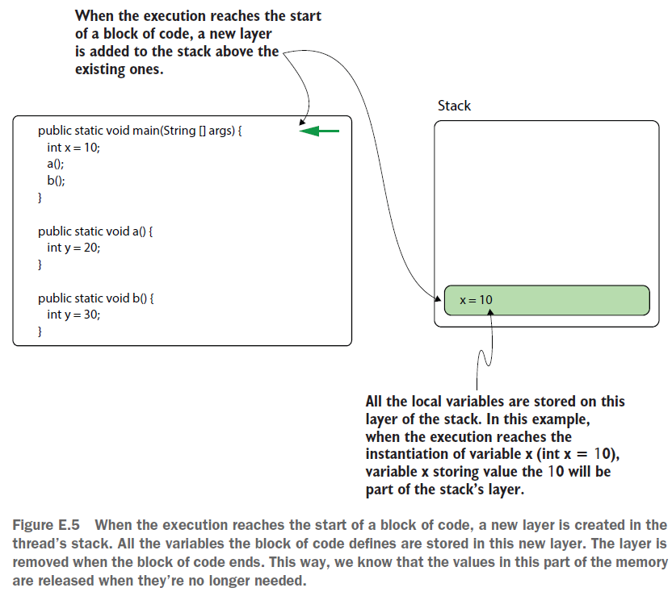

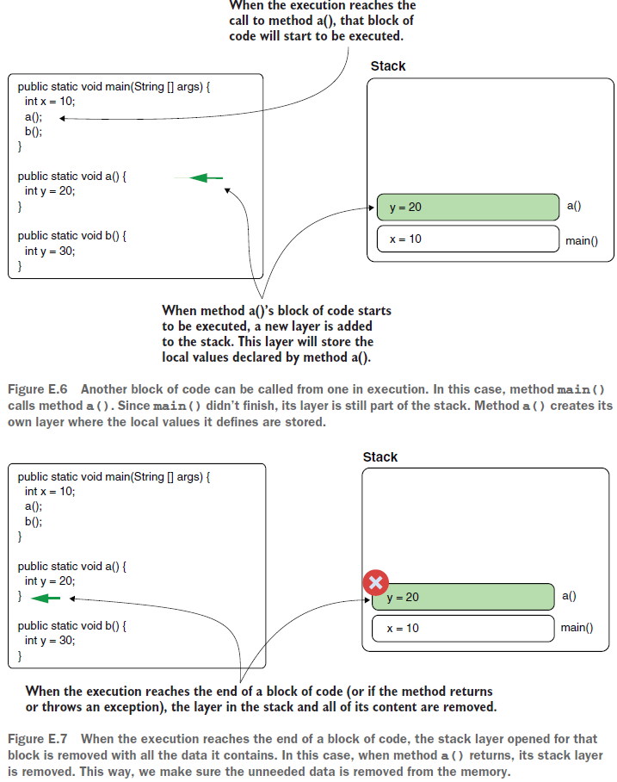
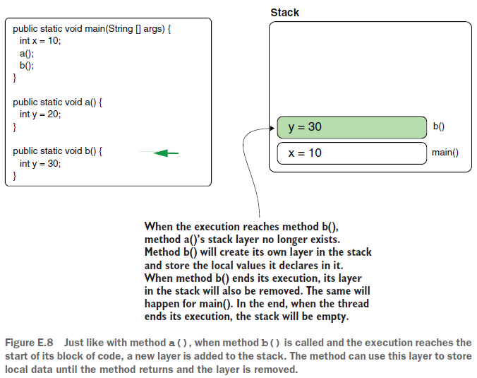
The stack has a default memory space allocated. You can find the precise values depending on the JVM you use here: http://mng.bz/JVYp.

This limit can also be adjusted, but you wouldn’t be able to make it infinite. A common issue with the stack is the StackOverflowError, which means a stack is filled completely, and no more layers
can be added.
When this happens, the code throws a StackOverflowError, and the thread whose stack became full stops completely.

A recursion (or recursive implementation), a method that calls itself until a given condition is filled, with a wrong stop condition usually causes such a problem. If this condition is missing or allows the method to call itself too many times, the stack may get filled with the layers the method creates
every time it begins its execution.

Since each thread has its own stack, a StackOverflowError affects only the thread
whose stack becomes full. The process can continue its execution, and other threads
will not be affected.
Also, a StackOverflowError produces a stack trace, which you can use to identify the code that caused the problem.

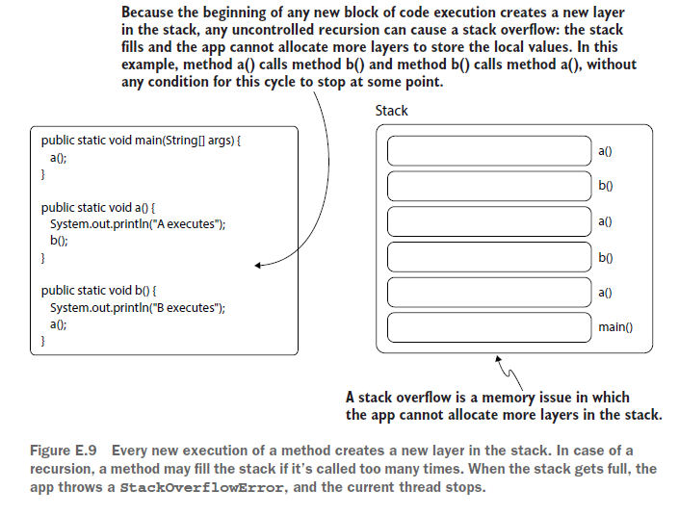
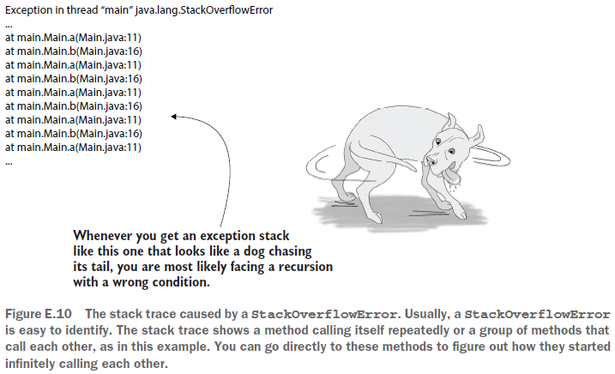

The heap the app uses to store object instances
In this section, we’ll discuss the heap: a memory location shared by all threads of a Java app. The heap stores object instance data. As you’ll see in this section, the heap causes problems more often than the stack does.

The first thing you need to remember about the heap is that it’s a memory location shared by all the threads (figure E.11). Not only does this allow for thread-related issues such as race conditions to happen, but it also makes memory issues more challenging to investigate. Since all the threads add the object instances they create in the same memory location, one thread may impact the execution of others. If one thread suffers from a memory leak (which means it adds instances in the memory but never removes them), it affects the whole process because other threads will also suffer from the lack of memory.

In most cases, when an OutOfMemoryError occurs, as shown in figure E.11, the situation
is signaled by a different thread than the one affected by the root cause of the problem (the memory leak).
The OutOfMemoryError is signaled by the first thread that tries to add something in the memory but cannot because there is no more free space.

The garbage collector (GC) is the mechanism that frees the heap by removing unneeded data. The GC knows that an object instance is no longer needed when nothing references it. Thus, if an object isn’t needed but the app fails to remove all the references, the GC won’t remove that object.

When an app continually fails to remove references to newly created objects until at some point they fill the memory (causing an OutOfMemoryError), we say that the app has a memory leak. An object instance may be referred to from another object in a heap (figure E.12).

A common example of a memory leak is a collection in which we continuously add object references. If these references aren’t removed, then, as long as the collection is in the memory, the GC won’t remove them; they become a memory leak. You should pay special attention to static objects (object instances referred to from static variables).

These variables don’t disappear once they are created, so unless you explicitly remove the reference, you can assume that an object referred to from a static variable will stay for the whole life of the process. If that object is a collection that refers to other objects that are never removed, it can potentially become a memory leak.

Any object in the heap can keep references to other objects in the heap. The GC can remove an object only when no reference to it exists.

An object instance can also be referred to from the stack (figure E.13). Usually, references from the stack don’t cause memory leaks since (as discussed in section E.2) a stack layer automatically disappears when the execution reaches the end of the code block for which the app created the layer.
But in specific cases, when combined with other issues, references from the stack can also cause trouble. Imagine a deadlock that keeps the execution from running through a whole block of code. The layer in the stack won’t be removed, and if it keeps references to objects, this may also become a memory leak.

So, references in the stack can also prevent garbage collection.

The metaspace memory location for storing data types
The metaspace is a memory location the JVM uses to store the data types used to create instances stored in the heap (figure E.14).

The app needs this information to handle the object instances in the heap. Sometimes, in specific conditions, an OutOfMemoryError can also affect the metaspace. If the metaspace becomes full and there’s no more space for the app to store new data types, the app throws an OutOfMemoryError, announcing that the metaspace is full. In my experience, these errors are rare, but I would like you to be aware of them.
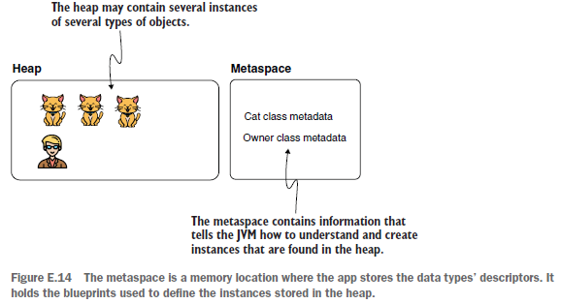

A Deep Dive into Memory Management in Java
The JVM divides its memory into several logical runtime data areas, each serving a specific role during program execution.

This structured memory model ensures isolation between different types of data, supports multithreading, and enables features like automatic garbage collection.

At runtime, the JVM creates a set of runtime data areas. These include:
- Heap Memory
- Stack Memory
- Method Area (Implemented as Metaspace in Java 8+)
- Program Counter (PC) Register
- Native Method Stack

Each area plays a unique role in executing Java programs and managing resources. Understanding these memory areas is crucial when tuning applications for performance, especially under conditions such as high object creation rates, frequent class loading, or memory-intensive workloads.

Heap Memory
In the Java Virtual Machine (JVM), heap memory is the primary area for dynamic memory allocation. All class instances, arrays, and objects created during program execution are stored here. Unlike stack memory, which is isolated to individual threads, the heap is a shared memory space, accessible by all threads in the JVM. This shared access allows objects to be passed between threads and persist beyond the execution of any single method.
Heap memory is automatically managed by the garbage collector, which reclaims memory occupied by objects that are no longer in use. To optimize this process and reduce application pause times, the JVM divides the heap into two regions: the Young Generation and the Old Generation.

This layout, known as the Generational Heap Model, is based on the principle that most objects in Java applications are short-lived, and those that survive are likely to live much longer.

The Young Generation
The Young Generation is where all newly created objects begin their lifecycle. It is optimized for fast allocation and frequent garbage collection. Because the majority of objects are short-lived (e.g., method-local objects, temporary buffers), this region is collected often using Minor Garbage Collections (Minor GCs), which are typically fast and efficient.

Internally, the Young Generation is divided into three spaces:

- Eden Space: This is the starting point for new object allocations. As soon as an object is created, the JVM attempts to place it in Eden. When Eden fills up, a Minor GC is triggered.
- Survivor Spaces: The two survivor spaces, commonly referred to as S0 and S1, act as staging areas for objects that survive a garbage collection. After each Minor GC, reachable objects from Eden are moved into one of the survivor spaces. Objects that continue to survive are moved between the two survivor spaces across collection cycles.

As objects survive more garbage collection cycles, their age increases. Once an object’s age exceeds a threshold (controlled by the JVM flag XX:MaxTenuringThreshold), it is promoted to the Old Generation. Promotion is also forced when the survivor spaces do not have enough room to hold surviving objects.

Minor GCs are stop-the-world events, meaning all application threads are paused briefly while the garbage collection is performed. However, because the volume of live data in the Young Generation is usually small, these pauses are minimal. Most modern garbage collectors perform Minor GCs using multiple threads, allowing the operation to complete quickly even in high-throughput environments.

Proper tuning of the Young Generation can help reduce promotion rates and delay costly collections in the Old Generation. For example, you can adjust:
- The size of the Young Generation with -Xmn
- The Eden-to-Survivor space ratio using -XX:SurvivorRatio
- The promotion age threshold with -XX:MaxTenuringThreshold

These parameters are particularly useful for applications with high allocation rates, such as REST APIs, streaming pipelines, or real-time event processing systems.

The Old Generation
The Old Generation, also known as the Tenured Generation, is designed to hold long-lived objects, those that have survived multiple Minor GCs. While the Young Generation handles the frequent allocation and disposal of short-lived data, the Old Generation is where objects that remain in use for extended periods are eventually stored. Examples include:
- Persistent application-level caches
- Large object graphs such as sessions or user data
- Static or shared data structures that are retained across requests

Because the Old Generation contains objects that are more likely to still be in use, it is collected less frequently than the Young Generation. Garbage collection in this region is referred to as a Major GC, and when both generations are collected together, the process is known as a Full GC.

Note:
- A Major GC typically targets only the Old Generation.
- A Full GC collects the entire heap (Young and Old Generations), and depending on the garbage collector and memory pressure, it may also include Metaspace, though this is not guaranteed.

Collections in the Old Generation are more expensive and typically involve:
- A full stop-the-world pause
- Tracing all reachable objects starting from the GC roots
- Compacting memory to eliminate fragmentation

In single-threaded collectors like the Serial GC, this process can take a significant amount of time. In contrast, parallel or concurrent collectors such as Parallel GC, CMS, or G1 reduce pause durations by performing some phases concurrently or using multiple threads.

If the Old Generation becomes full and the garbage collector is unable to reclaim sufficient memory, the JVM will throw a java.lang.OutOfMemoryError: Java heap space. This is often a sign of excessive object retention, memory leaks, or incorrect heap sizing.

To control the size and behavior of the Old Generation, you can adjust:
- The total heap size using -Xmx (maximum) and -Xms (initial)
- The size of the Young Generation using -Xmn, which affects how much memory is left for the Old Generation
- The ratio between the two using -XX:NewRatio
For example:
-Xms512m -Xmx2g -Xmn512m -XX:NewRatio=3
This configuration sets an initial heap size of 512 MB, a maximum heap size of 2 GB, allocates 512 MB to the Young Generation, and ensures the Old Generation is roughly three times larger than the Young Generation.
(does usin g bot h ratio and youn g gen size make sense t hou g h?)

In production environments, the Old Generation often needs close attention. If your application
- maintains large in-memory datasets
- or performs long-lived object caching

analyzing heap usage using tools like jstat, VisualVM, or Java Flight Recorder can help identify inefficiencies and tune the GC strategy accordingly.

For applications with strict latency requirements, consider switching to low-pause collectors such as G1, ZGC, or Shenandoah, which are better suited for managing large Old Generations without introducing long GC pauses.

Method Area (Implemented as Metaspace in Java 8+)
The Method Area is a critical part of the Java memory model that stores per-class metadata necessary for the JVM to execute Java programs. Unlike the heap, which holds individual object instances, the method area is used to store class-level information that is shared across all instances of a class and all threads within the application.

This area is logically defined by the Java Virtual Machine Specification and is shared among all threads. Although it is conceptually distinct from the heap, its actual implementation has evolved over different versions of the JVM, most notably with the transition from Permanent Generation (PermGen) to Metaspace in Java 8.

Wat the Method Area Stores
When a class or interface is loaded by the JVM, its definition is parsed and the following information is stored in the method area:

- Class structure metadata, including class names, superclasses, implemented interfaces, and modifiers (public, final, etc.)
- Runtime constant pool, which contains literal values and symbolic references used by the class
- Static variables, which are class-level variables shared across all instances
- Field and method information, including method signatures, access modifiers, and bytecode instructions
- Constructor code, including initialization routines for object creation
- Type information used for method resolution and dispatching

All of this information is essential for enabling runtime features such as dynamic method invocation, polymorphism, and class reflection.
Because this data does not change after the class is loaded (with few exceptions, such as dynamic class redefinition), it is considered immutable for the duration of the class’s life cycle.

PermGen: The Original Implementation (Before Java 8)

In JVM versions prior to Java 8, the method area was physically implemented in a fixed-size memory region called the Permanent Generation (PermGen). PermGen resided in the heap and had to be explicitly sized using JVM flags like:

-XX:PermSize=128m
-XX:MaxPermSize=256m

The fixed nature of PermGen introduced several challenges:
- Class metadata could exceed PermGen space, leading to java.lang.OutOfMemoryError: PermGen space, especially in applications that dynamically load many classes (e.g., application servers, modular frameworks).
- Memory management for PermGen was limited and difficult to tune correctly.
- It could not grow beyond its configured maximum, regardless of available system memory.
Because of these limitations, managing PermGen became a frequent pain point for developers and system administrators, particularly in large-scale Java EE applications.

Metaspace: Modern Implementation (Java 8 and Later)
With the release of Java 8, the JVM replaced PermGen with a new memory region called Metaspace. Unlike PermGen, Metaspace is not part of the Java heap; it is allocated from native memory, which allows it to grow dynamically as needed (subject to system limitations).

This change brought several improvements:
- Developers no longer need to worry about sizing PermGen manually.
- The risk of OutOfMemoryError: PermGen space is greatly reduced.
- Class metadata is handled more flexibly and efficiently.

However, while Metaspace can grow automatically, it is still constrained by available system memory. If too many classes are loaded (or not properly unloaded), Metaspace can still overflow, leading to a new error:
java.lang.OutOfMemoryError: Metaspace

To control Metaspace usage, the JVM provides the following flags:

-XX:MetaspaceSize=128m
-XX:MaxMetaspaceSize=512m

- MetaspaceSize defines the initial size, which affects when the first GC of class metadata will be triggered.
- MaxMetaspaceSize limits how large Metaspace can grow. If omitted, Metaspace will grow until it exhausts native memory.

Applications that dynamically load and unload classes — such as servlet containers (Tomcat, Jetty), OSGi platforms, or scripting engines — should monitor Metaspace usage closely. Tools like VisualVM, JFR (Java Flight Recorder), or jcmd can be used to track Metaspace growth and identify memory leaks related to class loaders.

Class Unloading and Garbage Collection
Metaspace memory is eligible for collection when classes are unloaded, but this only happens if:
- The class loader that loaded the class is no longer reachable.
- The garbage collector is invoked and identifies the class loader as unreachable.
- The JVM supports class unloading (some collectors may restrict this).

Uncollected class loaders can lead to Metaspace leaks, especially in environments where classes are reloaded frequently (e.g., hot deployment in development servers). To mitigate this, JVM options like XX:+ClassUnloading (enabled by default in modern JVMs) can help enable or improve class unloading behavior.

For older versions of the JVM that use the CMS garbage collector, the flag -XX:+CMSClassUnloadingEnabled was used to enable class unloading. However, CMS was deprecated in Java 9 and removed in Java 14, so this flag is only applicable to legacy JVMs.

https://www.digitalocean.com/community/tutorials/java-jvm-memory-model-memory-management-in-java#native-method-stack

https://docs.oracle.com/cd/E13150_01/jrockit_jvm/jrockit/geninfo/diagnos/garbage_collect.html
string pool or heap generations.

