Service Discovery, Service Registration, and Load Balancing in Microservices

# Introduction

* In the microservices architecture, we will have a microservices network inside which the microservices talk to each other
* External traffic to the application will enter this network through an API gateway which can be responsible for all sorts of tasks like authentication, auditing and logging
* In this document we will be focusing on how the service talk to each other
* In order for this internal communication to work, services need to discover other services and also register themselves in the network
* In this internal communication set-up, we will face 3 challenges:
* **Service Discovery**: as the run-time services are instances of a docker image for example, they can have different Ips for example and they may have been destroyed at the moment another service tries to call them. So, services need to be able to handle this dynamic nature of the running services
* **Service Registration**: The new instances should introduce themselves to the network so other services can use them
* **Load Balancing**: As there are multiple instances of each service the traffic should be balanced between these constantly changing instances

# What Happens if We Use Traditional Approaches for Internal Communication in a Microservices Architecture

## The Traditional Approach

* Let’s say we have a single instance of an upstream service that is reached by the client and it uses a downstream service that is also a one-instance service to process the requests
* In this scenario we can hardcode the IP or DNS address of the downstream service in the upstream service which has some level of flexibility given the fact that we can use a DNS address and map different IPs to this domain without the need to change anything on the upstream service
* But as we have multiple instances of a services so we need to map the IPs of the instances to the domain name and use algorithms like the **round-Robin scheduling** which will schedule the requests to a domain name to be distributed between different IPs equally in a circular order
* But the instances are constantly changing. They can have a short life-span. they can be added or disposed based on the network traffic. So, maintaining a constantly changing mapping between domain names and IP addresses will soon become a challenge and inefficient.
* Bellow, is the diagram of this approach and 98% sure that in this approach clients and other services are treated the same:

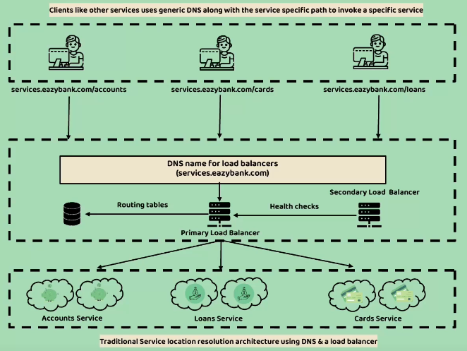

* While this works well with monolithic applications where you have a set of static IPs

It will introduce some problems in case of microservices

* **Limited scalability**: this guy says that you have to update the routing tables and IP addresses manually and this will be a problem for the ephemeral nature of microservices instances. So, this approach is not particularly container-friendly
* **Cost**: this load balancers are often costly.
* **Single Point of Failure**: although we have a backup, secondary load balancer that comes to play if the primary fails, we will still have just to of these that the entire system is relying on so the application will fail in case that these two load balancers fail.

# How to Move on to a New Approach to Overcome These Challenges

* In cloud-native applications we will have a Service Registry where service will subscribe/unsubscribe to or added/removed from upon creation/termination
* A service discovery is performed using this centralized service registry
* **Client-Side Service Discovery:** the services will register themselves in the registry, if a client wants to use a service it calls the registry and receives a list of available IPs and makes a load balanced request to one of them. The services should send their heartbeat as a health signal in intervals and if they fail to do so the registry will remove them. In case of a shut-down they need to deregister themselves from the registry.
* **Server-Side Service Discovery:** in this approach, services will be added to the registry by a third-party registration mean and when a client wants use a service it sends a request to the registry and the registry makes a load-balanced request to the proper instance of the queried service. So, the client won’t do anything regarding load balancing/registration

# Client-Side Service Registration and Load Balancing

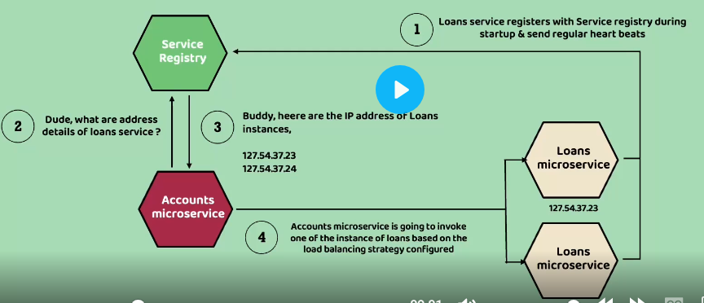Some of the advantages of performing service discovery on the client side:

* You don’t rely on a single point of failure which is the central load balancer
* Each service can implement its own load balancing algorithm such as, round-Robin, weighted round-Robin, least connections etc.
* I think in the server-side option, all the services must be in the Kubernetes cluster for example where with the client-side option it’s not an issue. But we will come back to this point after we learn about Kubernetes(?)

On the down side you have to do the load balancing logic in the client side and it adds to the responsibility of the client application developer.

Client-side load balancing in more details:

* Whenever a service wants to use another service, it first checks a local cache of the IP addresses, if it does not find it, it’s going to communicate with the service discovery layer which includes multiple service nodes and fetches the corresponding IP addresses for the target service. And then store these new addresses in its local cache to reduce network latency and the load on the service registry
* The records in the cache have a time-to-live so the client must communicate with the registry to have a fresh list of addresses.
* I read somewhere that this TTL(time-to-live) can vary from 30 seconds up to 5 minutes in environments where instances of the services are more stable.
* If an exception happens during connection to an IP address from the cache, the entire cache is going to be invalidated
* There can be an option for the registry to push the changes to clients so the TTLs can be even longer

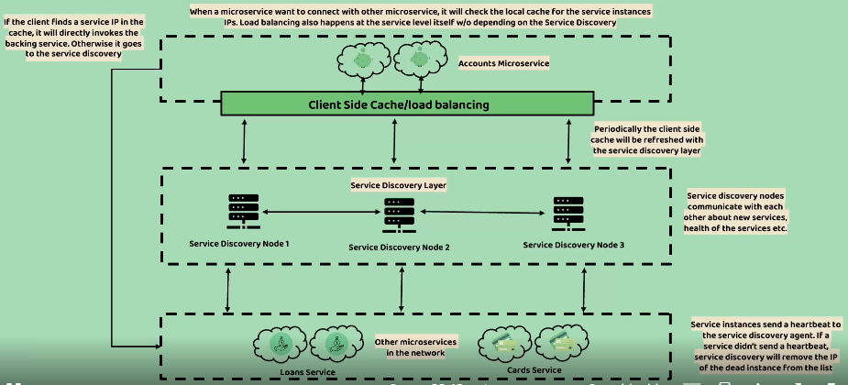In the picture bellow, you can see the process:

# Spring Cloud Support for Client-Side Service Discovery

There are three components in the spring cloud ecosystem that help us implement client-side service discovery and load balancing. Take the following list as in intro as we must discuss them in more details:

* **Spring Cloud Netflix’s Eureka:** There is a Eureka server which acts as a service registry and a Eureka Client which helps with registering services into this registry and I think it does the discovery and caching process also.

There other options like Apache Zookeeper that we don’t care about at the moment.

* **Spring Cloud Load Balancer:** To perform client-side load balancing. There is also Netflix’s Ribbon which is in maintenance mode so we’re not going to use it
* **Netflix’s Feign Client:** It helps with sending requests to other services without hard-coding URLs. It does it with the help of service names.

# Setting Up Service Discovery Agent Using Eureka