Synchronous Remote Procedure

Invocation (RPI) in Microservices

In RPI, A **client invokes a service** using a **synchronous,** **remote procedure invocation-based protocol, such as REST.**

When using a remote procedure invocation-based IPC mechanism, a client sends a request to a service, and the service processes the request and sends back a response**. Some clients may block waiting** for a response, and **others might have a reactive, nonblocking architecture**. But **unlike when using messaging, the client assumes that the response will arrive in a timely fashion.**

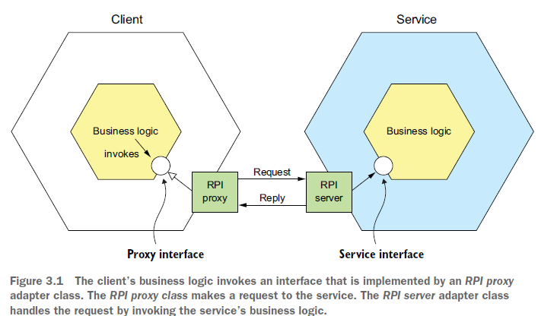

**The *proxy interface* usually encapsulates the underlying communication protocol**.

There are numerous protocols to choose from. We’ll talk about REST and gRPC as examples and how to improve the availability of your services by properly handling partial failure and **explain why a microservices-based application that uses RPI must use a service discovery mechanism.**

# Using REST

*REST* is an IPC mechanism that **(almost always) uses HTTP.** Roy Fielding, the creator of REST, defines REST as follows:

**(You should later on look for how exactly each one of these benefits are fulfilled:**

<https://learn.microsoft.com/en-us/azure/architecture/best-practices/api-design>

<https://www.ibm.com/topics/rest-apis>

<https://en.wikipedia.org/wiki/REST>

).

“*REST provides a set of architectural constraints that, when applied as a whole, emphasizes* ***scalability of component interactions****,* ***generality of interfaces, independent deployment of components****,* ***and intermediary components to reduce interaction latency, enforce security, and encapsulate legacy systems*.”**

* A key concept in REST is a ***resource***, **which typically represents a single business object, such as a Customer or Product, or a collection of business objects.**
* **REST uses the HTTP verbs for manipulating resources**, **which are referenced using a URL:**

For example, a GET request returns the **representation of a resource**, which is **often** in the form of **an XML document or JSON object**, although **other formats such as binary can be used.** A POST request creates a new resource, and a PUT request updates a resource. The Order Service, for example, has a POST /orders endpoint for creating an Order and a GET /orders/{orderId} endpoint for retrieving an Order.

Many developers claim their HTTP-based APIs are RESTful. But as Roy Fielding describes in a blog post**, not all of them actually are** (<http://roy.gbiv.com/untangled/2008/rest-apis-must-be-hypertext-driven>). To understand why, let’s take a look at the **REST maturity model:**

## The REST Maturity Model

Leonard Richardson (no relation to your author) defines a very useful maturity model for REST (http://martinfowler.com/articles/richardsonMaturityModel.html) that consists of the following levels:

○ *Level 0*—Clients of a level 0 service invoke the service by making HTTP POST requests to its **sole URL endpoint.** Each request specifies the action to perform, the target of the action (for example, the business object), and any parameters.(single verb/single URL)

I add: on this level you’re basically using the HTTP as a transport tool to just invoke a remote procedure and you’re not using it as a platform to its fullest potential (verbs, status codes, etc.). and at this level they use **a single verb** that’s usually POST and the request details come in the body of the request or GET with parameters and actions in the URL, and even the errors like 400 will be sent by 200ok announcing the error in the response body.

○ *Level 1*—**A level 1 service supports the idea of resources**. Level one employs **many URIs but only a single HTTP verb To perform an action on a resource**.(single verb/ multiple URLs)

a client for example makes a POST request that specifies the action to perform and any parameters in the body, or Get request with actions and parameters in the URL.

○ *Level 2*—**A level 2 service uses HTTP verbs to perform actions**: GET to retrieve, POST to create, and PUT to update. **The request query parameters and body**, if any, specify the **actions' parameters**.(multiple URLs/multiple verbs/multiple status codes/even location header in a 201ok response pointing to where the new resource can be retrieved)

**This enables services to use web infrastructure such as caching for GET requests.**

○ *Level 3*—The design of a level 3 service is based on the terribly named HATEOAS (Hypertext As The Engine Of Application State) principle. **The basic idea is that the representation of a resource returned by a GET request contains links for performing actions on that resource**. For example, a client can cancel an order using a link in the representation returned by the GET request that retrieved the order(They can be sent as a response to a POST request too. Check out the below example). The benefits of HATEOAS **include no longer having to hard-wire URLs into client code** (<www.infoq.com/news/2009/04/hateoas-restful-api-advantages>). As an example of a response to a GET request for a list of open slots:

<openSlotList>

<slot id = "1234" doctor = "mjones" start = "1400" end = "1450">

<link rel = "/linkrels/slot/book"

uri = "/slots/1234"/>

</slot>

<slot id = "5678" doctor = "mjones" start = "1600" end = "1650">

<link rel = "/linkrels/slot/book"

uri = "/slots/5678"/>

</slot>

</openSlotList>

Each slot now has a link element which contains a URI to tell us how to book an appointment. The point of hypermedia controls is that **they tell us what we can do next**, **and the URI of the resource we need to manipulate to do it**. Rather than us having to know where to post our appointment request, the hypermedia controls in the response tell us how to do it:

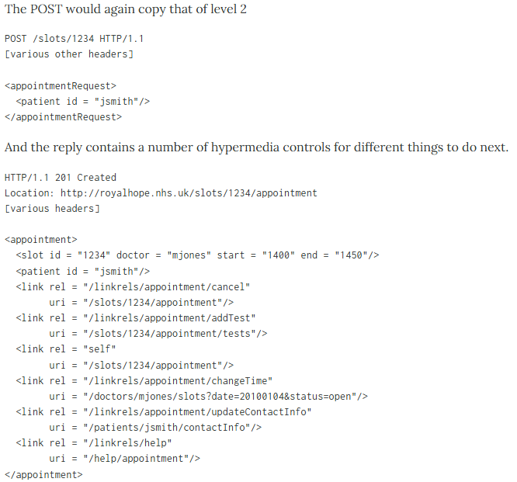

* One obvious benefit of hypermedia controls is that it allows the server to change its URI scheme without breaking clients. As long as clients look up the “addTest” link URI then the server team can juggle all URIs other than the initial entry points.

### The meaning of the Levels

I should stress that the RMM, while a good way to think about what the elements of REST are, is not a definition of levels of REST itself.

Roy Fielding has made it clear that Level 3 RMM(Richardson Maturity Model) is a pre-condition for REST APIs meaning that REST APIs must be hypertext-driven. You can see the levels as **tool to help us learn about the concepts** and **not something that should be used in some kind of** **assessment mechanism:**

* **Level 1** tackles the question of **handling complexity** by using **divide and conquer,** breaking a large service endpoint down into multiple resources.
* **Level 2** introduces a standard set of verbs so that **we handle similar situations in the same way, removing unnecessary variation.**
* **Level 3 introduces discoverability**, providing a way of making a protocol **more self-documenting**.

## Specifying REST APIs

As mentioned earlier in section 3.1, **you must define your APIs using an interface definition language** (IDL). Unlike older communication protocols like CORBA and SOAP, REST did not originally have an IDL. Fortunately, the developer community has rediscovered the value of an IDL for RESTful APIs.

The most popular **REST IDL is the Open API Specification** (www.openapis.org), which evolved from the Swagger open-source project. The Swagger project is a set of tools for developing and documenting REST APIs. It includes tools that generate client stubs and server skeletons **from an interface definition.**

## The Challenge of Fetching Multiple Resources in a Single Request

REST resources are usually oriented around business objects, such as Consumer and Order. Consequently, a common problem when designing a REST API is how to enable the client to retrieve multiple related objects in a single request. For example, imagine that a REST client wanted to retrieve an Order and the Order's Consumer. **A pure REST API would require the client to make at least two requests, one for the Order and another for its Consumer**. A more complex scenario would require even more round-trips and suffer from excessive latency.

One solution to this problem is for an API to allow the client to retrieve related resources when it gets a resource. For example, a client could retrieve an Order and its Consumer using GET /orders/order-id-1345**?expand=consumer**:

* The query parameter specifies the related resources to return with the Order.
* This approach **works well in many scenarios** but it’s often **insufficient for more complex scenarios**
* It’s also potentially time consuming to implement.

**This has led to** the increasing popularity of alternative API technologies such as **GraphQL** (http://graphql.org) and **Netflix Falcor** (http://netflix.github.io/falcor/), which are designed to support efficient data fetching.

## The Challenge of Mapping Operations to HTTP Verbs

Another common REST API design problem is how to map the operations you want to perform on a business object to an HTTP verb.

A REST API should use PUT for updates, **but there may be multiple ways to update an order**, including **cancelling it, revising the order**, and so on.

Also, **an update might not be idempotent**, **which is a requirement for using PUT**.

* One solution is to define a **sub-resource for updating a particular aspect of a resource**. The Order Service, for example, has a POST “/orders/ {orderId}/cancel” endpoint for cancelling orders, and a POST “/orders/{orderId}/ revise” endpoint for revising orders.
* Another solution is to **specify a verb as a URL query parameter.**
* Sadly, **neither solution is particularly RESTful.**

**This problem with mapping operations to HTTP verbs has led to the growing popularity of alternatives to REST, such as gPRC**, discussed shortly in section 3.2.2.

But first let’s look at the benefits and drawbacks of REST.

## Benefits and Drawbacks of REST

There are numerous benefits to using REST:

○ It’s simple and familiar.

○ You can test an HTTP API from within a browser using, for example, the Postman plugin, or from the command line using curl (assuming JSON or some other text format is used).

○ It directly supports request/response style communication.

○ **HTTP is, of course, firewall friendly.**

○ **It doesn’t require an intermediate broker**, which simplifies the system’s architecture.

There are some drawbacks to using REST:

**○ It only supports the request/response style of communication.**

○ **Reduced availability**. Because the client and service communicate directly **without an intermediary to buffer messages,** they must both be running for the duration of the exchange.

○ Clients must know the locations (URLs) of the service instances(s). As described in section 3.2.4, this is a nontrivial problem in a modern application. Clients must use what is known as a *service discovery mechanism* to locate service instances.

○ **Fetching multiple resources in a single request is challenging.**

○ **It’s sometimes difficult to map multiple update operations to HTTP verbs.**

Despite these drawbacks, **REST seems to be the de facto standard for APIs**, though there are a couple of interesting alternatives. GraphQL, for example, implements **flexible, efficient data fetching**.

Chapter 8 discusses GraphQL and covers the API gateway pattern.

gRPC is another alternative to REST. Let’s take a look at how it works.

# Using gRPC

* As mentioned in the preceding section, one challenge with using REST is that because HTTP only provides **a limited number of verbs**, it’s **not** always **straightforward** **to design a REST** API **that supports multiple update operations**. An IPC technology that avoids this issue is gRPC (<www.grpc.io>), a framework for writing cross-language clients and servers (see [https://en.wikipedia.org/wiki/Remote_procedure_call](https://en.wikipedia.org/wiki/Remote_procedure_call%20) for more).
* **gRPC is a binary message-based protocol**, and this means—as mentioned earlier in the discussion of binary message formats—**you’re forced to take an API-first approach to service design.**
* You define your gRPC APIs using a Protocol Buffers-based IDL, which is Google’s language-neutral mechanism for serializing structured data. You use the **Protocol Buffer compiler** to generate **client-side stubs** and **server-side skeletons**. The compiler can generate code for a variety of languages, including Java, C#, NodeJS, and GoLang. Clients and servers exchange **binary messages in the Protocol Buffers format** **using HTTP/2.**
* A gRPC API consists of **one or more services** **and request/response message definitions**. **A *service definition* is analogous to a Java interface and is a collection of strongly typed methods.**
* As well as supporting simple request/response RPC, **gRPC support streaming RPC**. **A server can reply with a stream of messages to the client**. Alternatively, **a client can send a stream of messages** to the server.
* gRPC uses **Protocol Buffers as the message format**. Protocol Buffers is, as mentioned earlier, **an efficient, compact, binary format**. It’s a tagged format. Each field of a Protocol Buffers message is numbered and has a type code. A message recipient can extract the fields that it needs and skip over the fields that it doesn’t recognize. As a result, gRPC enables APIs to evolve while remaining backward-compatible.
* Listing 3.1 shows an excerpt of the gRPC API for the Order Service. It defines several methods, including createOrder(). This method takes a CreateOrderRequest as a parameter and returns a CreateOrderReply: (=2 for example defines the **field tag**)

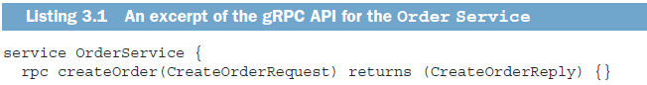

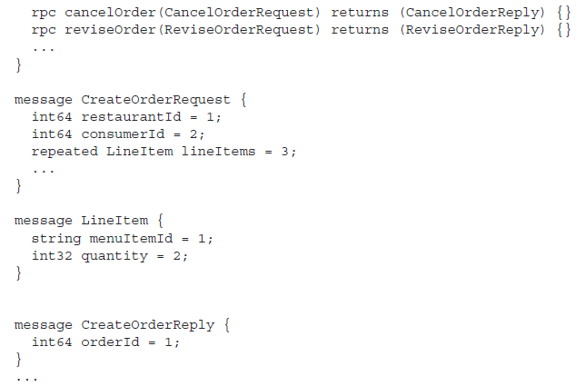

* gRPC has several benefits:

○ It’s straightforward to design an API that has **a rich set of update operations.**

○ It has an **efficient, compact IPC mechanism**, **especially** when exchanging **large messages.**

○ **Bidirectional streaming** enables **both RPI and messaging styles of communication**.

○ It enables interoperability between clients and services written in a wide range of languages.

* gRPC also has several drawbacks:

○ It takes more work for JavaScript clients to consume gRPC-based API than REST/JSON-based APIs.

○ Older firewalls might not support HTTP/2.

gRPC is a compelling alternative to REST, but like REST, it’s **a synchronous communication mechanism, so it also suffers from the problem of partial failure.** Let’s take a look at what that is and how to handle it.

# Handling Partial Failure Using the Circuit Breaker Pattern

**Pattern: Circuit breaker**

*“An* ***RPI proxy*** *that* ***immediately rejects invocations for a timeout period******after*** *the number of* ***consecutive failures******exceeds a specified threshold****”*

In a distributed system, **whenever a service makes a synchronous** **request** to **another service**, there is an ever-present **risk of partial failure.**

Because the client and the service are separate processes, a service may not be able to respond in a timely way to a client’s request:

* The service could be down because of a failure or for maintenance.
* Or the service might be overloaded and responding extremely slowly to requests.

**Because the client is blocked waiting for a response**, the danger is that the failure could **cascade to the client’s clients** and so on **and cause an outage.**

Consider, for example, the scenario shown in figure 3.2, where the Order Service is

Unresponsive:

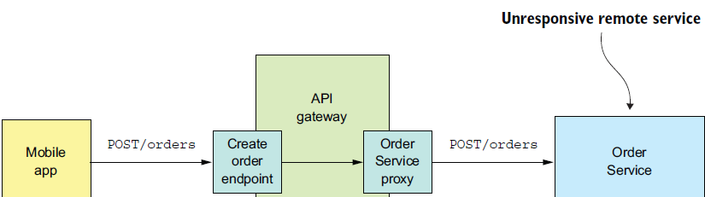

A naive implementation of the OrderServiceProxy would block indefinitely, waiting for a response.

* Not only would that result in a poor user experience
* but in many applications, it would consume a precious resource, such as a thread.
* Eventually the API gateway would run out of resources and become unable to handle requests. The entire API would be unavailable.

**It’s essential that you design your services to prevent partial failures from cascading throughout the application**. There are two parts to the solution:

○ You must use design RPI proxies, such as OrderServiceProxy, to handle unresponsive

remote services.

○ You need to decide how to recover from a failed remote service.

## Developing Robust API Proxies

Whenever one service synchronously invokes another service, it should protect itself using the approach described by Netflix (http://techblog.netflix.com/2012/02/faulttolerance-

in-high-volume.html). This approach consists of a combination of the following mechanisms:

○ ***Network timeouts***—Never block indefinitely and always use timeouts when waiting for a response. Using timeouts ensures that resources are never tied up indefinitely.

○ ***Limiting the number of outstanding(not-resolved) requests from a client to a service***—Impose an upper bound on the number of outstanding requests that a client can make to a particular service. If the limit has been reached, it’s probably pointless to make additional requests, and those attempts should fail immediately.

○ ***Circuit breaker pattern***:

* **Track the number of successful and failed requests, and if the error rate exceeds some threshold, trip the circuit breaker so that further attempts fail immediately**. A large number of requests failing suggests that the service is unavailable and that sending more requests is pointless.
* After a timeout period, **the client should try again**, and, **if successful, close the circuit breaker.**

*You’ll most likely use Spring Cloud Circuit Breaker that supports Resilience 4j and Spring Retry as implementations, Hystrix is in maintenance mode and I think R4j is inspired by Hystrix.*

*The book says tho:*

Netflix Hystrix (https://github.com/Netflix/Hystrix) is an open-source library that implements these and other patterns. If you’re using the JVM, you should definitely consider using Hystrix when implementing RPI proxies. And if you’re running in a non-JVM environment, you should use an equivalent library. For example, the Polly library is popular in the .NET community (<https://github.com/App-vNext/Polly>).

## Recovering from an Unavailable Service

Using a library such as Hystrix is only part of the solution. **You must also decide on a case-by-case basis how your services should recover from an unresponsive remote service**.

* One option is for a service to simply return an error to its client. For example, this approach makes sense for the scenario shown in figure 3.2, where the request to create an Order fails. The only option is for the API gateway to return an error to the mobile client.
* In other scenarios, returning a fallback value, s**uch as either a default value or a cached response**, may make sense. For example, chapter 7 describes how the API gateway could implement the findOrder() query operation by using the API composition pattern. As figure 3.3 shows, its implementation of the GET /orders/{orderId} endpoint invokes several services, including the Order Service, Kitchen Service, and Delivery Service, and combines the results. It’s likely that each service’s data isn’t equally important to the client. The data from the Order Service is essential. If this service is unavailable, the API gateway should return either a cached version of its data or an error. The data from the other services is less critical. A client can, for example, display useful information to the user even if the delivery status was unavailable. If the Delivery Service is unavailable, the API gateway should return either a cached version of its data or omit it from the response.

# Using Service Discovery

Say you’re writing some code that invokes a service that has a REST API. In order to make a request, your code needs to know the network location (IP address and port) of a service instance.

In a traditional application running on physical hardware, the network locations of service instances are usually static. For example, your code could read the network locations from a configuration file that’s occasionally updated. **But in a modern, cloud-based microservices** application, it’s usually **not that simple** and is **much more dynamic**.

Service instances have dynamically assigned network locations. Moreover, the set of service instances changes dynamically because of autoscaling, failures, and upgrades (They’re dynamically created and destroyed). Consequently, your client code must use **a service discovery.**

## Overview of Service Discovery

Service discovery is conceptually quite simple: its key component is a **service registry**, which is **a database of the network locations of an application’s service instances.**

**The** service **discovery mechanism updates the service registry** when service **instances start and stop**. When a client invokes a service, the service discovery mechanism queries the service registry to obtain a list of available service instances and routes the request to one of them. There are **two main ways to implement service discovery:**

○ **The services and their clients interact directly with the service registry.**

○ **The deployment infrastructure handles service discovery. (I talk more about**

**that in chapter 12.)**

Let’s look at each option:

### Application-Level Service Discovery Pattern

* A service instance registers its network location with the service registry.
* A service client invokes a service by first querying the service registry to obtain a list of service instances. **It then sends a request to one of those instances.**

This approach to service discovery is a combination of two patterns:

* The first pattern is the **Self registration pattern**.
  + A service instance invokes the service registry’s **registration API** to register its network location.
  + It may also supply a health check URL, described in more detail in chapter 11. The ***health check* URL** is an API endpoint **that the service registry invokes** periodically to verify that the service instance is healthy and available to handle requests.
  + A service registry may require a service instance to periodically invoke a “**heartbeat**” API in order **to prevent its registration from expiring**.
* The second pattern is the **Client-side discovery pattern**:
  + When a service client wants to invoke a service, it queries the service registry to obtain a list of the service’s instances.
  + To improve performance, **a client might cache the service instances**.
  + **The** service **client** then **uses a load-balancing algorithm**, such as a **round-robin or random**, to select a service instance.
  + It then makes a request to a select service instance.

*Application-level service discovery has been popularized by Netflix and Pivotal. Netflix developed and open sourced several components:* ***Eureka,*** *a highly available service registry, the Eureka Java client,* ***and Ribbon****, a sophisticated HTTP client that supports the Eureka client.*

*Pivotal developed Spring Cloud, a Spring-based framework that makes it remarkably easy to use the Netflix components. Spring Cloud-based services automatically register with Eureka, and Spring Cloud-based clients automatically use Eureka for service discovery.*

* One benefit of application-level service discovery is that it handles the scenario when services are deployed on multiple deployment platforms. Imagine, for example, you’ve deployed only some of services on Kubernetes, discussed in chapter 12, and the rest is running in a legacy environment. **Application-level service discovery using Eureka, for example, works across both environments, whereas Kubernetes-based service discovery only works within Kubernetes.**
* One drawback of application-level service discovery is that **you need a service discovery library for every language**—**and possibly framework—that you use**. Spring Cloud only helps Spring developers. If you’re using some other Java framework or a non-JVM language such as NodeJS or GoLang, you must find some other service discovery framework.
* Another drawback of application-level service discovery is **that you’re responsible for setting up and managing the service registry**, which is a distraction. As a result, **it’s usually better to use a service discovery mechanism that’s provided by the deployment infrastructure.**

### Platform-Provided Service Discovery Pattern

Later in **chapter 12** you’ll learn that many **modern deployment platforms** such as Docker and Kubernetes have a **built-in service registry and service discovery mechanism**.

* The deployment platform gives each service **a DNS name**, **a virtual IP (VIP) address**, **and a DNS name that resolves to the VIP address**.
* A service client makes a request to the DNS name/VIP
* and **the** deployment **platform** **automatically routes (a load-balanced routing)** the request **to one of the available service instances.**
* As a result, **service registration**, **service discovery**, and **request routing(load-balancing)** are **entirely handled by the deployment platform.**

Figure 3.6 shows how this works:

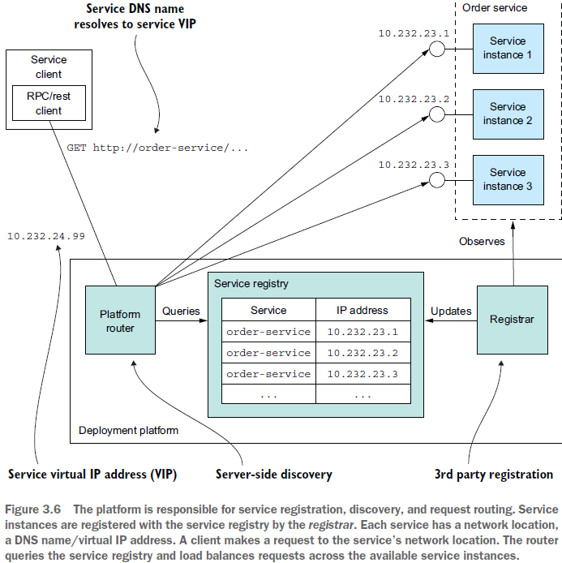

The deployment platform includes a service registry that tracks the IP addresses of

the deployed services. In this example, a client accesses the Order Service using the DNS name order-service, which resolves to the virtual IP address 10.1.3.4. **The deployment platform automatically load-balances requests across the three instances of the Order Service.**

This approach is a combination of two patterns:

○ ***3rd party registration pattern***—Instead of a service registering itself with the service registry, a third party **called the *registrar***, **which is typically part of the deployment platform**, handles the registration.

○ ***Server-side discovery pattern***—Instead of a client querying the service registry, it makes a request to a DNS name, **which resolves to a request router** **that queries the service registry and load balances requests.**

* The key benefit of platform-provided service discovery is that all aspects of service discovery are **entirely handled by the deployment platform**. Neither the services nor the clients contain any service discovery code. Consequently, the service discovery mechanism is readily available to all services and clients regardless of which language or framework they’re written in.
* One drawback of platform-provided service discovery is that it only supports the discovery of services that have been deployed using the platform. For example, as mentioned earlier when describing application-level discovery, Kubernetes-based discovery **only works for services running on Kubernetes.**

**Despite this limitation, I recommend using platform-provided service discovery whenever possible.**