Integrating Bounded Contexts

Not only does the bounded context pattern protect the consistency of a ubiquitous

language, it also enables modeling. You cannot build a model without specifying its

purpose—its boundary. The boundary divides the responsibility of languages. A language

in one bounded context can model the business domain to solve a particular

problem. Another bounded context **can represent the same business entities but**

**model them to solve a different problem.**

Moreover, models in different bounded contexts can **be evolved and implemented**

**independently**. That said, bounded contexts **themselves are not independent**. Just as a

system cannot be built out of independent components—**the components have to**

**interact with one another** to achieve the system’s overarching goals—so, too, do the

implementations in bounded contexts. Although they can evolve independently, they

have to integrate with one another. As a result, **there will always be touchpoints**

**between bounded contexts. These are called *contracts*.**

The need for contracts results from differences in bounded contexts’ models and languages.

Since each contract affects more than one party, they need to be defined and

coordinated.

Also, by definition, **two bounded contexts are using different ubiquitous**

**languages. Which language will be used for integration purposes?**

These integration concerns should be evaluated and addressed by the solution’s design.

We will learn about domain-driven design patterns **for defining relationships** and **integrations between bounded contexts**.

These patterns **are driven by the nature of collaboration between teams** working on bounded contexts. We will divide the patterns into three groups, each representing a type of team collaboration:

cooperation, customer–supplier, and separate ways.

# Cooperation

**Cooperation patterns relate to bounded contexts implemented by teams with well-established communication.**

**In the simplest case, these are bounded contexts implemented by a single team.**

**This also applies to teams with dependent goals, where one team’s success depends on the success of the other, and vice versa.**

**Again, the main criterion here is the quality of the teams’ communication and collaboration.**

Let’s look at two **DDD patterns suitable for cooperating teams**: the partnership and

shared kernel patterns.

## Partnership

**In the partnership model, the integration between bounded contexts is coordinated in an ad hoc manner. One team can notify a second team about a change in the API,**

**and the second team will cooperate and adapt—no drama or conflicts.**

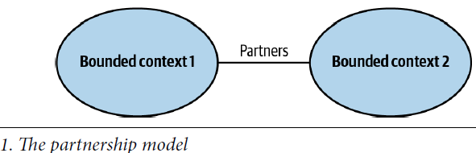

**The coordination of integration here is two-way**. **No one team dictates the language**

**that is used for defining the contracts.** The teams can work out the differences and

choose the most appropriate solution. Also, both sides cooperate in solving any integration

issues that might come up. Neither team is interested in blocking the other one.

**Well-established collaboration practices**,

**high levels of commitment,**

**and frequent synchronizations between teams** are required for successful integration in this manner.

From a technical perspective, continuous integration of the changes applied by

both teams is needed to further minimize the integration feedback loop.

**This pattern might not be a good fit for geographically distributed teams since it may**

**present synchronization and communication challenges.**

## Shared Kernel

***This section needs to be revisited later-on***

Despite bounded contexts being model boundaries, **there still can be cases when the**

**same model of a subdomain, or a part of it, will be implemented in multiple bounded contexts.**

It’s crucial to stress that the shared model is designed according to the needs of all of the bounded contexts. Moreover, the shared model has to be consistent across all of the bounded contexts that are using it.

As an example, consider an enterprise system that uses a tailor-made model for managing users’ permissions. Each user can have their permissions granted directly or inherited from one of the organizational units they belong to. **Moreover, each bounded context can modify the authorization model, and the changes each bounded context applies have to affect all the other bounded contexts using the model (what does this mean exactly?)**

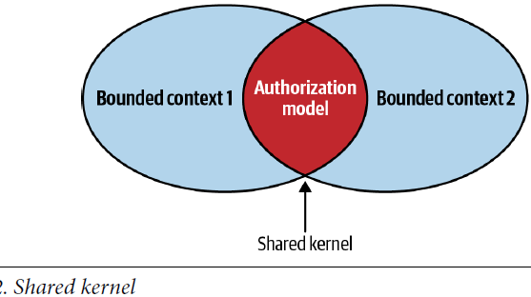

### Shared Scope

**The overlapping model couples the lifecycles of the participating bounded contexts.**

A change made to the shared model has an immediate effect on all the bounded contexts.

Hence, to minimize the cascading effects of changes**, the overlapping model should be limited**, exposing only that part of the model that has to be implemented by both bounded contexts. Ideally, the shared kernel will consist only of integration contracts and data structures that are intended to be passed across the bounded contexts’ boundaries.

### Implementation

**The shared kernel is implemented so that any modification to its source code is**

**immediately reflected in all the bounded contexts using it.**

If the organization uses the mono-repository approach, these can be the same source

files referenced by multiple bounded contexts.

If using a shared repository is not possible, the shared kernel can be extracted into a dedicated project and referenced in the bounded contexts as a linked library.

**Either way, each change to the shared kernel must trigger integration tests for all the affected bounded contexts.**

The continuous integration of changes is required because the shared kernel belongs

to multiple bounded contexts. Not propagating shared kernel changes to all related

bounded contexts leads to inconsistencies in a model: bounded contexts may rely on stale implementations of the shared kernel, leading to data corruption and/or runtime issues.

### When to Use Shared Kernel

The overarching applicability criterion for the shared kernel pattern is the cost of duplication versus the cost of coordination. Since the pattern introduces a strong dependency between the participating bounded contexts, it should be applied only

when the cost of duplication is higher than the cost of coordination—in other words,

only when integrating changes applied to the shared model by both bounded contexts

will require more effort than coordinating the changes in the shared codebase.

**The difference between the integration and duplication costs depends on the volatility of the model. The more frequently it changes, the higher the integration costs will be. Therefore, the shared kernel will naturally be applied for the subdomains that change the most: the core subdomains.**

**In a sense, the shared kernel pattern contradicts the principles of bounded contexts**

**introduced in the previous chapter. If the participating bounded contexts are not implemented by the same team, introducing a shared kernel contradicts the principle that a single team should own a bounded context. The overlapping model—the shared kernel—is, in effect, being developed by multiple teams.**

**That’s the reason why the use of a shared kernel has to be justified.** It’s a pragmatic

exception that should be considered carefully.

A common use case for implementing a shared kernel is when communication or collaboration issues prevent implementing the partnership pattern—for example, because of geographical constraints or organizational politics.

Implementing a closely related functionality without proper coordination will result in integration issues, desynchronized models, and arguments about which model is better designed.

**Minimizing the shared kernel’s scope controls the scope of cascading changes**, and **triggering integration tests for each change is a way to enforce early detection of integration issues.(BUT HOW?)**

Another common use case for applying the shared kernel pattern, albeit a temporary

one, is the gradual modernization of a legacy system. In such a scenario, the shared

codebase can be a pragmatic intermediate solution for gradually decomposing the

system into bounded contexts.

Finally, a shared kernel can be a good fit for integrating bounded contexts owned and

implemented by the same team. In such a case, an ad hoc integration of the bounded

contexts—a partnership—can “wash out” the contexts’ boundaries over time. A

shared kernel can be used for explicitly defining the bounded contexts’ integration

contracts.

# Customer-Supplier

The second group of collaboration patterns we’ll examine is the customer–supplier

patterns. one of the bounded contexts—the supplier—provides a service for its customers. The service provider is “upstream” and the customer or consumer is “downstream.

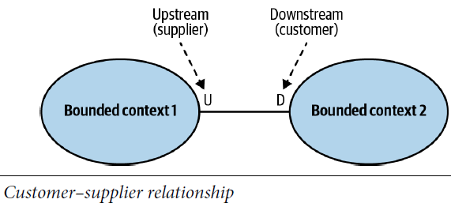

Unlike in the cooperation case, both **teams** (upstream and downstream) can succeed independently(*I add: he says teams meaning unlike the cooperation situation, teams’ success is not dependent on each other*). **Consequently, in most cases we have an imbalance of power**: **either** the upstream or the downstream team **can dictate** the integration contract. This section will discuss **three patterns addressing such power differences: the conformist, anti-corruption layer, and open-host service patterns.**

## Conformist

*I add: in this model the consumer accepts the upstream service as is and may not use some fields of its model for example. Which is different from what we have with the anti-corruption layer that translates the upstream service to the consumer’s acceptable model.*

In some cases, the balance of power favors the upstream team, which has no real

motivation to support its clients’ needs.

Instead, it just **provides the integration contract, defined according to its own model**—take it or leave it. Such power imbalances **can be caused by integration with service providers that are external to the organization or simply by organizational politics.**

**If the downstream team can accept the upstream team’s model, the bounded contexts’ relationship is called *conformist***. The downstream conforms to the upstream bounded context’s model, as shown below:

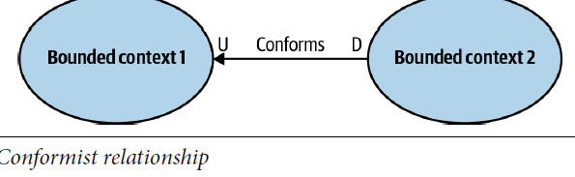

The downstream team’s decision to give up some of its autonomy can be justified in

multiple ways. **For example, the contract exposed by the upstream team may be an**

**industry-standard, well-established model, or it may just be good enough for the**

**downstream team’s needs.**

The next pattern addresses the case in which **a consumer is not willing to accept the**

**Supplier’s model.**

## Anticorruption Layer

As in the conformist pattern, the balance of power in this relationship is still skewed

toward the upstream service. However, in this case, the downstream bounded context

is not willing to conform. Instead, it can translate the upstream bounded context’s

model into a model tailored to its own needs via an anticorruption layer, as shown in

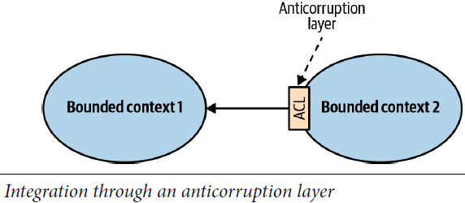

The anticorruption layer pattern addresses scenarios in which it is not desirable or

worth the effort to conform to the supplier’s model, such as the following:

### When the downstream bounded context contains a core subdomain

A core subdomain’s model requires extra attention, and adhering to the supplier’s

model might impede the modeling of the problem domain.

### When the upstream model is inefficient or inconvenient for the consumer’s needs

If a bounded context conforms to a mess, it risks becoming a mess itself. That is often the case when integrating with legacy systems.

### When the supplier’s contract changes often

The consumer wants to protect its model from frequent changes. With an anticorruption

layer, the changes in the supplier’s model only affect the translation mechanism.

From a modeling perspective, the translation of the supplier’s model isolates the downstream consumer from foreign concepts that are not relevant to its bounded context. Hence, it simplifies the consumer’s ubiquitous language and model.

In Chapter 9 of the book, he will explore the different ways to implement an anticorruption layer.