Managing Domain Complexity

We learned that the ubiquitous language should reflect the domain experts’ mental models of the business domain’s inner workings and underlying principles.

**Since our goal is to use ubiquitous language to drive software design decisions, the language must be clear and consistent**. It should be free of ambiguity, implicit assumptions, and extraneous details.

However, on an organizational scale, the domain experts’ mental models can be inconsistent themselves. Different domain experts can use different models of the same business domain. Let’s take a look at an example.

*I add: he doesn’t mean that their models are wrong, but the fact that a single term can represent different processes/entities depending on the department for example.*

# Inconsistent Models

Take a telemarketing company as an example. The term “lead” means differently in the sales and marketing departments. The marketing department uses it as simply a notification that somebody’s interested in our product. In the sales department OTOH, it means the entire process of a sale and carries much more details.

How do we formulate a ubiquitous language in the case of this telemarketing company?

* On the one hand, we know the ubiquitous language has to be consistent—each term should have one meaning.
* On the other hand, we know the ubiquitous language has to reflect the domain experts’ mental models.
* In this case, the mental model of the ”lead” is inconsistent among the domain experts in the sales and marketing departments.

This ambiguity doesn’t present that much of a challenge in person-to-person communications.

However, it is more difficult to represent such a divergent model of the business domain in software. **Source code doesn’t cope well with ambiguity**.

* If we were to bring the sales department’s complicated model into marketing, it would introduce complexity where it’s not needed— far more detail and behavior than marketing people need for optimizing advertising campaigns.
* But if we were to try to simplify the sales model according to the marketing world view, it wouldn’t fit the sales subdomain’s needs, because it’s too simplistic for managing and optimizing the sales process. We’d have an overengineered solution in the first case and an under-engineered one in the second.

## The Traditional Solution

The traditional solution to this problem is to design a single model that can be used

for all kinds of problems. Such models result in enormous entity relationship diagrams

(ERDs) spanning whole office walls.

Would this model be effective?

As the saying goes, “jack of all trades, master of none.” Such models are supposed to be suitable for everything but eventually are effective for nothing.

No matter what you do, you are always facing complexity:

* the complexity of filtering out extraneous details
* the complexity of finding what you do need
* and most importantly, the complexity of keeping the data in a consistent state.

## Another Bad solution

Another solution would be to prefix the problematic term with a definition of the context: ”marketing lead” and “sales lead.”

That would allow the implementation of the two models in code. However, this approach has two main disadvantages.

* First, it induces cognitive load. When should each model be used? The closer the implementations of the conflicting models are, the easier it is to make a mistake.

(why this is a problem will probably be more clear as we go further through the book)

* Second, **the implementation of the model won’t be aligned with the ubiquitous language.** No one would use the prefixes in conversations. People don’t need this extra information; they can rely on the conversation’s context.

Let’s turn to the domain-driven design pattern for tackling such scenarios: the bounded

context pattern.

# What is a Bounded Context?

The solution in domain-driven design is trivial: divide the ubiquitous language into multiple smaller languages, then assign each one to the explicit context in which it can be applied: its *bounded context*.

In the preceding example, we can identify two bounded contexts: marketing and sales. **The term *lead* exists in both bounded contexts**, as shown in Figure 3-3. As long as it bears a single meaning in each bounded context, each fine-grained ubiquitous language is consistent and follows the domain experts’ mental models.

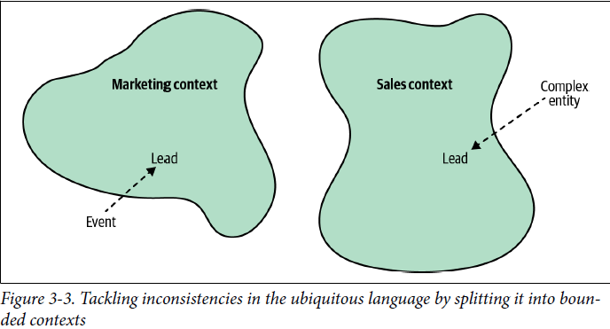

terminology conflicts and implicit contexts are an inherent part of any decent-sized business. **With the bounded context pattern, the contexts are modeled as an explicit and integral part of the business domain.**

# Model Boundaries

As we discussed in the previous chapter, a model is not a copy of the real world but a

construct that helps us make sense of a complex system.

**The problem it is supposed to solve is an inherent part of a model—its purpose.**

A model cannot exist without a boundary; it will expand to become a copy of the real world. That makes defining a model’s boundary—its bounded contexts—an intrinsic part of the modeling process.

We saw that each map has its specific context—aerial, nautical, terrain, subway, and so on. A map is useful and consistent only within the scope of its specific purpose.

* Just as a subway map is useless for nautical navigation, **a ubiquitous language in one bounded context can be completely irrelevant to the scope of another bounded context.**
* **Bounded contexts define the applicability of a ubiquitous language and of the model it represents.**
* **They allow defining distinct models according to different problem domains.**
* In other words, bounded contexts are the consistency boundaries of ubiquitous languages.
* A language’s terminology, principles, and business rules are only consistent inside its bounded context.

# Ubiquitous Language Refined

**Bounded contexts allow us to complete the definition of a ubiquitous language.**

A ubiquitous language is *not* “ubiquitous” in the sense that it should be used and applied “ubiquitously” throughout the organization. A ubiquitous language is *not* universal.

Instead, a ubiquitous language is ubiquitous only in the boundaries of its bounded context. The language is focused on describing only the model that is encompassed by the bounded context.

**As a model cannot exist without a problem it is supposed to address, a ubiquitous language cannot be defined or used without an explicit context of its applicability.**

# Scope of a Bounded Context