
Social Network
Homework 2

Full Name: | Erfan Shahabi
Student ID: | 810103166
Course: | Social Networks
Submission Date: | 31-Dec-2025
Github Link: | https://github.com/erfanshahabi/Social-Networks-Fall-2025/tree/main/SN_HW2_810103166

Table of Contents
List of Figures 3
List of Tables 3
1. Theoretical Framework 4
1.1. Structural Index 4
Part a: 4
Part b: 5
2.1. Distances and Neighbors 5
Part a 5
Part b: 6
Part c: 8
2. Practical Implementation 10
1.2. Question 1 10
Part (a): Power Geometry 10
• Centrality Calculations 10
• Gap Analysis 10
• Hub Analysis 11
Part (b): Information Bottlenecks 11
Part (c): Power in Local Structures 13
Part (d): Bonacich Power Dynamics 15
2.2. Question 2 18
Part (a): Hits vs PageRank 18
Part (b): Rank Stability 19

List of Figures
Figure 1 10
Figure 2 11
Figure 3 13
Figure 4 14
Figure 5 14
Figure 6 15
Figure 7 15
Figure 8 18
Figure 9 19
Figure 10 20

List of Tables
Table 1 10
Table 2 11
Table 3 12
Table 4 16
Table 5 16
Table 6 18
Table 7 19
Table 8 20

1. Theoretical Framework

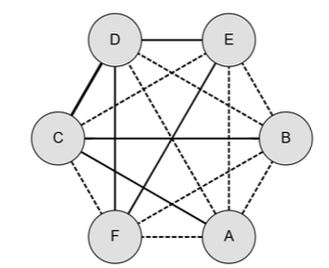
1.1. Optimizing Structural Balance in a Competitive Network

Part a:
Figure 1

Triangle | Situation | Signs
CDF | Imbalanced | ++-
CDB | Imbalanced | ++-
CDA | Imbalanced | ++-
CBA | Imbalanced | ++-
CDE | Imbalanced | ++-
DBA | Imbalanced | ---
EBA | Imbalanced | ---
EFA | Imbalanced | ---
ABF | Imbalanced | ---
Table 1

Part b:
Optimal two faction partition:
Group 1: {A, B, C}
Group 2: {D, E, F}
Minimum flips needed: 2 edges
- Edges that must change sign:
Edge 1: A-B
Current: Negative
Required: Positive
Reason: A and B must cooperate with faction 1
Edge 2: C-D
Current: Positive
Required: Negative
Reason: C and D are in opposing factions and must be adversaries.
- Yes, The partition is preserved
Bipartition Analysis
Analysis of Original Structure:
Positive edge distribution:
- Within Group 1: CB, CA
- Within Group 2: DF, DE, EF
- Between Groups: CD
Result: 5 out of 6 positive edges lie within fractions.
Original Bipartition is preserved. The network naturally exhibits the {A, B, C} vs {D, E, F} faction structure.
Why this partition is structurally preferable:
1. Minimal changes required
Only 2 edge flips (A-B and C-D)
Alternative partitions need 5+ flips

2. Eliminates all instability
Removes all 8 imbalanced triangles
Creates perfect balance structure
3. Natural alignment
Group 2 {D,E,F} already forms complete positive triangle
Group 1 {A,B,C} has 2/3 positive edges
Network naturally exhibits this division

2.1. Graph Reduction in Large and Irregular Signed Networks

Part a
Using the standard graph reduction algorithm, we identify connected components based on positive edges only. Each component becomes a supernode in the reduced graph G’.
Supernodes in G’:
S1: {1, 2, 3, 4, 5}
- Positive connections: 1-2, 1-3, 2-3, 2-4, 4-5
- Form densely connected cluster
S2: {6, 7}
- Positive connections: 6-7
- Small coalition
S3: {8}
- Isolated node
S4: {9}
- Isolated node
S5: {10, 11, 12, 13}
- Positive connections: 10-11, 11-12, 12-13
- Forms chain structure
S6: {14, 15, 16, 17, 18}
- Positive connections: 14-15, 14-16, 15-16, 16-17, 17-18
- Forms highly connected cluster
Reduced graph G’ contains 6 supernodes

Part b:
Reduced Graph G' Structure
Edges in G' (derived from negative edges in original G):
- S1-S2 (from 2-6 negative edge)
- S1-S3 (from 5-8 negative edge)
- S1-S5 (from 4-11 negative edge)
- S1-S6 (from 1-14, 3-16 negative edges)
- S2-S4 (from 7-9 negative edge)
- S4-S5 (from 9-10 negative edge)
- S5-S6 (from 13-15, 12-18 negative edges)
Bipartiteness Test
- Result: G' is NOT BIPARTITE
Cycle Analysis
- Odd-length cycle detected: S1 → S5 → S6 → S1
- This cycle has length 3 (odd), which prevents bipartite structure.
- Path:
  - S1 connects to S5 (via negative edge 4-11)
  - S5 connects to S6 (via negative edges 13-15, 12-18)
  - S6 connects back to S1 (via negative edges 1-14, 3-16)
Conclusion
The original network G does NOT satisfy strong structural balance

Part c:
Transform G' into bipartite structure by minimizing edge modifications (converting negative edges to positive, or equivalently, removing edges from G').
Optimal Bipolar Partition
Coalition 1: {S1, S4} Coalition 2: {S2, S3, S5, S6}
Minimum Changes Required
Number of edge changes: 1
Edge to modify:
- S5-S6: This edge must be removed (or converted to positive)
Verification
After removing S5-S6:
Edges within Coalition 1: None ✓
Edges within Coalition 2: None ✓
Edges between coalitions:
- S1-S2 ✓
- S1-S3 ✓
- S1-S5 ✓
- S1-S6 ✓
- S4-S2 ✓ (S2-S4)
- S4-S5 ✓
Result: Perfect bipartite structure achieved

3.1. Triadic Closure and Tie Stability in Social Networks

Part a
STC: A node A satisfies the STC property if:
- Whenever A has strong ties to two other nodes B and C
- Then B and C must connected by at least some tie (strong or weak)
In this problem node A’s situation:
- A has strong tie to B
- A has strong tie to C
- B and C have no connection
So node A violates the strong triadic closure principle.

Changes to Achieve STC Consistency
Option 1: Add Edge B-C
Create a connection between B and C (either strong or weak tie).
Result:
- Satisfies STC: A has strong ties to B and C, and B-C are now connected
- Completes the triad A-B-C
- Most natural solution reflecting social reality
Option 2: Weaken Tie A-B
Change A-B from strong to weak tie.
Result:
- No longer violates STC (STC only applies when both ties are strong)
- A-B becomes weak, A-C remains strong
- Only one strong tie from A, so STC doesn't apply
Option 3: Weaken Tie A-C
Change A-C from strong to weak tie.
Result:
- No longer violates STC
- A-C becomes weak, A-B remains strong
- Only one strong tie from A, so STC doesn't apply
Option 4: Weaken Both A-B and A-C
Change both ties to weak.
Result:
- Definitely satisfies STC (no strong ties from A to multiple nodes)
- Eliminates the precondition for STC

Part b
Given:
- Network satisfies STC
- Edge A, D is a local bridge
Definitions:
- STC: If node A has strong ties to both B and D, then B and D must be connected.
- Local Bridge: Edge A, D is a local bridge if A and D have no common neighbors.
Proof
Claim: A, D cannot be a strong tie
- Assume A, D is strong
- We know A-B is Strong
- By STC: Since A has strong ties to both B and D, edge B-D must exist
- Then B is a common neighbor of A and D
- This contradicts the local bridge definition (no common neighbors)
- Therefore, (A, D) must be weak

2. Practical Implementation

1.2. Question 1

Part (a): Power Geometry

Centrality Calculations
Network statistics: 5,696 politicians, 36,836 mutual connections. Fully connected network.
Table 2
Rank | Node ID | Degree | Eigenvector | Closeness
1 | 14650 | 0.0567 | 0.1837 | 0.3522
2 | 20415 | 0.0444 | 0.1810 | 0.2968
3 | 21491 | 0.0390 | 0.1778 | 0.2990

Gap Analysis
Figure 1 shows relationship between degree and eigenvector centrality.

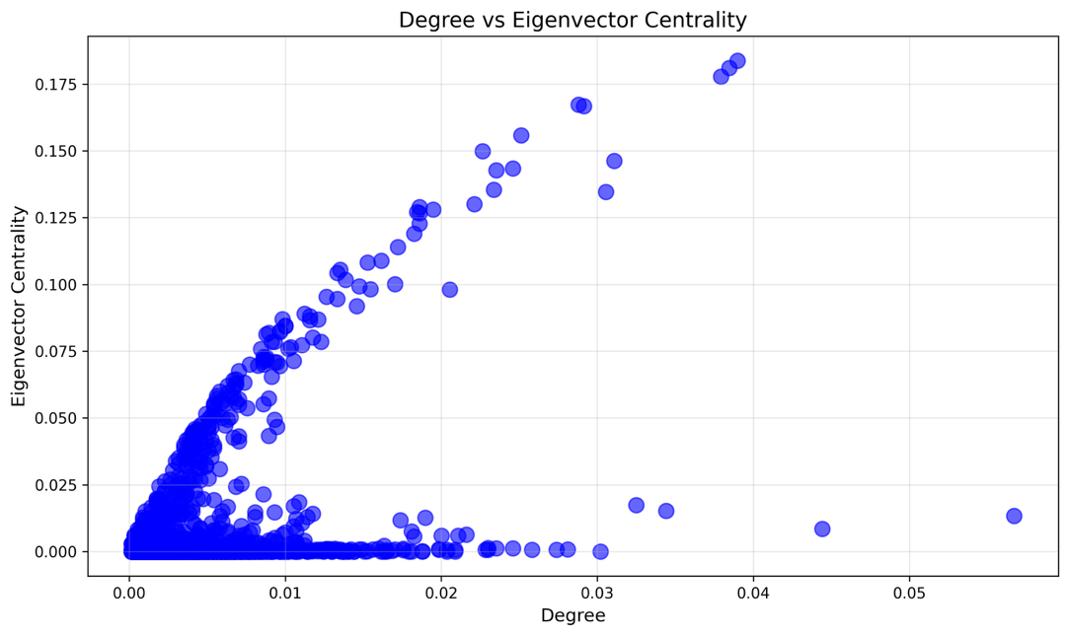

Figure 2

Key observations:
Most nodes follow linear correlation: higher degree leads to higher eigenvector centrality. Several outliers deviate significantly from trend line, indicating strategic positioning beyond simple connectivity.

Hub Analysis
Identified politicians with low degree but high eigenvector centrality, indicating connection to influential nodes despite limited direct connections.
Table 3
Node | Degree Rank | Eigenvector Rank | Closeness Rank | Interpretation
17495 | 103 | 30 | 320 | Gatekeeper/Advisor
7860 | 130 | 33 | 283 | Elite network position
15475 | 122 | 34 | 317 | Power broker access
Analysis:
These politicians demonstrate strategic positioning: connected to few but highly influential individuals. Likely roles include chiefs of staff, executive secretaries, or senior advisors who operate behind the scenes but maintain access to top-tier decision makers. Their moderate closeness ranks indicate they are not at network center but positioned strategically within elite circles.

Part (b): Information Bottlenecks
Betweenness centrality identifies politicians controlling information flow between otherwise disconnected groups.
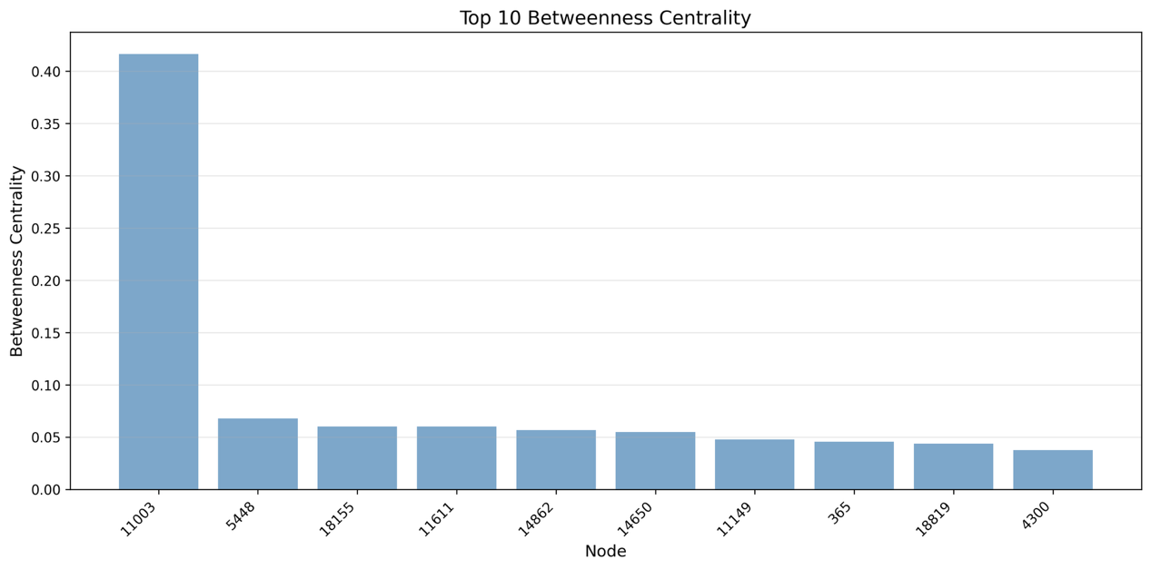

Figure 3

Table 4
Node | Name | Betweenness | Degree Rank | Closeness Rank
11003 | Barack Obama | 0.4166 | 6 | 1
5448 | Hillary Clinton | 0.0678 | 146 | 10
18155 | Angela Merkel | 0.0603 | 7 | 3

Contextual Analysis: Three Key Mediators
1. Barack Obama (Node 11003):
Ego network: 196 connections spanning degree range 1-177, average 23.0. Local clustering coefficient 0.012 indicates star topology. Bridges diverse political communities without tight interconnection among neighbors. As former US president, serves as central hub connecting international leaders, domestic politicians, and policy advocates across ideological spectrum. Low clustering reflects role as universal connector rather than leader of cohesive faction.
2. Hillary Clinton (Node 5448):
Ego network: 61 connections with degree range 1-177, average 26.1. Clustering 0.011 confirms hub-and-spoke structure. Despite moderate degree (rank 146), achieves high betweenness through strategic positioning between Democratic establishment, international diplomats, and progressive activists. Connects disparate groups that rarely interact directly.
3. Angela Merkel (Node 18155):
Ego network: 185 connections spanning degree 1-323, average 30.9. Higher clustering (0.073) suggests some neighbor interconnection within European political sphere. Bridges EU leadership, German domestic politics, and transatlantic relationships. Slightly higher clustering reflects cohesive European political community compared to more fragmented US landscape.
Why These Politicians Are Bridges:
All three demonstrate structural hole bridging: connecting communities that would otherwise remain disconnected. Their diverse Facebook friend networks mirror real-world coalition building across party lines, international borders, and ideological divides. Low clustering coefficients confirm neighbors do not form tight-knit groups, making these nodes critical for information diffusion and coordination

Part (c): Power in Local Structures
Identified efficient monitors: politicians achieving broad network reach with minimal direct connections.
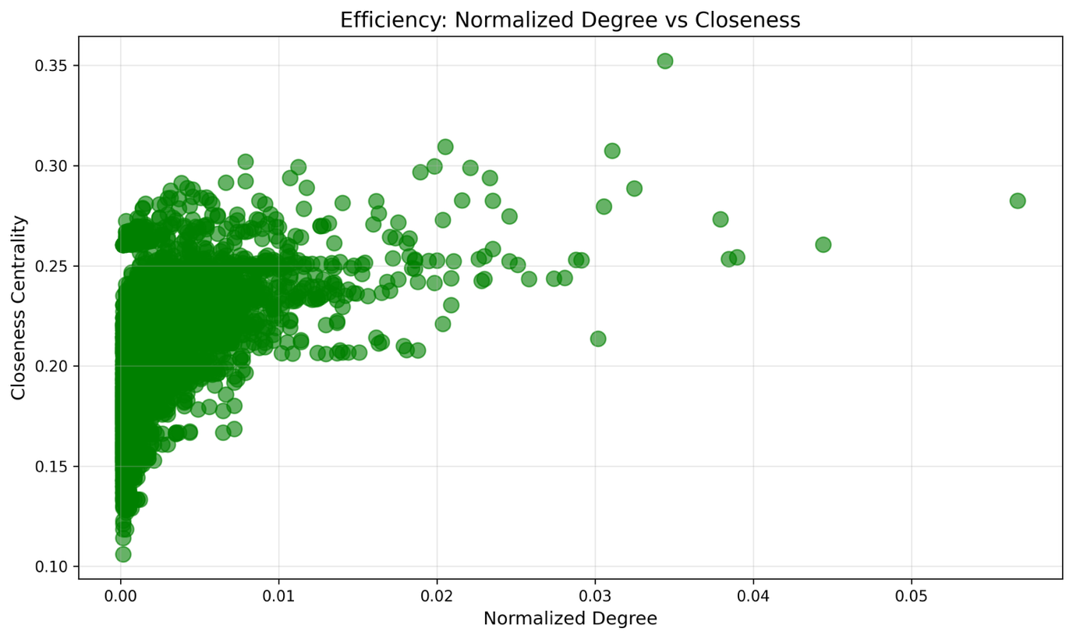

Figure 4
Ego Network Morphology
Node (Name) | Nodes/Edges | Density | Clustering | Neighbor Deg | Structure
19877 (Tanja Fajon) | 46 / 136 | 0.131 | 0.345 | 1-19 (5.0) | Mixed
6357 (Mariano Rajoy) | 65 / 205 | 0.099 | 0.232 | 1-18 (5.4) | Mixed
5448 (Hillary Clinton) | 62 / 82 | 0.043 | 0.093 | 1-4 (1.7) | Star
Structural Classifications:
Tanja Fajon (19877): Mixed structure with moderate density (0.131) and clustering (0.345). Neighbors show some interconnection, suggesting cohesive regional network. As Slovenian MEP, bridges EU parliamentary groups while maintaining ties to domestic politics.
Mariano Rajoy (6357): Mixed structure with 65 nodes and moderate clustering (0.232). Former Spanish PM connects conservative European leaders, Spanish domestic figures, and EU institutions. Larger ego network reflects broader international presence.
Hillary Clinton (5448): Classic star topology. Extremely low density (0.043) and clustering (0.093). Neighbors rarely connected to each other, average degree only 1.7. Hub-and-spoke structure ideal for chief of staff or senior advisor role: managing diverse relationships without requiring neighbor interaction.
Why Central Position Required:
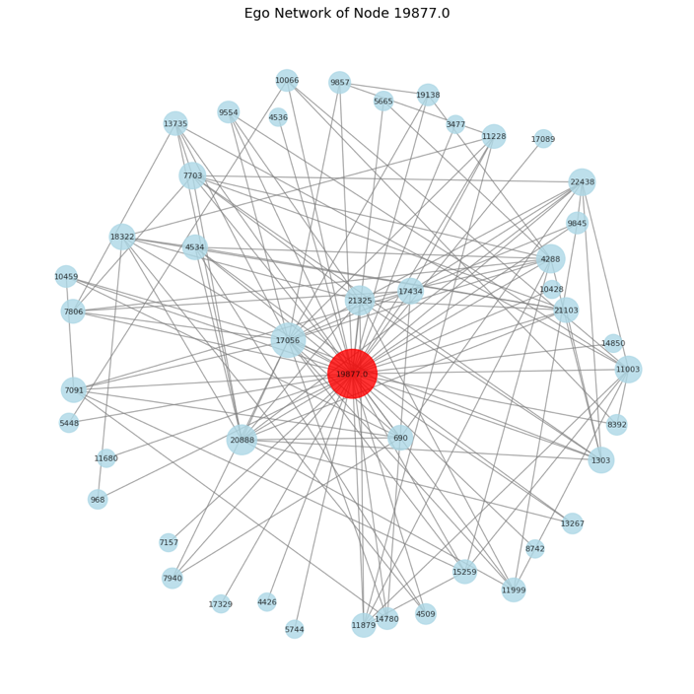
All three achieve closeness centrality above 0.29 (top 10) with normalized degree below 0.015. This efficiency enables: (1) Rapid information access across network without maintenance burden of extensive connections. (2) Strategic positioning for monitoring political landscape. (3) Oversight roles requiring broad awareness: committee chairs, party coordinators, senior advisors. (4) Jobs demanding understanding of diverse constituencies without deep embedding in single faction.

Figure 5
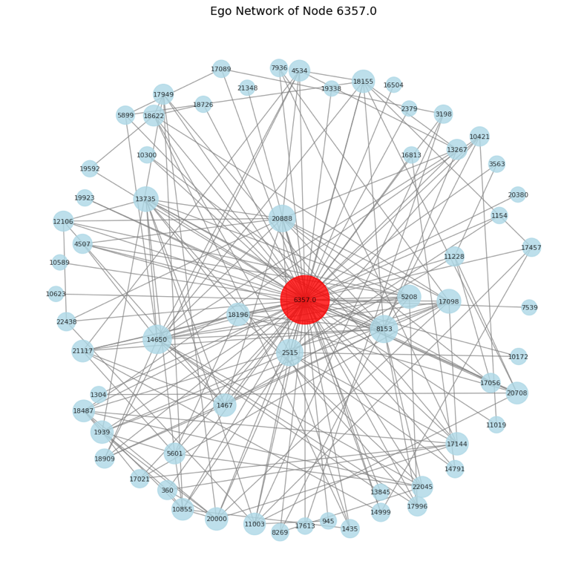
Figure 6

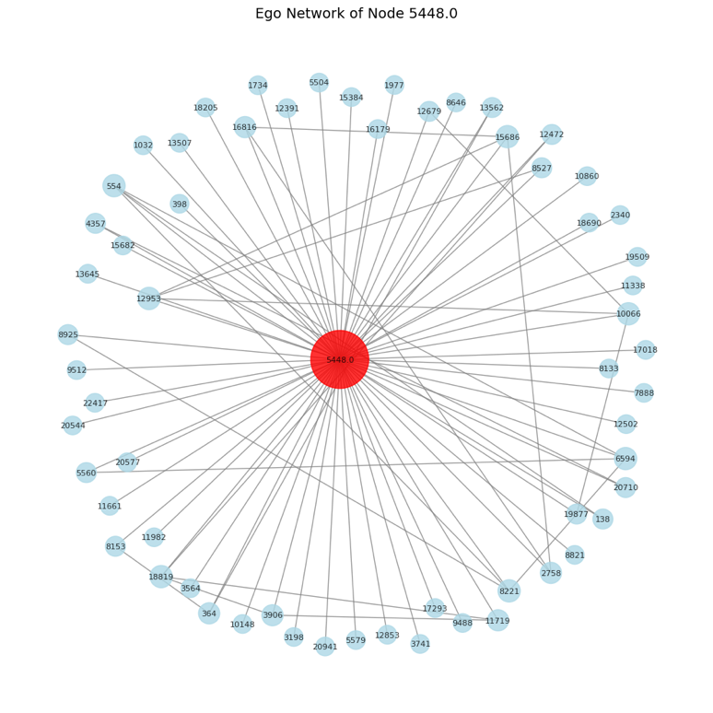

Figure 7

Part (d): Bonacich Power Dynamics
Analyzed power distribution across three regimes: neutral (β=0), supportive (β>0), and suppressive (β<0).
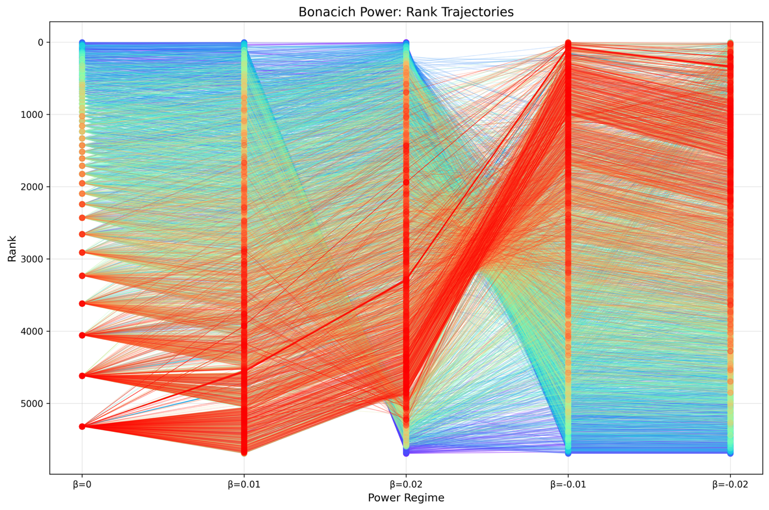

Figure 8

Power Amplifiers vs Inhibitors

Table 5
Category | Node | Rank β=0 | Rank β=0.02 | Interpretation
Amplifier | 13673 | 5320 | 1719 | Rich club member
Inhibitor | 11102 | 17 | 5695 | Peripheral hub
Power Amplifiers:
Nodes 13673, 34, 13496, 13099, 18941 jump from rank ~5320 to ~1700 under positive β. These politicians connect to high-degree hubs. In supportive regime where powerful neighbors amplify one's own power, their strategic positioning within elite circles creates exponential feedback. Represent rich club phenomenon: well-connected elites preferentially connecting to each other.
Power Inhibitors:
Node 11102 plummets from rank 17 to 5695. Node 16972 drops from 19 to 5694. These possess high individual degree but connect predominantly to low-degree periphery. In supportive regime, their power does not compound because neighbors lack influence. Represent bridge figures connecting elite core to broader population without belonging to inner circle.
Stable Actors

Table 6
Node | Rank Std | Rank Range | Avg Rank | Position | Interpretation
20412 | 1011.8 | 2355 | 2764 | Mid | Homophilous ties
12742 | 1023.2 | 2348 | 2537 | Mid | Similar neighbors
2055 | 1024.6 | 2060 | 2688 | Mid | Balanced network

Stable Actor Characteristics:
These politicians maintain consistent ranks across all power regimes (rank standard deviation ~1000-1100). All occupy mid-tier positions (average rank 2500-2850). Stability arises from homophilous connections: their neighbors have similar centrality to themselves. When β changes, both node and neighbors experience proportional power shifts, leaving relative ranking unchanged.

Network Mechanics:
Example: Node with degree 50 connecting to 50 neighbors who also have degree ~50. Under β>0, node's power amplifies but so does neighbors', maintaining relative position. Under β<0, both decrease proportionally. Contrast with amplifiers (low degree, high-degree neighbors) and inhibitors (high degree, low-degree neighbors) who experience asymmetric changes.

2.2. Question 2

Part (a): Hits vs PageRank
Hits and PageRank executed with alpha=0.85. Both converged successfully.
Table 7
Rank | HITS Auth | PageRank | Match
1 | 2398 | 4037 | ✗
2 | 4037 | 15 | ✗
9 | 15 | 2398 | △

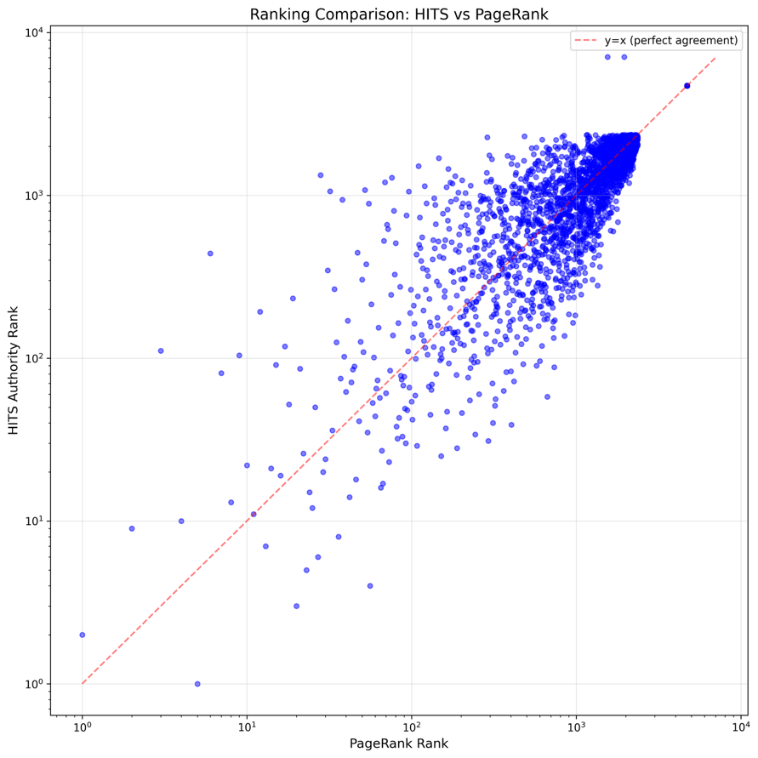
Figure 9

Mean rank difference: 107. Median: 2. Most nodes agree, significant outliers exist (max diff: 5,516).

Divergence Analysis
Identified 356 divergent nodes (top 5% rank difference).
Table 8
Node | Auth | PR | In | Out | Interpretation
7986 | 7066 | 1550 | 1 | 0 | Dead-end: PR benefits passive nodes
2185 | 2271 | 288 | 10 | 0 | Pure authority: HITS penalizes inactivity
Why Divergence Occurs:
HITS rewards quality incoming links from authorities. PageRank uses global random walk, treats all nodes equally. Dead-ends rank poorly in HITS but reasonably in PageRank.
Analysis of nodes endorsing divergent cases:
Node 7986 (1 endorser, 0 endorsing):
Single low-activity endorser. PageRank distributes baseline importance via teleportation. HITS assigns minimal authority due to weak endorser hub score.
Node 2185 (10 endorsers, 0 endorsing):
Ten endorsers with varying connectivity. PageRank: endorsers have moderate global position, transferring cumulative importance. HITS: endorsers lack high hub scores (don't endorse many other authorities), limiting mutual reinforcement.
Key difference: PageRank evaluates endorsers by global centrality. HITS requires endorsers to be active hubs. Nodes with passive endorsers rank higher in PageRank than HITS.

Part (b): Rank Stability
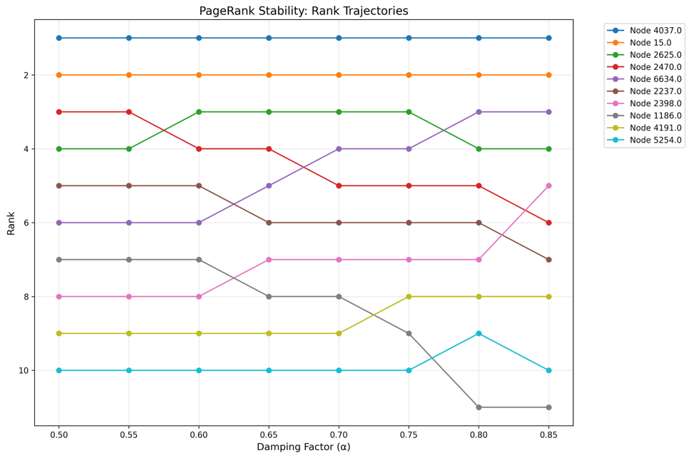
Analyzed PageRank sensitivity to damping factor α ∈ [0.50, 0.85].
Figure 10

Table 9
Node | α=0.5 | α=0.85 | Δ | Pattern
4037 | 1 | 1 | 0 | Stable: Dominant across all α
2470 | 3 | 6 | +3 | Declining: Benefits from local influence
6634 | 6 | 3 | -3 | Improving: Benefits from global structure

Interpretation:
Low α (0.50): Random surfer with high teleport probability. Emphasizes local structure. High α (0.85): Persistent surfer. Importance propagates through long paths. Stable nodes possess both local and global prominence.
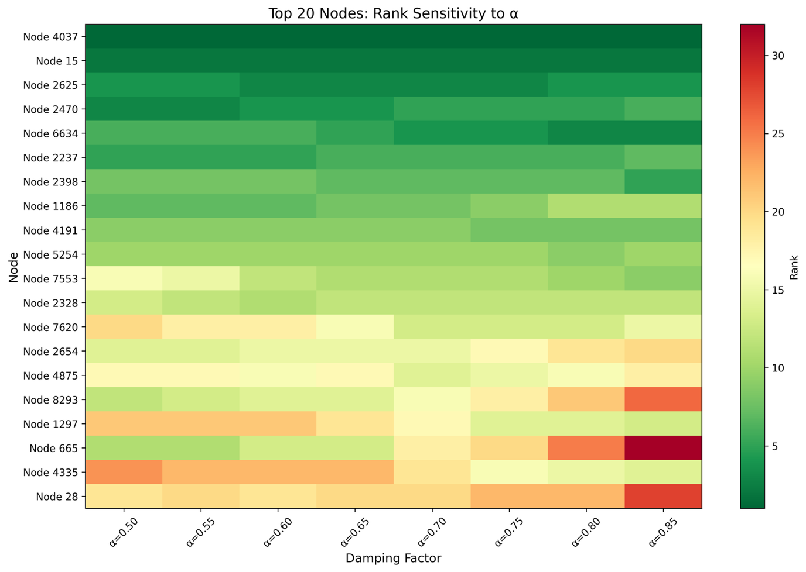
Figure 11

Node classification by influence type:
Stable nodes (4037, 15): Ranks unchanged across α values.
- Possess both local prominence (direct connections) and distributed influence (reachable through long paths)
- Random surfer reaches these nodes frequently regardless of persistence level Declining nodes (2470): Rank drops as α increases (3→6).
- Strong local neighborhood: benefits when surfer teleports frequently (low α)
- Weak distributed position: loses importance when surfer persists in following links (high α)
- Local hub without global integration Improving nodes (6634): Rank rises as α increases (6→3).
- Moderate local connections but excellent global positioning
- Embedded in authoritative subgraphs reachable through long paths
- Distributed influence: benefits from persistent surfer exploring deep link structures Random surfer interpretation:
Low α (0.50): Impatient surfer who frequently abandons paths. Rewards easily discovered nodes.
High α (0.85): Dedicated surfer following citation chains deeply. Rewards nodes in authoritative subgraphs.
Nodes with declining trajectories have local visibility but lack pathways from distant network regions. Nodes with improving trajectories are positioned in well-connected communities accessible through persistent exploration.
Conclusion
HITS and PageRank produce similar results for top nodes but diverge significantly for periphery. HITS favors pure authorities, PageRank treats all nodes more equally. Damping factor α provides tunable control: low α emphasizes local hubs, high α rewards global positioning. Top authorities remain stable across all α values, confirming consensus importance.

