Erfan Veyisi

Student ID: 210551

# Question 1:

Requirement:

The system shall support 10,000 users simultaneously without degrading performance and provide smooth operations even during the hours when the system is actively used such as during exams or live lectures.

Comment on Quality:

Completeness: The requirement is quite complete in that a performance limit is given which can be expressed in numbers poultices 10,000 end users and 10,000 end users and attempts to relate the situation to an event peak usage times. But it lacks explaining what is considered as performance and what specific system components (servers, databases) are involved.

Ambiguity: There is not much ambiguity but the term “performance degradation” can be further elaborated for example – maximum acceptable latency parameters or the error rate times high”.

Assumptions:

On the other hand, the tool assumes the VLE will experience peak usage scenarios egz. exams or live lectures.

Way the tool considers it to be applicable that 10,000 concurrent users is a good figure in the parameter space for which the entity can scale without knowledge on its size.

This runs but there is need to address lack of information with regard to what failure recovery and or redundancy mechanisms need to be put in place on the system.

1.2 Restated Requirement:

The Virtual Learning Environment system shall ensure that not less than ten thousand concurrent users will have their connections during the peak usage times defined above such as during the examination or live lecture and such honor will be able to response in no more than 2 seconds and error rate shall not exceed 1 percent.

# Question 2 :

2.1

One of the possible mandated constraint is that the system should provide feedback to the content creator if wrong credentials have been provided during the authentication process. The content creator should be able to try out the login by entering the correct username or password. This is possible through the use of features that are targeted at error detection and validation in real time.   
  
Another mandated constraint is that the content creator’s dashboard should be displayed ideally after the content creator has logged in to the account. This allows the user to have a smooth transition and improve their experience.  
  
Furthermore, if a content creator allows a course to be submitted or saved without putting an appropriate figure, they should be required to either specify the figure or modify the invalid one as a minimum before proceeding. This function ensures that there are no incomplete submissions to the platform as all requirements are met.   
  
Finally, the system shall provide the content creator with feedback on the specifics of the course review if the admin has decided not to approve of the course. Guidelines that impact the disapprovals and the reasons for the disapproval should also be included in these feedbacks in order to enhance transparency in content development and the quality of content.

2.2

1. User Interaction: The system shall permit users to login using valid credentials and has to show a personalized dashboard after logging in.  
  
2. Data Validation: The system has to check other users that will submit course material and determine if the course material that was submitted is usable before.  
  
3. Administrative Functionality: The system has to enable the administrator to examine the courses that have been submitted, the feedback towards a creator of the content commissioned material and the course and either approve or disapprove it.  
  
4. Business Rule Enforcement: The system will allow course authors to specify the price of the course, as well as allowing the course to be free, or setting limitations on who can take the course.

2.3

1. Scalability: The system should be able to manage 1000 concurrent users without any 1decrease in efficiency.

2. Security: The system must protect user information, such as passwords and files uploaded by users, so that these resources are encrypted no matter whether they are sent or stored.

3. Reliability: System uptime should be at least 99.9 percent so that users can access the system as required.

4. Performance: Course content and the dashboard of the site should not take more than 3 seconds to load in order to maximize user experience.

2.4

1.Requirement: VLE01

2.Description: Registration as content creators will allow users to create, manage, and publish courses by providing their name, contact details, and a unique creator identification number.

3.Rationale: Providing an easy and secure registration process for content creators enables a consistent flow of quality courses into the platform. This contributes to increased creator satisfaction and engagement, thereby enhancing the overall learning environment for learners.

4.Originator: System provided by the Virtual Learning Environment.

5.Fit Criterion: Creator registration forms or user interfaces should accurately capture and store creator information, including names and contact information. Upon successful registration, the creator should receive an email or notification confirming their registration. Managing and updating creator information should be possible through the system dashboard.

6.Supporting Material: Sample creator registration forms or mockups. User interface design specifications for the creator registration process.

7.Customer Satisfaction: On a scale of 1-5, 1 = uninterested, 5 = extremely pleased; the target score is 4.5 or higher.

8.Priority: High priority, as enabling seamless registration is a core component for attracting and retaining quality content creators on the platform.

2.5

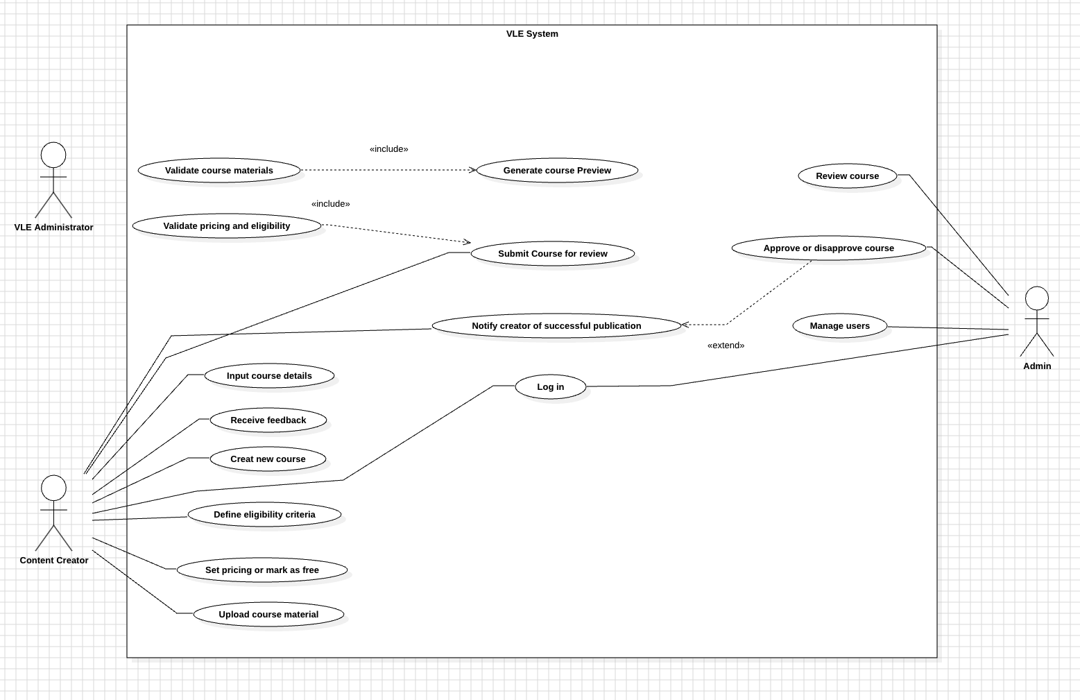

2.6

Using <<include>> allows for the clear separation of optional and conditional functionalities from the main use case. This approach improves the understanding of system operations by clearly defining when and how additional features are triggered, without disrupting the core workflow.

On the other hand, <<exclude>> is used to highlight common functionalities that are shared across multiple use cases. This enhances clarity by centralizing repeated actions, simplifying system management. It also promotes modularity, encouraging reuse, reducing redundancy, and ensuring consistent behavior across various scenarios.

Benefit of <<extend>>

1. Approve or Disapprove Course: The “Approve or Disapprove Course” use case extends the “Submit Course for Review” use case. If the course is disapproved, the system will notify the content creator with feedback for corrections. This extension adds an optional action that only occurs when the course is under review, without interrupting the primary submission workflow.

Benefit of <<include>>

1. Validate Course Materials: The “Validate Course Materials” use case includes the “Upload Course Materials” use case. This ensures that before submitting the course, the uploaded materials are verified for compatibility and platform standards. By reusing the validation process across different parts of the system, it reduces redundancy and ensures consistency in quality across all courses.

2.7

Identifier and Name: Create a new course in the VLE.

Initiator: Content Creator.

Goal: Successfully publish a course that is ready for learners to access.

Pre-Condition: The content creator must be registered and logged into the VLE system with valid credentials.

Post-Condition: The course is reviewed, approved, and published, and the creator is notified of successful publication.

Assumptions:

•The creator has prepared course materials in acceptable formats.

•The system has functional validations for materials and pricing.

Main Success Scenario:

1. The content author logs in to the Virtual Learning Environment (VLE) on the approved basis and is permitted to access the courses.  
2. The system allows the creator to log in and access the personalized dashboard that has been set for him/her.  
3. The creator selects the new course creation option.  
4. The creator is then prompted by the system to fill in the details of the course.  
5. The content creator provides the necessary materials that includes.  
6. The system examines the materials provided and makes sure they comply with the requirements of the platform and are appropriate for uploading.  
7. The creator is able to set the pricing for the course or indicate that it is free of charge and state the qualifying requirements for the learners.  
8. In the preview, the course is shown to the creator and if there is a need, changes can be made by the creator.  
9. The course, as reported by the content creator, is ready for review.  
10. This course is timely submitted to the admin team for review and subsequent quality review.  
11.Once approved, the system publishes the course, making it available to learners.  
12.The system notifies the content creator of successful publication.

Extensions:

• For Extension 1a: On the login page, when the content creator clicks “login” but types in the wrong username or password, the application must notify the user of this to enable him/her to try again.  
•For Extension 1b: When the content creator logs in, upon successful login, the application returns the user to the user’s dashboard.   
•For Extension 7a: If the content creator “saves” or submits a course without defining the price or with the wrong price, the application should prompt the content creator to enter a price before submission.  
•For Extension 11a: If the admin disapproves the course during the reviewing process, the message will send the creator of content the message that the content is disallowed and what corrections are required.

2.8(activity diagram)

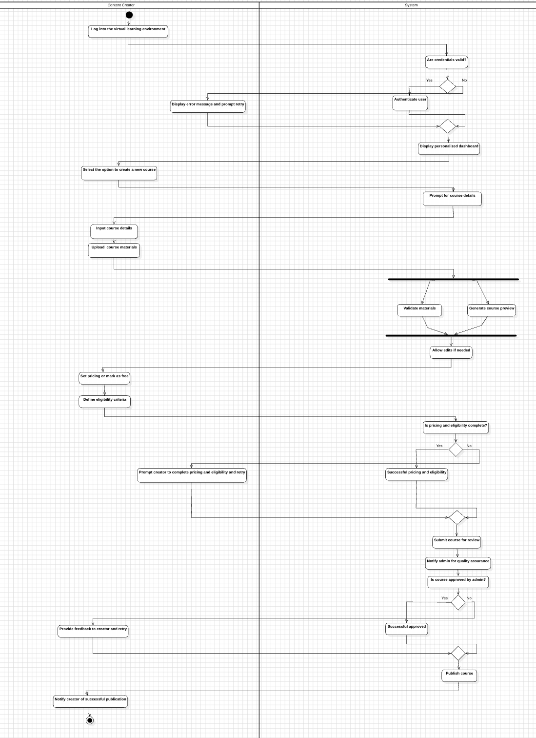

# Question 3 :

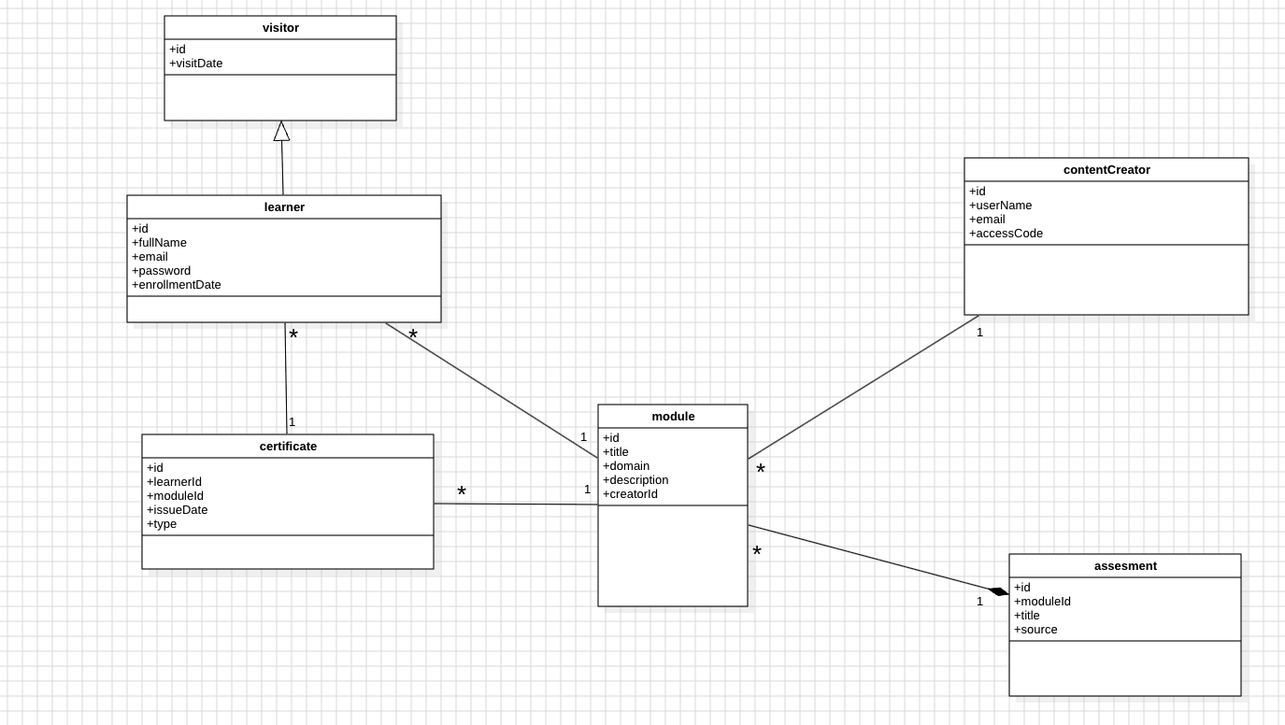

3.5 (Object diagram)

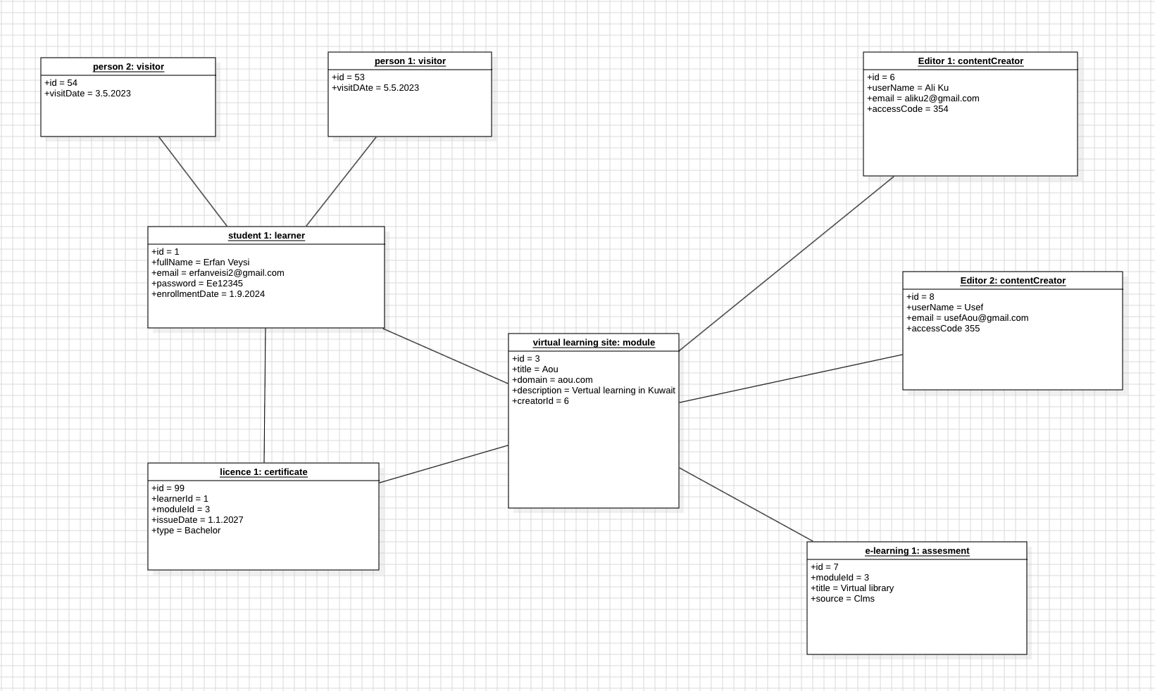

# Question 4 :

