CAP THEOREM
System Design Interview Notes
Theory • Diagrams • Trade-offs • Interview Questions • Quick Revision

Core idea: When a network partition happens in a distributed system, the system cannot guarantee both strong consistency and full availability for the affected data at the same time. It must choose how to behave.

CAP = Consistency + Availability + Partition Tolerance
During a partition: choose C or A (P is the condition you must tolerate).

Best revision rule: CAP is not “pick any two forever.” The trade-off matters specifically when a partition occurs.

1. CAP Theorem in 60 Seconds
CAP theorem describes a fundamental limitation of distributed systems that store or replicate data across multiple nodes. It says that when communication between nodes is interrupted by a network partition, the system cannot simultaneously guarantee both strong consistency and availability for the affected operations.
Interview definition: CAP theorem states that during a network partition, a distributed data system must trade off between Consistency and Availability while tolerating the partition.

C — Consistency | A — Availability | P — Partition Tolerance
Every read sees the latest successful write, or the operation fails instead of returning stale data. | Every request to a non-failing node receives a response, even if that response may not contain the newest value. | The system continues operating according to its chosen guarantees even when nodes cannot reliably communicate.
Important: The word “consistency” in CAP is about clients observing one logical, up-to-date value (commonly explained as linearizable behavior). It is not the same meaning as the “C” in ACID database transactions.

2. Why CAP Appears in Replicated Systems
Replication keeps copies of data on multiple nodes. That improves fault tolerance and can improve read scalability, but the copies must communicate to stay synchronized.
replicate updates
DB Node 1 ----------------------------> DB Node 2
x = 5 x = 5
\ /
\----------- Application -----------/
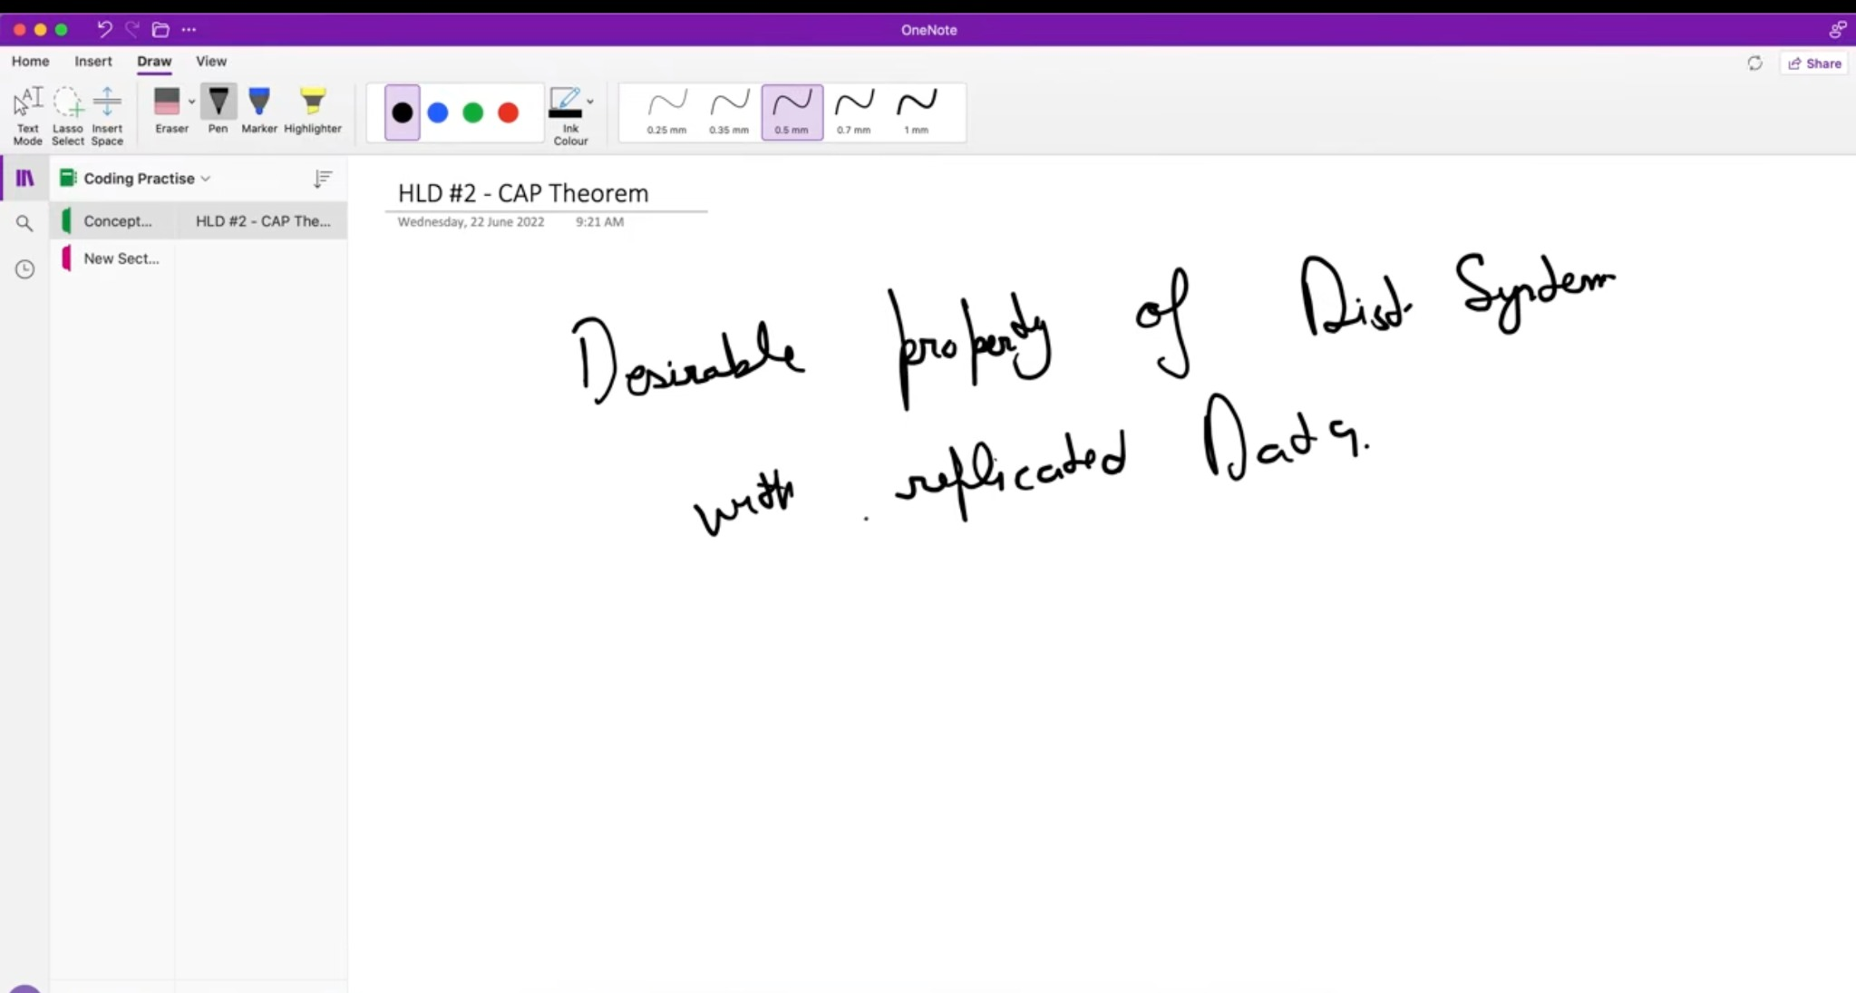
Lecture screenshot: CAP theorem as a desirable property of distributed systems with replicated data.
The problem starts when the connection between replicas fails. The nodes may still be alive, but they can no longer exchange updates or confirm which copy is newest. This failure mode is called a network partition.

3. Understanding C, A and P Properly

Consistency (C)
After a write is reported as successful, later reads should behave as if there is one single, up-to-date copy of the data. A node should not return an older value merely because it is disconnected from the node that accepted the latest write.
- Example: x = 5. A successful write changes x to 6. A consistent read should return 6, not the old 5.
- If a node cannot prove that its copy is current, a consistency-first design may reject, block, or time out the request.

Availability (A)
A request sent to a non-failing node receives a non-error response. Under a partition, an availability-first system may answer using the data it currently has rather than refusing service while waiting for unreachable replicas.
- The returned value may temporarily be stale.
- Availability in CAP is stronger and more specific than simply saying “our website has high uptime.”

Partition Tolerance (P)
A partition occurs when messages between groups of nodes are lost, delayed, or cannot be delivered even though the nodes themselves may still be running. A partition-tolerant distributed system has a defined way to continue when this communication failure happens.
- Partitions can be caused by network failures, routing problems, overloaded links, packet loss, or datacenter connectivity problems.
- In a real distributed system, you normally cannot assume partitions will never happen; therefore P is treated as a condition you must handle, not a convenient option to turn off.
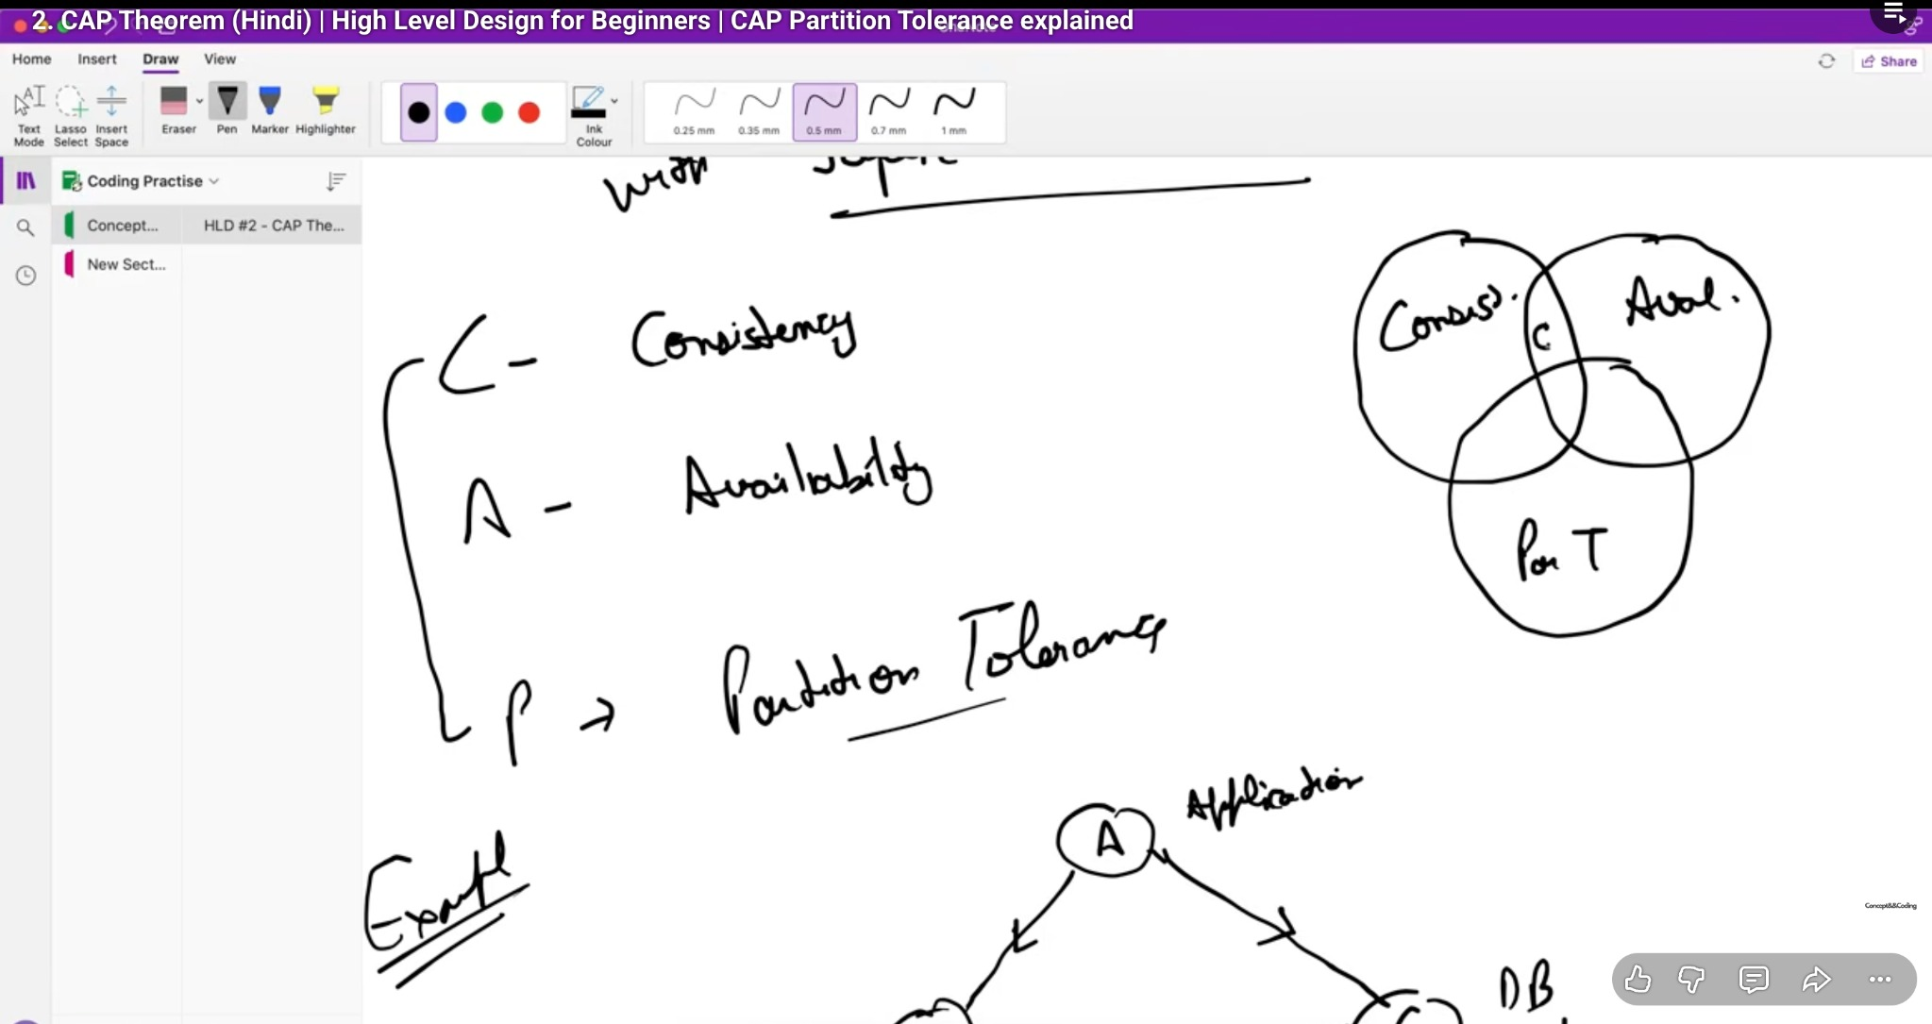
Lecture screenshot: the three CAP properties — Consistency, Availability and Partition Tolerance.

4. The Classic Two-Replica Example
Suppose an application talks to two database replicas. Initially both store the same value:
Application
| |
v v
DB Node 1 ---- DB Node 2
x = 5 x = 5
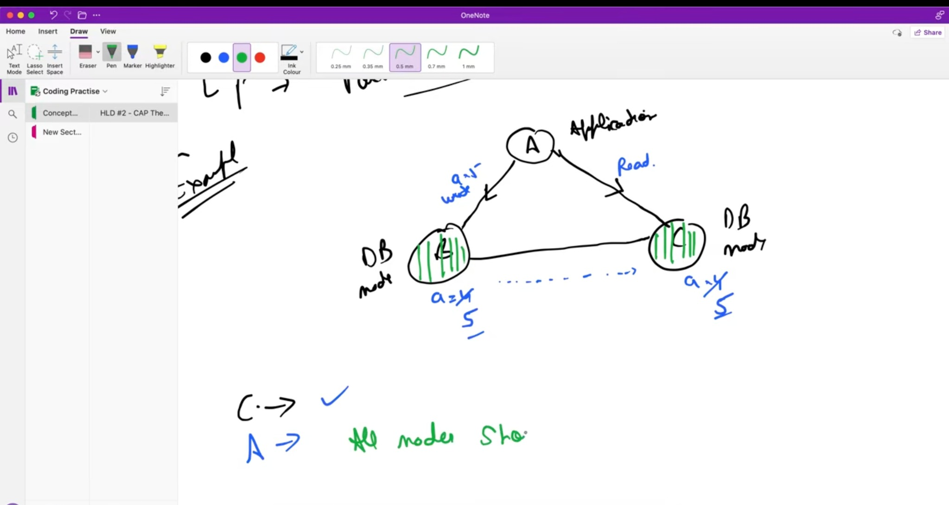
Lecture screenshot: both database nodes start with the same replicated value.
Now the network link between the two database nodes breaks. The application writes x = 6 to Node 1. Node 1 cannot send that change to Node 2, so the replicas disagree:
NETWORK PARTITION
DB Node 1 X X X X X DB Node 2
x = 6 x = 5
^ ^
| write | possible read
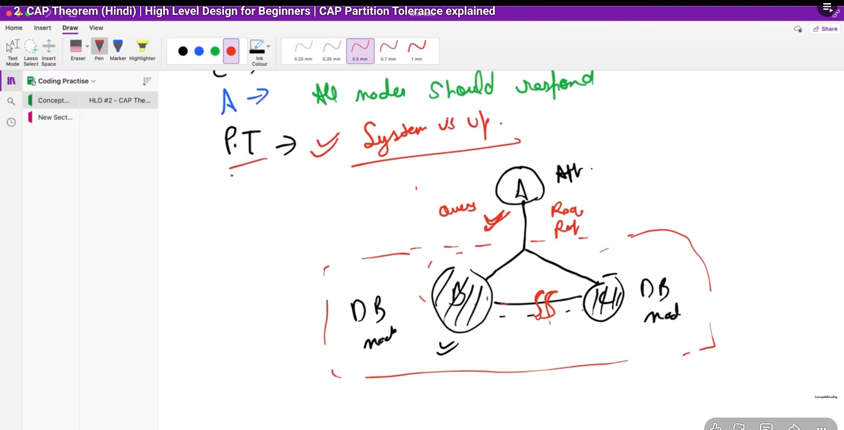
Lecture screenshot: a network partition separates the two database nodes.

Now imagine a read reaches Node 2. This is the CAP decision point:
Choice | What Node 2 does | Trade-off
CP — consistency first | Rejects, blocks, or otherwise avoids returning an unverified stale value. | Some requests become unavailable during the partition.
AP — availability first | Responds using the local copy (for example x = 5), or accepts local progress depending on the design. | Clients may temporarily observe stale or conflicting data.

5. CP, AP and the “CA” Misconception

CP — Consistency + Partition Tolerance
During a partition, the system preserves strong consistency, even if that means some requests cannot be completed until nodes can coordinate again. This is useful when returning an incorrect or stale result would be worse than temporarily refusing the operation.
- Typical concern: correctness of critical state, uniqueness, coordination, metadata, or transactions where stale decisions are dangerous.

AP — Availability + Partition Tolerance
During a partition, reachable nodes continue serving requests. Different replicas may temporarily disagree, and the system resolves or reconciles those differences later. This is often associated with eventual consistency.
- Typical concern: keeping the product responsive even during partial network failures when short-lived staleness is acceptable.

What about CA?
When there is no partition, a system can provide both consistency and availability. But “CA” is not a useful partition-time choice for a genuinely distributed system because it assumes away the failure that CAP is asking you to reason about. A single-node database can appear CA because there is no inter-node network partition to tolerate, but it loses the distributed fault-tolerance benefit.
Most important interview correction: Do not say “CAP means choose any two out of three.” A better statement is: when a partition actually occurs, you must choose how to trade off consistency versus availability for the affected operations.

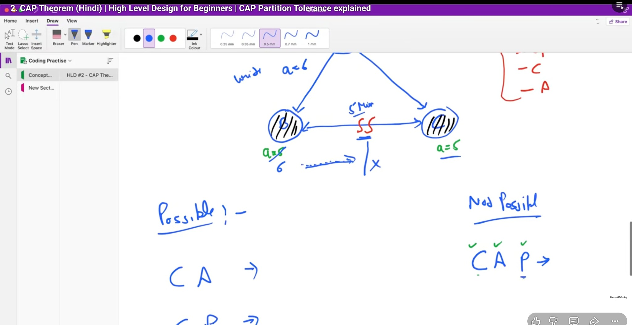
Lecture screenshot: possible combinations are discussed; in practice, the partition-time decision is CP versus AP.

6. How to Choose the Trade-off in an Interview
There is no universal “best” CAP choice. State the business requirement first, then explain which failure behavior is safer for that operation. Real systems often use different consistency levels for different data.
Example operation | Likely priority during partition | Reasoning | What may be sacrificed
Money transfer / ledger update | Consistency first | Two sides should not independently make conflicting decisions about the same funds. | Temporary availability for that operation
Username uniqueness / lock service | Consistency first | Two partitions should not both claim the same unique resource. | Some writes may fail or wait
Social feed / like count | Availability often preferred | A slightly stale count or feed is usually less harmful than the feature being completely unavailable. | Immediate consistency
Analytics / view counters | Availability often preferred | Temporary disagreement can be reconciled later. | Exact real-time value
Interview phrasing: “For the critical write path I would prefer consistency during a partition, so I am willing to reject some operations rather than risk conflicting state. For non-critical reads such as feed counts, I can relax consistency to keep the feature available.”

7. Replication, Consistency and CAP
CAP becomes easier to understand if you connect it to replication. Replicas can be updated synchronously or asynchronously, and that choice changes latency, availability and staleness behavior.
Replication style | Write behavior | Benefit | Trade-off
Synchronous | Wait for required replicas/acknowledgements before confirming the write. | Stronger freshness/correctness guarantees. | Higher latency and may reduce availability if replicas are unreachable.
Asynchronous | Confirm before all replicas receive the update. | Lower write latency and better tolerance of slow replicas. | Replication lag; readers may see older data.
Useful connection: Replication lag explains why an AP-style system may return stale data: one replica can continue serving while it has not yet received the newest update.

8. Common Interview Questions and Answers
Q. What is CAP theorem?
A. It states that when a network partition occurs in a distributed system, we cannot guarantee both strong consistency and availability for the affected data at the same time. We must decide which behavior to prioritize while tolerating the partition.
Q. What exactly is a network partition?
A. It is a communication failure where some nodes cannot reliably exchange messages with other nodes. The machines may still be running, but the network splits them into groups that cannot coordinate.
Q. Which CAP property do we normally trade off?
A. During a partition, the practical trade-off is between Consistency and Availability. Partition tolerance is not something we can safely assume away in a distributed deployment.
Q. Why can’t we have C, A and P together during a partition?
A. Because a node that cannot communicate with the rest of the system cannot simultaneously know the newest global value and always answer every request. To guarantee freshness it may need to refuse a request; to always answer it may have to use potentially stale local state.
Q. Does CAP mean choose any two out of three?
A. No. That phrase is an oversimplification. When the network is healthy, a system can often provide both consistency and availability. The hard trade-off appears when a partition occurs.
Q. What is a CP system?
A. A system that, during a partition, preserves its consistency guarantee even if some operations must be rejected, blocked, or delayed.
Q. What is an AP system?
A. A system that continues responding during a partition, accepting that replicas may temporarily disagree and that clients may see stale data until reconciliation.
Q. Is availability in CAP the same as high availability?
A. Not exactly. CAP availability means every request to a non-failing node receives a response under the model. Operational high availability is a broader engineering concept involving uptime, redundancy, failover, maintenance, and more.
Q. Is CAP consistency the same as ACID consistency?
A. No. CAP consistency refers to a single up-to-date view of distributed data, commonly explained through linearizable behavior. ACID consistency is about preserving database rules and invariants across transactions.
Q. For a banking system, would you choose CP or AP?
A. For critical operations such as changing account balances, consistency is usually prioritized because conflicting decisions can be dangerous. But a real banking platform can use different guarantees for different features, so explain the specific operation rather than labeling the entire product with one word.
Q. Can a system change between CP and AP?
A. Designs can make different choices by operation, data set, or configuration. Some distributed databases also provide tunable consistency, so the application can request stronger or weaker guarantees depending on the use case.
Q. What happens after an AP system’s partition heals?
A. Replicas exchange missing changes and reconcile conflicts. The exact method depends on the database and data model, such as versioning, timestamps, application-level conflict resolution, or quorum/merge mechanisms.

9. Common Mistakes to Avoid
- Saying “CAP means always choose exactly two properties.” The trade-off is specifically about behavior under partition.
- Treating P as optional in a distributed system. Networks can fail; the design needs defined partition behavior.
- Using “consistency” to mean relational constraints or ACID consistency. CAP uses a distributed-read/write consistency meaning.
- Calling an entire large product CP or AP without specifying the operation. Real systems often mix guarantees.
- Assuming eventual consistency means “incorrect forever.” It normally means replicas can diverge temporarily but are expected to converge when updates stop and communication recovers.

10. Bonus: PACELC (Good Follow-up Knowledge)
CAP focuses on what happens during a partition. PACELC adds a useful observation: even when there is no partition, distributed systems still make trade-offs between latency and consistency.
PACELC:
If Partition (P) -> choose Availability (A) or Consistency (C)
Else (E) -> choose Latency (L) or Consistency (C)
You do not need PACELC for every interview, but mentioning it after correctly explaining CAP can show that you understand the normal-operation trade-off as well as the failure-time trade-off.

11. 30-Second Interview Answer
Say this: “CAP theorem applies to distributed systems. C is consistency, A is availability, and P is partition tolerance. If a network partition separates replicas, we cannot guarantee both strong consistency and availability for the affected operation. A CP design may reject requests to avoid stale or conflicting data, while an AP design continues responding and accepts temporary inconsistency. The correct choice depends on the business requirement.”

12. Quick Revision Sheet
CAP | Consistency, Availability, Partition Tolerance
C | Read sees latest successful write / one logical current view
A | Non-failing node returns a response
P | System has defined behavior despite broken communication between nodes
CP | Keep consistency; some operations may be unavailable during partition
AP | Keep serving; temporary stale/conflicting data is possible
Golden line | During a partition, trade off C vs A — not “pick any two forever.”
End of CAP Theorem notes — revise the 30-second answer and the two-replica example before interviews.

