Monolithic & Microservices Architecture
Full System Design Interview Notes • Architecture • ACID • Decomposition • Databases • Communication • API Gateway • Saga
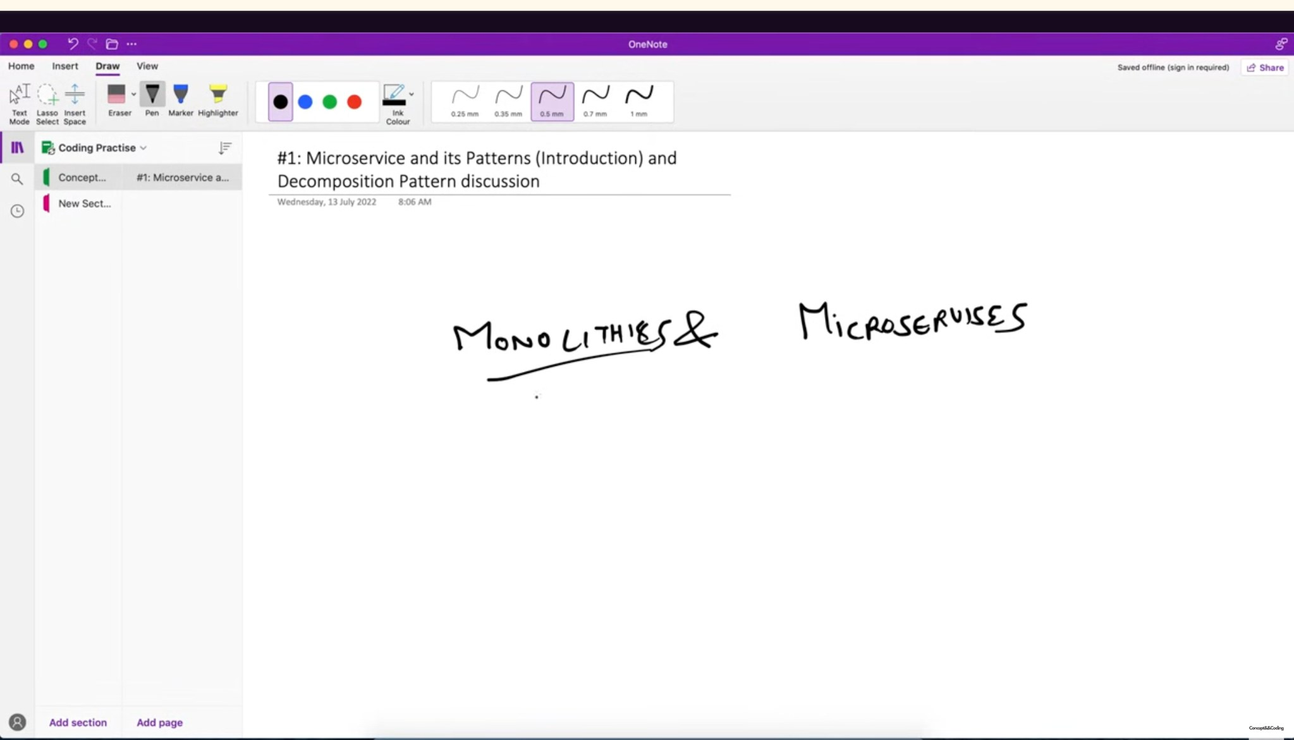
Lecture screenshot: introduction to monolithic and microservices.
Goal: Be able to explain the concepts in 30–60 seconds, draw the architecture, justify trade-offs, and handle follow-up questions.

What this document covers
Section | Interview focus
1. Monolithic architecture | Definition, structure, advantages, disadvantages, scaling, when to use
2. Microservices | Definition, characteristics, service size, pros/cons, distributed-monolith warning
3. ACID & transactions | Atomicity, Consistency, Isolation, Durability with practical example
4. Decomposition | Business capability and subdomain/DDD decomposition
5. Database patterns | Shared database vs database-per-service; ownership and trade-offs
6. Communication | Synchronous REST/gRPC vs asynchronous event/message communication
7. Integration | API Gateway and BFF for client-facing integration
8. Distributed transactions | Saga pattern; orchestration vs choreography
9. Interview Q&A | Common questions, short answers, mistakes and revision sheet

1. Monolithic Architecture
A monolithic application is built and deployed as a single application unit. The UI/API layer, business logic and data-access code live in the same deployable system. A monolith can still be well structured internally into modules; “monolith” describes the deployment boundary, not necessarily bad code.
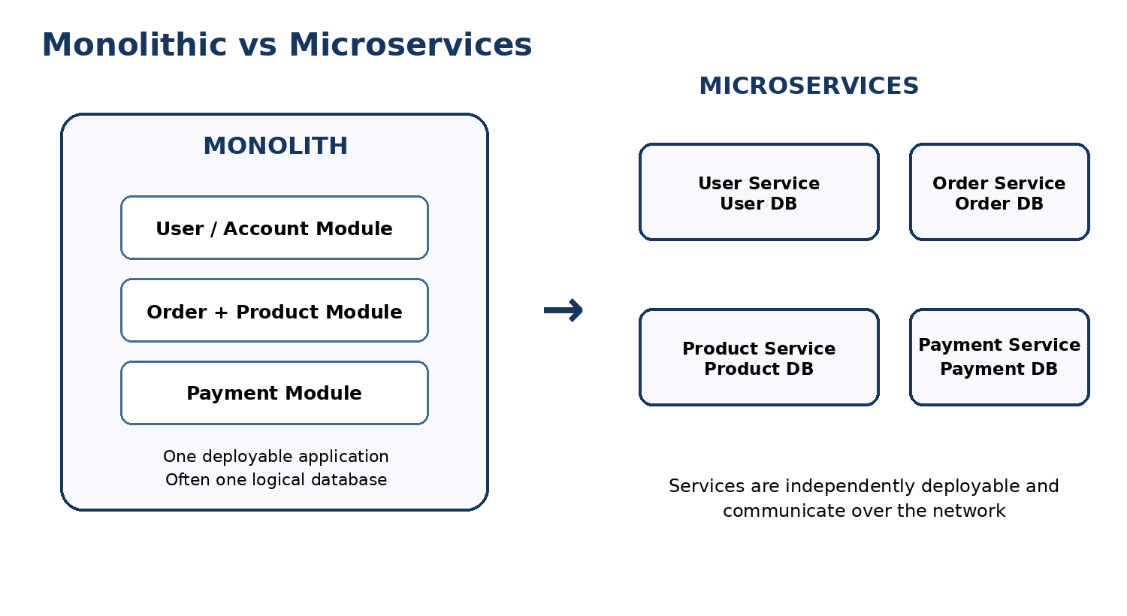
Clean architecture diagram: one deployable monolith versus independently deployable services.
Interview definition: A monolith is a single deployable application where multiple business capabilities are packaged, versioned and released together.

Typical monolith structure
- Presentation/API layer – controllers, HTTP endpoints, UI backend.
- Business/domain layer – order, product, account, payment logic.
- Data-access layer – repositories/ORM/database queries.
- Usually one deployment pipeline and commonly one logical database boundary.

Advantages of a monolith
- Simple to develop, test and deploy when the product/team is small.
- Function calls are in-process, so communication is fast and easy to debug.
- Database joins and ACID transactions are straightforward when data is in one database.
- Operational setup is simpler: fewer deployables, dashboards, service-to-service credentials and network failure modes.
- Good starting point for many products; a modular monolith can preserve clean boundaries without distributed-system complexity.

Disadvantages as the system grows
- Tight coupling can develop: a change in one area may require building and deploying the whole application.
- Independent scaling is coarse-grained. If only search is hot, you may still need to scale the whole monolith.
- A defect or resource leak can affect the entire process, so fault isolation is weaker.
- Large codebases can slow CI/CD, testing and onboarding.
- Multiple teams can interfere with one another when release cadence and ownership are shared.
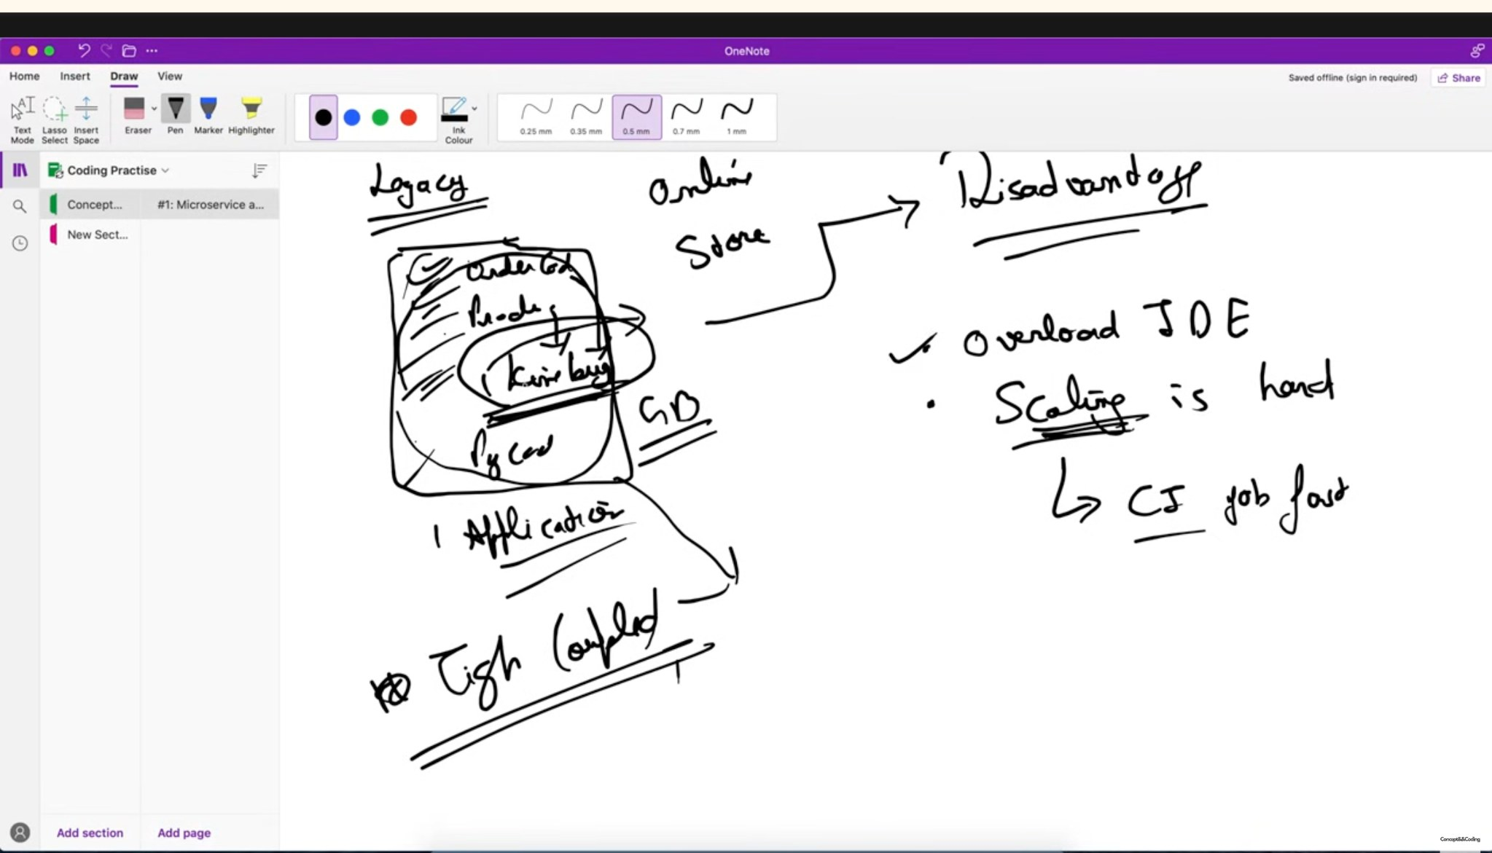
Lecture screenshot highlighting tight coupling and scaling/IDE complexity in a growing monolith.
Important correction for interviews: A monolith can scale horizontally by running multiple copies behind a load balancer. The limitation is that you normally scale the whole application, not one business capability independently.

When would you choose a monolith?
- Early-stage product with uncertain requirements.
- Small engineering team.
- Simple domain where independent service scaling is unnecessary.
- Strong transactions across many business operations are important and distribution would add more complexity than value.

Modular monolith
A modular monolith keeps one deployment but enforces clear internal module boundaries, for example Order, Payment and Catalog modules. It is often a strong intermediate design: simpler operations than microservices, but better separation than a “big ball of mud.”

2. Microservices Architecture
Microservices architecture decomposes an application into small, independently deployable services. Each service owns a specific business responsibility, exposes a contract (API/event), and can be developed, deployed and scaled with a degree of independence from other services.
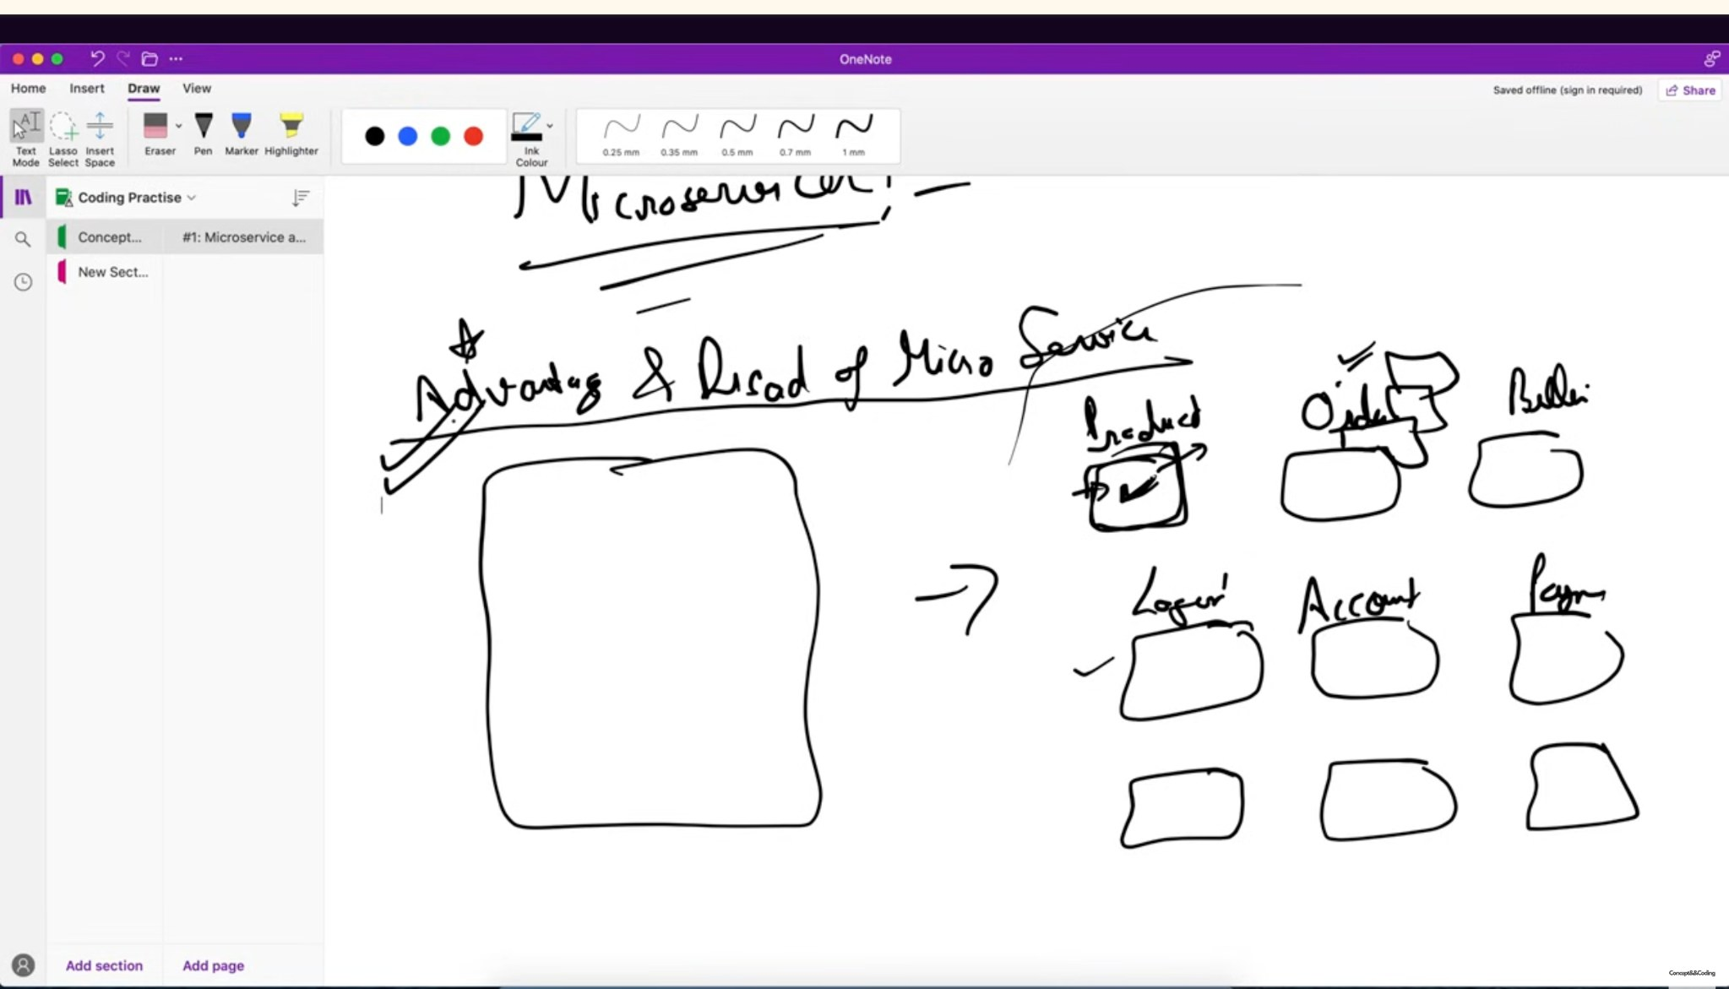
Lecture screenshot: moving from one application to multiple business-focused services.

Core characteristics
- Business-aligned: each service represents a capability or bounded context.
- Independent deployment: changing one service should not require redeploying the whole system.
- Explicit communication: services interact through APIs, RPC or events rather than direct in-process calls.
- Data ownership: ideally a service owns its data and other services access it through the owner’s contract.
- Independent scaling: high-traffic services can scale separately.
- Failure is expected: timeouts, retries, circuit breakers, idempotency and observability become important.

Advantages
- Independent deployments and team ownership.
- Fine-grained scaling: scale only the service that needs more capacity.
- Better fault isolation when boundaries and resilience are designed properly.
- Technology flexibility where justified (polyglot persistence or different runtimes).
- Smaller codebases per service can reduce cognitive load for individual teams.

Disadvantages / costs
- Network calls introduce latency and partial failures.
- Distributed transactions are difficult; eventual consistency is common.
- Operational complexity: discovery, configuration, deployment, logging, tracing, security and monitoring across many services.
- Data can be duplicated across services and cross-service queries are harder.
- Too many tiny services produce chatty networks, increased cost and a “distributed monolith.”

How micro should a microservice be?
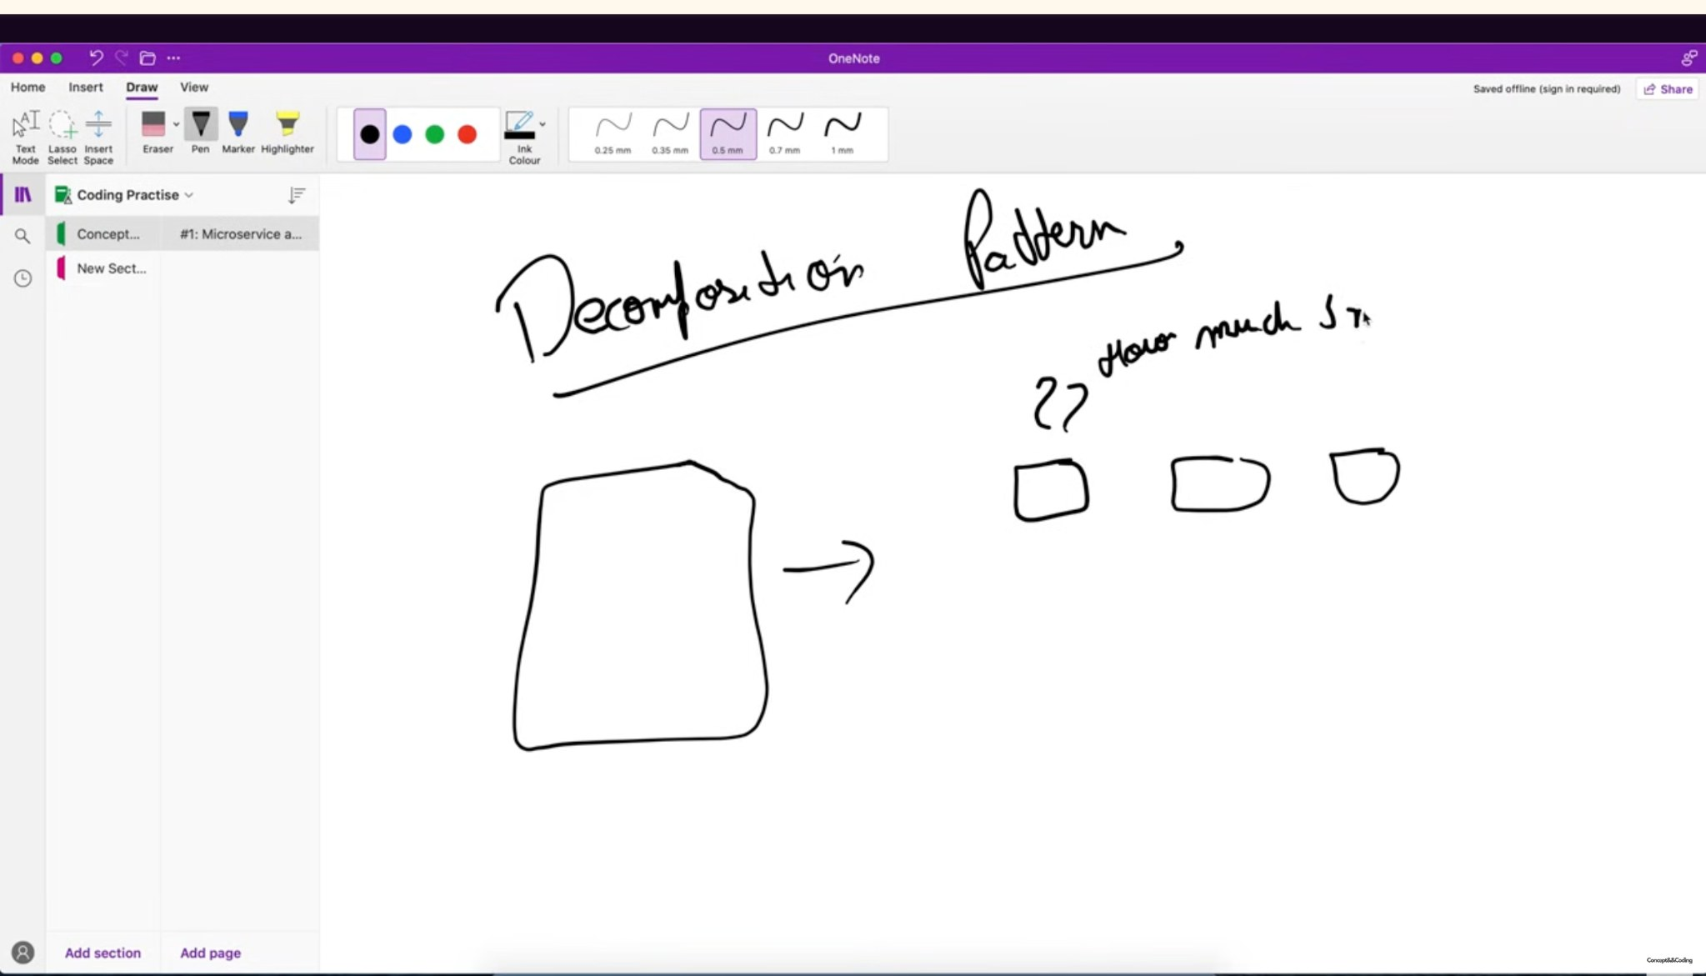
Lecture screenshot: “How much small?” — service size should follow a meaningful boundary, not an arbitrary line count.
Best interview answer: There is no fixed number of lines, endpoints or tables. A service should be small enough to own one cohesive business capability or bounded context and be independently deployable, but large enough to avoid excessive chatty calls and coordination.

- Too large: unrelated changes/releases are coupled and the service scales as one big unit.
- Too small: one user request fans out across many services; latency and operational overhead increase.
- A useful heuristic is team ownership + business boundary + independent lifecycle, not “one function = one service.”

Distributed monolith warning
If services must always be deployed together, share one schema directly, make many synchronous calls in a chain, or cannot evolve their contracts independently, you may have a distributed monolith: the complexity of microservices without the autonomy benefits.

3. ACID Properties and Transaction Management
ACID describes desirable properties of database transactions, especially in relational databases. A transaction groups one or more database operations into a logical unit of work.
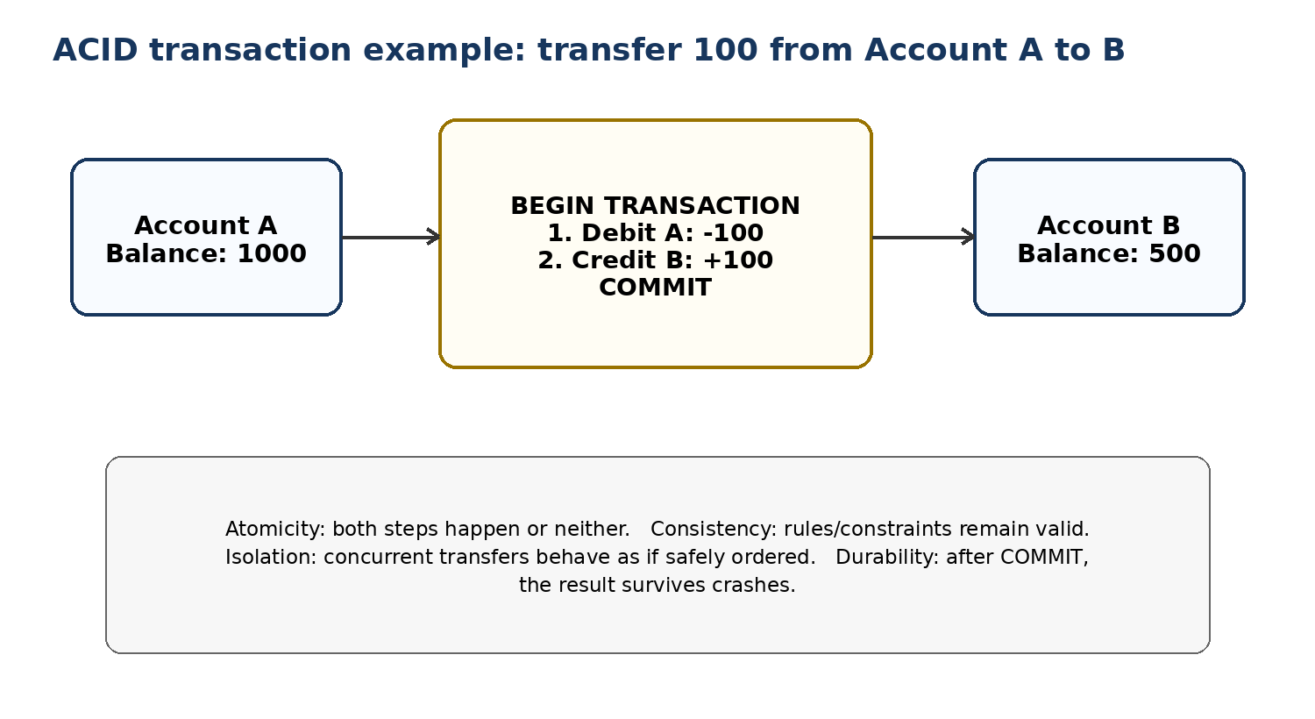
ACID example: bank transfer within one transactional database.
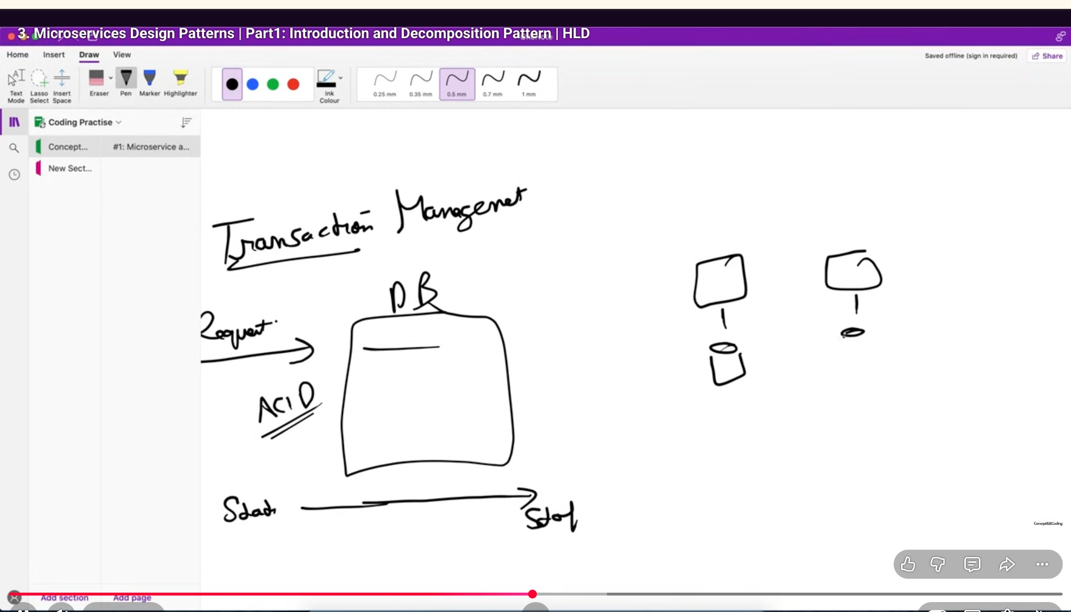
Lecture screenshot: transaction management and ACID in a single database.
Property | Meaning | Bank transfer example
Atomicity | All operations in the transaction succeed, or all are rolled back. | Debit A and credit B must happen together. If credit fails, undo the debit.
Consistency | A committed transaction preserves defined database rules/constraints. | Balances, foreign keys and invariants remain valid after commit.
Isolation | Concurrent transactions do not corrupt each other; result behaves according to the chosen isolation level. | Two simultaneous transfers should not create lost updates or invalid intermediate reads.
Durability | Once committed, data survives process/system failures according to the database durability guarantees. | After COMMIT, the new balances remain even if the DB process crashes.
Common confusion: ACID “Consistency” means database invariants/constraints across a transaction. It is not the same concept as “Consistency” in CAP theorem.

Practical SQL-style flow
BEGIN TRANSACTION;
UPDATE accounts SET balance = balance - 100 WHERE id = A;
UPDATE accounts SET balance = balance + 100 WHERE id = B;
COMMIT; -- or ROLLBACK if a step fails

Why transactions become harder in microservices
In a monolith with one database, a transaction manager can often commit or roll back all related writes together. In microservices, Order, Payment and Inventory may use separate databases. One local ACID transaction cannot automatically roll back writes in other services. This is where Saga, idempotency, outbox/event patterns and eventual consistency become relevant.

4. Decomposition Patterns: How to Split a Monolith
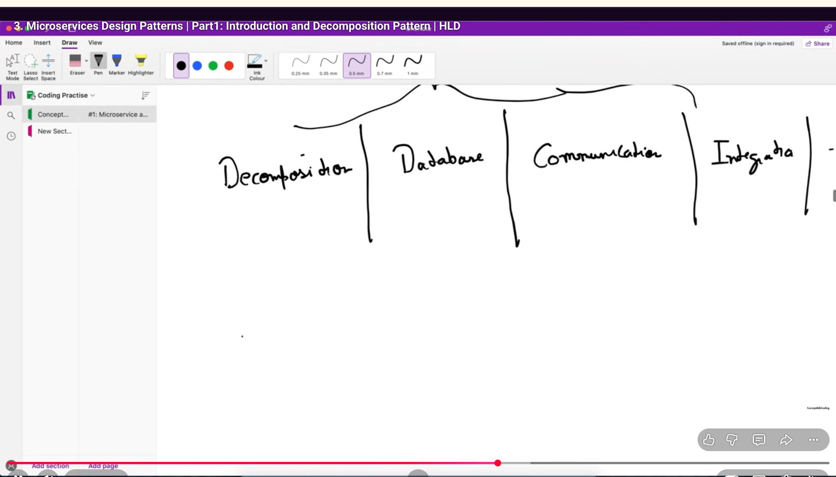
Lecture screenshot: key microservice pattern families — decomposition, database, communication and integration.
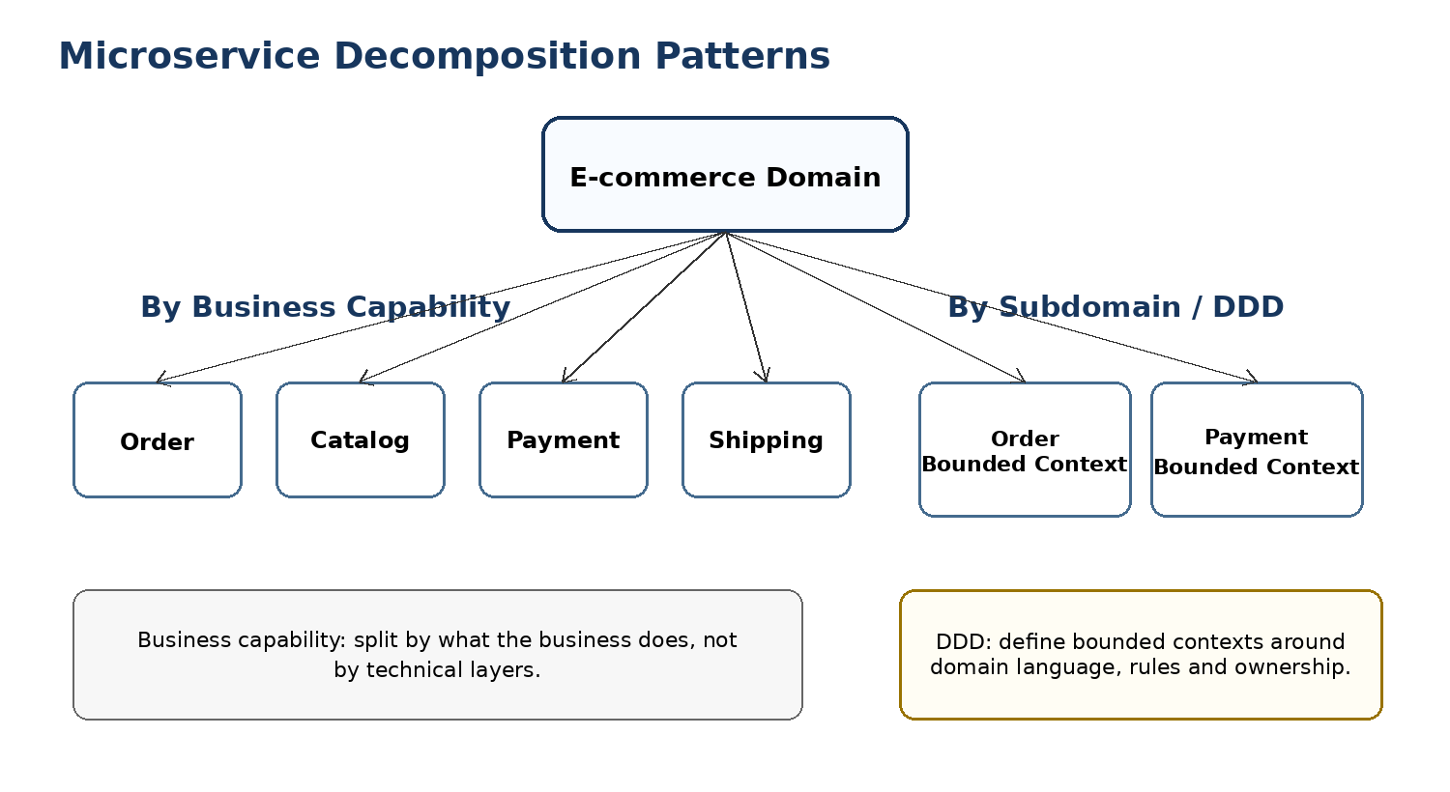
Two key decomposition approaches used in interviews.

A. Decompose by Business Capability
A business capability describes what the business does. Services are organized around capabilities such as Order Management, Catalog, Payment, Shipping, Account Management or Customer Support.
- Good boundary: service contains the business rules and data needed for that capability.
- Avoid decomposition by technical layer such as “Controller Service”, “Database Service” or “Utility Service”.
- Capabilities often map well to team ownership and independent release cycles.
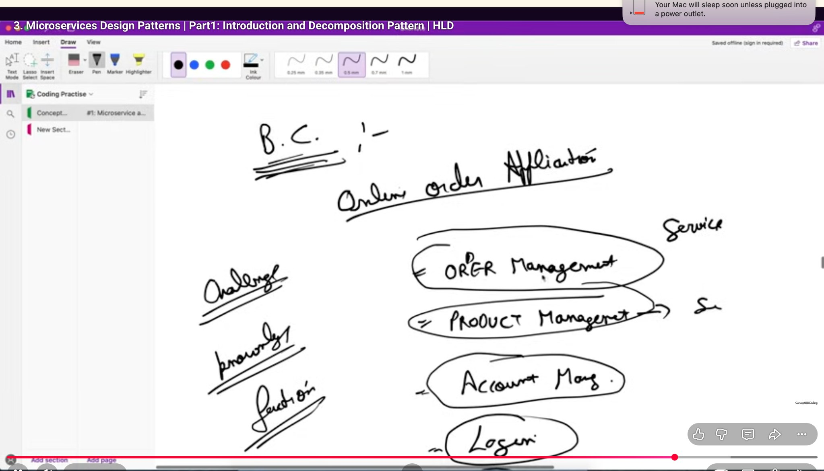
Lecture screenshot: online order application broken into business capabilities such as order, product, account and login.
Capability | Possible service responsibility
Order Management | Create/cancel orders, order lifecycle, order status
Catalog / Product | Product metadata, price display, searchable catalog
Payment | Authorize/capture/refund payments
Account / Identity | Customer profile, authentication/authorization
Shipping | Shipment creation, tracking and delivery status

B. Decompose by Subdomain (DDD)
Domain-Driven Design (DDD) splits a complex business domain into subdomains and bounded contexts. A bounded context has its own domain model and vocabulary. Microservice boundaries can align to these bounded contexts.
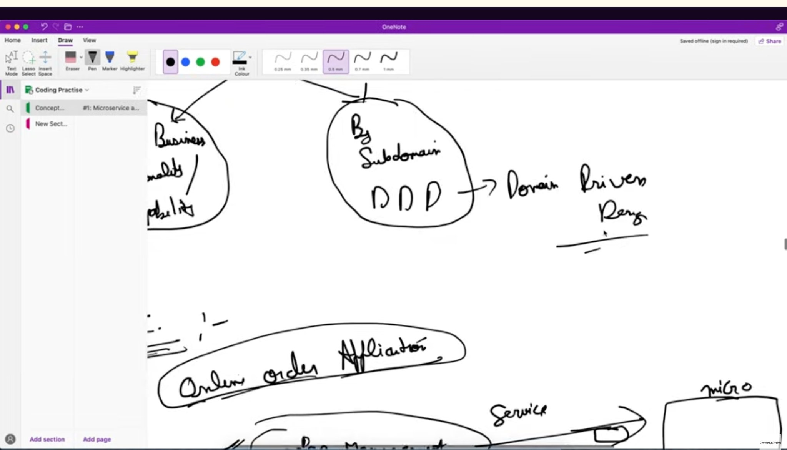
Lecture screenshot: decomposition by subdomain / Domain-Driven Design.
- Core subdomain: gives the business competitive value and needs the most domain attention.
- Supporting subdomain: necessary to support the core business but usually not the differentiator.
- Generic subdomain: common capability that may be bought or reused, e.g. identity/email in some systems.
- Bounded context prevents one “universal” model from becoming tightly coupled across the entire company.
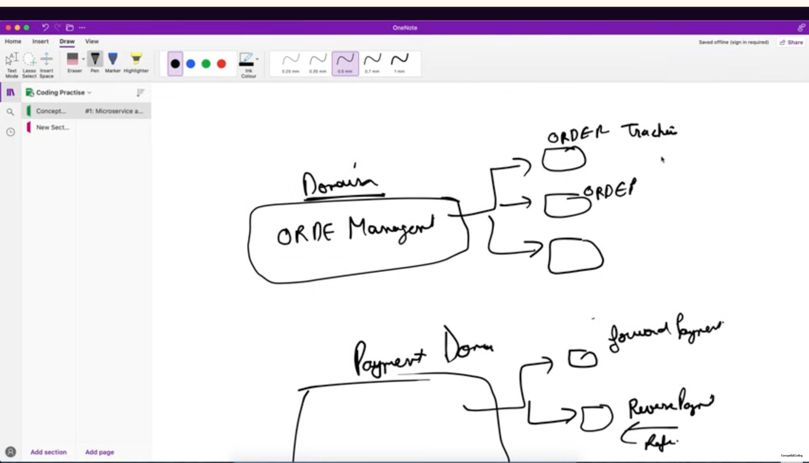
Lecture screenshot: domains can be further refined (e.g., order management and payment sub-capabilities).
Interview rule: Start with business/domain boundaries. A microservice should normally own a cohesive capability and its rules, not be split merely because a class or table exists.

5. Database Patterns in Microservices
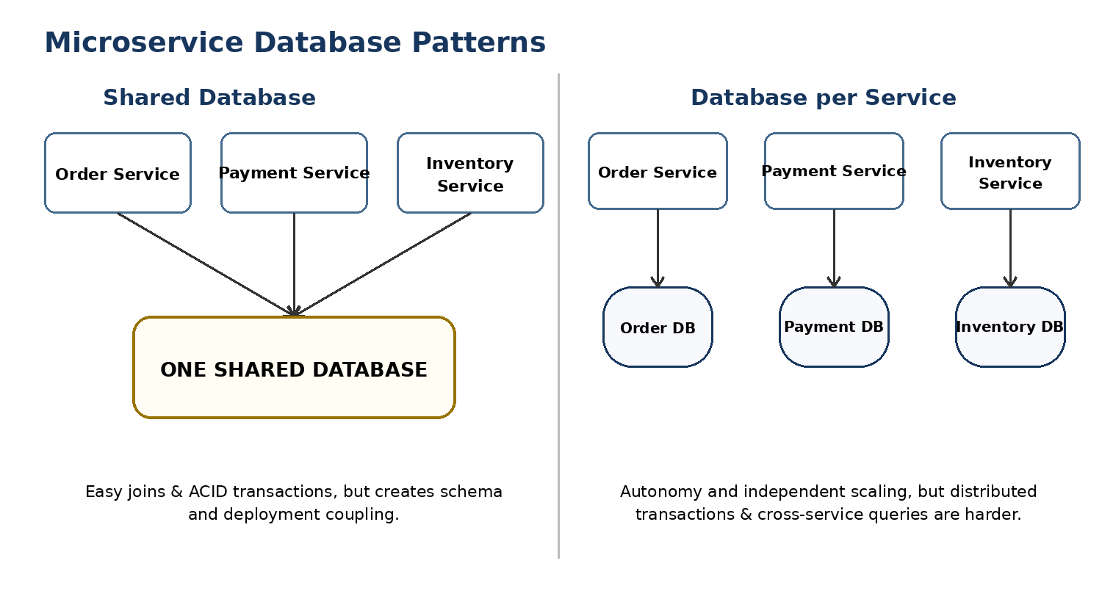
Shared database versus database-per-service.

Pattern 1: Shared Database
Multiple services access the same database. They may use separate tables/schemas or even shared tables.
- Advantages: simple cross-domain joins, easier ACID transactions, fewer database instances to operate.
- Disadvantages: schema coupling, weak service autonomy, one service can accidentally affect another’s data, independent deployment becomes harder, shared database can become a bottleneck/failure domain.
Good interview nuance: A shared database may be acceptable during migration from a monolith or for a small system, but it reduces the independence that microservices are meant to provide.

Pattern 2: Database per Service
Each service owns its persistent data. Other services do not directly query its tables; they use the service API or consume its events.
- Advantages: loose coupling, independent schema evolution, independent scaling and technology choice.
- Disadvantages: cross-service joins are unavailable directly, data may be duplicated, transactions span multiple services, consistency may be eventual.

How do cross-service queries work?
- API composition: an aggregator calls multiple services and combines the result.
- Materialized/read model: consume events and build a query-optimized view (common with CQRS).
- Data duplication: replicate the small subset of data a service needs, updated through events.

Polyglot persistence
With database-per-service, different services can use different storage types when justified: relational DB for payments/orders, key-value cache for sessions, document store for flexible catalog metadata, search engine for full-text search. Use this flexibility carefully because every extra technology increases operations and expertise requirements.

6. Service Communication Patterns
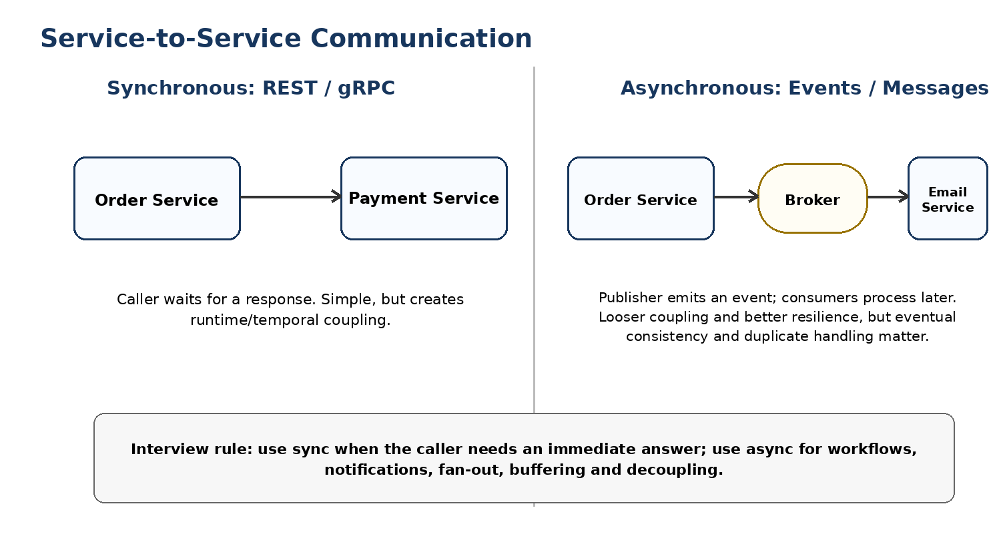
Synchronous request/response versus asynchronous event/message communication.

Synchronous communication
The caller sends a request and waits for a response. Common technologies are HTTP/REST and gRPC.
- Best when the caller needs an immediate result, e.g. “is this coupon valid?”
- Simple mental model and straightforward error reporting.
- Trade-offs: caller and callee must be available at the same time; long service-call chains increase latency and can cause cascading failures.
- Use timeouts, retries with backoff (only when safe), circuit breakers and idempotent operations.
Order Service --REST/gRPC--> Payment Service --> response

Asynchronous communication
A producer publishes an event/message to a broker; one or more consumers process it independently. Examples include Kafka, RabbitMQ, AWS SQS/SNS and cloud pub/sub systems.
- Useful for notifications, fan-out, workflow steps, buffering traffic spikes and decoupling producers from consumers.
- Improves temporal decoupling: consumer can recover and process later.
- Trade-offs: eventual consistency, duplicate delivery, message ordering, schema evolution and observability are harder.
- Consumers should be idempotent because at-least-once delivery can cause the same message to be processed more than once.
Order Service --OrderCreated event--> Broker --> Inventory / Email / Analytics

Command vs Event
Type | Meaning | Example
Command | Tells a specific receiver to do something. | ReserveInventory(orderId)
Event | States that something already happened; zero or many consumers may react. | OrderCreated(orderId)
Interview decision: Prefer a direct API call when the caller must know the result now. Prefer events/messages when you want loose coupling, fan-out, buffering or background processing.

7. Integration Pattern: API Gateway and BFF
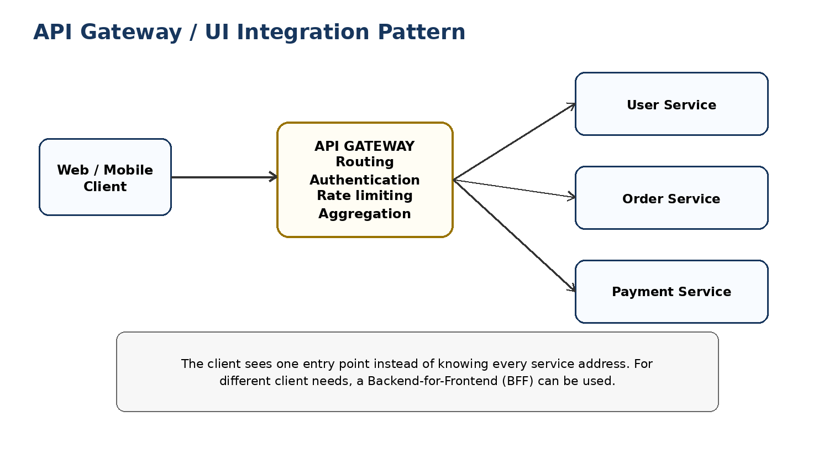
API Gateway provides one client-facing entry point and routes to internal services.

What an API Gateway does
- Routes /orders to Order Service, /users to User Service, etc.
- Authentication and authorization enforcement.
- Rate limiting / quotas.
- TLS termination and request validation.
- Response aggregation for simple client use cases.
- Logging, metrics and correlation IDs.
- Can hide internal service topology and reduce direct client-to-service coupling.

API Gateway trade-offs
- Pros: centralized cross-cutting concerns; simpler clients; controlled external surface.
- Cons: can become a bottleneck or “god gateway” if too much business logic is placed inside it; requires high availability.

Backend for Frontend (BFF)
A BFF is a gateway/aggregation backend tailored to a client type, such as Web BFF and Mobile BFF. It is useful when mobile and web need different payloads/workflows. Keep core business logic in domain services rather than duplicating it in each BFF.

8. Distributed Transactions and the Saga Pattern
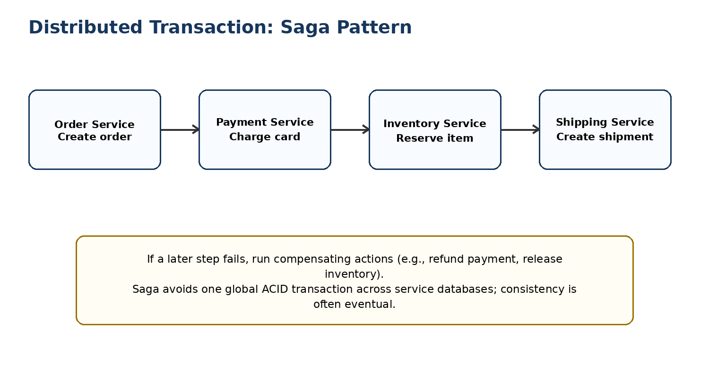
Saga: a sequence of local transactions with compensation on failure.

Why not one ACID transaction across all services?
Each service may own a separate database and fail independently. Holding a global lock/transaction across network boundaries is expensive and reduces availability. Microservice designs therefore often accept eventual consistency and coordinate a sequence of local transactions.

Saga styles
Style | How it works | Trade-off
Choreography | Services publish events and other services react. No central coordinator. | Loose coupling, but workflow can become hard to understand as it grows.
Orchestration | A Saga orchestrator explicitly tells services which step to execute and tracks progress. | Clear workflow and control, but coordinator is additional component/logic.

Example: place order
- Order Service creates order in PENDING state.
- Payment Service charges customer.
- Inventory Service reserves items.
- Shipping Service prepares shipment.
- If inventory fails after payment, compensate by refunding payment and marking the order failed/cancelled.
Interview concept: A compensating transaction is a business action that logically reverses an earlier successful step. It is not always a byte-for-byte rollback.

Reliability patterns commonly paired with events
- Transactional Outbox: write the business change and an outbox record in the same local DB transaction, then publish the event from the outbox.
- Idempotency key / deduplication: makes retries and duplicate messages safe.
- Dead-letter queue: isolate messages that repeatedly fail.
- Correlation/trace ID: follow one user request across many services.

9. Monolith vs Microservices — Interview Comparison
Area | Monolith | Microservices
Deployment | One main deployable unit | Many independently deployable services
Communication | Mostly in-process calls | Network APIs/events
Scaling | Scale application as a whole | Scale services independently
Transactions | Straightforward local ACID | Often local ACID + Saga/eventual consistency
Data | Often shared database/model | Prefer service-owned data
Fault isolation | Failure can affect whole process | Better potential isolation, but cascading network failures must be controlled
Development speed | Often faster for small team/product | Can improve team autonomy at scale
Operations | Simpler | More complex: discovery, tracing, deployment, security, observability
Best fit | Small/medium system, small team, early product | Large/complex domains, many teams, independent scaling/release needs
Do not say: “Microservices are always better.” A good system-design answer explains why the extra distributed-system complexity is justified for the stated scale, team structure and domain.

Example interview evolution path
- Start with a modular monolith when requirements/team are small.
- Measure bottlenecks and identify stable business boundaries.
- Extract a service only when independent deployment, ownership, scaling or isolation provides clear value.
- Move data ownership gradually; use events/APIs during migration.
- Avoid a big-bang rewrite unless there is a strong reason.

10. Common Interview Questions and Strong Answers
Q: What is a monolithic architecture?
A: A single deployable application containing multiple business capabilities. It is simple operationally and supports easy local transactions, but as it grows, deployment, scaling and team ownership can become coupled.
Q: What is a microservice?
A: An independently deployable service aligned to a cohesive business capability or bounded context, with explicit APIs/events and preferably clear ownership of its data.
Q: Why not use microservices for every project?
A: They add network failures, distributed transactions, observability, security and deployment complexity. For a small team or simple domain, a modular monolith is often easier and faster.
Q: How do you decide service boundaries?
A: Start with business capabilities or DDD bounded contexts. Look for cohesive rules/data, independent change rates, clear team ownership and minimal chatty coupling.
Q: How small should a microservice be?
A: There is no line-count rule. It should be cohesive and independently deployable. If services constantly call one another or must be deployed together, they are probably too small or boundaries are wrong.
Q: Shared DB or database per service?
A: Database-per-service gives stronger autonomy and independent evolution, but makes transactions and queries harder. Shared DB is simpler initially but couples schemas and services. The right choice depends on migration stage and autonomy needs.
Q: REST/gRPC vs events?
A: Use synchronous calls when an immediate answer is required. Use asynchronous events/messages for loose coupling, fan-out, background work and traffic buffering, accepting eventual consistency and more complex failure handling.
Q: What is API Gateway?
A: A client-facing entry point that routes requests to services and often handles authentication, rate limiting, TLS, observability and sometimes aggregation. Keep core business logic out of the gateway.
Q: How do transactions work across microservices?
A: Each service commits a local ACID transaction. Multi-service workflows are often coordinated with a Saga and compensating actions, plus idempotency/outbox patterns for reliability.
Q: What is a distributed monolith?
A: A system split into multiple deployables that still have tight runtime, data or deployment coupling. It has microservice operational cost without genuine independence.
Q: Can a monolith scale?
A: Yes. It can run multiple instances behind a load balancer. The key difference is scaling granularity: you typically scale the entire application rather than one service independently.
Q: What is the difference between ACID consistency and CAP consistency?
A: ACID consistency means a database transaction preserves defined invariants and constraints. CAP consistency is about clients observing a single up-to-date view across distributed replicas during network partitions.

Scenario follow-up: Design an e-commerce backend
A strong interview answer might identify User, Catalog, Order, Payment and Inventory boundaries. The client enters through an API Gateway. Order calls Payment synchronously if it needs immediate authorization, while OrderCreated can be published asynchronously for email/analytics. Each service owns its database. The checkout workflow uses a Saga if Order, Payment and Inventory must coordinate without a global transaction.

11. 60-Second Revision Sheet
Monolith: One deployable app. Easy local calls/transactions. Simple operations. Whole-app scaling and releases can become coupled.
Microservices: Business-focused independently deployable services. Independent scaling/ownership, but network and operational complexity.
Service size: No fixed size. Use cohesive business capability / bounded context. Avoid nano-services and distributed monoliths.
ACID: Atomicity, Consistency, Isolation, Durability. Strongly useful for local DB transactions.
Decomposition: By business capability or by DDD subdomain/bounded context.
Databases: Shared DB = easier transactions but coupling. DB-per-service = autonomy but distributed transaction/query complexity.
Sync comms: REST/gRPC. Immediate response; risk of latency and cascading failures.
Async comms: Events/messages. Decoupling/fan-out; eventual consistency, duplicates and ordering must be handled.
API Gateway: One external entry point for routing, auth, rate limits and simple aggregation.
Saga: Sequence of local transactions; compensate if later step fails. Choreography or orchestration.
30-second answer: “I would start by choosing clear business boundaries. For a small product I may keep a modular monolith because deployment and ACID transactions are simpler. At larger scale, I can extract independently deployable services around bounded contexts. Each service should own its data; communication can be synchronous for immediate responses or asynchronous for decoupled workflows. Client access can go through an API Gateway, and cross-service transactions are usually handled with Saga/compensation rather than one global transaction.”

12. Lecture Screenshots Used for Revision
These screenshots are included as visual memory aids; the typed notes above are the cleaned, interview-ready explanation.
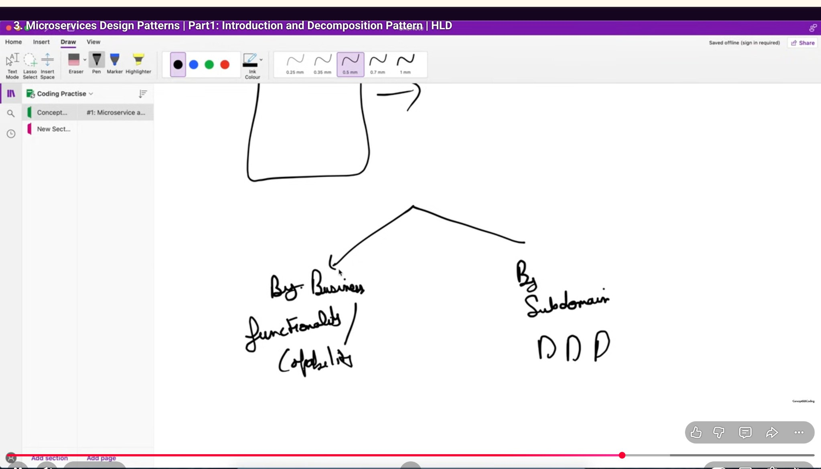
Decomposition types: business capability and subdomain/DDD.
Pattern families: decomposition, database, communication and integration.
Order/payment domain refinement example.

