SAGA, STRANGLER & CQRS
Microservices Data & Transaction Patterns
Interview Notes — local ACID, database-per-service, distributed transactions, Saga types, ₹10 transfer example, Strangler migration, and CQRS

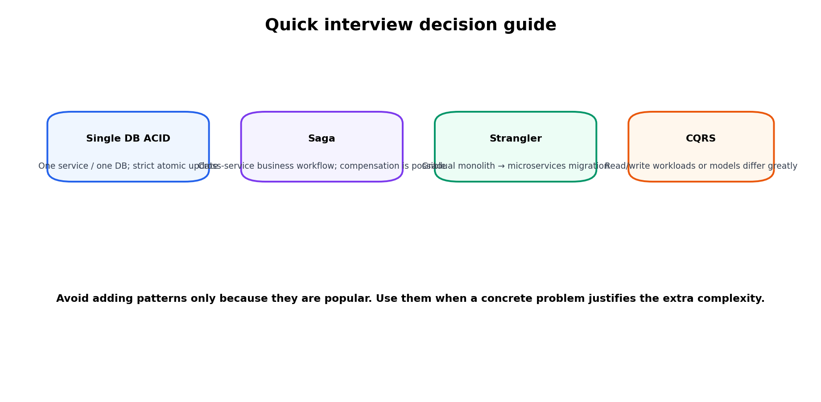
30-second summary: In a microservices architecture, each service usually owns its data and commits local ACID transactions. A business operation that spans several services is therefore not one normal database transaction. Saga coordinates those local transactions and uses compensating actions when a later step fails. Strangler helps migrate a monolith gradually, while CQRS separates command/write and query/read models when those workloads differ significantly.

1. Interview Roadmap
1. Understand the transaction boundary: local ACID vs distributed business transaction.
2. Know shared database vs database-per-service and why service ownership matters.
3. Explain Saga: local transactions, compensation, retries, idempotency, and eventual consistency.
4. Know both Saga styles: choreography and orchestration — and their trade-offs.
5. Be able to walk through a ₹10 transfer success path and at least two failure paths.
6. Know when not to use Saga and when one ACID transaction is better.
7. Understand Strangler for incremental migration and CQRS for separated read/write models.
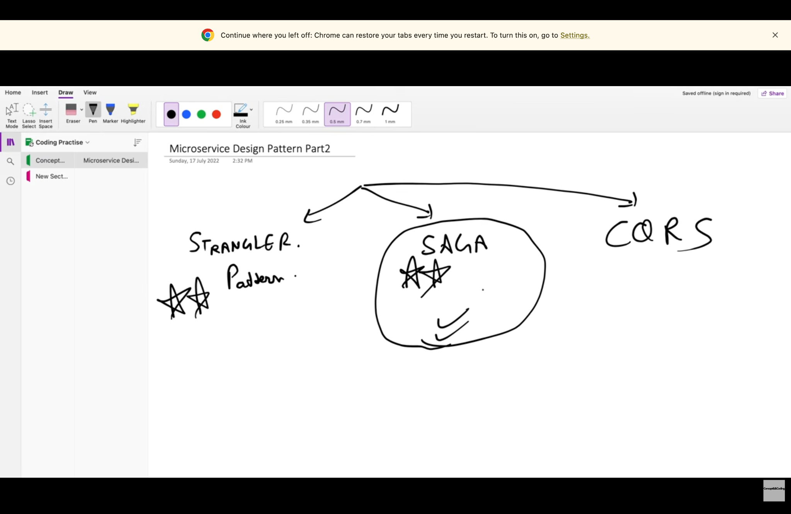
Lecture snapshot: the three patterns covered in this topic.

2. Why Different Databases Create a Distributed Transaction Problem
The key idea is not that ACID stops working. ACID still works inside each service’s own database transaction. The difficulty is that one business action may now span several independent databases, so there is no single local database transaction covering the whole workflow.
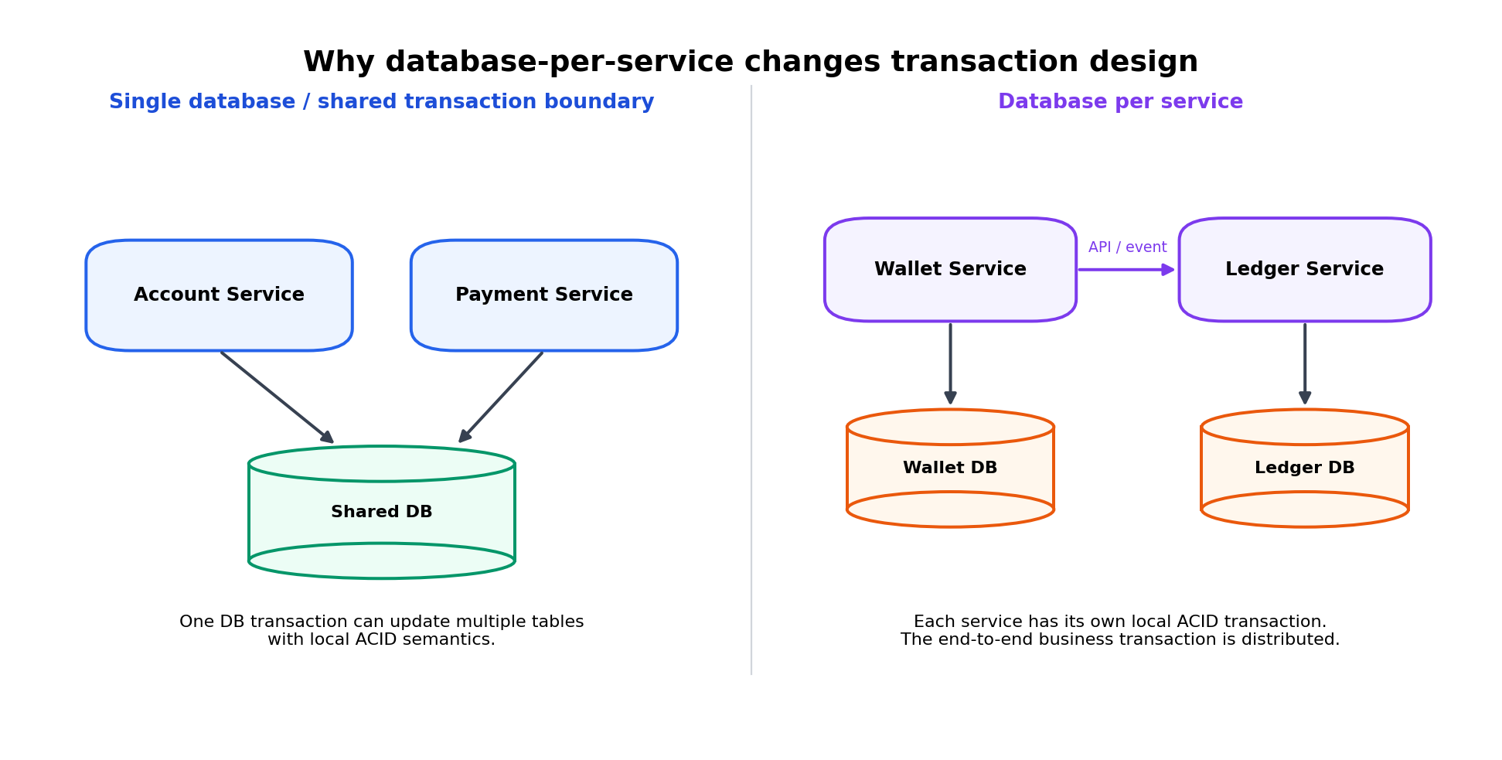
Local ACID is preserved inside each service; the end-to-end workflow becomes distributed.

2.1 Local ACID vs end-to-end atomicity
Case | What is atomic? | Typical mechanism
Single service + single DB | All changes in the DB transaction | BEGIN / COMMIT / ROLLBACK; ACID
Several services, each with own DB | Each service’s local change only | Local ACID + Saga for the business workflow
Shared DB across services | A shared DB transaction may be technically possible | Simpler transactions, but tighter coupling and weaker data ownership

2.2 Why not just use one global transaction?
- A network call can fail after one database has already committed.
- Independent services may use different database technologies (polyglot persistence).
- Holding locks across remote services increases latency and reduces availability.
- Two-phase commit (2PC) exists, but it introduces coordination, blocking, and operational complexity; many internet-scale microservice designs avoid it for long business workflows.
- Therefore systems often accept eventual consistency and model failure explicitly.
Interview line: “Database-per-service does not remove ACID. It changes the boundary of ACID. Each service is locally atomic, but cross-service atomicity must be coordinated at the application/workflow level.”

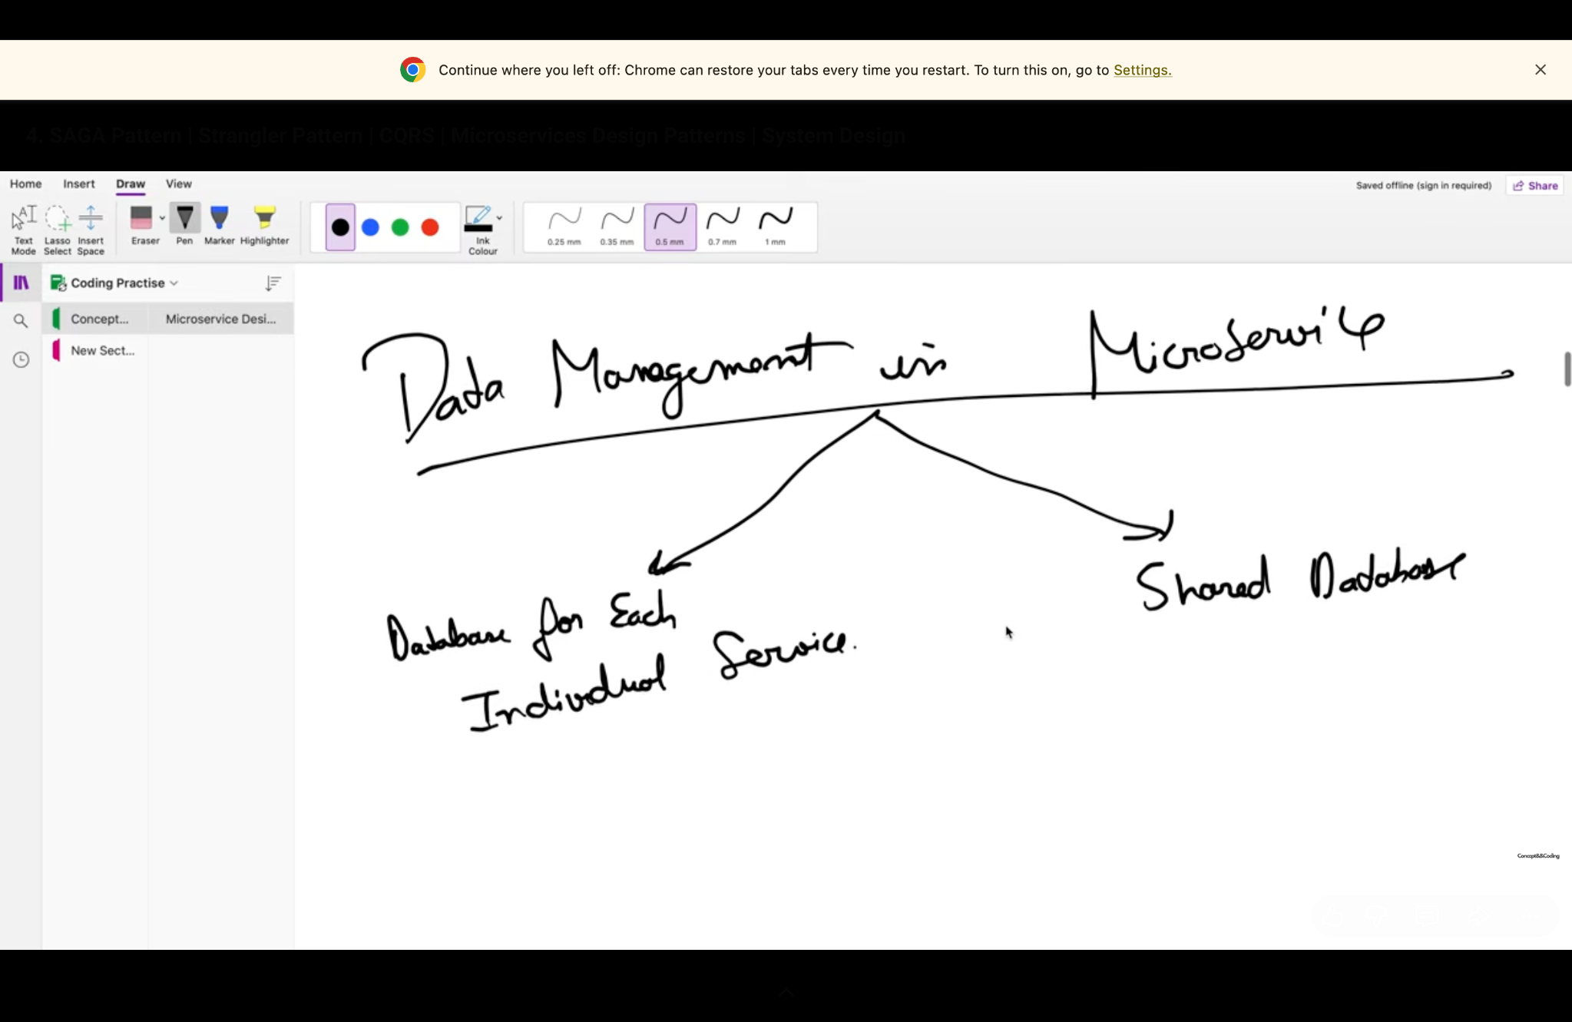
Lecture snapshot: database-per-service vs shared database.

3. Saga Pattern
A Saga is a distributed transaction pattern for a business operation that spans multiple services. The operation is split into a sequence of local transactions. After each local transaction commits, the workflow moves to the next step. If a later step fails, compensating transactions are executed to semantically undo earlier successful steps.
Definition to memorize: “Saga = a sequence of local ACID transactions + coordination + compensating actions on failure.”

3.1 What compensation really means
A compensation is a new business operation. It is not the same as rolling back a database transaction that already committed. For example, after charging ₹10, the compensation may be a refund of ₹10. The original charge remains part of the audit history, and the refund is another transaction.
- Compensation should be idempotent: retrying it must not refund twice.
- Not every action is perfectly reversible. Sending an email cannot be “unsent”; you may instead send a correction.
- For money movement, a ledger usually records both debit and compensating credit entries rather than deleting history.
- Saga often provides eventual consistency rather than instant global consistency.

3.2 Core building blocks
Building block | Purpose
Local transaction | Atomic change inside one service database.
Saga state | Tracks STARTED / STEP_COMPLETED / FAILED / COMPENSATING / COMPLETED.
Events or commands | Move the workflow to the next step.
Compensating transaction | Business-safe reversal when a later step fails.
Retry policy | Handles transient failures.
Idempotency key | Prevents duplicate execution during retries.
Outbox / reliable messaging | Reduces the “DB committed but event not published” failure window.
Observability | Correlation/saga ID, logs, tracing, metrics, dead-letter queues.

4. Saga Types: Choreography vs Orchestration

4.1 Choreography
In choreography there is no central workflow controller. A service performs its local transaction, publishes an event, and other services react to that event.
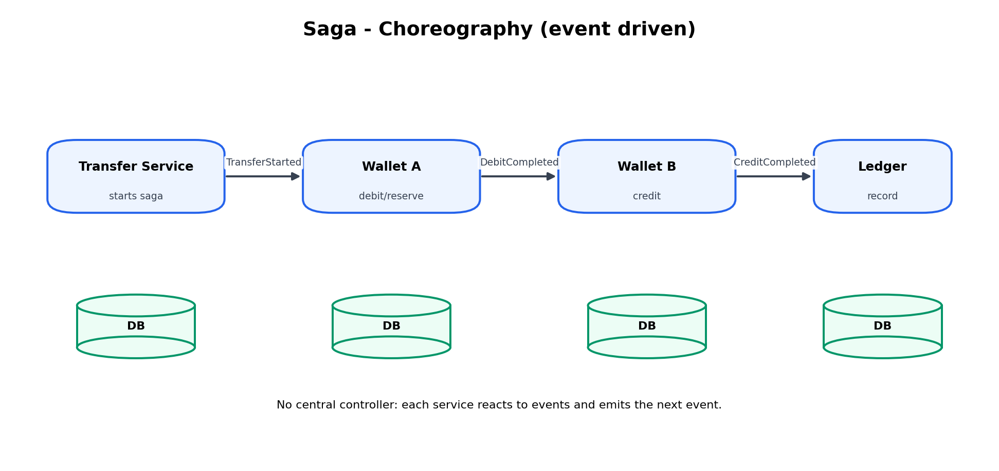
- Advantages: decentralized, loose coupling to a coordinator, natural fit for event-driven systems.
- Disadvantages: the end-to-end flow can become difficult to visualize; event chains can create hidden coupling; debugging and compensation become harder as the number of steps grows.
- Best fit: short/simple workflows with a small number of services and clear domain events.

4.2 Orchestration
In orchestration, a Saga orchestrator owns the workflow state. It sends commands to services, waits for outcomes, decides the next step, and triggers compensations when needed.
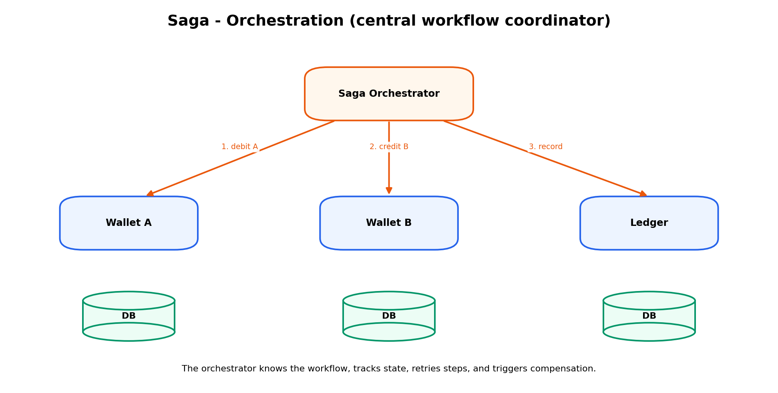
- Advantages: workflow is explicit, easier to reason about, easier to audit and monitor, compensation ordering is clearer.
- Disadvantages: the orchestrator adds infrastructure and can become overly central if it contains business logic that belongs inside services.
- Best fit: money/order/booking workflows with several steps, branching logic, timeouts, retries, or complex compensation.
Question | Choreography | Orchestration
Who decides next step? | Event-reacting services | Saga orchestrator
Coupling | Event contracts | Services depend on orchestrator commands
Flow visibility | Lower as workflow grows | High / explicit
Operational debugging | Harder | Usually easier
Good for | Simple event chains | Complex workflows
Main risk | Event spaghetti | God orchestrator
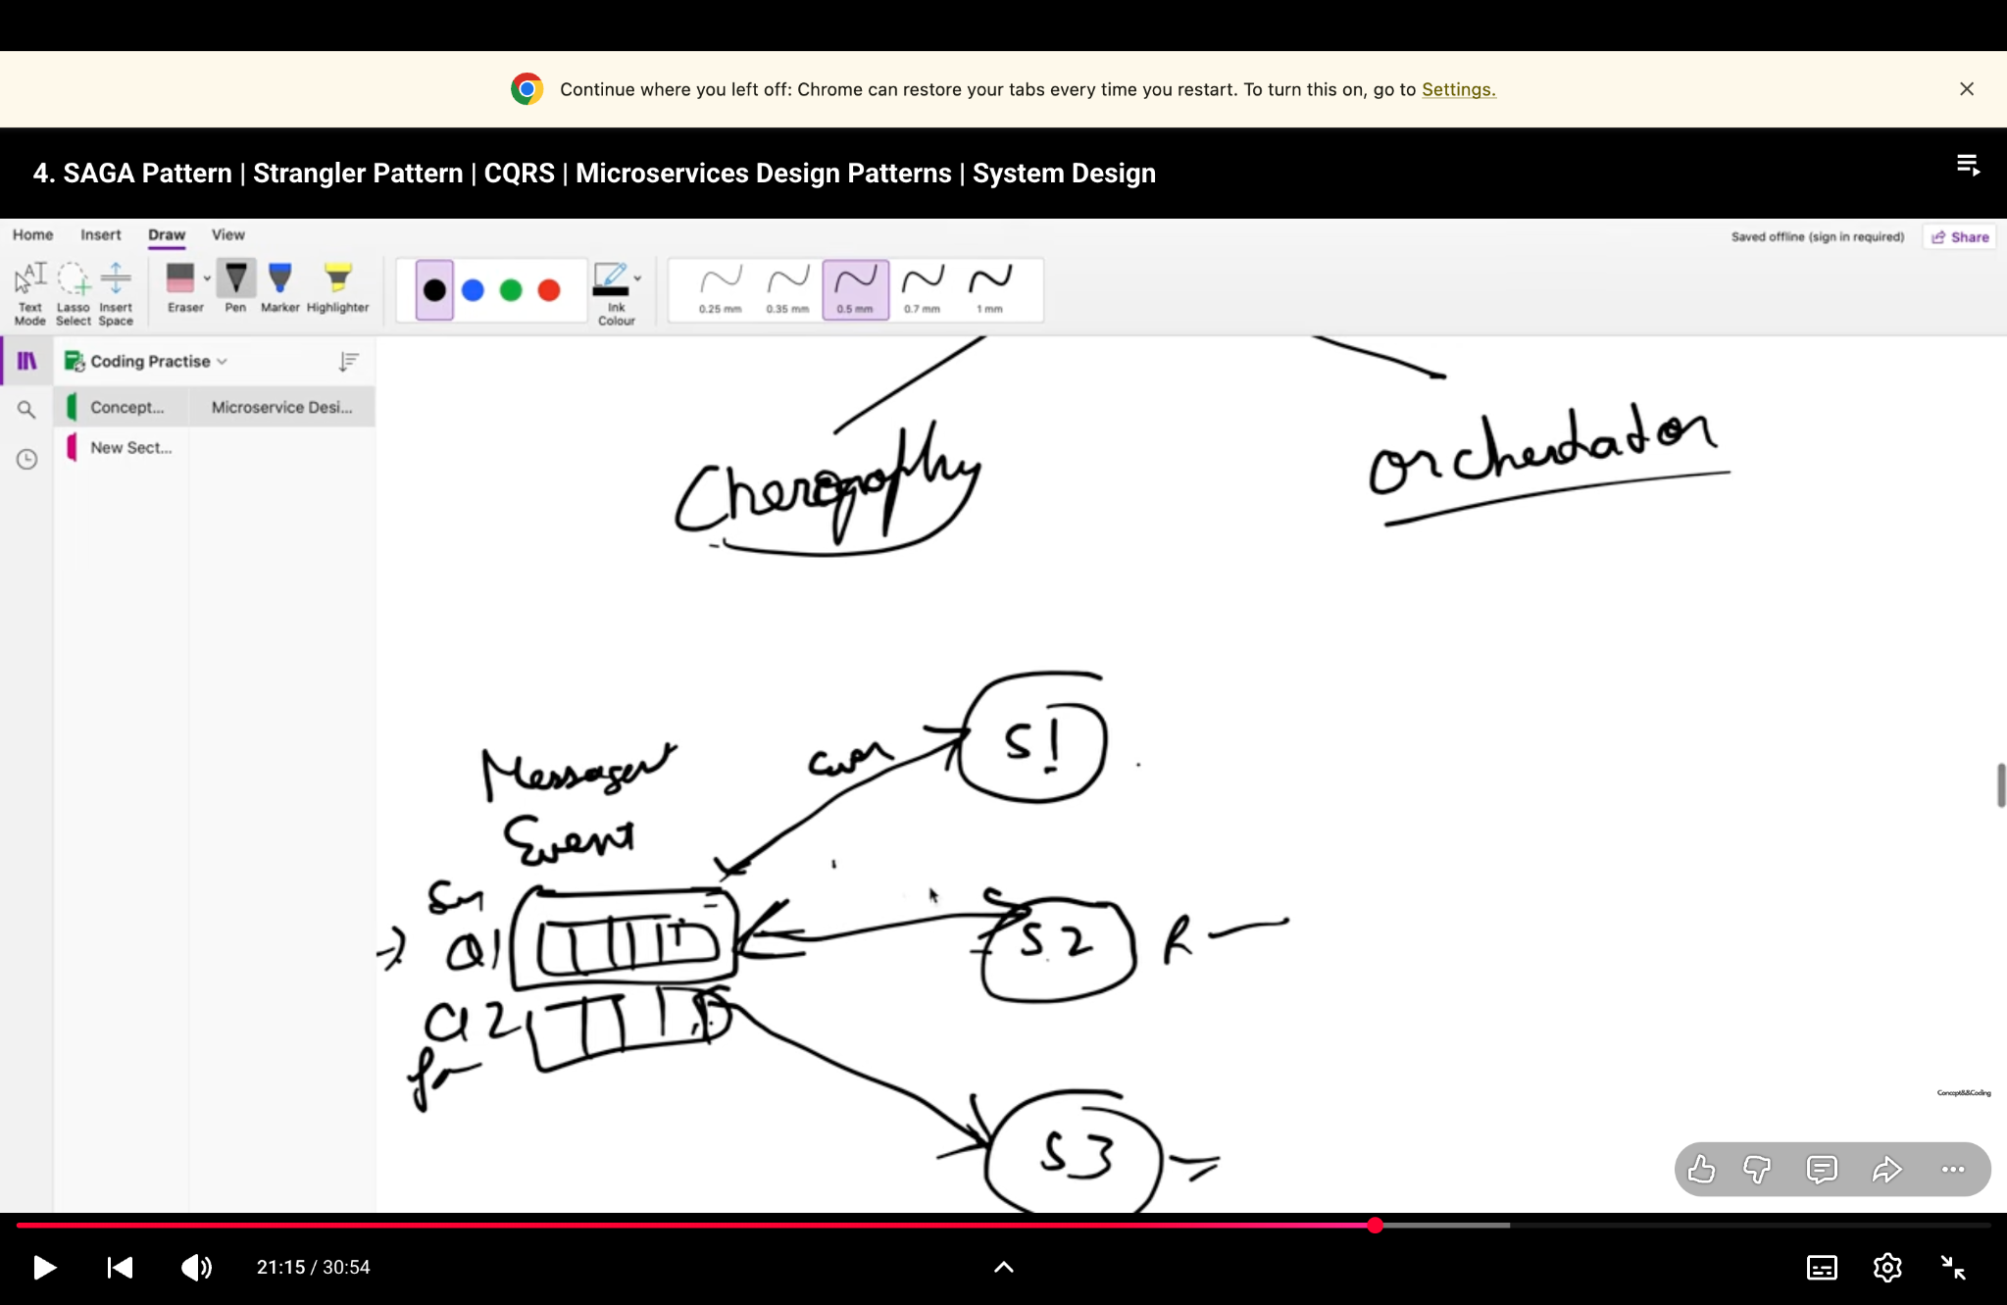
Lecture snapshot: choreography and orchestration.

5. Interview Walkthrough: Person A Sends Person B ₹10
Assume A and B are managed by separate wallet services/databases, or the transfer requires several independently owned components. This makes the operation a distributed business transaction. A production payment system typically also has an immutable ledger and a transfer record.
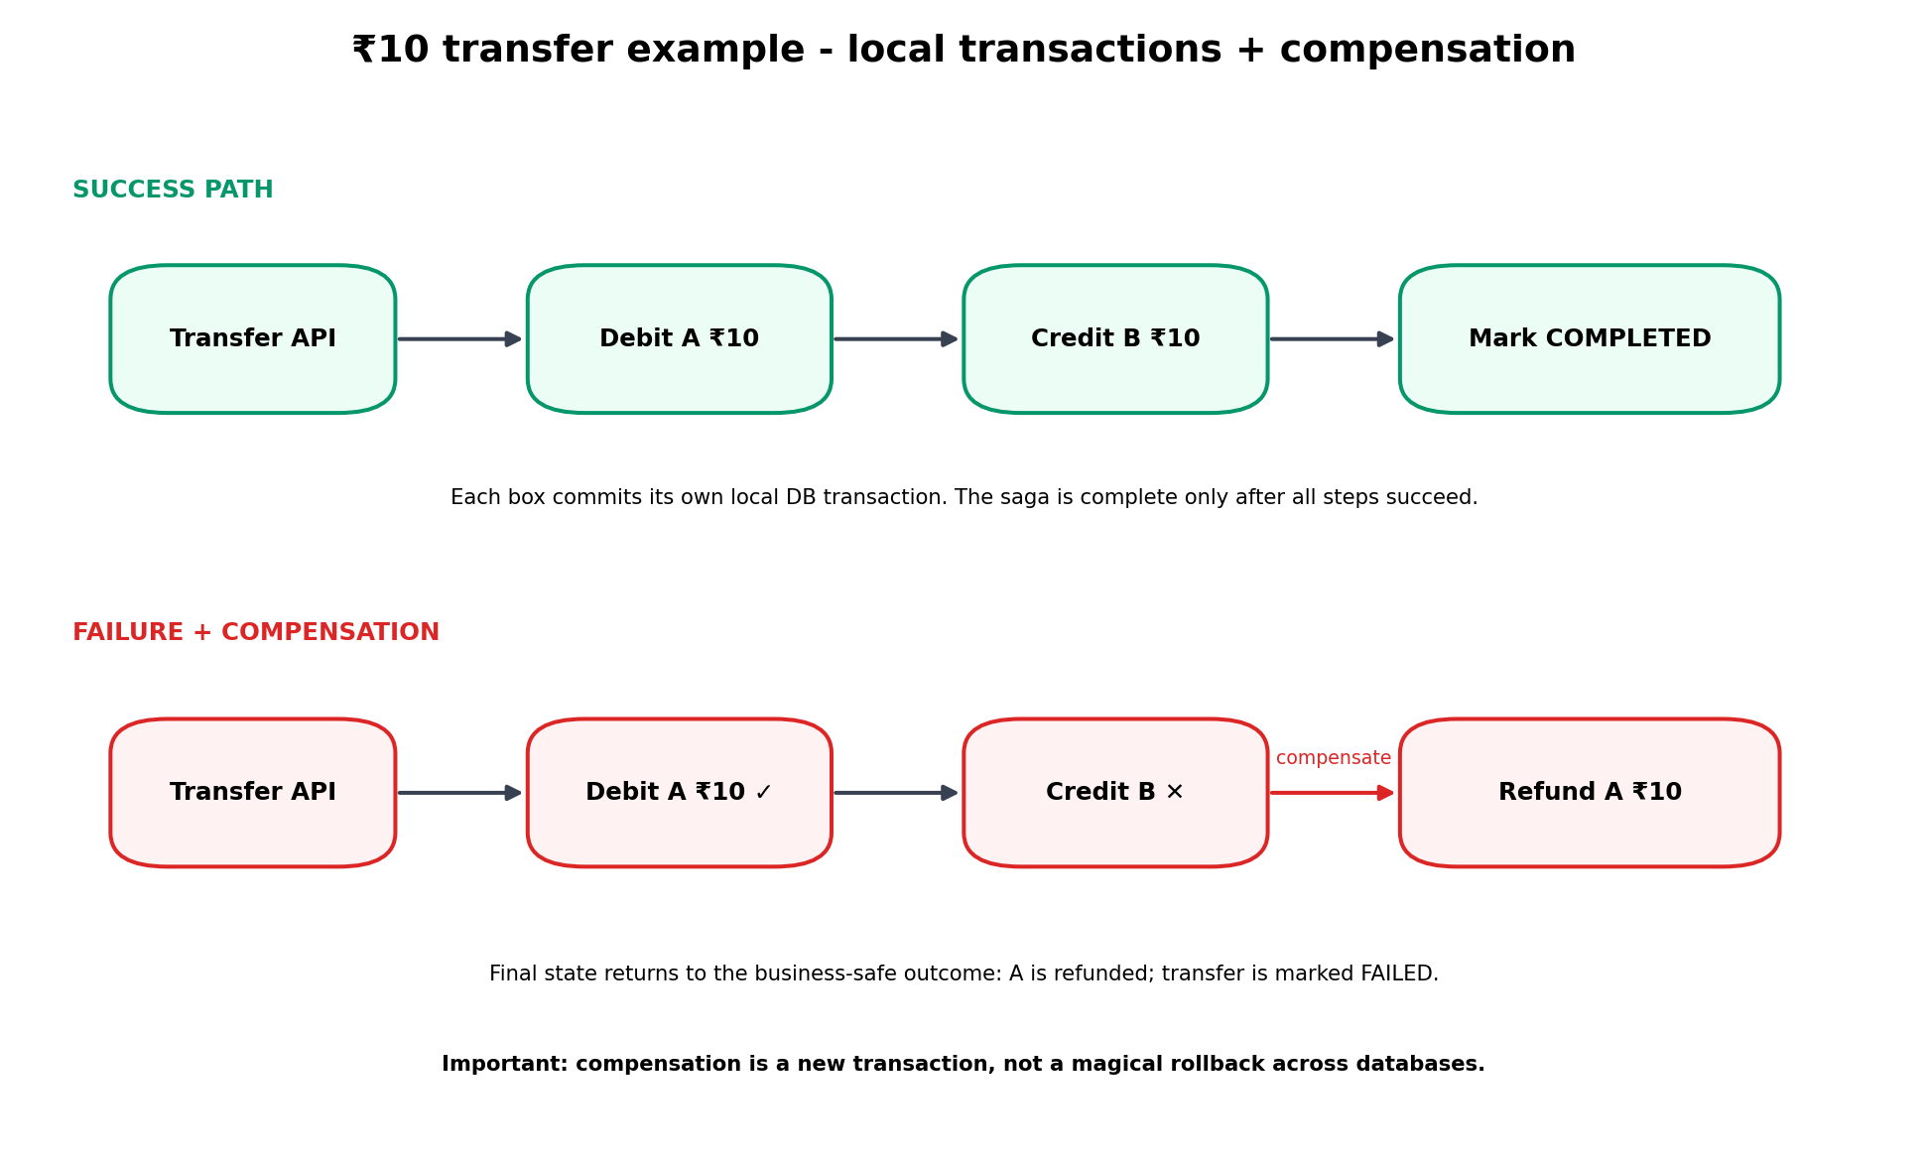

5.1 Recommended state model
- Create transfer T123 with status STARTED and an idempotency key.
- Debit or reserve ₹10 from A in Wallet A’s local transaction. Record “DebitCompleted”.
- Credit ₹10 to B in Wallet B’s local transaction. Record “CreditCompleted”.
- Write/confirm ledger entries and mark transfer COMPLETED.
- If credit fails permanently after A was debited, execute compensation: refund/release ₹10 to A and mark transfer FAILED/COMPENSATED.

5.2 Success example with balances
Initial: A = ₹100, B = ₹50
After successful transfer: A = ₹90, B = ₹60
Ledger view: Instead of “editing history,” record entries such as A −₹10 and B +₹10 against transfer ID T123. This makes auditing and reconciliation possible.

5.3 Failure cases interviewer may ask
Failure | What can go wrong | Typical response
Debit A fails | Insufficient balance / DB failure | Stop saga. Nothing else should execute.
Debit succeeds, credit B fails | A is temporarily down ₹10 | Retry credit if transient; otherwise compensate by refunding A.
Credit succeeds but ACK is lost | Retry may accidentally credit B again | Use transfer ID/idempotency key so repeated command is a no-op.
DB commit succeeds but event publish fails | Next service never hears about the step | Transactional outbox + message relay.
Orchestrator crashes | Workflow state may be incomplete | Persist saga state; resume from durable state after restart.
Compensation fails temporarily | A might remain unreconciled | Retry compensation, alert/queue for manual reconciliation if required.

5.4 Important money-transfer nuance
For real financial systems, do not casually “undo” money by deleting or overwriting records. Use immutable ledger entries, explicit transfer states, idempotent commands, reconciliation, and regulatory/accounting controls. If A and B are inside the same strongly consistent ledger/database, one ACID transaction may be simpler and safer than a Saga. Saga is most useful when the workflow truly crosses independently committed services or external systems.

6. Making Saga Reliable in Production

6.1 Idempotency
Messages and API calls can be delivered more than once. A command such as “credit B ₹10” must include a unique operation/transfer ID. The service stores processed IDs or enforces a unique constraint so the same command cannot apply twice.

6.2 Transactional Outbox
A common failure is: the service commits its DB update, then crashes before publishing the event. The outbox pattern writes the business change and an outbox row in the same local DB transaction. A background publisher later sends the event. This couples the DB change and “intent to publish” atomically.

6.3 Retries, timeout, DLQ, reconciliation
- Retry transient failures with backoff; do not retry permanent business errors forever.
- Use timeouts so a Saga does not wait indefinitely.
- Dead-letter or parking queues help isolate poison messages.
- Run reconciliation jobs that compare transfer state with ledger/service state.
- Trace every request with a correlation ID / saga ID.
Interview signal: If you mention compensation + idempotency + outbox + retries + reconciliation, you show that you understand the real failure modes rather than only the happy-path diagram.

7. Which Transaction Approach Should I Use?
Situation | Preferred approach | Reason
One service, one database | Normal ACID transaction | Simplest and strongest atomicity.
Several operations in same database | Normal ACID transaction | No need to create a distributed problem.
Cross-service workflow; business compensation is acceptable | Saga | Independent services + eventual consistency.
Long-running order/booking/payment workflow | Saga orchestration often fits well | Explicit workflow, timeout and compensation handling.
Small simple event-driven chain | Saga choreography may fit | Low coordination overhead.
Need strict global atomicity and environment supports distributed transactions | Consider 2PC / distributed transaction carefully | Stronger atomicity but higher coordination and availability/latency cost.
Irreversible side effects | Avoid assuming compensation can restore original world | Design reservation/confirmation states or manual recovery.

8. Strangler Pattern
The Strangler pattern is used to migrate a legacy monolith gradually. A routing layer is placed in front of the system. One capability at a time is reimplemented as a new service. Requests for migrated capabilities are routed to the new service; everything else continues to the monolith.
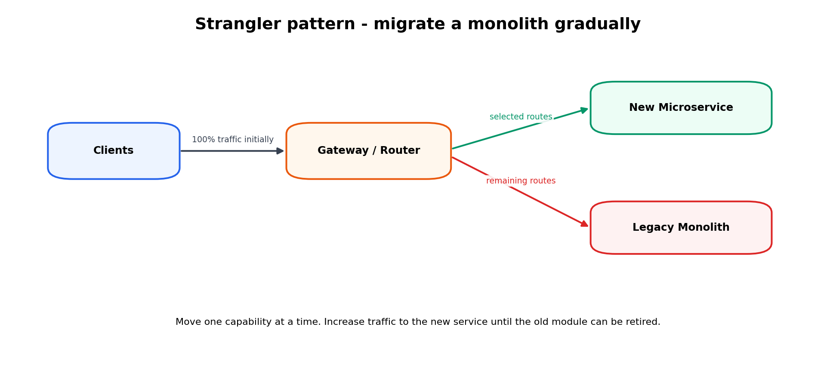
- Use when a big-bang rewrite is too risky.
- Migrate by business capability, not arbitrary code files.
- Run both old and new paths during the transition; observe and compare behavior.
- Retire the corresponding monolith module only when the new service is stable.
- Watch for temporary data duplication, dual writes, and shared-database coupling during migration.
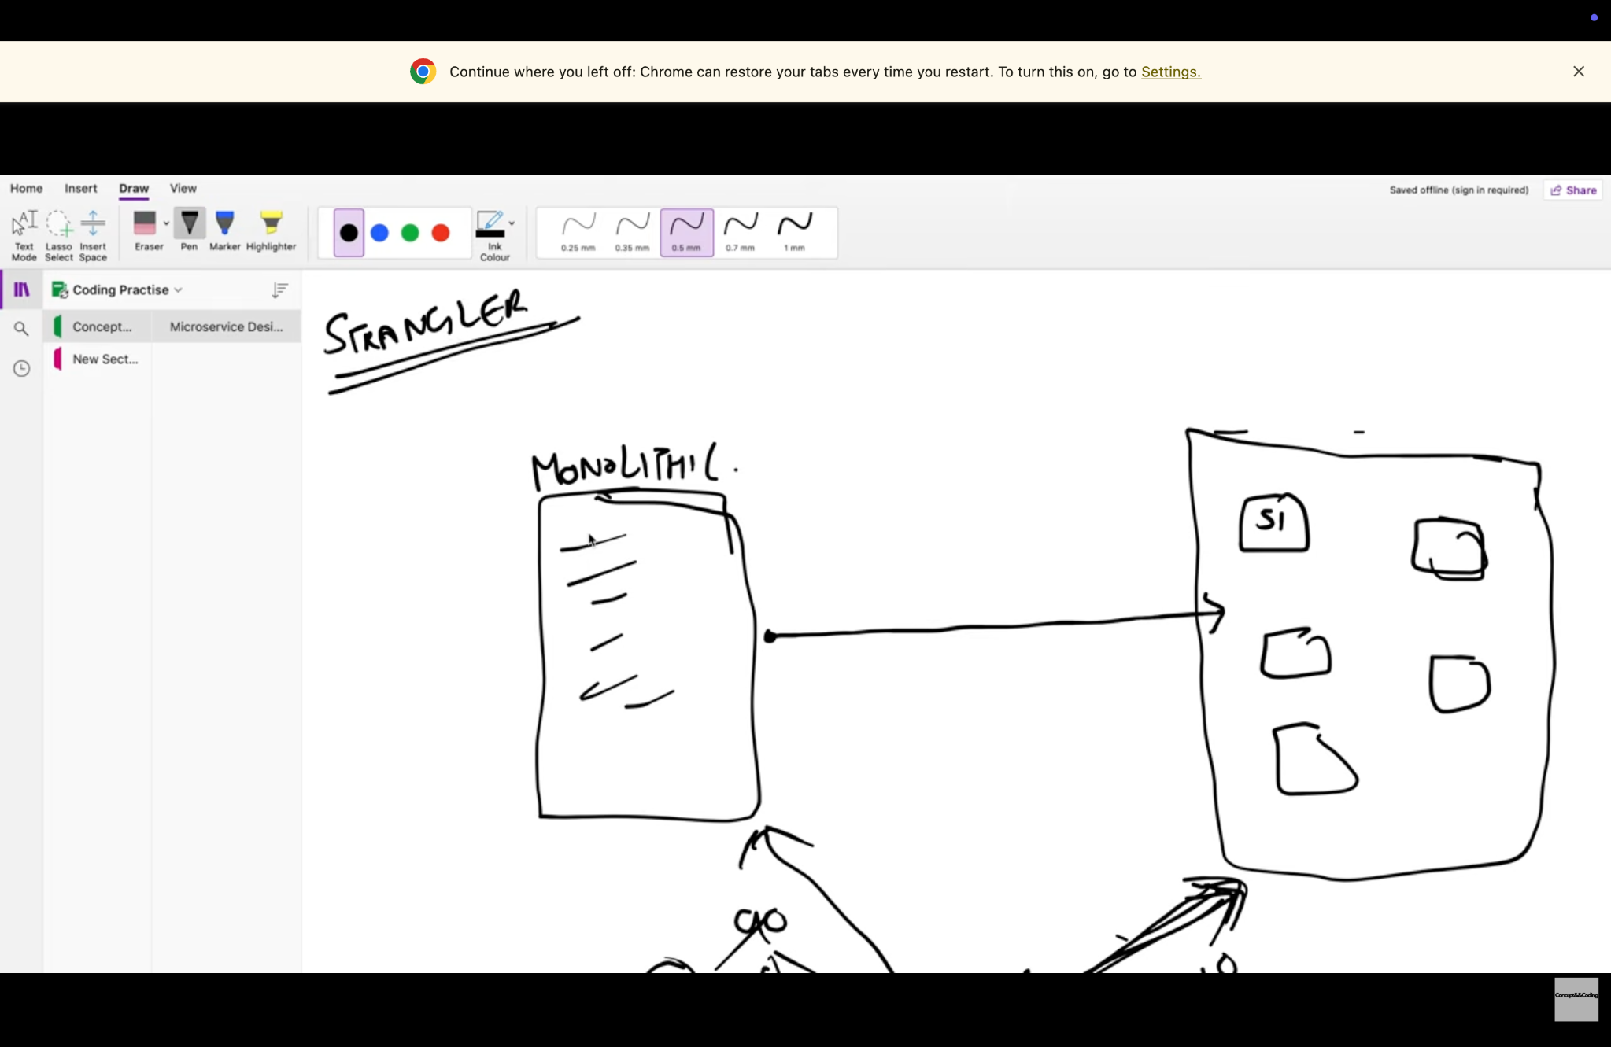
Lecture snapshot: monolith gradually replaced by services.

9. CQRS (Command Query Responsibility Segregation)
CQRS separates the model/path used to change state (commands) from the model/path used to read state (queries). The write side can optimize for business invariants and transactions; the read side can optimize for fast queries, denormalized views, search, or different storage.
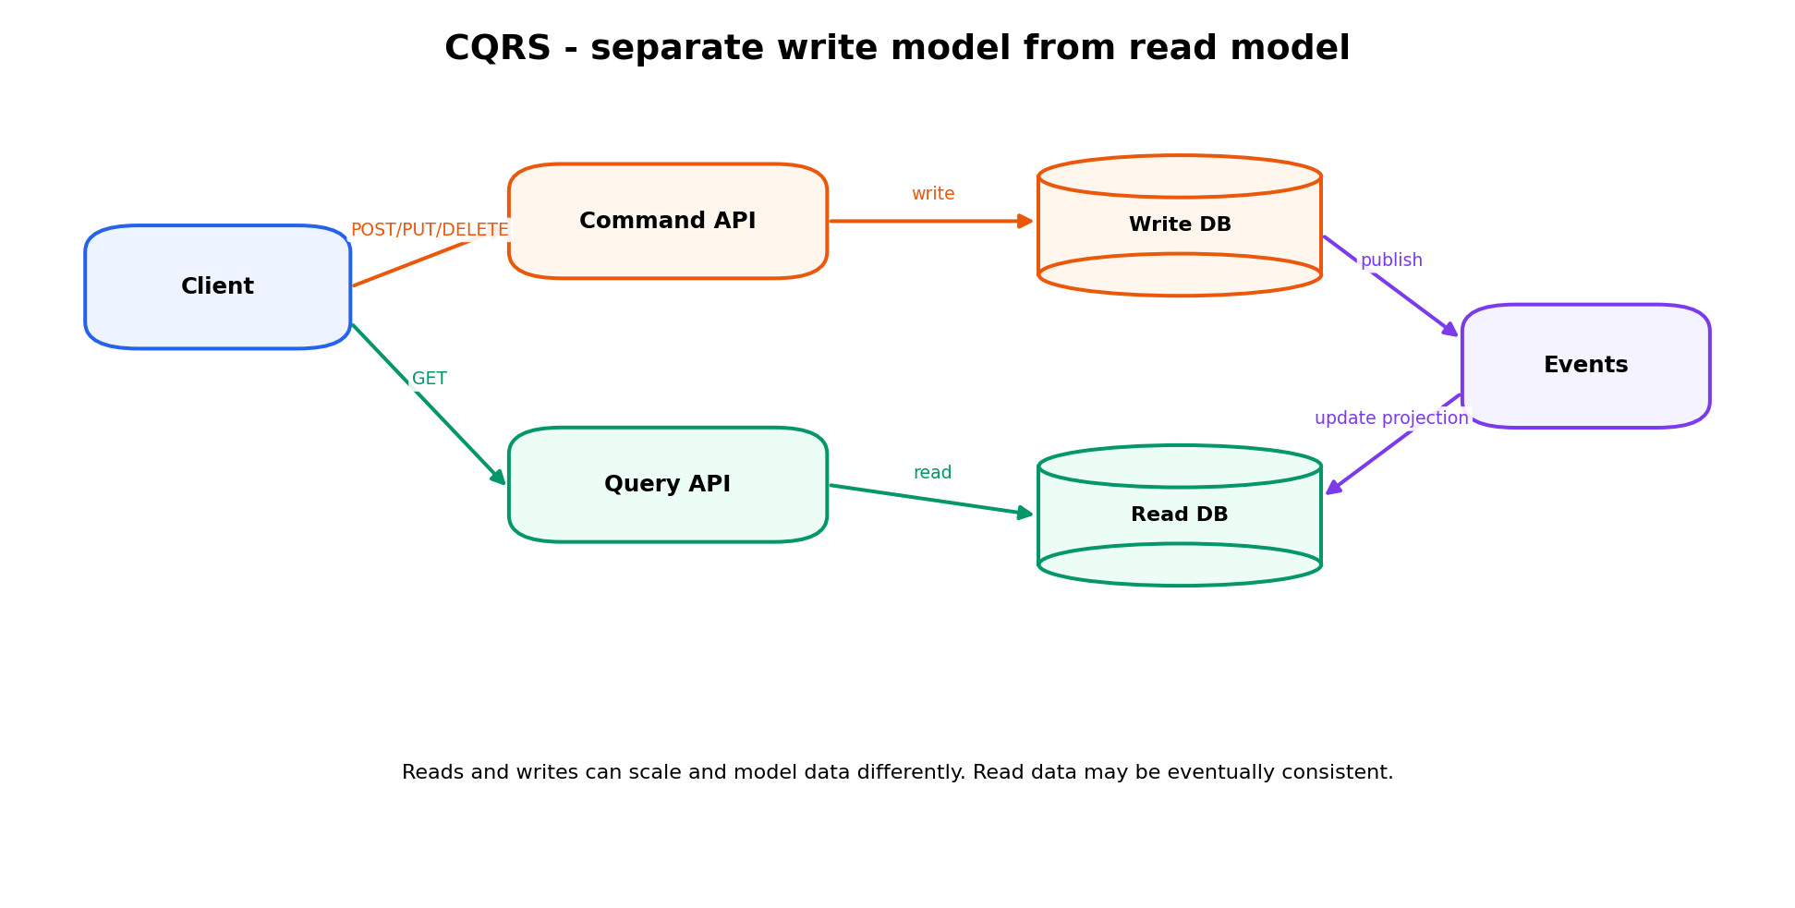

9.1 Command vs Query
- Command: changes state — create/update/delete, e.g., PlaceOrder or TransferMoney.
- Query: returns data without changing business state, e.g., GetOrderHistory.
- An event stream/message can update a read projection after a write; therefore the read view may lag briefly.

9.2 When CQRS helps
- Read traffic is far larger than write traffic and needs independent scaling.
- Read model is naturally different from the transactional/write model.
- Complex domain rules make a clean command model valuable.
- Multiple materialized views/search indexes are required.

9.3 When CQRS is overkill
- Simple CRUD application where the same schema works well for reads and writes.
- Team cannot justify extra eventing, synchronization, duplicate models, and eventual consistency.
- Strong read-after-write consistency is required everywhere and maintaining projections adds little value.
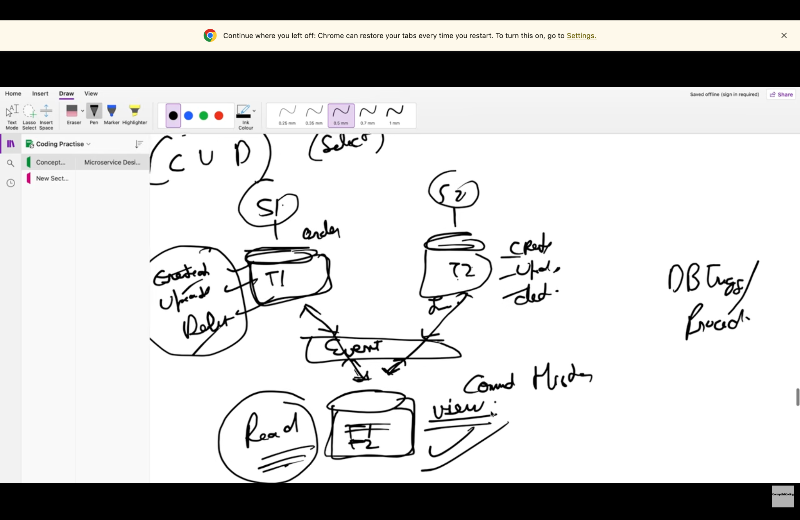
Lecture snapshot: commands update state and events build the read view.

10. Common Interview Questions & Model Answers
Q. Why do microservices make transactions harder?
A. Because each service commonly owns a separate database. ACID remains local to each database, but one business action can cross several independent commits and network calls. Therefore failure can happen between steps.
Q. What problem does Saga solve?
A. It coordinates a distributed business transaction as a sequence of local transactions and uses compensating actions if a later step cannot complete.
Q. Is Saga strongly consistent?
A. Usually no. It commonly provides eventual consistency across services, while each local step can still be ACID.
Q. What is the difference between rollback and compensation?
A. Rollback reverses an uncommitted local transaction. Compensation is a new committed business transaction that semantically reverses an earlier committed action.
Q. Choreography vs orchestration?
A. Choreography uses events with no central workflow controller. Orchestration uses a coordinator that explicitly commands services and tracks workflow state.
Q. What if an event is delivered twice?
A. Make handlers idempotent using a unique message/operation/transfer ID and a processed-message table or uniqueness constraint.
Q. What is the outbox pattern?
A. Write the business update and an outbox event record in the same local transaction; a separate publisher reliably sends the event later.
Q. When would you not use Saga?
A. If all data is in one transaction boundary, use a normal ACID transaction. Also be cautious when compensating actions are impossible or unacceptable.
Q. Why database per service?
A. It gives data ownership and independent evolution/scaling, and allows polyglot persistence, but it makes cross-service joins and transactions more complex.
Q. What is Strangler pattern?
A. A gradual migration approach where new services take over selected routes/capabilities while the legacy monolith continues handling the rest.
Q. What is CQRS?
A. A pattern that separates write/command responsibilities from read/query responsibilities so each side can use a model and scaling strategy suited to its workload.
Q. Can Saga guarantee exactly-once delivery?
A. Distributed messaging generally cannot rely on magical exactly-once end-to-end semantics. Design for at-least-once delivery with idempotent consumers and durable state.

11. Whiteboard Answer Template
If the interviewer says, “Design a transfer/order workflow across microservices,” use this sequence:
1. Define the business invariant and service boundaries.
2. State whether one ACID transaction is possible. If not, explain why the workflow is distributed.
3. Choose Saga choreography or orchestration and justify the choice.
4. Draw the happy path as local transactions.
5. Choose one failure in the middle and draw compensation.
6. Add idempotency, retries/timeouts, outbox, and saga/transfer state.
7. Discuss consistency: what can be temporarily inconsistent and how it converges.
8. Mention monitoring, reconciliation, and audit/ledger if money is involved.

12. Last-Minute Revision Sheet
Best interview closing sentence: “I would keep strong consistency inside each service, use Saga only where a business transaction genuinely crosses service boundaries, and make every distributed step retry-safe, idempotent, observable, and reconcilable.”

Concept | One-line interview answer
Database per service | Independent ownership; local ACID only; cross-service workflow becomes distributed.
Saga | Local transactions + coordination + compensation.
Compensation | New reverse business transaction, not rollback of an already committed DB change.
Choreography | Events drive next step; simple but can become hard to trace.
Orchestration | Central workflow coordinator; explicit and easier for complex flows.
Idempotency | Same command/event can be retried without duplicate side effects.
Outbox | DB update + event record committed together locally.
Strangler | Incrementally route capabilities from monolith to new services.
CQRS | Separate command/write model from query/read model; may be eventually consistent.
₹10 transfer | Debit/reserve A → credit B → finalize ledger; if B fails, compensate A; every step keyed by transfer ID.

