System Design Notes — Part 1
Network Protocols | Interview Revision Notes
Made by Md Farid for interview purpose

1. Quick Introduction: LLD vs HLD
LLD: Code-level design — classes, objects, interfaces, methods, SOLID principles and design patterns. HLD: System-level design — services, databases, networking, scalability and communication between components.

Low-Level Design roadmap
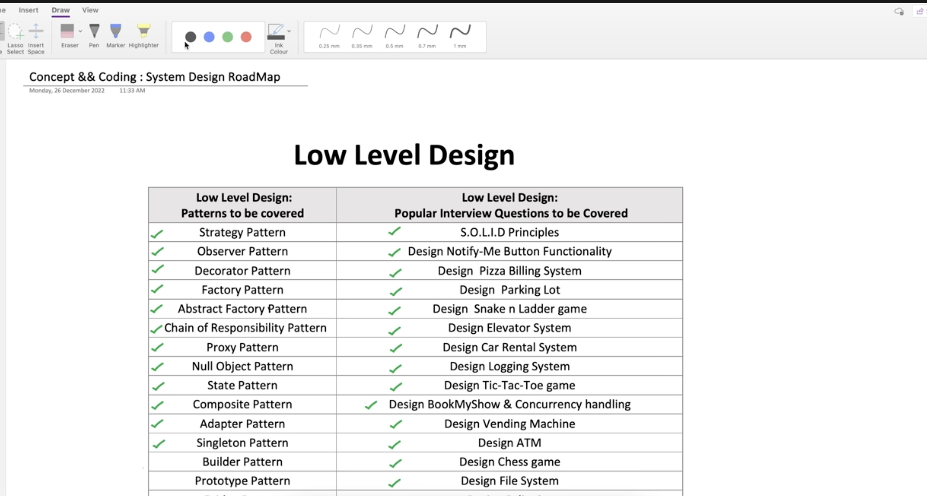
LLD roadmap — starting section
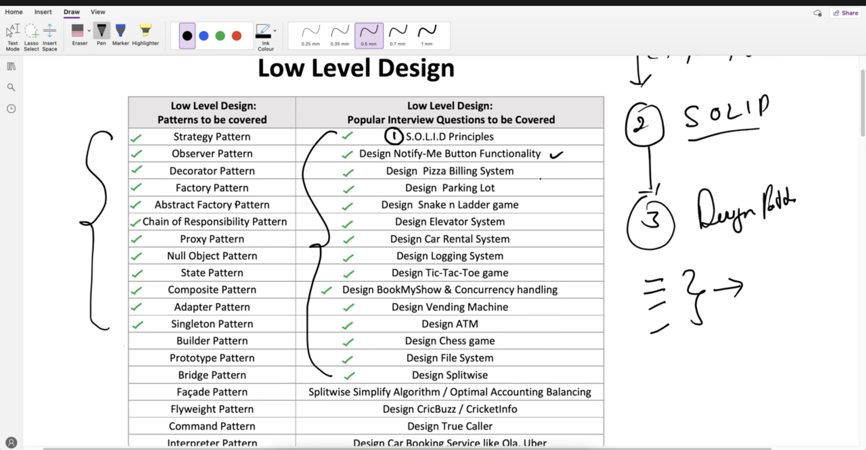
LLD roadmap — continuation
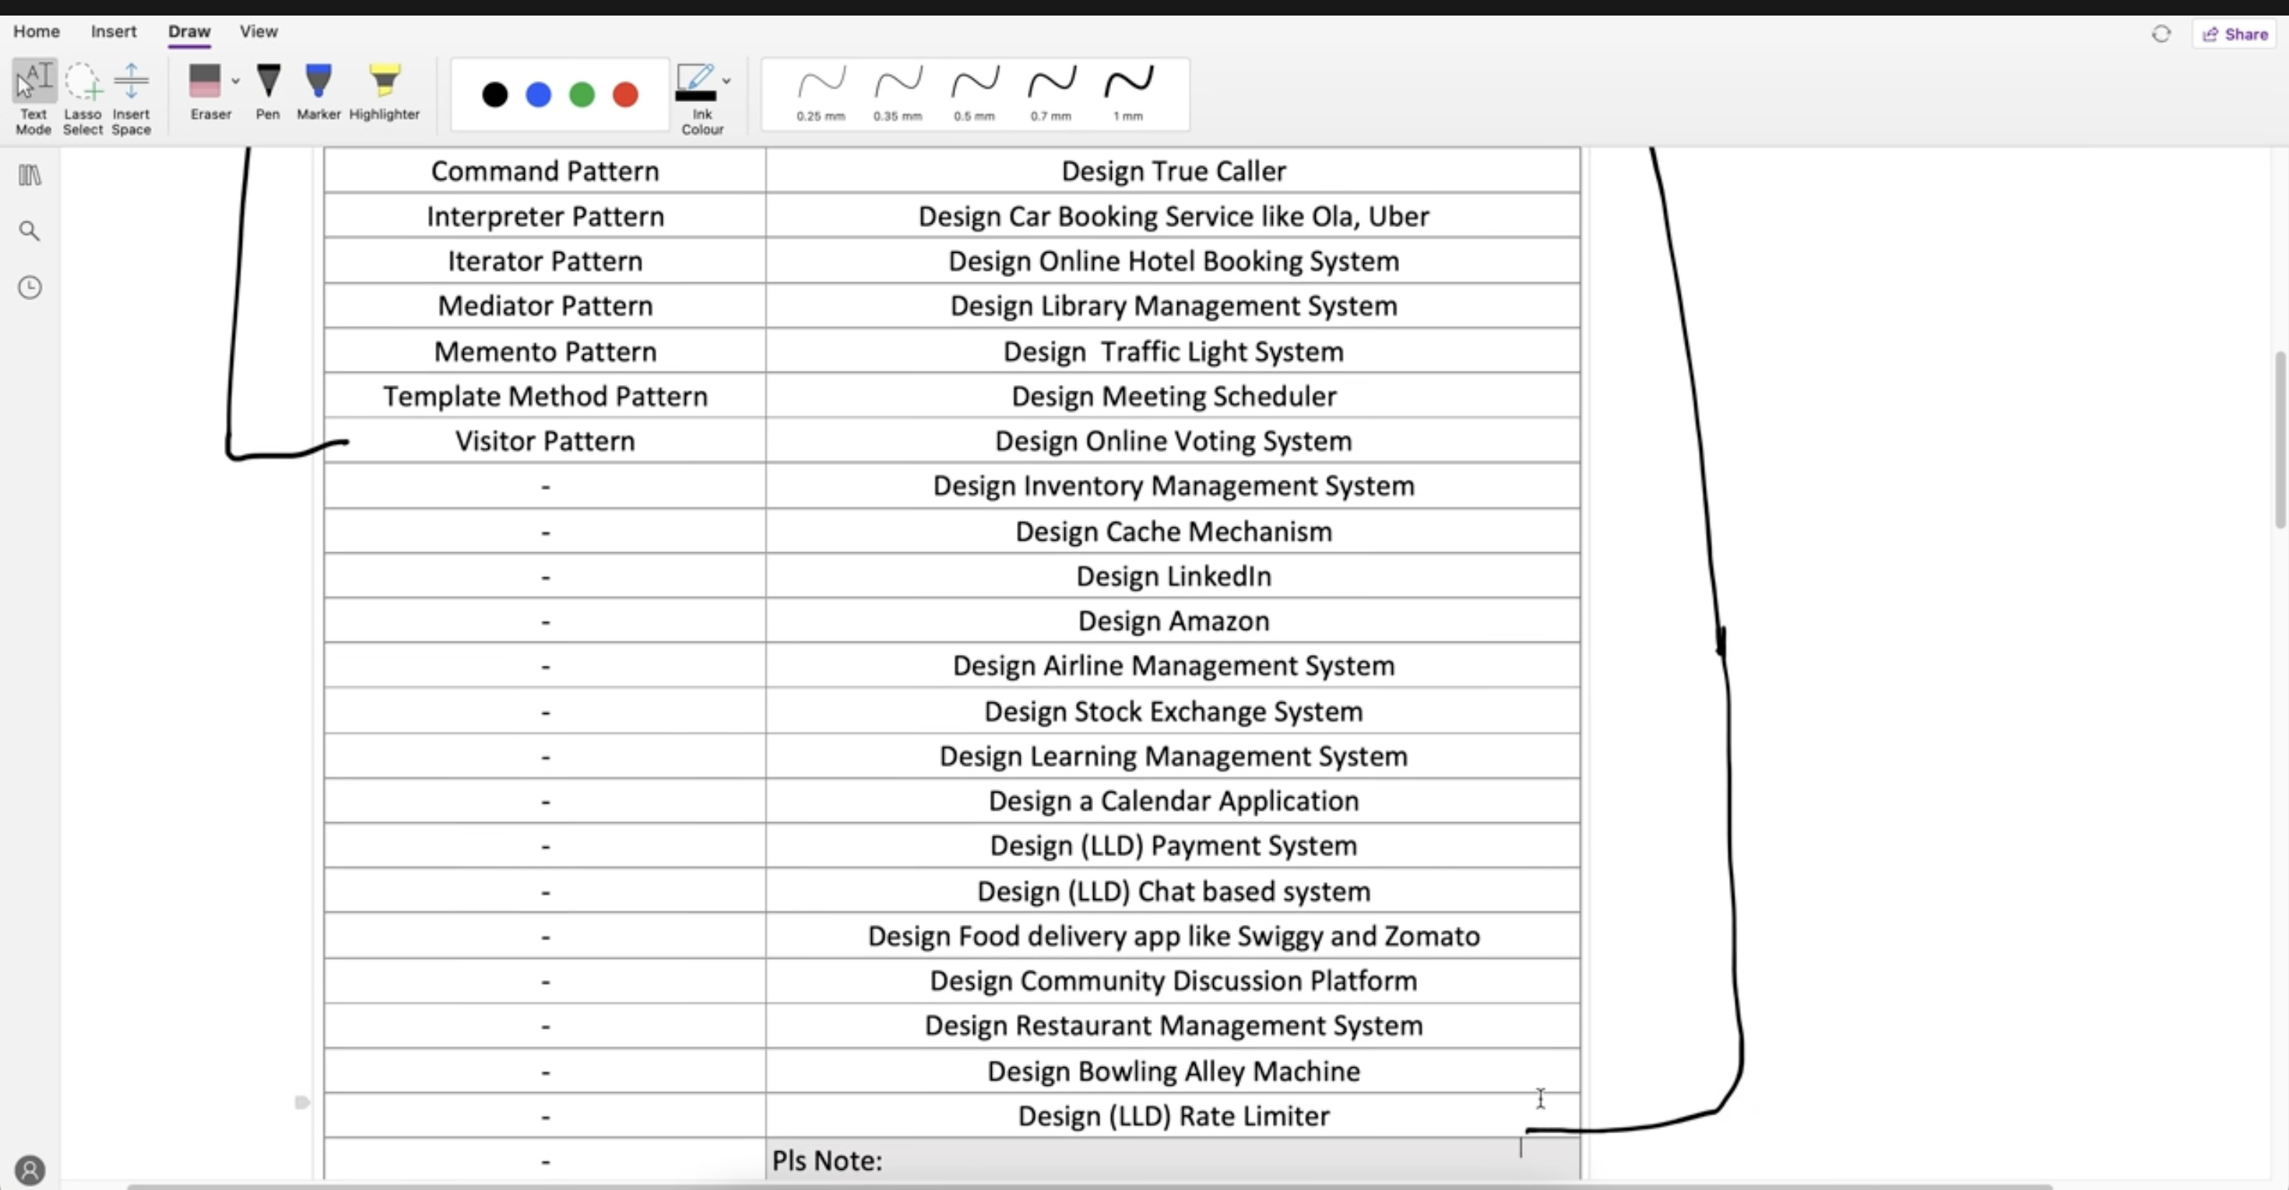
LLD roadmap — lower section / remaining interview questions

High-Level Design roadmap
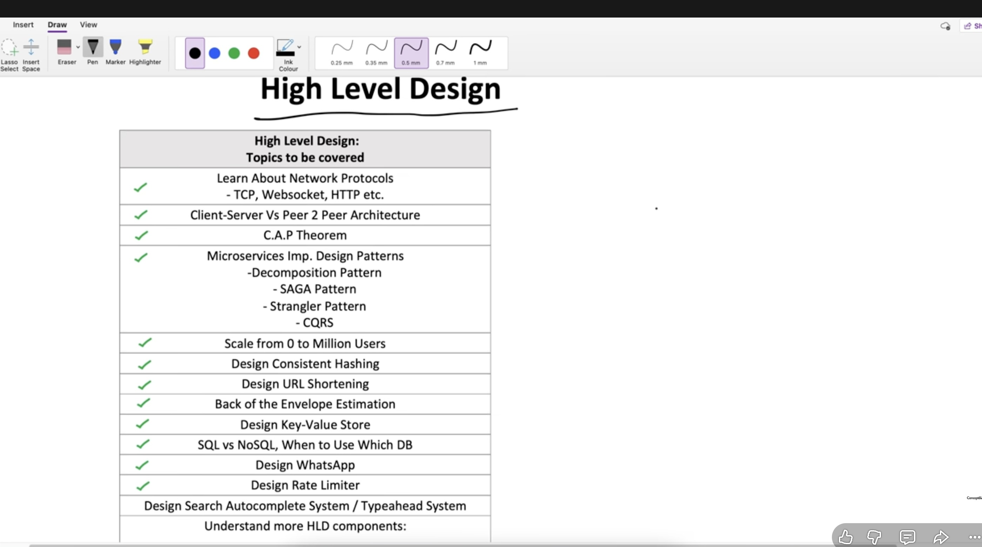
HLD roadmap — starting section
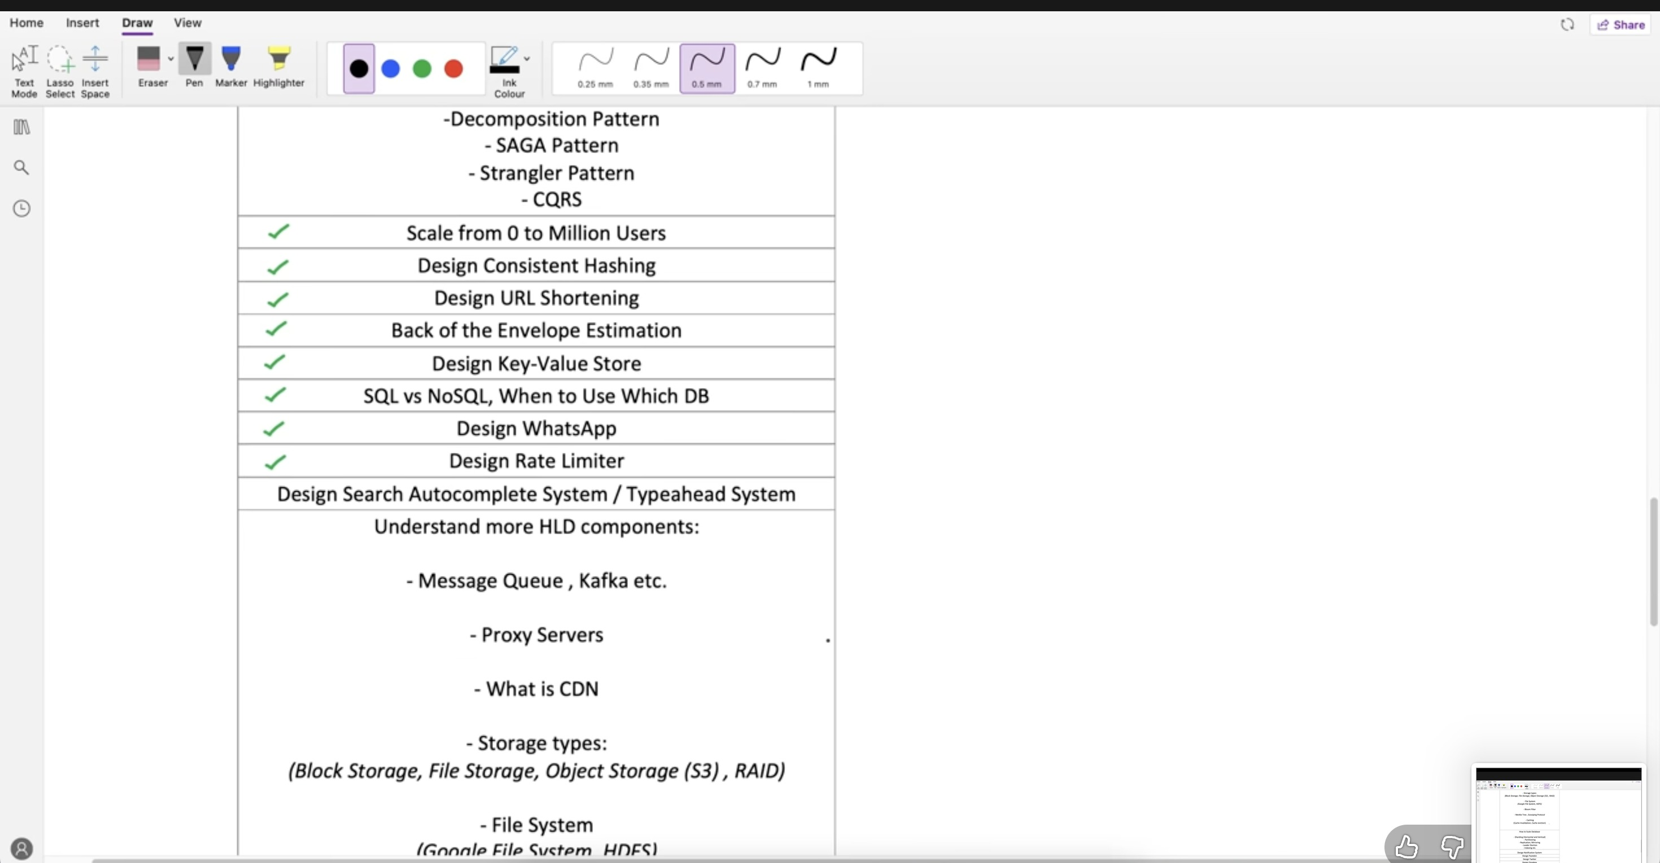
HLD roadmap — continuation: scaling, queues, proxy, CDN and storage
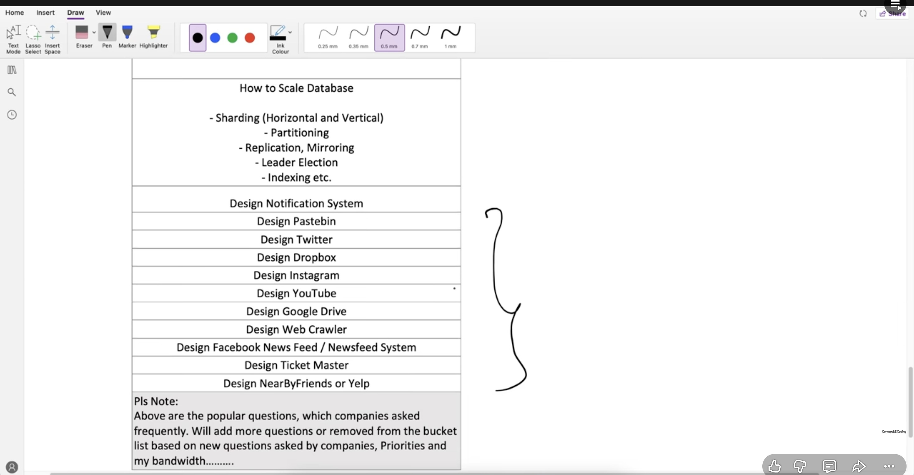
HLD roadmap — lower section: database scaling and common system-design questions

2. Network Protocols — Lecture Scope
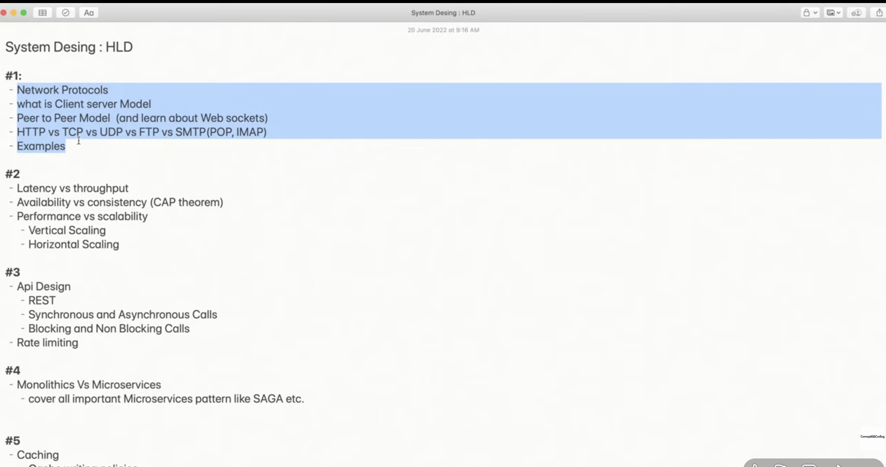
The lecture begins with protocols, client–server/P2P, WebSockets, and TCP vs UDP.
- Network protocol — a defined set of rules that tells devices how to format, send, receive and interpret data.
- Why protocols matter — both ends must agree on the same rules; otherwise communication cannot be understood.
- Examples — HTTP/HTTPS for the web, SMTP for sending mail, IMAP for accessing/synchronizing mail, TCP and UDP for transport.
Interview line: “A protocol is a contract for communication between networked systems.”

3. Where Protocols Fit: OSI / TCP-IP View
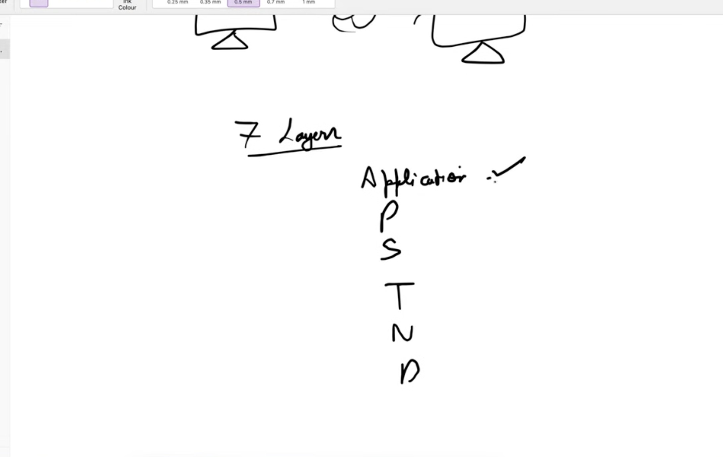
Whiteboard: 7-layer model (Application → Presentation → Session → Transport → Network → Data Link → Physical).
Layer | Main responsibility | Common examples / interview keywords
7. Application | Provides network services directly to user applications. | HTTP/HTTPS, FTP, SMTP, IMAP, DNS, WebSocket
6. Presentation | Transforms data format; handles encoding, encryption and compression. | TLS/SSL concepts, JSON/XML formatting, JPEG, UTF-8
5. Session | Creates, manages and terminates communication sessions between applications. | Session establishment, synchronization, checkpoints
4. Transport | End-to-end process communication, ports, reliability and flow control. | TCP, UDP; segments/datagrams; port numbers
3. Network | Logical addressing and routing packets between different networks. | IP, ICMP, routers; IP addresses; packets
2. Data Link | Node-to-node delivery on the local network; framing and MAC addressing. | Ethernet, Wi-Fi, switches, MAC address; frames
1. Physical | Transmits raw bits as electrical, optical or radio signals. | Cables, fiber, radio, hubs/repeaters; bits

Easy order: Application → Presentation → Session → Transport → Network → Data Link → Physical. A common mnemonic is “All People Seem To Need Data Processing.”

- Application / Presentation / Session — the upper layers deal with application communication, data representation and session management.
- Transport — TCP/UDP deliver data between application processes using port numbers.
- Network — IP and routers move packets from one network to another.
- Data Link — frames move between devices on the same local link using MAC addresses.
- Physical — the actual bits travel through cable, fiber or wireless signals.

4. Application-Layer Protocols
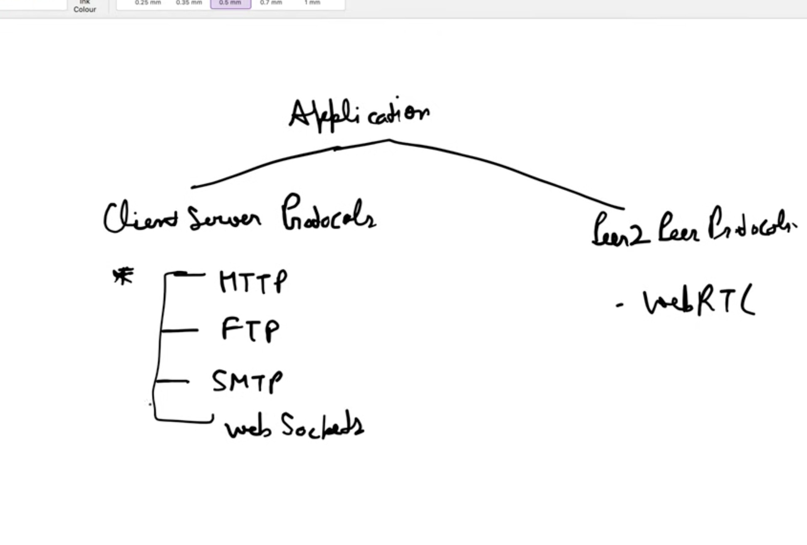
Whiteboard classification: client–server protocols and peer-to-peer communication.

Protocol | Main purpose | Interview point
HTTP / HTTPS | Web requests and responses | Usually request–response; HTTPS = HTTP protected with TLS.
FTP | File transfer | Traditional protocol for transferring files between a client and server.
SMTP | Send/relay email | Used when sending mail from a client to a mail server and between mail servers.
IMAP | Read/sync email | Keeps mail on the server and synchronizes folders/messages across devices.
WebSocket | Real-time two-way communication | One long-lived, full-duplex connection after an HTTP upgrade.

Do not confuse: WebSocket is typically client–server over TCP; WebRTC is commonly used for real-time peer-to-peer communication.

5. Client–Server Model
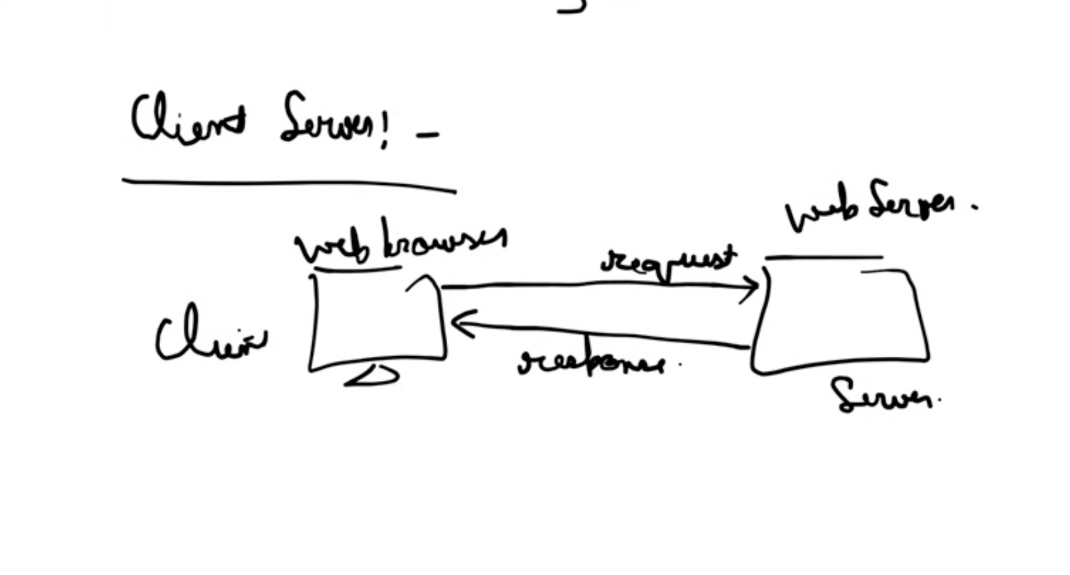
Whiteboard: client sends a request; server processes it and sends a response.
- Client — initiates communication, e.g., browser/mobile app.
- Server — listens for requests, performs logic/data access and returns a response.
- Typical flow — Client → request → server → response → client.
- Strength — centralized control, security and easier data management.
- Trade-off — the server can become a bottleneck or failure point unless it is replicated/scaled.

6. Peer-to-Peer (P2P) Model
- Definition — peers can communicate directly and each participant can act as both a client and a server.
- No mandatory central data path — once peers are connected, data can flow directly between them.
- Examples — BitTorrent-style file sharing, some blockchain networks, and WebRTC-based real-time communication.
- Important nuance — P2P systems may still use signaling, discovery or rendezvous servers to help peers find/connect to each other.
Client–Server | Peer-to-Peer
Central server is the main communication point. | Peers can exchange data directly.
Simpler control and security. | Can distribute load across participants.
Server scaling is important. | Peer availability and NAT/firewall traversal can be challenging.
Examples: websites, REST APIs. | Examples: BitTorrent, WebRTC sessions.

7. WebSocket
- What it is — a persistent, full-duplex connection between client and server.
- How it starts — the client begins with an HTTP request and asks to upgrade the connection to WebSocket.
- After upgrade — either side can send messages at any time without creating a new HTTP request for every update.
- Best use cases — chat, live notifications, multiplayer state, trading dashboards and collaborative apps.
- Key distinction — HTTP is primarily request–response; WebSocket keeps one connection open for continuous two-way communication.
Interview line: “Use WebSocket when the server must push frequent real-time updates to a connected client.”

8. Email Protocols: SMTP vs IMAP
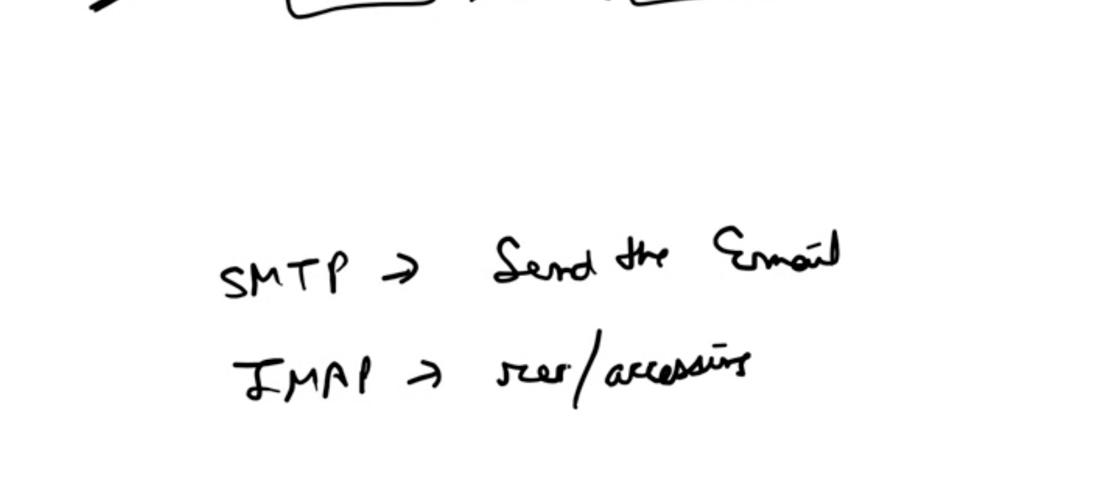
Whiteboard: SMTP is used for sending; IMAP is used for accessing/synchronizing email.
SMTP | IMAP
Simple Mail Transfer Protocol | Internet Message Access Protocol
Primarily sends and relays email. | Reads and synchronizes email from the mail server.
Used from sender/client → outgoing server and server → server. | Useful when the same mailbox is accessed from multiple devices.

Quick memory trick: SMTP = Send Mail. IMAP = Inbox Access/Sync.

9. Transport Layer: TCP and UDP
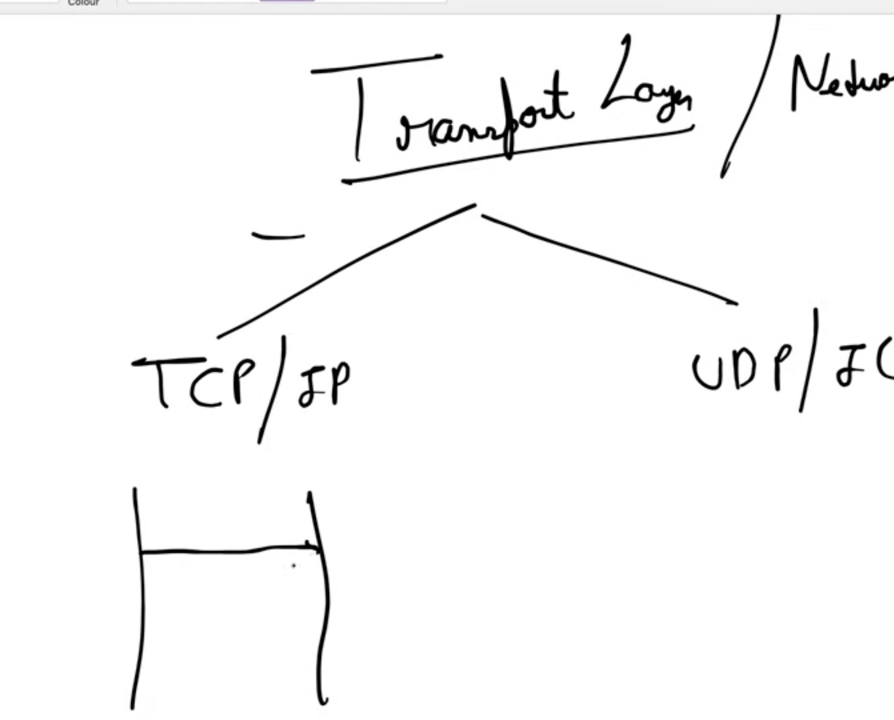
Whiteboard: transport communication is commonly discussed through TCP/IP and UDP/IP.
Both TCP and UDP operate above IP. IP handles addressing/routing; TCP or UDP defines how application data is transported end-to-end.

10. TCP vs UDP — Most Important Interview Comparison
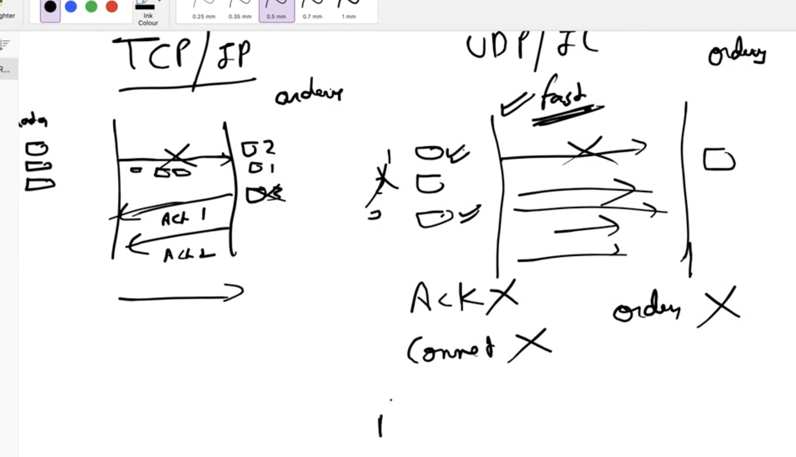
Whiteboard comparison: TCP uses acknowledgements/reliability; UDP prioritizes speed with no delivery/order guarantee.
TCP | UDP
Connection-oriented. | Connectionless.
Reliable delivery using acknowledgements, retransmission and sequencing. | No built-in acknowledgement/retransmission guarantee.
Preserves byte-stream order. | Packets may be lost, duplicated or arrive out of order.
More overhead; generally higher latency than UDP. | Lower overhead; useful when speed/timeliness matters more than perfect delivery.
Examples: HTTP/1.1, HTTP/2, HTTPS, SSH, WebSocket. | Examples: DNS queries, live voice/video, gaming; QUIC builds reliability on top of UDP.

Important: “UDP is faster” is a simplification. UDP has less protocol overhead, but real application performance depends on the network and any reliability logic the application adds.

TCP reliability idea
- Data is sequenced so the receiver can reconstruct the stream in order.
- Receiver acknowledgements (ACKs) confirm successful receipt.
- Missing data can be retransmitted.
- Flow/congestion-control mechanisms help avoid overwhelming receivers and networks.

When would you choose UDP?
- Real-time audio/video where an old packet is often less useful than the newest packet.
- Online gaming state updates where low latency is critical.
- Simple query/response protocols such as many DNS requests.

11. Interview Quick Revision
Q: What is a network protocol?
A: A set of rules defining how networked systems format, transmit and interpret data.
Q: Client–server vs P2P?
A: Client–server uses a central server; P2P allows peers to communicate directly and share responsibilities.
Q: HTTP vs WebSocket?
A: HTTP is mainly request–response; WebSocket creates a long-lived full-duplex connection for real-time messages.
Q: SMTP vs IMAP?
A: SMTP sends/relays email; IMAP accesses and synchronizes email stored on a server.
Q: TCP vs UDP?
A: TCP provides ordered, reliable delivery with more overhead; UDP is connectionless with lower overhead but no built-in delivery/order guarantee.
Q: Where do HTTP and TCP fit?
A: HTTP is an application-layer protocol; TCP is a transport-layer protocol. HTTP/1.1 and HTTP/2 typically run over TCP.
Q: Is WebSocket P2P?
A: Normally no. A WebSocket is typically a persistent client–server connection. WebRTC is a common technology for browser peer-to-peer communication.
One-line map: Application protocols (HTTP/SMTP/WebSocket) → Transport (TCP/UDP) → IP/network → lower network layers.

