WordCount算法实验手册

版本：1.0



华为技术有限公司

目录

1 课程介绍 1

1.1 简介 1

1.2 内容描述 1

1.3 读者知识背景 1

1.4 实验环境说明 1

2 WordCount实验 2

2.1 实验介绍 2

2.1.1 关于本实验 2

2.1.2 教学目标 2

2.2 实验任务操作指导 2

2.2.1 创建WordCount源码 2

2.2.2 创建makefile 8

2.2.3 进行编译 9

2.2.4 建立主机配置文件 10

2.2.5 运行监测 10

2.3 思考题及答案 11

# 课程介绍

## 简介

本书适用于学习并行计算课程的学生进行实验练习，完成本实验手册后，您将能更加充分理解集群WordCount算法，掌握在华为鲲鹏上如何运行。

## 内容描述

本实验指导书通过在华为鲲鹏上，编译运行WordCount程序。完成实验操作后，读者会掌握简单的程序编写，如WordCount中的getWords、countWords、treeMerge。

## 读者知识背景

本课程为并行计算基础课程，为了更好地掌握本书内容，阅读本书的读者应首先具备以下基本条件：

* 具备基本的Linux命令能力；

## 实验环境说明

* 华为鲲鹏云主机、openEuler 20.03操作系统；
* 安装mpich-3.3.2.tar.gz；
* 安装OpenBLAS-0.3.8.tar.gz；
* 每套实验环境可供1名学员上机操作。

# WordCount实验

## 实验介绍

### 关于本实验

实现多台主机WordCount算法的编译运⾏。

### 教学目标

掌握多台主机WordCount算法的编写运行。

## 实验任务操作指导

### 创建WordCount源码

实验说明：实验将提供两个文件夹，第一个文件夹包含100个小文件，第二文件夹包含一个大文件。请针对这两种情况分别实现WordCount算法，同时把结果打印到屏幕上。WordCount算法可分解为三步，分别为getWords 、countWords 、treeMerge。

以下步骤均在ecs-hw-0001上，以zhangsan用户执行。

执行以下命令，创建wordcount目录存放该程序的所有文件, 并进入wordcount目录（四台主机都执行）

mkdir /home/zhangsan/wordcount

cd /home/zhangsan/wordcount

执行以下命令，创建存放测试数据的目录（四台主机都执行）

mkdir –p project_file/big_file

mkdir –p project_file/small_file

执行以下命令，创建WordCount源码wordcount.cpp（四台主机都执行）

vim wordcount.cpp

代码内容如下：

#include <math.h>

#include <stdio.h>

#include <stdlib.h>

#include <sys/time.h>

#include <string>

#include <cstring>

#include <fstream>

#include <sstream>

#include <iterator>

#include <vector>

#include <map>

#include <unordered_map>

#include <dirent.h>

#include <iostream>

#include "mpi.h"

using namespace std;

void getFiles(string path, vector<string>& filenames)

{

DIR *pDir;

struct dirent* ptr;

if(!(pDir = opendir(path.c_str()))){

return;

}

while((ptr = readdir(pDir))!=0) {

if (strcmp(ptr->d_name, ".") != 0 && strcmp(ptr->d_name, "..") != 0){

filenames.push_back(path + "/" + ptr->d_name);

}

}

closedir(pDir);

}

std::string readFile(std::string filename) {

std::ifstream in(filename);

in.seekg(0, std::ios::end);

size_t len = in.tellg();

in.seekg(0);

std::string contents(len + 1, '\0');

in.read(&contents[0], len);

return contents;

}

std::vector<std::string> split(std::string const &input) {

std::istringstream buffer(input);

std::vector<std::string> ret((std::istream_iterator<std::string>(buffer)),

std::istream_iterator<std::string>());

return ret;

}

std::vector<std::string> getWords(

std::string &content, int rank, int worldsize) {

std::vector<std::string> wordList = split(content);

std::vector<std::string> re;

std::string tmp;

for (int i = 0 ; i < wordList.size(); i++) {

if (i % worldsize) {

// re.push_back(wordList[i]);

tmp += " " + wordList[i];

}

}

re.push_back(tmp);

return re;

}

std::vector<pair<std::string, int>> countWords(

std::vector<std::string> &contentList) {

// split words

std::vector<std::string> wordList;

std::string concat_content;

for (auto it = contentList.begin(); it != contentList.end(); it++) {

std::string content = (*it);

concat_content += " " + content;

}

wordList = split(concat_content);

// do the word count

std::map<std::string, int> counts;

for (auto it = wordList.begin(); it != wordList.end(); it++) {

if (counts.find(*it) != counts.end()) {

counts[*it] += 1;

} else {

counts[*it] = 1;

}

}

std::vector<pair<std::string, int>> res;

for (auto it = counts.begin(); it != counts.end(); it++) {

res.push_back(std::make_pair(it->first, it->second));

}

return res;

}

std::vector<pair<std::string, int>> mergeCounts(

std::vector<pair<std::string, int>> &countListA,

std::vector<pair<std::string, int>> &countListB) {

std::map<std::string, int> counts;

for (auto it = countListA.begin(); it != countListA.end(); it++) {

counts[it->first] = it->second;

}

for (auto it = countListB.begin(); it != countListB.end(); it++) {

if (counts.find(it->first) == counts.end())

counts[it->first] = it->second;

else

counts[it->first] += it->second;

}

std::vector<pair<std::string, int>> res;

for (auto it = counts.begin(); it != counts.end(); it++) {

res.push_back(std::make_pair(it->first, it->second));

}

return res;

}

void sendLocalCounts(int from, int to,

std::vector<pair<std::string, int>> &counts) {

int num = counts.size();

MPI_Send(&num, 1, MPI_INT, to, from, MPI_COMM_WORLD);

if (num) {

int *counts_array = new int[num];

int i = 0;

for (auto it = counts.begin(); it != counts.end(); it++, i++) {

counts_array[i] = it->second;

}

MPI_Send(counts_array, num, MPI_INT, to, from, MPI_COMM_WORLD);

delete counts_array;

}

std::string words = " ";

for (auto it = counts.begin(); it != counts.end(); it++) {

words += it->first;

words += " ";

}

num = words.length();

MPI_Send(&num, 1, MPI_INT, to, from, MPI_COMM_WORLD);

if (num) {

char *_words = new char[num];

words.copy(_words, num);

MPI_Send(_words, num, MPI_CHAR, to, from, MPI_COMM_WORLD);

delete _words;

}

}

void recvCounts(int from, int to, std::vector<pair<std::string, int>> &counts) {

MPI_Status status;

int _num = 0, num = 0;

int *counts_array;

char *_words;

std::string words;

MPI_Recv(&_num, 1, MPI_INT, from, from, MPI_COMM_WORLD, &status);

if (_num) {

counts_array = new int[_num];

MPI_Recv(counts_array, _num, MPI_INT, from, from, MPI_COMM_WORLD, &status);

}

MPI_Recv(&num, 1, MPI_INT, from, from, MPI_COMM_WORLD, &status);

if (num) {

_words = new char[num];

MPI_Recv(_words, num, MPI_CHAR, from, from, MPI_COMM_WORLD, &status);

for (int _i = 0; _i < num; _i++) words+=_words[_i];

delete _words;

}

if (_num) {

std::vector<std::string> word_vec = split(words);

for (int i = 0; i < _num; i++) {

counts.push_back(std::make_pair(word_vec[i], counts_array[i]));

}

delete counts_array;

}

}

void treeMerge(int id, int worldSize,

std::vector<pair<std::string, int>> &counts) {

int participants = worldSize;

while (participants > 1) {

MPI_Barrier(MPI_COMM_WORLD);

int _participants = participants / 2 + (participants % 2 ? 1 : 0);

if (id < _participants) {

if (id + _participants < participants) {

std::vector<pair<std::string, int>> _counts;

std::vector<pair<std::string, int>> temp;

recvCounts(id + _participants, id, _counts);

temp = mergeCounts(_counts, counts);

counts = temp;

}

}

if (id >= _participants && id < participants) {

sendLocalCounts(id, id - _participants, counts);

}

participants = _participants;

}

}

int main(int argc, char *argv[]) {

int rank;

int worldSize;

MPI_Init(&argc, &argv);

MPI_Comm_size(MPI_COMM_WORLD, &worldSize);

MPI_Comm_rank(MPI_COMM_WORLD, &rank);

/*

* Word Count for big file

*/

{

struct timeval start, stop;

gettimeofday(&start, NULL);

std::string big_file = "./project_file/big_file/big_100.txt";

auto content = readFile(big_file);

auto partContent = getWords(content, rank, worldSize);

auto counts = countWords(partContent);

treeMerge(rank, worldSize, counts);

gettimeofday(&stop, NULL);

if (rank == 0) {

cout << "word count: "

<< (stop.tv_sec - start.tv_sec) * 1000.0 +

(stop.tv_usec - start.tv_usec) / 1000.0

<< " ms"<< endl;

}

/*

if (rank == 0) {

for (auto it = counts.begin(); it != counts.end(); it++) {

std::cout << it->first << " : " << it->second << endl;

}

}

*/

}

/*

* Word Count for small file

*/

{

struct timeval start, stop;

gettimeofday(&start, NULL);

std::string small_file_folder = "./project_file/small_file/";

std::vector<std::string> _small_files, small_files;

getFiles(small_file_folder, _small_files);

for (auto it = _small_files.begin(); it!= _small_files.end(); it++) {

std::size_t _hs = std::hash<std::string>{}(*it);

if (int(_hs % worldSize) == rank) {

small_files.push_back(*it);

}

}

std::vector<std::string> wdlst;

for (int i = 0; i < small_files.size(); i++) {

auto content = readFile(small_files[i]);

wdlst.push_back(content);

}

auto counts = countWords(wdlst);

treeMerge(rank, worldSize, counts);

gettimeofday(&stop, NULL);

if (rank == 0) {

cout << "word count: "

<< (stop.tv_sec - start.tv_sec) * 1000.0 +

(stop.tv_usec - start.tv_usec) / 1000.0

<< " ms"<< endl;

}

// if (rank == 0) {

// for (auto it = counts.begin(); it != counts.end(); it++) {

// std::cout << it->first << " : " << it->second << endl;

// }

// }

}

MPI_Finalize();

return 0;

}

### 创建makefile

执行以下命令，创建Makefile（四台主机都执行）

vim Makefile

代码内容如下：

CC = mpic++

CCFLAGS = -O2 -fopenmp

LDFLAGS = -lopenblas

all: wordcount

wordcount: wordcount.cpp

${CC} ${CCFLAGS} wordcount.cpp -o wordcount ${LDFLAGS}

clean:

rm wordcount

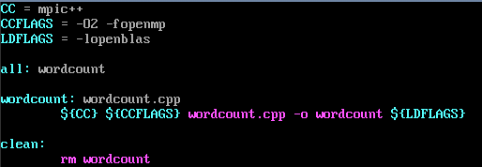

### 进行编译

执行以下命令，获取包（四台主机都执行）

wget https://github.com/xianyi/OpenBLAS/archive/v0.3.8.tar.gz

执行以下命令，进行编译（四台主机都执行）

tar -zxvf v0.3.8.tar.gz && cd OpenBLAS-0.3.8

make -j2

sudo make PREFIX=/usr/local/openblas install

sudo chmod -R 777 /usr/local/openblas/

执行以下命令，完成安装（四台主机都执行）

sudo ln -s /usr/local/openblas/lib/libopenblas.so /usr/lib/libopenblas.so

执行以下命令，配置OpenBLAS环境（四台主机都执行）

vim ~/.bashrc

添加下列内容

export CPLUS _INCLUDE_PATH=$CPLUS_INCLUDE_PATH: /usr/local/openblas/include

export LD_LIBRARY_PATH=$LD_LIBRARY_PATH:/usr/local/openblas/lib

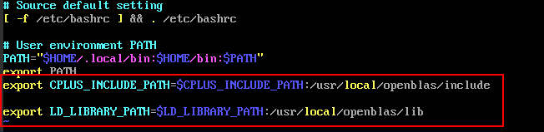

执行以下命令，使环境变量均生效（四台主机都执行）

source ~/.bashrc

执行以下命令，进行编译（四台主机都执行）

make

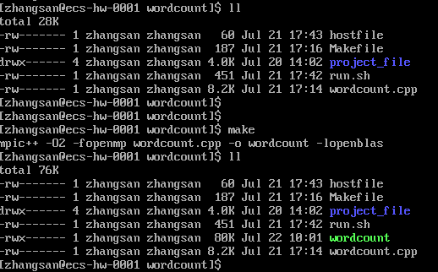

### 建立主机配置文件

执行以下命令，建立主机配置文件（四台主机都执行）

vim /home/zhangsan/wordcount/hostfile

添加内容如下：

ecs-hw-0001:2

ecs-hw-0002:2

ecs-hw-0003:2

ecs-hw-0004:2

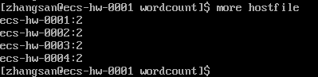

### 运行监测

编写run.sh脚本，内容如下：

app=${1}

if [ ${app} = "wordcount" ]; then

mpirun --hostfile hostfile -np ${2} ./wordcount

fi

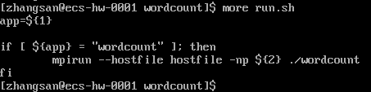

分别执行以下命令，查看wordcount运行结果（只需要在ecs-hw-0001上执行）

bash run.sh wordcount 2

bash run.sh wordcount 4

bash run.sh wordcount 6

bash run.sh wordcount 8

2、4、6、8数字表示启动处理的进程数量。

结果如下：

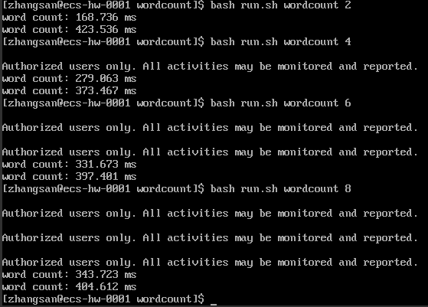

通过上述运行，可以看出wordcount算法程序已经在集群中并行运行起来。其中第一行输出代表的是大文件统计耗时，第二行输出代表的是小文件统计耗时。

## 思考题及答案

实现WordCount算法中比较关键的三步是哪些？

参考答案：getWords 、countWords 、treeMerge。