**Introduction to Robotics**

Homework 1

1. What are the characteristics of robot? (5 points)
2. Draw the configuration of robotics system. (5 points)
3. Draw the System block diagram of Intelligent Robot. (5 points)
4. What is DOF? How many DOFs does a mobile robot moving in a plane have? How many DOFs does an underwater robot have? How many DOFs does a mass point have in 3D space? Specify the translation DOF and rotation DOF respectively for each question. (10 points)
5. What’s the categories of articulated robots? What are their features, respectively? (5 points)
6. What’s the categories of Parallel robots? What are their features, respectively? (5 points)
7. Consider a mobile robot equipped with four Mecanum wheels (one kind of Omnidirectional Wheel).
   1. Describe the motion that mobile robot equipped with Mecanum wheels can do but the ordinary mobile robot cannot. (5 points)
   2. How many DOFs of the four Mecanum wheel mobile robot? (5 points)
   3. How to allocate angular velocities *ω*1, *ω*2, *ω*3 and *ω*4 of the Mecanum wheels enabling mobile robot has different kinds of motion direction (corresponding to the DOFs of the Mecanum wheel mobile robot), draw a force diagram and indicate the relationship among the angular velocities of the Mecanum wheels. (15 points)

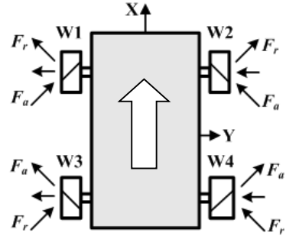

*ω*4

*ω*3

*ω*2

*ω*1

This figure is an example of force diagram. Here, to ensure the robot move along x-axis, angular velocity should satisfied relation *ω*1 = *ω*3 and *ω*2 = *ω*4.

1. Consider a mobile robot equipped with four Mecanum wheels, its geometry is given as follow. Assume its mass is *M* and distributed uniformly at the top plate. Mass of wheels and legs are ignored.

Top view

The top plate is a

regular hexagon

*L*

*M*

Mass load *m*

*L/2*

Wheels

*H*

*M*

Mass load *m*

*L/2*

Left view

Wheels

*H*

*M*

Mass load *m*

*L/2*

*L/2*

Front view

*x*

*y*

*y*

*z*

*O*

Coordinate (0,0,*H*)

*x*

*z*

*O*

*O*

* 1. Where is the ZMP? Describe the support polygon in mathematic form. (10 points)
  2. What are the largest accelerations of this robot along x-axis and y-axis (including positive and negative directions). (10 points)
  3. When the robot moves along y+ direction with acceleration *a* (it can ensure that *a* is smaller than maximum acceleration without load), what is the largest mass of load. (The load can be viewed as a mass point. Position of the load is given as follow). (20 points)