Image Transmission Module User Manual
- Connect the camera, image transmission module, and battery as shown below. 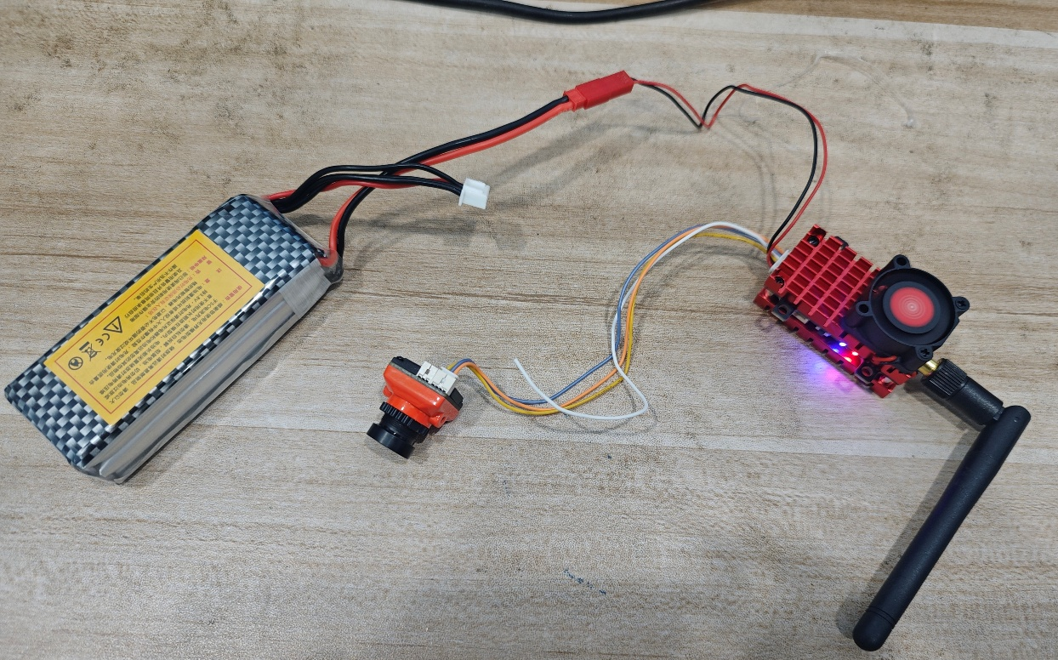
- After powering on the remote controller, configure it as shown below. 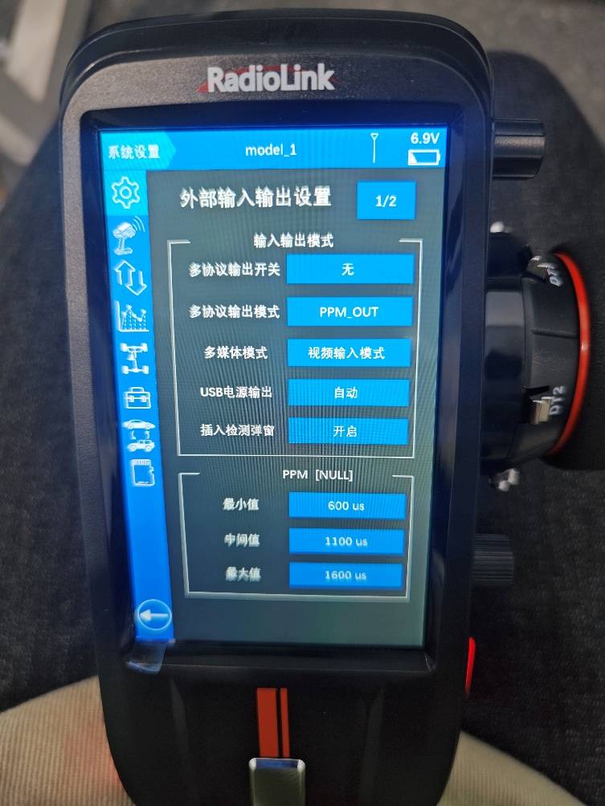
- Connect the receiver to the remote controller using the dedicated remote controller cable as shown below (the receiver is already paired with the image transmission module).
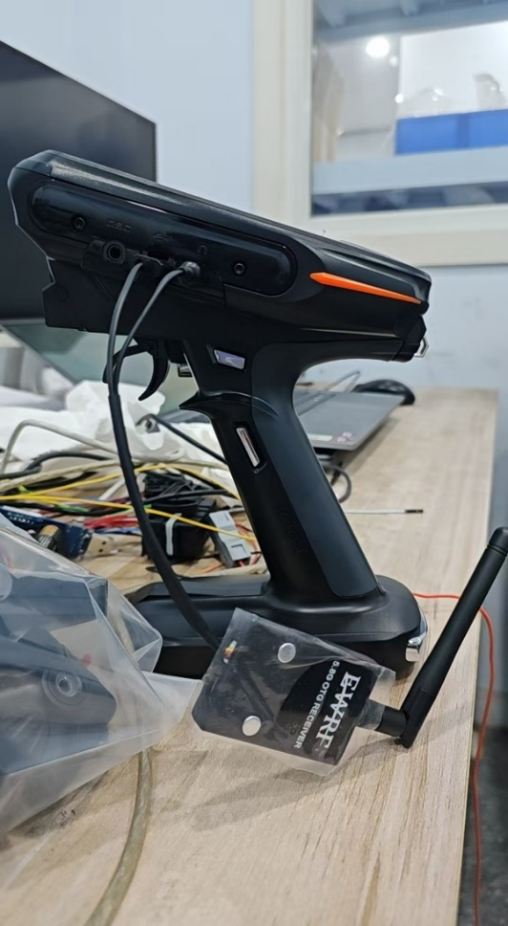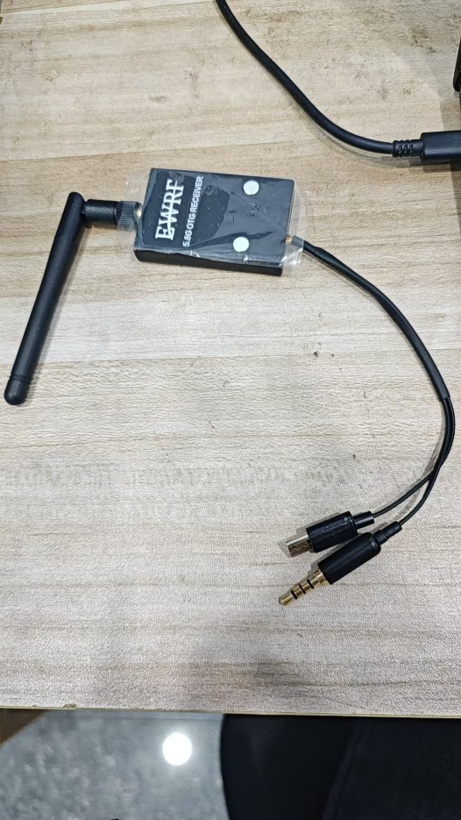
- In the pop-up window, tap and select “OK”.
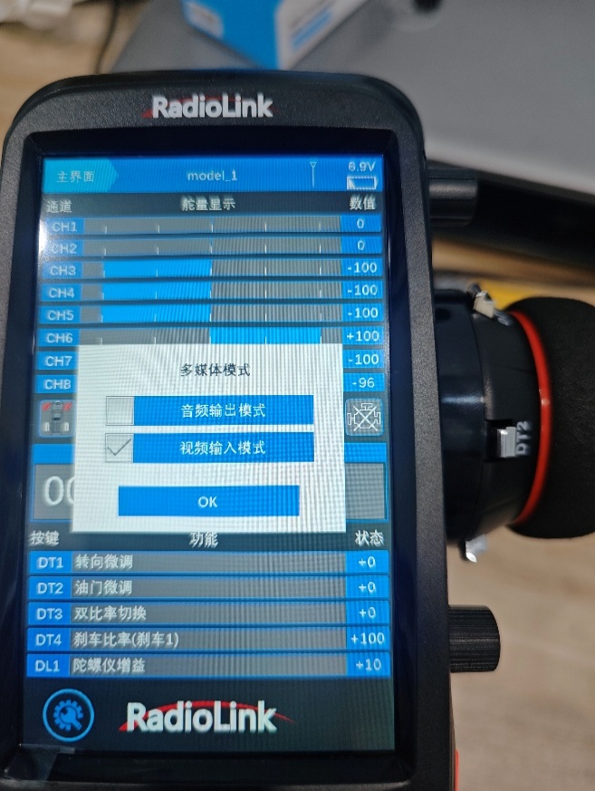
- When the connection is successful, the image will be displayed at the bottom of the screen.
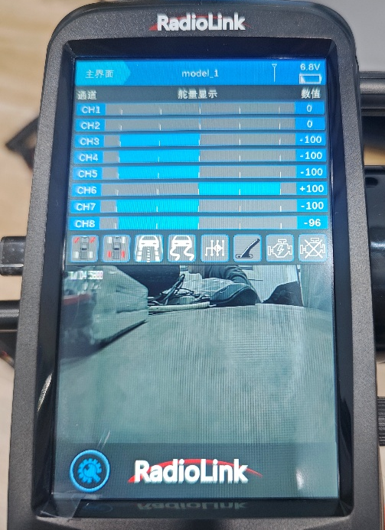
- If the image colors appear abnormal, connect the adjustment button to the camera as shown, then press the button and select VIDEO SETTING >> APPLY&REBOT.
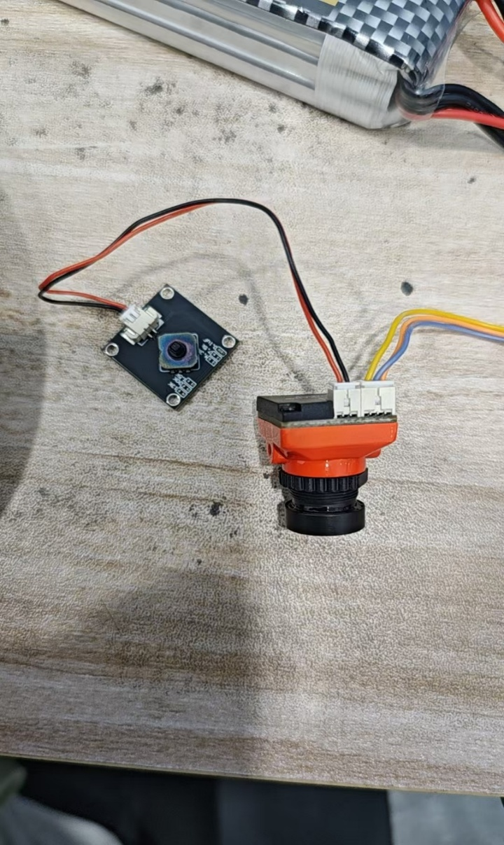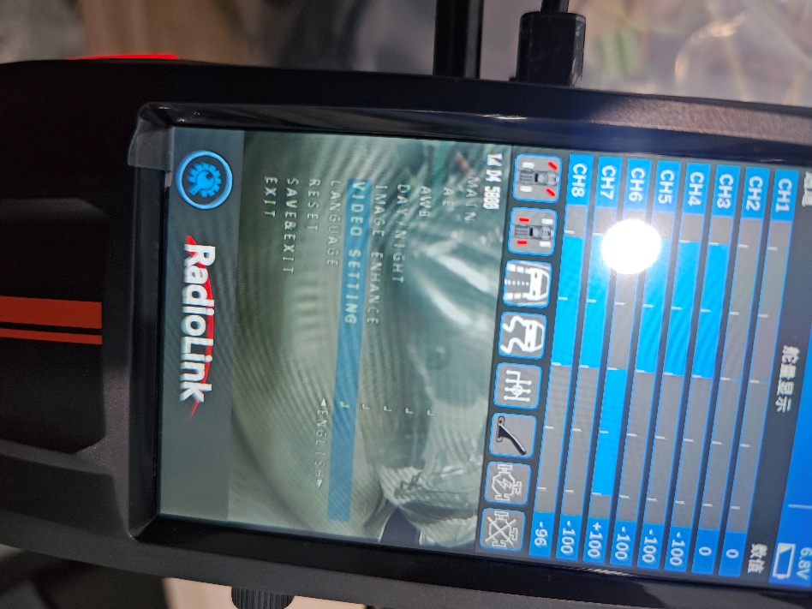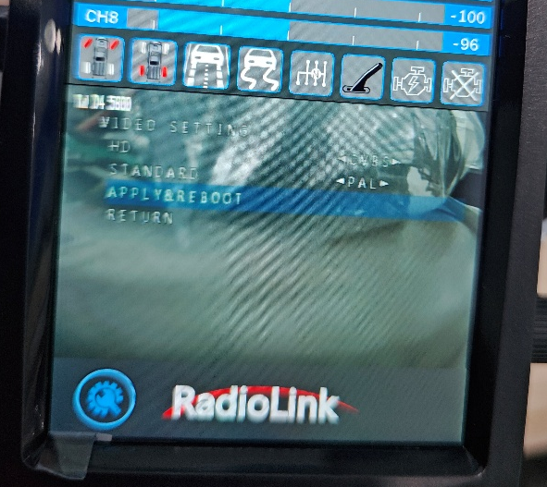
- Alternatively, use a phone cable to connect the receiver to your phone, open the app and view the feed, as shown below. 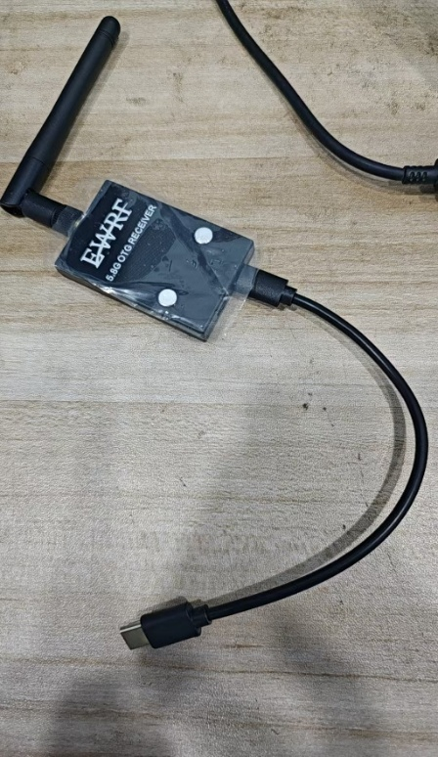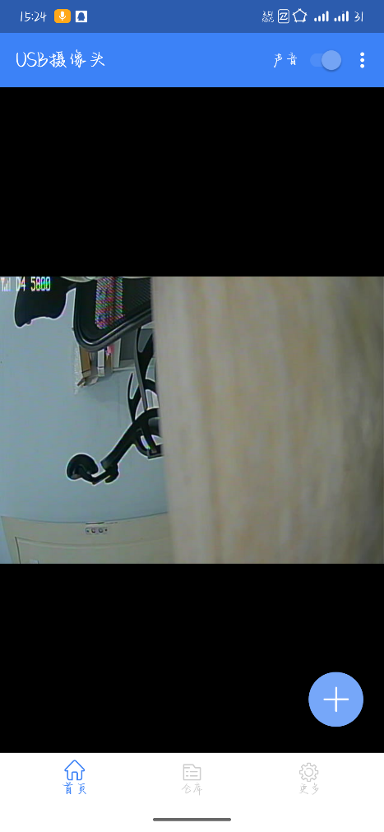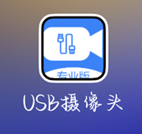

Notes:
- Do not change any other settings on the remote controller, otherwise there is a risk of losing control.
- Do not press any buttons on the image transmission module or the receiver, otherwise pairing will fail.

