Remote Control Vehicle User Manual
- Power On with Key
Insert and turn the key to power on the vehicle.
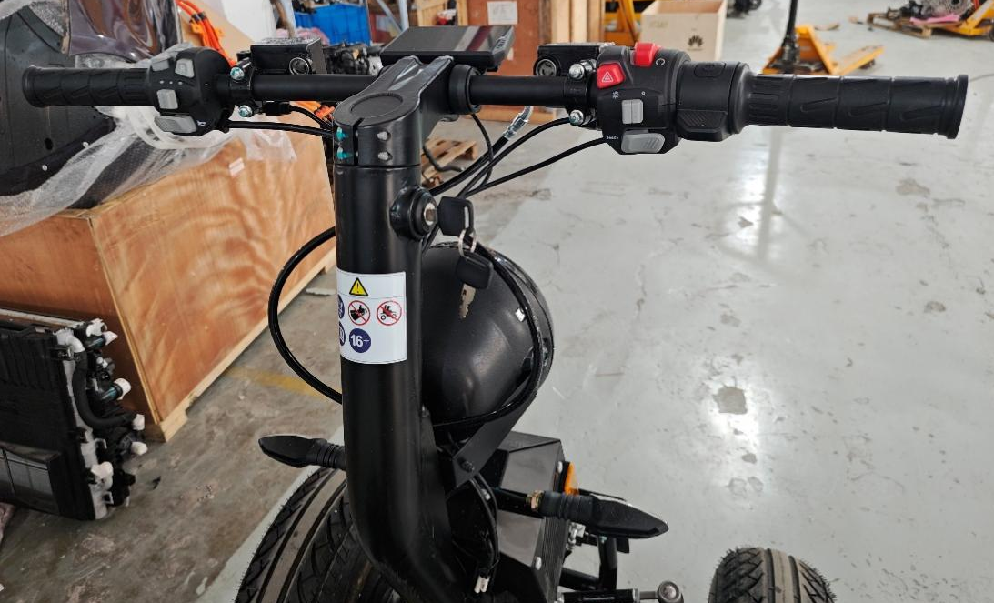
Key Switch
- Switch to Remote Control Mode
Press and hold the Mode Switch button for 3 seconds to activate Remote Control mode, as shown below. In remote control mode, the maximum speed is 10 km/h. Note: With the addition of remote control mode, the vehicle cannot perform spin turns when manually driven.
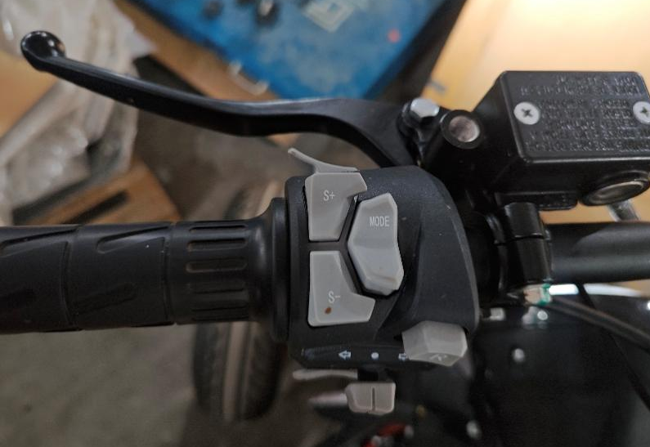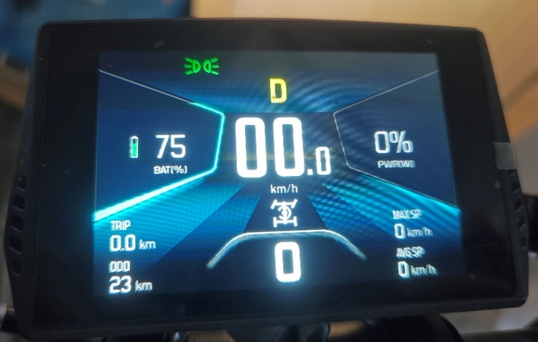
Remote Control Mode Indicator
Mode Switch Button
- Power On the Remote Controller
Press and hold the remote controller power button for 1.5 seconds. The remote controller will power on and automatically connect, as shown below.

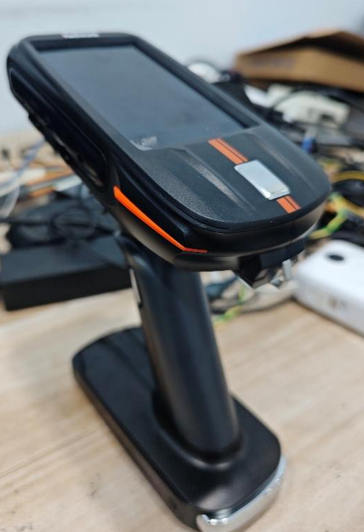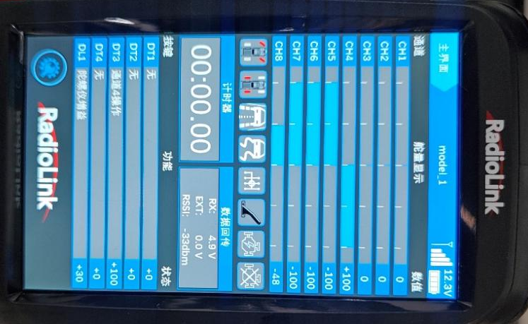
Touch Screen
Power Switch
Connection Indicatior
- Using the Remote Controller

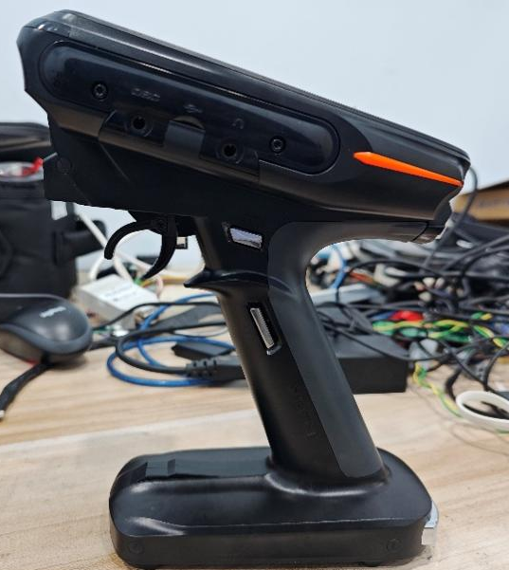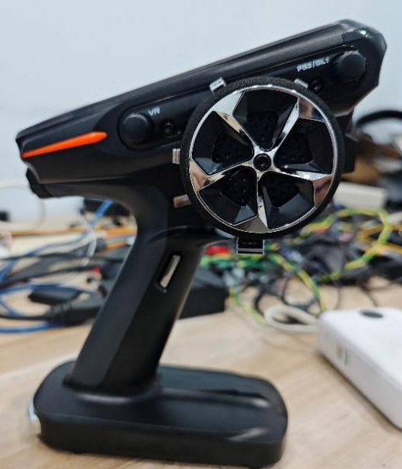
3
1
2
Switch 1 (DT3 – Gear Shift):
Toggle the switch up/down to shift gears. The display shows "ch4" and the corresponding signals:
- D (Drive) = +100
- N (Neutral) = 0
- R (Reverse) = –100
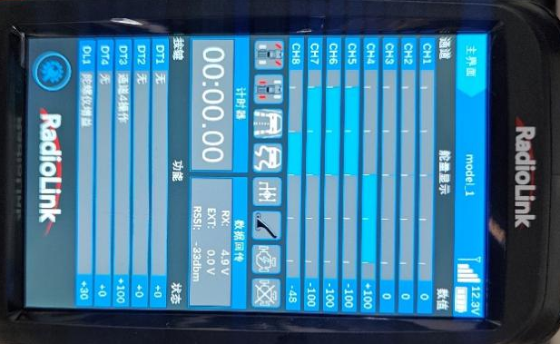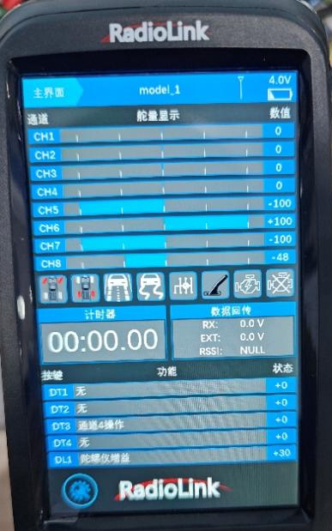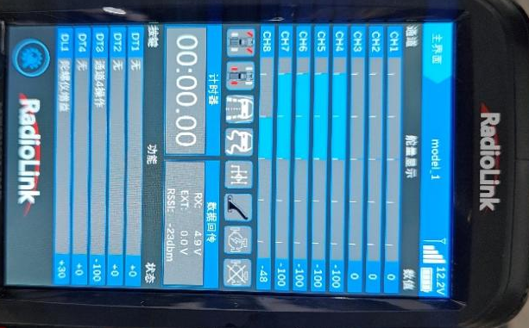

Switch 2 (Throttle Lever):
- Push down = drive
- Push up = brake
Switch 3 (Steering Wheel):
- Rotate forward → turn right
- Rotate backward → turn left
Spin Turn (Self-Rotation):
Before performing a spin turn, lock the steering mechanism using the same key used for power-on (see image). When the vehicle is in neutral gear, fully turn the steering wheel to enter spin turn mode. The spin torque increases as you push the throttle lever downward.
- Steering wheel fully forward (full lock) → spin right
- Steering wheel fully backward (full lock) → spin left
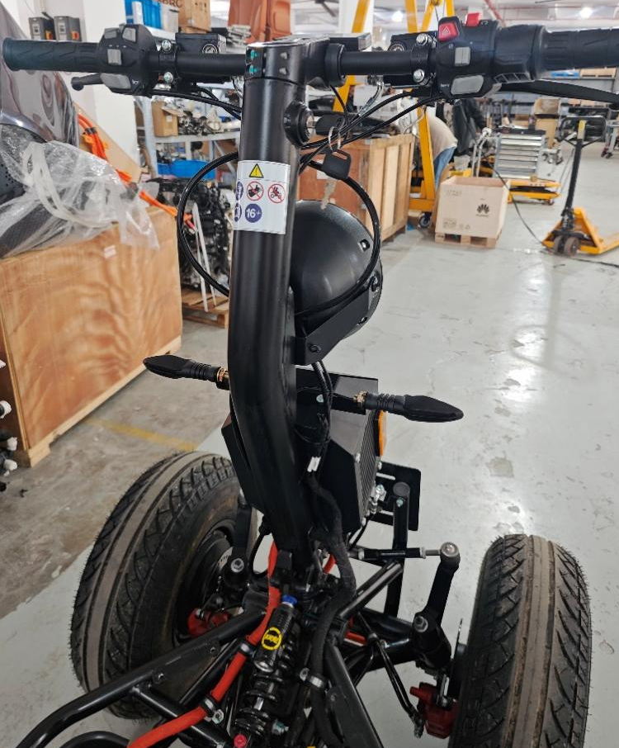
Locking Position
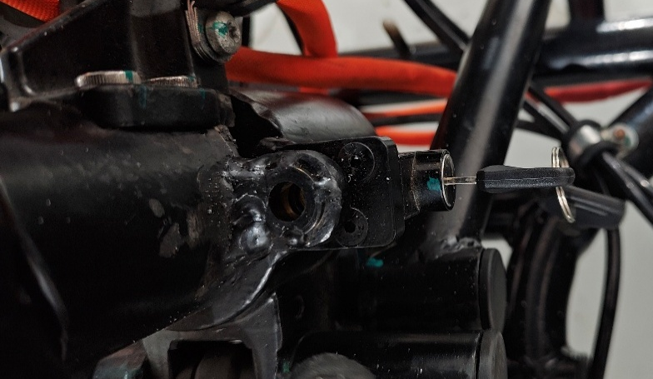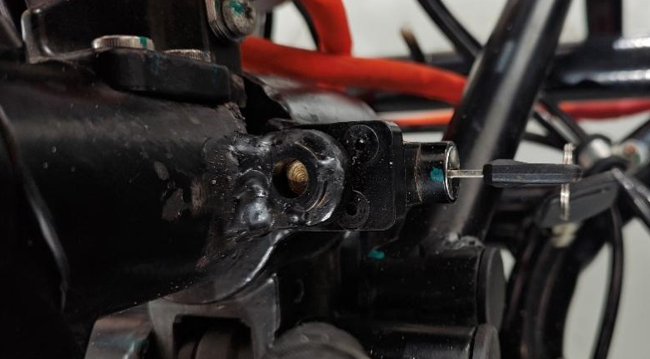
Locked
Unlocked
- Charging
Connect the charger to the charging port on the vehicle.
- Charging in progress: Red indicator light on the charger remains solid
- Fully charged: Green indicator light remains solid
- Error/Abnormal condition: Red indicator light flashes
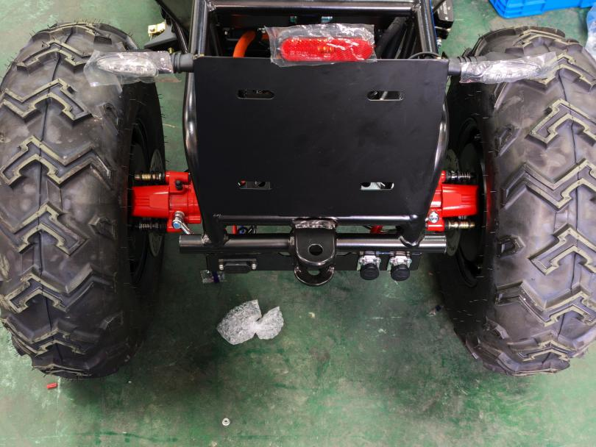
Charging Port
- Important Notes
(1) The vehicle will automatically power off after 5 minutes of inactivity.
(2) The remote controller is pre-configured; do not change its settings arbitrarily.
(3) Before turning off the remote controller, always shift the gear back to N (Neutral) position.

