QUALITATIVE ANALYSIS OF MACHINE LEARNING ALGORITHMS USING LIVER DISEASE DATASET.

Dissertation

Submitted by
Faizan Shakeel
Farwah Fatimah
Sehvish Riyaz
in partial fulfillment for the award of the degree of
BACHALORES OF ENGINEERING
in
INFORMATION TECHNOLOGY

Under the Guidance of
ASSIT.PROFF RAVINDER BHAIL


MODEL INSTITUTE OF ENGINEERING & TECHNOLOGY
MAY 2018

MODEL INSTITUTE OF ENGINEERING & TECHNOLOGY , J&K, INDIA

BONAFIDE CERTIFICATE

Certified that this Report titled “QUALITATIVE ANALYSIS OF MACHINE LEARNING ALGORITHMS USING LIVER DISEASE DATASET” is the bonafide work of FAIZAN SHAKEEL(517/14),FARWAH FATIMA(525/14),SEHVISH RIYAZ(527/14) carried out the work under my supervision. Certified further that to the best of my knowledge the work reported herein does not form part of any other project or dissertation on the basis of which a degree or award was conferred on an earlier occasion on this or any other candidate.

SIGNATURE
HEAD OF THE DEPARTMENT
SIGNATURE
SUPERVISOR

Acknowledgment

Successful completion of any task is unimaginable without appreciating the people associated with it. So, after the completion of this dissertation report, We would like to express our regards to all the persons who contribute with their helping hands, whether in a direct or indirect way. With a deep sense of gratitude, I wish to express my sincere thanks to Mr Ravinder Bhail, School of Information Technology and Engineering for his assistance and constant source of encouragement and for his exampolary guidance, monitoring and constant encouragement throughout the course of this project. The blessing, help and guidance given by him time to time shall carry a long way in the journey of life on which we are about to embark. We are extremely grateful to him for providing such a nice support and guidance throughout the session which helped us to complete project. I would like to extend my sincere regards to all the Faculty members of School of Information Technology and Engineering, MIET for their timely support.

Abstract
The Medical diseases analysis is emerging in the area of research. In recent years, various attempts are made for the creation of computer aided diagnosis applications. Due to errors in medical diagnostics systems can result in seriously misleading the treatment of patients. Machine learning finds various applications in the areas including computer aided diagnosis. After converting subject in equation disease can be indicated accurately. For the analysis of multi model bio medical data, machine learning offer the convenient approach for making classy and automatic algorithms. This project provides the comparative analysis of different machine learning algorithms for detection of liver disease.
The liver diseases are one of the most prevalent chronic diseases, worldwide. It is proved to be based on multi factors caused by complex interactions involving the genetic, epigenetic and environmental factors. This project demonstrate and analytical approach for prediction of liver diseases in patients using probabilistic model based on Artificial Neural network (ANN), KSVM, SVM, Naïve Baye’s. The technique used for classification and prediction are based on recognizing typical and diagnostically most important clinical features considered responsible for Liver diseases. These clinical features are provided as input to the classification model for prediction and qualitative analysis.
The main contribution of project involve developing of classifier model based on the above mentioned machine learning algorithms. The analysis confirmed high risk and low risk patients based on the predictions by the probabilistic model. The qualitative parameters involved in the research are Accuracy, Specificity and Sensitivity.

CONTENTS
CHAPTER NO. TITLE PAGE NO. ABSTRACT
LIST OF TABLE
LIST OF FIGURES
LIST OF SYMBOLS
1 INTRODUCTION 1
1.1 Motivation 2
1.2 Problem 2
2 LIVER DISEASE 3
2.1 Causes of liver disease 4
2.1.1 Alcohol abuse 5
2.1.2 Cirrhosis 5
2.1.3 Infectious hepatitis 5
2.1.4 Non-alcoholic fatty liver disease 6
3 DATA MINING 7
3.1 Data mining and its techniques 7
3.1.1 Knowledge Discovery from Data (KDD) Process 8
3.2 Classification 10
3.3 Machine learning 11
3.4 Machine learning in Healthcare 12
3.5 Popular machine learning techniques 13
3.6 Machine learning algorithms types 15
3.6.1 Naïve Bayes Classifier Algorithm 16
3.6.2 Artificial Neural Network (ANN) 16
3.6.3 K Nearest Neighbour 17
3.6.4 Support Vector Machines (SVM) Algorithm 17
3.6.5 Random Forest 18
3.6.6 Decision Tree 19
3.7 State of art 19
3.7.1 Specific requirements for machine learning systems 19
3.7.1.2 Performance optimization 20
3.7.1.2 Checking with missing data 20
3.7.1.3 Reduction of noisy data 20
3.7.1.4 Transparency of diagnostic knowledge 20
3.7.1.5 Explanation ability 20
3.7.1.6 Reduction of number of tests 21
4 LITERATURE SURVEY 22

5 DESCRIPTION OF DATA 26
5.1 Data set 26
5.2 Clinical attributes analysis 27
5.3 Methodology 31
5.3.1 Data cleaning 32
5.3.2 Feature selection 33
5.3.3 Classification and Model Building 33
5.3.3.1 KSVM Model 33
5.3.3.2 SVM Model 34
5.3.3.3 Naïve bayes Model 36
5.3.3.4 Artificial Neural Network (ANN) 38
5.3.4 Performance Evaluation 41
5.3.5 Tabulation of results and visualization. 43

6 RESULTS AND DISCUSSION 44
6.1 Experimental results 44
6.2 SVM model results 45
6.3 KSVM model results 46

6.4 Neural Network model results 47

6.5 Naive Bayes model results 49

7 CONCLUSION 51
7.1 Contribution 51
7.2 Future work 52
Refrences 57

s

List of tables
Table 5. 1: Snapshot of the liver data set
Table 5.2: Normal range values of the clinical attributes of Liver Function Test (LFT).
Table 5. 3: Confusion Matrix of the two classes in the data set.
Table 6.1: Showing the output of the Algorithms.

List of figures
Figure 2.1: Position of the liver in human body.
Figure 3.1: KDD Process.
Figure 3.2: General process of classification of data.
Figure 3.3 : Shows types of machine learning
Figure 5.1: Phase 1 of the methodology applied.
Figure 5.2: Separating hyper planes and margin. Two different possible separating hyper plane are shown.
Figure 5.3: Architecture of a neural network.
Figure 5.4: Phase 2 of the methodology applied.
Figure 5.5: System architecture.
Figure 6.1: Confusion Matrix of the SVM model.
Figure 6.2: Confusion Matrix of the KSVM model.
Figure 6.3: Confusion Matrix of Neural network model.
Figure 6.4: R-Plot of Neural network.
Figure 6.5: Confusion Matrix of Naïve Bayes Model.
Figure 6.6: Showing the output of the machine learning algorithms with there classification parameters.

Chapter 1
Introduction
Liver disease is a disturbed influence of liver capacity that causes disease. The liver is responsible of numerous basic processes inside the body and it shouldn’t be infected or damaged, the loss of these organs can make huge harm to the body.
Liver disease is a wide term that covers all the issues that the liver neglect to do its assigned capacities. Normally, over 75% or 75% of liver tissue should be influenced before a diminishing in function happens.
Machine learning is that part of Artificial Intelligence which learn from the past experiences. This project looks at classification, where an algorithm predicts the performance valuation of an unknown sample. Single set of features is called as samples. The machine learning algorithms uses these sample and build up themselves for the classification. Using the model, with machine learning in it, the system can then predict the labels of new samples, called the testing set. The most important applications of machine learning in medical diagnostics are feature selection and classification, which we also use in this project to address the underlying problem.

As many classification machine learning methods have been proposed here like KSVM, Naivye bayes , ANN, SVM being the advanced method have attained the highest accuracy.

1.1 Motivation
One of the most common diseases is Liver disease. Worldwide, Liver cancer is the fifth most commonly diagnosed cancer in men and the seventh in women.[1]
Failure of liver are at high rate of risk among Indians. The diagnosis of liver disorder at any early stage helps in designing effective prevention measures. In India, one in five persons is affected by liver disease. It is expected that by 2025 India may become the ‘World Capital for Liver Diseases’. The widespread occurrence of liver infection in India is contributed due to deskbound lifestyle, increased alcohol consumption and smoking.
There has been a paradigm shift in the dynamics of liver cirrhosis and about 10 lakhs new patients are diagnosed with it every year in India.
In this project various Liver Function Test (LFT) reports are been given input to the models which are being proposed and the highest accurate and proper model is been given the preference in the comparison.
1.2 Problem statement
The main problem in this work we have shown is that we compare various machine learning models on the basis of their parameters like sensitivity, accuracy, specificity. The main part of the research involves to find out the appropriate and suitable algorithm for the efficient diagnosis and classification of the liver disease data set. The algorithms use mathematical techniques to separate different data features.

Chapter 2
Liver disease
The liver is the biggest strong organ in the body; and is likewise viewed as an organ in the body, it makes and secretes bile. It is situated in the upper right portion of the stomach area covered by the rib confine. It has two primary flaps that comprise of modest lobules. The liver cells have two roots of blood supply. The hepatic course supplies oxygen rich blood that is pumped from the heart, while the entryway vein supplies supplements from the digestive system and the spleen.
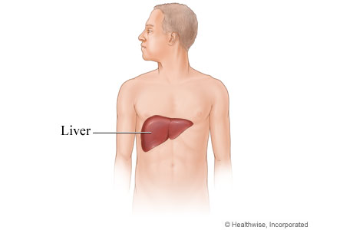
Figure 2.1: Position of the liver in human body.
Image Source: https://www.webmd.com/hepatitis/liver-diagram
2.1 Causes of liver disease
As a component of its capacity, the liver makes bile, a liquid that contains among different substances, water, chemicals, and bile. Bile goes in the gallbladder and when sustenance enters the duodenum, bile is emitted into the duodenum, to help in the absorption of nourishment.
The liver is the main organ in the body that can work without much of damaged cells, yet in the process that enough cells are lost.
Cirrhosis is a term that depicts changeless scarring of the liver. In cirrhosis, the typical liver cells are replaced by scar tissue that can't play out any liver capacity.
Intense liver damaged could possibly be reversible, implying that now and again, there is a treatable reason and the liver might have the capacity to recoup and continue its ordinary capacities.
The liver can be damaged in many ways.
• Cells can wind up excited, for example hepatitis.
• Bile stream can be obstructed.
• Cholesterol ortriglycerides can gather.
• Blood stream to the liver might be compromised.
• Tissues of liver can be harmed by chemicals and minerals, or invaded by irregular cells, similar to tumor cells.
2.1.1 Alcohol abuse
Alcohol abuse is the most well-known reason for liver illness. Alcohol is straight forwardly poisonous to liver cells and can cause liver irritation, known to as alcoholic hepatitis. In access alcohol mishandle, fat is gathered in liver cells which reduce their capacity to work.

2.1.2 Cirrhosis
Cirrhosis is a late-phase of liver illness. Scarring of the liver and loss of working liver cells make the liver come up short. Significant number of liver cells should be damaged before the organ neglects to work.
2.1.3 Infectious hepatitis
The expression "hepatitis" implies irritation, and liver cells can wind up aggravated in view of contamination.
Hepatitis A is a viral disease that spread through the fecal-oral course. Hepatitis A causes an intense irritation of the liver by which enlarge suddenly. Proper hand washing, particularly while preparing the food is the most ideal approach to protect the spread of hepatitis A. This is particularly vital for laborers who work in the food and eatery enterprises.
Hepatitis B is spread by exposure to body fluids (needles from tranquilize abusers, polluted blood, and sexual contact) and can cause an intense infection, however this can lead the cirrhosis and liver cancer. The hepatitis B antibody can keep this disease.
Hepatitis C causes chronic hepatitis. A infected individual may not find any intense sickness. Hepatitis C is spread by introduction to body liquids. Chronic hepatitis C may prompt cirrhosis and liver tumor. At present, there is no immunization against this infection. More medicines and drugs are presently accessible to treat and cure Hepatitis C.
Hepatitis D is an infection that requires attending disease with hepatitis B to survive, and is spread by mean s of body fluid.
Hepatitis E is an infection that is spread by means of exposure to contaminated food and water.
2.1.4 Non-alcoholic fatty liver disease
NASH or non-alcoholic steatohepatitis (also referred to as "fatty liver") is the accumulation of fat within the liver that may cause inflammation of the liver and a instant decrease in liver function.[2]

Chapter 3
Data mining
3.1 Data mining and its techniques
With advancement in science, many machines have emerged in our lives. One of the most famous areas where computers as the mostly used machines can be helpful is knowledge extraction with the help of a machine (machine learning). [3]
The term data mining [4] alludes to the discoveries of significant and helpful data from databases. Data mining is the large extraction of verifiable, beforehand obscure and conceivably valuable data from the information. This envelops various specialized methodologies, for example, clustering, data outline, grouping, discovering reliance organize, examining changes and recognizing inconsistencies. Data mining and data revelation is the new interdisciplinary field, combining thoughts from insights, machine learning, database and parallel figuring.

3.1.1 Knowledge Discovery from Data (KDD) Process
Several people treat data mining as a synonym for another popularly used term,
Knowledge discovery from data or KDD [5] is the process of getting the hidden knowledge from data warehouse. The knowledge discovery process is another sequence of many steps. The first step is data cleaning which includes removal of noise and irrelevant data. The second step is data integration in which multiple data sources can be gathered for a better data. The next step is data selection where data relevant to the analysis task are retrieved from the database. In data transformation data are transformed and consolidated into forms appropriate for mining by performing operations. Next step is data mining where intelligent methods are applied to extract data patterns.

Next step is pattern evaluation where the identification of truly interesting patterns representing knowledge are performed. The last step is knowledge presentation where visualization and knowledge representation techniques are used to present mined data knowledge to users. The following figure 3.1 shows the KDD process.

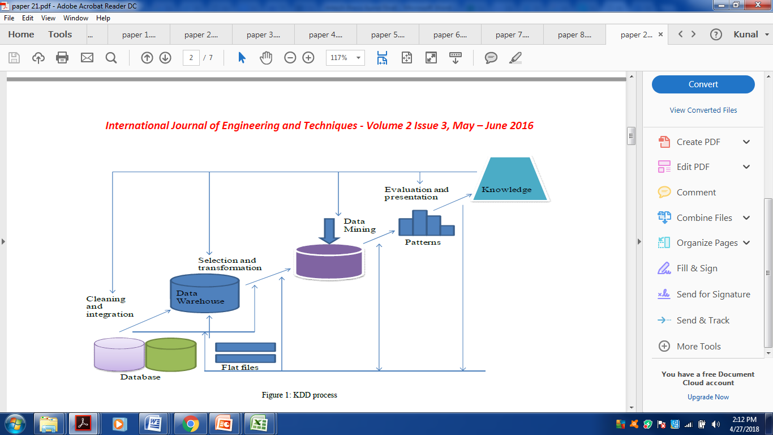
Figure 3.1: KDD Process.

Many data mining applications like classification, clustering, association rule mining and prediction. In this research, we have focus on classification techniques to classify the liver patient data. The figure 3.2 shows that general process of classification of liver patient data. In this process we have applied the liver data set on the classifier that is capable of classifying the data as liver and not liver data.

NON DISEASED PATEINTS
LIVER DATASET

CLASSIFIER

DISEASED PATIENTS

Figure 3.2: General process of classification of data

3.2 Classification
The most important unsupervised learning is classification. To provide a class to one of the given classes in the data is the basic aim of classification. The aim to develop a classification problem is to get better accuracy results in the classification of the objects. The classification problem can be discussed as follows:
The purpose of classifier is to differentiate between the attributes of the objects within the classes. Then, the classifier is used to predict the group attributes of new cases from the data based on the values of other attributes.
Measurement vectors along with the known classes of them are input to the classifier. This is called the training set,and is used to build the classifier. When the classifier is builde up, it gives a new test sample, x, it’s class is predicted by the classifier. Very large number of variables may impose difficulty for the classifiers to perform accordingly. Thus we use small amount of features which is known as feature selection in data mining. The classifiers are builded so that there is accurate and perfect result.The medical data has very few features in it which is the problem for the model to work prpoerly. Thus, the classifier has to design a general behavior from relatively few samples. If the size of the sample is small, it is less likely to accurately represent the real world, and more likely to be biased. The model complexity and its relationship to performance and generalization capabilities is another major reason for poor performance of the classifiers. If the classifier is too simple, it fails. On the other side, if the classifiers is much complex and there are many irrelevant features it may lead to over fitting in the classifier model. The classifier can achieve 100% accuracy on the training set but the real performance on testing is poorer. [6].
3.3 Machine learning
It is a sub field of artificial intelligence that focuses on automatic methods. In other words, the primary concern of machine learning is to construct algorithms that can learn automatically without human assistance. Machine learning is the process of studying computer algorithms for learning to complete a task, or to behave intelligently when new or unexpected problems arise, or to make accurate predictions. The learning is based on some of the observations or data, such as examples, direct experience, or instructions. So it can be said that machine learning is about learning to do better in the future based on what was experienced in the past.

3.4 Machine Learning in Healthcare
In human life healthcare plays a great role, automatic knowledge extraction from medical data sets has become an important issue. Research on knowledge extraction from medical data is emerging very fast. All activities in healthcare can be divided into six tasks: screening, diagnosis, treatment, prognosis, monitoring and management.
In the modern time, healthcare is more reliant on medical automated diagnosis. Machine learning methods are required to assist the physicians in identifying and curing abnormalities at early stages. Medical diagnosis is one of the important activities of medicine. The accuracy of the diagnosis helps in deciding the exact treatment and also helps in curing the diseases. Humans have a strong skill for sensing the environment and perform according to that change. They act against what they get from environment. There actions are machine based actions, which benefit them for the easiness [7].
Modern hospitals are well equipped with monitoring and other data collection devices, and data is gathered and shared in information systems. Health care field have large data about clinical report’s regarding patient, follow-ups, medication etc. It is complex to arrange in a suitable way. Fine quality of the data organization has been hampered due to improper management of the data. Enhancement in the amount of data needs some proper means to extract and process data effectively and efficiently [8].
We have to train a computer program using the patient records. The medical diagnostic knowledge can be automatically derived from the details of cases solved in the past. The derived classifier can then be used either to assist the physician when diagnosing new patients in order to improve the diagnostic speed, accuracy, and/or to train students or physicians.

Medical diagnosis is the art of showing a person’s clinical status from an available set of clinical reports. Diagnosis is often challenging because many diseases have similar signs and symptoms. Due to the mixing of various parameters between multiple diseases, which have a deciding impact over the correct & timely diagnosis of a disease, it becomes a difficult task for the medical expert to manually diagnose the underlying disease; if the medical expert could be assisted in this work of diagnosis it will be helpful for him as well as for the patient. Ample use of machine learning algorithms in medical diagnosis can help the computer based systems in the healthcare. Especially in developing and highly populated country like India where mortality ratio is high the proposed system in medical diagnosis can assist physicians to diagnose and cure diseases at early stage.
3.5 Popular Machine Learning Techniques
Supervised learning.
Unsupervised learning.
Semi supervised learning.
Reinforcement learning.
Evolutionary learning.
Deep learning.

Figure 3.3 : Shows types of machine learning
1) Supervised learning: In supervised learning training sets are created with the valid inputs. These training set then further train the model for the testing of the new data. Algorithms performs according to the training set data.Learning from examples is another name of Supervised Learning. Classification and regression are the types of Supervised Learning. [9]

2) Unsupervised learning: It doesn’t provide correct responses. Unsupervised learning tries to find out the similarities between the input data and based on these similarities, un-supervised learning classifies the data. This is also known as density estimation.

3) Semi supervised learning: Semi supervised learning technique is a class of
Supervised learning techniques. The unlabelled data is used in training of this learning.

4) Reinforcement learning: This learning is boosted by behavior of psychology. The algorithm is informed that the output is wrong but the solution is not there how to correct the problem. It explores and test various possibilities until it finds out the right answer. It is also known as learning with a critic. It does not do improvements.It give prefence on on-line performance.

5) Evolutionary Learning: It is a biological learning, which is considered as a learning process: biological organisms adapt themselves to make progress in their survival rates and chance of having off springs. By having the idea of fitness, to check how accurate the solution is, we can use this model in a computer.

6) Deep learning: This branch of machine learning is based on set of algorithms.
In data, these learning algorithms model high-level abstraction. It uses
many processing layers, which are composed of many linear and nonlinear transformation.

3.6 Machine learning algorithms types
Some of the machines learning algorithms are: Naïve Bayes Classifier Algorithm, K Nearest Neighbour Algorithm, Support Vector Machine Algorithm, Random Forests, Decision Trees, Artificial Neural Network, Genetic Algorithms, Linear and Logistic Regression, Kernel Support Vector Algorithm.

3.6.1 Naïve Bayes Classifier Algorithm
Bayesian Classifiers are based on bayes theorem. It is a algorithm and it shows higher accuracy rate on large databases. It mainly works on the effect of an attribute value on a given class and it is independent of the values of the other attributes. Bayesian classification can predict class membership probabilities, such as probability that a given tuple belongs to a particular class.
[10]

3.6.2 Artificial Neural Network (ANN)
It is an important tool that can be widely used for classification problems. This technique is performed in three steps for the classification of data. These steps are formation of the network, training, network pruning and rule extraction. To train the neural network four parameters are used. These four parameters are the numbers of hidden layers, training cycle, training rate and momentum. The classification error rate of ANN is less than all other models but the response time of this model is high as compare to others [11], [12].

3.6.3 K Nearest Neighbour
K-Nearest neighbor algorithm (KNN) is the supervised learning algorithms which is used in the field of data mining previously. It follows a pattern for classifying objects based on closest training examples in the feature space [13].
M majority of its neighbors classifies the object. K is always a positive integer. The correct classification is known by which the neighbors are selected from set of objects. The K nearest neighbors’ algorithm is as follows:

1.It determine the parameter K which is , total of nearest neighbors beforehand.

2. Distance is measured between query-instance and all the training samples.

3. Distances for all the training samples are checked and nearest neighbor based on the K-th minimum distance is determined.

4. KNN is supervised learning, it get all the types of the training data under K.

5. Value of the prediction is measured by using the majority of nearest neighbors.

3.6.4 Support Vector Machines (SVM) Algorithm
A Support Vector Machine (SVM) classifies the data into two broad categories of performing classification and constructing a N-dimensional hyper plane. This model uses a sigmoid kernel function which is equivalent to a two-layer, perceptron neural network. By using a kernel function, these are an another training method for polynomial, and multilayer perceptron classifiers in which the weights of the network are found by the solution of a quadratic programming problem with linear constraints.

In the SVM model, a predictor called as an attribute and a transformed attribute which defines the hyper plane is called a feature. Choosing the most suitable representation known as feature selection. A set of features that depicts one case is called a vector. The task of this modeling is to find the optimal hyper plane which differentiate clusters of vector in such a way that cases with one category of the target variable are on one side of the plane and cases with the other category are on the other side of the plane. The vectors which are closed to the hyper plane are called support vectors. [14]
3.6.5 Random Forest
Random forests is as learning method for classification which is operated by constructing a multitude of decision trees at training time and outputting the class that is the mode of the classes output by individual trees. It works efficiently on large data base sets [15]. It handels thousands of input variables without it’s deletion in the data set. It gives an estimate of the variables which are important in the classification. Random Forests emerges many classification trees. In ordert o classify a new object from an input vector, put the input vector in each of the trees in the forest. Each tree gives a classification, and we say the tree "votes" for that class. The forest chooses the classification having the most votes [16].

3.6.6 Decision Tree
Decision trees are powerful classification algorithms. Popular decision tree algorithms include C4.5, C5, and Breiman et al.’s CART. This technique separates observations in branches to construct a tree for the purpose of improving the prediction accuracy. Mathematical algorithms are used to identify a variable and corresponding threshold. This step is repeated at every leaf node until the complete tree is constructed.

3.7 State of art
In this section, we give brief description of the main requirements that any machine learning system has to satisfy in order to be used in the development of application in the medical field for the diagnosis of the diseases. We have compared the performance of all the algorithms on the liver data set and their appropriateness for application in medical diagnosis is discussed.

3.7.1 Specific requirements for machine learning systems
For a machine learning (ML) system to be useful in solving medical diagnostic tasks, the following features are observed: good performance, the ability to appropriately deal with missing data and noisy data, the transparency of diagnostic knowledge, the ability to explain decisions, and the ability of the algorithm to reduce the number of tests necessary to obtain reliable diagnosis.
3.7.1.1 Performance optimization
The algorithm must be able to extract important information from the data available. It is expected from the algorithm to achieve the same level of accuracy on each test case as achieved for the training case. Most of the algorithms perform as same as the physicians and often accuracy of the algorithms are more accurate then the physicians.
3.7.1.2 Dealing with missing data
In medical diagnosis, very often the description of patients in patient records lacks certain data. Machine learning algorithms have to deal accordingly with such incomplete descriptions of the patients.

3.7.1.3 Dealing with noisy data
Medical data mainly suffers from errors. Therefore, machine learning algorithms suitable for medical applications have to have effective means for handling noisy data.

3.7.1.4 Transparency of diagnostic knowledge
The generated knowledge and the explanation of decisions should be transparent to the physician. He should analyze the knowledge extracted.

3.7.1.5 Explanation ability
The system should be able to explain decisions while diagnosing the new patients. When having an unexpected solution to a new problem, the physician shall require further explanation from the system.

3.7.1.6 Reduction of number of tests
In the field of medical practice, the collection of patient data is mostly expensive, time consuming, and harmful. Therefore it is essential to have a classifiers that can diagnose the problem with a small amount of data .

CHAPTER 4
LITERATURE SURVEY
In this paper, authors A. Singh, B. Pandey made a survey on combination of Artificial Intelligence methods which are used to obtain the results in classifying unhealthy liver from healthy liver. Their survey has confirmed that integrated intelligent technologies may be used for identifying liver disorders [17].

Prof. N. B. Venkateswarlu has proposed the application of back propogation and support vector based machine learning techniques involving first data set from UCLA liver data set with 5 attributes and another one from actual liver patients based records having 12 attributes from the state of Andhra Pradesh in India [18].

Mehdi Neshat , has taken the data set from UCI machine learning repository to find out the diseased liver from healthier one. Here author considered combination of two methods namely CBRPSO and PSO. CBRPSO method was better in relation to PSO method in an average state and has higher efficiency [19].

Anju Gulia, Dr. Rajan Vohra, Praveen Rani, have applied ILDP dataset from UCI Machine learning Repository with five different Classification algorithms. Authors in this paper showed that out of all five classification algorithms, Random Forest algorithm performance was with 72.0% accuracy which is the highest when compared to all the other techniques with the help of feature selection[20].

In this, authors Meherwar Fatima, Maruf Pasha, have described and proved the use of new tools of machine learning algorithms that are used to analyze the diseases and in decision making process accordingly[21].

Shimaa Abd Allah Ibraheem et.al designed a Hybrid Rough-Fuzzy Classifier for Liver Disease Diagnosis. In initial stage rough sets were used to generate and reduce classification rules which are then used in fuzzy were found to further enhance the classification accuracy of liver diseases diagnoses. The proposed model had shown 99.1 % classification accuracy [22].

Rajeswari, P. put forward an analysis of liver disorder by using Data Mining Algorithm [23]. Naive Bayes provide 96.52% Correctness. By using FT tree 97.10% accuracy is achieved. K star algorithm which have classified the instances about 83.47% accurately.

Milan Kumari and Sunila Godara analyze a cardiovascular data set by using the following machine learning algorithms RIPPER classifier, Decision Tree, Artificial neural networks (ANNs), and Support Vector Machine (SVM) .
10-fold cross validation method was used to measure the unbiased estimate of
these prediction models. SVM predicts cardiovascular disease with least error rate and highest accuracy.[24]

Vijayarani and Dhayanand analyzed the liver disease by using Support vector machine and Naive bayes Classification algorithms. Comparison of the algorithms was done on the basis of accuracy and time execution. Naive bayes shows 61.28% correctness, 79.66% accuracy achieved by SVM. For implementation, MATLAB is used. SVM shows highest accuracy as compared to the Naive bayes for liver disease prediction. Naive bayes took less time than SVM[25].

Sangman Kim et.al proposed effective liver cancer diagnosis method based on neural network and fuzzy neural network. The fuzzy logic finds only the important attributes that helps in diagnosis of liver diseases and the proposed model detects liver cancer patients with an accuracy of 98~99 % [26].

According to Parisa Tavakkoli et.al classification and clustering of liver disorders data into two healthy and ill categories is done by using five-layer ANFIS combined structure. The results show an appropriate separation between the healthy and patient data; therefore the result will be reliable and credible to detect the disease and extension for the other disease [27].

Shiladitya Saha et.al employed artificial neural network and support vector machine classifiers for the classification of patients who was suffering from jaundice on the basis of liver data condition. Many sets of MLP and SVM classifiers are combined with Decision template and Dempster-Shafer theory fusion techniques. Hybridization of two ANNs and four SVM classifiers with Dempster-Shafer algorithm gives up to 97.33% of prediction accuracy [28].

In a study by Ramana various different classification algorithms were implemented for the diagnosis of liver disease. The machine learning algorithms which were implemented are Naïve Bayes, C4.5, Neural Network, K-means and SVM. The performance of the algorithms was tested in different data sets. In this neural network classifier resulted best in an accuracy of 71.59% for all the features in the liver dataset [29].

Karthik et.al implemented a soft computing method for intelligent early diagnosis of liver disease. They implemented classification and its type detection in three phases. In the first phase, they classified liver disease using Artificial Neural Network (ANN) classification algorithm. In the second phase, they generated the classification rules using rough set rule induction using Learn by Example (LEM) algorithm. In the third phase they applied fuzzy rules on the livber data set [30].

Chapter 5
Data Model
5.1 Data set
The study aims to establish the relation between liver diseases and various clinical test features present in the data set. The data of 558 patients including 371 with normal liver grouped as Class A and 187 with diseased liver grouped as Class B are analyzed. Each case was associated with attributes Gender, Age , Total Bilirubin (TB ) ,Direct Bilirubin (DB), IndirectTB, Total Proteins (TP), Albumin (ALB), Alkphos alkaline phosphate(ALKP), Aspartate aminotransferase (SGOT), Almine aminotransferase (SGPT).
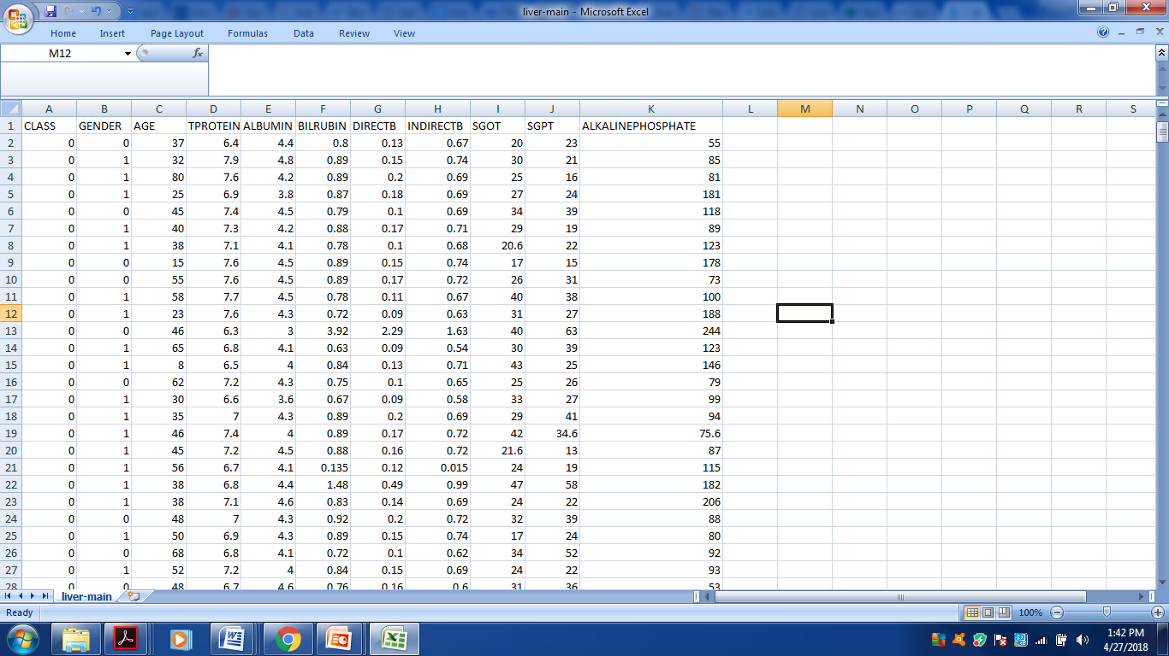

Table 5. 1: Snapshot of the liver data set.
The attributes are described in the row 1, with their values on the column respectively.
5.2 Clinical attributes analysis
The clinical attributes considered for the liver disease analysis are Gender, Age, Total Bilirubin (TB),Direct Bilirubin (DB), Total Proteins (TP), Albumin (ALB), Alkphos alkaline phosphate(ALKP), Aspartate aminotransferase (SGOT), Almine aminotransferase (SGPT). Liver function tests helps in determining the health of liver by measuring the levels of proteins, liver enzymes, or bilirubin present in the blood.
S.No. | Attributes | Short Name | Reference Value
1 | Gender | GENDER | Male M  Female F
2 | Age | AGE | Min -4 years  Max -90 years
3 | Total Bilirubin | TB | 0.1 – 1.45 mg/dl
4 | Direct Bilrubin | DB | 0 – 0.7 mg/dl
5 | Total Protein | TP | 6.1 – 8.0 gm/dl
6 | Albumin | ALB | 3.2-5.5 gm/dl
8 | Alkphos alkaline phosphate | ALKP | 20 – 140 IU/L
9 | Aspartate aminotransferase | SGPT | 5.0 – 49.0 IU/L
10 | Almine aminotransferase | SGOT | 5.0 – 46.0 IU/L

Table 5. 2: Normal range values of the clinical attributes of Liver Function Test (LFT).
5.2.1 Total protein(TP)
Normal range 6.1 – 8.0 mg/dl :A total protein test measures the total amount of protein in the blood. It measures the amounts of two major groups of proteins in the blood: albumin and globulin.
5.2.2 Albumin (ALB):
Normal range is 3.5 to 5 gm/dl. Albumin is synthesized by liver and thus the level of serum albumin represents the synthetic ability of the liver. The total serum albumin level is 3.5 to 5 gm/dl.
Low albumin shows severe liver failure
5.2.3. Ag ratio (albumin/globulin)(AGR) normal range for albumin/globulin ratio is 1.2 to 1.5.
The normal range for albumin/globulin ratio is 1.2 to 1.5. In case of liver diseases this ratio lowers towards 1 as the synthetic function of liver is compromised. The reversal of the ratio i.e if the value recedes below 1, it is an alarming sign and can be marked as an infective case.

5.2.4. Total Bilirubin (TB) (Normal range 0.1- 1.2 mg/dl)
It is a waste product ordinarily processed by the liver. It is created because of the breakdown of the red blood cells. Since damaged liver can’t properly process bilirubin. This leads to an abnormally high level of bilirubin in the blood. A high result on the bilirubin test is a clear indicator that the liver isn’t functioning properly.
Bilirubin is of two types: Indirect bilirubin (Unconjugated) and Direct bilirubin (Conjugated bilirubin)
A rise of bilirubin level to that of 2 mg/dl results in the symptoms of jaundice. Jaundice is divided into three types
Pre hepatic jaundice: In this case the cause of jaundice is at the level of bilirubin processing before it reaches the liver. In this case level of unconjugated bilirubin is more than conjugated bilirubin

Hepatic jaundice: It mainly occur by cellular dysfunction of the liver. It is also called hepatocellular jaundice. Hepatic Jaundice is caused by the inability of the liver cells to process and excrete the bilirubin in the system. This is seen in hepatitis, cirrhosis of liver etc. This type of jaundice leads to rise in total, direct as well as indirect bilirubin levels.
Post hepatic jaundice: It is also known as obstructive jaundice which is caused by obstruction to the outflow of bile which results in reabsoption of conjugated bilirubin. In this type of jaundice we see a rise in total as well as direct (conjugated) bilirubin.
Enzymes leak from damaged liver cells and they indicates liver injury.The commonly measured enzymes are: SGOT AND SGPT
5.2.6. Aspartate aminotransferase (SGOT) Normal Range (5 – 46 gm/dl)
SGPT is a more specific marker of hepatic injury than SGOT as SGOT elevation is also seen in cardiac tissue injury, haemolysis and muscle tissue.
5.2.7. Almine aminotransferase (SGPT) Normal Range (5 – 49 gm/dl)
SGOT/SGPT values less than 2 indicate normal condition. Value greater than 2 indicates presence of alcoholic injury to liver.
5.2.8. Phosphatase: ALKP
Alkphos alkaline phosphate (ALKP) is an enzyme found in your bones, bile ducts, and liver. An ALP test is typically ordered in combination with several other tests. High levels of ALP may indicate liver damage, blockage of the bile ducts, or a bone disease.

5.3 Methedology
For the purpose of building the classification models we use, a data mining tool called as R. This tool help in statistically define the data classification in the confusion matrix form. The analysis involves two phases. Phase 1 involves data cleaning, feature extraction and classification as shown in fig 5.1

DATA
OUTPUT
CLASSIFICATION
FEATURE SELECTION
CLEANISNG PHASE

Figure 5.1: Phase 1 of the methodology applied.

Phase 1
5.3.1 Data cleaning
Data cleaning is the process of changing data in the storage source to make it accurate and correct. Most of the data cleaning software’s rely on review of the data set and the way they are attached with the data storage technology. Data cleaning is also known as data scrubbing.
Data cleaning is compared to data purging, in which old or useless data is deleted from a data set. Data cleaning involves deleting of the old, incomplete and duplicate data. A data cleansing method uses methods to get rid of syntax errors, typographical errors or fragments of records.
Data Cleaning techniques are applied to remove noise and correct instances in the data. For example, data cleaning can involve transformations to correct wrong data, such as by transforming all entries for a date field to a common format. It can be associated with Missing data and Noisy data.
In case of any missing data, that particular data entry can be:
- Ignored
- Manually entered
- Given the value of a constant
- Given the value of the mean

5.3.2 Feature selection
Dimensionality is the main problem which is associated with the machine learning. If there are many features which are in the data set (irrelevant features) it is time consuming. Thus the feature selection is needed for removing the irrelevant data. There are many benefits of using feature selection, especially when dealing with a very large number of features. Feature selection removes redundant or irrelevant information and get a better classification performance from the raw data. By, reducing the number of features used by the classifier can increase the capability of that model . Thus, one of the goals in this study is to obtain a small set of features that can effectively daignose the liver disease.

5.3.3 Classification and Model Building

5.3.3.1 KSVM model
Kernel Support vector machines (KSVMs) algorithm is that which can learn itself from training examples for binary classification problems. The KSVM learning algorithm can be explained in four basic concepts, which includes, the separating hyperplane, the maximum-margin hyperplane, the soft margin, and the kernel function. In linear classifier, the data values are viewd as an n-dimensional vector, and an (n – 1) dimensional hyperplane is used to separate the positive instances from the negative ones. In non-linear classifiers which are mostly applicable in biological problems, a kernel function is used to measure the distance between data points in a higher dimensional space. This function allows the KSVM algorithm to fit the maximum-margin hyperplane in the transformed space.

Kernal methods are a group of classifiers that takes user defined similarity functions (called kernels) to compute similarity over a pair of data points instead of using feature vectors. Under some condition every kernel can be represnted by a dot product in feature space. Since many machine learning algorithms can be expressed entirely in terms of dot product the need of large feature vectors for classification can be eliminated by using kernels in place of dot product. Any machine learning algorithm that can be expressed as a dot product can be written using kernels like KSVM and KKNN.

5.3.3.2 SVM MODEL
SVMs are famous linear discrimination methods based on a simple, but powerful idea. They use the support vectors for separating the classes. A separating hyperplane H is the best if it contains the largest margin. The margin is defined as the largest distance between two hyperplanes parallel to H. Figure 5.2 shows an example of such hyperplane. We can precieve that there are different separating hyperplanes that may be used depending on the given training set. The separating hyperplane that leaves the closest points from different classes at maximum distance from it is preferred, as the two groups of samples are separated from each other by the largest margin..
The SVM could also be modeled as a non-linear classifier with the use of different
kernel functions..
The SVM maps the input samples into a higher dimension feature space, and tries to find a hyperplane that separates the classes with the largest margin possible .In case that the problem is not linearly separable, based on the idea of the softmargin, the SVM chooses a hyperplane that separates the samples as clearly as possible. In this project we use R data mining tool for the implementation.

Figure 5.2 : Separating hyperplanes and margin. Two different possible separating hyperplane are shown.
5.3.3.3 Naive Bayes model
Naïve Bayes classifier is a probabilistic classifier which is based on applying Bayes’ Theorem. A more descriptive term for this probability model would be independent feature model. The independenc of features make the features order is irrelevant and consequently that the present of one feature does not affect other features in classification tasks. These assumptions makes the Bayesian classification approach more efficient, but this assumption limits its applicationability. According to the nature of the probability model, the naïve Bayes classifiers can be trained efficiently by requiring a relatively small amount of training data to necessary for classification. Due to its simplified assumptions, the Naïve bayes classifiers often work much better in many real-world situations than one can expect.. The main advantage of the Naïve Bayes classifier is that it need a small amount of training data for classification. Bayesian classification approach arrives at the correct classification as long as the correct category is more probable than the others. In other words, the overall classifier is robust enough to ignore serious deficiencies in its underlying naïve probability model. The main disadvantage of the Naïve Bayes classification approach is its relatively low classification performance compare to other discriminative algorithms, such as the SVM with its bets classification effectiveness. Thus, researches are going out to clarify the reasons for what the Naïve Bayes classifier fails in classification tasks and enhance the traditional approaches by implementing some effective and efficient techniques.
From many years Naïve Bayes is the popular classification algorithm. Its simplicity makes the framework attractive in various tasks and its accurate performances are obtained in the tasks. Still this learning is based on an unrealistic assumptions,it produces accurate results. For this reason, there also have been many interesting works of investigating Naive Bayes.

Naive Bayes work well on numeric and textual data, it easy to implement and comparing with other algorithms.

5.3.3.4 Artificial Neural Network (ANN)
Artificial neural networks are constructed from a large number of elements with magnitudes larger than in computational elements of traditional architectures. The elements called as neuron are connected in a group with a mathematical model. This model is made for the computational purpose of the information. The neural networks make their neuron sensitive to store item in the model. It can be used for distortion tolerant storing of a large number of cases represented by high dimensional vectors. Many types of neural network approaches have been designed for the classification tasks. Some of the researches use the single-layer perceptron, which contains only an input layer and an output layer. Inputs are fed directly to the outputs through series of weights. Thus, it can be the simplest type of feed-forward network. The multi-layer perceptron which is more sophisticated, which consists of an input layer, one or more hidden layers, and an output layer in its structure also performs the classification tasks. The main advantage of the implementation of artificial neural network in classification tasks is the ability in dealing high-dimensional features, and documents with noisy data. The drawback of the artificial neural networks is the high computing cost which consumes high CPU , physical memory usage and time consuming. The artificial neural networks are difficult to understand for average users. This may negatively influence the acceptance of these methods. In recent years, neural network has been applied in document classification systems to improve efficiency. Text categorization models using back-propagation neural network (BPNN) and modified back-propagation neural network (MBPNN). An efficient feature selection method is used to reduce the dimensionality as well as improve the performance. New Neural network based document classification method , was presented, which is helpful for companies to manage patent documents more effectively. [31]

An artificial neural network have an input layer of neurons (or nodes, units), one or two (or even three) hidden layers of neurons, and a final layer of output neurons. Figure 6 shows a sample architecture, in which lines connecting neurons are also shown. Each connection is connected with a numeric number called weight. The output, hi, of neuron I in the hidden layer is
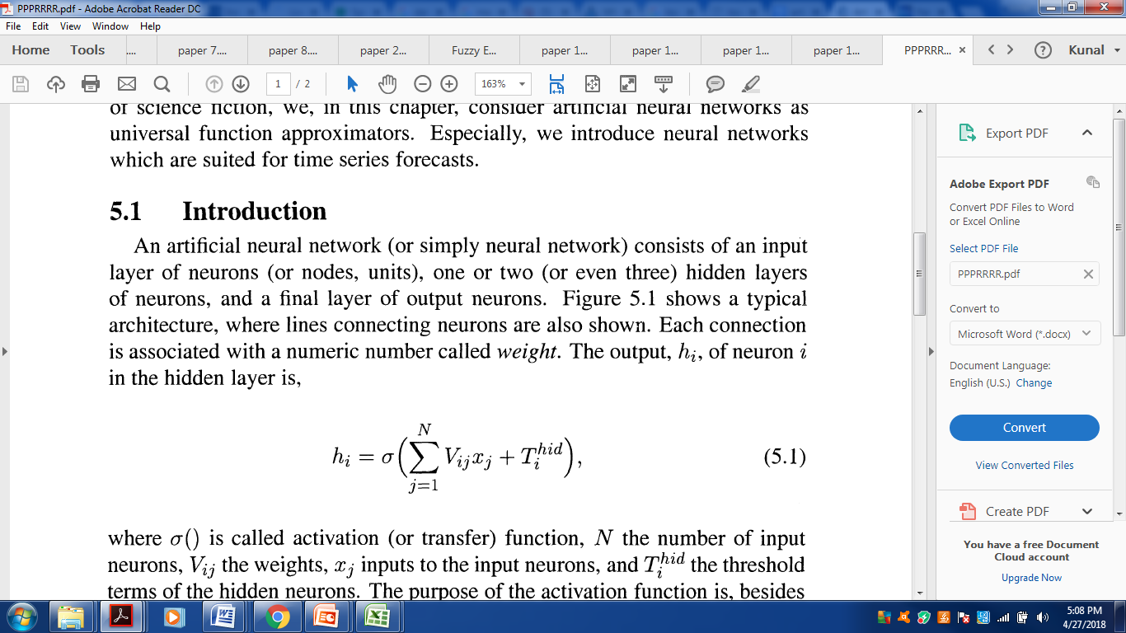
where σ() is called activation function, N the number of input neurons, Vij the weights, x j inputs to the input neurons, and T_{i}^{hid} the threshold terms of the hidden neurons. The purpose of the activation function is to bound the value of the neuron so that the neural network doesn’t get paralyzed by divergent neurons. A common example of the activation function is the sigmoid function.
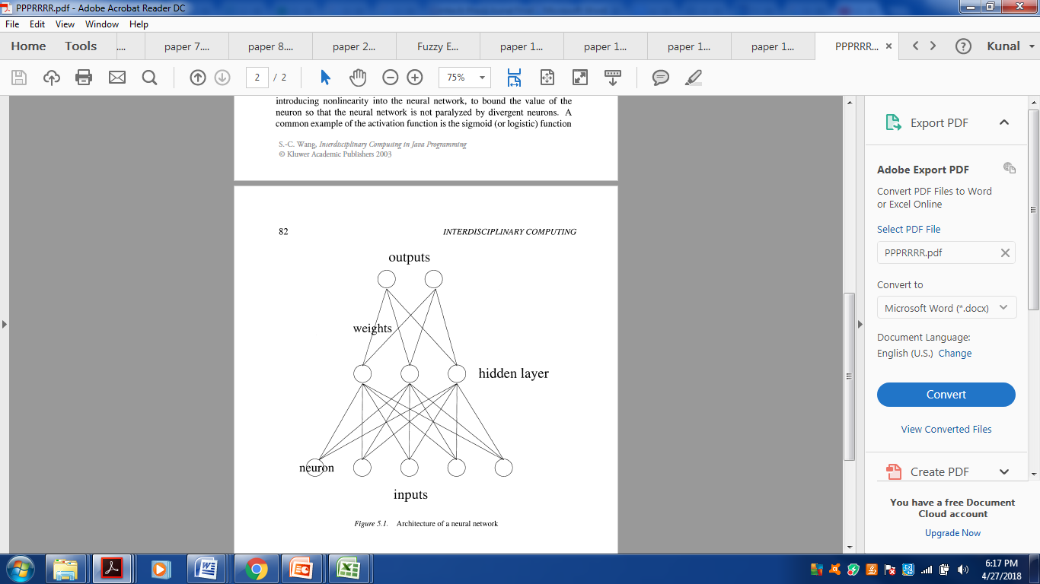

Figure5.3: Architecture of a neural network
Phase 2
While Phase (2) involves measuring the accuracy of the machine learning algorithms used in the study and visualization of the results as shown in fig 5.4

INPUT

MEASURING ACCURACY

TABULATION OF RESULTS

VISULIZATION

Figure 5.4: Phase 2 of the methodology applied.
5.3.4 Performance Evaluation
Assessing the performance of a classifier is very important and critical toward obtaining a good and robust model. There are different types of performance metrics that we briefly review here. Suppose that we deal with two classes: positive and negative. Table 5.3 shows the confusion matrix of these two classes.

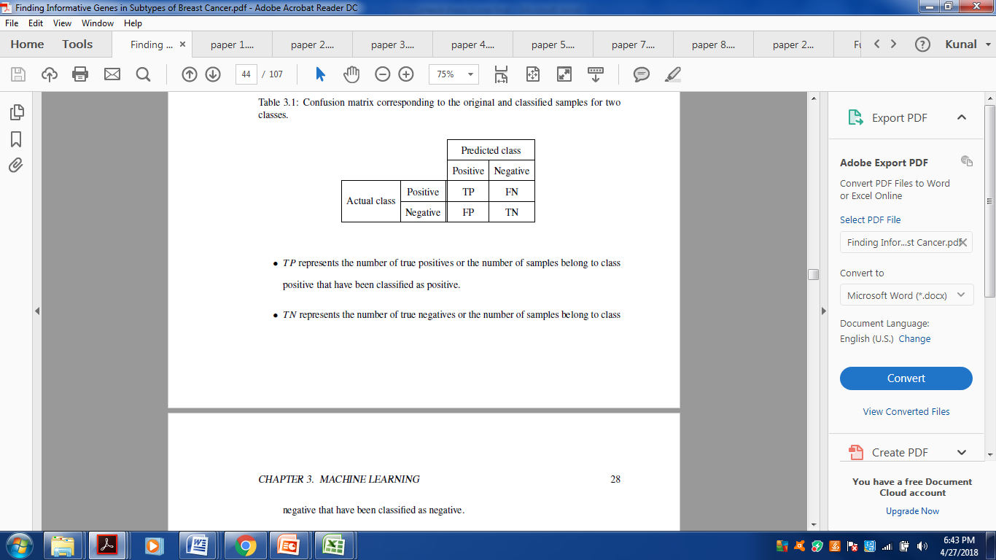
Table 5.3 : Confusion Matrix of the two classes in the data set.
TP represents the number of true positives or the number of samples belong to positive class that have been classified as positive.

TN represents the number of true negatives or the number of samples belong to negative class that have been classified as negative

FP represents the number of false positives or the number of samples belong to negative class that have been classified incorrectly as positive.

FN represents the number of false negatives or the number of samples belong to positive class that have been classified incorrectly as negative.

Accuracy: Accuracy of a classifier is the percentage of the test set tuples that are correctly classified by the classifier.

Accuracy = True positives + True negatives
True and false positives + True and False negatives

Sensitivity: Sensitivity is the percentage of true positives correctly classified.
Sensitivity = True positives
False negatives + True positives

Specificity: Specificity is the fraction of negative tuples correctly identified.
Specificity = True negative
True negatives + False positives

5.3.5 Tabulation of results and visualization.
The accuracy results are viewed in the tabular form in the data mining tool R.
The matrix is formed in the tabular form. The matrix formed have the results in it.

DATA SET

CLASSIFICATION ALGORITHMS

NAVIE BAYES
ANN
SVM
KSVM

PERFORMANCE EVALUTION

KSVM

Figure 5.5: System Architecture
Chapter 6
Results and discussion

6.1 Experimental Results
The qualitative analysis was made against four machine learning algorithms as mentioned in the table 6.1 containing 558 records of patients and non patients. The following qualitative analysis were drawn against the parameters including accuracy, sensitivity and specificity.

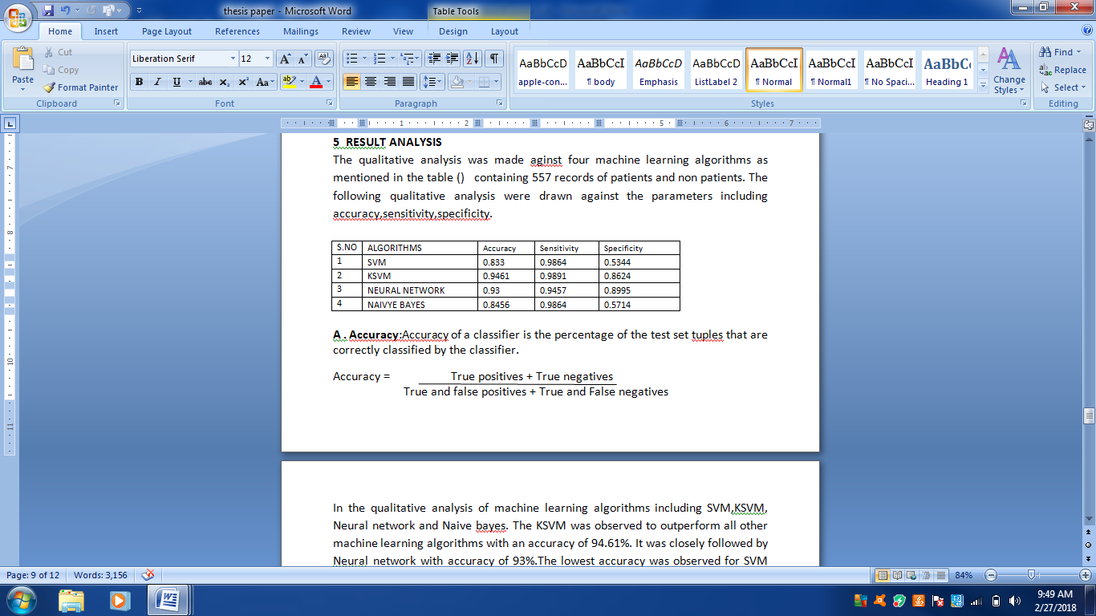
Table 6.1: Showing the output of the Algorithms.
The models SVM, KSVM, ANN,and Navie Bayes with their parameters such as Accuracy, Sensitivity and Specificity are build up and there concurrent results are shown in the table above.
By viewing the table we can see that the desired output of the models which are being analyzed.

6.2 SVM model results
The Support Vector Machine (SVM) model performs the following results with the data set provided to it.
Accuracy of this model comes out to be about 83.3%, Sensitivity was about 98.64% and Specificity was about 53.44%.
Cross fold validation in the model makes the results of the model varies from the previous recorded results.

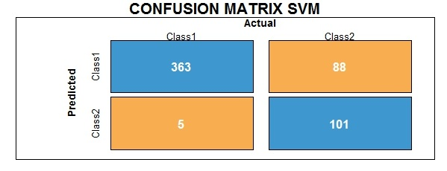
Figure 6.1: Confusion Matrix of the SVM model.

6.3 KSVM model results
The Kernel Support Vector Machine (KSVM) model is kernel based model. The data set is imputed to this model.
Accuracy of this model comes out to be about 94.61%, Sensitivity was about 98.91% and Specificity was about 86.24%.

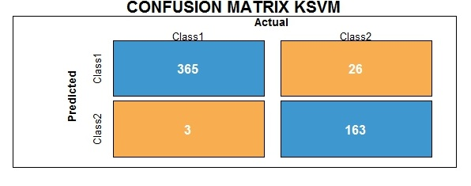
Figure 6.2 : Confusion Matrix of the KSVM model.
6.4 Neural Network model results
Artificial neural network model with the liver data set performed the following results with Accuracy 93%, Sensitivity 94.57% and Specificity 89.95%.

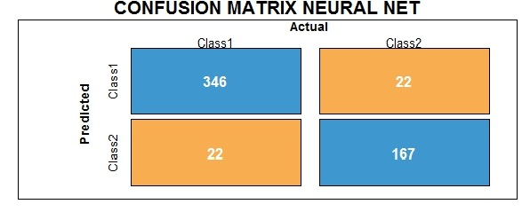
Figure 6.3: Confusion Matrix of Neural network model

The following diagram shows the model as a neural network. The black lines are positive weights and the grey lines are negative weights. Line thickness is in proportion to magnitude of the weights related to others. Each of the eight random variables is shown in the first layer (labeled as I1-I8) and the response variable is shown in the right layer (labeled as ‘0’ and ‘1’). The hidden layer is depicted as H1 through H5, which was specified using the size argument in the Neural network function. B1 and B2 are bias layers that gives constant values to the nodes.

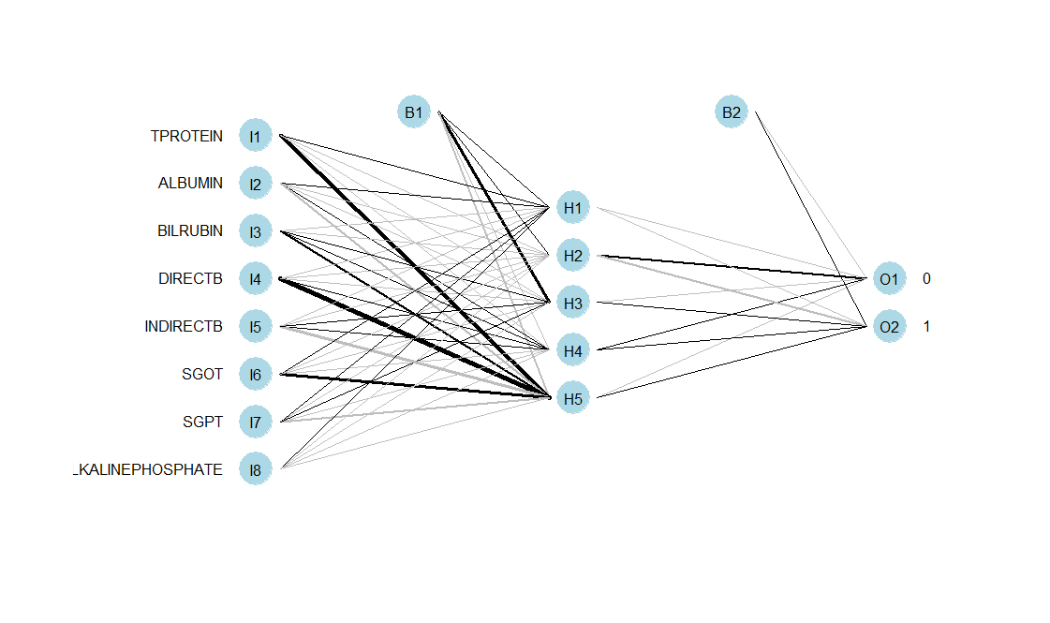
Figure 6.4: R-Plot of Neural network

6.5 Naive Bayes model results
Naive bayes model gives the following results with Accuracy of 84.56%, Sensitivity 98.64%and Specificity 57.14%.

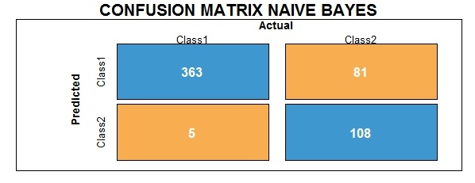
Figure 6.5: Confusion Matrix of Naïve Bayes Model.

By plotting the parameters of the above algorithms in the graph we get the following graph.
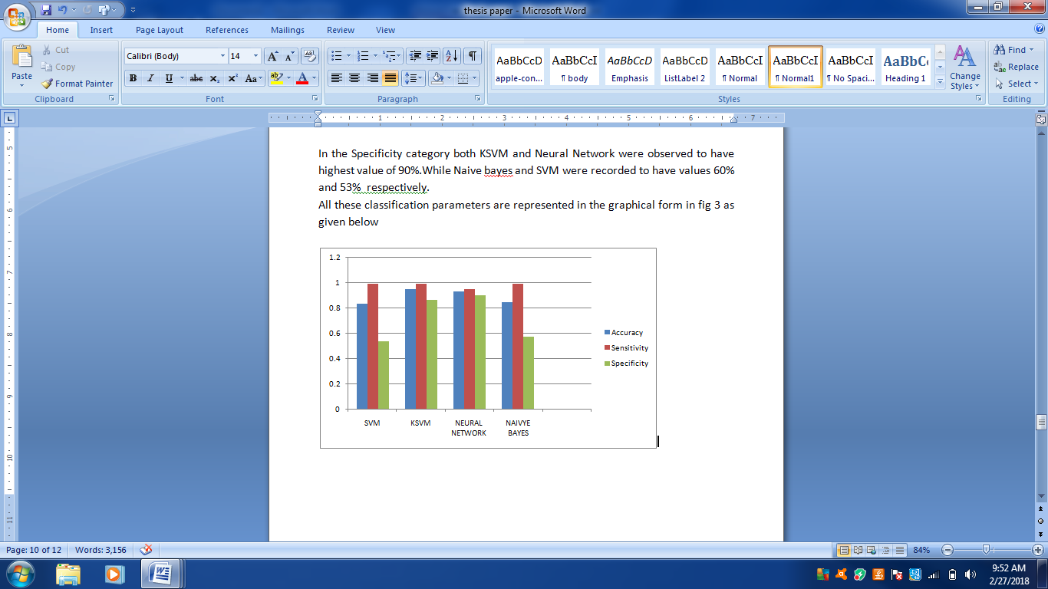 Figure 6.6: Showing the output of the machine learning algorithms with there classification parameters.

The above graph shows that KSVM performs the best and score the rank 1 in the model comparison and also sum of all the parameters of the Models shows that KSVM has the best Accuracy.

Chapter 7
Conclusion
In our research, our goal was to build machine learning algorithms which perform the best accurate results with the liver data of about 558 patients.
Various models like KSVM, SVM, Neural network and Naïve bayes have their different range of predictions of the diseased and non diseased patients.
Another challenge which we faced in this research is the feature selection; relevant features are extracted in the data. This feature makes the data more quality wise and efficiently performs the results for the medical diagnosis of the previous reports.

7.1 Contributions
The contribution of the project can be stated as below.
- The liver data set is reframed and feature selection is done in the data.
- The important medical machine learning algorithms like KSVM,SVM, Neural network, Naïve bayes are observed with the clinical features of the data set.
- Cross fold validation makes the model with more accurate results.
- The models are compared with the confusion matrix and the actual data is verified with the predicted data.
- Evaluating the proposed models with different performance measures and comparing the best model with others.

7.2 Future work
Although we have taken four machine learning algorithm’s for the performance evaluation, we would like to proposed a hybrid model.
In future a Hybrid model could be proposed which may contain most efficient machine learning algorithms for further classifying the data of the patient’s and easy diagnosing of the clinical reports.
Apart from using the categorical data, we can further include the image detection and natural language processing for diagnosis of liver disease.

Refrences
[1] K. Na, S.K. Jeong, M.J. Lee (2013), Human liver carboxylesterase 1 outperforms alpha-fetoprotein as biomarker to discriminate hepatocellular carcinoma from otherliver diseases in Korean patients, International Journal of Cancer 33 (2)408–415.
[2] Source https://www.medicinenet.com/liver_disease/article.htm
[3] Abdar, Moloud, et al (2017). "Performance analysis of classification algorithms on early detection of liver disease." Expert Systems with Applications 67 : 239-251.
[4] A.K. Pujari( 2001) , Data mining techniques, 4th edition, University Press (India) Private Limited, 2001.

[5] J. Han. & K. Micheline (2006), Data mining: Concepts and Techniques, MorganKaufmann Publisher.

[6] Firoozbakht, Forough (2014), "Finding Informative Genes in Subtypes of Breast Cancer."

[7] Sharma, P. and Kaur, M. (2013) Classification in Pattern Recognition: A Review. International Journal of Advanced Research in Computer Science and Software Engineering, 3, 298.

[8] Rambhajani, M., Deepanker, W. and Pathak, N. (2015) A Survey on Implementation of Machine Learning Techniques for Dermatology Diseases Classification. International Journal of Advances in Engineering & Technology , 8, 194-195.

[9] Marshland, S. (2009) Machine Learning an Algorithmic Perspective. CRC Press, New Zealand, 6-7.

[10] P. Domingos, M. Pazzani, On the optimality of the simple Bayesian classifier under zero-one loss, Machine Learning 29 (2–3) (1997) 103–130.

[11] Shavlik, J. W., Mooney, R. J., & Towell, G. G. Symbolic and neural learning algorithms: An experimental comparison. Machine Learning, 1991; 6(2), 111-143.

[12] Setiono, R. A penalty-function approach for pruning feedforward neural networks. Neural Computation, 1997; 9(1), 185-204.

[13] Bendi Venkata Ramana, Prof.M.Surendra Prasad Babu, Prof. N. B. Venkateswarlu, “A Critical Study of Selected Classification Algorithms for Liver Disease Diagnosis,” IJDMS, Vol.3, No.2, May 2011
[14] Michael J. Sorich John O. Miners, Ross A. McKinnon, David A. Winkler,Frank R. Burden, and Paul A. Smith Comparison of linear and nonlinear classification algorithms for the prediction of drug and chemical metabolism by human UDP- Glucuronosyltransferase Isoforms

[15] Leo Breimen (2001), "Random Forests", Machine Learning ,Vol. 45, PP.5-32

[16] Akin Ozcift and Arif Gulten ( 2011) :” Classifier Ensemble Construction With Rotation Forest To Improve Medical Diagnosis Performance Of Machine Learning Algorithms”. In Proceedings of the Computer Methods and Programs in Biomedicine, pages 443-451.

[17] Aman Singh, B. Pandey (2014),” Intelligent techniques and applications in liver disorders: a survey”, Int. J. Biomed. Eng. Technol. 16 .27 – 70.

[18] Bendi Venkata Ramana, Prof.M.Surendra Prasad Babu, Prof. N. B. Venkateswarlu (May 2011) , “A Critical Study of Selected Classification Algorithms for Liver Disease Diagnosis,” IJDMS, Vol.3, No.2.

[19] Mehdi Neshat, Mehdi Sargolzaei, Adel Nadjaran Toosi and Azra Masoumi (2012)“Hepatitis Disease Diagnosis Using Hybrid Case Based Reasoning and Particle Swarm Optimization”, International Scholarly Research Network ISRN Artificial Intelligence Volume 2012, Article ID 609718, 6 pagesdoi:10.5402/2012/609718.

[20] Anju Gulia, Dr. Rajan Vohra, Praveen Rani, “Liver Patient Classification Using Intelligent Techniques”, (IJCSIT) International Journal of Computer Science and Information Technologies, Vol. 5 (4), 2014, 5110-5115.

[21] Fatima M, Pasha M. Survey of Machine Learning Algorithms for Disease Diagnostic. Journal of Intelligent Learning Systems and Applications. 2017 Jan 24;9(01):1-6.

[22] Shimaa Abd Allah Ibraheem, Hatem Mohamed Abd Elkader, Ibraheen Selim, and Reda Hussein,” Hybrid Rough-Fuzzy Classifier for Liver Disease Diagnosis” 2016 I. J. of Electronics and Information Engineering (IJEIE), 2016

[23] Vijayarani, S. and Dhayanand, S., 2015, “Liver Disease Prediction using SVM and Naïve Bayes Algorithms”, International Journal of Science
Engineering and Technology Research (IJSETR), Vol.4, pp. 816-820.

[24] Rajeswari, P. and Reena, G.S., 2010, “Analysis of Liver Disorder Using Data Mining Algorithm”, Global Journal of Computer Science and Technology”, 10, pp.48-52.

[25] Vijayarani, S. and Dhayanand, S., 2015, “Liver Disease Prediction using SVM and Naïve Bayes Algorithms”, International Journal of Science
Engineering and Technology Research (IJSETR), Vol.4, pp. 816-820.

[26] Kim, Sangman, et al. "Effective liver cancer diagnosis method based on machine learning algorithm,(2014)" Biomedical Engineering and Informatics (BMEI), 2014 7th International Conference on. IEEE.

[27] Tavakkoli, Parisa, et al (2015). "Classification of the liver disorders data using Multi-Layer adaptive Neuro-Fuzzy inference system." Computing, Communication and Networking Technologies (ICCCNT), 2015 6th International Conference on. IEEE.

[28] S. Saha, S. Saha, and P. P. Bhattacharyya (2015), “Classifier fusion for liver function test based Indian jaundice classification,” 2015 International Conference on Man and Machine Interfacing (MAMI).

[29] Ramana, Bendi Venkata, M. Surendra Prasad Babu, and N. B. Venkateswarlu ( 2011). "A critical study of selected classification algorithms for liver disease diagnosis." International Journal of Database Management Systems 3.2 (2011): 101-114.

[30] Karthik, S., et al (2011). "Classification and rule extraction using rough set for diagnosis of liver disease and its types." Adv Appl Sci Res 2.3 (2011): 334-345.

[31] Khan, Aurangzeb, et al (2010). "A review of machine learning algorithms for text-documents classification." Journal of advances in information technology 1.1.

Publication

"4th International Conference on Recent Trends and Advancements in Engineering and Technology (ICRTAET)" on November 3-4, 2017.

